A DETAILED REPORT ON DRIVES

Maxon Rodrigues
First Year Student
B.Tech in Computer Science and Engineering
Manipal Institute of Technology
Manipal, Karnataka, India
maxonrodrigues@gmail.com

Abstract—This document is a detailed report on eight different drive types. Namely they are Differential Drive, Omnidirectional Drive, Mecanum Drive, Ackermann Steering Drive, Swerve Drive, Tracked Drive, Four-Wheel Drive (4WD) and Skid-Steer Drive. It will explain the working principle, advantages, disadvantages and why it is used.
Keywords— Drive, Mecanum, Ackermann.

Introduction
When selecting the correct robotic drive system, it must have the matching mechanical capabilities with operational requirements that matches its use case. They are mainly classified into holonomic and non-holonomic drives. Holonomic drives are the ones that do not have any constraint on their degrees of freedom. They can move in any direction without the need to orient themselves. Whereas non-holonomic drives do have some constraints and need to be properly oriented to move in a certain direction. It can’t move side to side without orienting itself first. The manoeuvrability of any mobile robot is fully defined by its degree of mobility ($δ_{m}$) and its degree of steerability ($δ_{s}$). The overall degree of maneuverability ($δ_{M}$) is expressed as the sum of these two parameters:
$$δ_{M}=δ_{m}+δ_{s}$$
Let us talk about eight major drive systems with their working principles, real-world applications, and their advantages along with disadvantages such that selecting a type of drive becomes clearer and easier.

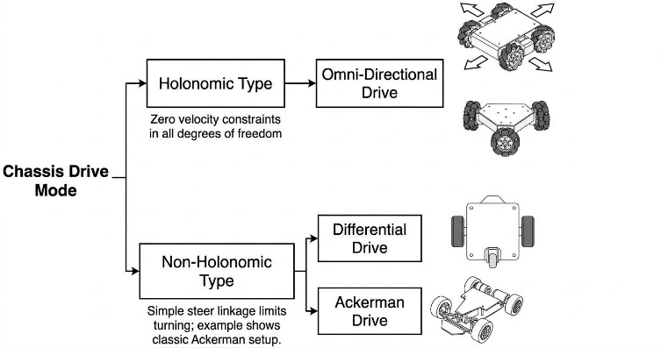
Source: Generated With Gemini for Illustrative Purposes
Img. 1 Mind Map of Some Robotic Drives

Differential Drives
Differential drives are the drives that rely on two independently powered drive wheels mounted co-axially on a central transverse axis, supported by one or two passive caster wheels or omni-rollers for static stability. Vehicle steering is achieved entirely through velocity differentials between the left and right drive wheels ($ω_{l}$and $ω_{r}$). It can’t move sideways, so it is a non-holonomic drive.

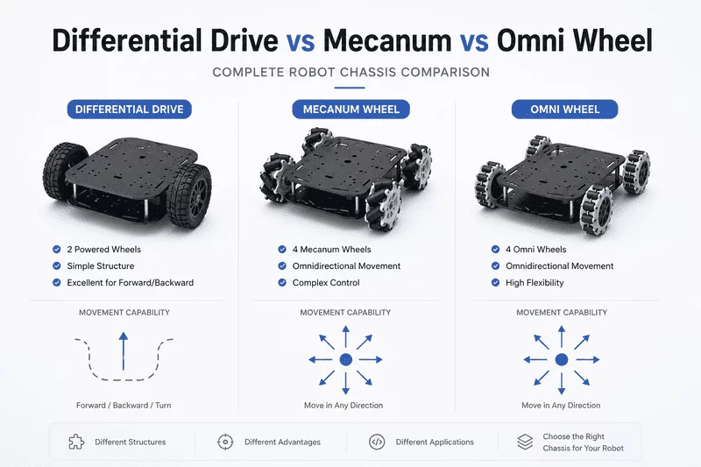
Source: https://www.fdatabot.com/differential-drive-vs-mecanum-vs-omni-wheel-robot-chassis/
Img. 2 Differential Drive

Working Principle
Differential drive relies on two independently powered drive wheels mounted co-axially on a central transverse axis, supported by one or two passive caster wheels or omni-rollers for static stability. Vehicle steering is achieved entirely through velocity differentials between the left and right drive wheels ($ω_{l}$ and $ω_{r}$). Since the drive cannot generate instantaneous sideways translation, it is a nonholonomic. So, $δ_{m}=2 and δ_{s}=0$. Some ways its motion is achieved is:
- Linear motion: Both wheels turn at identical speeds in the same direction ($ω_{r}=ω_{l}$).
- Turning arc: One wheel turns faster than the other ($ω_{r}≠ω_{l}$).
- Zero-radius turn: Wheels turn at equal speeds in opposite directions ($ω_{r}=-ω_{l}$), causing the robot to rotate in place around the axle midpoint.

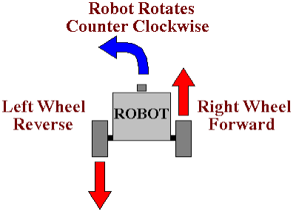
Source: https://www.societyofrobots.com/programming_differentialdrive.shtml
Img. 3 Working of a Differential Drive

Advantages and Disadvantages?
- Advantages: Low cost of parts used. Mechanically simple and highly reliable. Easy open-loop control chain and zero-radius turning capability.
- Disadvantages: Cannot move sideways. The non powered wheels cause vibration and trajectory changes during sudden directional changes. Poor performance over uneven ground.

Applications
- Indoor Autonomous Mobile Robots and Automated Guided Vehicles in warehouse logistics.
- Consumer domestic robots like robotic vacuum cleaners.
- Educational, research, and desktop mobile platforms.

Omnidirectional Drive
An omnidirectional drive or an omni wheel drive is a type of holonomic mobile robot locomotion system capable of moving instantaneously in any direction within a 2D planar workspace while independently controlling its rotational orientation. Unlike standard non-holonomic platforms, an omnidirectional robot can move sideways or diagonally without needing to rotate its chassis or reorient its wheels beforehand.

Source: https://www.fdatabot.com/differential-drive-vs-mecanum-vs-omni-wheel-robot-chassis/
Img. 4 Omni Wheel Drive

Working Principle
An omnidirectional platform utilizes three or four specialized wheels equipped with passive rollers around their circumference, oriented at ${90}^{∘}$ relative to the main wheel axis. By varying the relative rotational speeds of the main hubs, the passive rollers absorb unactuated lateral forces while the active hubs apply directional forces. The vector sum of all wheel forces produces instantaneous movement in any 2D planar direction ($v_{x},v_{y}$) alongside chassis rotation ($ω_{z}$). This design is fully holonomic ($δ_{m}=3,δ_{s}=0$).

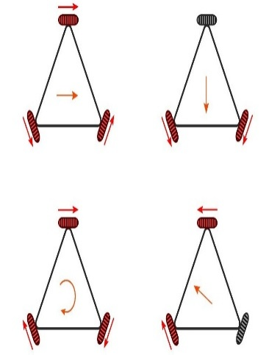
Source: www.servomagazine.com/magazine/article/get-rolling-with-omni-directional-wheels
Img. 5 Working of an Omni-Wheel Drive

Types of Omni Wheel Drives
Omni Wheels are of the following types:
- 3-Wheel Triangular Layout
Also called the Kiwi drive. It has three omni wheels arranged at ${120}^{∘}$ increments around a circular chassis. This configuration uses only three motors to achieve complete 3-DOF holonomic agility, keeping weight, parts count, and cost low.
- 4-Wheel Orthogonal Layout
Also called the X-Drive or Plus-Drive. It contains four omni wheels positioned at ${90}^{∘}$ intervals along the chassis corners or sides. This setup provides more uniform force distribution, smoother motion, and higher payload capacity than 3-wheel configurations.

Advantages and Disadvantages?
- Advantages: True 3-DOF holonomic mobility, rapid multidirectional response without reorienting steering linkages.
- Disadvantages: Low traction and pushing force. Bumpiness and chassis vibration are caused due to the roller transition gaps. It has a high susceptibility to lateral sliding when pushed by external forces.

Applications
- Compact indoor service and hospitality robots.
- Used in competitive robotic sports.
- Laboratory automation and small-scale agile assembly platforms.

Mecanum Drive
A Mecanum drive is a holonomic mobile robot locomotion system that utilizes specialized wheels fitted with peripheral rollers mounted typically at a ${45}^{∘}$ angle to the wheel rotational axis. This configuration allows the vehicle to move instantaneously in any direction and rotate simultaneously without needing to reorient the chassis.

Source: https://www.fdatabot.com/differential-drive-vs-mecanum-vs-omni-wheel-robot-chassis/
Img. 6 Mecanum Drive

Working Principle
The drive consists of four independent motor-driven Mecanum wheels. When the wheels rotate, the diagonal rollers translate the rotational force into longitudinal and transverse force vectors. By carefully coordinating the individual wheel speeds and directions ($ω_{1},ω_{2},ω_{3},ω_{4}$), the net force vector allows omnidirectional planar movement ($v_{x},v_{y},ω_{z}$). This design provides full holonomic capability ($δ_{m}=3,δ_{s}=0$).

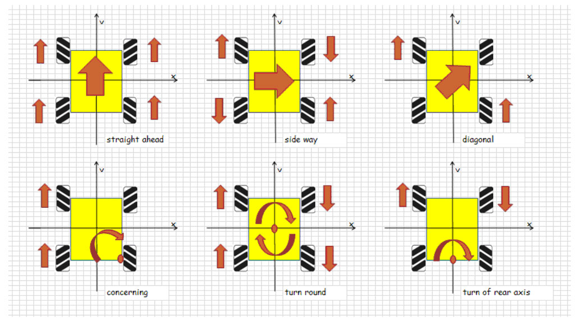
Source:www.roboteq.com/technology/all-blogs/5-driving-mecanum-wheels-omnidirectional-robots
Img. 7 Working of a Mecanum Drive

Types of Mecanum Drives
Mecanum Drives are of the following types:
- Standard 4-Wheel Mecanum
Features four wheels with ${45}^{∘}$ angled rollers arranged in an "X" pattern when viewed from above.
- Active-Roller or Dual-Roller Mecanum
Advanced variants where rollers are powered or double-stacked to reduce gap bumpiness and vibration during rotation.

Advantages and Disadvantages?
- Advantages: True holonomic mobility within a standard rectangular footprint. It allows agile movement, diagonal travel, and tight navigation in confined spaces.
- Disadvantages: Reduced traction compared to standard wheels and is susceptible to slipping. It is vulnerable to debris jamming the rollers and has a slightly bumpy ride over roller transition gaps.

Applications
- Warehouse automated guided vehicles and flexible material handling systems.
- Competitive robotics platforms.
- Indoor autonomous service robots.

Ackermann Steering Drive
An Ackermann steering drive is a traditional non-holonomic kinematic arrangement used primarily in automotive vehicles and wheeled mobile robots where the front wheels pivot on independent vertical axes to steer.

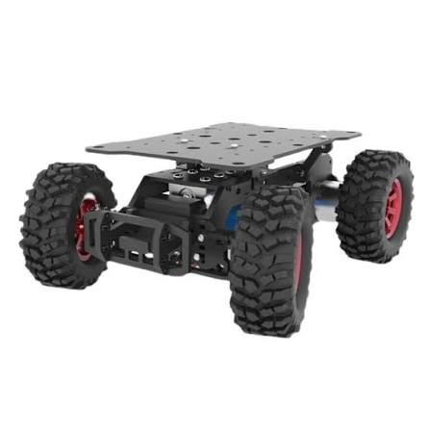
Source: https://probots.co.in/
Img. 8 Ackermann Steering Drive

Working Principle
The steering geometry utilizes a pivoted linkage that ensures the inner and outer front wheels turn along different radii, meeting at a common instantaneous centre of rotation. This geometric alignment minimizes tire scrubbing during turns. Since it cannot translate sideways instantaneously, it is a non-holonomic system ($δ_{m}=2,δ_{s}=1$).

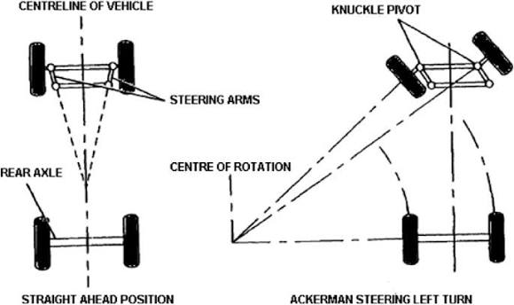
Source: https://link.springer.com/chapter/10.1007/978-981-16-2857-3_3
Img. 9 Working of an Ackermann Steering Drive

Types of Ackermann Steering Drives
Ackermann Steering Drives are of the following types:
- Standard Front-Wheel Ackermann
Features steerable front wheels paired with a fixed rear drive axle (standard automobile architecture).
- Four-Wheel or All-Wheel Steering
Both front and rear axles steer actively. It can steer front and rear wheels in opposite directions for tighter turns, or in the same direction for "crab steering" (moving diagonally while keeping a fixed orientation).

Advantages and Disadvantages?
- Advantages: High-speed stability, excellent energy efficiency, smooth handling, and great performance on paved roads and rough terrain.
- Disadvantages: Large turning radius and it is non-holonomic. Needs mechanically complex steering linkages.

Applications
- Autonomous passenger vehicles and delivery pods.
- Outdoor agricultural rovers and utility vehicles.
- Golf carts and traditional automobiles

Swerve Drive
A swerve drive also known as an independent steering drive system is an advanced holonomic mobile robot drive where every wheel assembly can be independently driven and steered across a full ${360}^{∘}$ range.

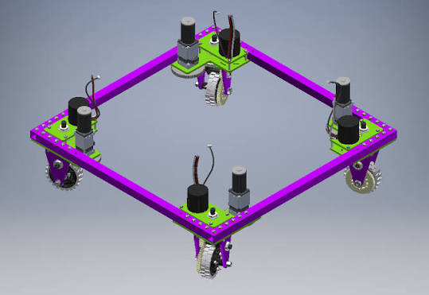
Source: https://www.chiefdelphi.com/t/4926-offseason-swerve-drive/359358
Img. 10 Swerve Drive

Working Principle
Each wheel assembly is powered by two independent actuators, where one motor is used to drive the wheel's rotation and a second motor to steer the entire wheel module's orientation. By continuously adjusting both the speed and steering angle of all wheels, the vehicle can achieve vector-summed omnidirectional motion and instantaneous heading changes ($δ_{m}=2,δ_{s}=2$).

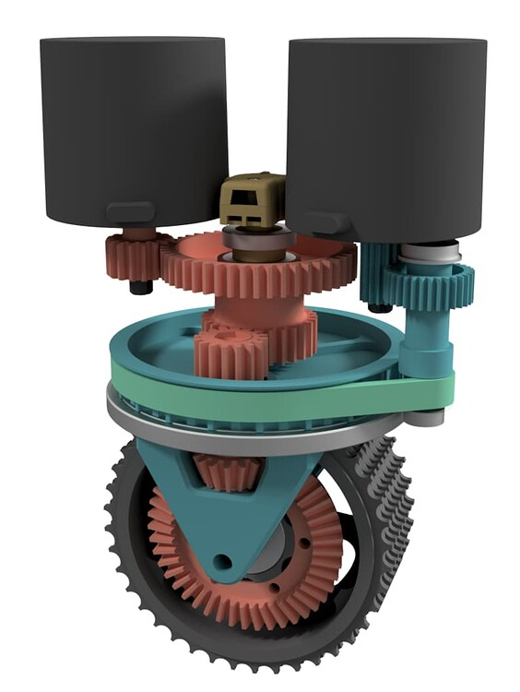
Source: https://www.chiefdelphi.com/t/coaxial-swerve-explanation/439591
Img. 11 Working of an Swerve Drive

Types of Swerve Drive
Swerve Drives are of the following types:
- Coaxial Swerve
Each pod uses two dedicated motors. One motor turns a central shaft passing through a coaxial bevel gear to drive the wheel, while the second motor rotates the pods orientation.
- Differential Swerve
Each pod uses two motors coupled through an internal differential gearset. Both motors share the load to drive the wheel and pivot the module simultaneously, increasing power density.

Advantages and Disadvantages?
- Advantages: Exceptional maneuverability, full holonomic agility, superior traction, and maximum efficiency compared to omni or mecanum wheels.
- Disadvantages: High mechanical and control complexity. It is expensive due to the high motor count and is prone to calibration drift.

Applications
- Advanced high-performance competitive robotics.
- Heavy-duty industrial AGVs and material transport systems.
- Advanced omnidirectional research platforms

Tracked Drive
A tracked drive is a non-holonomic locomotion system that replaces traditional wheels with continuous flexible metal, rubber, or composite tracks wrapped around multiple bogie and drive wheels on each side of the chassis.

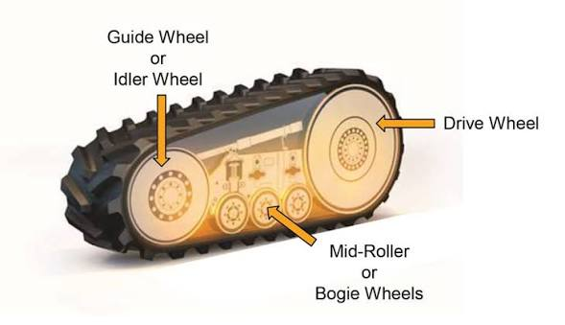
Source: www.farm-equipment.com/articles/18856-friction-vs-positive-drive-ag-track-systems/
Img. 12 Tracked Drive

Working Principle
Traction and propulsion are distributed over a large surface area by using continuous treads. Steering is accomplished by creating a velocity differential between the left and right tracks, enabling zero-radius in-place rotation. It is a non-holonomic drive ($δ_{m}=2,δ_{s}=0$).
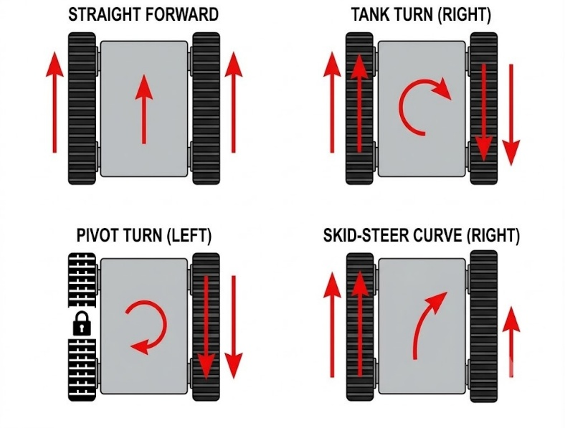
Source: Generated With Gemini for Illustrative Purposes
Img. 13 Working of a Tracked Drive

Types of Tracked Drives
Tracked Wheels are of the following types:
- Standard Dual-Track Skid-Steer
Twin continuous rubber or steel treads. Same drive to that of a tank-style layout.
- Articulated or Flipper Track Systems
Features two main tracks plus two to four auxiliary tracked "flipper" arms that rotate ${360}^{∘}$ around the main track axles to climb stairs, ledges, and steep rubble.

Advantages and Disadvantages?
- Advantages: Outstanding traction and low ground pressure over soft, muddy, sandy, or steep terrain. It has an exceptional obstacle and stair-clearing capabilities.
- Disadvantages: High friction during turns causes high mechanical wear, consumes more power, damages delicate indoor flooring, and results in lower top speeds.

Applications
- Military and tactical ground robots.
- Planetary exploration rovers and heavy construction equipment.
- Search and rescue disaster-response platforms

Four-Wheel Drive (4WD)
A Four-Wheel Drive (4WD) system is a non-holonomic drivetrain configuration where power from the motor or engine is delivered simultaneously to all four wheels to maximize traction across challenging outdoor environments.

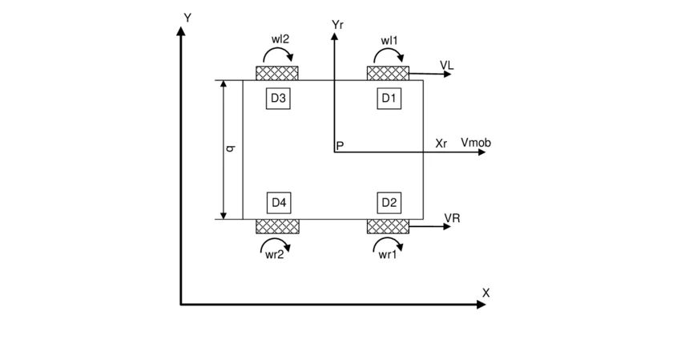
Source: https://www.researchgate.net/figure
Img. 14 Four-Wheel Drive

Working Principle
A Four-Wheel Drive only talks about how the power is delivered to each of the four wheels. However, the steering can be any of the above-mentioned steering techniques. Based on these techniques It adopts the same degrees of movement and degrees of steering as that of the steering mechanism.

Advantages and Disadvantages?
- Advantages: Superior traction, balanced weight distribution and stability on slippery, wet or uneven outdoor surfaces.
- Disadvantages: Increased mechanical complexity, higher weight, greater power consumption and a wider turning circle.

Applications
- Outdoor all-terrain mobile robots.
- Agricultural inspection and monitoring vehicles.
- Commercial four-wheel-drive utility rovers

Skid-Steer Drive
A skid-steer drive is a non-holonomic locomotion system characterized by rigid, non-steerable wheels or axles locked in parallel on each side of the chassis.

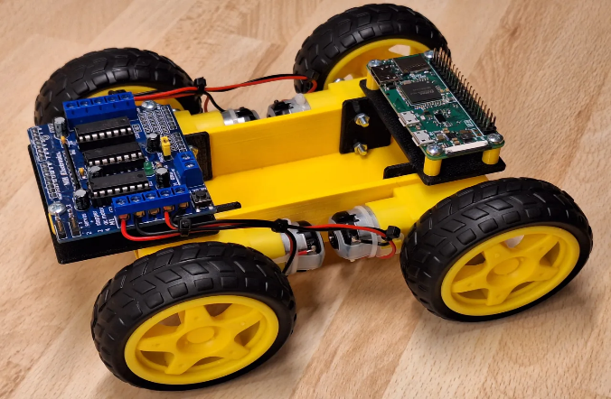
Source: printables.com/model/647566-modular-skid-steer-robot-platform
Img. 16 Skid-Steer Drive

Working Principle
Steering is accomplished by driving the wheels on the left side at a different speed or direction than the wheels on the right side. This velocity differential forces the tires to drag, slip, or "skid" sideways across the ground surface to execute a turn, allowing for zero-radius in-place rotation ($δ_{m}=2,δ_{s}=0$).

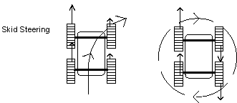
Source: https://www.semanticscholar.org/paper
Img. 17 Working of an Skid-Steer Drive

Types of Skid-Steer Drives
Skid-Steer Drives are of the following types:
- 4WD Fixed Skid-Steer
Four fixed wheels where the left-side and right-side pairs are driven independently via chains, belts, or dual motors.
- Multi-Wheel Skid-Steer
6WD or 8WD variants equipped with passive articulated suspensions to keep all wheels grounded over rough obstacles.

Advantages and Disadvantages?
- Advantages: Mechanically simple, robust and highly agile with zero-radius turning capability. It can handle rugged outdoor environments.
- Disadvantages: High tire and ground wear due to sliding friction during turns. It has higher power loss and imprecise odometry caused by wheel slippage.

Applications
- Industrial skid-steer loaders like Bobcats.
- Outdoor heavy-duty service and construction robots.
- Rugged agricultural mobile robotics platforms.

Acknowledgment
I would like to thank the team of Robo Manipal to give us this opportunity to learn more about different kind of robotic drives and for guiding and helping us.

References
- Wikipedia contributors. (2026). Omni wheel. In Wikipedia, The Free Encyclopedia. Retrieved from https://en.wikipedia.org/wiki/Omni_wheel
- Roboteq. (2026). Driving mecanum wheels and omnidirectional robots. Roboteq Technology Blogs. Retrieved from https://www.roboteq.com/technology/all-blogs/5-driving-mecanum-wheels-omnidirectional-robots
- SEER Robotics. (2025). Behind every great robot is a smarter drive model — Let’s break them down. YouTube Video. Retrieved from https://www.youtube.com/watch?v=SGGWSNQOU3w
- Mar Athanasius College Autonomous. (2026). Module 3: Steerability and manoeuvrability in robotics. Robotics Intelligence and Systems Course Materials. Studocu. Retrieved from https://www.studocu.com/in/document/mar-athanasius-college-autonomous-kothamangalam/robotics-intelligence-and-systems/module-3-steerability-manoeuvrability-in-robotics/160400878?sid=2d72b557-a1f9-4caf-ac67-841e0d5512111792333262
- Wikipedia contributors. (2026). Differential wheeled robot. In Wikipedia, The Free Encyclopedia. Retrieved from https://en.wikipedia.org/wiki/Differential_wheeled_robot
- Siegwart, R., & Nourbakhsh, I. R. (2004). Robot maneuverability. In Introduction to Autonomous Mobile Robots (Section 3.3.3). Carnegie Mellon University. Retrieved from https://www.cs.cmu.edu/~rasc/Download/AMRobots3.pdf

