A DETAILED REPORT ON MOTORS

Maxon Rodrigues
First Year Student
B.Tech in Computer Science and Engineering
Manipal Institute of Technology
Manipal, Karnataka, India
maxonrodrigues@gmail.com

Abstract—This document is a detailed report on ten different sensors. Namely DC Motors, Brushless DC Motors, Servo Motors, Stepper Motors, Smart Servos, Induction Motors, Synchronous Motors, Reluctance Motors and Permanent Magnet Synchronous Motors. It will explain the working principle, components, basic construction, production of torque, advantages and disadvantages, its applications and real-world examples along with diagrams.
Keywords—Motors, Servo, Brushless, Synchronous, Reluctance.

Introduction
After finding out about electricity, the next obstacle that remains is how do we use it for mechanical tasks. Motors are devices that convert electric energy to mechanical energy. We have motors in all sizes used to run small remote-controlled cars to larger ones used in EVs and Trains. Motors are generally classified into AC motors, DC motors and Special motors. AC motors generally use Alternating current, and DC motors use Direct current to run. AC Motors are further classified as Synchronous Motors and Induction or Asynchronous motors. DC Motors are further classified as Brushless and Brushed Motors. Special Motors are motors that are specifically designed for special purposes requiring high precision in position. Motors generally consist of a rotor and a stator. The part that moved in a motor is called the rotor and the part that stays stationary is called stator. The armature can be either the rotor or the stator depending on which contains electric current. This report will contain a detailed description of these motors.

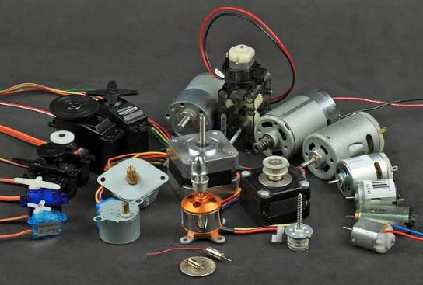
Source: https://learn.adafruit.com/adafruit-motor-selection-guide/types-of-motors
Img. 1 Collection of some Motors

Brushed DC Motors
Brushed DC motors are DC Motors where a mechanical contact is used to transfer electric current to the rotor. This electric current creates the magnetic field required to move the rotor.

Parts
A conventional brushed DC motor consists of these sub-assemblies:
- Stator (Stationary Frame):
Houses field poles composed of either permanent magnets or field windings wound around ferromagnetic iron cores. It provides a static radial magnetic field.
- Rotor and Armature:
Consists of laminated silicon steel core slots housing insulated copper coils connected to an axial output shaft.
- Commutator:
A cylindrical assembly of split copper segments mounted on the shaft, insulated from each other by mica layers.
- Brushes:
Spring-loaded carbon or graphite blocks held stationary against the rotating commutator segments to maintain sliding electrical contact between the external DC supply and the rotating armature windings.

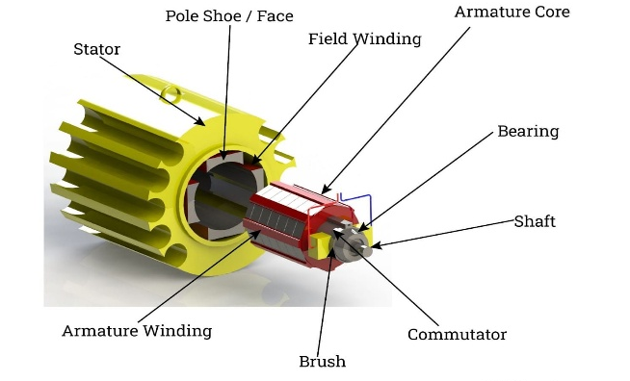
Source: https://www.iqsdirectory.com/articles/electric-motor/dc-motors.html
Img. 2 Parts of a DC Motor

Working Principle
In a brushed DC motor, the magnetic field is generated by electric current passing through the commutator and carbon brushes linked to the rotor. According to the Lorentz force law, a current-carrying wire inside a magnetic field experiences a mechanical force.
$$\vec{F}=I⋅\left(\vec{L}×\vec{B}\right)$$
Because the current flows in opposite directions on either side of the rotating loop, the forces push one side up and the other side down, creating rotational torque that spins the shaft. The stator, often built with laminated steel for reduced eddy current losses, houses the field winding that creates the constant magnetic field.
The commutator works as an internal rotary switch, periodically reversing current flow between the rotor and external power supply. This continual direction change generates sustained rotating torque. By alternating current, the motor's armature windings are energized, providing smooth operational speed and control, which is crucial for applications like industrial machinery, electric traction, and battery-powered devices.

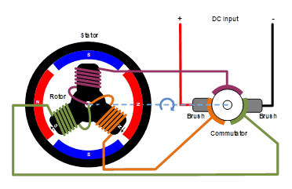
Source: monolithicpower.com/en/learning/resources/brushless-vs-brushed-dc-motors
Img. 3 Working of a Commutator

Torque Production
The total electromagnetic torque produced by a DC motor is proportional to the main field flux and armature current:
$$T=K_{t}⋅Φ⋅I_{a}$$
Where, $K_{t}$, is the structural motor constant,
$Φ$ is the magnetic flux per pole,
$I_{a}$ is the armature current.
Back-EMF ($E_{b}$) opposes the applied supply voltage ($V$), regulating armature current:
$$E_{b}=\frac{P⋅Φ⋅N⋅Z}{60⋅A}$$
Where, $P$, is the Number of magnetic field poles.
$N$, is the Number of rotations in rpm,
$Z$, is twice the total number of Coils,
$A$, Number of parallel paths in armature coil.
$$I_{a}=\frac{V-E_{b}}{R_{a}}$$
Where, $V$, is the Voltage supplied to the motor,
$R_{a}$, is the resistance of the armature windings and brushes.

Different Types
Depending on design, they may be separately excited, self-excited or permanent magnet DC motors.
- Separately Excited DC motor:
In a separately excited DC motor, independent electrical sources energize the armature winding and field winding. The armature and field currents are isolated, allowing for finer adjustments and flexible response to load variations.
- Self-Excited DC motor:
In a self-excited DC motor, a single power supply energizes both the field and armature windings. Depending on the circuit configuration, the field wiring could either be connected in series or in parallel to the armature wiring.
- Permanent Magnet DC motor:
The permanent magnet DC motor uses powerful magnets to create a steady magnetic field within the stator. By eliminating the need for a field winding, PMDC motors achieve reduced size and weight, and improved electrical efficiency compared to conventional wound field motors.

Advantages and Disadvantages?
- Advantages:
High Starting Torque: They deliver strong rotational force right from a complete stop, which makes them ideal for tasks requiring heavy lifting or sudden movement.
Simple Speed Control: You can easily control the motor's rotational speed by simply adjusting the applied voltage.
Low Initial Cost: Their straightforward mechanical design makes them significantly cheaper to manufacture and purchase than brushless alternatives.
Straightforward Drive Circuitry: They can run directly on DC power sources without needing complex electronic controllers or microcontrollers.
- Disadvantages:
Brush Wear: The physical friction between the carbon brushes and the rotating commutator causes the brushes to wear down over time.
Sparking and Noise: The switching action creates sparks every time a brush crosses a gap, producing electromagnetic interference that can disrupt nearby electronic circuits.
Speed Limitations: Friction and heat buildup limit how fast a brushed motor can safely spin compared to brushless designs.
Thermal Constraints: Because the electrical current runs through the rotor windings in the centre, heat is harder to dissipate than if the coils were on the outer frame.

Applications
DC Power Tools: Cordless drills and electric screwdrivers use brushed motors because they can deliver high torque instantly from a complete stop.
Automotive Systems: Small permanent-magnet brushed DC motors power components that run occasionally, such as windshield wipers, power windows or seat adjustments.
Household Appliances: Electric toothbrushes and small handheld mixers utilize compact brushed motors for quick, reliable mechanical motion.

Brushless DC Motors
Brushless DC motors are DC Motors where instead of mechanical contact, an electronic controller is used.

Parts
A conventional Brushless DC motor consists of these main sub-assemblies:
- Stator:
Polyphase (typically 3-phase) star-connected or delta-connected distributed copper windings slotted into a laminated steel outer frame.
- Rotor:
Made from high-remanence permanent magnet materials configured with alternating radial magnetic N and S poles.
- Position Feedback Sensors:
Hall effect sensors positioned at electrical intervals along the stator to monitor exact rotor magnet position for electronic commutation timing.
- Commutator:
BLDCs do not have a physical commutator or brushes. Instead, it uses electronic commutation driven by an external motor controller and a semiconductor bridge circuit.

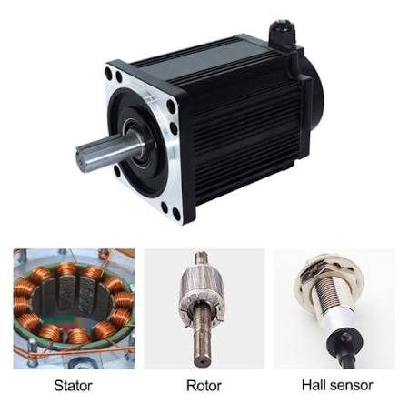
Source: https://www.iqsdirectory.com/articles/electric-motor/dc-motors.html
Img. 4 Parts of a BLDC Motor

Working Principle
In a brushed DC motor, instead of sliding carbon brushes, it relies on a 3-phase bridge inverter consisting of six power switches like MOSFETs.
The controller energizes two of the three stator phases at any given instant. Current entering Phase A and exiting Phase B creates a stator magnetic field vector positioned at 60º relative to the rotor field vector. The permanent magnet rotor turns to align with the stator field. As the rotor approaches alignment, Hall effect sensors trigger the inverter to switch current into Phase C, rotating the stator field vector by another 60º and maintaining continuous rotational torque.

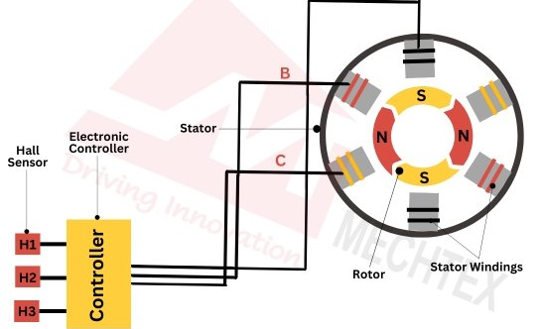
Source: monolithicpower.com/en/learning/resources/brushless-vs-brushed-dc-motors
Img. 5 Working of a BLDC

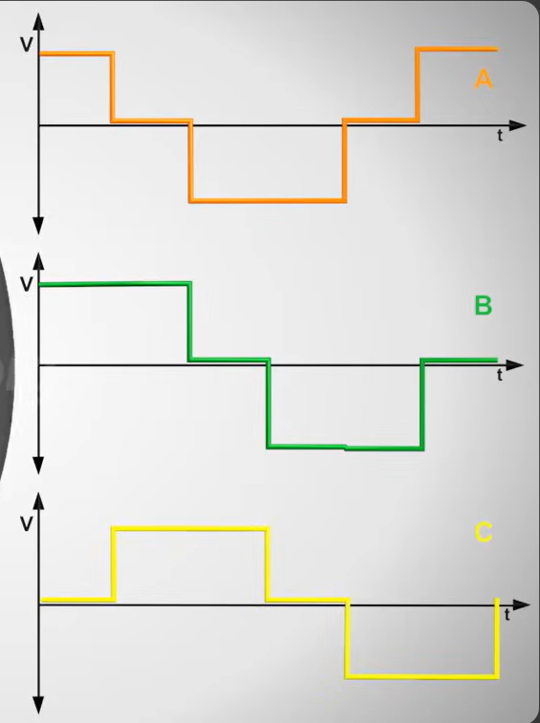
Source: https://www.youtube.com/watch?v=bCEiOnuODac
Img. 6 Graph portraying the voltage supplied to each stator winding

Torque Production
Trapezoidal back-EMF matching rectangular stator coil currents yields flat-topped electromagnetic torque:
$$T=\frac{E_{a}I_{a}+E_{b}I_{b}+E_{c}I_{c}}{ω_{m}}$$
Where, $ω_{m}$, is the angular velocity.

Different Types
Depending on design, they may be inrunner or outrunner Brushless DC motors.
- Inrunner BLDC:
Rotor rotates inside an outer stator. Features low rotor inertia, enabling fast mechanical acceleration and high rotational RPM.
- Outrunner BLDC:
Rotor shell rotates around an inner stator hub. Features high magnetic pole count, producing superior low-speed torque without mechanical gear reduction.

Advantages and Disadvantages?
- Advantages:
High Efficiency: Without carbon brushes creating friction and electrical resistance, significantly more electrical energy converts directly into mechanical motion rather than waste heat.
Longer Lifespan: The absence of physical contact points means no brush wear, eliminating the need for regular maintenance or part replacements.
High Torque-to-Weight Ratio: BLDC motors deliver more power relative to their physical size.
Silent Operation: Electronic switching removes the physical arcing, sparking, and noise inherent to mechanical commutators.
.
- Disadvantages:
Driver Complexity and Cost: They require a dedicated electronic speed controller and inverter circuitry to operate.
Position Feedback Dependency: The system requires physical sensors to continuously track the rotor's position.
Cogging Torque: At very low speeds, the magnetic attraction between the stator teeth and the rotor's permanent magnets can create a slight stutter or resistance.
.

Applications
Aerospace & Consumer Drones: Multirotor propulsion systems.
Transportation & Tools: Electric bicycles, battery EVs, high-efficiency HVAC blowers, cordless brushless power tools, computer cooling fans.

Induction Motors
Induction motors or Asynchronous motors are AC Motors in which the electric current in the rotor that produces torque is obtained by electromagnetic induction from the magnetic field of the stator winding. An induction motor therefore needs no electrical connections to the rotor.

Parts
A conventional Induction motor consists of these sub-assemblies:
- Stator:
Made of laminated, high-permeability silicon steel rings with internal longitudinal slots containing insulated single-phase or three-phase distributed AC windings.
- Rotor:
The Rotor in an induction motor can be of two types. A Squirrel Cage Rotor is Longitudinal heavy copper or aluminium bars embedded in laminated rotor slots, permanently short-circuited at both axial ends by conductive end-rings. A Slip Ring or Wound Rotor is a type of rotor with insulated 3-phase windings matching the stator pole count, connected to external slip rings and brushes to insert variable external starting resistors.

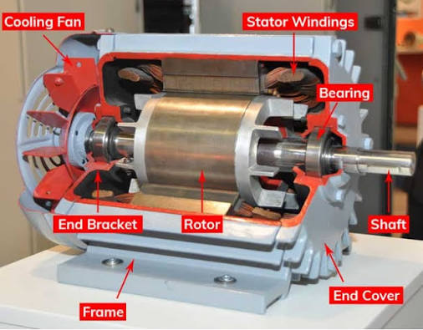
Source: https://www.ic-components.com/
Img. 7 Parts of an Induction Motor.

Working Principle
The working principle of an induction motor is based on electromagnetic induction. When AC supply is applied to the stator windings, it creates a rotating magnetic field that moves around the stator at synchronous speed. This rotating field alternates between north and south poles as it spins, producing a changing magnetic flux.
The rotor, placed inside the stator, isn’t connected to any power source. As the stator’s rotating magnetic field cuts through the rotor conductors, it induces current in them according to Faraday’s law of electromagnetic induction. This induced current produces its own magnetic field, which interacts with the stator’s field to generate torque and cause rotation. The rotor always turns slightly slower than the rotating field a difference known as slip which is necessary for continuous induction and motor operation. They also work in two different phase inputs, namely in single phase and triple phases.

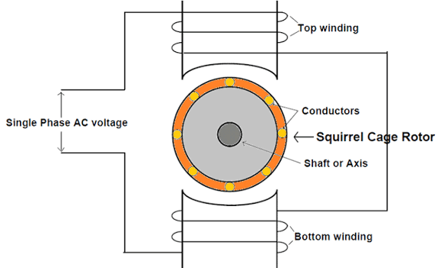
Source: https://circuitdigest.com
Img. 8 Working of a Single Phase Induction Motor

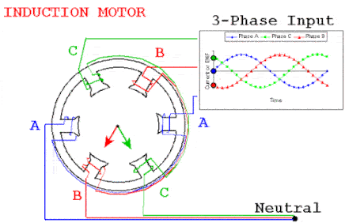
Source: https://www.allaboutcircuits.com
Img. 9 Working of a Three Phase Induction Motor

Torque Production
- Single-phase AC Motor:
According to Double Revolving Field Theory, any pulsating field:
$$Φ=Φ_{m}\cos\left(ωt\right)$$
along a fixed axis can be mathematically resolved into two equal rotating fields turning in opposite directions at synchronous speed ($N_{s}$), each having a constant maximum flux magnitude of $\frac{Φ_{m}}{2}$:
$$Φ\left(θ,t\right)=\frac{Φ_{m}}{2}\cos\left(ωt-θ\right)+\frac{Φ_{m}}{2}\cos\left(ωt+θ\right)$$
At standstill ($N=0$, $s_{f}=1$, $s_{b}=1$), both the forward and backward rotating fields induce equal and opposite torques within the rotor. Thus, a basic single-phase induction motor produces zero net starting torque and is not inherently self-starting.
To make single-phase induction motor self-starting, we add a Capacitor-Start. An auxiliary winding physically offset by ${90}^{∘}$ relative to the main winding is connected in series with a starting capacitor. This generates an electrical ${90}^{∘}$ phase shift, initiating rotation. Once it almost reaching rated speed, a centrifugal switch disconnects the auxiliary circuit.
- Triple-phase AC Motor:
As the rotor bars experience a changing magnetic field, Faraday's law of induction causes a voltage to be induced in the rotor winding. Since the rotor forms a closed circuit (typically via end rings in a squirrel-cage design), this induced voltage drives heavy electrical currents through the rotor bars. According to the Lorentz force principle, these current-carrying conductors inside a magnetic field experience a physical force, producing a mechanical torque that forces the rotor to chase and follow the RMF.

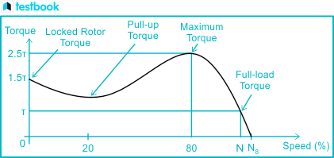
Source:testbook.com/electrical-engineering/torque-speed-characteristics-of-induction-motor
Img. 10 Torque speed graph

Different Types
Depending on design, they may be single phase, triple phase Induction AC motor.
- Single-phase AC Motor:
A Single-Phase AC Voltage supplied to a single stator winding generates an alternating flux along a fixed spatial axis.
- Three-Phase AC Motor:
A Three-phase AC induction motor utilizes three separate alternating currents, each phase shifted by 120 electrical degrees, to naturally generate a continuous Rotating Magnetic Field (RMF) inside the stator. Unlike single-phase motors, this inherent phase separation eliminates the need for any auxiliary starting windings or capacitors, allowing the motor to self-start efficiently.

Advantages and Disadvantages?
- Advantages:
Design & Construction: Simple structure with fewer parts, making it robust and easy to maintain.
Cost: Economical to manufacture and install compared to other electric motors.
Operation: Reliable, smooth, and self-starting for three-phase motors.
Performance: High efficiency and consistent speed under varying loads.
Torque: Provides steady torque for most industrial applications.
Power Factor: Operates efficiently under full load.
Durability: Rugged, long-lasting, and suitable for harsh working environments

- Disadvantages:
Repairability: Difficult to repair if the rotor or stator is damaged.
Speed Control: Limited speed control compared to DC motors.
Requires starting aids (for Single Phase): Single-phase types have low starting torque and need extra starting aids.
Slipping: Slip causes a small energy loss, reducing overall efficiency slightly.

Applications
Industrial Machines: Used in conveyors, compressors, pumps, blowers, drilling machines, and lathes because of their strong torque and reliable performance.
HVAC Systems: Power fans, air conditioners, exhaust systems, and ventilation units for smooth airflow and energy efficiency.
Household Appliances: Common in washing machines, refrigerators, mixers, and water pumps due to their quiet operation and low maintenance.
Agriculture: Drive irrigation pumps, threshers, grain grinders, and crushers, offering dependable service in rural and farm applications.
Transportation: Used in electric vehicles, elevators, cranes, and escalators where steady speed and torque are required.
Textile and Paper Industry: Run spinning machines, looms, and paper rollers that need consistent speed and efficient operation.
Mining and Construction: Operate hoists, crushers, and drilling equipment, valued for their rugged design and durability.

Synchronous AC Motors
Synchronous AC motors are AC Motors where the rotor spins at the exact same rotational speed as the rotating magnetic field (RMF) generated in the stator, resulting in zero slip. Unlike induction motors that always lags behind the RMF to produce torque, synchronous motors are locked in step with the frequency of the power supply.

Parts
A conventional Synchronous AC motor consists of these main sub-assemblies:
- Stator: Houses 3-phase distributed copper armature windings slotted into a laminated silicon steel frame, which creates the rotating magnetic field when connected to an AC supply.
- Rotor: Equipped with salient poles or a cylindrical core excited by a direct current (DC) source to create fixed north and south magnetic poles.
- Slip Rings and Brushes: Used to supply DC excitation current to the rotating field windings (in wound-rotor designs).
- Damper Windings (Amortisseur Windings): Short-circuited copper bars embedded in the pole faces of the rotor to help the motor start and damp out oscillations during speed changes.

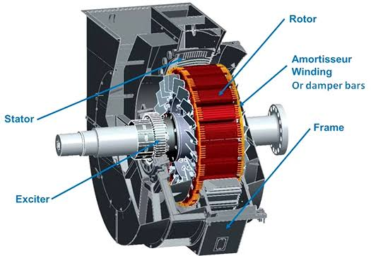
Source: https://hecoinc.com/what-is-an-ac-synchronous-motor/
Img. 11 Parts of a Synchronous AC Motor

Working Principle
When a three-phase AC supply is applied to the stator windings, it creates a rotating magnetic field (RMF) that rotates at synchronous speed. Because a synchronous motor is not inherently self-starting under main AC frequency alone, the rotor must first be brought up close to synchronous speed by external means or damper windings. Once near synchronous speed, the DC-excited rotor poles lock magnetically with the revolving stator poles, causing the rotor to rotate in lockstep with the RMF without slip.

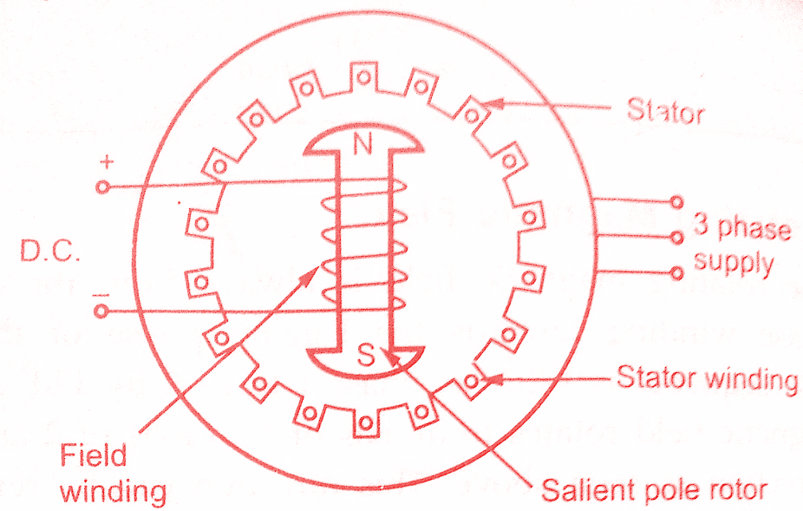
Source: https://www.electricalengineeringinfo.com/
Img. 12 Working of a Synchronous AC Motor

Torque Production
Synchronous torque depends on the applied voltage, excitation voltage, synchronous reactance ($X_{s}$), and the load angle ($δ$) between the rotor and stator fields:

$$T=\frac{3⋅V⋅E_{f}}{ω_{s}⋅X_{s}}\sin\left(δ\right)$$
Where, V is the phase voltage,
$E_{f}$ is the excitation EMF,
$ω_{s}$ is the synchronous angular velocity,
and δ is the load angle.

Different Types
Depending on design, they may be salient or cylindrical Synchronous AC motors.
- Salient Pole Synchronous Motor:
Features projecting poles on the rotor; best suited for low-to-medium speed hydro generators and large drives.
- Cylindrical Rotor Synchronous Motor:
Features a smooth cylindrical rotor with distributed windings. Ideal for high-speed turbo-alternators.

Advantages and Disadvantages?
- Advantages:
Constant Speed: Operates at constant speed regardless of load fluctuations.
Reduce Power Demand: Capable of improving the overall power factor of an electrical grid.
- Disadvantages:
Not Self Starting: Not self-starting on its own without auxiliary mechanisms.
Needs Control Circuitry: Requires a DC excitation source and complex control circuitry.

Applications
Power Factor Correction: Used as synchronous condensers in industrial power grids.
Heavy Industrial Drives: Powers large compressors, pumps, and rolling mills requiring constant speed.

Stepper Motors
Stepper motors are brushless DC motors that divide full rotation into several discrete, equal steps. By sequentially energizing internal electromagnetic phases, the motor can hold or move to a precise angular position without needing feedback sensors.

Parts
A conventional Synchronous AC Motor consists of these sub-assemblies:
- Stator:
Houses multiple electromagnetic pole pairs arranged in a circular frame, featuring teeth designed to align with the rotor.
- Rotor:
Can be a permanent magnet, a soft iron variable reluctance core, or a hybrid combination, featuring precision teeth that align with the stator poles.
- Driver Circuit:
A microcontroller-based switching circuit that sends precise electrical pulses to energize stator windings in sequence.

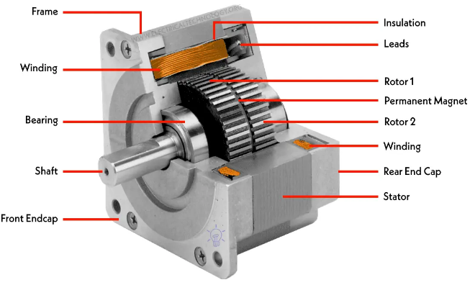
Source: https://www.electricaltechnology.org/
Img. 13 Parts of a Stepper Motor

Working Principle
The stepper motor operates by sequentially switching current on and off across different stator phases. Each electrical pulse switches the magnetic polarity of the stator poles, creating an electromagnetic pull or push that forces the rotor to advance by a fixed mechanical step angle.
When a stator phase pole is energized with DC, it forms an electromagnet. The nearest rotor teeth are drawn into alignment with the energized stator teeth to minimize the air-gap magnetic reluctance path. Sequential excitation of neighbouring stator phases turns the rotor by a specific step angle ($θ_{step}$):
$$θ_{step}=\frac{{360}^{∘}}{N_{r}⋅m}$$
Where, $N_{r}$, is the number of rotor teeth,
And $m$, is the number of excited stator phases.

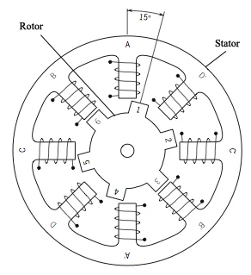
Source: https://circuitdigest.com/tutorial/what-is-stepper-motor-and-how-it-works
Img. 14 Working of a Stepper Motor

Different Types
Depending on design, they may be Variable Reluctance, Separately Excited DC motor:
- Variable Reluctance (VR):
Soft iron rotor with salient teeth. Operates entirely on magnetic reluctance minimization; no permanent magnets.
- Permanent Magnet (PM):
Smooth cylindrical permanent magnet rotor with alternating axial N/S poles. Produces larger step angles (${7.5}^{∘}$ to ${15}^{∘}$).
- Hybrid Stepper Motor (HSM):
Combines VR and PM structures. Uses an axially magnetized permanent magnet core surrounded by two slotted soft iron cup caps with half-tooth mechanical offsets. Delivers small step angles (typically ${1.8}^{∘}$ or ${0.9}^{∘}$) with high holding torque.

Advantages and Disadvantages?
- Advantages:
Accurate open-loop position control: No encoder is required for standard operation.
High holding torque at standstill: Even at a complete standstill there is a high amount of torque.
Precise low-speed torque delivery: At low Speeds the torque delivery is precise.
- Disadvantages:
Over Rotation: Risk of missing steps under excessive load torque.
Excessive waste of idling power: High continuous power drain at rest.
Insufficient torque at higher speeds: Torque drops off at higher speeds.

Applications
Additive Manufacturing: 3D printer axis positioners.
Automated Instrumentation: CNC desktop routers, flatbed scanners, automated medical fluid dispensers, camera pan-tilt heads.

Servo Motors
A conventional servo motor is an integrated electromechanical assembly, not an isolated motor type. Servo motors are closed-loop rotary actuators that allow for precise control of angular position, velocity, and acceleration. They integrate a motor coupled with a sensor for position feedback.

Parts
A conventional Servo motor consists of these sub-assemblies:
- DC or AC Motor Core: The underlying electromagnetic motor providing mechanical power.
- Gearbox: A gear train that reduces speed while substantially amplifying output torque.
- Feedback Sensor: A potentiometer or optical encoder attached to the output shaft to monitor actual position.
- Control Circuit Board: A closed-loop PID controller that compares command input signals with feedback signals to correct positioning errors.

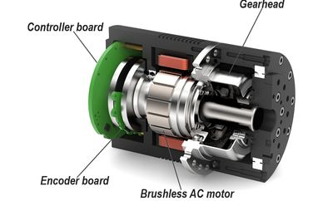
Source: https://eltra-trade.com/blog/what-is-servo-motor-and-how-it-works
Img. 15 Parts of a Servo Motor.

Working Principle
The servo drive continuously runs a Proportional-Integral-Derivative (PID) control algorithm. The system compares the target position command signal (e.g., $1.0\text{ ms}$ to $2.0\text{ ms}$ PWM pulse width) with the internal position sensor output. The resulting position error ($ϵ=θ_{target}-θ_{actual}$) is processed by the internal controller to drive the motor H-bridge. As the shaft approaches the target orientation, the error signal drops to zero, stopping the motor at the target angle.

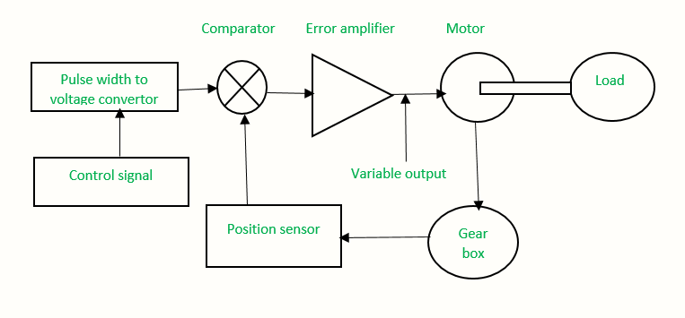
Source: https://robu.in/servo-motor-working/
Img. 16 Working of a Servo Motor

Different Types
Depending on design, they may be AC or DC Servo motors.
- AC Servo Motors:
Powered by AC sinusoidal signals; used in high-power industrial automation.
- DC Servo Motors:
Powered by DC voltage; ideal for smaller robotics and lower-power positioning tasks.

Advantages and Disadvantages?
- Advantages:
Extremely high positioning accuracy.
Fast dynamic response.
High torque-to-inertia ratio.
- Disadvantages:
Expensive compared to stepper systems.
Requires tuning of control loops.
Vulnerable to mechanical wear in gear trains if heavily loaded.

Applications
Industrial Robotics: Multi-axis robotic arms and automated assembly lines.
Aerospace and Defence: Control surface actuators in aircraft and missile guidance systems.

Smart Servo Motors
Smart servos are advanced digital servo motors equipped with onboard microcontrollers, digital communication protocols, and extensive real-time telemetry sensors, representing an evolution of standard RC/industrial servos.

Parts
A conventional Smart Servo motor consists of these sub-assemblies:
- Coreless or Brushless Motor: High-efficiency internal motor assembly.
- Onboard Microcontroller: Processes control algorithms, PID tuning, and communication data locally.
- Absolute Encoder: High-resolution non-contact magnetic or optical encoder for precise position tracking.
- Communication Bus Interface: Supports half-duplex asynchronous serial communication allowing daisy-chaining.
- Environmental Sensors: Built-in sensors monitoring internal temperature, operating voltage, and load current.

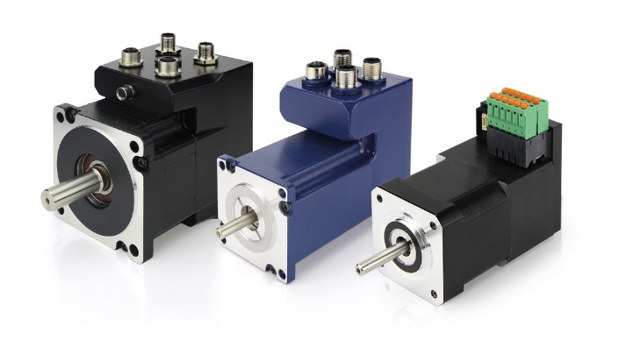
Source: https://www.nanotec.com/
Img. 17 Example of a Smart Servo Motor.

Working Principle
Instead of receiving continuous analog PWM width signals, smart servos connect to a shared communication bus where they are addressed individually via digital packets. The internal MCU manages closed-loop control internally, reporting real-time telemetry (position, velocity, load, temperature, voltage) back to the master controller while accepting dynamic parameter adjustments on the fly. It features programmable torque limits to prevent motor burnout under stall conditions.

Different Types
Depending on design, they may be Bus Network Servos or Programmable Digital Servos.
- Bus-Network Servos: Daisy-chainable digital servos sharing a single communication line.
- Programmable Digital Servos: Standalone smart servos allowing user-customizable compliance margins and overload protection profiles.

Advantages and Disadvantages?
- Advantages:
Eliminates messy wiring harnesses through daisy-chaining
Provides rich diagnostic feedback; overload protection prevents motor burnout.
- Disadvantages:
Significantly higher cost due to the additional parts.
Require software configuration and protocol implementation.

Applications
Advanced Humanoid Robotics: Joint actuation in bipedal robots and quadruped mechanical dogs.
Complex Animatronics: Multi-axis movable joints in animatronic figures and interactive installations.

Permanent Magnet Synchronous Motors
Permanent Magnet Synchronous Motors are high-efficiency AC motors that use permanent magnets embedded in or mounted on the rotor, while the stator creates a sinusoidal rotating magnetic field.

Parts
A conventional PMSM consists of these sub-assemblies:
- Stator:
Laminated silicon steel core with 3-phase distributed sinusoidal copper windings.
- Rotor:
Features high-remanence permanent magnets arranged as surface-mounted or interior configurations.
- Inverter Drive System:
Advanced variable-frequency drive using Field-Oriented Control to regulate phase currents.

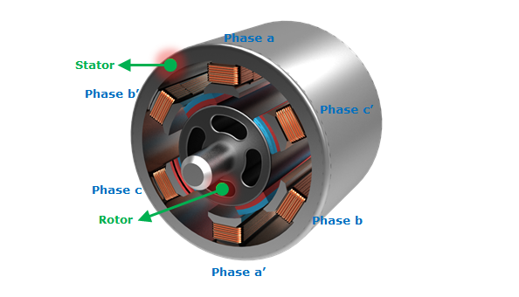
Source: https://functionbay.com
Img. 18 Parts of an Induction Motor.

Working Principle
PMSMs operate similarly to brushless synchronous machines, driven by 3-phase sinusoidal AC voltages generated using Variable Frequency Drives or Field-Oriented Control vector inverters.
Three sinusoidal currents displaced by ${120}^{∘}$ electrically are injected into the 3-phase stator windings. This creates a smooth rotating magnetic field in the air gap. The rotor's permanent magnet field locks synchronously with this stator field.

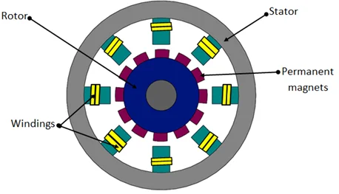
Source: https://www.embitel.com
Img. 19 Working of a Permanent Magnet Synchronous Motor

Torque Production
Single PMSMs generate torque through both magnetic alignment and magnetic reluctance variations:
$$T=\frac{3}{2}⋅P⋅\left[λ_{pm}⋅I_{q}+\left(L_{d}-L_{q}\right)⋅I_{d}⋅I_{q}\right]$$
Where, $P$ is the pole pairs
$λ_{pm}$ is the permanent magnet flux linkage,
$I_{d} and I_{q}$ are the direct and quadrature axis stator currents in the park-transformed reference frame respectively,
$L_{d} and L_{q}$ are the direct and quadrature axis inductances respectively,

Different Types
Depending on design, they may be SPMSM or IPMSM.
- Surface PMSM (SPMSM):
Magnets mounted on the rotor surface; smooth operation with uniform air gap.
- Interior PMSM (IPMSM):
Magnets embedded inside the rotor core; harnesses reluctance torque for enhanced efficiency and high-speed operation.

Advantages and Disadvantages?
- Advantages:
Exceptional energy efficiency.
High power density and compact size.
Superior dynamic performance.

- Disadvantages:
High manufacturing cost due to rare-earth magnets.
Requires complex closed-loop vector control drives.

Applications
Electric Vehicles (EVs): Primary traction motors in modern battery electric vehicles and hybrids.
Industrial Automation: High-performance CNC spindles and industrial servo drives.
.

Reluctance Motors
Reluctance motors are electric motors that generate torque through the principle of magnetic reluctance minimization, utilizing a passive rotor made of ferromagnetic material without any windings, brushes, or permanent magnets. They usually work on AC.

Parts
A conventional Reluctance motor consists of these sub-assemblies:
- Stator: Wound pole pairs connected to a polyphase AC supply to produce a rotating magnetic field.
- Rotor: A salient-pole soft iron core shaped with specific geometric cuts or barriers to create paths of high and low magnetic resistance (reluctance).

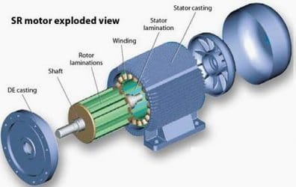
Source: https://electrical-engineering-portal.com
Img. 20 Parts of an Switched Reluctance Motor.

Working Principle
In a Switched Reluctance Motor, when the stator windings are energized, they produce a magnetic field. Because magnetic flux always follows the path of least resistance, the unexcited iron rotor experiences a magnetic pull that forces its salient poles to align with the active stator magnetic field. As the stator field rotates, the rotor is continuously pulled along to maintain the position of minimum magnetic reluctance.
A Synchronous Reluctance Motor is powered by a standard 3-phase sinusoidal AC inverter drive. The stator produces a smooth rotating magnetic field ($N_{s}$). The flux-barrier rotor rotates synchronously with the stator field vector to align its maximum permeability axis ($d$-axis) with the stator field, minimizing magnetic reluctance.

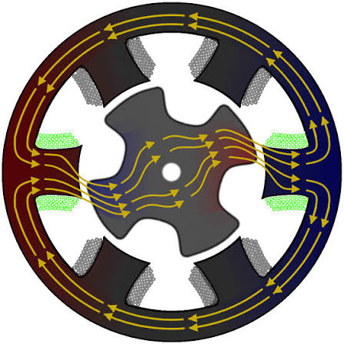
Source: https://en.wikipedia.org/wiki/Reluctance_motor
Img. 21 Working of a Switched Reluctance Motor

Torque Production
Reluctance torque is generated due to the variation of self-inductance ($\text{L}$) as a function of rotor position ($θ$):
$$T=\frac{1}{2}I^{2}\frac{dL}{dθ}$$
Because torque depends on the square of current ($I^{2}$), torque direction is independent of current polarity. Unidirectional torque depends entirely on pulsing current while phase inductance is increasing

Different Types
Depending on design, they may be switched or synchronous reluctance motor.
- Synchronous Reluctance Motor: It operates at true synchronous speed using specially shaped flux-barrier rotors.
- Switched Reluctance Motor: Operates by sequentially switching DC pulses to stator phases as the rotor poles pass by.

Advantages and Disadvantages?
- Advantages:
Rugged, highly reliable construction with no rotor windings, copper bars or magnets.
Excellent high-temperature tolerance.
Low rotor inertia.
Lower manufacturing cost (no rare-earth permanent magnets or active copper rotor windings).
- Disadvantages:
It exhibits pronounced acoustic noise, high vibration levels, and significant torque ripple.
It requires specialized electronic power drives.

Applications
Switched Reluctance Motors: Heavy mining haulage trucks, high-speed industrial centrifuges, industrial washing machines.
Synchronous Reluctance Motors: Modern magnet-free industrial pump drives, commercial HVAC fans, sustainable electric vehicle powertrains.

Acknowledgment
I would like to thank the team of Robo Manipal to give us this opportunity to learn more about different kind of motors and for guiding and helping us.

References
- Wikipedia contributors. (2025). Brushed DC electric motor. In Wikipedia, The Free Encyclopedia. Retrieved from https://en.wikipedia.org/wiki/Brushed_DC_electric_motor
- Wikipedia contributors. (2025). Brushless DC electric motor. In Wikipedia, The Free Encyclopedia. Retrieved from https://en.wikipedia.org/wiki/Brushless_DC_electric_motor
- Wikipedia contributors. (2025). Servomotor. In Wikipedia, The Free Encyclopedia. Retrieved from https://en.wikipedia.org/wiki/Servomotor
- Wikipedia contributors. (2025). Stepper motor. In Wikipedia, The Free Encyclopedia. Retrieved from https://en.wikipedia.org/wiki/Stepper_motor
- Wikipedia contributors. (2025). Induction motor. In Wikipedia, The Free Encyclopedia. Retrieved from https://en.wikipedia.org/wiki/Induction_motor
- Wikipedia contributors. (2025). Reluctance motor. In Wikipedia, The Free Encyclopedia. Retrieved from https://en.wikipedia.org/wiki/Reluctance_motor#Synchronous_reluctance
- Wikipedia contributors. (2025). Synchronous motor. In Wikipedia, The Free Encyclopedia. Retrieved from https://en.wikipedia.org/wiki/Synchronous_motor#Amortisseur_winding
- Wikipedia contributors. (2025). Permanent magnet motor. In Wikipedia, The Free Encyclopedia. Retrieved from https://en.wikipedia.org/wiki/Permanent_magnet_motor
- IQS Directory. (2025). Electric motor: Types, components, and applications. IQS Directory Technical Articles. Retrieved from https://www.iqsdirectory.com/articles/electric-motor.html
- MathWorks. (2025). Brushless DC motors: An introduction. MathWorks Technical Resources. Retrieved from https://in.mathworks.com/campaigns/offers/brushless-dc-motors-introduction.html
- Adafruit Industries. (2025). Adafruit motor selection guide: DC motors. Adafruit Learning System. Retrieved from https://learn.adafruit.com/adafruit-motor-selection-guide/dc-motors
- Monolithic Power Systems. (2025). Brushless vs. brushed DC motors: Key differences and applications. MPS Learning Resources. Retrieved from https://www.monolithicpower.com/en/learning/resources/brushless-vs-brushed-dc-motors
- IC-Components. (2025). Three-phase, two-phase and single-phase motors: How they are built and what they are used for. IC-Components Blog. Retrieved from https://www.ic-components.com/blog/three-phase,two-phase-and-single-phase-motors-how-they-are-built-what-they-are-used-for.jsp
- Circuit Digest. (2025). What is a stepper motor and how it works. Circuit Digest Tutorials. Retrieved from https://circuitdigest.com/tutorial/what-is-stepper-motor-and-how-it-works
- Embitel Technologies. (2025). Brushless DC motor vs PMSM: How these motors and motor control solutions work. Embitel Embedded Blog. Retrieved from https://www.embitel.com/blog/embedded-blog/brushless-dc-motor-vs-pmsm-how-these-motors-and-motor-control-solutions-work
- Electrical Engineering Portal. (2025). Characteristics and work principles of switched reluctance (SR) motor. EEP Technical Articles. Retrieved from https://electrical-engineering-portal.com/characteristics-and-work-principles-of-switched-reluctance-sr-motor

