A DETAILED REPORT ON ADDITIVE MANUFACTURING

Maxon Rodrigues
First Year Student
B.Tech in Computer Science and Engineering
Manipal Institute of Technology
Manipal, Karnataka, India
maxonrodrigues@gmail.com

Abstract—This document is a detailed report on the working of a 3D Printer, the types of filaments and infill patterns and 3D printers like resin and metal 3D printers.
Keywords— additive manufacturing, 3D Printers, Resin 3D Printers, Metal 3D Printers, Filaments, Infill patterns.

Introduction
Additive manufacturing is a production methodology that builds three-dimensional objects directly from digital models by depositing, fusing or curing material layer by layer as compared to subtractive manufacturing, which creates parts by cutting, carving, or drilling away excess material from a solid block or billet using tools like CNC mills and lathes. Because additive processes build structures from scratch, they excel at producing highly complex geometric shapes, custom internal channels, and lightweight lattice patterns with minimal raw material waste. Conversely, subtractive manufacturing relies on mechanical material removal, which generates significantly more scrap waste and faces geometric constraints based on cutting tool access, but it delivers superior dimensional tolerances, ultra-smooth surface finishes, and faster unit production speeds for high-volume manufacturing.

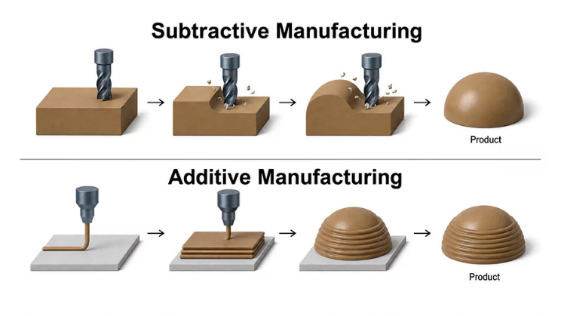
Source: https://caeassistant.com/blog/what-is-additive-manufacturing/
Img. 1 Difference between additive and subtractive manufacturing

FDM Filaments: Types and Applications
FDM filaments are the raw, spool-fed thermoplastic materials used in Fused Deposition Modelling 3D printers. They are supplied as thin, solid plastic strings and are pulled into a heated nozzle, melted, and extruded layer by layer to construct a physical object. Different polymers provide distinct properties for various applications, ranging from user-friendly, biodegradable PLA for general prototypes to tough ABS and flexible TPU for functional mechanical parts.

PLA Filament
Polylactic acid or PLA is a biodegradable thermoplastic derived from renewable plant resources like cornstarch, making it the most popular and user-friendly 3D printing material available. Its advantages include low printing temperatures, minimal thermal expansion, and virtually zero warping, which allows it to produce highly detailed models without requiring an enclosed build chamber. However, its major disadvantages are its low heat deflection temperature. So, it warps easily around 60°C. It is more brittle, which makes it prone to snapping under high mechanical impacts or continuous stress.

ABS Filament
Acrylonitrile Butadiene Styrene or ABS is a classic engineering plastic known for its high impact resistance, tough mechanical durability, and impressive heat resistance. Key advantages include its ability to withstand operational temperatures above 80°C and its compatibility with post-processing techniques like acetone vapor smoothing, which creates a glossy, seamless surface finish. However, it shrinks noticeably as it cools, making it prone to severe warping and layer splitting unless printed on a heated bed inside a fully closed enclosure, and it emits unpleasant, potentially toxic styrene fumes during extrusion that necessitate well-ventilated workspaces.

PETG FIament
Polyethylene Terephthalate Glycol or PETG Filaments bridges the gap between PLA and ABS by offering the high physical strength and impact resistance of ABS combined with the low-warping, easy-printing characteristics of PLA. Its major advantages are excellent layer adhesion, high chemical and moisture resistance, and food-safe potential, making it ideal for outdoor functional parts and liquid containers. Its main disadvantages are a tendency to string and form blobs during extrusion due to its high viscosity, a relatively sticky surface while molten that can adhere too strongly to print beds and poor bridging performance across long open gaps.

TPU
Thermoplastic Polyurethane or TPU is an elastomeric material designed specifically for flexible 3D printing applications requiring rubber-like elasticity and vibration absorption. Its distinct advantages include outstanding flexibility, high tear resistance, high impact absorption and excellent resistance to oils, greases, and abrasion, making it suitable for functional gaskets, tires, and protective cases. However, its flexibility is also its biggest disadvantage during the printing process. Soft TPU easily buckles or tangles inside long feeding tubes, requiring very slow print speeds and precise retraction control.

Nylon
Nylon is an advanced industrial grade polymer valued for its extreme toughness, high flexibility-to-strength ratio, low coefficient of friction and superior fatigue resistance. Its primary advantages make it exceptional for functional load-bearing components like gears, sliding bushings, and durable hinges that endure continuous mechanical wear without breaking. Its significant disadvantages stem from its extreme hygroscopic nature which means that it rapidly absorbs moisture from ambient air and must be dried thoroughly and printed directly from a dry box. Additionally, it suffers from high thermal contraction, requiring high bed temperatures and strict enclosure control to prevent severe warping.

Infills Patterns
Instead of printing a model entirely solid, which wastes material and time, 3D printers use internal lattices called infill. The geometry or pattern and density or percentage dictates the part's structural properties.

Gyroid Infill
Gyroid or Wavy Lattice infills are mathematical, wave-like internal structures that provide incredible structural efficiency. Its advantages are uniform (isotropic) strength in all directions, an exceptional ability to handle multi-directional stress and dynamic vibrations, and smooth extrusion paths that reduce printer vibration. Its disadvantages include slightly higher processing time for complex slicing software and unnecessary complexity for basic cosmetic prints. Their primary applications include heavy-duty mechanical brackets, drone frames, aerospace components, and parts subjected to complex multidirectional loads.

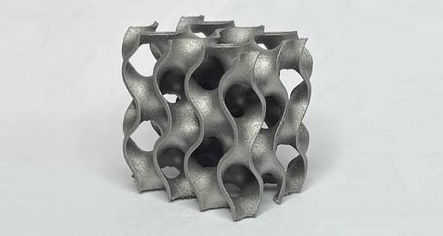
Source: https://all3dp.com/1/gyroid-lattices-in-3d-printing-the-ultimate-guide/
Img. 2 Gyroid Infill

Cubic Infill
Cubic infills are three-dimensional lattice structures composed of stacked, tilted cubes distributed throughout the interior of a print. Its advantages are high rigidity and uniform multi-axis strength, making it exceptional for supporting heavy structural loads from any direction. Its disadvantages include a slightly slower print time and higher material density compared to simpler two-dimensional patterns. Their primary applications are heavy-duty structural parts, high-stress mechanical components, and functional brackets that require robust internal support.

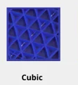
Source: https://support.bcn3d.com/knowledge/infill
Img. 3 Cubic Infill

Grid or Rectilinear Infill
Grid or Rectilinear infills are traditional patterns formed by intersecting perpendicular lines that create a standard square mesh. Its advantages are fast printing speeds, easy slice generation, and balanced structural support along the main axes, making it a reliable default choice. Its disadvantages include nozzle collisions where the intersecting lines cross on the same layer, which can cause annoying ticking sounds and slight surface artifacts, alongside lower multi-directional strength. Their primary applications include general-purpose prototypes, aesthetic models, and low-stress household items.

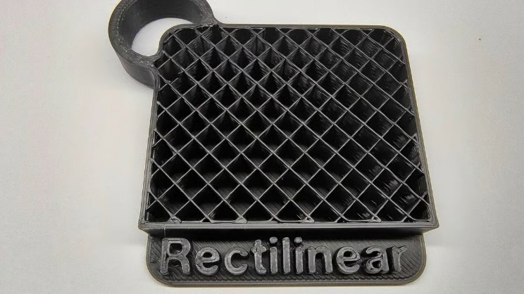
Source: https://all3dp.com/2/strongest-infill-pattern/
Img. 4 Grid or Rectilinear Infill

Honeycomb or Hexagonal Infill
Honeycomb or Hexagonal infills are cellular patterns inspired by nature that mimic bees' nests with interlocking six-sided walls. Its advantages are an exceptional strength-to-weight ratio, superb dimensional stability, and great resistance to compressive forces. Its disadvantages are that they are not completely isotropic, which means that they are stronger vertically than horizontally, and can cause the printer to make many rapid directional shifts, increasing print time. Their primary applications include aerospace components, lightweight structural panels, and mechanical enclosures requiring maximum rigidity with minimal weight.

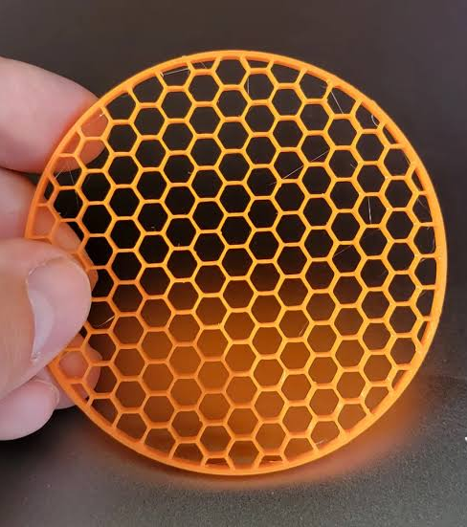
Source: www.printables.com/model/986103-innovative-non-intersecting-honeycomb-infill-achie
Img. 4 Honeycomb or Hexagonal Infill

Concentric Infill
Concentric infills are internal structures where the printer traces lines that mimic and mirror the exact outer perimeter of the model. Its advantages are extremely fast printing times, excellent preservation of transparency in clear plastics, and a flexible internal nature that accommodates bending. Its disadvantages include very weak structural integrity, poor load-bearing capacity, and a lack of proper support for flat top surfaces if printed with low density. Their primary applications include flexible components, bendable functional prints, transparent decorative models, and hollow containers where rigidity is not required.

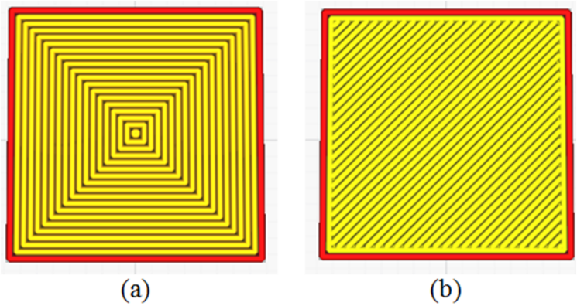
Source: https://pubs.sciepub.com/ajme/7/2/5/figure/4
Img. 5 Concentric Infill

FDM 3D Printer
Fused Deposition Modelling commonly abbreviated as FDM is the most popular and widely accessible form of 3D printing. Here are some of its processes:

- Material Feeding: A spool of solid thermoplastic filament is loaded into the printer. A motorized gear assembly also called the extruder grips the filament and pushes it steadily through a tube into the print head.

- Melting in the Hot end: Inside the print head, the filament enters the hot end, which contains a heated metal block and a fine nozzle. The printer heats this area to the exact melting point of the plastic typically between 190°C and 250°C, turning the solid string into a semi-liquid state.

- Precise Movement & Extrusion: Guided by digital G-code instructions, the printer's motion system using belts, motors, and linear rails moves the print head along the X and Y axes across a build platform. As it moves, it squeezes out a microscopic, continuous bead of molten plastic.

- Layer-by-Layer Stacking: The printer lays down the first flat layer onto the build plate. Once complete, the printer's Z-axis motor raises the print head or lowers the build plate by a tiny fraction of a millimetre equal to one layer height and begins printing the next layer directly on top of the previous one.

- Rapid Cooling: As the hot plastic leaves the nozzle, cooling fans mounted on the print head instantly blow air across the fresh bead. This causes the polymer to cool and solidify within milliseconds, allowing it to bond securely with the layer beneath it without collapsing.

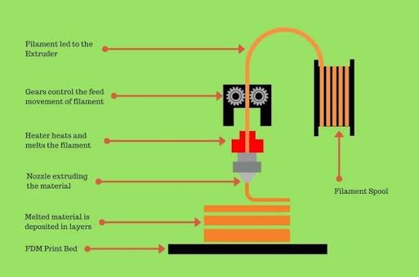
Source: https://manufactur3dmag.com/working-fdm-3d-printing-technology/
Img. 6 Working of a FDM 3D printer

Other 3D Printing

Resin 3D Printing
Als known as Vat Photopolymerization instead of melted plastic, resin printers use liquid photopolymer resins that cure and harden selectively when exposed to UV light sources.
- Working: The build plate dips into a vat of liquid resin. A light source cures one precise cross-section layer, the plate steps up or down, and the process repeats. Post-processing requires washing prints in isopropyl alcohol and secondary UV curing.
- Advantages: Micro-scale precision and ultra-smooth surface finishes completely free of visible layer lines.
- Applications:
Dentistry: Precision aligner molds, surgical guides, and crowns.
Jewellery: High-detail master patterns for direct investment casting.
Miniatures: Highly intricate gaming figures and artistic display sculptures.
.

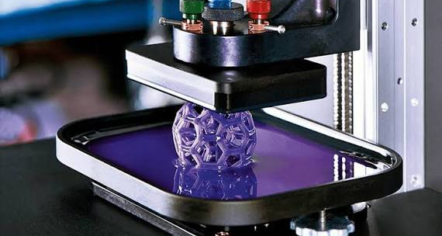
Source: https://www.plastik3d.com/en/blog/resin-3d-printers-what-they-are-and-how-they-.html

Img. 7 Resin 3D Printing

Metal 3D Printing
Also known as Industrial Additive Manufacturing, It uses a metal additive manufacturing for high-end industrial, aerospace, and medical applications.
- Working: A fine layer of metal powder is spread across a build platform. A high-powered laser or electron beam selectively melts and fuses the powder particles together layer by layer within an inert gas chamber.
- Key Advantages: Capable of printing complex internal cooling channels, topology-optimized lightweight structures, and fully dense components that match or exceed the strength of traditionally forged metals.
- Primary Applications:
Aerospace: Lightweight rocket engine combustion chambers and turbine blades.
Medical: Patient-specific custom orthopaedic and titanium jaw implants.
Motorsports: Rapid production of high-performance, heat-resistant cooling blocks and exhaust components.

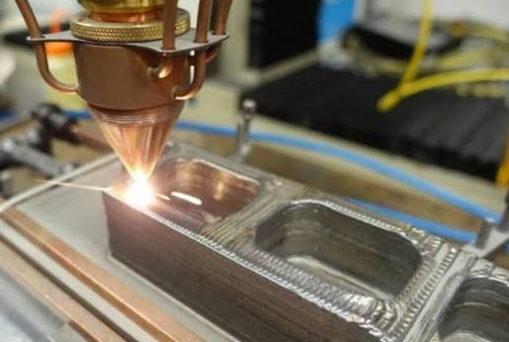
Source: https://www.esa.int/Enabling_Support/Space_Engineering_Technology
Img. 8 Metal 3D Printing

Acknowledgment
I would like to thank the team of Robo Manipal to give us this opportunity to learn more about additive manufacturing and for guiding and helping us.

References
- CAE Assistant. (2026). What is additive manufacturing? CAE Assistant Blog. Retrieved from https://caeassistant.com/blog/what-is-additive-manufacturing/
- Additive-X. (2026). What is infill and what does it do? Additive-X Learning Hub. Retrieved from https://www.additive-x.com/blog/what-is-infill-what-does-it-do
- Owen, J. (2024). How does a 3D printer work? (A1 by Bambu Lab). YouTube Video. Retrieved from https://www.youtube.com/watch?v=f94CnlQ0eq4
- Plastik 3D. (2026). Resin 3D printers: What they are and how they work. Plastik 3D Blog. Retrieved from https://www.plastik3d.com/en/blog/resin-3d-printers-what-they-are-and-how-they-.html
- Hubs. (2026). Introduction to metal 3D printing. Hubs Knowledge Base. Retrieved from https://www.hubs.com/knowledge-base/introduction-metal-3d-printing/

