A DETAILED REPORT ON SENSORS

Maxon Rodrigues
First Year Student
B.Tech in Computer Science and Engineering
Manipal Institute of Technology
Manipal, Karnataka, India
maxonrodrigues@gmail.com

Abstract—This document is a detailed report on five different sensors. Namely Inductive Proximity Sensors, Capacitive Proximity Sensors, Optical Proximity Sensors, Ultrasonic Proximity Sensors, IMUs, Encoders, Hall Effect Sensors and LDR sensors.
Keywords—Sensors, Proximity, IMU, Encoder, LDR, Hall Effect

Introduction
In our modern world, life is not imaginable without sensors. Every single electrical gadget around us uses sensors in one way or other. Everything from the smart watches in our hands to self-driving cars need sensors to work as intended. A self-driving car cannot be designed without cameras or lidar sensors, an aircraft would be impossible to fly without instruments like altimeter, GPS or compass. Considering biological beings like humans, we too have sensory organs that makes us aware about our surroundings. is used to be spatially aware. By detecting environmental changes and converting them into readable signals, sensors help in automating decision-making in every industry.


- Source: beadelectronics.com/blog/the-expanding-market-of-electronic-sensors
Img. 1 Different types of sensors

Let us go through some of these sensors.

Inductive Proximity Sensors
Inductive Proximity sensors are a type of proximity sensors used to detect metallic targets using the principle of electromagnetic induction. Since these work on the principle of electromagnetic induction; they are basically used as metal detectors.

How they work?
Inductive proximity sensors operate on the Eddy Current Killed Oscillator (ECKO) principle, utilizing high-frequency electromagnetic field interactions to detect metallic objects without physical contact. The physical assembly comprises an LC resonant tank circuit connected to an inductive sensing coil wound around a ferrite core, a high-frequency oscillator, a demodulator/rectifier circuit, a threshold trigger circuit, and an output switching transistor stage. The internal oscillator generates an alternating electromagnetic field radiating from the sensor face, typically operating at frequencies between 100 kHz and 1 MHz. When an electrically conductive metallic target approaches this oscillating magnetic field, Faraday's Law of Induction dictates that localized circulating electrical currents, known as eddy currents, are induced on the target surface. These induced currents generate a secondary magnetic field that directly opposes the primary field produced by the sensor coil.
The flow of eddy currents causes electrical energy dissipation proportional to the metallic target's electrical resistance. This energy loss increases the equivalent series resistance $R_{s}$ of the sensor's inductive coil, draining energy from the LC resonant circuit.
As the target moves closer to the sensing face, $R_{s}$ increases, dampening the oscillation amplitude. An internal envelope detector continuously rectifies this oscillation amplitude to a DC voltage signal. When the voltage drops below a calibrated threshold level, the Schmitt trigger changes state, driving the output transistor stage to signal target detection. [1]

Diagrams
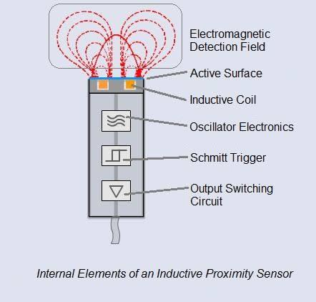
- Source: https://machinegeeks.blog/2019/02/19/how-to-keep-prox-sensors-from-latching-on/
Img. 2 Diagram Of an Inductive Proximity Sensor

Capacitive Proximity Sensors
Capacitive Proximity sensors are a type of proximity sensors used to measure electrostatic change, allowing them to detect virtually any material with a dielectric constant different from air.

How they work?
Capacitive proximity sensors detect conductive and non-conductive targets by evaluating capacitance changes in the electrostatic field generated at the sensing face. The sensing head consists of two concentric metallic electrodes designed as an open-plate capacitor, which forms part of the feedback loop in an internal high-frequency CR oscillator circuit.
When a target approaches the sensing face, it alters the measured capacitance through one of two physical mechanisms:
- Conductive Targets: The target acts as an extended virtual ground electrode. This effectively reduces the dielectric separation distance, driving the capacitance upward.
- Non-Conductive Targets: The target enters the electrostatic field, replacing the air gap with a material featuring a higher dielectric constant. This increase in dielectric permittivity elevates the overall capacitance proportional to $ε_{r}$.
The resulting increase in capacitance raises the loop gain of the CR oscillator, initiating AC oscillations. Signal conditioning circuits rectify this oscillation amplitude into a DC voltage, which is evaluated by a Schmitt trigger to activate the output switching transistor. [2]

Diagrams
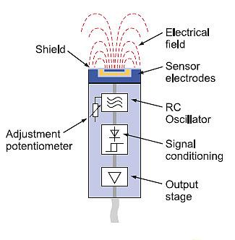
- Source: https://robu.in/capacitive-proximity-sensor-working-principle/
Img. 3 Diagram Of a Capacitive Proximity Sensor

Optical Proximity Sensors
Optical Proximity sensors are a type of proximity sensors that use light beams, usually infrared to detect targets over long distances.

How they work?
Optical proximity sensors detect targets by transmitting visible or infrared light beams and monitoring changes in received light intensity or beam interruption. The emitter consists of an LED or semiconductor laser diode modulated at high frequency ($1 kHz-100 kHz$) to prevent interference from ambient light. The receiver utilizes a PIN photodiode or phototransistor paired with an optical bandpass filter matched to the emitter wavelength.
Optical proximity sensors are arranged in three primary configurations:
- Through-Beam (Opposed Mode): The emitter and receiver are housed in separate enclosures positioned directly opposite each other. Object detection occurs when a target interrupts the light beam path. This mode provides maximum operational margins, long sensing ranges (up to 50 meters or more), and complete immunity to target surface finish or colour.
- Retro-Reflective Mode: Emitter and receiver components are integrated into a single housing. The light beam is directed toward a retroreflector that returns light along a parallel path back to the receiver. Polarized models fit orthogonal polarizing filters over the optical lenses, enabling the sensor to distinguish reflections from shiny metallic objects from light returned by retroreflectors.
- Diffuse-Reflective Mode: Emitter and receiver share a single housing and rely on light scattering directly off the target surface. Detection range is sensitive to target colour, surface roughness, and overall reflectivity. [3]

Diagrams
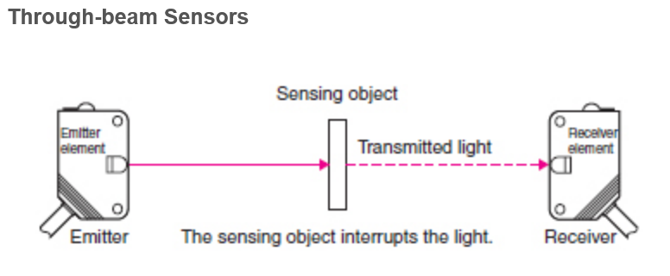
- Source: https://www.sensortips.com/featured/faq-on-optical-proximity-sensing-part-1/
Img. 4 Diagram Of a Through-Beam Optical Proximity Sensor

Ultrasonic Proximity Sensors
Ultrasonic Proximity sensors are a type of proximity sensors that rely on acoustic sound waves beyond the human audible threshold (typically 40 kHz to 400 kHz) to detect targets.

How they work?
Ultrasonic proximity sensors measure distance by emitting high-frequency acoustic sound waves and calculating the Time-of-Flight of the reflected echo. The primary component is a piezoelectric ceramic transducer (such as Lead Zirconate Titanate) mounted behind an acoustic impedance-matching layer. The sensor operates cyclically through alternating transmission and receives cycles managed by a microcontroller. During the transmit phase, high-voltage electrical pulses excite the piezoelectric element, causing it to vibrate at its resonant frequency (typically between 60 kHz and 400 kHz) and launch a cone of ultrasonic compression waves through the air. The microcontroller then switches the transducer to receive mode, starting an internal timer. When the sound waves strike a target and reflect back, the returning acoustic echo vibrates the piezoelectric element, generating a voltage pulse. The measured time delay is converted to target distance using the speed of sound. The division by two accounts for the round-trip distance traveled by the acoustic pulse. [4]

Diagrams
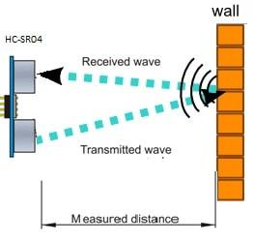
- Source: https://www.engineersgarage.com/distance-measurement-with-hcsr04-and-nodemcu/
Img. 5 Diagram Of an Ultrasonic Proximity Sensor

IMUs
An IMU (short for Inertial Measurement Units) is an integrated sensor module that measures a body's specific force, angular rate, and magnetic field vector. It usually consists of an accelerometer, gyroscope and a magnetometer.

How they work?
Inertial Measurement Units (IMUs) measure linear acceleration and angular velocity along three orthogonal spatial axes. Advanced IMUs integrate a 3-axis accelerometer, a 3-axis gyroscope, and a 3-axis magnetometer into a single package. Modern IMUs rely on Micro-Electro-Mechanical Systems (MEMS) etched into silicon substrates.
MEMS accelerometers measure non-gravitational linear acceleration. The sensor frame holds a silicon proof mass $m$ suspended by flexible polysilicon springs. Applied acceleration induces an inertial force, displacing the proof mass by a small distance proportional to acceleration.
Interdigitated capacitive fingers extend from the proof mass and fixed outer frame. The small displacement due to inertial force alters the gap between fixed and moving fingers, creating a differential capacitance shift. On-chip ASIC electronics convert this capacitance change into an analog voltage or digital output proportional to linear acceleration.
MEMS gyroscopes measure angular velocity by utilizing the Coriolis Effect acting on vibrating microstructures. An internal silicon mass is continuously driven to vibrate along a drive axis at a velocity. Rotating the sensor about an axis perpendicular to this drive motion generates a Coriolis force along a third orthogonal sense axis. This force flexes internal sense springs, causing capacitive displacement proportional to angular velocity. [5]

Diagrams
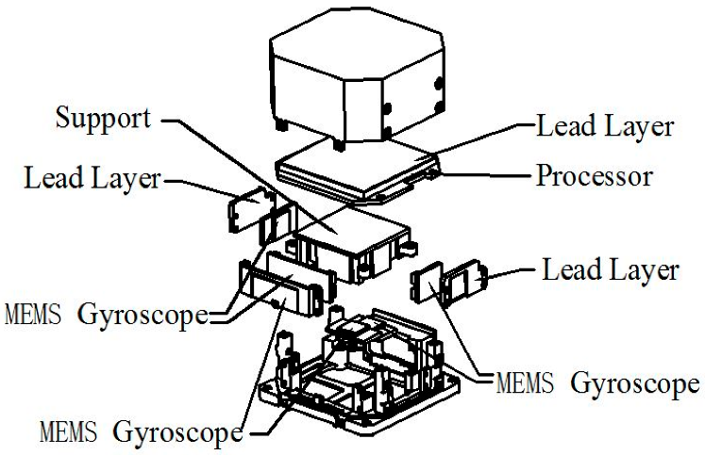
- Source: https://www.mdpi.com/2072-666X/12/2/151
Img. 6 Exploded image of an IMU

Encoders
Encoders translate rotational or linear mechanical position into digital or analog electronic signals.

How they work?
Rotary encoders convert shaft rotation into digital pulse trains or absolute digital codes. Encoders are categorized by feedback type (Incremental versus Absolute) and sensing technology (Optical versus Magnetic).
Optical Encoders: Feature a glass or plastic disc etched with transparent and opaque radial lines placed between an LED light source and a photodiode array. Disk rotation interrupts the light path, generating optical pulses. Optical encoders offer high resolution (up to tens of thousands of counts per revolution).
Magnetic Encoders: Utilize a magnetized wheel featuring alternating North and South magnetic poles paired with a Magneto-Resistive or Hall Effect sensor array. Magnetic encoders are resistant to dust, vibration, oil, and moisture that can disrupt optical units. [6]

Diagrams
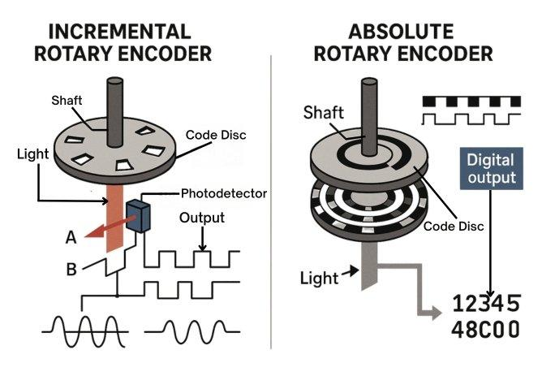
- Source: https://mechtex.com/blog/how-rotary-encoders-work-a-complete-guide
Img. 7 Diagram for Incremental and absolute encoders

Hall Effect Sensors
A Hall effect sensor detects the presence, strength, and polarity of a magnetic field.

How they work?
Hall Effect sensors detect magnetic fields by measuring the galvanomagnetic potential difference generated across a current-carrying semiconductor element exposed to a perpendicular magnetic field. When a constant bias current flows longitudinally through a thin semiconductor bar (such as Gallium Arsenide, Indium Antimonide, or Silicon), mobile charge carriers experience the Lorentz force upon encountering a magnetic flux density vector applied normal to the plane of the current path. This force deflects electrons or holes toward one transverse edge of the semiconductor substrate, creating an asymmetric spatial charge distribution. This charge separation establishes an internal electrostatic field that opposes further carrier movement. Under dynamic equilibrium, a stable transverse potential difference—the Hall Voltage develops across the edges of the semiconductor. [7]

Diagrams
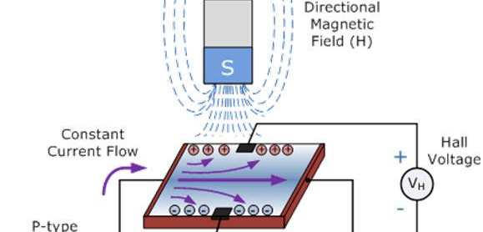
- Source: https://www.engineersgarage.com/low-cost-hall-effect-sensor/
Img. 8 Image For Hall Effect

LDRs
A LDR (short for Light Dependent Resistors) or photoresistors are passive light-sensitive components whose electrical resistance changes in response to ambient light intensity.

How they work?
Light Dependent Resistors (LDRs), or photoresistors, are passive optoelectronic components whose electrical resistance decreases as incident light intensity increases. The active element consists of a thin semiconductor layer—typically Cadmium Sulfide (CdS) or Cadmium Selenide (CdSe)—deposited onto an insulating ceramic substrate. CdS photoresistors rely on intrinsic bulk photoconductivity. In darkness, valence band electrons lack sufficient thermal energy to cross the material bandgap, leaving the conduction band unoccupied. Under these conditions, the component exhibits a high dark resistance. When exposed to light containing photon energies equal to or exceeding the bandgap, valence electrons absorb the photon energy and jump to the conduction band. This leaves behind mobile holes in the valence band, generating electron-hole pairs that increase material conductivity. As light intensity increases, the higher carrier concentration reduces the element's resistance. [8]

Diagrams
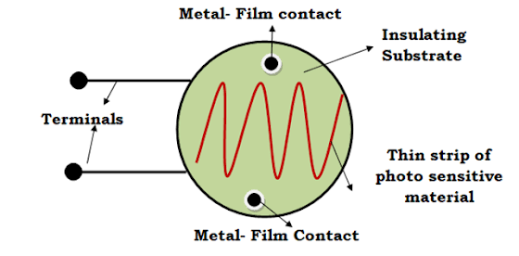
- Source: https://www.learnelectronicswithme.com/2020/10/light-dependent-resistor-ldr.html
Img. 9 Diagram of a LDR

Acknowledgment
I would like to thank the team of Robo Manipal to give us this opportunity to learn more about different kind of sensors and for guiding and helping us.

References

- Wikipedia contributors. "Inductive sensor." Wikipedia, The Free Encyclopedia, https://en.wikipedia.org/wiki/Inductive_sensor
- Wikipedia contributors. "Capacitive sensing." Wikipedia, The Free Encyclopedia, https://en.wikipedia.org/wiki/Capacitive_sensing
- Wikipedia contributors. "Photoelectric sensor." Wikipedia, The Free Encyclopedia, https://en.wikipedia.org/wiki/Photoelectric_sensor
- Wikipedia contributors. "Ultrasonic transducer." Wikipedia, The Free Encyclopedia, https://en.wikipedia.org/wiki/Ultrasonic_transducer
- Wikipedia contributors. "Inertial measurement unit." Wikipedia, The Free Encyclopedia, https://en.wikipedia.org/wiki/Inertial_measurement_unit
- Wikipedia contributors. "Rotary encoder." Wikipedia, The Free Encyclopedia, https://en.wikipedia.org/wiki/Rotary_encoder
- Wikipedia contributors. "Hall effect sensor." Wikipedia, The Free Encyclopedia, https://en.wikipedia.org/wiki/Hall_effect_sensor
- Wikipedia contributors. "Photoresistor." Wikipedia, The Free Encyclopedia, https://en.wikipedia.org/wiki/Photoresistor

