A DETAILED REPORT ON FASTENERS

Maxon Rodrigues
First Year Student
B.Tech in Computer Science and Engineering
Manipal Institute of Technology
Manipal, Karnataka, India
maxonrodrigues@gmail.com

Abstract—This document is a detailed report on different fasteners. It will explain its classifications and different permanent, semi-permanent and temporary fasteners.
Keywords— fasteners, nuts, bolts, washers, adhesives, screws.

Introduction
Fastening systems are fundamental to mechanical engineering, structural design, and industrial manufacturing. The selection of a fastening methodology dictates not only the static and dynamic load capacity of an assembly, but also its maintainability, structural longevity, and failure modes under operational stress. Fastening joints are categorized into three distinct primary classifications based on their disassembly characteristics, stress distribution, and destruction dynamics upon removal. They are temporary, semi-permanent, and permanent fastening systems. In this report we will discuss them.

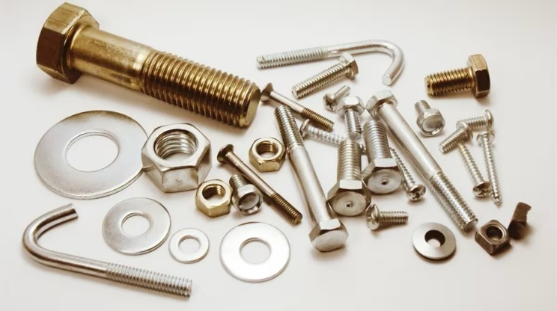
Source: https://www.expometals.net/en/metal-working-basics/industrial-fasteners
Img. 1 Types of Fasteners

Temporary Fasteners
It utilizes reversible mechanical interfaces such as helical threads, radial springs, or sliding interference pins. Primary load transfer occurs through induced axial clamping force or shear resistance across unthreaded shanks. Disassembly preserves both the host component and the fastener intact for repeated reuse. Some of these temporary fasteners are:

Hex Head Bolts
Featuring a six-sided hexagonal head profile, these are the standard for structural, mechanical, and industrial applications. They allow high torque transmission using open-end, box, or socket wrenches and are manufactured in fully threaded or partially threaded shanks. Partially threaded variants provide an unthreaded shoulder within the shear plane, optimizing shear resistance.

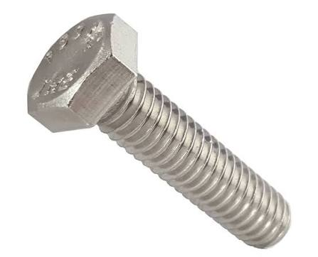
Source: https://www.amazon.in/Hex-Bolts-External-Stainless-Fastenere/dp/B01E0LNHCC
Img. 2 Hex Head Bolts

Anchor Bolts
Mechanical expansion anchor bolts also called wedge and sleeve types are driven into pre-drilled concrete holes. As the wedge bolt is torqued, an expanding metal clip or sleeve drives outward against the concrete wall, converting friction into tensile resistance for removable or adjustable baseplates.

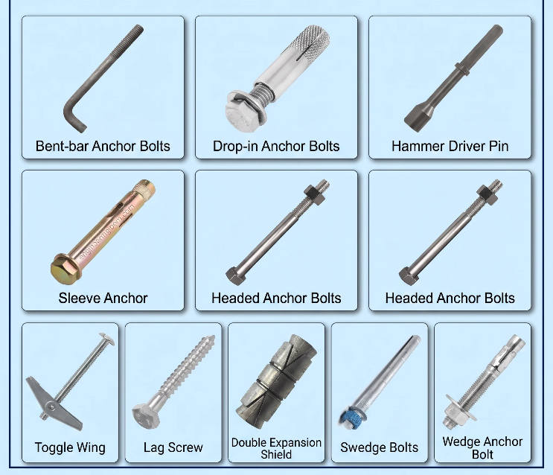
Source: https://engineersguidebook.com/anchor-bolt-types-sizes-and-applications/
Img. 3 Anchor Bolts

Arbor Bolts
These are precision-engineered fasteners featuring an integral fixed washer head and left-hand (reverse) thread shanks. The reverse threading prevents dynamic rotational inertia from unscrewing the bolt during high-speed operation, making them critical safety components in circular saws, miter saws, and rotating machine tooling.

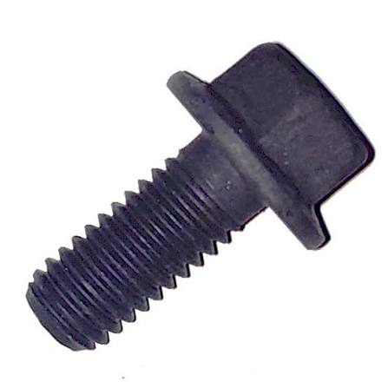
Source: https://www.lewiscontractorsales.com/husqvarna-soff-cut-150-blade-shaft-arbor-bolt.html
Img. 4 Arbor Bolts

Carriage Bolts
These bolts are defined by a smooth, rounded domed head underlaid by a square neck collar. When inserted into a square pre-punched hole in wood or composite-to-metal assemblies, the square neck locks into place, preventing fastener rotation when tightening the nut from the opposite side.

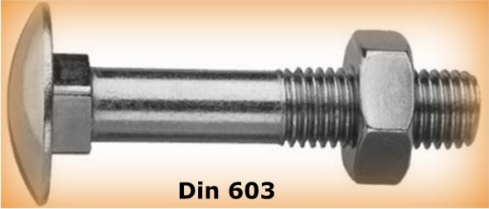
Source: https://en.wikipedia.org/wiki/Carriage_bolt
Img. 5 Carriage Bolts

Elevator Bolts
These are designed for conveyor belt systems, elevator bolts possess a thin, exceptionally wide, flat bearing head underlaid by a square neck. The wide bearing surface spreads clamping force across flexible belt materials to prevent pull-through while maintaining a flush surface profile.

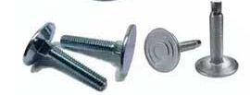
Source: https://www.jigneshsteel.com/elevator-bolts.html
Img. 6 Elevator Bolts

Wheel Bolts and Wheel Nuts
These are precision automotive fasteners designed with conical or spherical tapered seat heads. The tapered head seats into matching recessed wheel rim holes, ensuring concentric alignment of the wheel hub assembly while transferring heavy shear and alternating stress loads.

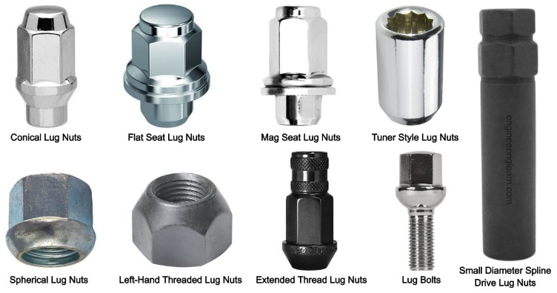
Source: https://engineeringlearn.com/9-types-of-lug-nuts-lug-nut-sizes-lug-bolts-vs-lug-nuts/
Img. 7 Wheel Bolts and Wheel Nuts

Flange Bolts
Hex-headed bolts incorporating an integrated circular washer flange beneath the head. This flange increases the surface contact area, distributing clamping pressure across fragile materials and eliminating the need for an independent flat washer.

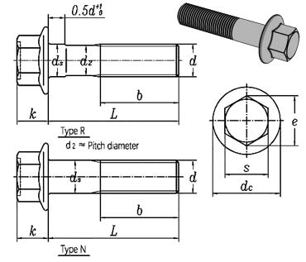
Source: https://www.jigneshsteel.com/din-6921-iso-4162-flange-bolts.html
Img. 8 Flange Bolts

Double-End Studs and Bolts
These are headless threaded fasteners featuring threads at both terminal ends. Tap-end studs feature a short thread segment designed to be screwed into a tapped hole in a casting or housing, leaving the opposite, longer threaded shank exposed to receive component clearance holes and a nut.

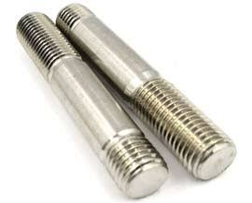
Source: https://www.jigneshsteel.com/stainless-steel-double-ended-studs.html
Img. 9 Double-End Studs and Bolts

Screws
Machine screws feature uniform diameters for pre-tapped holes. Wood screws possess coarse threads and tapered points to compress wood fibers. Sheet metal and self-tapping screws cut mating threads directly into soft metals or plastics. Lag screws are heavy-duty structural wood screws driven by hexagonal heads.

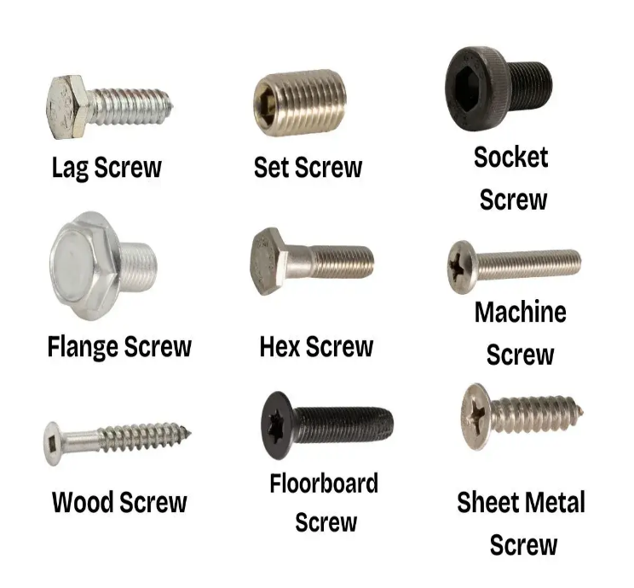
Source: https://thefastenerdepot.com/blogs/news/types-of-screws
Img. 10 Screw

Nuts
Standard hexagonal nuts rely on thread friction and component seating tension to maintain joint preload. Wing nuts and thumb nuts allow manual hand-tightening without tools. Flange nuts distribute load over an integrated washer face. Cap or acorn nuts encapsulate exposed bolt threads to protect against corrosion or fluid ingress.

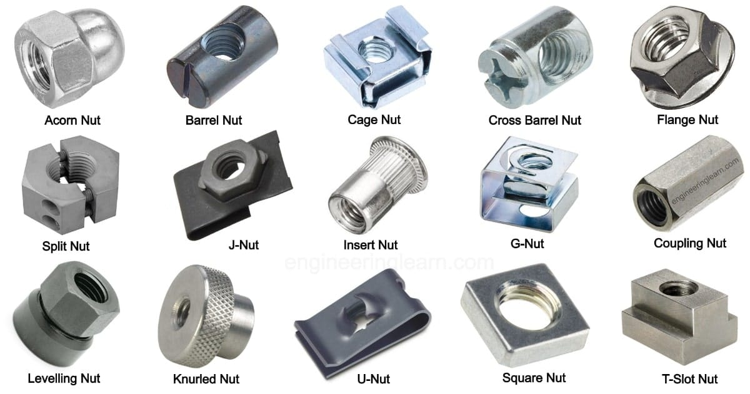
Source: https://engineeringlearn.com/
Img. 11 Nut

Pins and Keys
Clevis pins paired with cotter pins form articulated linkages. Hardened dowel pins align mating machine components. Square, rectangular, or Woodruff keys prevent rotational slip between rotating shafts and gear hubs.

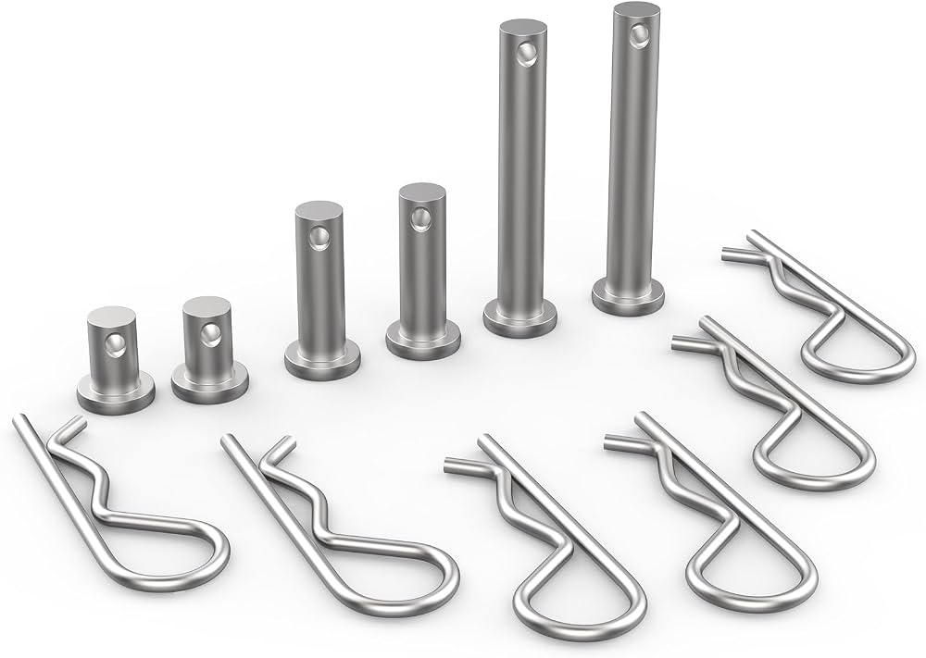
Source: https://www.amazon.in/dp/B08HLYWRCR
Img. 12 Pins and Keys

Supporting parts of Fasteners
- Washers:
Flat washers spread clamping loads over a wider surface area to lower localized bearing stress. However, they aren’t Fasteners by themselves as they don’t have the means to connect two parts. Fender washers spread loads over expansive areas on thin sheet metal. Helical spring and tooth lock washers exert axial tension or bite into contact faces. Belleville or conical spring washers store immense axial energy to absorb thermal expansion differentials and dynamic axial shocks

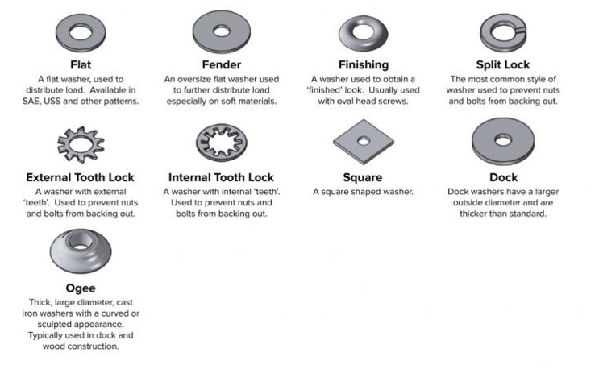
Source: https://www.premiumparts.com/blog/an-ultimate-guide-to-types-of-washers-materials-sizes
Img. 13 Washers

Semi-Permanent Fasteners
In these joints, removal is technically possible without destroying the parent host materials, but the fastening device itself or its auxiliary locking media is permanently deformed, sheared, degraded, or destroyed during extraction and cannot be reused. Some of these fasteners are:

Nylock Nuts
It features a captive nylon collar positioned at the top internal thread exit. As the bolt engages the collar, the nylon deforms elastically and plastically over the male threads, creating a high-friction prevailing torque. Once removed, the nylon insert undergoes permanent deformation, requiring nut replacement.

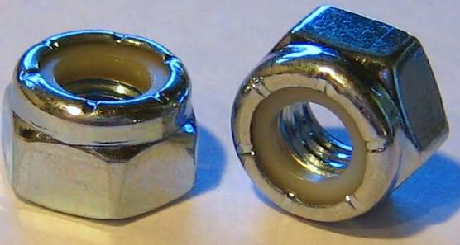
Source: https://en.wikipedia.org/wiki/Nyloc_nut
Img. 14 Nylock Nuts

Castle Nuts with Cotter Pins
Castle nuts feature slots through which a split cotter pin is inserted via a transverse hole in the fastener shank. The legs of the cotter pin are permanently bent backward to lock the nut. Disassembly requires shearing or destroying the sacrificial cotter pin.

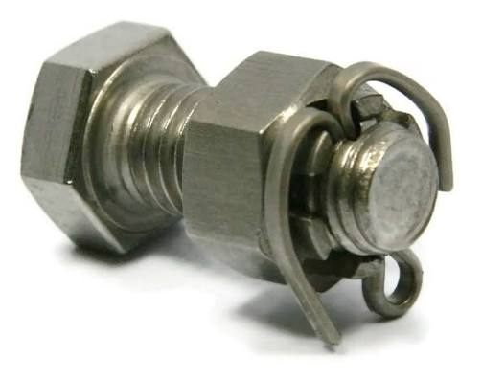
Source: https://www.albanycountyfasteners.com/castle-nuts-304-stainless-steel-38-16-129026/
Img. 15 Castle nuts with Cotter Pins

Starlock or Push-On Retaining Rings
These are groove less self-locking rings equipped with interior spring steel teeth that bite radially into smooth shaft metal. Once pressed into position, they provide high push-off friction resistance, and the removal destroys the ring and scratches the shaft surface.

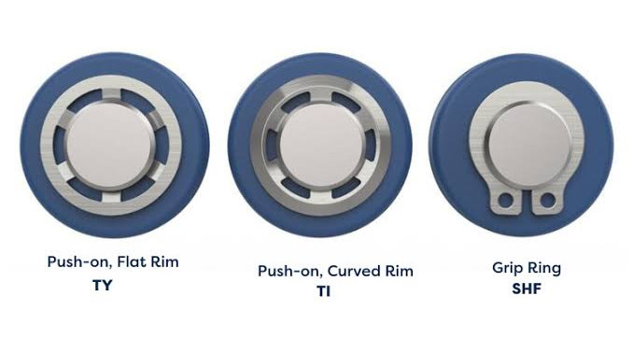
Source: https://www.rotorclip.com/post/product_type/self-locking-and-push-on-retaining-rings/
Img. 16 Starlock or Push-On Retaining Rings

Torque-to-Yield Fasteners
These fasteners are engineered to be torqued past their elastic yield point into plastic deformation. TTY fasteners provide consistent clamping force across thermal cycles, but because they undergo permanent plastic elongation during installation, they cannot be reused and must be discarded upon removal.

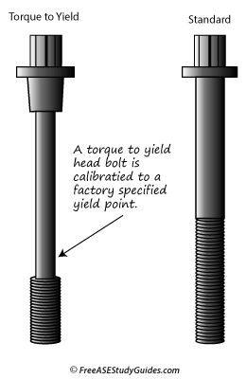
Source: https://www.freeasestudyguides.com/a1_4.html
Img. 17 TTY Fastener vs A Standard one

Shear Pins
These are sacrificial mechanical pins designed with precision-machined necks that shear at predetermined overload limits to protect machinery, requiring destruction and replacement of the pin to reset the system.

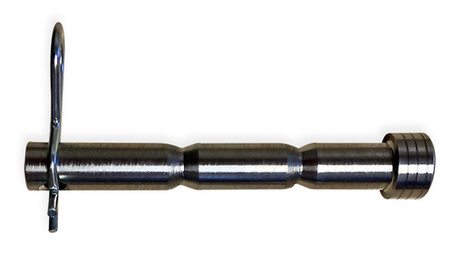
Source: https://www.tradeindia.com/products/shear-pins-6252186.html
Img. 18 Shear Pins

Permanent Fasteners
Permanent fasteners establish unremovable structural joints where disassembly cannot be accomplished without causing severe structural damage or catastrophically destroying the connected host materials or the joining media. Permanent joining relies on plastic material deformation, localized thermal fusion, or chemical bonding across the joint interface. Some of these fasteners are:

Solid Rivets
It features a solid un-cleaved shank. These are installed by driving the tail end against a heavy steel bucking bar. Solid rivets provide shear strength, fatigue resistance, and joint reliability, making them the standard structural joint in aircraft fuselage skins, structural steel bridges, and pressure vessels.

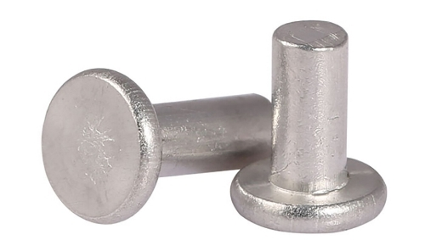
Source: https://www.tradeindia.com/products/solid-rivets-9709524.html
Img. 19 Solid Rivets

Blind Rivet
Also known as pop rivets. They are engineered for applications where access is restricted to only one side of the assembly. A blind rivet consists of a hollow tubular rivet body mated with a central mandrel wire. An installation tool pulls the mandrel head through the rivet body, expanding the blind-side tubular shank into a swollen rivet head before breaking the mandrel at a pre-etched snap notch.

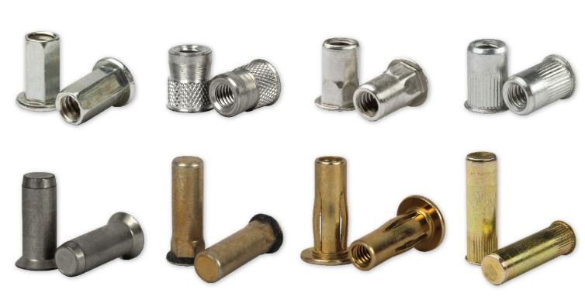
Source: https://www.huyett.com/blog/what-is-a-blind-rivet
Img. 20 Blind Rivets

Tubular and Semi-Tubular Rivets
It incorporates a partial hole at the tail tip. Installation requires lower axial cold-forming forces to roll the hollow edges outward into a lip, making them common in consumer goods, electronics, and light-duty commercial assemblies.

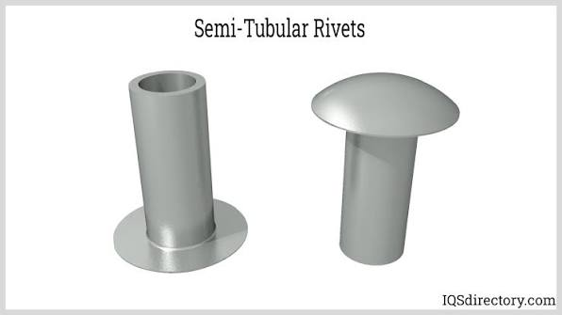
Source: https://www.iqsdirectory.com/articles/fastener/rivets.html
Img. 21 Tubular and Semi-Tubular Rivets

Common Nails
These nails feature heavy-duty carbon steel shanks and wide flat heads, designed to deliver high shear and bending resistance in structural timber framing.

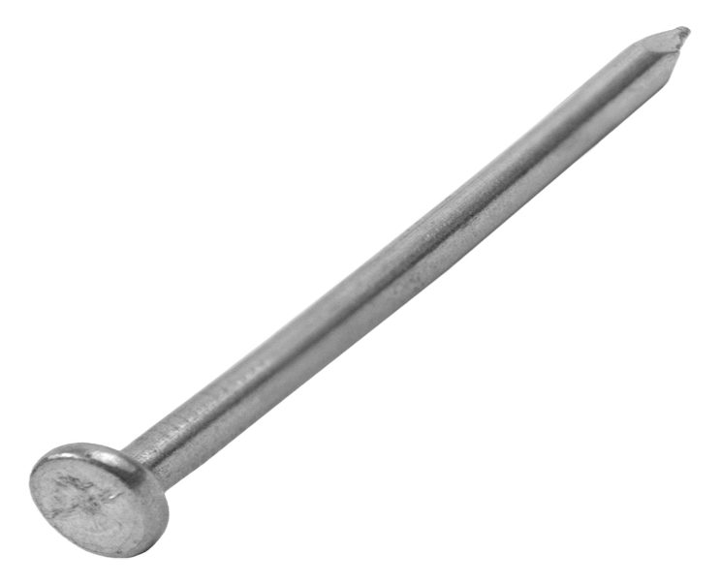
Source: https://grip-rite.com/product/fasteners/hand-drive/nails/exterior-nails/common-nail/
Img. 22 Common Nails

Box Nails
These nails are manufactured with thinner shank diameters to minimize wood splitting in light carpentry, millwork, and crate assembly.

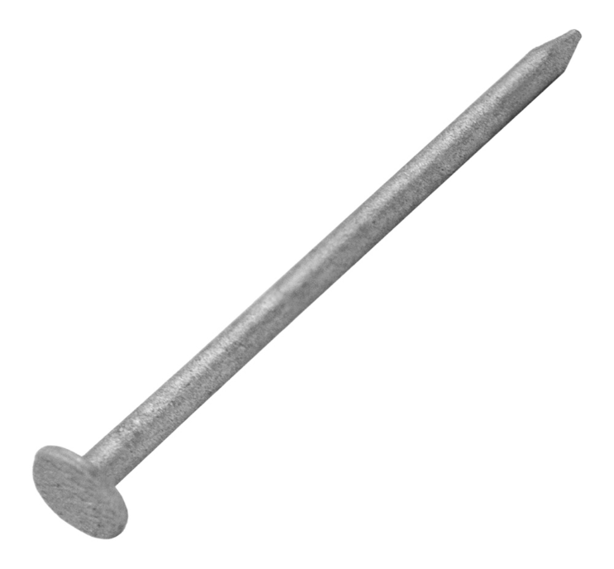
Source: https://grip-rite.com/product/fasteners/hand-drive/nails/exterior-nails/box-nail/
Img. 23 Box Nails

Ring-Shank Nails
These Nails are incorporated with a series of circumferential rings or ridges along the shank. When driven into timber, wood fibres wedge into the annular grooves, drastically increasing resistance to axial pull-out forces.

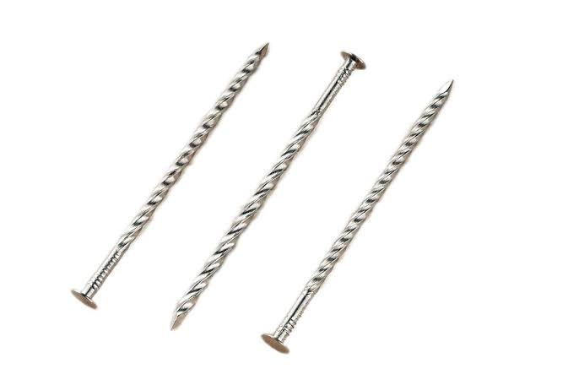
Source: https://sanjubz.en.made-in-china.com/product/FmkRKrNuZzUj/
Img. 24 Ring-Shank Nails

Masonry and Concrete Nails
They are manufactured from hardened high-carbon steel, and they feature fluted or smooth shanks capable of penetrating mortar, concrete, and brick without buckling.
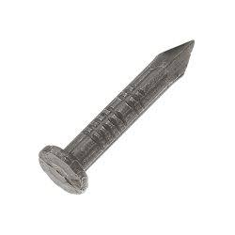
Source: https://grip-rite.com/product/fasteners/hand-drive/nails/masonry-nails/
Img. 25 Masonry and Concrete Nails

Finishing Nails and Brads
These are low-profile fasteners with small, cupped heads designed to be driven flush or countersunk below wood surfaces in delicate trim and cabinetry work.

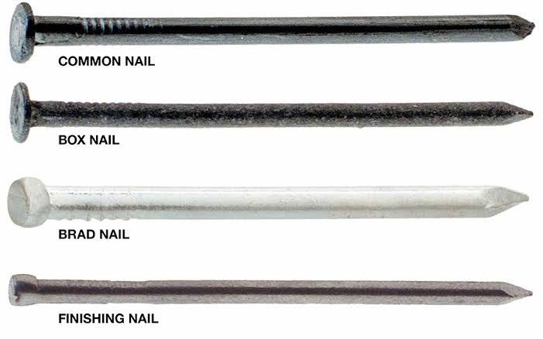
Source: https://contour-construct.com/difference-between-brad-nails-vs-finish-nails/
Img. 26 Fishing Nails and Brads

Chemical Concrete Anchors
These fasteners are synthetic resin cartridges injected into concrete boreholes prior to inserting a threaded stud. The chemical resin cures around the steel rod, creating an adhesive bond capable of supporting extreme dynamic loads without introducing expansion stresses into cracking-prone concrete. Disassembly requires destroying the concrete surrounding the anchor.

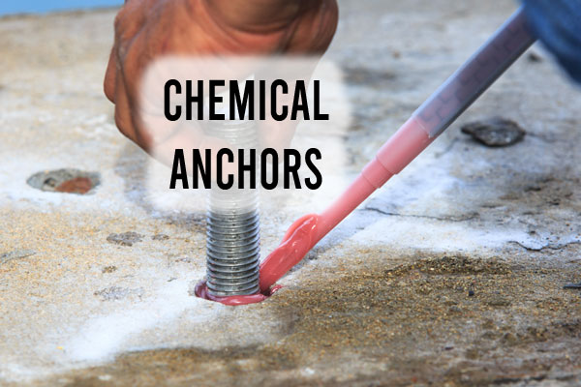
Source: https://constrofacilitator.com/different-types-of-chemical-anchors-used-in-structures/
Img. 27 Chemical Concrete Anchors

Weld Studs and Weld Nuts
These fasteners are engineered with welding projections or pilot rings to allow permanent spot-welding or capacitor discharge welding directly to sheet metal fabrications or heavy plates.

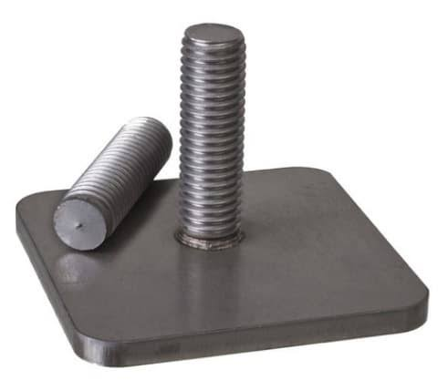
Source: https://learnmech.com/what-is-stud-welding-process-types-of-stud-welding/
Img. 28 Weld studs and Weld Nuts

Welded Joints
In these fasteners, the base materials are locally melted at their interface, fusing together with or without the addition of a molten filler rod. Welding produces continuous joints with strength properties matching or exceeding the parent metals.

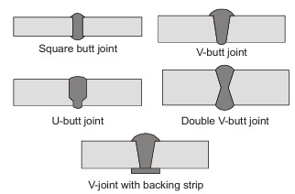
Source: https://www.madeeasy.in/study/me/machine-design/types-of-welded-joint
Img. 29 Welded Joints

Brazed and Soldered Joints
In these fasteners, the parent metals are joined without melting the base metals. Non-ferrous filler metals flow into the capillary space between closely fitted component interfaces at temperatures above ${450}^{∘}\text{C}$ for brazing or below ${450}^{∘}\text{C}$ for soldering to form a permanent bond.

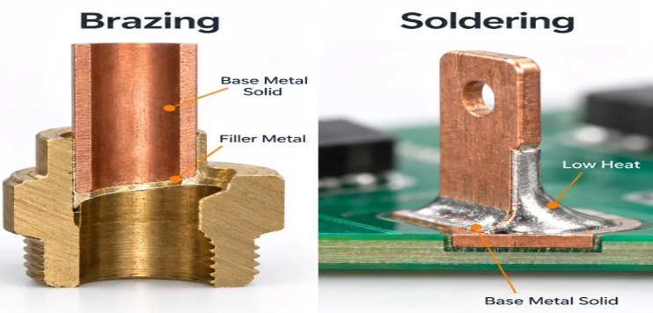
Source: https://www.rapiddirect.com/blog/brazing-vs-welding-vs-soldering/
Img. 30 Brazed and Soldered Joints

Acknowledgment
I would like to thank the team of Robo Manipal to give us this opportunity to learn more about different kind of fasteners and for guiding and helping us.

References
- Expometals. (2026). Industrial fasteners: Basics, types, and applications. Expometals Metal Working Basics. Retrieved from https://www.expometals.net/en/metal-working-basics/industrial-fasteners
- IQS Directory. (2026). Fasteners: Types, materials, and manufacturing processes. IQS Directory Technical Articles. Retrieved from https://www.iqsdirectory.com/articles/fastener.html
- The Engineer's Post. (2026). Types of fasteners and their applications in engineering. The Engineer's Post. Retrieved from https://www.theengineerspost.com/types-of-fasteners/
- Wikipedia contributors. (2026). Fastener. In Wikipedia, The Free Encyclopedia. Retrieved from https://en.wikipedia.org/wiki/Fastener

