A DETAILED REPORT ON POWER TRANSMISSIONS

Maxon Rodrigues
First Year Student
B.Tech in Computer Science and Engineering
Manipal Institute of Technology
Manipal, Karnataka, India
maxonrodrigues@gmail.com

Abstract—This document is a detailed report on four different transmission types. Namely belt drives, chain drives, rope drives and gear drives. It will explain the working principle, advantages, disadvantages and applications.
Keywords— transmission, belt, chain, rope, gear, drives.

Introduction
The rotational motion can be transmitted from one mechanical element to the other with the help of certain systems known as transmission systems. A common part of all transmission systems is that one-part drives and is called the driving system. The other part is driven by the driving system and is called driven system. Some commonly used methods of power transmission are belt drives, gear drives, rope drives and chain drives. Drives that allow some slippage between their driving and driven systems are called friction drives whereas the drives that do not allow any slippage are called positive drives or mesh drives. This report will contain a description of these drives and explain them.

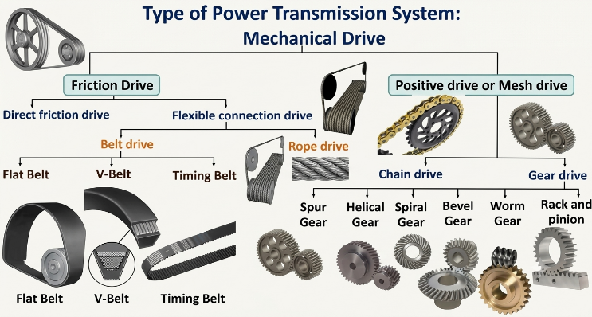
Source: https://www.youtube.com/watch?v=Ekctz5W_zf4
Img. 1 Mind Map of Some Transmission Drives

Belt Drives
Belt drives, as the name suggests, are drives that use flexible belts to transmit power. They are a type of friction drive. Its working principle is that the power is transmitted due to the friction between the belt and the pulley rim. Tension on one side of the belt will be more than the other side. The portion of the belt having less tension is called slack side and the portion of the belt having high tension is called tight side.

Terminology
- Arc / angle of contact :
It is the portion of the belt which is in contact with pulley surface. Denoted by θ.
- Tight side:
The portion of the belt having/possessing the maximum tension. Denoted by T₁.
- Slack side:
The portion of the belt having/possessing the minimum tension. Denoted by T₂.
- Velocity Ratio:
The ratio between the speeds of the driver and driven pulleys, inversely proportional to their diameters
- Slip:
The relative motion between the belt and the pulley rim due to insufficient frictional grip, causing a loss in power and speed ratio accuracy.
- Creep:
The slight alternate stretching and contracting of the belt as it passes from the tight side to the slack side, which also causes a minor speed loss.
- Centrifugal Tension:
At high rotational speeds, centrifugal force pulls the belt outward away from the pulley rim, reducing the effective frictional grip. This creates an upper speed limit for standard flat and V-belt drives.

Types of Belt Drive
Depending on the different types of outputs given by the belt drives, they are arranged in several configurations:
- Open Belt Drive:
Used when parallel shafts rotate in the same direction. The belt runs over the outside of both pulleys. The tighter side (tension side) is usually at the bottom so that sagging pulls the belt into better contact with the pulleys, increasing the arc of contact.
- Crossed Belt Drive:
Used when parallel shafts need to rotate in opposite directions. The belt is crossed between the two pulleys. While this provides a high arc of contact and strong grip, the point where the belt crosses cause rubbing and friction against itself, which generates extra wear and limits operation to lower speeds.
- Compound Belt Drive:
Used when power needs to be transmitted from one shaft through a series of intermediate steps to the final driven shaft to achieve a very high velocity ratio. Multiple pulleys of different sizes are mounted on common intermediate shafts.
- Stepped or Cone Pulley Drive:
Frequently used in traditional machine tools like lathes and drilling machines where variable spindle speeds are required. Consists of stepped pulleys of varying diameters on both the driver and driven shafts, allowing the operator to manually shift the belt to different steps to change the speed ratio.
- Fast and Loose Pulley Drive:
Used when a driven machine needs to be started or stopped frequently without shutting down the primary prime mover. The driven shaft has two pulleys side by side. A fast pulley securely keyed to the shaft and a loose pulley that spins freely on the shaft. Shifting the belt to the loose pulley stops the machine.
Based on the Types of belts used they can be classified as:
- Flat Belts:
Features a rectangular cross-section. Best suited for high-speed, long-distance power transmission with moderate power capacity. They require high initial tension and wide pulleys.
- V-Belts:
Features a trapezoidal cross-section that wedges into matching V-grooves on the pulleys. The wedging action provides a much higher frictional grip than flat belts, allowing them to transmit significantly higher torque without slipping, even with smaller centre distances.
- Timing Belts:
Features internal transverse teeth that mesh directly with corresponding grooves on the pulley. Unlike friction belts, timing belts act as a positive drive, making them ideal for precise synchronization tasks like internal combustion engine camshaft drives.
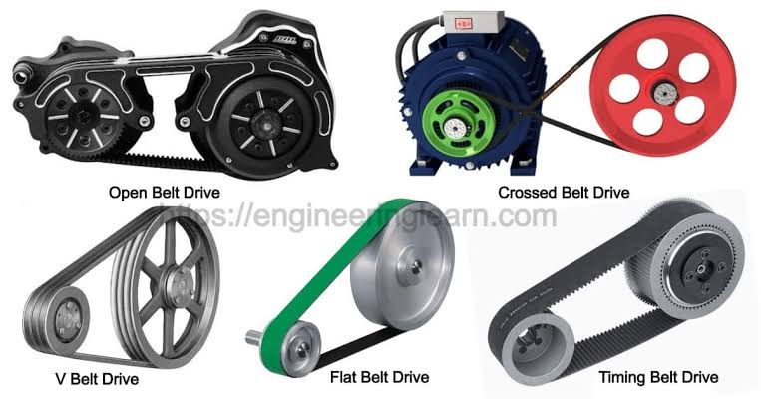
Source: https://engineeringlearn.com/
Img. 2 Types of Belt Drive

Advantages and Disadvantages?
- Advantages:
  - Simple design.
  - Low cost.
  - Smooth and silent operation.
  - Inherent shock/overload absorption due to belt slip.
- Disadvantages:
  - Prone to slip and creep leading to variable velocity ratios
  - Lower efficiency compared to gear drives
  - Requires periodic tensioning.

Applications
Industrial Machinery and Machine Tools: Used in traditional workshop machines like lathes, drilling machines and milling machines.
Agricultural Equipment: Power transmission in tractors, threshers, and grain milling machinery.
Automotive Systems: Timing Belts are used in internal combustion engines to synchronize the rotation of the crankshaft and camshaft, ensuring engine valves open and close at the correct times.
Domestic and Household Appliances: Used in washing machines to drive the drum from the electric motor.
Conveyor Systems: Flat and V-belts are widely used in material handling conveyor systems to transport packages, assembly line goods, and bulk materials.

Rope Drives
Rope drives are flexible power transmission systems like belt drives, but they utilize fiber ropes or steel wire ropes running over grooved pulleys known as sheaves to transmit power, especially over long distances. They are classified as friction drives.

Types of Rope Drive
Depending on the materials used and application requirements, rope drives are classified into:
- Fiber Rope Drives:
Utilizes natural fiber ropes such as manila, hemp, or cotton running over grooved pulleys. Best suited for transmitting light loads over moderate distances.
- Wire Rope Drives:
Utilizes multiple steel wire strands wound around a central core. Highly durable and designed for heavy-duty power transmission over very large distances and high-tension environments.

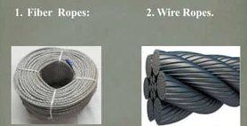
Source: https://www.slideshare.net/slideshow/belt-and-rope-drives/84089374
Img. 3 Types of Rope Drive

Advantages and Disadvantages?
- Advantages:
  - Capable of transmitting power over very large distances between shafts where standard belt drives are ineffective.
  - High reliability and excellent capacity to handle heavy shock loads.
  - Smooth and quiet operation across large spans.
- Disadvantages:
  - Wire ropes are less flexible and require large-diameter sheaves to prevent bending fatigue.
  - Higher initial installation cost and bulkier setup compared to standard belt drives.
  - Prone to internal and external wear, requiring regular inspection and lubrication.

Applications
Mining and Hoisting: Used extensively in mine hoists, elevators, and vertical lifting equipment for high-load operations.
Material Handling: Overhead traveling cranes, cable cars, and long-distance aerial ropeways.
Domestic and Household Appliances: Used in wells to pull up water.

Chain Drives
Chain drives are positive (mesh) power transmission systems consisting of an endless roller chain that wraps around toothed wheels called sprockets. Unlike friction drives, power is transmitted through positive mechanical engagement between the links of the roller chain and the protruding teeth of the sprockets. This positive engagement ensures that there is zero slip and maintains a perfectly constant velocity ratio between the driving and driven shafts.

Types of Chain Drive
- Power Transmission Chains:
These chains are designed specifically to transmit rotational power and motion between rotating shafts with high efficiency and a constant velocity ratio.
  - Block Chain:
Consists of solid blocks or shaped metal pieces connected by side plates and pins, where the blocks directly mesh with the sprocket teeth. Simple in construction and economical. However, because the sliding friction against the sprocket teeth is high, they are limited to low speeds and light loads.
  - Roller Chain:
Comprises alternating inner and outer link plates, pins, bushes, and free-spinning cylindrical rollers. The rollers reduce friction by rolling into the sprocket tooth spaces rather than sliding. Highly efficient, durable, and capable of handling high speeds and high-power transmission. They are the most widely used industrial chain drive.
  - Bushed Chain:
Like a roller chain, but it lacks the independent rotating outer roller around the bush. The sprocket teeth engage directly with the cylindrical bush. Simpler and cheaper to manufacture than roller chains. They experience slightly more wear on the sprocket teeth due to sliding friction rather than rolling friction.
  - Silent Chain (Inverted Tooth Chain):
Built from a stack of flat link plates shaped with inverted teeth. The teeth are designed to engage with the sprocket like a gear rather than wrapping around pins. Operates with significantly less noise, vibration, and chordal action than roller chains, even at high rotational speeds. They distribute load across multiple teeth.

- Conveyor Chains
Conveyor chains are built specifically for material handling, designed to pull, drag, or carry materials along a designated path rather than transmitting high-speed rotational power between shafts.
  - Detachable (Hook) Chain:
Made of individual cast or stamped metal links that feature an open hook design, allowing links to be easily connected or disconnected without specialized tools. Inexpensive and flexible, though limited to low speeds and light-to-moderate loads in clean environments.
  - Pintle Chain:
A more rugged version of the detachable chain where the links feature closed barrels connected by steel pins secured with cotter pins. Highly resistant to dirt, grit, and wear, making them ideal for harsh, abrasive environments.
  - Flat-Top Chain (Hinged Chain):
Features wide, flat upper plates that interlock like hinges, forming a continuous, smooth flat surface or table as the chain moves over tracks. Designed so that items can slide smoothly on top of the chain without needing pallets or containers.
  - Bushed Roller Conveyor Chain:
Heavy-duty roller chains equipped with oversized rollers that project past the link plates, allowing the chain to roll along fixed metal tracks or guides. Reduces friction over long conveyor spans and supports very heavy bulk loads.
- Hoisting and Pulling Chains
These chains are designed exclusively for high-tension vertical lifting, counterweight balancing, or pulling heavy static loads rather than continuous circular power transmission.
  - Leaf Chain:
Consists solely of parallel link plates held together by cylindrical hinge pins, with no bushes or rollers. Designed strictly for high tensile stress under reciprocating or lifting motions. They cannot wrap around sprockets in continuous loops and are operated using smooth sheaves or anchor pins.
  - Welded Steel / Engineering Steel Chain:
Fabricated from heavy-gauge steel plates and bars welded together into robust, high-strength links. Built to withstand severe shock loads, extreme tension, and gruelling outdoor industrial environments.

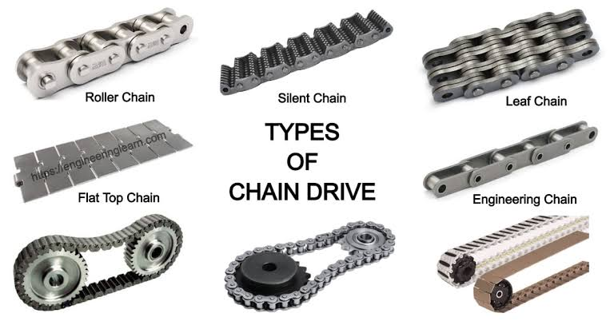
Source: https://engineeringlearn.com/
Img. 4 Types of Chain Drive

Advantages and Disadvantages?
- Advantages:
  - Positive drive with zero slip, ensuring a constant and reliable velocity ratio. High mechanical efficiency.
  - Capable of transmitting high torque over moderate center distances without requiring high initial tension.
  - Less affected by temperature changes, oil, or environmental conditions compared to belts.
- Disadvantages:
  - Requires regular lubrication and precise alignment to prevent rapid wear of pins and bushings.
  - Higher initial cost and noisier operation than belt drives, especially at high rotational speeds.

Applications
Forklift truck mast lifting mechanisms, hydraulic lift gates, and heavy machinery counterweight balancing systems.
Automobile assembly lines, heavy material handling conveyors, and grain elevators.
High-speed industrial drives, automotive engine timing chains, and high-precision machine tool drives.
Motorcycle final drives, industrial machinery gearboxes, and engine auxiliary drives.

Gear Drives
Gear drives are rigid, positive power transmission systems that use toothed wheels in direct contact to transmit motion and power between rotating shafts without any slip. Direct tooth-to-tooth positive contact forces the driven gear to rotate when the driver gear turns, ensuring an exact, slip-free velocity ratio.

Terminology
- Pitch Circle:
An imaginary circle that rolls without slipping with the pitch circle of a mating gear. All calculations are based on this circle.
- Pitch Circle Diameter ($D$):
The diameter of the pitch circle.
- Module ($m$):
It is the standard metric measure of gear tooth size. It is the ratio of the pitch circle diameter to the number of teeth:
$$m=\frac{D}{T}$$
Where $T$ is the number of teeth.
- Circular Pitch ($P_{C}$):
The arc distance measured along the pitch circle from a point on one tooth to the corresponding point on the next tooth:
$$P_{C}=π⋅m$$
- Diametral Pitch ($P_{d}$): The ratio of the number of teeth to the pitch circle diameter:
$$P_{d}=\frac{T}{D}$$
- Addendum: The radial distance from the pitch circle to the outermost tip of the tooth.
- Dedendum: The radial distance from the pitch circle to the bottom of the tooth space (root circle).
- Clearance: The difference between the dedendum of one gear and the addendum of the mating gear.
- Gear Ratio ($i$ or $G_{r}$): The ratio of the angular velocities or the inverse ratio of the number of teeth between two meshing gears:
$$i=\frac{ω_{1}}{ω_{2}}=\frac{T_{2}}{T_{1}}=\frac{D_{2}}{D_{1}}$$

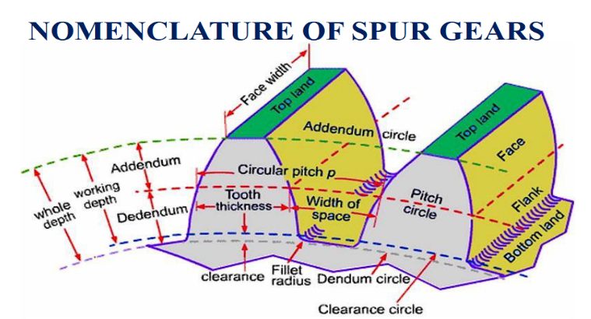
Source: Manipal Fundamentals of Mechanical Engineering Slides
Img. 5 Terminology of Gear Drives

Types of Gear Drives
Depending on the different types of gears used, they are classified as:
- Spur Gears:
Straight teeth parallel to the axis of rotation. Used for parallel shafts and are simple to manufacture but can be noisy at high speeds.
- Helical Gears:
Teeth are cut at an angle (helix angle) to the axis. Engagement is gradual, resulting in smoother, quieter operation and higher load capacity, but generates axial thrust forces.
- Bevel Gears:
Conical shaped gears used to transmit power between intersecting shafts typically at ${90}^{∘}$ or at an angle. They are further classified as straight bevel and spiral bevel gears.
- Worm and Worm Wheel:
Consists of a screw called worm meshing with a helical gear called worm wheel. Used for non-intersecting, perpendicular shafts. Provides extremely high velocity reduction ratios in a compact space and is often self-locking.
- Rack and Pinion:
Consists of a circular gear called pinion meshing with a linear toothed bar called rack. Converts rotational motion into linear motion. They are used in automotive steering systems.
When two or more gears are combined to transmit power from a driving shaft to a driven shaft, it is called a gear train.
- Simple Gear Train:
Each shaft carries only one gear. Intermediate or idler gears are placed between the driver and driven gears, and they do not alter the overall velocity ratio but reverse the direction of rotation.
- Compound Gear Train:
Multiple shafts carry two or more gears keyed to the same rotating shaft. This allows for high velocity ratios in a compact layout.

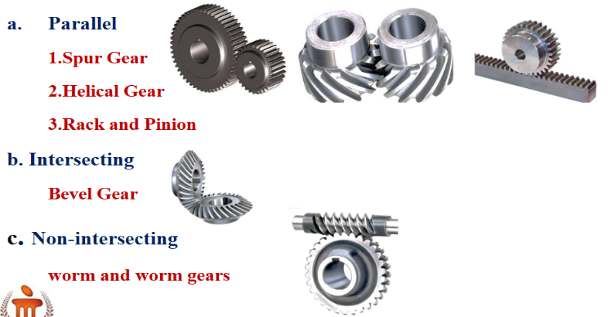
Source: Manipal Fundamentals of Mechanical Engineering Slides
Img. 6 Types of Gear Drive

Advantages and Disadvantages?
- Advantages:
  - Positive, non-slip drives, hence transmission efficiency is high.
  - Most convenient for very small center distances.
  - Transmits power when the axes of the shafts are parallel, nonparallel, intersecting, non-intersecting.
  - Velocity ratio will remain constant throughout.
  - Employed for low, medium and high-power transmission.
  - Gears are employed for wide range of applications.
- Disadvantages:
  - Not suitable for shafts of very large center distances.
  - Require some kind of lubrication.
  - At very high speeds noise and vibrations will be more.
  - Not economical because of the increased cost of production
  - Use of large number of gear wheels in gear trains increases the weight of the machine.

Applications
Automotive Industry: Transmission gearboxes and differential assemblies in cars and trucks.
Industrial Equipment: Lathes, milling machines, heavy-duty industrial speed reducers, and robotics actuators.
Precision Instruments: Mechanical watches, aerospace guidance control systems, and household appliances.

Acknowledgment
I would like to thank the team of Robo Manipal to give us this opportunity to learn more about different kind of transmission drives and for guiding and helping us.

References
- Engineering Learn, "Types of chain drive: Mechanism, uses, design, applications, advantages & disadvantages," Engineering Learn, [Online]. Available: https://engineeringlearn.com/types-of-chain-drive-mechanism-uses-design-applications-advantages-disadvantages/.
- Engineering Learn, "Types of belt drive: Material, applications, advantages & disadvantages," Engineering Learn, [Online]. Available: https://engineeringlearn.com/types-of-belt-drive-material-applications-advantages-disadvantages/.
- C. Dineshbabu, "Belt and rope drives," SlideShare, Dec. 12, 2017. [Online]. Available: https://www.slideshare.net/slideshow/belt-and-rope-drives/84089374.
- YouTube video title / Mechanical Engineering Lecture, [Video file]. Available: https://www.youtube.com/watch?v=Ekctz5W_zf4.
- School of Mechanical Engineering, Fundamentals of Mechanical Engineering, lecture notes and course material, Manipal Institute of Technology (MIT), Manipal, India.

