

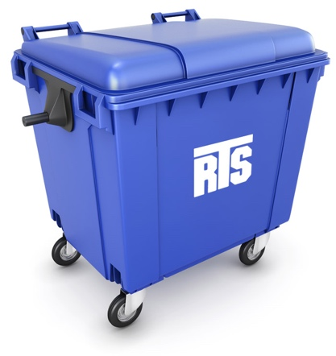

…

Recycling

Trash

ObjDetect

DetritusAI

RoutePlanning

Directions…

1Dundas

UofT

True

Notif

Notif

State

State

RecyclingVol

TrashVol

TrashVol

RecyclingVol