1) Start mongo server

2) Create new DB

Run "node create_mongo_db.js"

3) Create collection (table) like customers

Run "node create_collection.js"

4) for start server Use

“Node nodeserver.js”

Directory Structure:

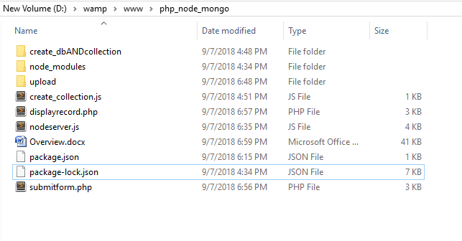

View Entries in MongoDB: