Task 1 - CT70A3000 Software Maintenance

Maksim Vakulenko

1. System Architecture Overview
The Inventory Management System (IMS) is a desktop application built entirely in Python. It uses the standard-library Tkinter framework for its graphical user interface and SQLite as its embedded relational database. Bills (customer receipts) have persisted as plain-text files on the local filesystem.
The codebase consists of seven source modules plus a database initialisation script:
dashboard.py | Application entry-point. Creates the main Tk window, left-side navigation menu, and dashboard summary tiles. Instantiates all feature windows.
billing.py | Full billing screen. Shows active products, manages a shopping cart, computes totals with a 5 % discount, and generates/prints customer receipts.
product.py | CRUD screen for products. Reads category and supplier names from the DB for combo-box population.
category.py | CRUD screen for product categories (add / delete).
supplier.py | CRUD screen for suppliers (invoice-based, with contact and description).
employee.py | CRUD screen for employees (personal details, role, salary).
sales.py | Read-only view of previously generated bill files stored in bill/.
create_db.py | One-time script that creates the ims.db SQLite database and its five tables.

1.1 Architectural Pattern
The system follows a monolithic desktop-application architecture with a thin-layer separation between UI and data access. Each feature class contains its own Tkinter widget setup, event handlers, and direct SQLite calls - there is no explicit Model-View-Controller separation, but the classes map naturally to the View+Controller role while the SQLite tables serve as the Model.

1.2 Data Model
The SQLite database ims.db contains the following tables:
Table | Columns
employee | eid (PK), name, email, gender, contact, dob, doj, pass, utype, address, salary
supplier | invoice (PK), name, contact, desc
category | cid (PK AUTOINCREMENT), name
product | pid (PK AUTOINCREMENT), Category, Supplier, name, price, qty, status
bill files | Not a DB table — stored as bill/{invoice_no}.txt on the filesystem

1.3 Technology Stack
Component | Technology
Language | Python 3.11
GUI Framework | Tkinter (stdlib) + ttk
Database | SQLite 3 via sqlite3 stdlib module
Image handling | Pillow (Pillow 12.1.0)
Bill storage | Plain-text files (.txt) in bill/ directory
Runtime | Single-process desktop app; no server or network layer

2. Class Diagram
The diagram below shows all seven application classes, their key attributes and methods, and the relationships between them. Blue arrows denote instantiation (the IMS dashboard creates each feature window). Green arrows represent DB read dependencies, and red arrows represent DB read/write dependencies.
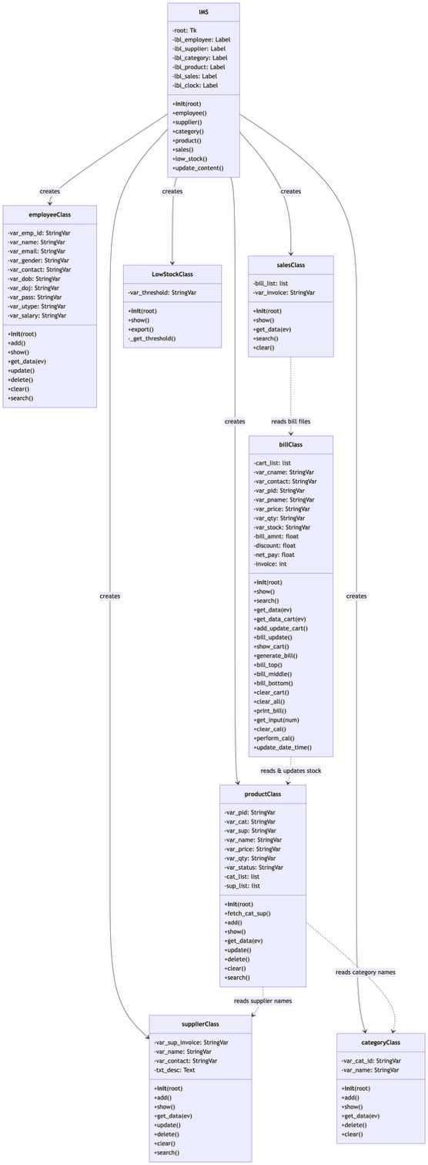
Figure 1 — Class Diagram

Key Relationships
- IMS (dashboard) creates instances of all five feature classes inside Toplevel windows.
- productClass reads category and supplier names from the DB to populate combo-boxes.
- billClass reads the product table (to list available stock) and writes back updated quantities and status after a sale.
- salesClass reads bill text files from the filesystem (bill/ directory) — it does not interact with the DB.
- All classes that perform CRUD open their own sqlite3 connection per method call (no shared connection object).

3. Sequence Diagram
The sequence diagram below illustrates the most complex workflow in the system: generating a customer bill. This flow involves four participants — the User, the billClass UI, the SQLite database, and the filesystem — and captures all state changes that occur when a sale is completed.
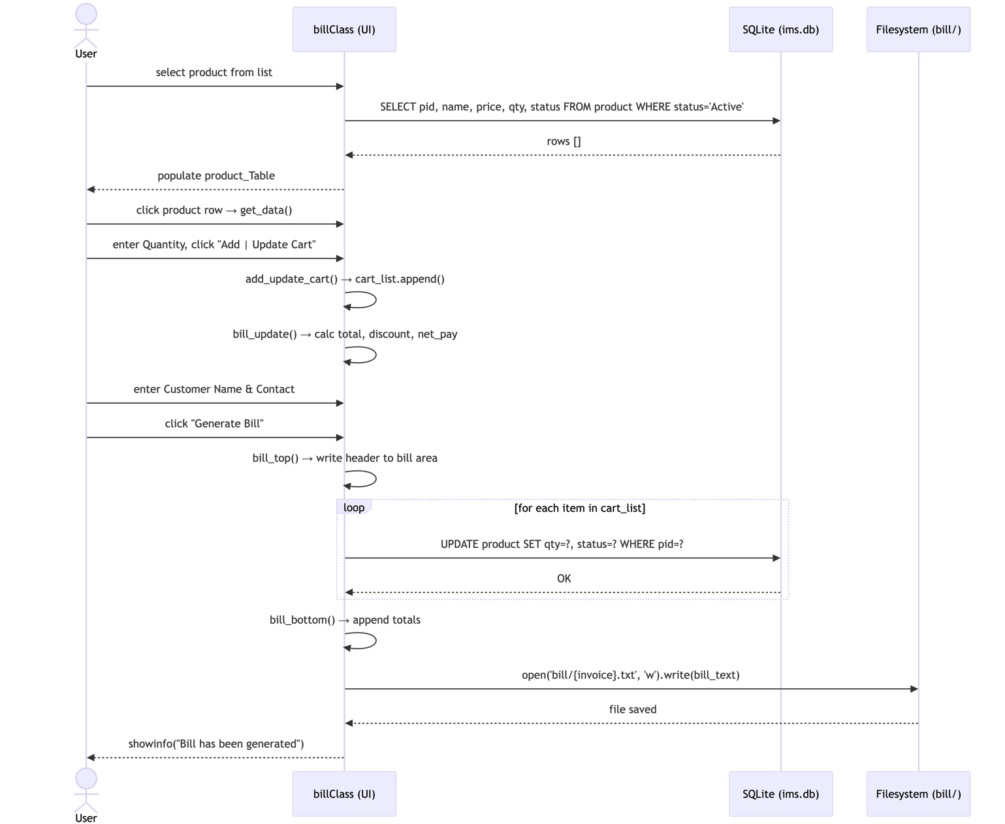
Figure 2 — Sequence Diagram: Generate Bill Workflow

Workflow Description
The bill-generation workflow proceeds in the following steps:
- 1. The user selects a product from the product table; billClass calls show() which queries the DB for Active products.
- 2. The user selects a row — get_data() populates the product-detail fields.
- 3. The user enters a quantity and clicks "Add | Update Cart" — add_update_cart() appends to cart_list.
- 4. bill_update() recalculates the bill amount, 5 % discount, and net pay labels.
- 5. The user enters customer name and contact, then clicks "Generate Bill".
- 6. bill_top() writes the receipt header (invoice number, date, customer info) to the text area.
- 7. bill_middle() iterates cart_list: for each item it updates the product qty and status in the DB.
- 8. bill_bottom() appends totals. The full receipt text is saved to bill/{invoice}.txt.
- 9. A success dialog is shown to the user.

4. Module Dependency Graph
The graph below maps every import-level dependency in the project. Blue nodes are project modules, green nodes are Python standard-library modules, the orange node is the Pillow third-party library, and red nodes are external resources (the SQLite database file and the bill/ directory).
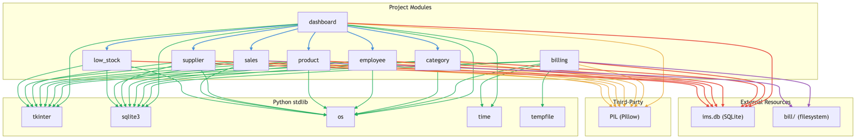
Figure 3 — Module Dependency Graph

Observations
- dashboard.py is the only module that imports other project modules — it acts as the composition root.
- billing.py is completely independent of the other five feature modules; it accesses the DB directly.
- All six feature modules share the same three external dependencies: tkinter, Pillow, and sqlite3.
- category.py contains a hardcoded absolute path ("Inventory-Management-System/images/...") which will fail when the project is run from a different working directory — a finding addressed in T2 (Refactoring).
- All modules open a new sqlite3 connection per method call rather than reusing a shared connection — a code-quality concern also addressed in T2.

