Chapter 2
- Television channels are 6 MHz wide. How many bits/sec can be sent if four-level digital signals are used? Assume a noiseless channel.
- 波特率为 2W=2*6M=12M
- 离散状态数为4，则每一个码元能表示Log₂⁴=2Bit
故最终速率为 12M*2=24Mbps
- What signal-to-noise ratio is needed to put a T1 carrier on a 50-kHz line?
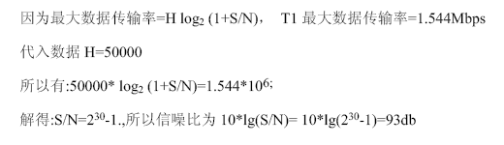
- In Fig. 2-40, the user data rate for OC-3 is stated to be 148.608 Mbps. Show how this number can be derived from the SONET OC-3 parameters.
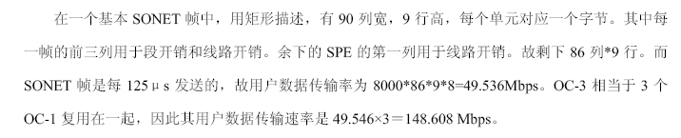
- A CDMA receiver gets the following chips: (-1 +1 -3 +1 -1 -3 +1 +1). Assuming the chip sequences defined in Fig. 2-28(a), which stations transmitted, and which bits did each one send?
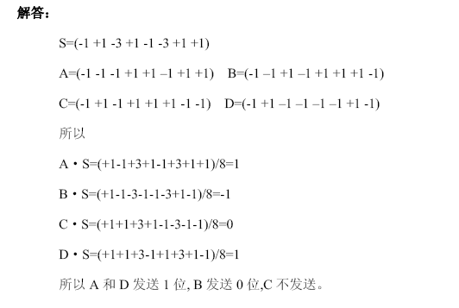
谢希仁老师第五版补充题：
2-04，2-07，2-18

2-04 试解释以下名词：数据，信号，模拟数据，模拟信号，基带信号，带通信号，数字数据，数字信号，码元，单工通信，半双工通信，全双工通信，串行传输，并行传输。
答：数据：是运送信息的实体。
信号：则是数据的电气的或电磁的表现。
模拟数据：运送信息的模拟信号。
模拟信号：连续变化的信号。
数字信号：取值为有限的几个离散值的信号。
数字数据：取值为不连续数值的数据。
码元(code)：在使用时间域（或简称为时域）的波形表示数字信号时，代表不同离散数值的基本波形。
单工通信：即只有一个方向的通信而没有反方向的交互。
2-07 假定某信道受奈氏准则限制的最高码元速率为20000码元/秒。如果采用振幅调制，把码元的振幅划分为16个不同等级来传送，那么可以获得多高的数据率（b/s）?
答：C=R*Log2（16）=20000b/s*4=80000b/s

2-18为什么在ASDL技术中，在不到1MHz的带宽中却可以传送速率高达每秒几个兆比？
答：靠先进的DMT编码，频分多载波并行传输、使得每秒传送一个码元就相当于每秒传送多个比特

Chapter 3
1. One of your classmates, Scrooge, has pointed out that it is wasteful to end each frame with a flag byte and then begin the next one with a second flag byte. One flag byte could do the job as well, and a byte saved is a byte earned. Do you agree?
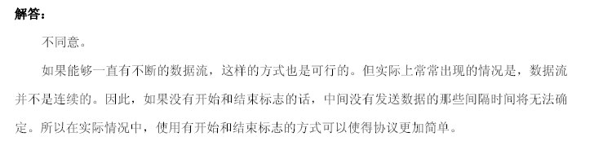
2.Sixteen-bit messages are transmitted using a Hamming code. How many check bits are needed to ensure that the receiver can detect and correct single-bit errors? Show the bit pattern transmitted for the message 1101001100110101. Assume that even parity is used in the Hamming code.
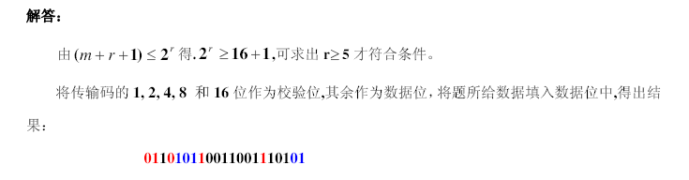

1 | 2 | 3 | 4 | 5 | 6 | 7 | 8 | 9 | 10 | 11 | 12 | 13 | 14 | 15 | 16 | 17 | 18 | 19 | 20 | 21
R1  0 | R2  1 | 1 | R3  1 | 1 | 0 | 1 | R4  1 | 0 | 0 | 1 | 1 | 0 | 0 | 1 | R5  1 | 1 | 0 | 1 | 0 | 1
反向排序亦可
3. A bit stream 10011101 is transmitted using the standard CRC method described in the text. The generator polynomial is x 3 + 1. Show the actual bit string transmitted. Suppose that the third bit from the left is inverted during transmission. Show that this error is detected at the receiver’s end. Give an example of bit errors in the bit string transmitted that will not be detected by the receiver.
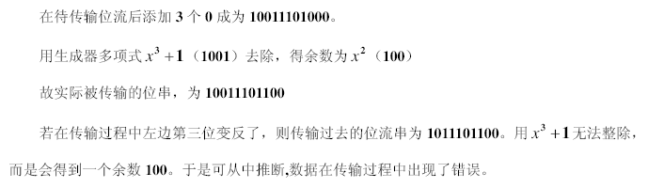
4.A channel has a bit rate of 4 kbps and a propagation delay of 20 msec. For what range of frame sizes does stop-and-wait give an efficiency of at least 50%?
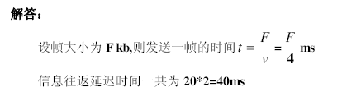
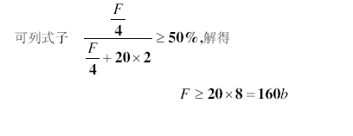
5.A 3000-km-long T1 trunk is used to transmit 64-byte frames using protocol 5. If the propagation speed is 6 μsec/km, how many bits should the sequence numbers be?
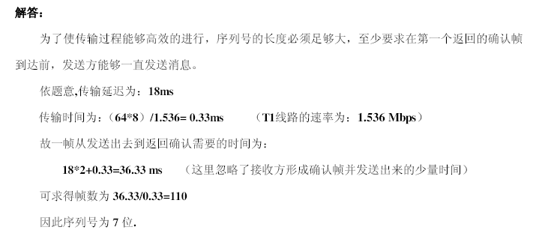
T1线路的速率不应该是1.544Mbps吗
6.Frames of 1000 bits are sent over a 1-Mbps channel using a geostationary satellite whose propagation time from the earth is 270 msec. Acknowledgements are always piggybacked onto data frames. The headers are very short. Three-bit sequence numbers are used. What is the maximum achievable channel utilization for
(a) Stop-and-wait
(b) Go-Back_N ARQ
(c) Selective ARQ
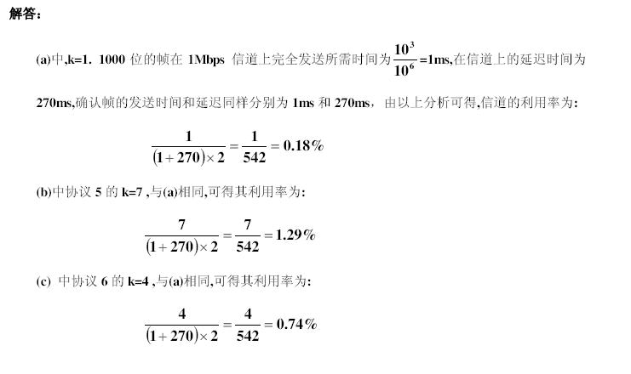

Chapter 4
- Consider the delay of pure ALOHA versus slotted ALOHA at low load. Which one is
less? Explain your answer.
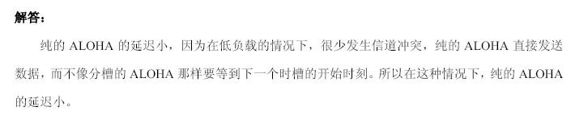
- What is the baud rate of classic 10-Mbps Ethernet?
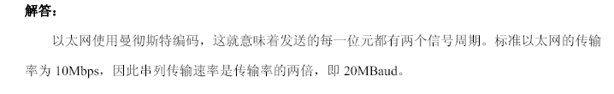
- Ethernet frames must be at least 64 bytes long to ensure that the transmitter is still going in the event of a collision at the far end of the cable. Fast Ethernet has the same 64-byte minimum frame size but can get the bits out ten times faster. How is it possible to maintain the same minimum frame size?
网络直径缩短到原来的1/10
- 考虑在一条1km 长的电缆（无中继器）上建立一个1Gbps 速率的CSMA/CD 网络，信号在电缆中的速度为200000km/s。请问最小的帧长度为多少？
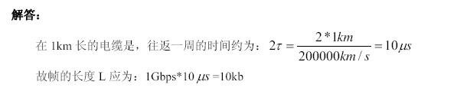
以下三题取自谢希仁网络教材第五版，p106-107
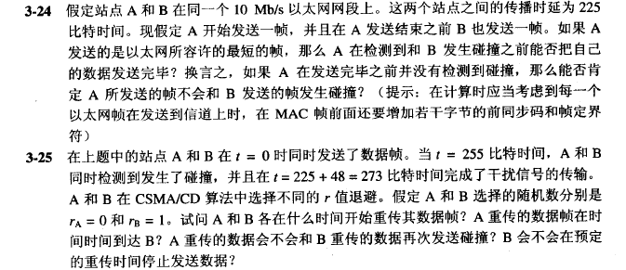
3-24：
A:t0时刻发送一帧，帧最短长度为512Bit,则A发送完最后一个Bit的时间是 T1=t0+512位时；
A发送的第一个Bit在t0+225前可到达B，假如A发送完之前B发送，那么，B的发送时刻一定<t0+225，否则B检测到信道忙，不会发送
则，冲突信号回到A的时间一定小于T2: t0+2*225=t0+510
T1>T2.可见A肯定能检测到冲突信号
3-25:
1）T=0,A、B开始发送数据；
2）t=255位时,A、B检测到碰撞；
3）t=273位时, A、B结束强化干扰信号传输；
4）A、B计算退避算法，rA=0,A立即重传，rB=1,B回退一个时槽（）
A在273位时开始监听信道（此时信道一直忙，直到B传给A的干扰信号传播完毕，需要225位时），273+225位时后，信道开始空闲。A持续监听信道，直到信道空闲时间达到了96位时，认为信道空闲，开始发送数据。
因此，A开始发送数据的时间是：273+225+96=594位时；
5）B从273开始退回，重新监听信道。此时的时间为：273+512=785位时，此时刻如果B监听到信道空闲，需要持续监听96位时内均空闲（直到 785+96=881位时），才认为信道空闲；但A重传的数据在594+225=819位时到达B，显然785<819<881，即B在监听信道空闲过程中，得到了A的信号，因此，没有达到持续空闲96位时的条件，因此B放弃发送

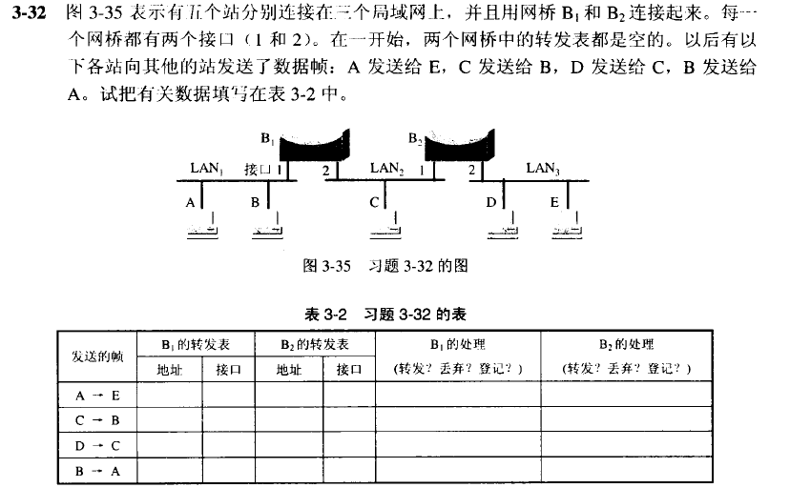

Chapter 5
- Consider the network of Fig. 5-12(a). Distance vector routing is used, and the following vectors have just come in to router C: from B: (5, 0, 8, 12, 6, 2); from D: (16, 12,6, 0, 9, 10); and from E: (7, 6, 3, 9, 0, 4). The cost of the links from C to B, D, and E,are 6, 3, and 5, respectively. What is C’s new routing table? Give both the outgoing line to use and the cost.
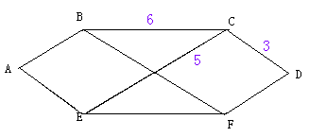
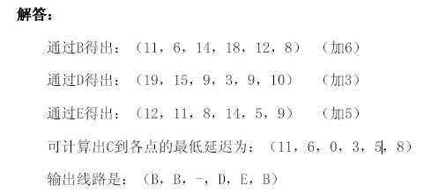
- A router has just received the following new IP addresses: 57.6.96.0/21, 57.6.104.0/21, 57.6.112.0/21, and 57.6.120.0/21. If all of them use the same outgoing line, can they be aggregated? If so, to what? If not, why not?
96=(0110 0000)
104=(0110 0100)
112=(0111 0000）
120= (0111 1000)
/19
- The set of IP addresses from 29.18.0.0 to 29.18.128.255 has been aggregated to 29.18.0.0/16. However, there is a gap of 1024 unassigned addresses from 29.18.60.0 to 29.18.63.255 that are now suddenly assigned to a host using a different outgoing line. Is it now necessary to split up the aggregate address into its constituent blocks, add the new block to the table, and then see if any reaggregation is possible? If not, what can be done instead?
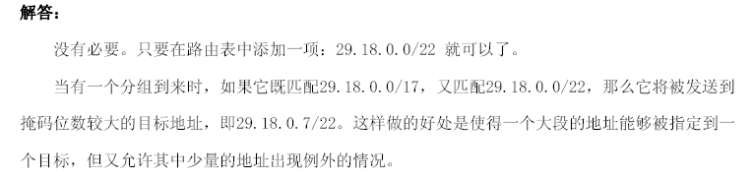
应该是29.18.60.0/22
- A router has the following (CIDR) entries in its routing table:
Address/mask | Next hop
135.46.56.0/22 | Interface 0
135.46.60.0/22 | Interface 1
192.53.40.0/23 | Router 1
default | Router 2
For each of the following IP addresses, what does the router do if a packet with that address arrives?
(a) 135.46.63.10
(b) 135.46.57.14
(c) 135.46.52.2
(d) 192.53.40.7
(e) 192.53.56.7
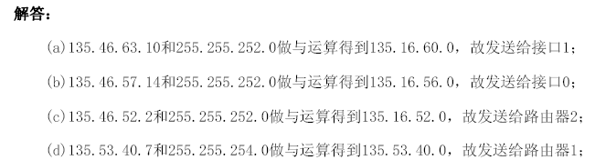
- Most IP datagram reassembly algorithms have a timer to avoid having a lost fragment tie up reassembly buffers forever. Suppose that a datagram is fragmented into four fragments. The first three fragments arrive, but the last one is delayed. Eventually, the timer goes off and the three fragments in the receiver’s memory are discarded. A little later, the last fragment stumbles in. What should be done with it?
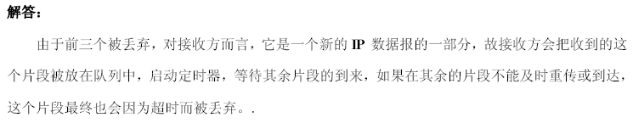
- The Protocol field used in the IPv4 header is not present in the fixed IPv6 header. Why not?
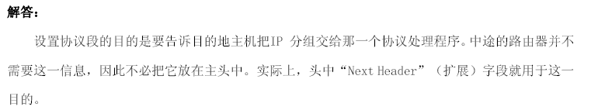
- OSPF运作机制如何保证OSPF报文的可靠传输？


