Camera + Rotating-Arm Rig
Setup Guide -- Files, Wiring, and Installation
Arduino-free build: ESP32-P4-WIFI6 hub, Arducam IMX708 camera, Cytron MD13S motor driver.

This document explains every file in this folder and walks through the complete process of building, wiring, flashing, and installing this system -- from a bare board and a bare phone to a working rig. It assumes no prior knowledge of this project.
What this system does: an ESP32-P4 board with a camera streams live video over WiFi to an Android app. The same app has a button that rotates an arm 120°, holds it there for a set time, then returns it to 0. One board does everything -- there is no separate microcontroller.

How the pieces connect
- Arducam IMX708 camera → (MIPI-CSI ribbon) → ESP32-P4 board
- ESP32-P4 board → (WiFi) → Android app, on your phone
- ESP32-P4 board → (PWM + DIR signal wires) → Cytron MD13S motor driver → (M1+/M1-) → BRINGSMART worm-gear motor

Contents
- Before You Begin -- what you need
- What's in This Folder -- a guide to every file
- Wiring the Hardware
- Building and Flashing the Firmware
- Building and Installing the Android App
- Verifying Everything Works
- Troubleshooting
- Notes and Known Limitations

1. Before You Begin
Every part this system needs is listed, with exact purchase links, in BOM.xlsx in this same folder. Build with those exact parts -- this firmware was written for the specific camera and motor driver in that list, and a different part (a different camera sensor, a different motor driver's control scheme) will not work without code changes.

Tools and software to install, in this order
- Python 3.9 or newer -- ESP-IDF's installer needs it. Most Mac/Linux machines already have it; on Windows, get it from python.org and check “Add to PATH” during install.
- ESP-IDF v5.4 or newer -- Espressif's toolchain for this chip. Follow Espressif's official “Get Started” guide for your operating system (search “ESP-IDF get started esp32p4”). Confirm it worked by running idf.py --version in a new terminal; it should print 5.4 or higher.
- Qt 6.5 or newer, with the Android kit -- get the Qt online installer from qt.io, and during setup check the box for “Qt for Android” (this automatically pulls in a matching Android SDK/NDK -- nothing else to install separately). Only needed to build the phone app, not the firmware.
- An Android phone, Android 9 (Pie) or newer. If you want to install the app over a USB cable, turn on USB debugging first (Settings → About phone → tap “Build number” seven times → Developer options → USB debugging). You can also just copy the finished app file to the phone and open it directly, which skips this step.

2. What's in This Folder
A guide to every file and folder here, and what to do with each one.

Documents (read these)
File | What it's for
This document | Everything you need in one place: file guide, wiring, build, install, and troubleshooting.
BOM.xlsx | The exact parts list, with purchase links. Buy from this list, not a substitute.
wiring-guide.html | A larger, interactive version of the wiring diagram in this document. Open it in any web browser (double-click it) -- no internet connection needed.
CHANGES.md | Engineering notes on this specific build: what was written from documentation rather than a confirmed working build, and exactly what to double-check before your first build. Plain text -- open with any text editor.

Firmware -- the code that runs on the ESP32-P4 board
File / folder | What it's for
CMakeLists.txt | Tells the ESP-IDF build system this is a project. You will not need to open or edit this.
partitions.csv | Describes how the board's flash memory is divided up. You will not need to edit this.
sdkconfig.defaults | Build-time firmware settings (memory, camera pipeline options). You will not need to edit this unless a build error tells you to.
main/config.h | The one file you will edit: your WiFi network name and password, and the GPIO pin numbers wired to the camera and motor driver.
main/ (everything else) | The firmware's source code: WiFi/network setup, camera capture, motor control, and the web server the phone app talks to. You do not need to edit any of these to install the system.

The Android app
File / folder | What it's for
app/CMakeLists.txt | Tells Qt how to build the app. You will not need to edit this.
app/config.h | The rig's default address and the default hold time, used when you first open the app (both can also be changed later from inside the app itself).
app/ (everything else) | The app's source code and interface. You do not need to edit any of these to install the system.

You will only ever need to edit two files:
main/config.h (WiFi credentials and pin numbers) and, optionally, app/config.h (the rig's default address). Everything else is built as-is.

3. Wiring the Hardware
Do this with everything unpowered. The diagram below is a smaller copy of wiring-guide.html in this folder -- open that file in a browser for a larger, easier-to-read version of the same information.
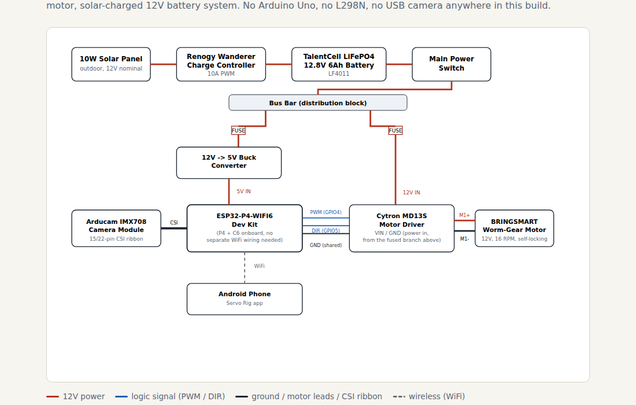
Pin numbers below are confirmed, not guessed:
Waveshare publishes a “Pinout Definition” diagram for the ESP32-P4-WIFI6-DEV-KIT labeling every pin on its 40-pin header. Checked against it: the camera's GPIO7/GPIO8 were right; the motor's original pins (GPIO40/GPIO41) were wrong -- that diagram shows those two aren't on the header at all, they're used internally for the onboard microSD card slot, and wiring the motor to them would have shared its PWM/DIR signals with the SD card interface. Reassigned to GPIO4/GPIO5, confirmed free on the same diagram. If you're building this on a different P4 board, don't assume these four numbers carry over -- check that board's own pinout diagram before wiring, and update main/config.h to match if they differ.

Connections
From | To | Notes
Solar panel | Charge controller | Panel's own leads; outdoor-rated wire.
Charge controller | Battery | Confirm the controller has a LiFePO4 charge profile set -- it charges differently from lead-acid.
Battery | Main power switch | Single point of full shutoff for the whole rig.
Main switch | Bus bar | Distribution point for both fused branches below.
Bus bar (fused) | 12V→5V buck converter | Size the fuse to the converter's rated input current.
Buck converter | ESP32-P4-WIFI6 board | 5V output into the board's power input (USB-C).
Bus bar (fused) | Cytron MD13S driver | Size this fuse to the motor's stall current, not just its running current.
Cytron MD13S “PWM” | ESP32-P4 GPIO 4 | main/config.h: kMotorPwmPin. Confirmed free on this board's own pinout diagram.
Cytron MD13S “DIR” | ESP32-P4 GPIO 5 | main/config.h: kMotorDirPin. Confirmed free on this board's own pinout diagram.
Cytron MD13S logic GND | ESP32-P4 GND | Required -- without a shared ground the signals have no reference.
Cytron MD13S “M1+” / “M1-” | Motor red / black leads | Polarity is arbitrary -- swap both if the arm runs backwards on first test.
Camera ribbon | ESP32-P4-WIFI6 CSI connector | Check ribbon orientation against the connector's own latch markings.
Camera control bus (SDA/SCL) | ESP32-P4 GPIO 7 / GPIO 8 | Confirmed -- the board's own pinout diagram labels these two pins SDA/SCL. Often already wired internally on the board -- confirm before adding these wires yourself.

4. Building and Flashing the Firmware
- Open a terminal in this folder (the one containing this document and CMakeLists.txt).
- Set the build target once:
idf.py set-target esp32p4
- Open main/config.h and fill in your WiFi network:
kStaSsid = "YOUR_WIFI"
kStaPass = "YOUR_PASSWORD"
Leaving kStaSsid blank is also valid -- the board will instead create its own WiFi network named “servo-rig” (password “servo1234”) that the phone can join directly. Useful if there's no WiFi network on site.
- Confirm the four pin numbers from the wiring section match your physical wiring (edit main/config.h if not).
- Build:
idf.py build
The first build downloads several dependencies automatically and can take several minutes. If the build fails, read the error carefully -- main/idf_component.yml, main/mipi_cam.cpp, and CHANGES.md each flag specific version-compatibility risks that could not be confirmed without a physical build.
- Connect the board over USB and flash it:
idf.py -p <PORT> flash monitor
Replace <PORT> with the board's serial port (for example /dev/ttyACM0 on Linux, /dev/cu.usbmodemXXXX on macOS, COM3 on Windows).
- Watch the boot log for lines like:
net: co-processor ready
net: reachable at http://<some IP>/
motor: ready: ...
cam: capturing ...
hub: hub ready
If the co-processor firmware is reported as 0.0.0:
The board's onboard WiFi co-processor has no firmware and WiFi will never come up. Many boards ship with this already installed from the factory, so this is only a problem if you see this exact message. See Troubleshooting for what to do about it.
Press Ctrl+] to exit the serial monitor once the log looks healthy.

5. Building and Installing the Android App
- Open a terminal in this folder's app subfolder.
- Build the app. Using Qt Creator (simpler): open app/CMakeLists.txt in Qt Creator, pick the Android Qt 6 kit when prompted, and click Run with the phone connected over USB -- this builds, installs, and launches the app in one step.
From a terminal instead:
qt-cmake -S . -B build-android
cmake --build build-android --target apk
This produces an .apk file under build-android/. Copy it to the phone and open it to install (allow “install unknown apps” if asked), or install it directly with adb install if the phone is connected over USB.
- Open the app on the phone.
- Connect the phone to the rig's network: join the same WiFi network the rig joined (see the board's boot log for its IP address), or, if you left kStaSsid blank, join the phone to the “servo-rig” network the board created itself (password servo1234) -- the rig is then at 192.168.4.1.
- In the app's settings (the drawer/gear icon), enter the rig's address.
- You should see the live camera feed appear. Tap the rotate button -- the arm should sweep to 120°, hold, then return.

6. Verifying Everything Works
Useful for isolating whether a problem is the app, the network, or the rig itself. With a phone or computer on the same network as the rig, open a web browser to http://<rig-ip>/ -- this loads a plain built-in control page (no app needed) with the same rotate/home buttons and the live video feed. If this page works but the app doesn't, the problem is specific to the app or phone; if this page doesn't load either, the problem is the rig or the network.

Individual web addresses, for testing
Address | Effect
/stream | Live video.
/snapshot.jpg | One still frame.
/rotate | Rotate to 120°, hold, return.
/rotate?hold=4000 | Same, with a one-time 4-second hold.
/home | Return to 0 immediately.
/hold?ms=10000 | Change the default hold duration.
/status | Plain-text status: state, angle, time remaining, camera health.
/ | The plain control page described above.

7. Troubleshooting
Problem | What to do
Build fails downloading esp_hosted (Windows), with a FileNotFoundError pointing at a very long path under ...AppData\Local\Espressif\ComponentManager\Cache\...\examples\power_save\host+cp\... | A Windows-only limitation, not a problem with this project's code: esp_hosted ships deeply nested example folders that exceed Windows' 260-character path limit once combined with the component cache location. Fix: (1) as Administrator, run New-ItemProperty -Path "HKLM:\SYSTEM\CurrentControlSet\Control\FileSystem" -Name "LongPathsEnabled" -Value 1 -PropertyType DWORD -Force, then reboot; (2) delete the folders %LOCALAPPDATA%\Espressif\ComponentManager\Cache, .\build, and the file .\dependencies.lock; (3) re-run idf.py set-target esp32p4.
Build fails with “Partitions tables occupies 4.1MB ... does not fit in configured flash size 2MB.” | A pre-existing bug in sdkconfig.defaults, independent of anything in this rewrite: it never set the flash chip size, so ESP-IDF assumed the smallest possible one (2MB). Fixed in this package by setting it to 16MB, matching Waveshare's published specs for this board. If you still see this, either re-copy sdkconfig.defaults from this package, or -- if building for a different board -- check its actual flash size, edit CONFIG_ESPTOOLPY_FLASHSIZE in sdkconfig.defaults to match, delete the build folder, and rebuild.
Build fails with ‘kHoldOverrideMs’ is not a member of ‘cfg’ in http_api.cpp. | A mistake in this rewrite, now fixed: the original /rotate handler used a config constant, cfg::kHoldOverrideMs, that didn't make it into the rewritten config.h. Fixed by removing the now-unnecessary fallback in http_api.cpp -- motor::rotate() already falls back to cfg::kHoldMs the same way, so behavior is unchanged. If you still see this, re-copy http_api.cpp from this package.
Build fails with “Missing ‘mdns.h’ file name found in the following component(s): lwip(...), openthread(...)”. | Those two components are red herrings -- unrelated headers that happen to share the name. The real cause: net.cpp uses the mDNS API (so the rig is reachable at http://<name>.local/), but idf_component.yml never declared a dependency on the espressif/mdns component. Older IDF releases bundled mDNS with the SDK itself; current versions split it out. This is a pre-existing gap, the same way esp_hosted itself was originally missing from this file -- not something the camera/motor rewrite introduced. Fixed by adding espressif/mdns to idf_component.yml. If you still see this, re-copy idf_component.yml from this package, delete build and managed_components, and rebuild.
Build fails in mipi_cam.cpp with errors like ‘esp_video_init_sccb_config_t’ has no member named ‘i2c_port’, ‘freq_hz’, or invalid conversion from int to gpio_num_t. | The real, installed esp_video component uses different field names/types than this file originally guessed (see mipi_cam.cpp's own header comment and CHANGES.md). Already fixed in this package by reading the actual installed esp_video_init.h and matching its real shape. If you still see this, re-copy mipi_cam.cpp from this package; if it persists even then, your installed esp_video version has changed again -- compare managed_components/espressif__esp_video/include/esp_video_init.h against what mipi_cam.cpp sets.
Build fails with “format ‘%d’/‘%u’ expects argument of type ... but argument N has type ‘uint32_t’/‘uint16_t’”, with a HINT about PRI-family macros. | A pre-existing formatting mismatch, now fixed throughout this package: a uint16_t value promotes to plain int in C/C++ varargs, and this toolchain's uint32_t is typedef'd to unsigned long -- so a bare %d/%u doesn't match either, and this toolchain treats that as a hard error, not a warning. Fixed by casting explicitly (static_cast<unsigned>(...)) or using PRIu32 from <cinttypes>, matching the style already used elsewhere in this codebase. If you still see this, the file named in the error is the one to re-copy from this package.
Board won't connect over USB / idf.py can't find the port. | Install your computer's USB-serial driver for the board's USB-to-UART chip if it isn't auto-detected (check the board's product page). Try a different USB cable -- some are power-only.
Build fails pulling in the camera components. | Check your internet connection and that a firewall isn't blocking it. If the error is specifically about version compatibility, see CHANGES.md's “Verify before you flash” section -- this is the single riskiest part of this build.
Boot log never shows “co-processor ready” / WiFi never comes up. | This is the board's onboard WiFi co-processor, not the main chip you just flashed. Its firmware lives in a separate area of memory and is not touched by the normal flash command. Many boards already have it from the factory, so try booting first. If the log explicitly reports firmware version 0.0.0, it genuinely needs to be installed separately -- this is a real, nontrivial step; see CHANGES.md for what's involved.
Camera never shows a frame / a capture error appears in the log. | Check the ribbon cable is fully seated and the right way round. If the sensor was never detected at all, double-check the two camera control-bus pins in main/config.h against your board.
Arm rotates the wrong direction. | Flip kMotorDirForwardIsHigh in main/config.h (true to false, or back) and reflash -- no rewiring needed.
Arm over- or under-shoots 120°. | There's no position sensor; the timing is computed from the motor's rated speed. Measure the arm's actual travel with a protractor over a few cycles and adjust kMotorRpm in main/config.h, then reflash.
App shows “Cannot reach the rig.” | Confirm the address entered in the app's settings, confirm the phone is on the same network as the rig, and try loading http://<rig-ip>/status in the phone's own browser to isolate whether it's the app or the network.
Everything builds and flashes but the board resets in a loop. | Almost always power -- the motor's stall current can brown out an undersized or shared supply. Confirm the motor driver has its own fused 12V feed, separate from the board's 5V supply.

8. Notes and Known Limitations
A short, plain-language summary of CHANGES.md, for anyone who runs into trouble and wants to know what's most likely to need attention. Read CHANGES.md itself for the full technical detail.
- The camera-driving code was written from official documentation and the standard camera-programming interface it says it follows, not from a confirmed working build -- if the build fails specifically around the camera component, this is the first place to look.
- Four GPIO pin numbers (two for the motor driver, two for the camera's control bus) are best-inference placeholders, not numbers read from this specific board's schematic. Confirm them before wiring.
- The camera sensor driver is a third-party component, not an official one from the chip manufacturer. Check it is still maintained before relying on it long-term.
- The onboard WiFi co-processor's own firmware could not be handed over as a ready-made file for safety and verification reasons -- see the Troubleshooting entry above and CHANGES.md for what to do if your board needs it installed.

