AI AGENT FOR AUTOMATED TEACHING MATERIAL GENERATION FROM MULTI-SOURCE CONTENT

TAN CHI HONG

UNIVERSITI TUNKU ABDUL RAHMAN

AI AGENT FOR AUTOMATED TEACHING MATERIAL GENERATION FROM MULTI-SOURCE CONTENT

TAN CHI HONG

A project report submitted in partial fulfilment of the
requirements for the award of Bachelor of Software Engineering
with Honours

Lee Kong Chian Faculty of Engineering and Science
Universiti Tunku Abdul Rahman

April 2026

DECLARATION STATEMENT

I hereby declare that this project report is my original work, with all sources duly acknowledged, and that it has not been submitted previously or concurrently for any degree or award at UTAR or elsewhere. I also declare the following (check the boxes if applicable):
£ Generative AI tools (e.g., open, Gemini, Copilot, etc.) were used for language refinement, such as grammar correction and readability improvement.
£ Vibe coding tools and/or frameworks (e.g., Replit Agent, Cursor Composer, Bolt, etc.) were used in project development.
£ Other declaration(s), if any (please consult your supervisor for guidance in completing this section):
_________________________________________________________________________________________________________________________
I take full responsibility for the originality, accuracy, and integrity of all content presented in this report. No Generative AI tools were used to manipulate project data and results in ways that could cause falsification or misrepresentation.
Name | : | Tan Chi Hong
ID No. | : | 2205466
Date | : | 25/4/2026

COPYRIGHT STATEMENT

© 2026, Tan Chi Hong. All right reserved.

This final year project report is submitted in partial fulfilment of the requirements for the Bachelor of Software Engineering with Honours. This final year project report represents the work of the author, except where due acknowledgement has been made in the text. No part of this final year project report may be reproduced, stored, or transmitted in any form or by any means, whether electronic, mechanical, photocopying, recording, or otherwise, without the prior written permission of the author or UTAR, in accordance with UTAR’s Intellectual Property Policy.

ACKNOWLEDGEMENTS

The “ACKNOWLEDGEMENTS” page is not required in the FYP1 Report and is optional for the FYP2 Report.

Any individual or organization that has rendered any sort of special assistance in this final year project can be acknowledged. The text of the acknowledgement should not exceed one page. The acknowledgement can include:
- Name of Supervisors
- The faculty/department where the research was conducted
- Financial sponsors (if applicable)
- General dedication

I would like to express my gratitude to Assistant Professor Dr. Fatimah Audah binti Md. Zaki as my research supervisor for her invaluable advice, guidance and enormous patience throughout the development of the research.

I would also like to thank the faculty and the departmental members from Lee Kong Chian Faculty of Engineering and Science and Department of computing, for creating a pleasant working environment throughout my years in UTAR.

Lastly, to my dearest Tan Gyap Xun and Khor Jun Zhi for their help, friendship, and support throughout the research which has been instrumental to the success of this research project.

ABSTRACT

Educators frequently spend substantial time manually searching, reading, and consolidating instructional content from multiple sources, including textbooks, videos, and web articles into structured teaching materials. This project designed and developed an AI agent for automated teaching material generation from multi-source content, comprising a three-agent pipeline in which a Research Agent retrieved and synthesised content extracted from PDF documents, YouTube video transcripts, and web pages using a Retrieval-Augmented Generation architecture backed by ChromaDB. A Curriculum Designer Agent drafted four material types: lecture slides, summary notes, multiple-choice questions, and glossary terms using the Groq API. A Quality Evaluator Agent assessed each draft using a composite metric combining Flesch-Kincaid readability, ROUGE-based source-context similarity, structural compliance, and CLIP visual alignment triggering an automated critique-and-rewrite loop of up to three iterations for drafts that did not meet the passing threshold. The system was implemented as a Streamlit web application with SQLite for user and history management and was evaluated through unit testing, integration testing, usability testing, and user acceptance testing with educators. The evaluation demonstrated that the closed-loop revision mechanism improved output readability, reducing the Flesch-Kincaid Grade Level of content. The results demonstrate the feasibility of a multi-agent, retrieval-grounded approach for automating teaching material generation while incorporating automated quality control.

TABLE OF CONTENTS

DECLARATION STATEMENT i
ACKNOWLEDGEMENTS iii
ABSTRACT iv
TABLE OF CONTENTS v
LIST OF TABLES x
LIST OF FIGURES xi
LIST OF APPENDICES xiii

CHAPTER
1 INTRODUCTION 1
1.1 General Introduction 1
1.2 Importance of the Study 1
1.3 Problem Statement 2
1.3.1 Current Challenges in Teaching Material Preparation 2
1.3.2 Limitations of Existing AI Tools 3
1.3.3 Research Gap 3
1.4 Aim and Objectives 4
1.5 Proposed Solution 4
1.5.1 System Overview 6
1.6 Scope and Limitation of the Study 7
1.7 Contribution of the Study 7
1.8 Outline of the report 8
2 LITERATURE REVIEW 10
2.1 Introduction 10
2.2 Review of Current Technologies and Techniques 10
2.2.1 Large Language Models 10
2.2.2 Natural Language Processing 11
2.2.3 AI Agents vs Conventional Chatbots 12
2.2.4 Multi-Source Content Retrieval and Processing 14
2.2.5 Visual Content Retrieval, Generation and Relevance Evaluation 15
2.3 Review of Tools and Development Platforms 16
2.3.1 NLP and Language Models 16
2.3.2 Vector Memory Store 17
2.3.3 Relational Database 17
2.3.4 Content Extraction Tools 17
2.3.5 Video Processing Tools 18
2.3.6 Web Data Extraction 18
2.3.7 Pedagogical Evaluator 18
2.3.8 Development Frameworks 19
2.4 Personalization in Educational System 20
2.5 Comparison of Existing Education AI Tools 21
2.6 Summary of Key Findings 22
2.6.1 Limitations of Existing Systems 23
2.6.2 Technology Gaps 23
2.6.3 How the Proposed System Addresses These Gaps 23
2.7 Summary 24
3 METHODOLOGY AND WORK PLAN 25
3.1 Introduction 25
3.2 Methodology 25
3.2.1 Iteration 1: PDF Extraction, Vector Storage and Research Agent 26
3.2.2 Iteration 2: YouTube Transcript Retrieval and Web Scraping 26
3.2.3 Iteration 3: Curriculum Designer and Quality Evaluator Agents 26
3.2.4 Iteration 4: Education-Level Personalisation and Export Functionality 27
3.2.5 Iteration 5: UI Refinement, Integration and User Evaluation 27
3.3 Work Breakdown Structure 28
3.4 Gantt Chart 30
3.5 Summary 30
4 PROJECT SPECIFICATION 31
4.1 Introduction 31
4.2 Requirements specification 31
4.2.1 Collecting Requirements 31
4.2.2 System Functional and Non-Functional Requirements 42
4.3 Use Case Diagram 44
4.4 Use Case Descriptions 44
4.4.1 Log In 45
4.4.2 Sign Up 46
4.4.3 Enter Topic and Select Education Level 47
4.4.4 Retrieve Content from PDF Documents 48
4.4.5 Retrieve YouTube Video Transcripts 49
4.4.6 Retrieve Web-Based Educational Content 50
4.4.7 Generate Structured Teaching Materials 51
4.4.8 Preview Generated Materials 52
4.4.9 Export Materials as PDF or PowerPoint 53
4.4.10 View Multi-Agent Execution Telemetry 54
4.4.11 Extract and Filter Subtopics 55
4.4.12 Configure and Generate Slide Visual Assets 56
4.4.13 Evaluate Visual-Textual Alignment via CLIP 57
4.4.14 Manage Generation History and Archive 58
4.5 Summary 58
5 SYSTEM DESIGN 60
5.1 Introduction 60
5.2 User Interface Flow Diagram 60
5.2.1 Authentication Page 60
5.2.2 Dashboard Workflow 63
5.2.3 Generation History & Archive 67
5.3 User Interface Design 67
5.3.1 Design Theme and Layout Rationale 67
5.3.2 Screen Layout Descriptions 68
5.4 System Architecture Diagram 69
5.5 Database Schema (Entity-Relationship Diagram) 71
5.6 Data Dictionary 72
5.7 Data Flow Diagram (DFD) 75
5.7.1 Level-0 Context Diagram 75
5.7.2 Level-1 Data Flow Diagram 76
5.8 Activity Diagram 78
5.9 Summary 79
6 SYSTEM IMPLEMENTATION 80
6.1 Introduction 80
6.2 Project Setup 80
6.3 Frontend Implementation 83
6.3.1 Authentication and Account Onboarding 84
6.3.2 Multi-Modal Source Ingestion 86
6.3.3 Subtopic Filtering and Pedagogical Setup 88
6.3.4 Real-Time Multi-Agent Generation Canvas 91
6.3.5 Visual Asset Canvas and Pedagogical Evaluation 93
6.3.6 Document Exporters 94
6.3.7 Historical Archive Catalog 95
6.4 Backend Implementation 98
6.4.1 Server Setup and Database Management 98
6.4.2 Retrieval-Augmented Generation Pipeline 100
6.4.3 Multi-Agent Orchestration Pipeline 101
6.4.4 Pedagogical Evaluation Engine 103
6.5 API Integration 110
6.5.1 Integration with Backend Subsystems and State Management 110
6.5.2 Integration with External APIs 110
6.6 Summary 115
7 SYSTEM TESTING 116
7.1 Introduction 116
7.2 User Interface Testing 116
7.3 Unit Testing 117
7.4 API Testing 122
7.5 Integration Testing 123
7.6 System Usability and Technology Acceptance Testing 125
7.7 User Acceptance Testing 126
7.8 Structural Compliance Validation Study 127
7.9 Image Relevance and Accuracy Evaluation 128
7.10 Summary 130
8 CONCLUSION 130
8.1 Introduction 130
8.2 Limitations 132
8.3 Future Improvements 133
REFERENCES 134
APPENDICES 137

LIST OF TABLES
Table 2.1 Key Differences Between Conventional Chatbots and AI Agents 13
Table 2.2 Summary of Tools and Development Platforms Reviewed 19
Table 2.3 Comparative Analysis of Existing Educational AI Tools 21
Table 3.1 Iterative Prototyping Development Plan 27
Table 3.2 Work Breakdown Structure of the Project 28
Table 4.1 Functional Requirements 42
Table 4.2 Non-Functional Requirements 43
Table 5.1 Users Table Data Dictionary 73
Table 5.2 History Table Data Dictionary 74
Table 6.1 Structural Compliance Scoring Rubric 104
Table 7.1 User Interface Task Completion Results 116
Table 7.2 Mean User Interface Evaluation Scores 117
Table 7.3 Unit Test Cases (UT-01 to UT-11) 118
Table 7.4 API Test Cases (AT-01 to AT-06) 122
Table 7.5 Integration Test Cases (IT-01 to IT-06) 124
Table 7.6 Mean Technology Acceptance Scores 125
Table 7.7 UAT Scenario Results (C1 to C12) 126
Table 7.8 Human-LLM Structural Compliance Agreement 128
Table 7.9 Automated Image Relevance Evaluation Threshold Matrix 129

LIST OF FIGURES
Figure 1.1 System Overview 6
Figure 4.1 Distribution of Respondents by Teaching Role 32
Figure 4.2 Distribution of Respondents by Teaching Level 32
Figure 4.3 Distribution of Respondents by Teaching Experience 33
Figure 4.4 Distribution of Frequency on Preparation 34
Figure 4.5 Distribution of Time on Preparation 34
Figure 4.6 Sources Commonly Used by Educators for Teaching Material Preparation 35
Figure 4.7 Difficulty to Organize Content from Multiple Sources for Teaching Material Preparation 36
Figure 4.8 Material Preparation Increases Workload 36
Figure 4.9 Difficulty of Manually Extracting and Summarizing Information from Educational Videos 37
Figure 4.10 Frequency of AI Tool Usage 38
Figure 4.11 Current AI Tools Used by Educators 38
Figure 4.12 Ability of Current AI Tools to Generate Fully Structured Teaching Materials 39
Figure 4.13 Manual Editing of AI-Generated Teaching Materials 39
Figure 4.14 Frustrations with Current AI Teaching Tools 40
Figure 4.15 Usefulness of Proposed AI Teaching Material Features 41
Figure 4.16 Support for Education Level Adaptation in AI-Generated Content 41
Figure 4.17 Preferred Output Formats for AI-Generated Teaching Materials 42
Figure 4.18 Acceptance of Multi-Source AI Integration in Teaching Systems 42
Figure 4.19 Importance of Source Citation in AI-Generated Educational Content 43
Figure 4.20 Use Case Diagram 44
Figure 4.21 UC01: Log In Description 45
Figure 4.22 UC02: Sign Up Description 46
Figure 4.23 UC03: Enter Topic and Select Education Level Description 47
Figure 4.24 UC04: Retrieve Content from PDF Documents Description 48
Figure 4.25 UC05: Retrieve YouTube Video Transcripts Description 49
Figure 4.26 UC06: Retrieve Web-Based Educational Content Description 50
Figure 4.27 UC07: Generate Structured Teaching Materials Description 51
Figure 4.28 UC08: Preview Generated Materials Description 52
Figure 4.29 UC09: Export Materials as PDF or PowerPoint Description 53
Figure 4.30 UC10: View Multi-Agent Execution Telemetry Description 54
Figure 4.31 UC11: Extract and Filter Subtopics Description 55
Figure 4.32 UC12: Configure and Generate Slide Visual Assets Description 56
Figure 4.33 UC13: Evaluate Visual-Textual Alignment via CLIP Description 57
Figure 4.34 UC14: Manage Generation History and Archive Description 58
Figure 5.1 Login Page 60
Figure 5.2 Error Message When Both Fields Are Not Filled In 61
Figure 5.3 Error Message for Incorrect Password 61
Figure 5.4 Create Account Page 62
Figure 5.5 Error Message When Have Empty Fields 62
Figure 5.6 Error Message When Passwords Do Not Match 63
Figure 5.7 Main Workspace Dashboard 63
Figure 5.8 Upload Multi-Modal Sources Interface 64
Figure 5.9 Education Level and Output Format Selection 64
Figure 5.10 Generation Material Processing State 65
Figure 5.11 Generated Material Display 65
Figure 5.12 Generated Slide Images and CLIP Score 66
Figure 5.13 Generation History and Archive Interface 67
Figure 5.14 Visual Theme and Styling of Main Page 68
Figure 5.15 System Architecture Overview Diagram 70
Figure 5.16 Entity-Relationship Diagram 71
Figure 5.17 Level-0 Context Data Flow Diagram 75
Figure 5.18 Level-1 Data Flow Diagram 76
Figure 5.19 System Activity Diagram 78
Figure 6.1 Project Directory Setup and File Scaffolding 82
Figure 6.2 Sign In User Interface 84
Figure 6.3 Create Account User Interface 85
Figure 6.4 Authentication Module Implementation Code 85
Figure 6.5 Multi-Modal Source Ingestion Interface 86
Figure 6.6 Multi-Source Extraction and Chunk Ingestion Code 87
Figure 6.7 Subtopic Selection Interface 88
Figure 6.8 Subtopic Extraction and Filtering Code 89
Figure 6.9 Target Topic and Pedagogical Parameters Workspace 90
Figure 6.10 Workspace Configuration Logic Implementation 90
Figure 6.11 Generated Lesson Output Canvas 91
Figure 6.12 Multi-Agent Execution Telemetry and Evaluation UI Code 92
Figure 6.13 Generated Slide Images Preview Grid 93
Figure 6.14 Visual Asset Rendering and CLIP Badge Display Code 94
Figure 6.15 Document Export Action Options 94
Figure 6.16 Multi-Format Document Compilation Implementation Code 95
Figure 6.17 Historical Archive Catalog Dashboard 96
Figure 6.18 History and Filtering Implementation Logic 97
Figure 6.19 Server Setup and SQLite Initialization Code 98
Figure 6.20 Relational Database Management Module Code 99
Figure 6.21 ChromaDB Retrieval-Augmented Generation (RAG) Pipeline Code 100
Figure 6.22 Multi-Agent Orchestration Engine Implementation Code 102
Figure 6.23 Deterministic Structural Compliance Evaluation Code 105
Figure 6.24 Context Faithfulness (ROUGE Metrics) Computation Code 107
Figure 6.25 Readability (Flesch-Kincaid) Engine Implementation Code 108
Figure 6.26 CLIP Visual-Textual Alignment Calculation Code 109
Figure 6.27 Groq API Client Configuration Code 111
Figure 6.28 YouTube Transcript API Extraction Pipeline Code 112
Figure 6.29 External Diagram and Image Generation Logic Code 113
Figure 6.30 Local Hugging Face CLIP Scoring Pipeline Code 114

LIST OF APPENDICES

Appendix A: Questionnaire 137
Appendix B Project Gantt Chart 145
Appendix C Initial System Prototype Mock-ups 148
Appendix D User Interface Testing Evaluation Responses 152
Appendix E Independent Structural Quality Evaluation Responses 185

Appendix F User Acceptance Testing (UAT) Completed
Verification Forms 200

INTRODUCTION

General Introduction
The quick development of Artificial Intelligence has drastically transformed many industries including education. In recent years, AI-powered tools have been increasingly used by educators in preparing teaching materials, conducting assessments and personalizing learning experiences. However, many educators still spend a significant amount of time creating lecture slides, notes, quizzes and summaries manually. This gathering material process can be time-consuming and inconsistent when materials are collected from multiple sources such as textbooks, online articles and videos.

With the emergence of powerful Natural Language Processing (NLP) models such as OpenAI GPT models and open-source frameworks like Hugging Face, it is possible to automatically generate structured content from unstructured data now. These technologies enable machines to understand, summarize and reorganize information from the unstructured data into meaningful formats.

This project proposes the development of an AI Agent that automatically generates structured teaching materials from multiple sources. The system aims to assist educators by reducing preparation time while maintaining content quality and consistency.

Importance of the Study
As digital learning environments continue to grow, the use of AI in education is becoming more important compared to the old days. Educators frequently deal with heavy workloads, limited preparation time and the challenge of ensuring that teaching materials are well-structured and suitable for different educational levels. Due to restricted availability to high-quality materials and technological support, these difficulties could be considerably more serious in settings with limited resources.

This study is important because it tackles the real-world difficulties encounter by educators in preparing teaching materials. By developing an AI-driven system that can automatically generates lecture slides, notes, quizzes and summaries. This project can greatly reduce the amount of time required for content preparation. Furthermore, the system enhances consistency and logical organization in teaching materials by applying structured summarization techniques. The system will also have the ability to adapt content to different educational levels such as primary, secondary and tertiary education. It helps make learning experiences more individualized. Overall, this study supports the effective use of AI technologies to improve teaching efficiency and accessibility of quality educational resources.

Problem Statement
Educators today face a major workflow issue that has not been addressed by current AI tools. Although there are many digital educational resources available such as PDF textbooks, Youtube videos and online platforms. There are no tool currently in use supports the entire educator workflow in a single automated pipeline. This includes entering a topic in natural language, retrieving content from multiple sources automatically and creating level-appropriate structured teaching materials that ready for use in the classroom. Even where AI tools exist, educators must manually coordinate between multiple applications, reformat outputs and adapt content to their students' level before any material is usable. This project investigates how Retrieval-Augmented Generation (RAG) combined with multi-source content retrieval can be applied to automate this workflow.

Current Challenges in Teaching Material Preparation
Nowadays, educators commonly gather information from multiple sources including textbooks, academic articles, online platforms and educational videos. However, these sources often vary widely in format, structure and depth of explanation. It takes a lot of time and effort to manually extract relevant content, summarise key concepts and reorganizing the information into lecture slides or structured notes. According to Merrill (2002), effective instruction requires carefully structured design to facilitate meaningful learning through demonstration and application. To achieve this level of instructional structure in practice significantly increases the burden of lesson preparation. When educators manually combine content from different sources may causes inconsistencies in vocabulary and organization occur. Consequently, this repetitive task adds substantial workload which leaves less time for active classroom facilitation and student engagement.

Limitations of Existing AI Tools
Recent advancements in Large Language Models developed by OpenAI have demonstrated remarkable capabilities in text generation and summarization (Brown et al., 2020). These models can produce human-like responses from user prompts but majority of currrent AI-powered tools focus primarily on single-input text generation rather than automated multi-source integration. They generally rely on direct prompts instead of retrieving and synthesizing information from diverse sources such as PDF books, video transcripts and educational websites.

Furthermore, many AI systems generate general textual outputs without organizing the content into structured teaching materials such as lecture slides, quizzes and glossary terms. Kasneci et al. (2023) state that although generative AI tools have potential in eductional settings, content organization and organised pedagogical alignment continue to be a challenge. Therefore, current AI tools are not fully optimized to support comprehensive teaching material development.

Research Gap
Although previous studies have explored automatic summarization, question generation and intelligent teaching systems. Limited research has focused on integrating multi-source content retrieval, intelligent summarization, personalization and structured teaching material generation into a single AI agent framework. Instead of offering a comprehensive end-to-end solution, the majority of systems address isolated functions .

There is currently a lack of systems that capable of accepting a simple topic input and it automatically generating a structured and level-appropriate teaching package that includes slides, notes, quizzes and glossary terms. This gap emphasizs the necessity for a complete AI-based solution that combines content extraction, natural language processing and structured generation within a single intelligent system. The proposed project aims to address this research gap.

Aim and Objectives
The aim of this project is to design and develop an AI-based system that assists educators by automatically generating structured teaching materials from multiple content sources.

Objectives:

1. To design and develop an AI-powered system that automatically generates structured teaching materials including lecture slides, summary notes, and quizzes. It will be based on a user-supplied topic by the end of the system development phase.

2. To implement multi-source content extraction and assessment mechanisms that enable the system to retrieve and process relevant information from books, YouTube video transcripts and selected online educational platforms during the project implementation period.

3. To design, implement, and evaluate a multi-metric evaluation engine using readability, ROUGE-based similarity, agent review, structural compliance, and visual relevance to improve the quality of generated teaching materials.

Proposed Solution
This project propose building an AI-powered teaching material production system that automates the process of producing organised instructional content from various sources in order to solve the issues mentioned in the problem description. The proposed solution aims to reduce educators’ workload by minimizing the amount of manual effort in searching, summarizing and organizing educational materials.

The proposed approach allows users to enter a topic in simple terms and select a specific education level. From the given topic, the system will retrieves relevant educational content from diverse sources such as PDF textbooks, YouTube video transcripts and selected online educational platforms. After the content has been downloaded, it is analysed using natural language processing techniques to identify important definitions, concepts and explanations related to the subject.

After extract the content, the system can automatically organizes and summarizes the information into structured teaching materials. The generated materials are designed to be logically organized and easy to understand ensuring they are suitable for classroom use. Additionally, the system has a personalisation process that adjusts the the complexity and depth of the generated’s content based on several educational.

System Overview
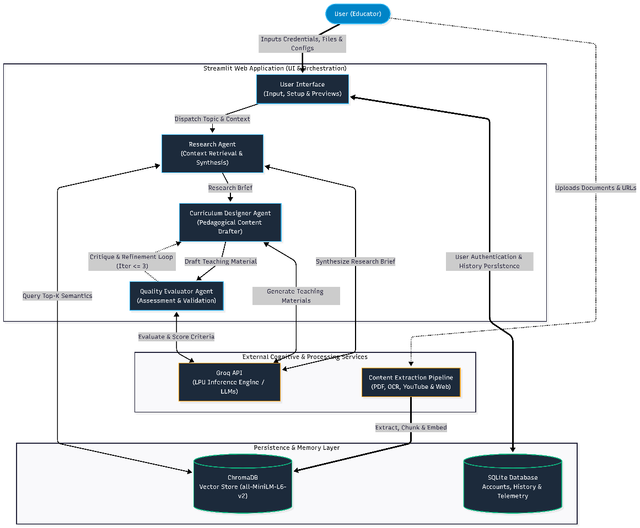
Figure 1.1: System Overview

The system overview of the suggested AI-powered teaching material creation system is shown in Figure 1.1. Streamlit is used to build the system to utilize an autonomous Multi-Agent Collaboration architecture and Retrival-Augmented Generation (RAG) to ensure factual correctness and educational quality.

Educators use an online dashboard to choose an education level, upload reference materials and select the output format they want. The output format includes slides, quizzes or notes. The system easily pulls text from a varierty of sources such as scanned PDFs, YouTube video transcripts, and web pages.

The backend operates using three specialized AI agents powered by the Groq API. The extracted data is first combined into a factual brief by a research agent. The structured teaching materials are then created by a Curriculum Designer Agent. Lastly, the draft's reading difficulty is audited by a Quality Evaluator Agent. If the text is too complex for the target students, it immediately starts a rewrite loop until the content is perfectly calibrated. The final approved materials can be downloaded as PDF or PowerPoint files and are then shown to the educator along with a real-time tracking panel.

Scope and Limitation of the Study
The scope of this project involves the development of an AI agent that takes topic-based input in English and fetches content from selected open-access sources such as PDF books, YouTube transcripts and educational websites. The system will implement NLP-based summarization and content organization techniques to identify key information and generate structured teaching materials. The output will include lecture slides, summary notes, practice questions and glossary terms. It can be exported into formats such as PDF or PowerPoint. The system will be evaluated using five standardised test topics with each topic drawing from up to three PDF documents, up to three YouTube videos and up to five educational web pages for a total of 55 source documents across all evaluation runs.

However, this project has several limitations. The system will mainly support English-language content and multilingual processing will not be fully supported unless basic translation features are integrated. No commercial textbook integration will be included due to copyright restrictions. Real-time video analysis will not be deploying apart from transcript processing. Additionally, the system will not be fully aligned with specific national curriculum standards as project’s goal is to demonstrate the integration of artificial intelligence technologies rather than full curriculum compliance.

Contribution of the Study
This project adds to the practice and knowledge in the area of AI-assisted educational content generation.

In practice, the finished system reduces the time and effort teachers spend on manually searching, reading and gathering material from multiple sources into usable teaching content. To do this, we train the model to take a single topic input and output a structured set of lecture slides, summary notes, practice questions and glossary terms grounded in the retrieved source material. The system automates a task that would otherwise require an educator to synthesise content individually from PDF textbooks, video transcripts, and educational websites. This is a direct benefit for educators who are preparing teaching materials under time constraints, especially those who do not have access to pre-built curriculum resources for a given topic.

From a technical standpoint, the project demonstrates a working multi-agent Retrieval-Augmented Generation (RAG) pipeline with a Research Agent, Curriculum Designer Agent, and Quality Evaluator Agent working sequentially. The Quality Evaluator Agent that can generate an automated critique-rewrite loop when the content produced falls outside an acceptable range of readability. This self-correction mechanism in closed loop fills a gap identified in the literature review.

Outline of the report
The rest of the report is organised as follows. Chapter 2 provides an overview of the literature on large language models, natural language processing, AI agents and multi-source content retrieval. Chapter 2 also includes comparison of existing educational applications and development tools related to the proposed system. Chapter 3 describes the methodology followed for the project along with the Work Breakdown Structure, project schedule and the development tools used. Chapter 4 presents the results of the fact finding via the educator questionnaire, the resulting functional and non-functional requirements and the use case diagram and descriptions derived from them. Chapter 5 describes the system design that includes user interface flow, interface mock-ups, system architecture and database schema. The system implementation is covered in Chapter 6 which also covers the frontend and backend modules and how they integrate with external APIs. The outcomes of unit, API, integration, usability, and user acceptability testing on the finished system are presented in Chapter 7. Chapter 8 wraps up the report by going over the project's goals again, talking about the challenges faced throughout development, and suggesting ways to make it better in the future.

LITERATURE REVIEW

Introduction
This chapter reviews current studies and technologies relevant to the development of the proposed AI Agent for Automated Teaching Material Generation from Multi-Source Content. The review is divided into four primary areas. First, discus about the current technologies and techniques, specifically large language models (LLMs), natural language processing (NLP) and the distinction between autonomous AI Agents and conventional chatbots. Second, it asseses the current tools and development platforms required for system implementation. Thirdly, it offers a comparison of existing AI systems in education. Finally, the chapter ends with a summary of key findings, highlighting the limitations of existing tools, identifying technological gaps and detailing how the proposed solution addresses these shortcomings.

Review of Current Technologies and Techniques

Large Language Models
Large Language Models (LLMs) are deep learning systems that have been trained on huge amounts of textual data to enable them to understand and generate human language effectively. A major turning point in natural language processing was the creation of the transformer architecture by Vaswani et al. (2017). He introduced an attention mechanism that enables models to capture long-range contextual relationships within text more effectively than pervious recurrent neural network-based approaches.

The Generative Pre-trained Transformer (GPT) series of models was created by OpenAI based on the transformer architecture. With little task-specific fine-tuning, GPT-3 demonstrated that a single big model trained on a variety of online content could execute a wide range of linguistic tasks, including as text synthesis, summarisation, and question answering (Brown et al., 2020). GPT-4 which is further improved reasoning, instruction following and factual accuracy by making it particularly suitable for generating structured educational content (OpenAI, 2023).

Despite their strong performance, LLMs have significant drawbacks when applied to educational content generation. They are frequently produce plausible but inaccurate information which is a phenomenon commonly referred to as hallucination (Ji et al., 2023). This is a critical concern in educational contexts where accuracy is essential. Furthermore, standard LLMs operate purely from their pre-trained knowledge and do not have access to specific external documents or up-to-date sources at inference time. This limits their ability to generate content grounded in specific teaching materials.

To address these limitations and improve the performance, Retrieval-Augmented Generation (RAG) was proposed by Lewis et al. (2020). Before producing a response, the model is given relevant documents that have been collected from an external knowledge source as part of RAG's retrieval and generation steps. This method helps ensure that the retrieved source materials serve as the foundation for the created content. It significantly reducing hallucinations and improving factual reliability. RAG has since been widely adopted in question answering, document summarization and knowledge-intensive tasks. RAG forms the core AI technique of the proposed system.

However, RAG is not without limitations that must be acknowledged. First, output quality is limited by retrieval quality if the retrieved chunks are irrelevant. The generated content will reflect those errors regardless of the language model’s capability. Second, chunking approach affects RAG systems because chunks that are too large dilute retrieval relevance while chunks that are too small lose necessary context. Therefore, the optimal chunk size for the educational area needs to be empirically discovered.

Natural Language Processing
Natural Language Processing (NLP) is a branch of artificial intelligence that enables computers to analyse, interpret and generate human language. NLP includes a range of tasks including tokenization, named entity recognition, part-of-speech tagging, sentiment analysis, machine translation and text summarization. In the context of educational content generation, the most relevant NLP tasks are text summarization and information extraction.

Text summarization is broadly divided into two approaches. Extractive summarization identifies and selects the most important sentences directly from the source text without modifying them (Nallapati et al., 2016). While abstractive summarization generates new sentences that convey the main ideas of the source in a more concise and natural way. Transformer-based models such as BERT and GPT have significantly advanced abstractive summarization by learning deep contextual representations of language (Devlin et al., 2019).

Despite these advances, most NLP-based summarization tools are designed to produce plain condensed text. They do not organize the summarized information into structured educational formats such as slide outlines and summary notes with headings or assessment questions. Adapting NLP summarization techniques to produce outputs that are structured for teaching and learning is still a challenge and has not been fully solved in research.

AI Agents vs Conventional Chatbots
A conventional chatbot operates by receiving a text prompt from the user and generating a response based entirely on its pre-trained internal knowledge. The model responds to each prompt independently without planning. While general purpose chatbots such as early versions of ChatGPT are capable of answering questions and generating text but they cannot autonomously retrieve information from external sources. It also cannot execute multi-step workflows or produce structured file-based outputs.

An AI Agent is a system that combines a language model with the ability to use external tools. It retain working memory across steps and execute multi-step plans to accomplish a defined goal (Wang et al., 2024). Rather than responding to a single prompt, an AI Agent perceives the task and follow by decides which tools to invoke. It continue by executes those tools and uses the results to inform subsequent actions. Tools available to an AI Agent may include web search, document retrieval, code execution, file reading and API calls.

Table 2.1 Key differences between conventional chatbots and AI Agents.

Aspect | Conventional Chatbot | AI Agent
Input Processing | Responds to single prompt | Interprets goal and plans steps
Memory | Stateless, no memory between turns | Maintains working memory across steps
Tool Use | None. Relies on internal knowledge only | Invokes external tools (search, APIs, files)
Task Complexity | Single-step responses | Multi-step, goal-directed workflows
Output | Plain text response | Structured files, reports or actions
Example | ChatGPT (standard prompting) | AI Agent with tool orchestration

In the context of this project, an AI Agent framework is necessary because the system must autonomously retrieve content from three different source types and process each source through different technical pipelines. It will synthesize the retrieved content using RAG and generate structured output files. These tasks require multi-step planning and tool orchestration that a conventional chatbot cannot perform. The proposed system is designed as an AI Agent that uses external tools to autonomously retrieve content by process it through different pipelines and generate structured output files.

To bridge this gap, the proposed system implements a full Multi-Agent ReAct framework. Rather than generating text in a single unassisted call, the system decomposes generation into specialized agent roles. In order to create a closed-loop self-correction pipeline that greatly enhances factual foundation and pedagogical quality, the Quality Evaluator Agent independently assesses draft text against target grade-level criteria and provides structured critique to the Curriculum Designer Agent.

Multi-Source Content Retrieval and Processing
There are many various forms for educational content and each one calls for a unique processing strategy. One of the most popular formats for academic articles and textbooks is PDF. A popular Python package for effectively extracting text and structural data from digital PDF files is called PyMuPDF (Artifex Software, 2023). For scanned or image-based PDFs, Optical Character Recognition is required to convert page images into machine-readable text. One of the most popular OCR engines, Tesseract OCR supports a wide variety of languages and was first created by Hewlett-Packard before being made open-source by Google (Smith, 2007).

For video-based educational content, automatic speech recognition is used to generate text transcripts. OpenAI's Whisper is an end-to-end speech recognition model that provides good transcription accuracy across a range of accents and recording settings. It was trained on extensive multilingual audio data (Radford et al., 2022). YouTube video transcripts can also be retrieved directly through the YouTube Data API where auto-generated captions are available.

Web-based educational content is extracted using web scraping techniques. BeautifulSoup is a Python library that parses HTML and XML documents to extract structured content from static web pages (Richardson, 2007). It is commonly used to retrieve article text from educational websites such as Wikipedia and Khan Academy. However, many modern educational websites render their content dynamically using JavaScript meaning that the full page content is only loaded after the browser executes client-side scripts. BeautifulSoup alone cannot access this dynamically rendered content. Selenium is a browser automation framework that controls a real web browser programmatically and allowing it to load and interact with JavaScript-rendered pages before extracting their content (Selenium, 2024). In the proposed system, BeautifulSoup is used for static pages while Selenium is used as a fallback for dynamic educational websites that require JavaScript execution to render their full content.

Although these tools are individually well-established, most existing AI systems process only one content type at a time. Limited research has addressed the challenge of integrating PDF extraction, video transcription and web scraping into a single unified content retrieval pipeline for educational material generation.

Visual Content Retrieval, Generation and Relevance Evaluation
Visual content plays an important role in teaching materials because images can help learners understand concepts, improve engagement, and provide additional context to textual explanations. Therefore, an automated teaching material generation system should not only generate textual content but also be able to retrieve or generate suitable visual content based on the generated material. While image generation uses artificial intelligence models to create new images from textual prompts, image retrieval uses keywords or descriptions to retrieve suitable photos from available sources. Both approaches can support the automatic inclusion of visual materials in lecture slides and other educational outputs.

However, retrieving or generating an image does not necessarily mean that the image is relevant to the intended educational content. An image may be visually appropriate but fail to represent the concept described in the teaching material. Therefore, visual relevance evaluation is required to assess whether the selected image is semantically related to the corresponding text or topic. Automated evaluation can reduce the need for manual checking and provide a more consistent method for selecting suitable images.

Contrastive Language–Image Pre-training (CLIP) is one approach that can be used for evaluating the semantic relationship between textual descriptions and images. CLIP is a multimodal model that learns representations of images and text in a shared embedding space. By comparing the similarity between an image embedding and a text embedding, CLIP can provide a quantitative indication of how closely an image corresponds to a given textual description. A higher similarity score indicates stronger semantic relevance between the image and the text.

In the proposed system, CLIP can therefore be used as a visual relevance evaluation mechanism after an image has been retrieved or generated. The generated teaching material provides the textual context or prompt, while the retrieved or generated image is evaluated against this context. Images with higher semantic similarity scores can be considered more relevant to the corresponding educational content. This helps the system choose visual content that more closely matches the produced teaching materials and adds another automatic quality-control phase.

It is important to note that CLIP-based evaluation measures semantic similarity rather than factual accuracy. Therefore, a high CLIP score does not guarantee that an image is factually correct or pedagogically suitable. Instead, CLIP serves as a supplementary visual relevance measure that can support the overall quality evaluation process of the proposed system.

Review of Tools and Development Platforms
The platforms and tools utilized in the creation of the suggested system are examined in this section. The tools are grouped into five categories based on their function in the system.

NLP and Language Models
Groq API is an inference platform that serves open-weight large language models, including openai/gpt-oss-120b and qwen/qwen3.6-27b, through custom Language Processing Unit (LPU) hardware that provides significantly faster token generation than conventional GPU-based inference (Groq, 2024). In this project, Groq API is used to power the reasoning and generation steps of all three agents. The Research Agent's synthesis of retrieved context, the Curriculum Designer Agent's drafting of lecture slides, summary notes, quizzes and glossary terms, and the Quality Evaluator Agent's critique of draft content. Groq API is accessed through its Python SDK and its low-latency inference is particularly important given that a single material-generation request may involve several sequential agent-to-agent calls.

HuggingFace's sentence-transformers library provides pre-trained models that convert text into dense vector embeddings suitable for semantic similarity search (Reimers & Gurevych, 2019). In this project, sentence-transformers is used to generate the embeddings for chunked PDF, web and transcript content before the chunks are stored in the vector database and to embed each incoming topic query so that semantically relevant chunks can be retrieved.

Vector Memory Store
ChromaDB is an open-source vector database designed for storing and querying embeddings at low latency (Chroma, 2024). In this project, ChromaDB persists the sentence-transformers embeddings generated for chunked PDF, web and video-transcript content, indexed per topic. The Research Agent queries ChromaDB with the embedded input topic to retrieve the most semantically relevant chunks across all three source types, which are then assembled into the grounded Research Brief passed to the Curriculum Designer Agent.

Relational Database
SQLite is a lightweight, file-based relational database engine that requires no separate server process (Hipp, 2020). In this project, SQLite stores educator account records with bcrypt hashed credentials and maintains a history of each educator's past material-generation requests. This allows generated materials to be retrieved again without re-running the full agent pipeline.

Content Extraction Tools
PyMuPDF is a Python library used for extracting text from PDF documents (Artifex Software, 2023). It is able to handle both digital and scanned PDF files and produces accurate text output while preserving the document structure. In this project, PyMuPDF is used to extract text from open-access PDF textbooks and educational documents provided as input to the system.

Tesseract OCR is an open-source optical character recognition tool that converts scanned or image-based documents into machine-readable text (Smith, 2007). Tesseract OCR is used alongside PyMuPDF to handle PDF pages that contain image-based text which cannot be extracted directly in this project.

Video Processing Tools
youtube-transcript-api is an open-source Python library that retrieves the auto-generated or manually created caption tracks of a YouTube video directly, without requiring an authenticated Google API key(Depoix, 2024). In this project, youtube-transcript-api is used to fetch the transcript of each educational video identified for the input topic, which is then chunked, embedded and stored in ChromaDB alongside the PDF and web-derived content.

Because the library reads existing caption tracks rather than performing speech-to-text transcription, it introduces no additional model-inference cost or latency, and videos without any available captions are simply skipped by the Research Agent in favour of the remaining PDF and web sources for that topic.

Web Data Extraction
BeautifulSoup4 is a Python library used for parsing HTML content and extracting information from web pages (Richardson, 2007). For this project, BeautifulSoup4 is used to scrape educational content from open-access websites such as Wikipedia and Khan Academy where the page content is available in static HTML.

Selenium is a browser automation tool that allows a program to control a web browser and interact with web pages that load their content dynamically using JavaScript (Selenium, 2024). Selenium is used as a fallback for websites where BeautifulSoup4 is unable to retrieve the full page content due to dynamic rendering throughout this project.

Pedagogical Evaluator
textstat is an open-source Python library that computes standard readability metrics, including the Flesch-Kincaid Grade Level and Flesch Reading Ease scores directly from a block of text (Bansal & Aggarwal, 2023). In this project, textstat is used by the Quality Evaluator Agent to score each draft produced by the Curriculum Designer Agent against the readability level expected for the selected education level and to decide whether an automated revision cycle is required.

Rouge-score is an open-source implementation of the ROUGE family of summarisation-evaluation metrics (Lin, 2004). In this project, rouge-score is used during internal testing to compute ROUGE-1, ROUGE-2 and ROUGE-L overlap between the Curriculum Designer Agent's generated summary notes and human-authored reference materials across the standardised test topics, providing a quantitative check on summarisation quality alongside the Quality Evaluator Agent's readability audit.

Development Frameworks
Python is selected as the main programming language for this project because it has a wide range of libraries that support AI development, web scraping, natural language processing and web application development. The system can be developed and integrated consistently without moving between languages because the use of Python in every component.

The system's full-stack web interface was constructed using the Streamlit Python framework. It allows the interface to be developed entirely using Python without requiring additional knowledge of HTML, CSS or JavaScript. In this project, Streamlit is used both as the presentation layer where educators enter a topic, select an education level, and view or download the generated teaching materials. It is also serve as the orchestration layer that directly invokes the Research, Curriculum Designer and Quality Evaluator agents in sequence. There are no separate backend API framework. Streamlit's session state calls the agent functions, the Groq API and ChromaDB clients directly within the same Python process which simplifies deployment for a system of this scale. All of the tools discussed in this section are compiled in Table 2.2.

Table 2.2: Summary of Tools and Development Platforms Reviewed.
Tool / Technology | Category | Role in Proposed System
Groq API (openai/gpt-oss-120b; qwen/qwen3.6-27b) | NLP & Language Models | Used to generate structured teaching materials such as slides, notes, quizzes and glossary terms based on retrieved content.
ChromaDB (SentenceTransformer embeddings) | Vector Memory Store | Persistent vector database storing chunked multi-source documents.
PyMuPDF | Content Extraction | Used to extract text from digital PDF documents.
Tesseract OCR | Content Extraction | Used to convert scanned or image-based PDF pages into machine-readable text.
youtube-transcript-api | Video Processing | Used to retrieve video transcripts from YouTube based on the input topic.
BeautifulSoup4 | Web Data Extraction | Used to extract content from static educational websites such as Wikipedia and Khan Academy.
Selenium | Web Data Extraction | Used to scrape content from dynamic websites that require JavaScript to load their content.
Python | Development Frameworks | Primary programming language used across all system components.
Streamlit | Development Frameworks | Used to build the frontend web interface for educator interaction.
textstat & rouge-score | Pedagogical Evaluator | Computes Flesch-Kincaid Grade Level and Reading Ease for automated agent critique.
CLIP | Visual Relevance Evaluation | Used to measure the semantic relevance between generated/retrieved images and the corresponding teaching content.
Image Generation API / Pollinations.ai | Image Generation | Used to generate educational images based on prompts derived from the generated teaching materials.
Wikipedia API | Web Data Extraction | Used to retrieve educational content from Wikipedia based on the selected topic.

Personalization in Educational System
Personalization is a fundamental component of modern educational technology. As demonstrated by Pane et al. (2015), adaptive systems that tailor content difficulty and presentation style to individual learner characteristics foster greater academic achievement. Personalization enhance learning effectiveness by ensuring that content matches learners' cognitive abilities and academic stages.

Nevertheless, a lot of AI-based text generating systems provide generalized outputs without taking the target audience's educational level into account. In order to adapt AI-generated content to primary, secondary, or tertiary education contexts, educators frequently have to do it by hand. The practical usability of automated teaching material production systems can be enhanced and manual editing effort can be greatly reduced by incorporating level-based adaptation.

Comparison of Existing Education AI Tools
Content generation and educational assistance are currently supported by a number of tools. Three popular tools which are ChatGPT, Gamma.app, and NotebookLM are compared. This comparision reveals distinct limitations when evaluated against the requirements of an automated teaching material generation system.

ChatGPT is a general-purpose conversational AI that generates text responses based on user prompts. On the other hand, it can generate draft quiz questions, summaries and explanations. It does not automatically organize outputs into structured and downloadable teaching materials such as slides or formatted notes. Each output requires manual structuring by the user.

Gamma.app is an AI-powered slide creation tool that generates visually formatted presentations from text prompts. However, it does not retrieve content from external sources such as PDFs or videos and it does not support quiz or glossary generation. Its strength lies in visual design rather than content depth.

NotebookLM developed by Google, it allows users to upload multiple documents and interact with them through a conversational interface. It supports multi-source grounding which reduces hallucinations but it operates as a closed research assistant. It does generate natively editable presentation files. It also support video transcript retrieval but does not adapt outputs to different education levels.

Table 2.3: Comparative Analysis of Existing Educational AI Tools.
Criteria | ChatGPT | Gamma | NotebookLM | Proposed System
Primary Function | Conversational AI | AI slide creation | AI document assistant | Automated teaching material generator
Multi-Source Integration | No | No | Yes | Yes
RAG-Based Content Grounding | Limited | No | Yes | Yes
Automatic Slide Structuring | No | Yes | Yes | Yes
Summary Notes Generation | Yes | Limited | Yes | Yes
Quiz Generation | Limited | No | Yes | Yes
Glossary Generation | No | No | No | Yes
Educational Level Adaptation | No | No | Limited | Yes
OCR & Video Transcription Support | No | No | Yes | Yes
Downloadable File Export | No | Yes | Limited | Yes
Fully Automated Workflow | No | Partial | No | Yes

As shown in Table 2.3, none of the existing tools fully integrates multi-source content retrieval, a RAG-based foundation and structured teaching material generation in a single system. In addition, the majority of tools do not support all output types, educational level adaptation and downloadable file export in a single automated procedure. The proposed system is designed to address all of these requirements together.

Summary of Key Findings

Limitations of Existing Systems
Three primary shortcomings of current educational AI systems are identified by the literature research and comparative analysis. First, most AI tools function as reactive conversational assistants rather than autonomous agents. They are unable to design and carry out multi-step workflows that require getting content from numerous external sources but they can react to specific requests.

Second, existing tools generally support only a single input type. Systems capable of parsing text from PDF documents do not also process video transcripts or web content and vice versa. This increases rather than decreases the workload for educators by requiring them to use several different tools and manually combine the results.

Third, educational level personalization is largely absent from existing AI-based content generation tools. Generated outputs are typically generic and require significant manual editing by educators before they are suitable for use with a specific student group.

Technology Gaps
Based on the review, three specific technology gaps are identified. The first is the absence of a unified multi-source content retrieval pipeline that can process PDF documents, video transcripts and web-based educational content within a single system. The second is the lack of RAG implementation in educational content generation tools which leaves outputs vulnerable to factual inaccuracies. The third is the absence of an end-to-end automated workflow that produces multiple output types including slides, notes, quizzes and glossary terms from a single topic input without requiring manual intervention.

How the Proposed System Addresses These Gaps
The proposed system directly addresses all three identified gaps. The multi-source content retrieval pipeline integrates PyMuPDF and Tesseract OCR for PDF processing, the YouTube Transcript API for video transcript retrieval, and BeautifulSoup together with Selenium for web content extraction into a single framework. BeautifulSoup handles static educational websites while Selenium is used for dynamic pages that require JavaScript rendering. Content from all three sources is chunked, embedded, and indexed in ChromaDB, allowing the system to draw from all three source types simultaneously for any given topic.

The RAG approach ensures that all generated content is grounded in the retrieved source materials before being passed to openai/gpt-oss-120b via the Groq API. Retrieved content from the three sources is cleaned to combined and provided directly as context in the generation prompt. This greatly lowers the possibility of hallucinations and enhances the created educational materials' factual dependability.

Finally, the level personalization module adapts the complexity, vocabulary and question difficulty of all generated outputs based on the selected education level. Produce materials that are ready for immediate classroom use without requiring manual editing. Together, these features make the proposed system a more complete and practical solution than any of the existing tools reviewed.

Summary
This chapter reviewed current technologies and techniques relevant to the proposed system including large language models, natural language processing, the distinction between AI Agents and conventional chatbots, and multi-source content retrieval and processing methods. The key development tools and platforms were also reviewed and their roles in the proposed system were identified. A comparative analysis of existing educational AI tools revealed that none of the current systems combines multi-source retrieval, RAG-based grounding, structured material generation, educational level adaptation and file export in a single automated workflow. The key findings identified three limitations of existing systems and three corresponding technology gaps. Those are all intended to be addressed by the suggested system. These results demonstrate the necessity and value of the suggested AI-powered method for generate teaching materials.

METHODOLOGY AND WORK PLAN

Introduction
This chapter describes the methodology adopted for the development of the proposed AI Agent for Automated Teaching Material Generation from Multi-Source Content. The methodology outlines the structured phases that guide the project from initial planning through to final deployment ensuring that each project objective is addressed in a systematic manner. This chapter also presents the Work Breakdown Structure (WBS), the project Gantt chart and the development tools selected for implementation.

Methodology
Iterative Prototyping was selected as the development methodology for this project. Iterative Prototyping is a software development approach in which the system is built progressively through a series of self-contained iterations, each producing a working and testable component that is evaluated before the next iteration begins. This methodology is particularly suited to AI system development where the quality of generated outputs can only be properly assessed after a working version is produced. Building and evaluating each module in isolation before integration reduces the risk of discovering fundamental technical issues only after the full system is assembled.

As explained in the following subsections, the development is organised into five iterations. Before the next iteration starts, each iteration adheres to a standard internal cycle of design, implementation, testing and review. Educator involvement is introduced at Iteration 3 for a small pilot review and formally at Iteration 5 for the full evaluation. To reflect the reality that meaningful feedback on AI-generated educational content requires a sufficiently complete system to evaluate.

Iteration 1: PDF Extraction, Vector Storage and Research Agent
The first iteration focuses on establishing the core retrieval foundation of the system. To extract clean text from open-access PDF documents, the PDF extraction module was created using PyMuPDF and Tesseract OCR. Sentence-transformers are used to chunk and embed the extracted content, which is then stored in ChromaDB. The Research Agent is developed to query ChromaDB with the embedded input topic and assemble the retrieved chunks into a grounded Research Brief. The grounded Research Brief is then sent over the Groq API to openai/gpt-oss-120b for an initial structured draft. The evaluation checkpoint for this iteration is unit testing to verify that PDF content is correctly extracted, embedded, stored in ChromaDB, and retrieved by the Research Agent before being passed to the Groq API.

Iteration 2: YouTube Transcript Retrieval and Web Scraping
The second iteration extends the Research Agent's retrieval capability to cover the remaining two source types. The video transcript module is developed using youtube-transcript-api to retrieve existing caption tracks for videos related to the input topic. The web scraping module is developed using BeautifulSoup for static pages and Selenium for dynamic JavaScript-rendered pages. Content retrieved from both modules is chunked, embedded and stored in ChromaDB using the same pipeline built in Iteration 1. So that the Research Agent can draw on all three source types when assembling the Research Brief. The evaluation checkpoint is unit testing to verify that transcripts and web content are accurately retrieved, embedded and made retrievable through ChromaDB.

Iteration 3: Curriculum Designer and Quality Evaluator Agents
The third iteration develops the Curriculum Designer Agent and Quality Evaluator Agent, and connects them into a closed-loop self-correction pipeline. The Curriculum Designer Agent is developed to draft all four output types lecture slides, summary notes, multiple choice questions and a glossary of key terms from the Research Brief produced in Iterations 1 and 2. The Quality Evaluator Agent is developed to score each draft's readability using textstat's Flesch-Kincaid metrics and to return structured critique to the Curriculum Designer Agent when a draft falls outside the target grade-level range, triggering an automated revision cycle. For every output category, structured prompts are created to guarantee that the produced materials are consistently prepared and pedagogically coherent. The evaluation checkpoint for this iteration is an internal quality review using rouge-score (ROUGE-1, ROUGE-2 and ROUGE-L) computed against human-authored reference materials across five standardised test topics, together with a check that the critique-refinement loop measurably improves the Flesch-Kincaid score of a deliberately over-complex draft.

Iteration 4: Education-Level Personalisation and Export Functionality
The fourth iteration extends the Curriculum Designer and Quality Evaluator Agents with an education-level personalisation profile that adapts the vocabulary, content complexity and question difficulty of all generated outputs based on the selected education level by adjusting the target Flesch-Kincaid range the Quality Evaluator Agent checks against. Export functionality is also implemented in this iteration. This allows educators to download generated materials as PDF files using ReportLab and as PowerPoint files using python-pptx. The evaluation checkpoint is a comparison of Flesch-Kincaid Grade Level scores computed across the three education levels for the same test topic, verifying that personalisation produces measurable readability differences.

Iteration 5: UI Refinement, Integration and User Evaluation
The fifth iteration integrates all modules into a complete system and refines the Streamlit frontend to ensure a smooth and intuitive user experience for non-technical educators. To ensure that every module operates as a cohesive pipeline, end-to-end integration testing is carried out. In this iteration, at least 10 educators are given a Technology Acceptance Model (TAM) questionnaire to complete as part of the formal user evaluation. The questionnaire gathers ratings on perceived usefulness, ease of use and general satisfaction with the generated materials.

Table 3.1: Iterative Prototyping Development Plan.
Iteration | Duration | Focus | Evaluation Checkpoint
1 | 2 weeks | PDF extraction, ChromaDB vector storage, Research Agent | Unit testing to verify content is extracted, embedded, stored and retrieved correctly
2 | 2 weeks | YouTube transcript retrieval (youtube-transcript-api) and web scraping (BeautifulSoup/Selenium) into ChromaDB | Unit testing to verify transcripts and web content are accurately retrieved and embedded
3 | 2 weeks | Curriculum Designer Agent and Quality Evaluator Agent, self-correction loop | ROUGE scores against reference materials to verified readability improvement after critique loop
4 | 2 weeks | Education-level personalisation and export functionality | Flesch-Kincaid scores compared across three education levels
5 | 2 weeks | UI refinement, end-to-end integration and user evaluation | TAM-based educator satisfaction survey with at least 10 educators

This approach directly tackles the project risk that was discovered during planning. That building a complete user interface before the backend generation pipeline is validated could result in significant rework. The methodology ensures that feasibility is confirmed early and each subsequent iteration builds on a proven foundation by establishing a working end-to-end flow in Iterations 1 and 2 before any additional output types or UI features are added.

Work Breakdown Structure
The Work Breakdown Structure (WBS) decomposes the project into its five major phases and breaks each phase down into specific tasks. Table 3.1 presents the full WBS for the project, covering all 26 tasks distributed across both FYP1 and FYP2.

Table 3.2: Work Breakdown Structure of the Project.
Phase | Phase Name | Task ID | Task Description
1 | Requirements Gathering | 1.1 | Review project proposal and existing literature on AI-based educational tools
 |  | 1.2 | Identify and analyse educator requirements through literature-based user analysis
 |  | 1.3 | Define functional requirements (retrieval, generation, personalization, export)
 |  | 1.4 | Define non-functional requirements (response time, accuracy, usability, scalability)
 |  | 1.5 | Produce requirements specification document
2 | System Design | 2.1 | Design overall Multi-Agent system architecture (Streamlit, Groq API, ChromaDB, SQLite)
 |  | 2.2 | Design content retrieval pipeline (PDF/OCR, youtube-transcript-api, web scraping)
 |  | 2.3 | Design Multi-Agent RAG pipeline (Research, Curriculum Designer, Quality Evaluator agents; Groq API / gpt-oss-120b, qwen3.6-27b)
 |  | 2.4 | Design level personalization module (primary, secondary, tertiary profiles)
 |  | 2.5 | Produce system architecture diagram, data flow diagram and database schema
 |  | 2.6 | Design Streamlit frontend wireframes
3 | Implementation | 3.1 | Develop PDF extraction module (PyMuPDF + Tesseract OCR)
 |  | 3.2 | Develop video transcription module (youtube-transcript-api)
 |  | 3.3 | Develop web scraping module (BeautifulSoup + Selenium)
 |  | 3.4 | Implement embedding and vector storage pipeline (sentence-transformers + ChromaDB)
 |  | 3.5 | Implement Research, Curriculum Designer and Quality Evaluator agents with self-correction loop (Groq API / gpt-oss-120b, qwen3.6-27b)
 |  | 3.6 | Develop level personalization module
 |  | 3.7 | Develop Streamlit full-stack frontend, including SQLite-backed authentication and history
 |  | 3.8 | Implement export functionality (PDF via ReportLab, PPT via python-pptx)
4 | Testing & Evaluation | 4.1 | Conduct unit testing for each module
 |  | 4.2 | Conduct end-to-end integration testing
 |  | 4.3 | Conduct user evaluation with educators (TAM questionnaire)
 |  | 4.4 | Analyse results and apply system refinements
5 | Deployment | 5.1 | Package system and produce setup and installation documentation
 |  | 5.2 | Conduct final system demonstration
 |  | 5.3 | Complete FYP2 report and prepare viva presentation

Gantt Chart
The Gantt Chart is attached in the Appendix B.

3.5 Summary
This chapter presented the methodology and work plan for the proposed AI Agent for Automated Teaching Material Generation from Multi-Source Content. The iterative methodology was adopted to support iterative, modular development and was structured into five phases. Each phase was described in detail and specifying the activities performed and the expected outcomes. The Work Breakdown Structure decomposed all project tasks into 26 items across the five phases and the Gantt chart mapped these tasks across the project timeline. The development tools were identified and justified with respect to their specific roles in the system architecture.

PROJECT SPECIFICATION

Introduction
This chapter will be discussing the requirements for the AI agent for automated teaching material generation from multi-source content. The project's functional and non functional requirements, use case descriptions and diagrams will all be covered in this chapter.

Requirements specification

Collecting Requirements
A questionnaire is used to gather requirements and input for this project in order to fully understand what potential user’s needs from the AI agent in the web application. A total of 20 responses were collected from the questionnaire, and the results are presented and discussed in this section.

Section A: Respondent Background
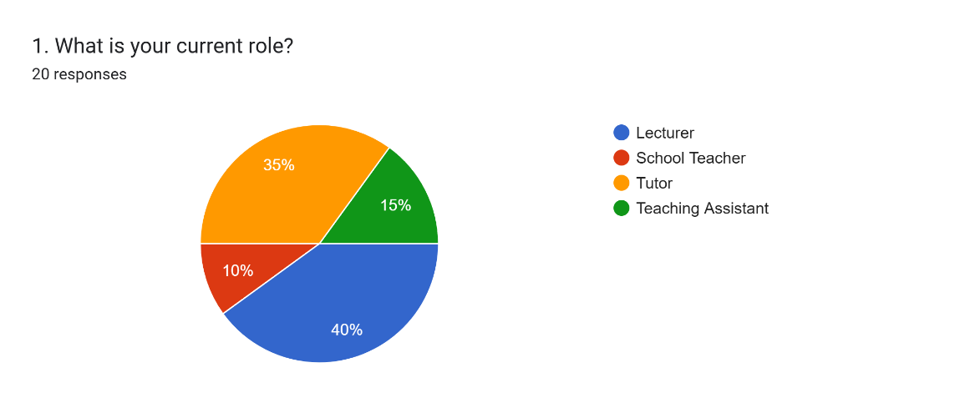

Figure 4.1: Distribution of Respondents by Teaching Role.
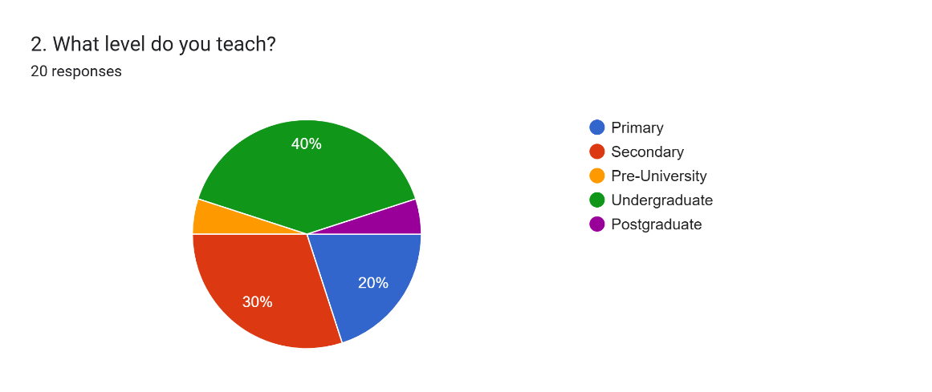
Figure 4.2: Distribution of Respondents by Teaching Level.

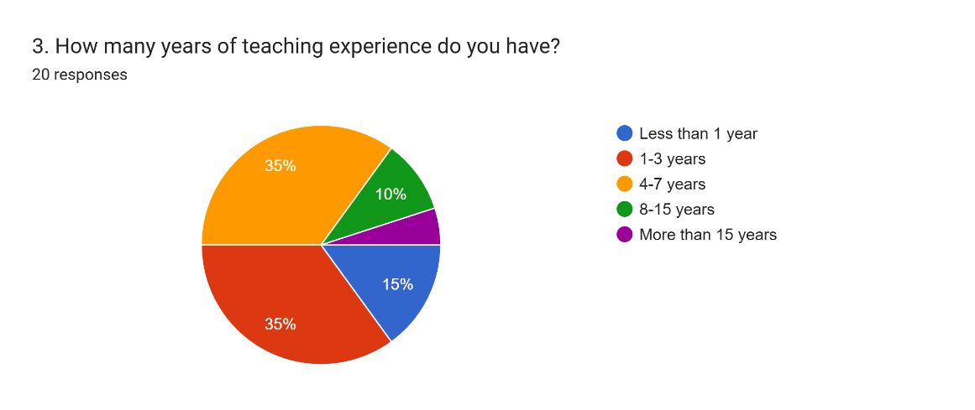
Figure 4.3: Distribution of Respondents by Teaching Experience.

The first section collected basic demographic information about the respondents. Figure 4.1 shows the distribution of respondents by role. The majority of respondents were lecturers (40%) and tutors (35%) with the remaining 25% for school teacher and teaching assistants. This distribution indicates that the survey captured responses from educators at both tertiary and secondary education levels.

In Figure 4.2, 40% of respondents teach at the undergraduate level, 30% at the secondary level and the remaining 30% at primary, pre-university and postgraduate levels. Regarding teaching experience in Figure 4.3, there are two majority group with same distribution 35% which are 1-3 years and 4-7 years. 15 % of respondents for 8-15 years and 10% of respondents for less than one year. The results suggest that the study mainly reflects the views of moderately experienced educators.

Section B: Current Teaching Material Preparation
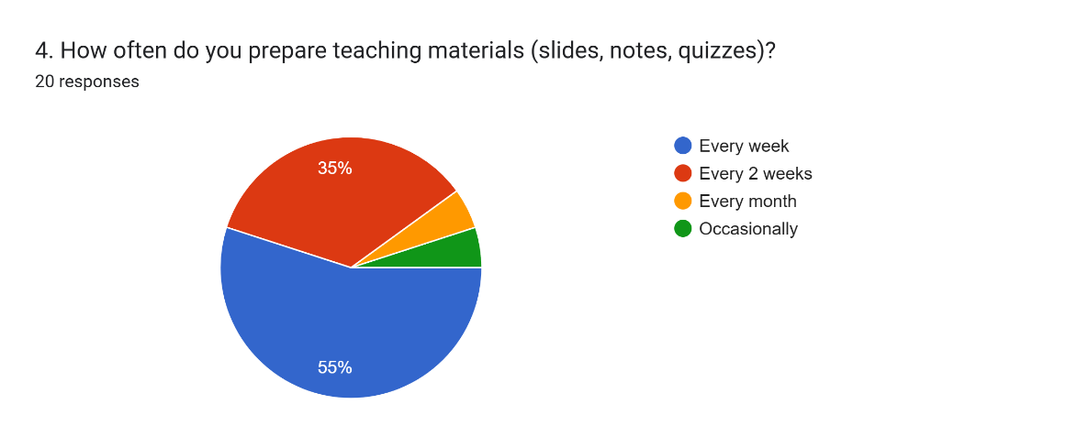
Figure 4.4: Distribution of Frequency On Preparation.

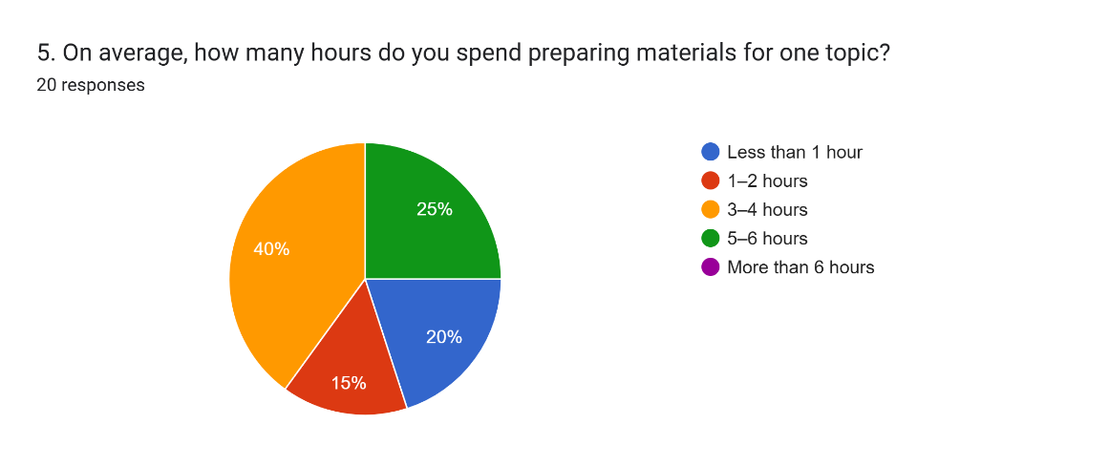
Figure 4.5: Distribution of Time On Preparation.

The majority of respondents (55%) prepare teaching materials every week with a further 35% preparing materials every two weeks. This indicates that material preparation is a frequent and repetitive task for most educators. Regarding the time invested, 40% of respondents spend between 3 to 4 hours preparing materials for a single topic and 25% spend more than 5 hours. Only 20% spend less than 1 hour. These results confirm that teaching material preparation is a time-consuming activity and support the need for an automated system to reduce this workload.
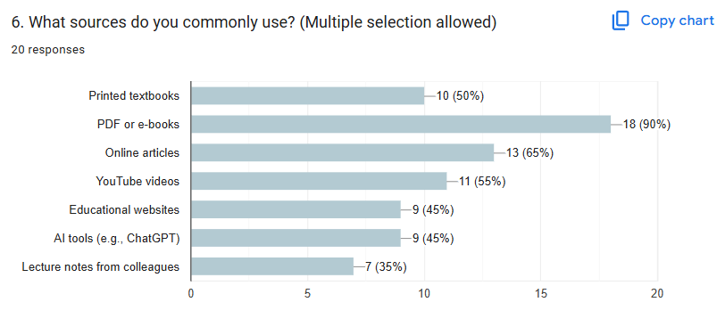
Figure 4.6: Sources Commonly Used by Educators for Teaching Material Preparation.

Respondents were asked to select all the sources they commonly use when preparing teaching materials. The most frequently selected sources were PDF or e-books (90%) and online articles (65%). YouTube videos were selected by 55% of respondents, indicating that video-based content is a common source for preparing teaching material despite the additional effort required to extract information from it. Printed textbooks (50%) and AI tools such as ChatGPT (45%) were also commonly used. These findings confirm the need for a multi-source integration system that can process PDFs, videos and web content simultaneously.

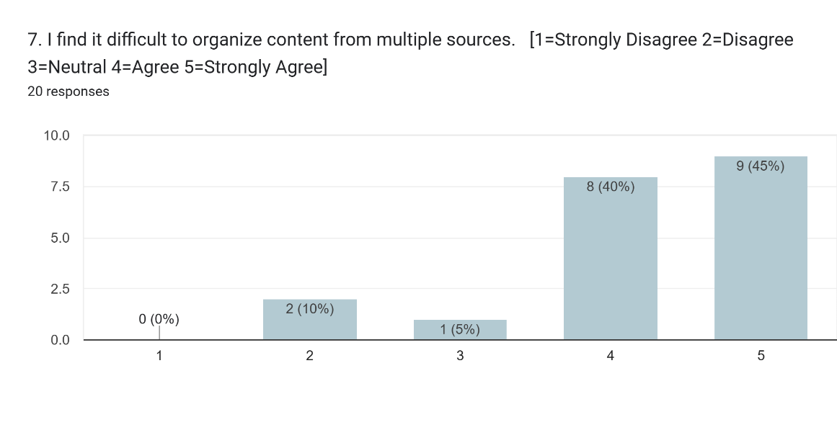 Figure 4.7: Difficutly To Organize Content From Multiple Sources for Teaching Material Preparation.
Question 7 asked respondents to rate the difficulty of organizing content from multiple sources on a five-poin scale. The results show that 85% of respondents agreed or strongly agreed that organizing content from multiple sources is difficult. This indicates that multi-source content organization is a pain point for educators.

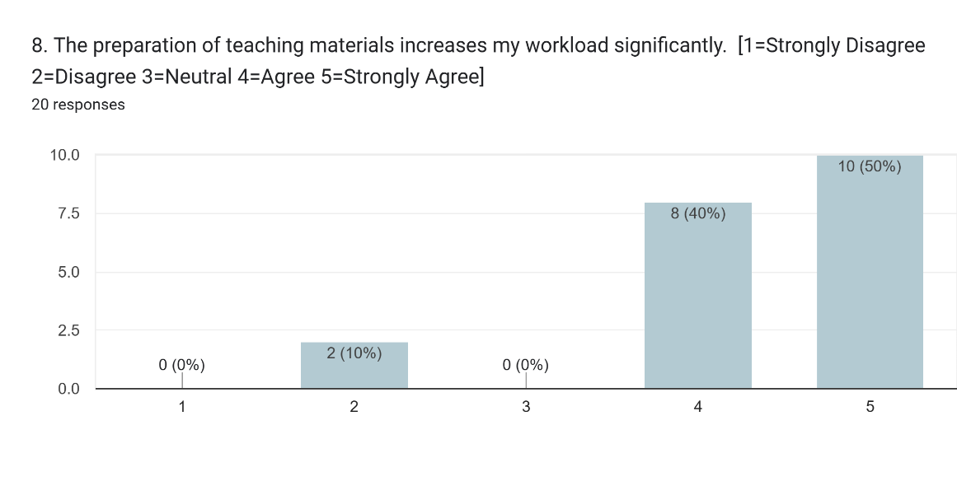
Figure 4.8: Material Preparation Increases Workload .

Question 8 asked respondents to rate whether material preparation increases their workload. A large majority of 90% agreed or strongly agreed that preparation significantly increases their workload. This strongly supports the case for developing an automated system that reduces the manual effort involved in lesson preparation.
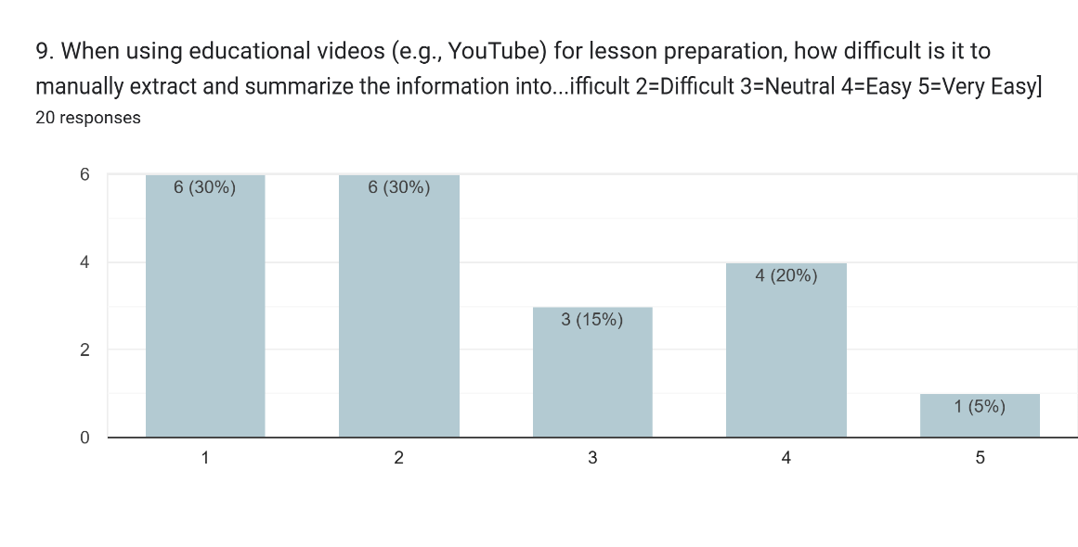
Figure 4.9: Difficulty of Manually Extracting and Summarizing Information from Educational Videos.

Question 9 asked respondents to rate the difficulty of manually extracting and summarizing information from educational videos. The results show that 60% of respondents found this task difficult or very difficult where 1 = Very Difficult and 5 = Very Easy. This supports the YouTube transcript retrieval module in the suggested system and draws attention to the particular difficulty of processing video-based content.

Section C: Use of AI Tool Usage
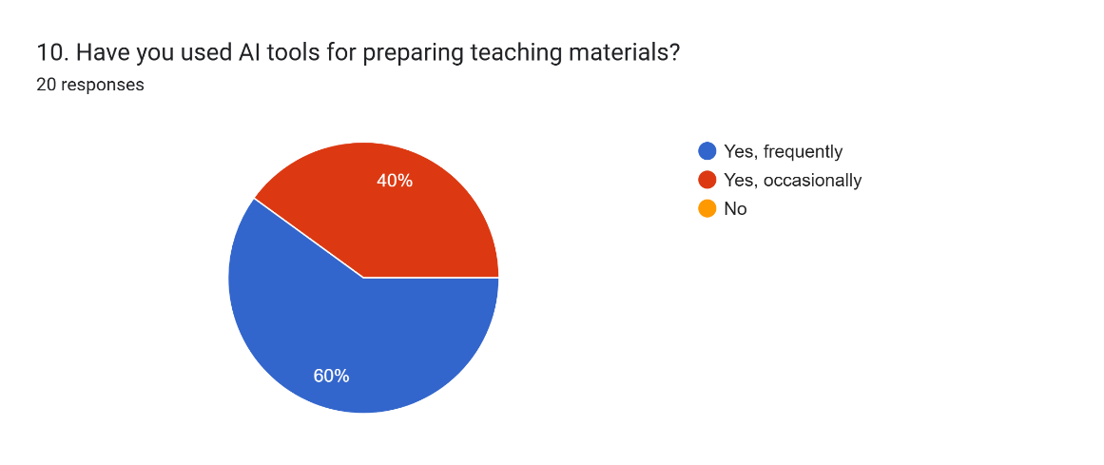
Figure 4.10: Frequency of AI Tool Usage.

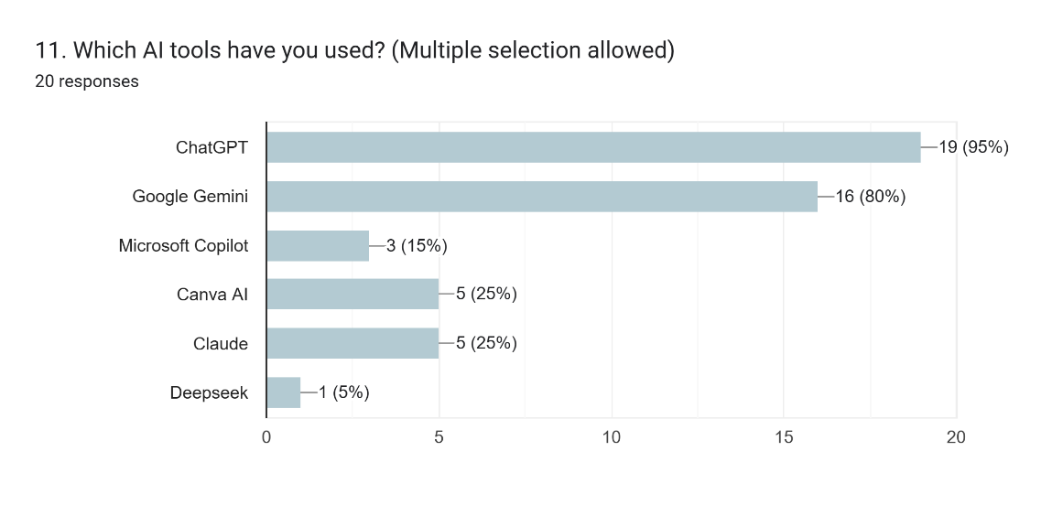
Figure 4.11: Current AI Tool Used by Educators.

According to the results of Question 10, it show that 40% of respondents use AI tools occasionally and 60% use them frequently. This suggests that educators are already using AI tools at a substantial rate. Google Gemini (80%) and ChatGPT (95%) were the two most popular tools.

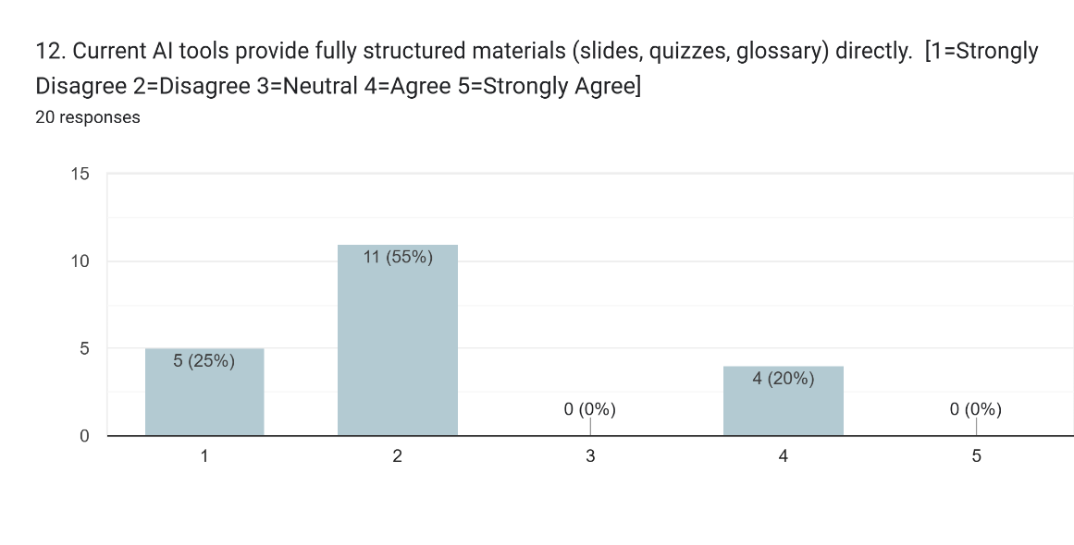 Figure 4.12: Ability of Current AI Tools to Generate Fully Structured Teaching Materials.

The question in figure 4.12 asked respondents to rank the degree to which current AI technologies offer completely structured information, such as glossary terms, quizzes, and slides. No one strongly agreed with this remark, and just 4% of respondents agreed with it. This demonstrates that current AI techniques are insufficient in creating organised and usable teaching materials. It demonstrates why the suggested system is necessary.

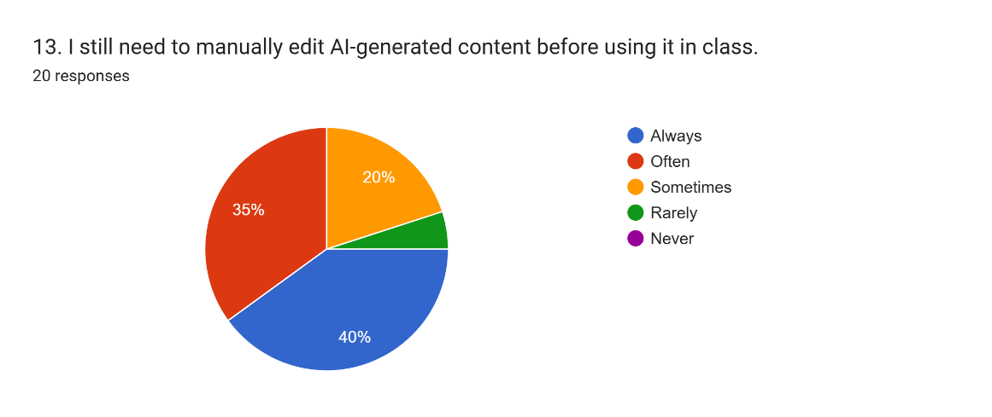
Figure 4.13: Manual Editing of AI-Generated Teaching Materials.

From figure 4.13, the question revealed that 75% of respondents always or often need to manually edit AI-generated content before using it in class and a 20% sometimes require editing. The rest are rarely need to make edits. his result suggests that existing AI outputs are not accurate or well-organised enough for direct use in classrooms.

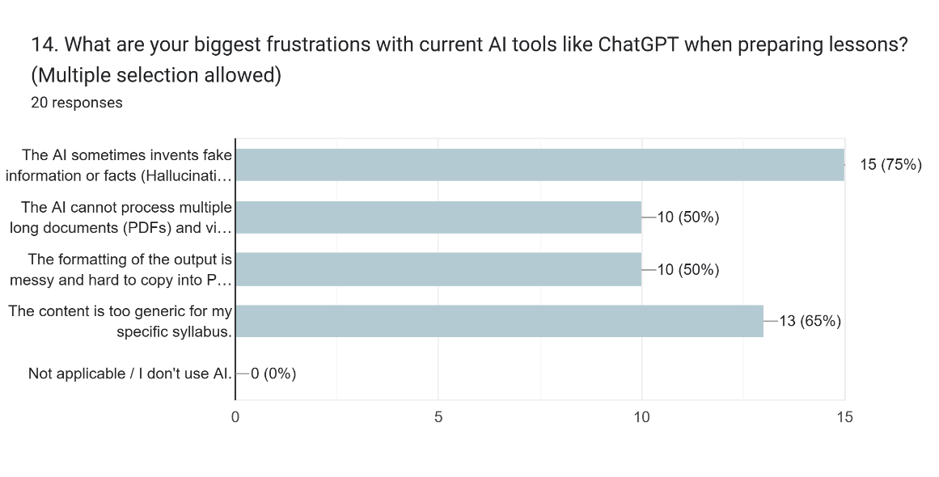
Figure 4.14: Frustrations with Current AI Teaching Tools.

In Question 14, respondents were asked to list the main frustrations they face when using current AI tools. According to 75% of respondents, hallucinations or inaccurate generated facts were the most frequent problem. Next, 65% of respondents think that the information was overly general and poorly matched with the particular syllabus. Additionally, 50% of respondents reported that current AI tools have trouble processing numerous lengthy documents and video links simultaneously. While another 50% of respondent highlighted poor and messy output formatting as a major concern. These findings strongly influenced the proposed system design in terms of implementing the RAG approach, multi-source content integration, and education level personalization features.

Section D: Proposed System Features
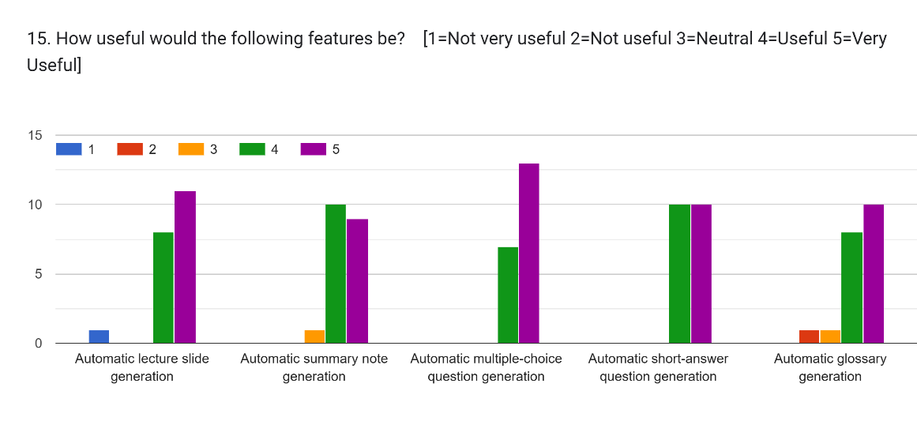
Figure 4.15: Usefulness of Proposed AI Teaching Material Features

Question 15 asked respondents to rate the usefulness of five proposed features on a five-point scale. All five features received mean ratings above 4.0, indicating that educators consider all of the proposed output types to be useful or very useful. These results confirm that all five output types should be included in the proposed system.

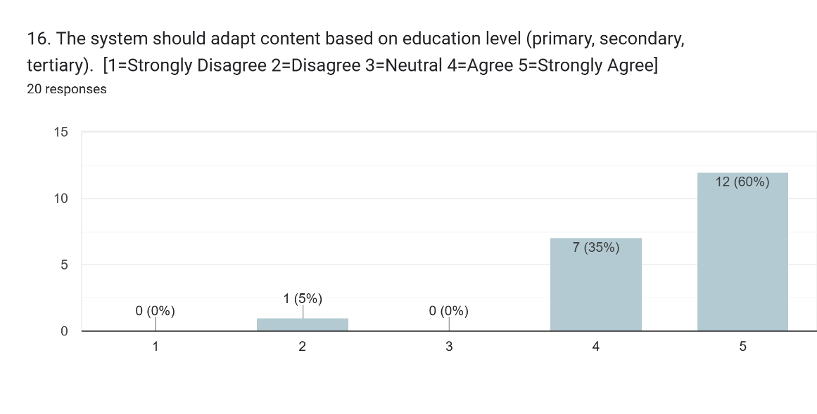
Figure 4.16: Support for Education Level Adaptation in AI-Generated Content.

Question 16 asked whether the system should adapt content based on education level. A strong majority of 95% agreed or strongly agreed with this requirement and only one person disagree. This result confirms that education level personalization is an important feature and should be included as a core functionality of the proposed system.

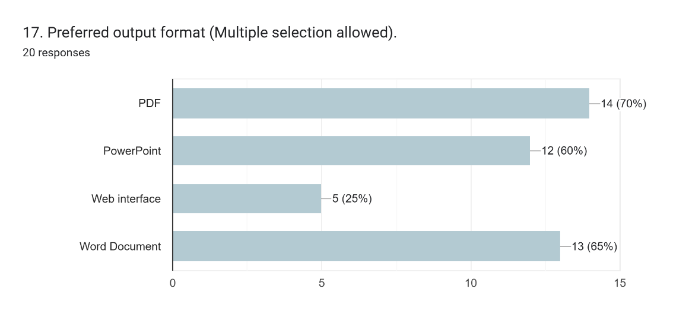
Figure 4.17: Preferred Output Formats for AI-Generated Teaching Materials.

Question 17 asked respondents to select their preferred output formats. PDF was the most preferred format (70%), followed by Word Document (65%) and Power Point (60%). Web interface was preferred by 25% of respondents. These results confirm that the system should prioritize Word Doucment and PDF export functionality but the system would only implement PDF and PowerPoint.

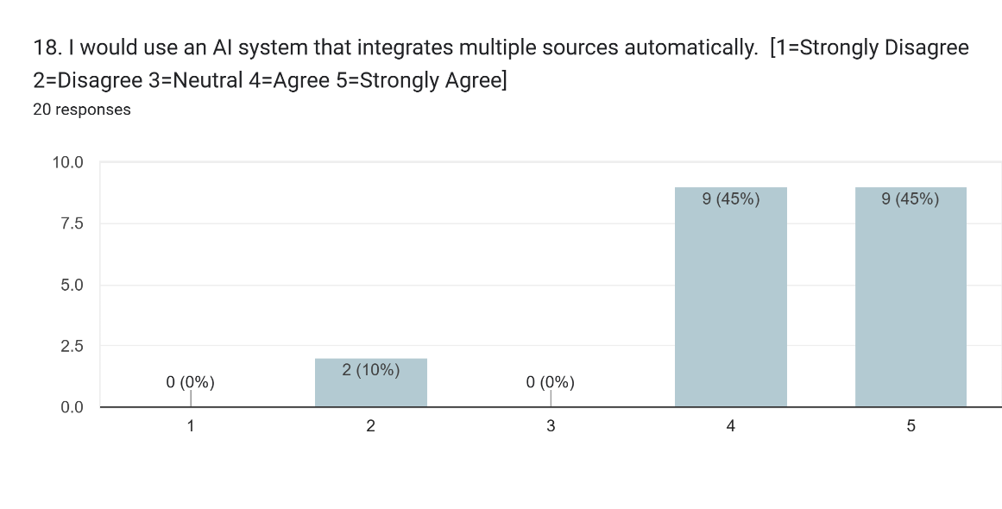
Figure 4.18: Acceptance of Multi-Source AI Integration in Teaching Systems.

Question 18 asked whether respondents would use an AI system that integrates multiple sources automatically. An overwhelming 90% agreed or strongly agreed with this statement. The multi-source integration design of the suggested system is clearly justified by this finding, which is the strongest of the entire survey.

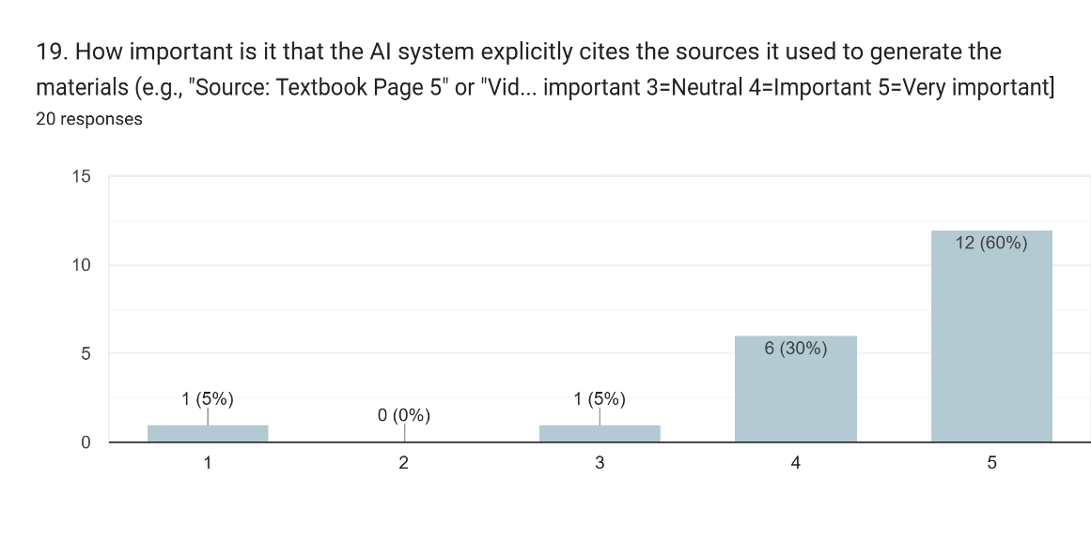
Figure 4.19: Importance of Source Citation in AI-Generated Educational Content.

Question 19 asked respodents how important it is for the AI system to specifically cite the sources used to generate the materials. A total of 90% of respondents rated this as important or very important. This outcome validates the application of the RAG approach in the proposed system which can identify content to particular sources and grounds all generated content in retrieved source materials.

Conclusion on the questionnaire
The results of the questionnaire survey conducted with 20 educators and discussed how the findings informed the system requirements. The results confirmed that teaching material preparation is a frequent and time-consuming task for the majority of educators with most spending 3 or more hours preparing materials for a single topic. Multi-source content organization was identified as a significant challenge with 95% of respondents finding it difficult. The analysis of current AI tool usage revealed that existing tools do not produce fully structured outputs. It also require significant manual editing and are prone to hallucinations and generic content.

The evaluation of proposed features showed strong demand for all five output types with lecture slide generation and multiple choice question receiving the highest usefulness ratings. The need for multi-source integration was confirmed by 85% of respondents and education level adaptation was supported by 95%. These findings directly guided the definition of the fourteen functional requirements and four non-functional requirements of the proposed system.

System Functional and Non-Functional Requirements
This section represent the functional and non-functional requirements of the proposed system identified during the requirement analysis phase. These requirements were derived from the research objectives, the literature review and the questionnaire responses collected from educators.

Functional Requirement

Table 4.1: Functional Requirements.

ID | Requirement | Description
FR-01 | Login and Sign Up | The system shall allow educator to sign up and login before enter into the web interface.
FR-02 | Topic Input | The system shall accept a topic string in natural language as input from the educator.
FR-03 | Education Level Selection | The system shall allow the educator to select one of three education levels: primary, secondary or tertiary.
FR-04 | PDF Content Extraction | The system shall extract textual content from open-access PDF documents using PyMuPDF and Tesseract OCR.
FR-05 | Video Transcript Retrieval | The system shall retrieve transcripts from YouTube videos related to the input topic using the youtube-transcript-api.
FR-06 | Web Content Scraping | The system shall scrape relevant educational content from open-access websites using BeautifulSoup and Selenium.
FR-07 | Material Generation | The system shall generate lecture slides, summary notes, quiz questions and a glossary of key terms via the Curriculum Designer Agent using openai/gpt-oss-120b through the Groq API.
FR-08 | Education Level Adaptation | The system shall adapt the complexity, vocabulary and question difficulty of generated materials based on the selected education level.
FR-09 | Export Functionality | The system shall allow the educator to export the generated materials as a PDF or PowerPoint file.
FR-10 | Multi-Agent Orchestration & Quality Audit | The system shall execute a multi-agent workflow featuring automated self-correction loops and real-time thought trace logging.
FR-11 | Subtopic Extraction and Filtering | The system shall analyze extracted source text to identify distinct subtopics and allow the educator to select specific subtopics to focus the lesson scope.
FR-12 | Configurable Slide Visual Asset Synthesis | The system shall allow the educator to select the visual density for lecture slides and generate relevant diagrams via Wikipedia API and Pollinations.ai.
FR-13 | Visual-Textual Alignment Evaluation | The system shall evaluate the relevance between generated presentation diagrams and slide titles using the pre-trained CLIP model.
FR-14 | Generation History and Archive Management | The system shall allow the educator to view, search, reload past generation runs into the editor, and delete records from the history archive.

Non-functional Requirement

Table 4.2: Non Functional Requirements.
ID | Requirement | Description
NFR-01 | Response Time | The system shall return generated materials within 60 seconds for a standard topic query.
NFR-02 | Output Accuracy | Generated content shall be grounded in the retrieved source materials to minimize factual inaccuracies.
NFR-03 | Usability | The web interface shall be simple enough for non-technical educators to use without training.
NFR-04 | Reliability | The system shall gracefully handle external API timeouts or invalid file uploads by displaying clear and user friendly error messages instead of crashing.

Use Case Diagram

The figure above presents the use case diagram of the proposed system. The diagram shows the Educator as the sole actor and illustrates the fourteen cases that the system supports. The system boundary is represented by the dashed rectangle and all use cases are contained within it.

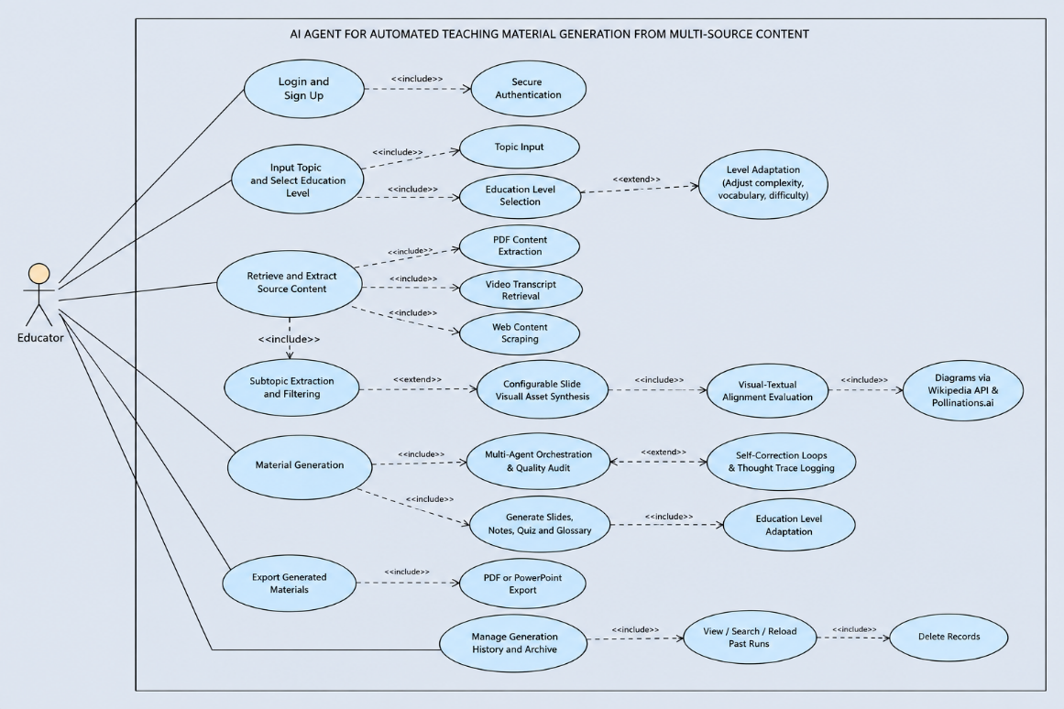
Figure 4.20: Use Case Diagram.

Use Case Descriptions
The detailed use case descriptions for each of the fourteen use cases shown in the use case diagram are shown in the following figure.

Log In
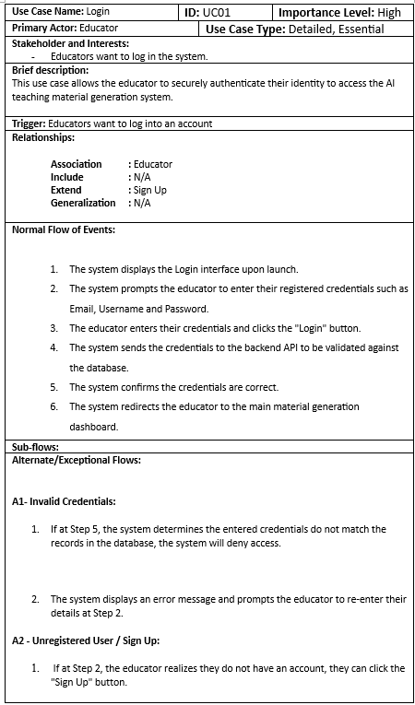
Figure 4.21: Log In.

Sign Up
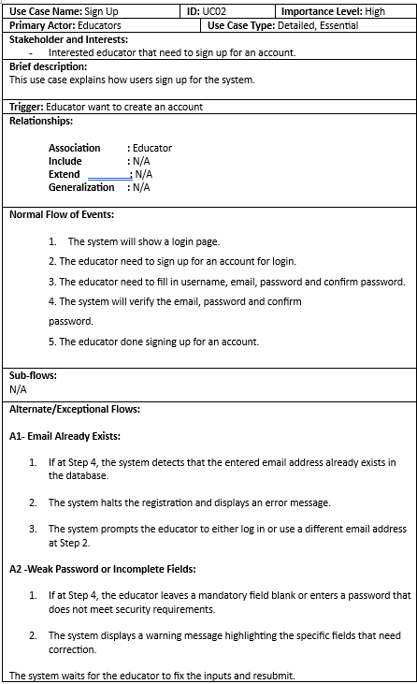
Figure 4.22: Sign Up.

Enter Topic and Select Education Level
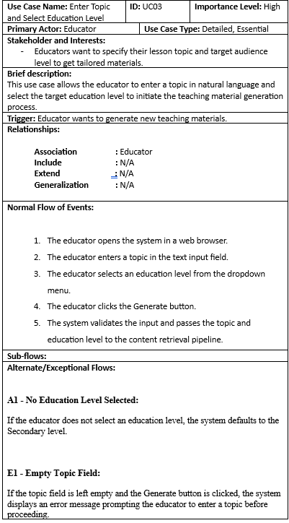
Figure 4.23: Enter Topic and Select Education Level.

Retrieve Content from PDF Documents
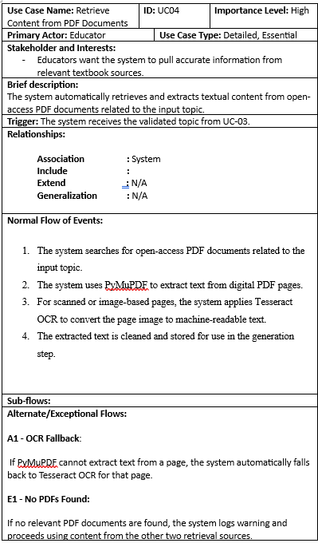
Figure 4.24: Retrieve Content from PDF Documents.

Retrieve YouTube Video Transcripts
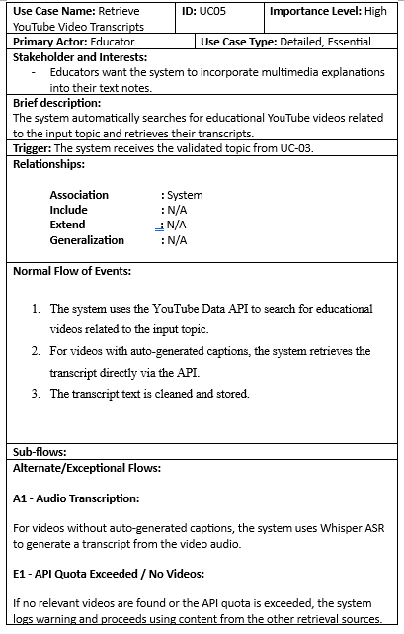
Figure 4.25: Retrieve YouTube Video Transcripts.

Retrieve Web-Based Educational Content
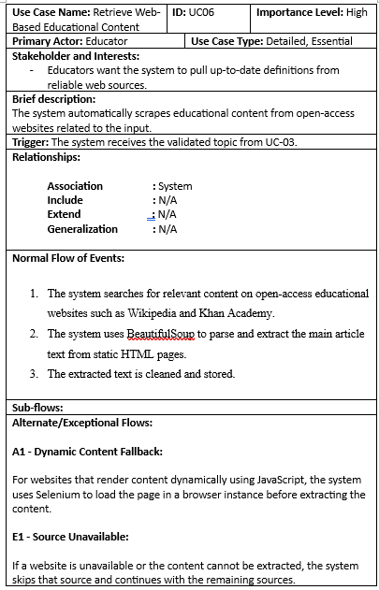
Figure 4.26: Retrieve Web-Based Educational Content.

Generate Structured Teaching Materials
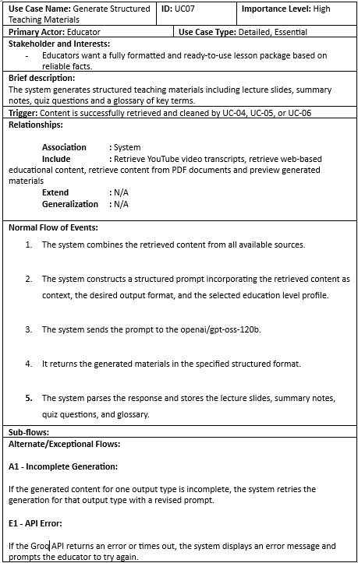
Figure 4.27: Generate Structured Teaching Materials.

Preview Generated Materials
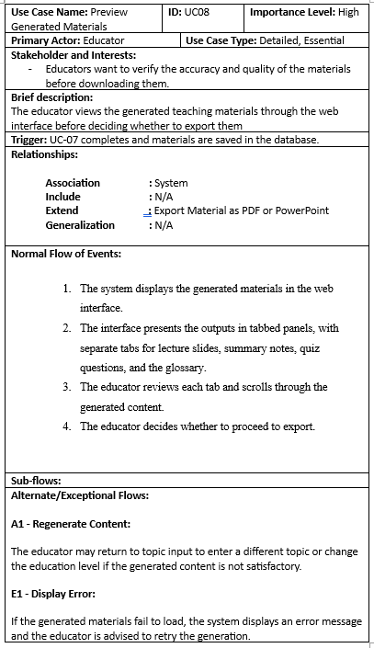
Figure 4.28: Preview Generated Materials.

Export Materials as PDF or PowerPoint
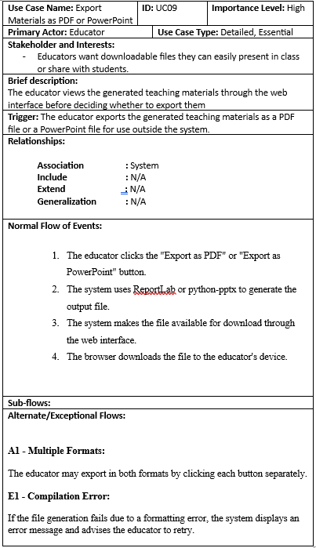
Figure 4.29: Export Materials as PDF or PowerPoint.

View Multi-Agent Execution Telemetry
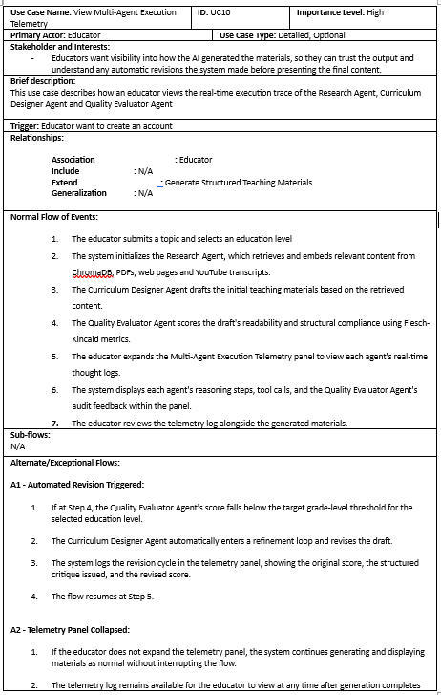
Figure 4.30: View Multi-Agent Execution Telemetry.

Extract and Filter Subtopics
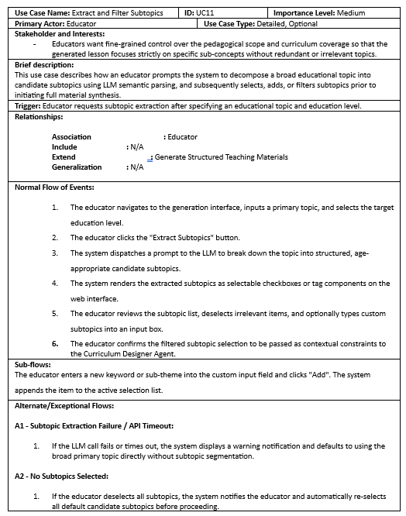
Figure 4.31: Extract and Filter Subtopics.

Configure and Generate Slide Visual Assets
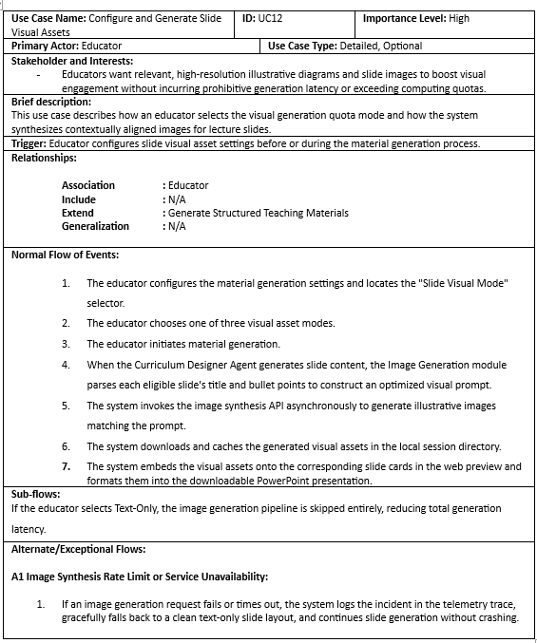
Figure 4.32: Configure and Generate Slide Visual Assets.

Evaluate Visual-Textual Alignment via CLIP
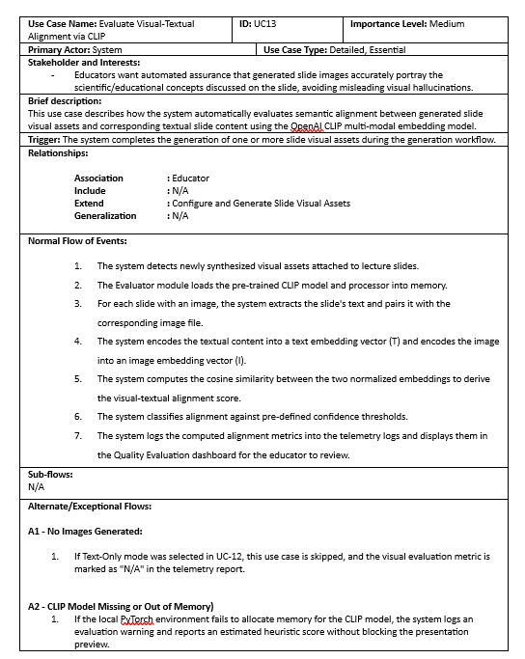
Figure 4.33: Evaluate Visual-Textual Alignment via CLIP

Manage Generation History and Archive
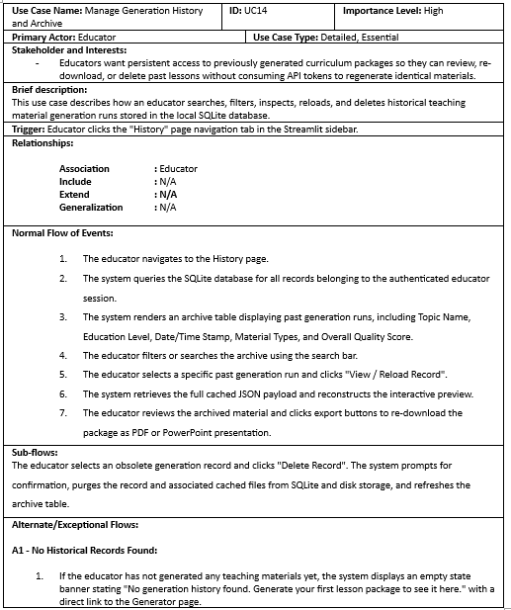
Figure 4.34: Manage Generation History and Archive

Summary

This chapter presents the early results of the proposed AI Agent for generating teaching materials from multiple sources. It starts with the requirements analysis, based on a questionnaire given to 20 educators. Based on the results, the system requirements were defined include fourteen functional requirements and four non functional requirement. A use case diagram was then created, showing the Educator as the main user with seven system functions. Each use case was explained with its main, alternative and exception flows. Lastly, the prototype developed in FYP1 was introduced. It demonstrates key features like topic input, education level selection, content retrieval, material generation and preview. This prototype will be the base for further development in FYP2.

SYSTEM DESIGN

Introduction
In this chapter, the detailed system specifications and structural designs for the proposed system are comprehensively presented to bridge the gap between the requirement specifications defined in Chapter 4 and the actual implementation phase. To ensure consistency, maintainability, and architectural integrity throughout the software development lifecycle by establishing a clear design framework. This chapter covers the following critical areas user interface design, system architecture, entity relationship diagram, data flow diagrams and activity diagrams.

User Interface Flow Diagram
This section illustrates how users navigate and interact with the proposed system. The Streamlit framework is used to built a single-page web application, the system uses session states to manage user logins and keep track of data during the material generation process.

Authentication Page

Login Page
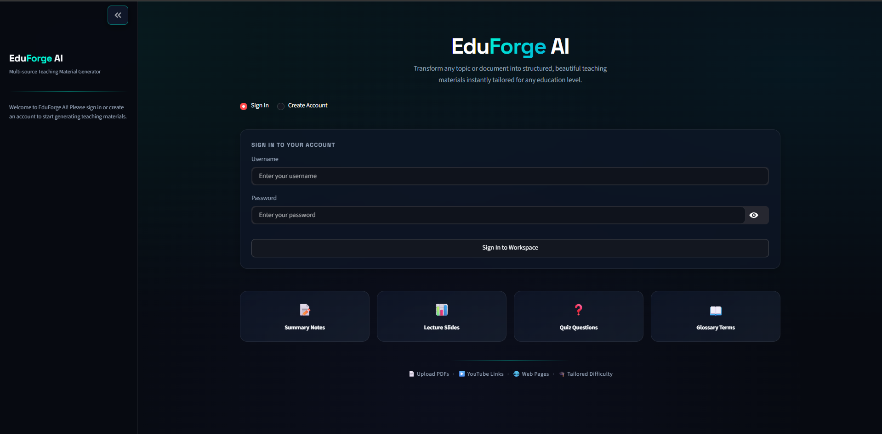
Figure 5.1: Login Page

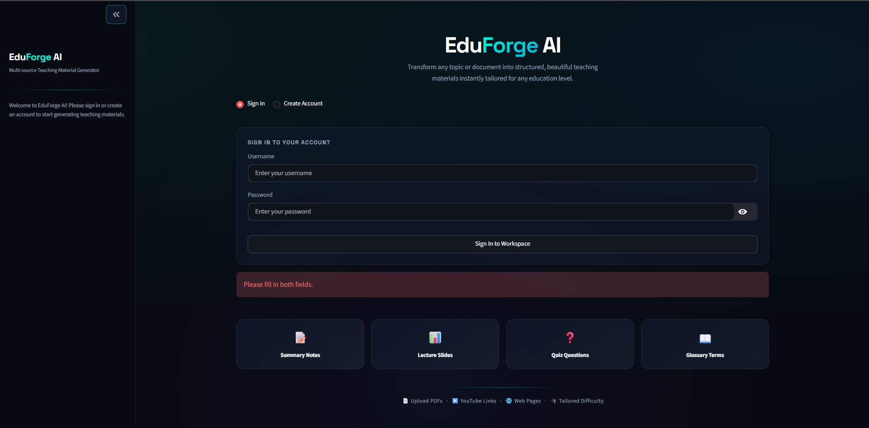
Figure 5.2: Both fields are not filled in

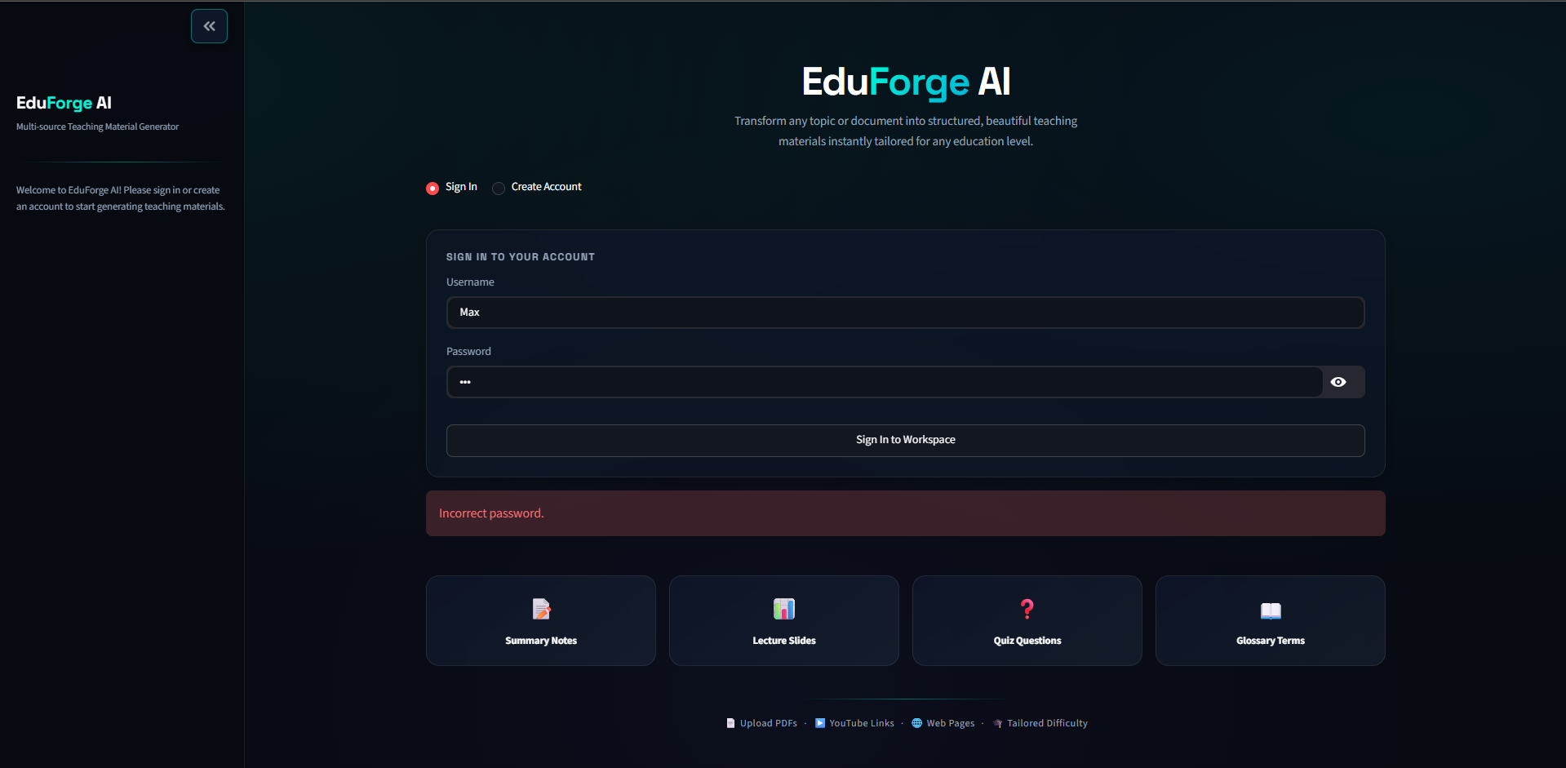
Figure 5.3: Incorrect password

Sign Up Page
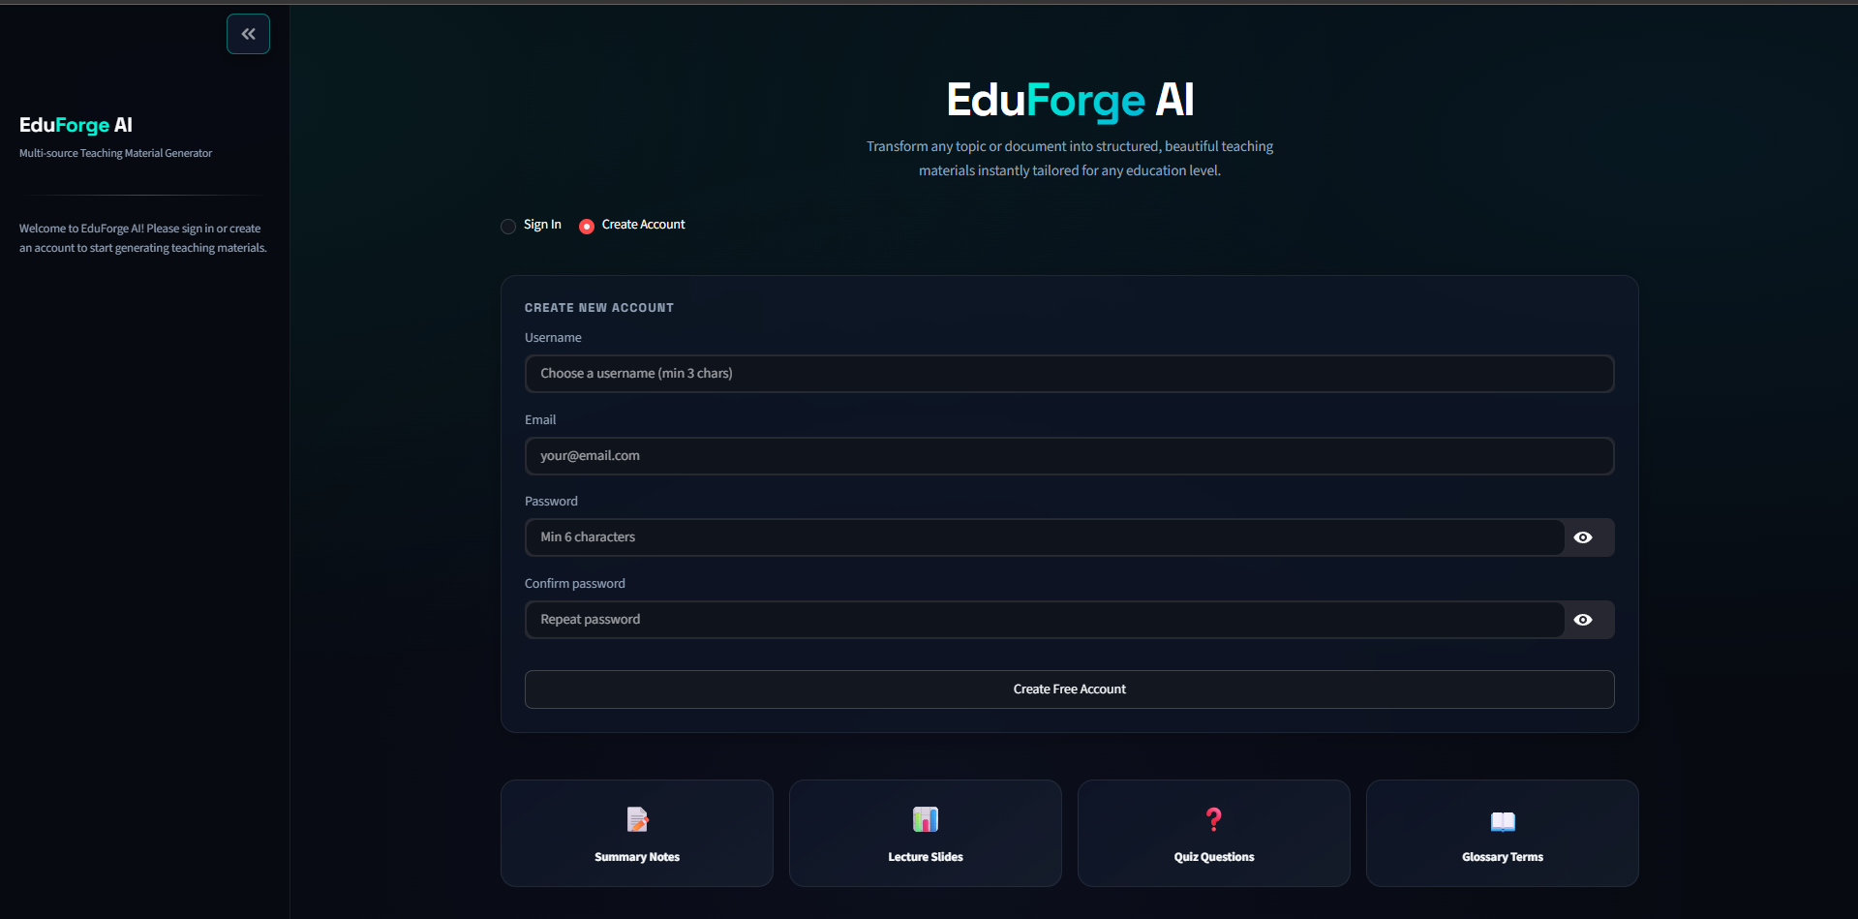
Figure 5.4: Create Account

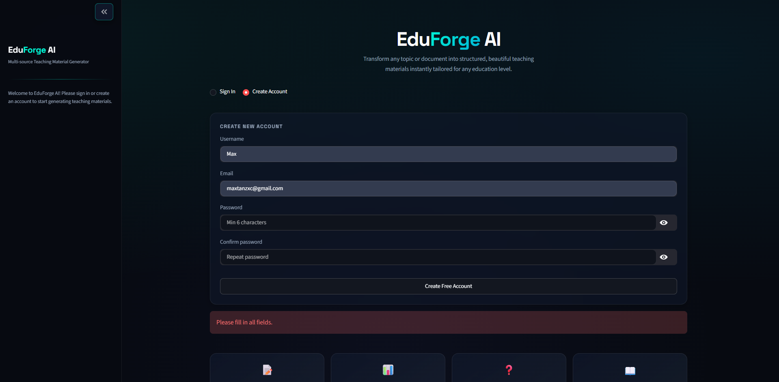
Figure 5.5: Empty fields

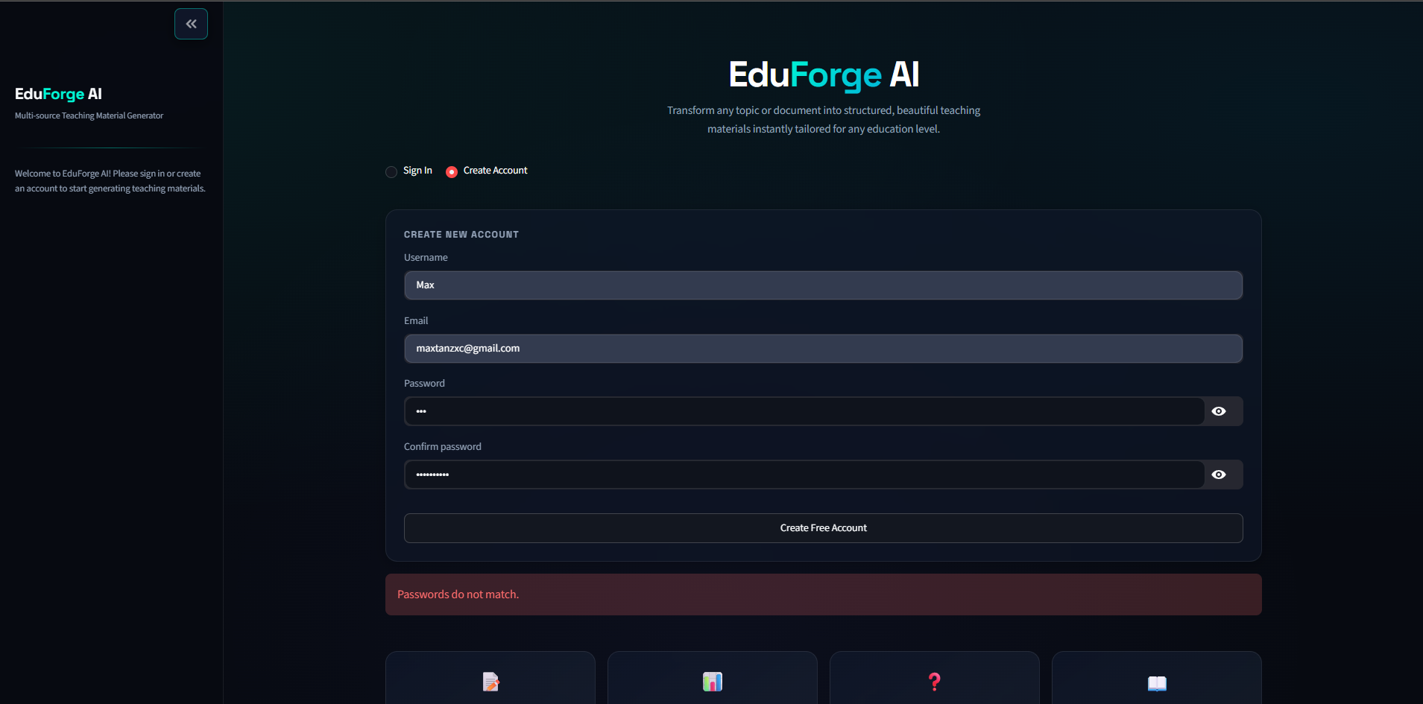
Figure 5.6: Password do not match

Both new and existing users begin by logging in to the system or creating a new account at the login page. The user's inputs are compared to the SQLite database by the system. If the login details is incorrect or any required fields are empty, an error message is shown on the screen and ask the user to try again. The system automatically takes the user to the Generation Dashboard after the login is successful.

Dashboard Workflow

Generation Dashboard
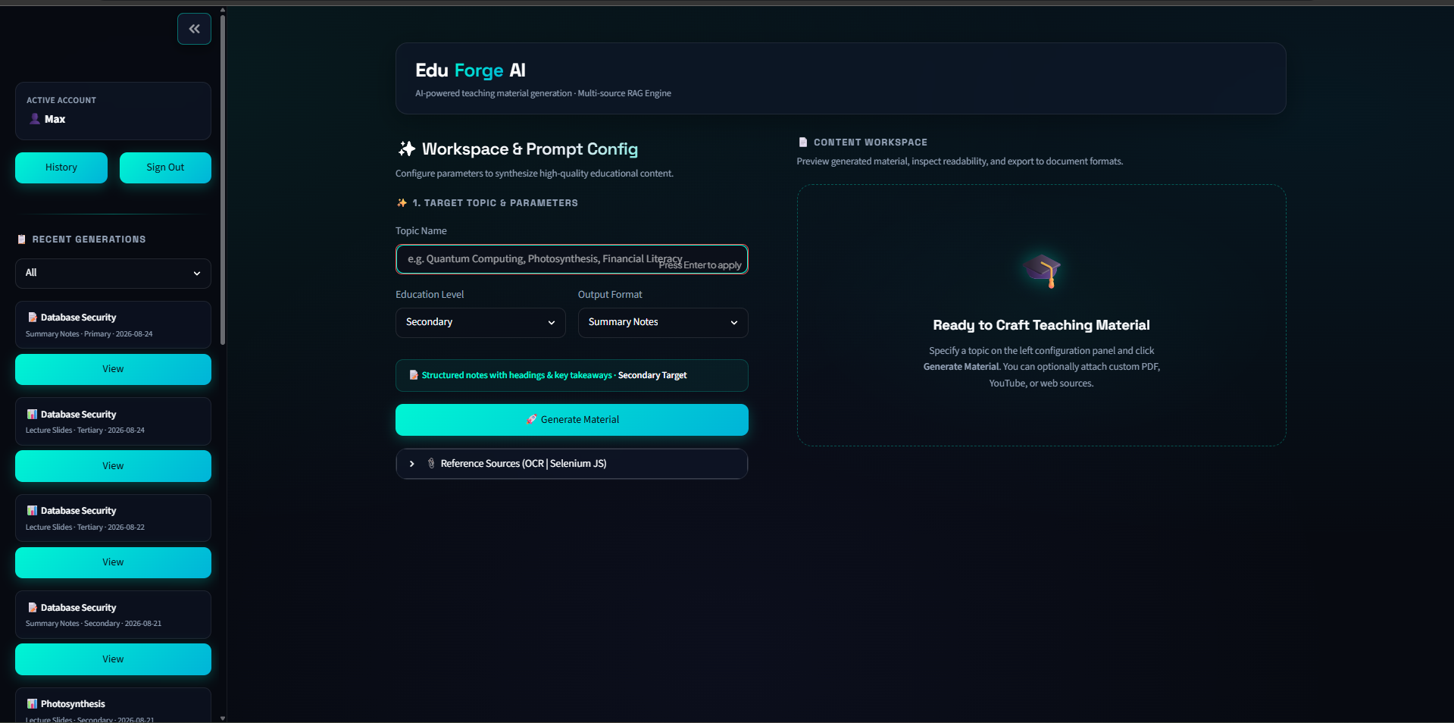
Figure 5.7: Main Page

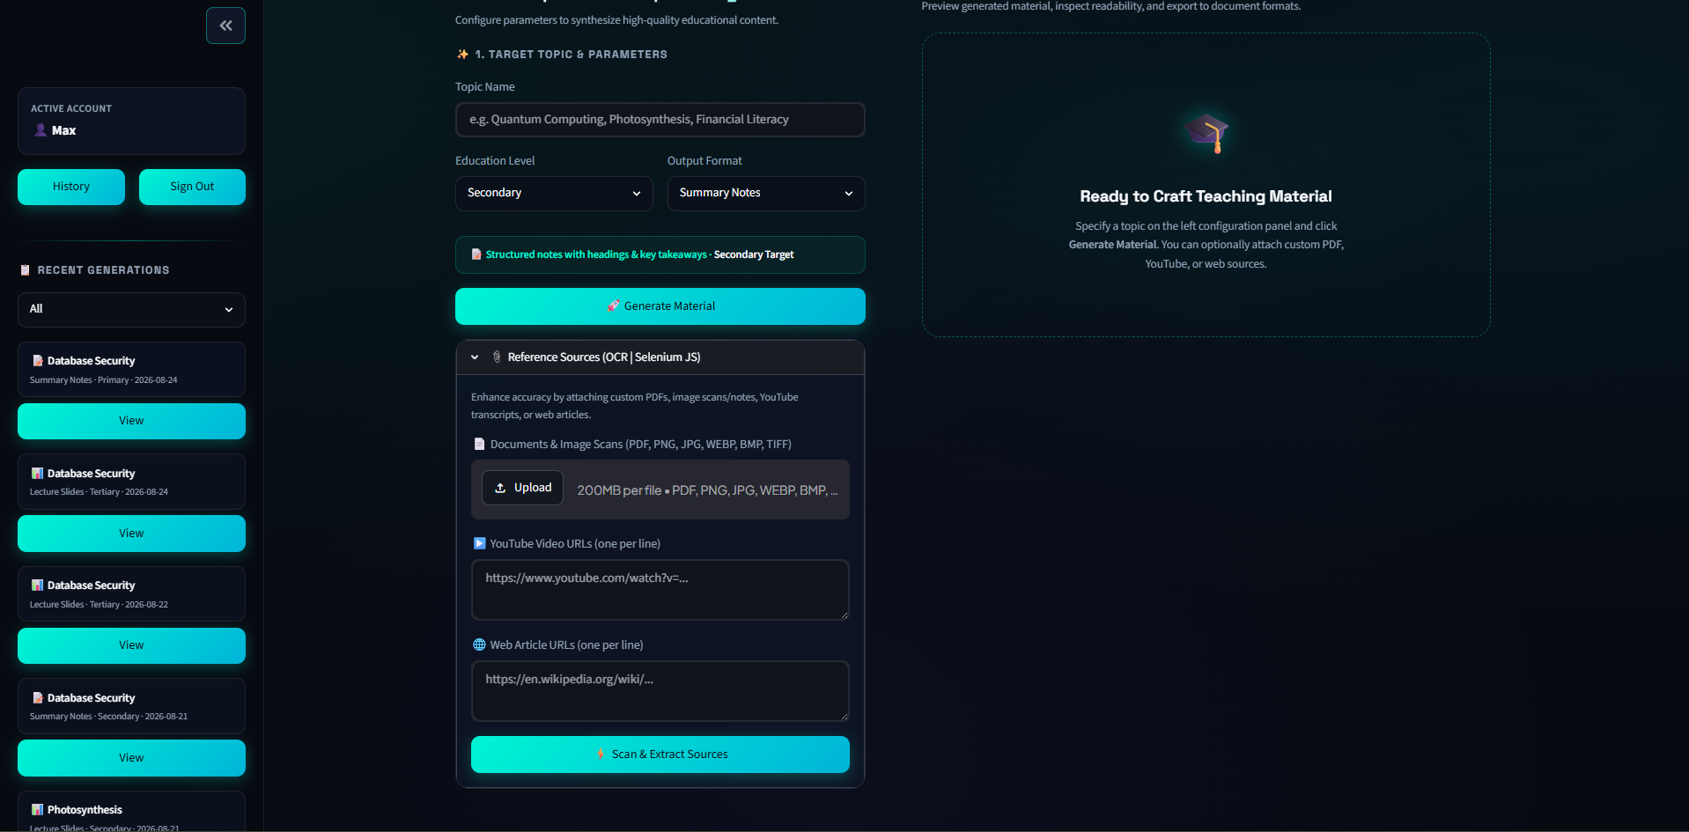
Figure 5.8: Upload Source

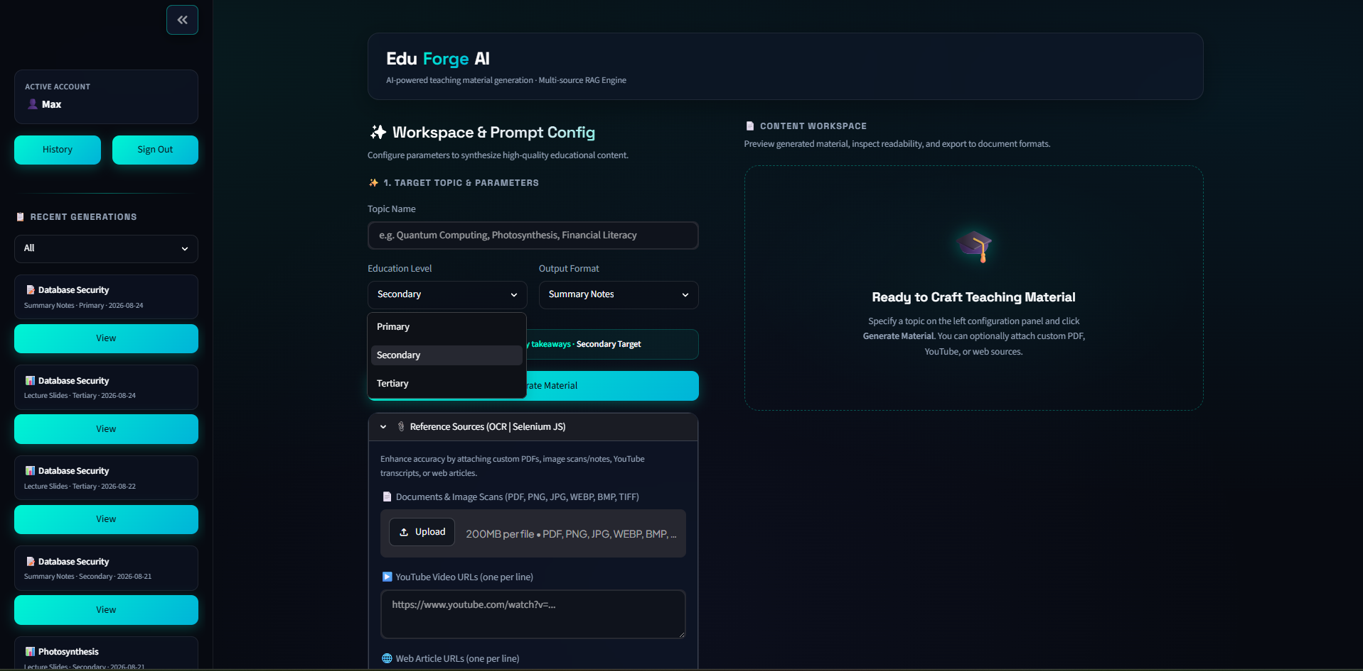
Figure 5.9: Select Education level and Output Format

Users go through a straightforward two-step setup process in the Generation Dashboard. They start by uploading their educational resources, which include PDF files, YouTube video links, and website URLs. Users have the option of extracting particular subtopics or using the entire document. Second, the target education level, output type, primary topic, and quantity of questions are all customisable by users for the teaching materials.

System processing
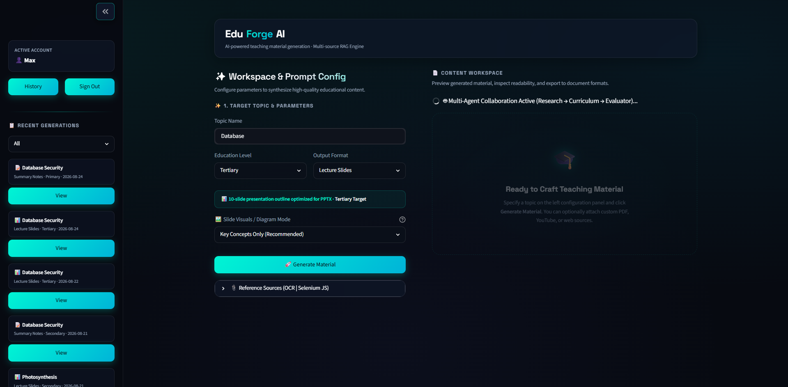
Figure 5.10: Generation Material Processing

The screen switches to an active processing state once the request has been submitted. To see the current state of the creation process, users can access system logs and a real-time progress bar.

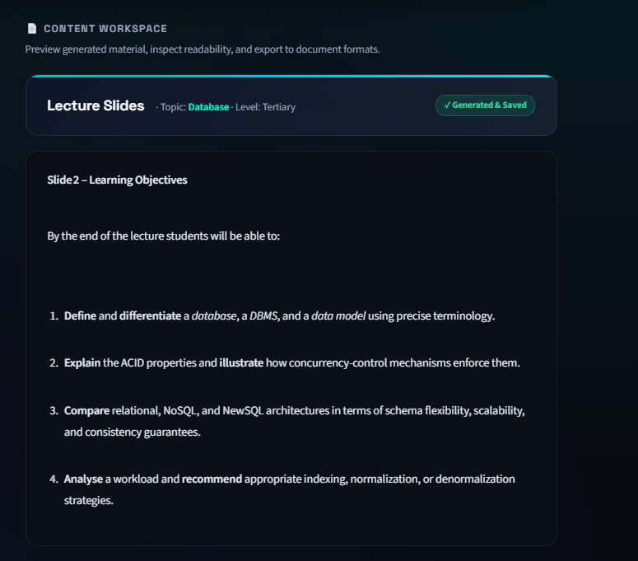
Figure 5.11: Generated Material

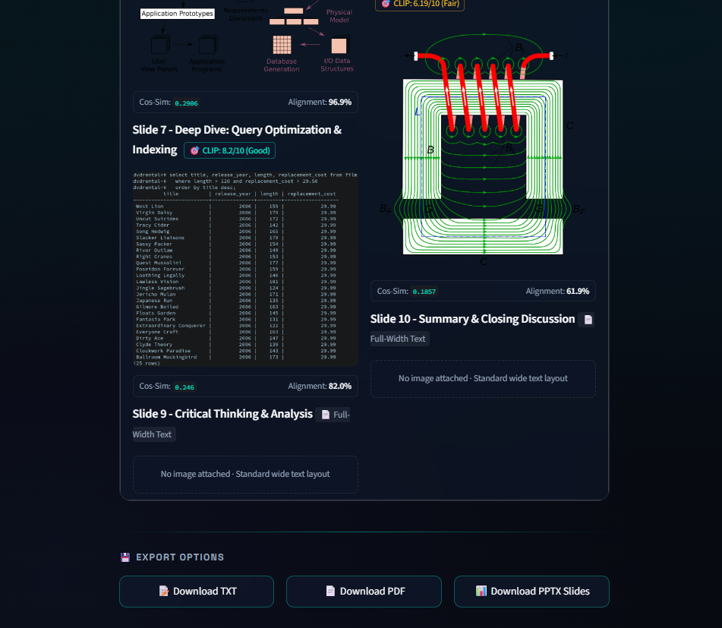
Figure 5.12: Slide Images and CLIP score

The user can examine the produced instructional materials directly on the screen after processing is finished. Additionally, users can create slide images here and download the finished products in PDF (.pdf) or Microsoft PowerPoint (.pptx) formats.

Generation History & Archive
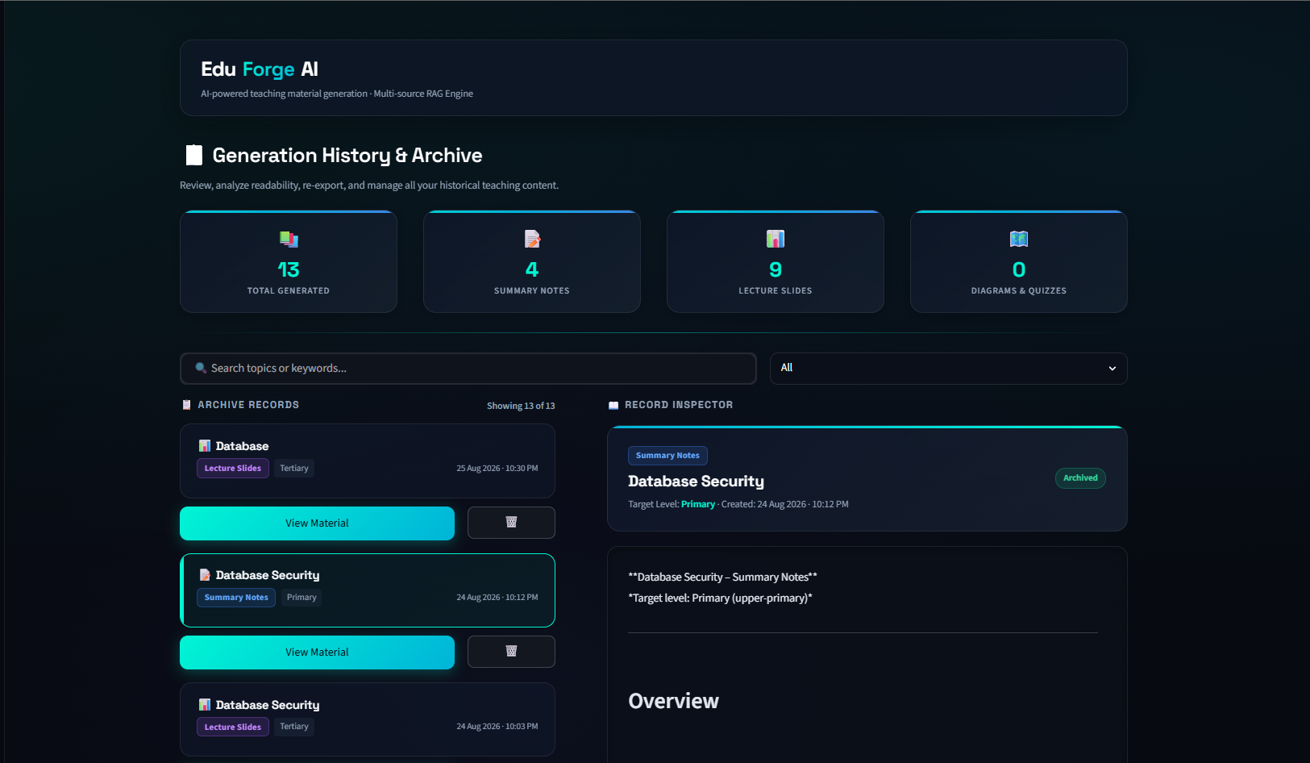
Figure 5.13: Generation History and Archive

Users can access the History Archive site by utilising the sidebar. Without having to go through the entire generating process again, this page makes it simple for users to see, manage, and download their previously created items.

User Interface Design

Design Theme and Layout Rationale
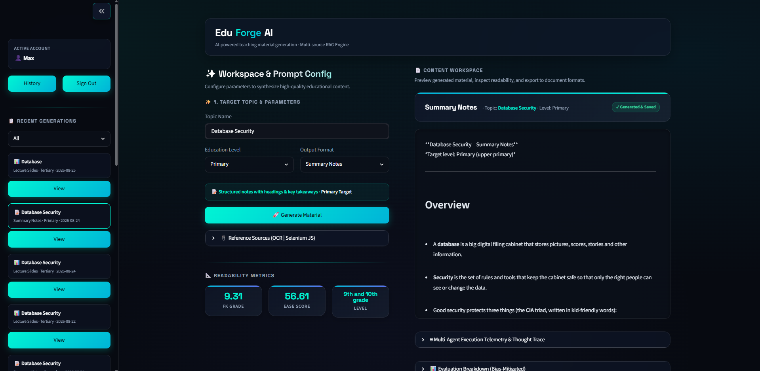
Figure 5.14: The theme of Main Page

A modern dark theme is used in the system’s visual desgin to provide a comfortable and user-friendly experience. The main background uses dark navy and grey colors to help reduce eye strain for educators who use the system for long periods. Important buttons and interactive elements use a vivid cyan colour to make the application easy to operate. The user's attention is automatically drawn to the next actionable steps by this powerful visual contrast.

The 'Space Grotesk' font is used by the system for main titles while standard fonts for normal paragraphs, tables, and instructions. This combination ensures all data is clear, well-organised, and easy to read on any size screen.

Screen Layout Descriptions

The user interfaces are designed to be simple to ensure users can complete their tasks without confusion.

The system logo is shown in the center of the Authentication Screen, which also has a straightforward option for switching between user login and new account registration. If the user submits wrong information, the input boxes will display straightforward error messages and have distinct borders.

For improved desktop screen organization, the Main Generation Dashboard is separated into two columns. All of the input buttons, including file upload sections, URL link inputs and subtopic selectors are located in the left column. The generated outputs are shown in the right column. The created slide images, system processing logs, final text, and download links are all included in this.

The AI-produced presentation visuals are shown in a clean grid in the Slide Image Section which is situated just beneath the dashboard's generated text. The title of the slide and an accuracy score indicating how well the image corresponds with the content are displayed on each image card.

Multi-Agent Telemetry and Evaluation Panel just located adjacent to the output preview. This panel displays color-coded cards tracking the execution of the Research, Curriculum, and Evaluator agents along with composite quality scores, Flesch-Kincaid readability indices, and ROUGE metric values.

All previously created instructional materials are listed on the History Archive Screen. Important information such as the topic, target education level, date, and type of material are displayed in each record along with options to quickly reload or remove the record.

System Architecture Diagram
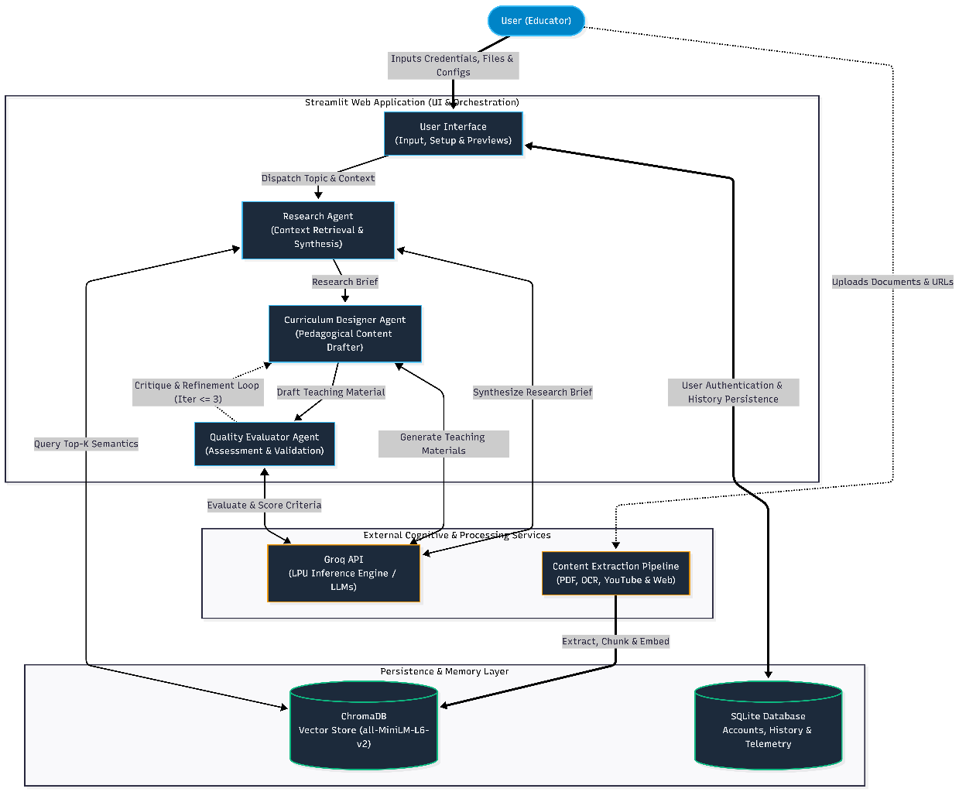
Figure 5.15: System Overview

The proposed system is engineered utilizing a multi-tier software architecture. To guarantee high maintainability and scalability, this design pattern methodically divides the system into several levels. It includes display, business logic orchestration, cognitive thinking and persistent data storage. The architectural framework is divided into the following specialized tiers.

The client-facing interface is called the Presentation Layer, this layer is built completely on top of the Streamlit framework and enhanced with a custom responsive Cascading Style Sheets layer. It is mainly responsible for rendering interactive application widgets, managing the lifecycle of user sessions, displaying real-time system execution logs, and handling the packaging of file downloads for the end-user.

Application and Orchestration Layer is the backend core that functions as the central business logic tier and encapsulated within the modules and directory. This layer coordinates the system's complex internal processes. It controls the topic segmentation parser, the hybrid semantic Retrieval-Augmented Generation engine, and the multi-agent generation pipeline. It also manages the visual asset synthesizer and the automated pedagogical evaluation suite.

Data Extraction Subsystem. This intermediary processing unit is dedicated to normalizing unstructured and multi-modal source documents into machine-readable formats. It integrates a wide range of parsing tools such as PyMuPDF document text extractor , Optical Character Recognition pipeline for image processing, YouTube subtitle scraping endpoint, Selenium and BeautifulSoup-driven web scraper.

External Cognitive Services is to facilitate advanced generative reasoning and visual synthesis. Through secure HTTPS Representational State Transfer Application Programming Interfaces, the system communicates with cloud-based foundation models. The main external services include Groq Cloud API running models like openai/gpt-oss-120b for core content generation and qwen/qwen3.6-27b for evaluation. YouTube Transcript endpoints for video metadata retrieval are also included. The Wikipedia API, Pollinations.ai, and Hugging Face Contrastive Language-Image Pretraining alignment scoring openai/clip-vit-base-patch32 are used for multi-modal diagram production and retrieval.

All application data is securely managed, stored, and retrieved under the control of the Persistence and Storage Layer. It consists of a ChromaDB vector database for indexing dense semantic vector embeddings, a persistent relational SQLite3 database for managing user authentication and historical records. As specific local artefact directory for caching the completed presentation slide decks and document summaries is included.

Database Schema (Entity-Relationship Diagram)

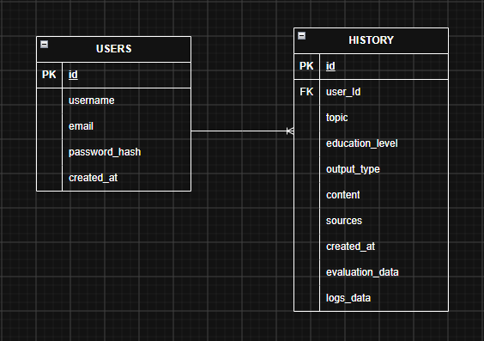
Figure 5.16: Entity-Relationship Diagram

The persistent data storage architecture of the proposed system is based on normalized relational database schema with two primary entities which are users entity and the history entity. The relational mapping between these two tables strictly follows to a One-to-Many cardinality constraint. Throughout their interactions with the system, a single registered user is permitted to create and own numerous historical artefact records in this structural context. On the other hand, each specific historical generation entry is exclusively associated with exactly one unique user through the implementation of a user_id foreign key.
Furthermore, database-level referential integrity is strictly enforced. This architectural choice prevents data abnormalities like orphaned records or referential redundancy inside the system by guaranteeing that all historical generation records consistently preserve direct and accurate attribution to their respective creators.

Data Dictionary
The users table that shown at below manages user credentials, account identification, and registration timestamps.

Field Name | Data Type | Constraints | Description
id | INTEGER | PRIMARY KEY, AUTOINCREMENT, NOT NULL | Unique internal identifier for each registered educator account.
username | TEXT | UNIQUE, NOT NULL, Length ≥ 3 | Unique alphanumeric username chosen by the user during registration.
email | TEXT | UNIQUE, NOT NULL, Valid Email Format | User email address used for identification and account records.
password_hash | TEXT | NOT NULL | Salted one-way cryptographic hash generated via the Bcrypt algorithm.
created_at | TEXT | NOT NULL, ISO-8601 Format | Server timestamp recording when the account was registered.
Table 5.1: Users Table

The history table is used to store generated educational content, instructional parameters, and source tracking information.

Field Name | Data Type | Constraints | Description
id | INTEGER | PRIMARY KEY, AUTOINCREMENT, NOT NULL | Unique internal identifier for each historical generation record.
user_id | INTEGER | FOREIGN KEY (users.id), NOT NULL | Identifier linking the generated record to the creating user account.
topic | TEXT | NOT NULL | The main lesson title entered during generation.
education_level | TEXT | NOT NULL, Enum Value | The target educational level. (e.g., Primary, Secondary, Tertiary).
output_type | TEXT | NOT NULL, Enum Value | The format of generated content. (e.g., Slide Deck, Summary Notes, Quiz).
content | TEXT | NOT NULL | The full synthesized markdown teaching text generated by the AI.
sources | TEXT | NOT NULL | Serialized string of source references, file names, or ingested URLs.
created_at | TEXT | NOT NULL, ISO-8601 Format | Server timestamp capturing the exact time of material generation.
evaluation_data | TEXT | Nullable | Serialized JSON string containing composite scores, readability, structural compliance, and ROUGE metrics.
logs_data | TEXT | Nullable | Serialized JSON string containing execution timestamps and action logs of all subagents.
Table 5.2: History Table

Data Flow Diagram (DFD)

Level-0 Context Diagram
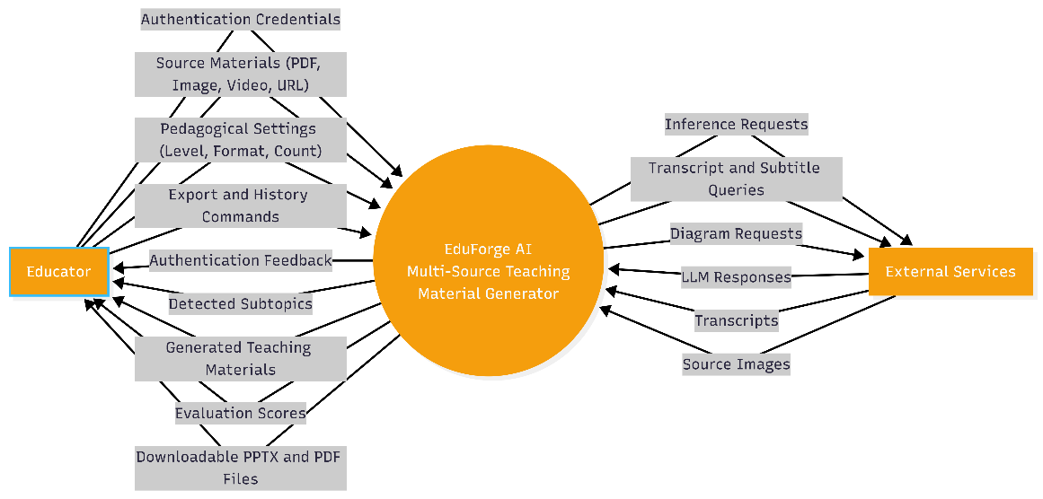
Figure 5.17: Level 0 Context Diagram
The Context Diagram provides an overall visualization of the system's boundaries and its continuous interactions with external entities. In this architecture, the Educator as the primary external entity supplies raw authentication credentials, multi-modal pedagogical source data and specific instructional constraints to the system. In response, the system processes these inputs and returns verified authentication states, interactive material previews, AI-generated slide diagrams, and downloadable deliverables in .pptx and .pdf formats. Furthermore, the system outputs automated pedagogical evaluation analytics which includes Flesch–Kincaid readability indices, ROUGE summarization scores, and CLIP multimodal alignment metrics.

Level-1 Data Flow Diagram
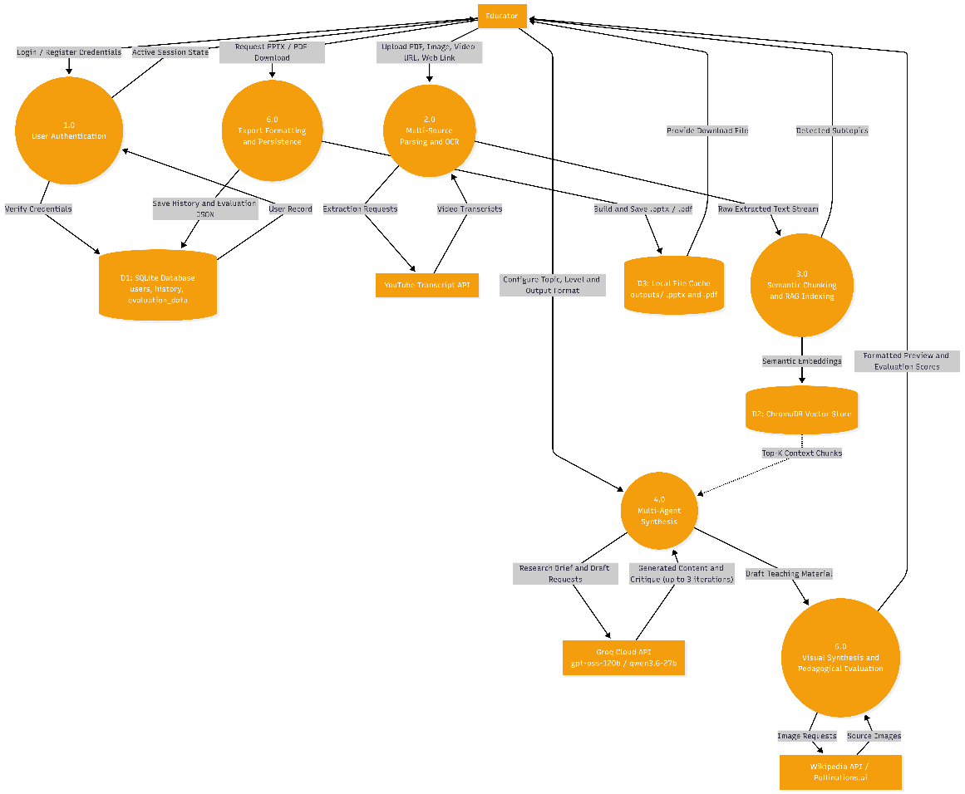
Figure 5.18: Level 1 Data Flow Diagram

The Level-1 DFD describes the internal data routing between processes and data stores by further breaking down the single system representation from the Context Diagram into six core operational modules.
.

Process 1.0 User Authentication validates the submitted login credentials against the normalized users database table to authorize access and instantiate an secure user session.

Process 2.0 Multi-Source Parsing & OCR ingests uploaded files and digital hyperlinks, routing them through specialized extraction pipelines to systematically convert multi-modal inputs into raw textual streams.

Process 3.0 Semantic Chunking & RAG Indexing partitions the parsed text into overlapping semantic passages and extracts critical subtopics. The process then computes dense vector embeddings for these passages and indexes them into the ChromaDB vector repository for highly efficient retrieval.

Process 4.0 Multi-Agent Synthesis coordinates a collaborative multi-agent workflow powered by Groq Cloud LPU inference. The Research Agent constructs a grounded factual brief from retrieved RAG chunks. The Curriculum Agent drafts structured lesson content and the independent Evaluator Agent scores the draft. If the score is below the 7.0 threshold, the Evaluator Agent returns targeted feedback for automated revision up to 3 iterations.

Process 5.0 Visual Synthesis & Pedagogical Evaluation generates contextual educational imagery for presentation slide headers. Concurrently, this process evaluates the synthesized instructional materials using Flesch-Kincaid grade level metrics and assesses the semantic relevance between the text and generated images via CLIP vision-language alignment scores.

Process 6.0 Export Formatting & Persistence serializes the finalized output into structured Microsoft PowerPoint (.pptx) or Portable Document Format (.pdf) files. To ensure persistent record-keeping, the procedure concurrently commits the entire generating payload and related metadata into the SQLite database's history table.

Activity Diagram
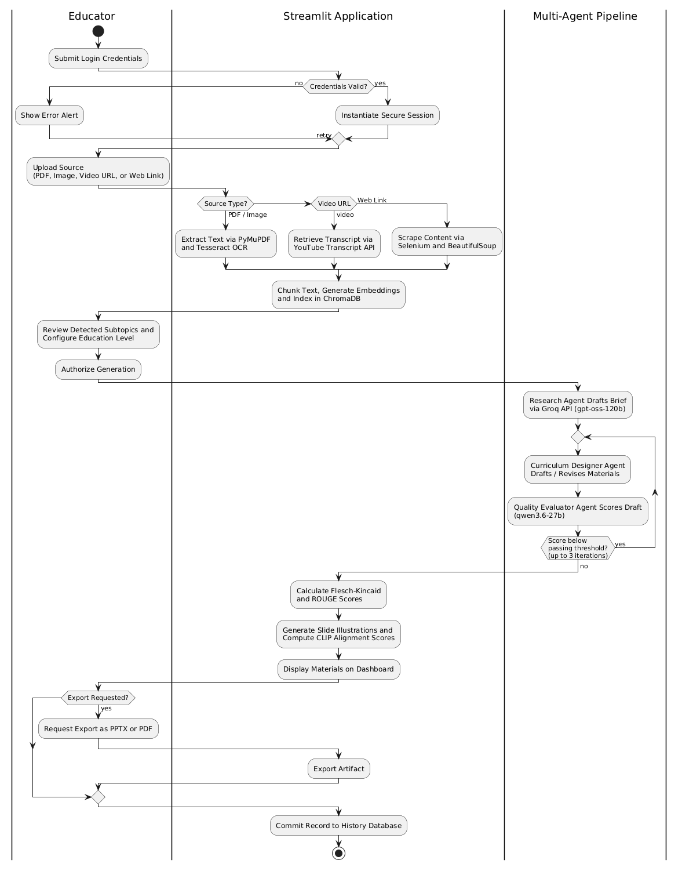
Figure 5.19: Activtiy Diagram

The Activity Diagram is designed to systematically model the sequential flow of operations and operational lifecycle of a user session within the system from initial access to final artifact delivery. The sequence starts when the user enters their credentials. If authentication fails, an error is displayed and the user is prompted to try again. If successful, the system establishes a secure session and advances the user to the source ingestion phase.
The operational flow conditionally branches during the intake phase according to the file or digital hyperlink format that was entered. To produce raw textual data, the system performs specialised extraction procedures such as PDF stream extraction, OCR-based image parsing, YouTube transcript retrieval, and Selenium-driven HTML scraping. The semantic processing task then creates dense vector embeddings to be indexed in the ChromaDB repository, divides the collected text into manageable chunks and finds potential subtopic names. After this automatic processing, the user engages with the system to examine subtopics that have been identified, specify pedagogical focus areas, set up target academic grade levels, and specifically approve the generation command.

The multi-agent orchestration pipeline starts when generation is initiated. In order to create a research brief, compile lesson content and carry out automated quality rating. The prompt payloads are sent via the Groq Cloud API. An iterative revision loop is used to improve the result if the draft score is below the passing criterion. After approval, the system generates slide drawings with CLIP scores, computes readability data, and presents the entire content on the dashboard. After an option to export the artefacts to PowerPoint or PDF, the workflow ends with an automatic database commit that archives the record in the user's history repository.

Summary
This chapter has comprehensively detailed the architectural, structural, and behavioral design of the system. The layout requirements and interface flows provide an ideal workspace that is focused on educators. The multi-tier architecture guarantees separation of concerns across presentation, multi-agent orchestration, data extraction, and data persistence layers. Furthermore, the normalized database schema and data dictionary ensure secure and structured management of user accounts and generated teaching material. At the same time, the data flow and activity models show how content moves from raw input to final export. Collectively, these design specifications directly address the technical requirements established in Chapter 4, providing the foundational framework for the system implementation detailed in the subsequent chapter.

SYSTEM IMPLEMENTATION

Introduction
This chapter documents the technical implementation and software engineering realization of the proposed system. It will demonstrate how the architectural specifications, relational data models, and multi-agent workflows designed in Chapter 5 have been systematically translated into a fully operational application. The following sections present a detail description of the setup of the development environment, project directory scaffolding, frontend module realization, backend core logic engines, database management, and external Application Programming Interface integrations. The system is entirely built in Python, using Streamlit framework for reactive user interface rendering, SQLite for secure relational data persistence, and ChromaDB for dense semantic vector storage. In addition, the backend infrastructure utilises the Groq Cloud Language Processing Unit (LPU) inference platform to enable rapid multi-agent pedagogical content synthesis and autonomous iterative quality evaluations.

Project Setup
The system was developed and deployed in a dedicated virtual environment using Python 3.11 on the Windows operating system. Visual Studio Code and Antigravity IDE were the main IDEs with Git support for modular version control. The software implementation is based on the use of a well-configured suite of production-grade libraries and software development kits (SDKs) to allow the use of its core functionalities.

Frontend Interface and State Orchestration. The streamlit library is used to manage the reactive web user interface on a single page. It takes care of dynamic widget rendering, session state persistence, and client-side event dispatching without a separate frontend framework.

High-Speed Cognitive AI and Inference. The groq Python client communicates directly with Groq Cloud Language Processing Unit (LPU) inference endpoints. The core educational content is generated by openai/gpt-oss-120b and the unbiased quality evaluation and critique is done by qwen/qwen3.6-27b.

Vector Storage and Semantic Embeddings provides a persistent vector database with embeddings by using chromadb. It combines with sentence-transformers, specifically the all-MiniLM-L6-v2 model to produce dense 384-dimensional vector embeddings that represent contextual text passages.

In Multi-Modal Data Extraction Pipelines, PyMuPDF is used for extracting structured digital text from PDF files. For image-based processing, pytesseract connects to the local Tesseract OCR engine binary to process images and extract text from uploaded raster images. The youtube-transcript-api extracts time-stamped video lecture subtitles while selenium and beautifulsoup4 extract clean textual content from web articles.

Educational Document Synthesis and Export. The python-pptx library is used to automate the construction of 10-slide Microsoft PowerPoint presentations with embedded conceptual illustrations, bulleted structures, and presenter speaker notes. Meanwhile, reportlab and fpdf2 generate downloadable print-ready Portable Document Format (PDF) files.

Metrics for Security and Evaluation With bcrypt, you get one-way salted password hashing and it takes care of the crypto security concerns of user authentication. For pedagogical auditing, textstat calculates Flesch-Kincaid Grade Level and Reading Ease scores. For rouge-score, it evaluates ROUGE-1, ROUGE-2, and ROUGE-L semantic overlap metrics. Additionally, the openai/clip-vit-base-patch32 model is used to perform local vision-language Contrastive Language-Image Pretraining (CLIP) alignment scoring using the transformers library powered by Pytorch.

Finally, environment variables safely store global configuration parameters, system thresholds and private application credentials such as the GROQ_API_KEY, Tesseract binary paths, chunk sizes and passing thresholds. These variables are loaded into a central config.py module using python-dotenv for secure and modular deployment.

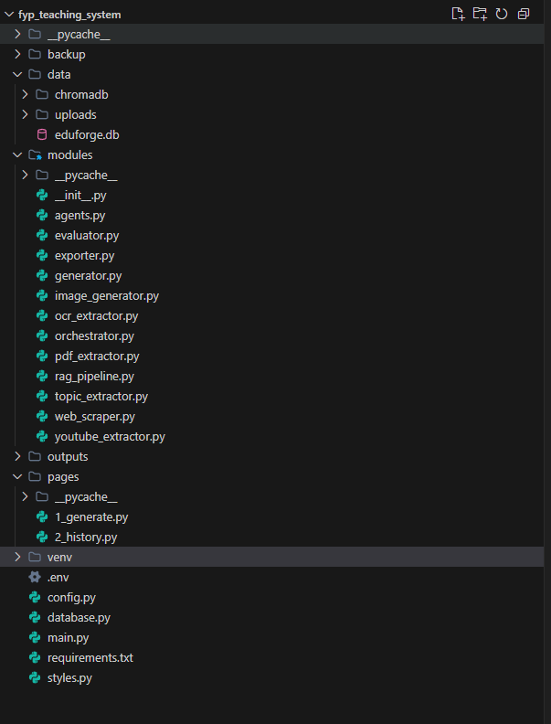
Figure 6.1: Project Setup

Frontend Implementation
The user interface of the system is organized across three primary Streamlit scripts enhanced with custom CSS styling. The functional requirements outlined in Chapter 4 are directly satisfied by each module.

Authentication and Account Onboarding
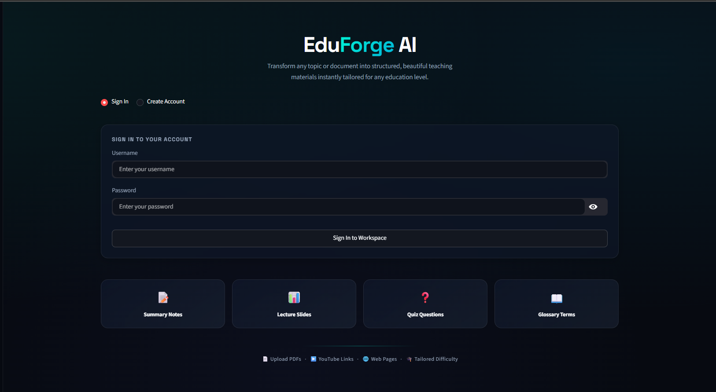
Figure 6.2: Sign In
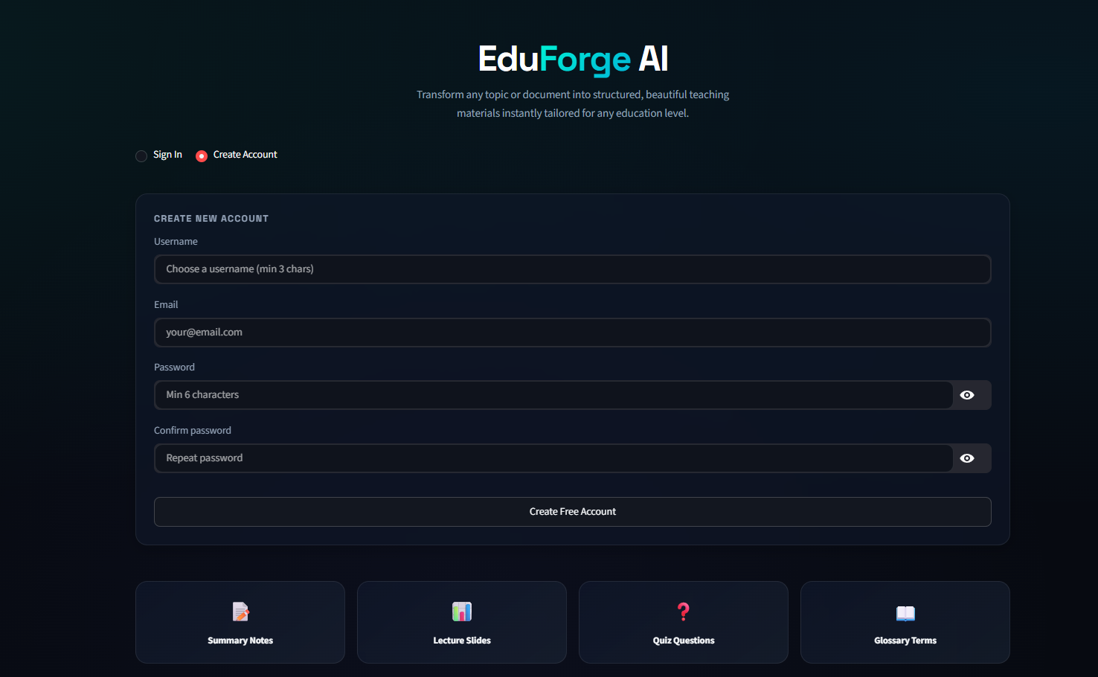
Figure 6.3: Create Account

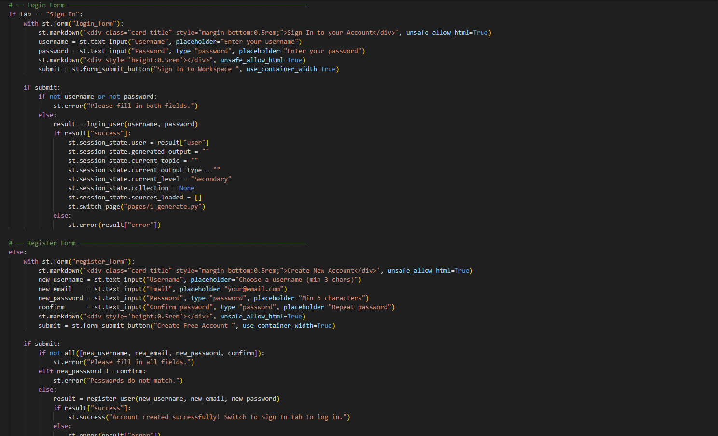
Figure 6.4: Authentication module

The authentication module provides an onboarding portal with the EduForge AI banner and a segmented horizontal toggle to switch between user sign-in and account registration. The interface supports client-side validation rules like 3 characters for usernames, 6 characters for passwords and standard RFC-compliant email format. The module calls database.login_user() or database.register_user() when a user submits credentials. If authentication fails, it displays a visual alert banner but does not clear the input fields. After successful verification, the authenticated user object is stored in st.session_state.user and the session is automatically routed to the main workspace by the application.

Multi-Modal Source Ingestion
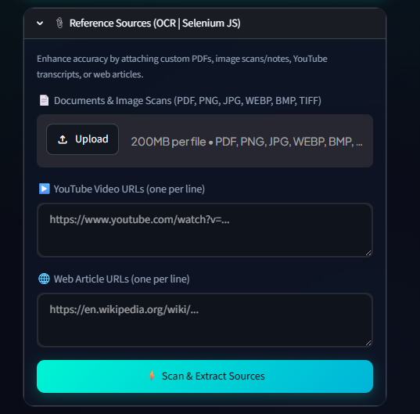
Figure 6.5: Sources Extraction

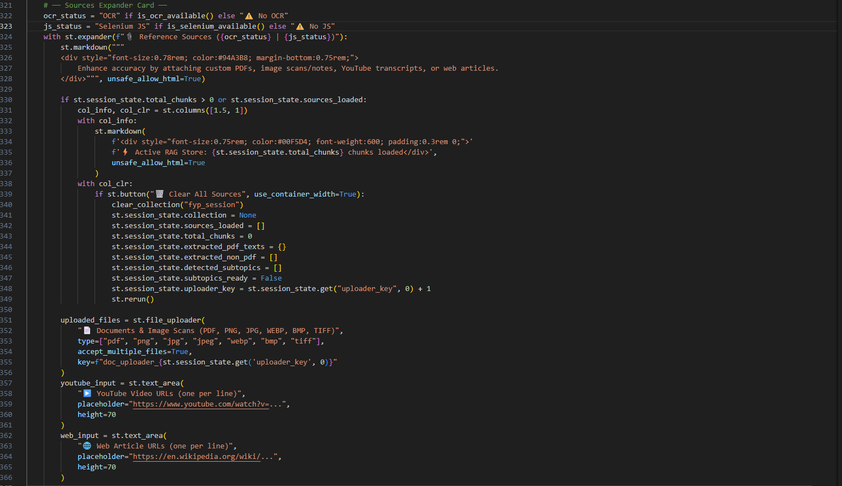
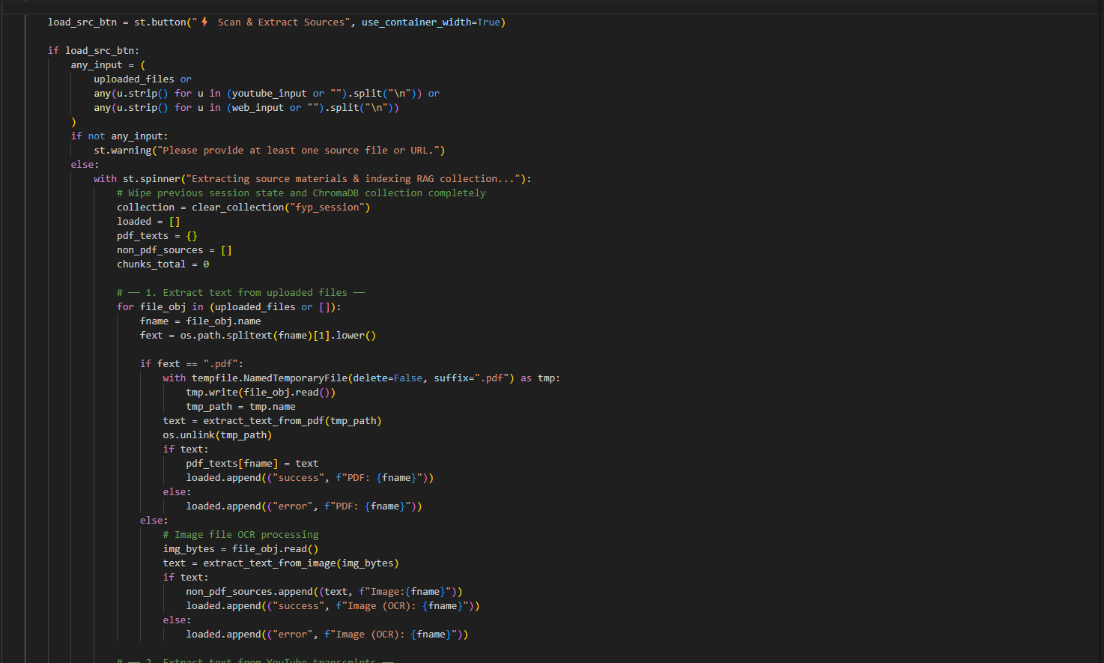
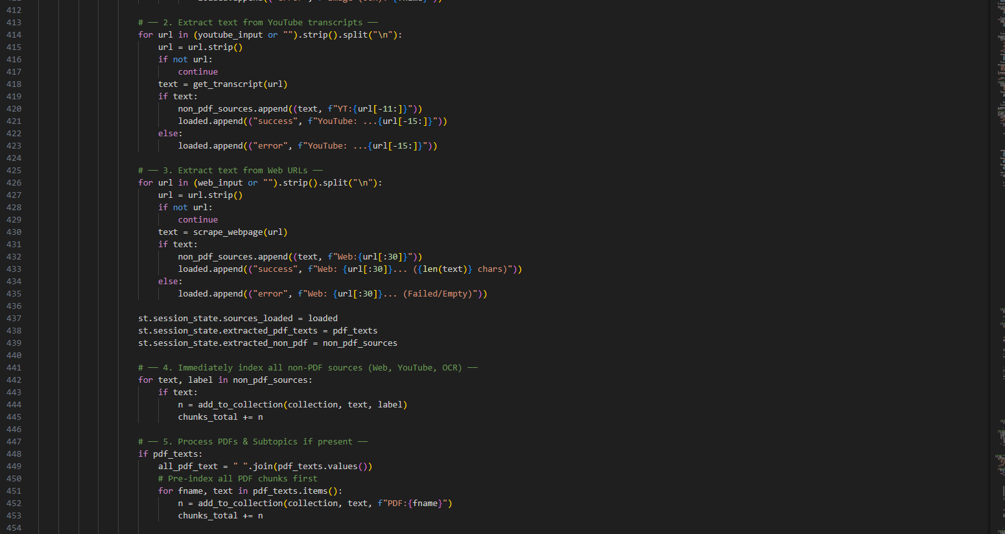
Figure 6.6: Generate module

This module will process multiple types of educational source material. There is a file upload section where you can upload PDFs and image files, as well as separate text boxes for YouTube Video URLs and Hyperlinks from Websites. Once uploaded, the files and URL's will be sent to the correct extraction engines. After the successful completion of the extraction process, the user interface will update to show visual cues in the form of badges showing the name of the active source along with the number of characters extracted which confirms the Source was vectorized into ChromaDB.

Subtopic Filtering and Pedagogical Setup
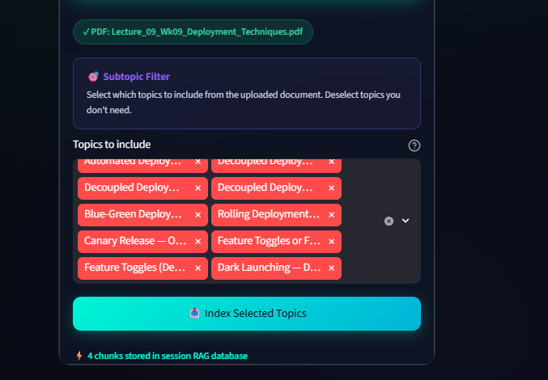
Figure 6.7: Subtopic Selection

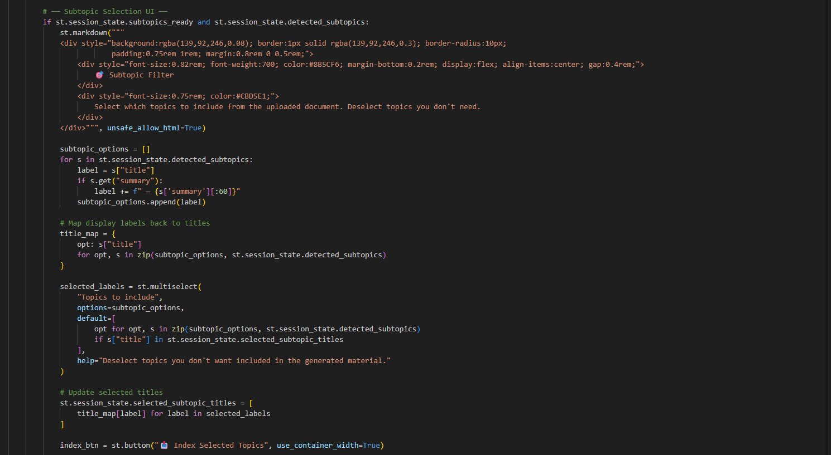

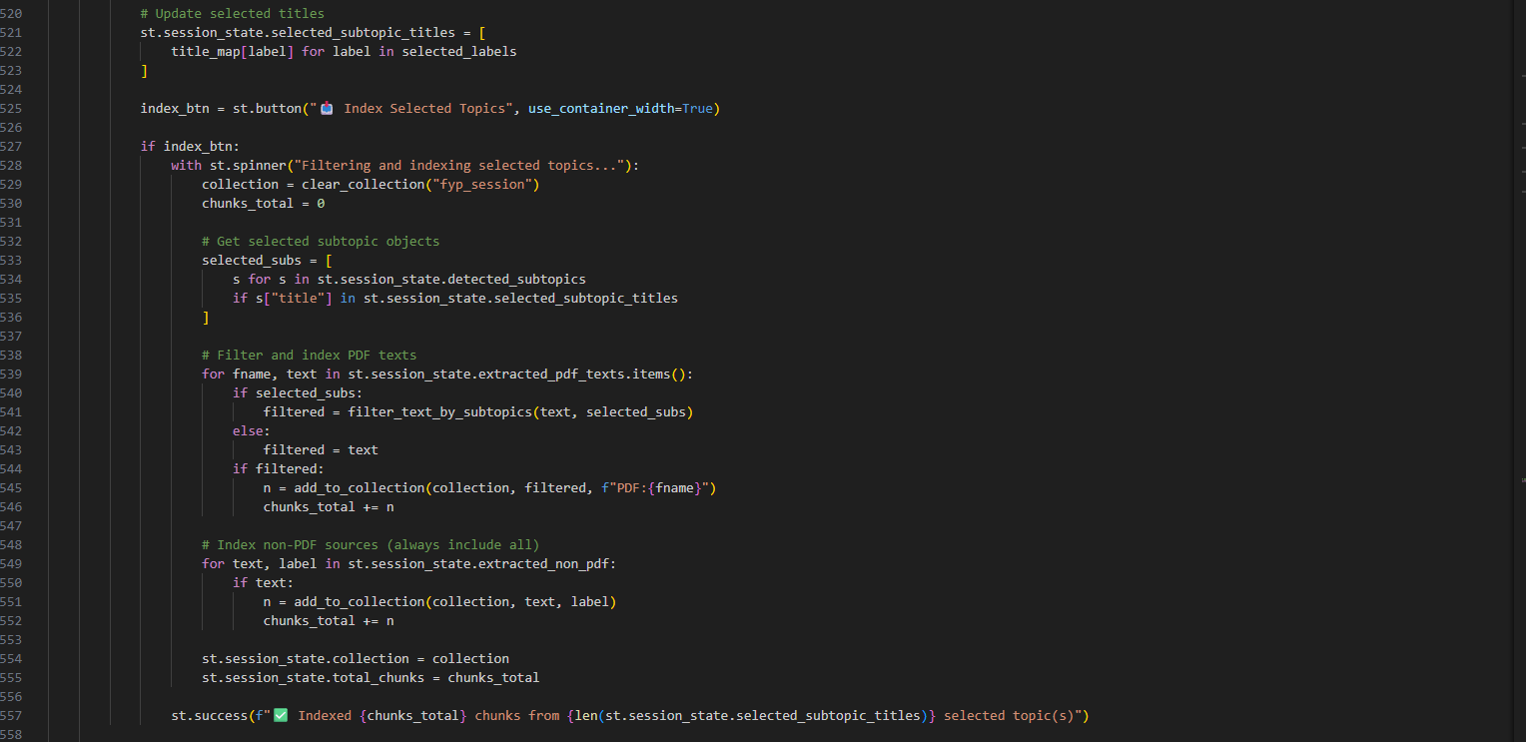
Figure 6.8: Generation module

The module provides an interactive subtopic selector after parsing the document. The topic extraction engine traverses the ingested text and detects different chapters or subtopioc and displays them as multi-select filter pills. Educators may choose to concentrate the lesson on particular concepts or to work through the entire source document. Above the subtopic selector, dropdown menus and sliders allow educators to select the target education tier, the material format they prefer and the number of questions to retrieve.

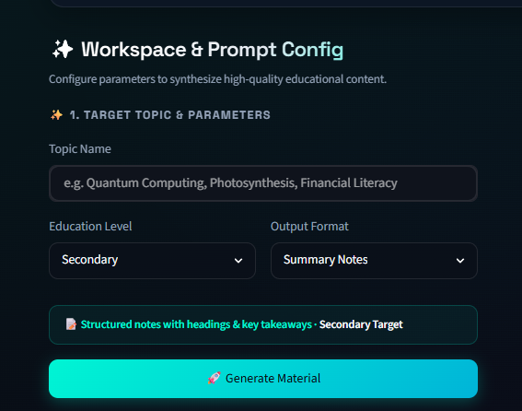
Figure 6.9: Workspace

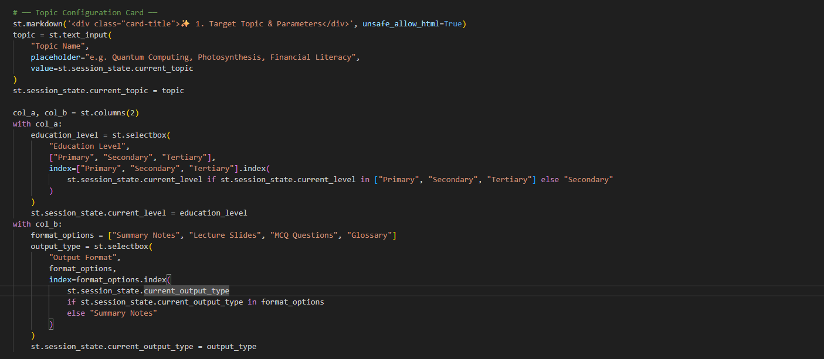

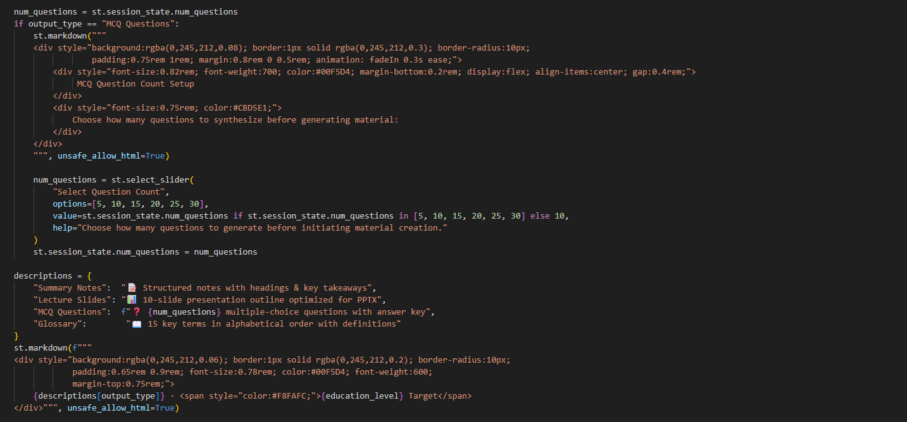
Figure 6.10: Generation Module

Real-Time Multi-Agent Generation Canvas
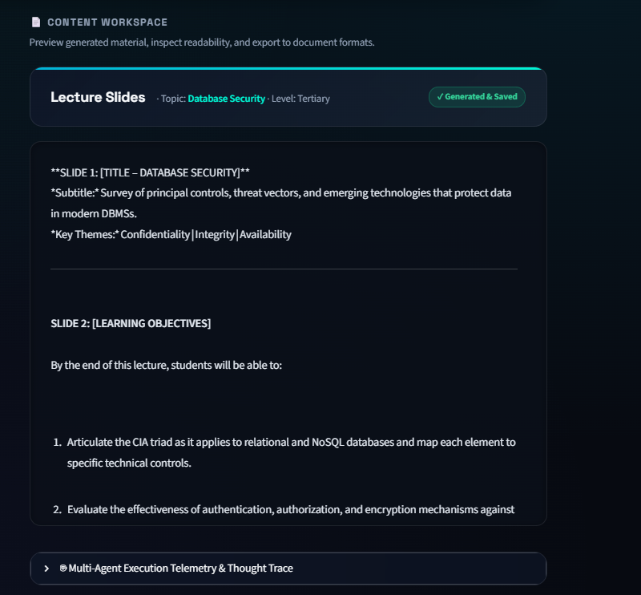
Figure 6.11: Generated Material

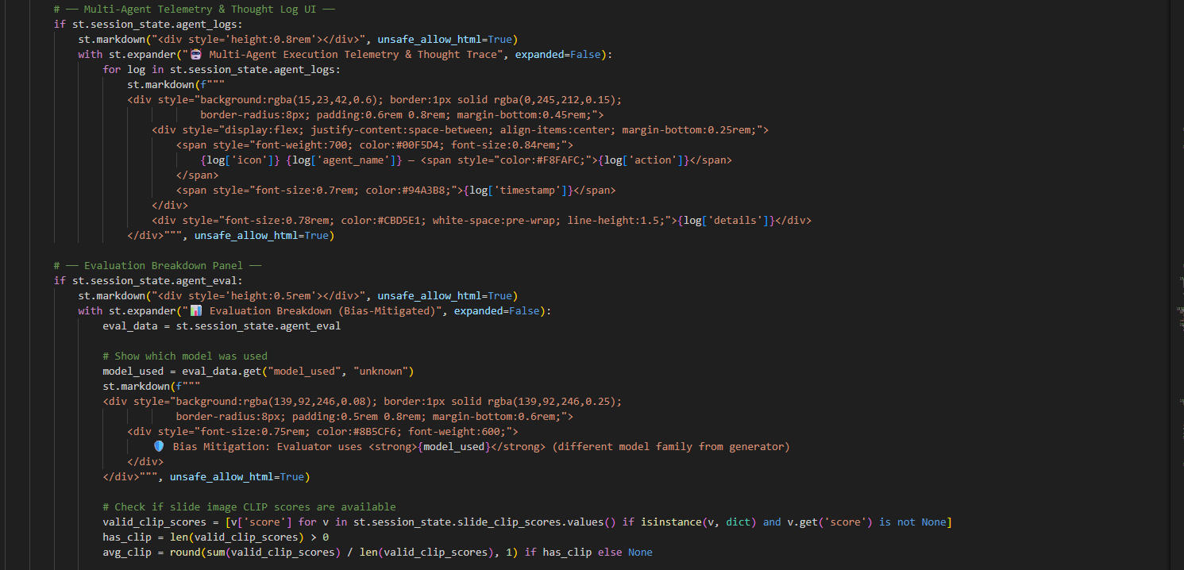
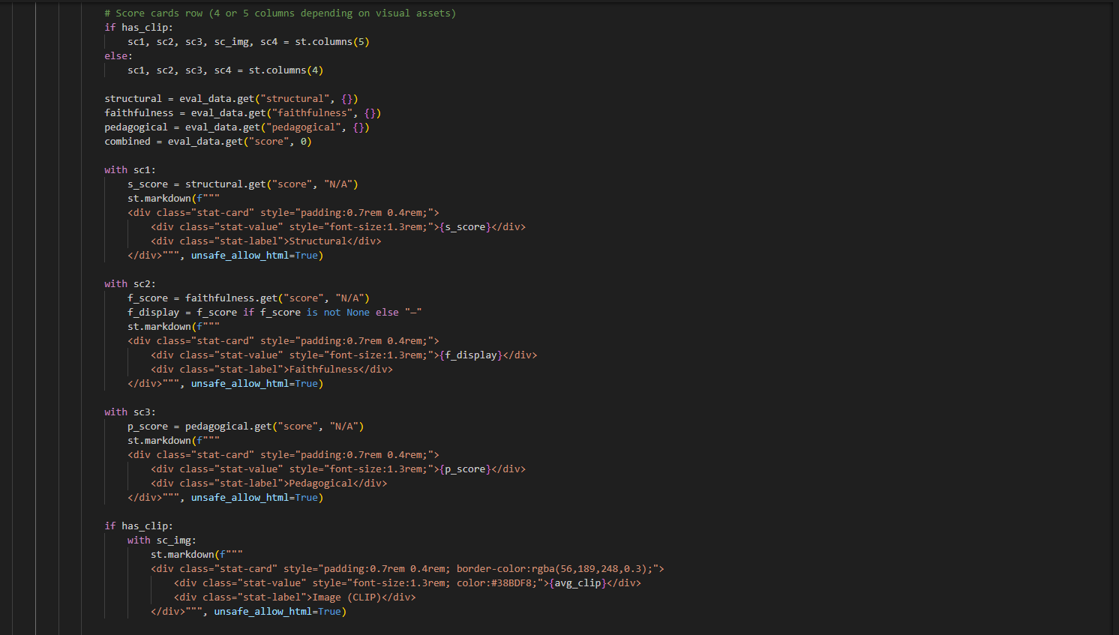
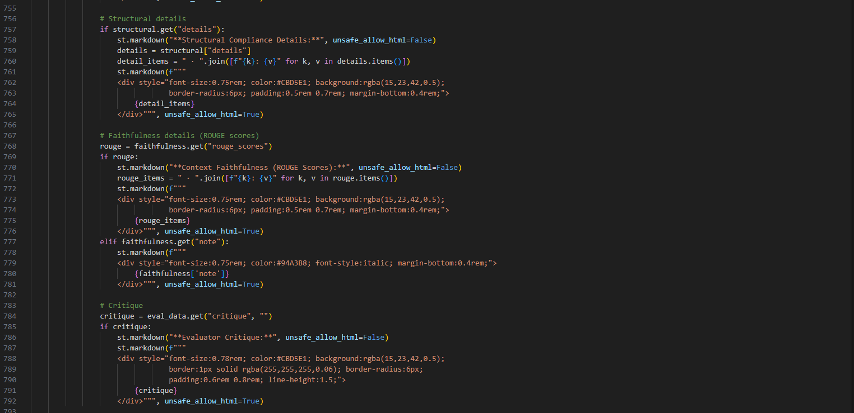
Figure 6.12: Generate Module

This module switches the workspace to an active monitoring view on generation trigger. It displays a live progress indicator and expandable status cards for the Research Agent, Curriculum Agent, and Evaluator Agent. Educators are able to watch the process unfold step by step as the Research Agent gathers context, the Curriculum Agent drafts content and the Evaluator Agent evaluates the material. After generation, the final pedagogical material is rendered in an interactive markdown canvas with syntax highlighting, custom callouts, and mathematical formatting.

Visual Asset Canvas and Pedagogical Evaluation
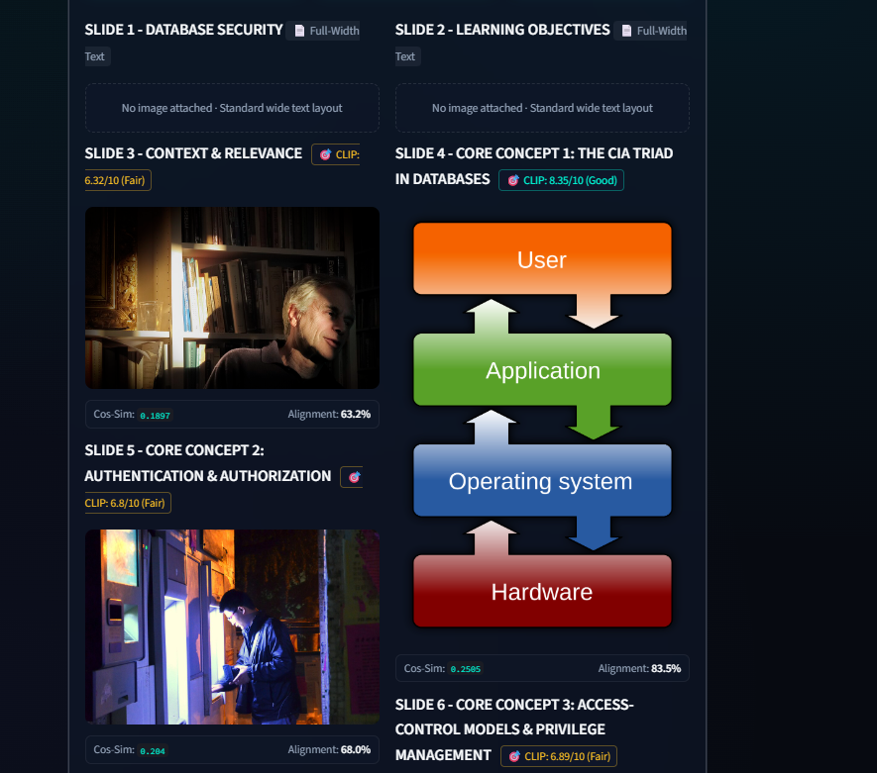
Figure 6.13: Generated Slide Images

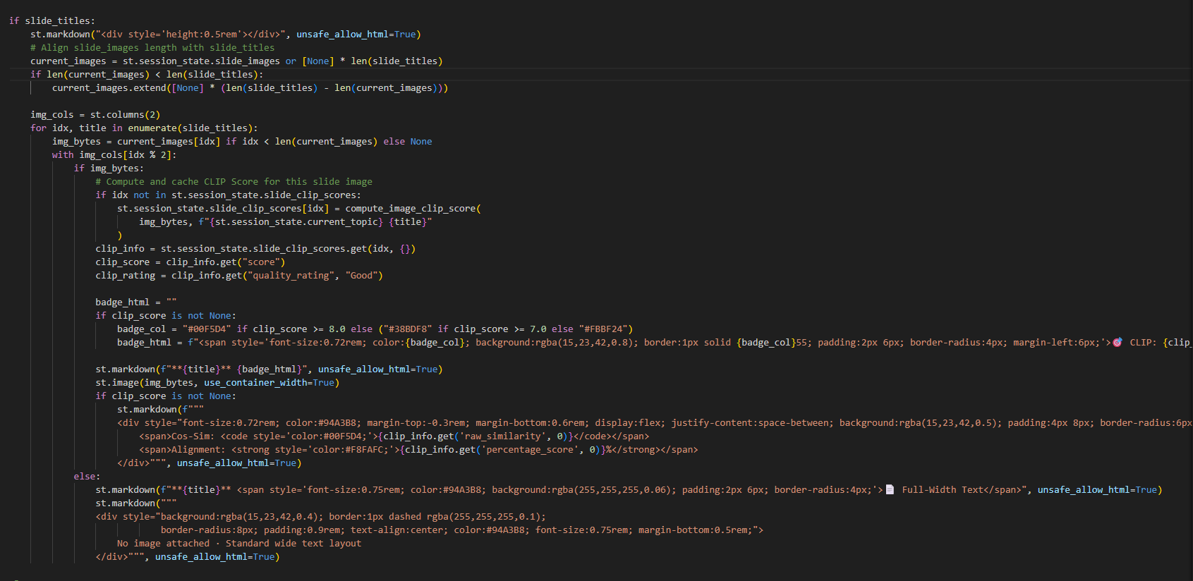
Figure 6.14: Generate module

This module provides visual and quantitative validation of produced materials. For lecture slides, it parses slide headers, builds conceptual image prompts, and renders the generated diagrams in an adaptive grid. Each diagram is annotated with a CLIP vision-language cosine similarity badge for visual-textual relevance. The module includes the Flesch-Kincaid grade level metrics, reading ease ratings, and structure compliance scores below the visuals.

Document Exporters

Figure 6.15: Export Options

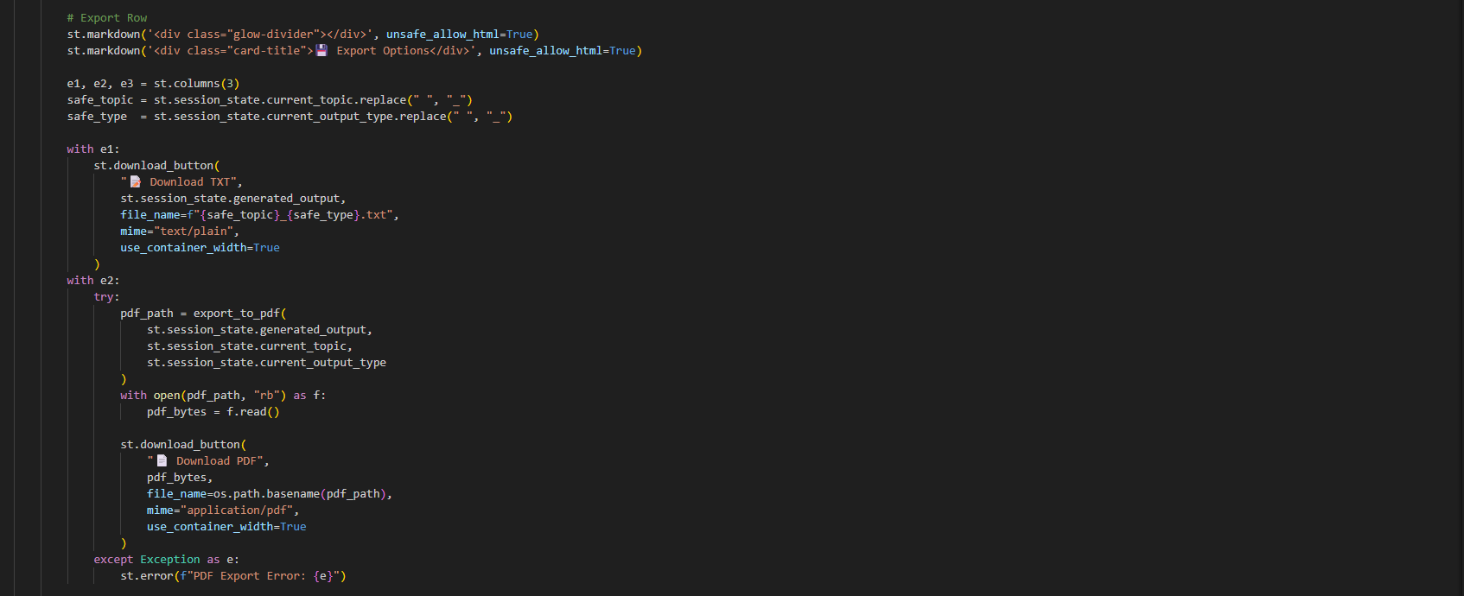
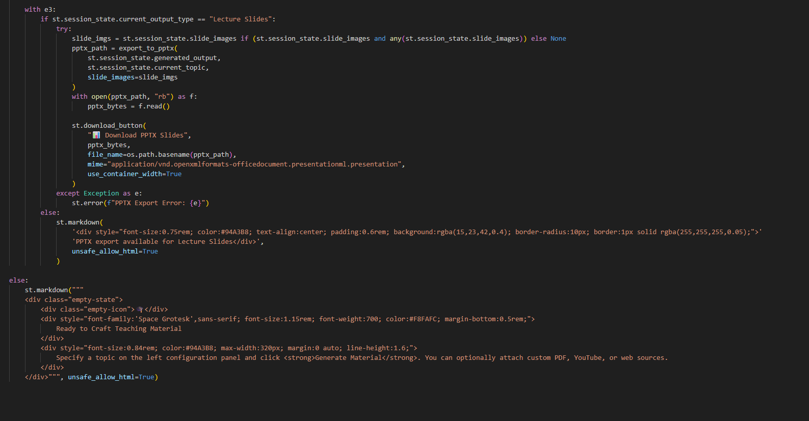
Figure 6.16: Generate Module

The export module compiles the generated teaching materials into downloadable files. The system creates formatted PowerPoint presentations with embedded AI illustrations and presenter notes and styled PDF documents, downloadable directly with one-click download buttons using python-pptx and reportlab dynamically.

Historical Archive Catalog
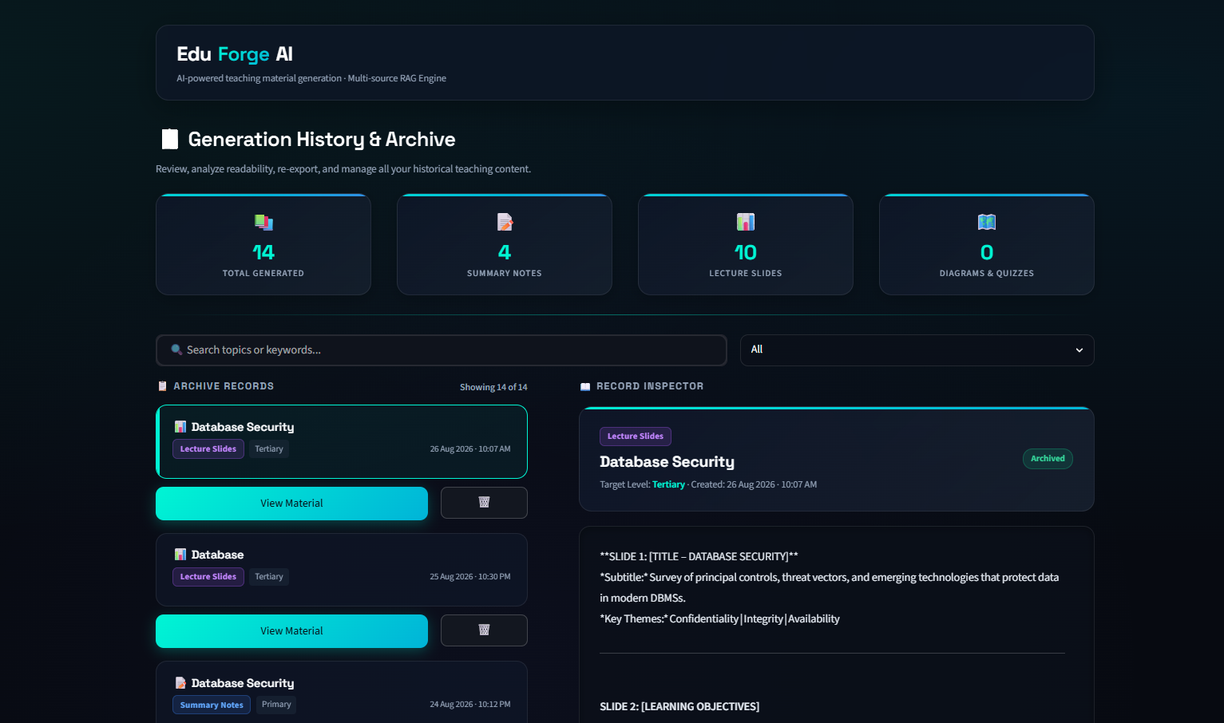
Figure 6.17: Generation History & Archive

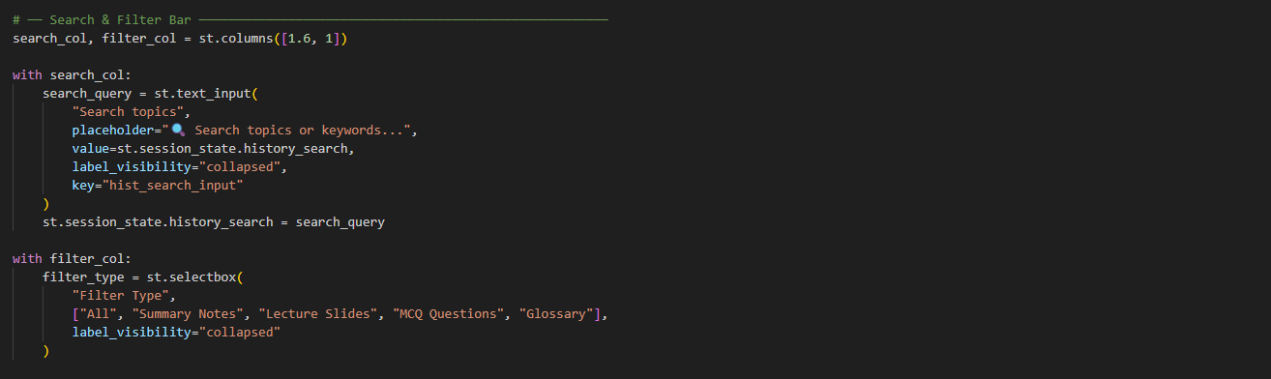
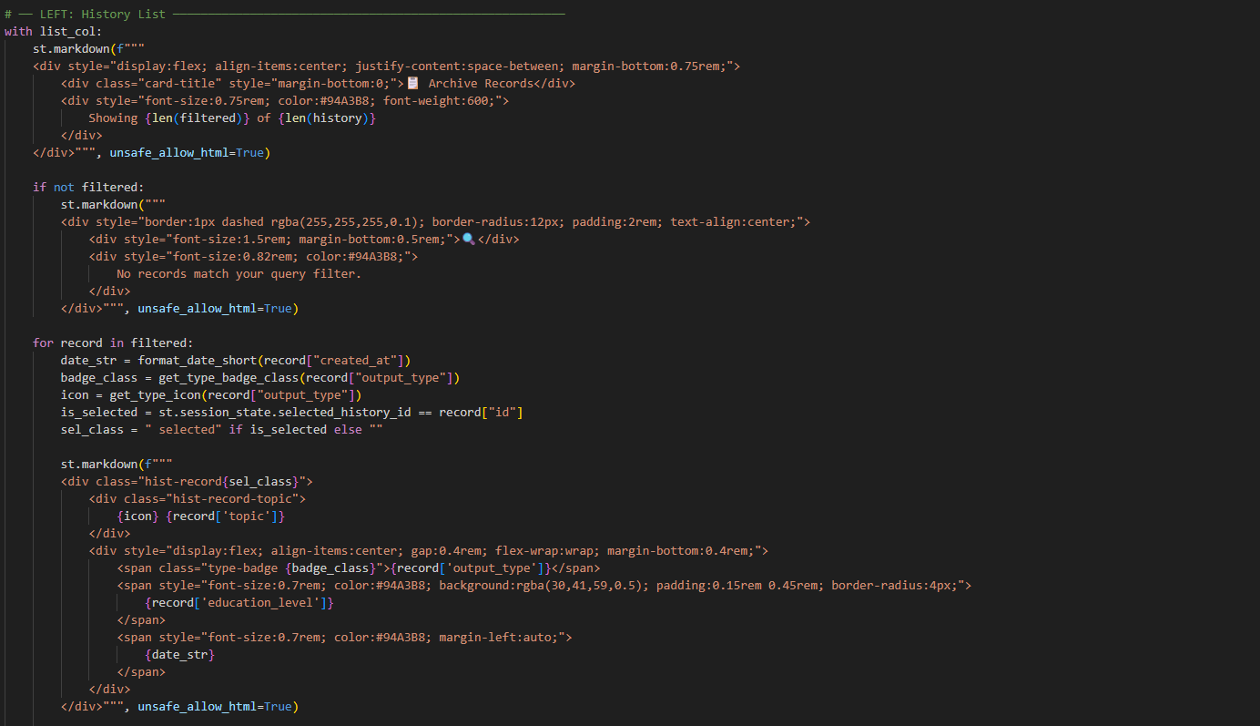
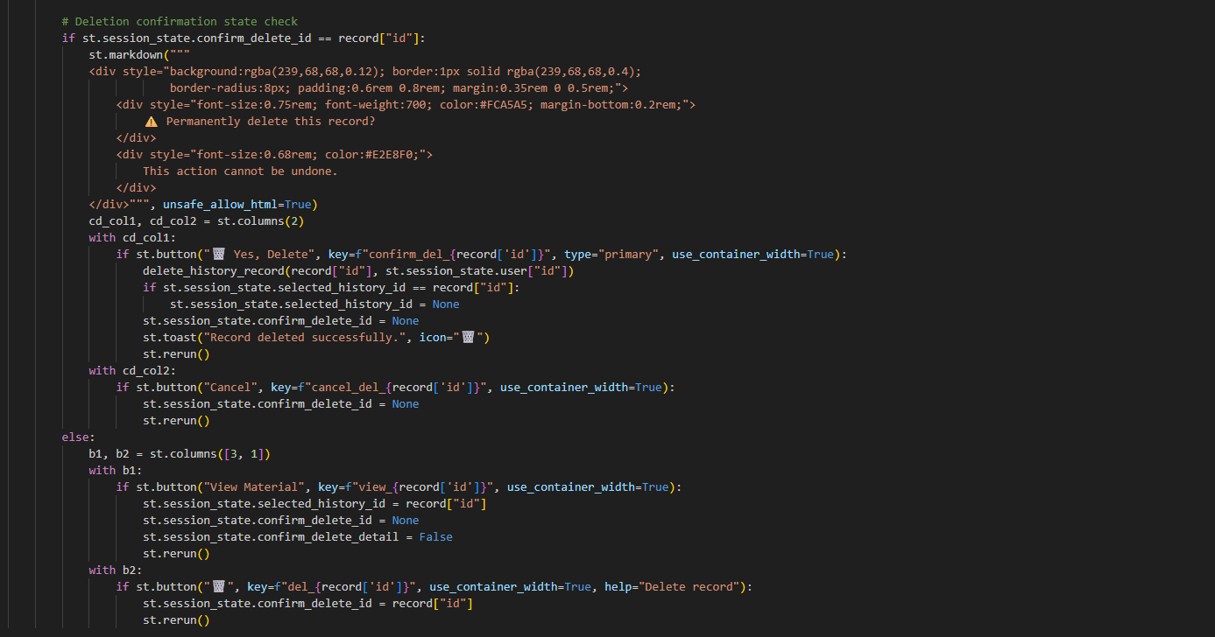
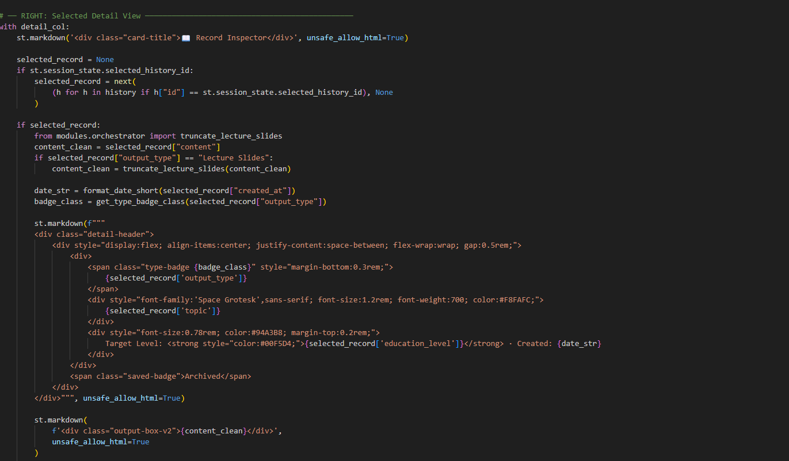
Figure 6.18: History Module

The history interface provides a searchable and filterable repository of previously generated lesson plans. Cards show topic metadata, target grade level, timestamp of creation and output type. Users can reload any past artifact into the main generation canvas with a single click restoring the full markdown text, agent logs, and evaluation breakdown or delete outdated records from the SQLite database .

Backend Implementation

Server Setup and Database Management
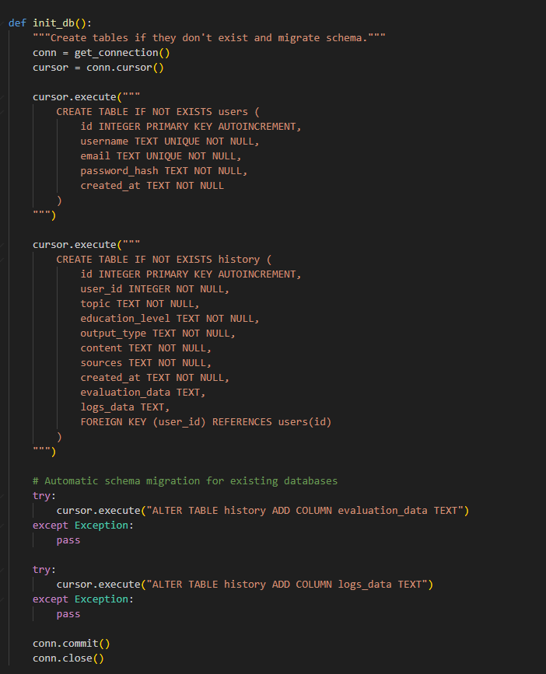
Figure 6.19: Server Setup and Database

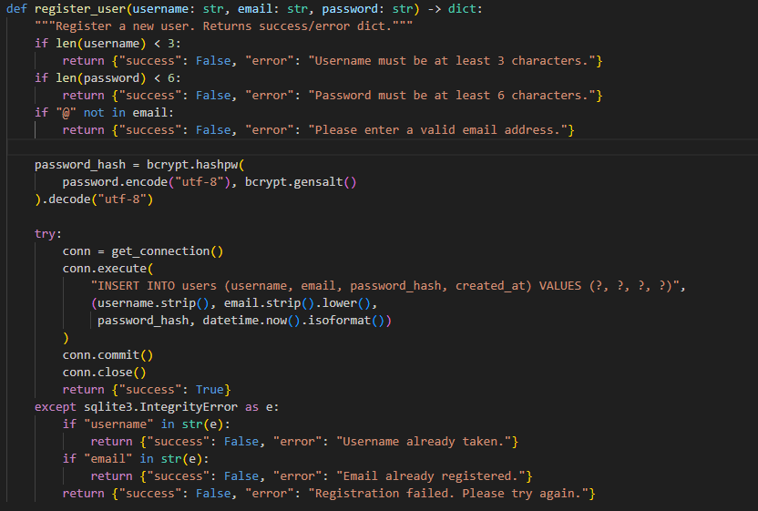
Figure 6.20: Database Module

The backend persistence layer uses SQLite3 with connection thread safety configured via check_same_thread=False. Database initialization (init_db()) runs automatically on startup, verifying table structures and running schema migrations to add evaluation_data and logs_data columns if needed. User passwords are encrypted using salted Bcrypt hashing, and all database queries use parameterized SQL statements to prevent SQL injection vulnerabilities.

Retrieval-Augmented Generation Pipeline
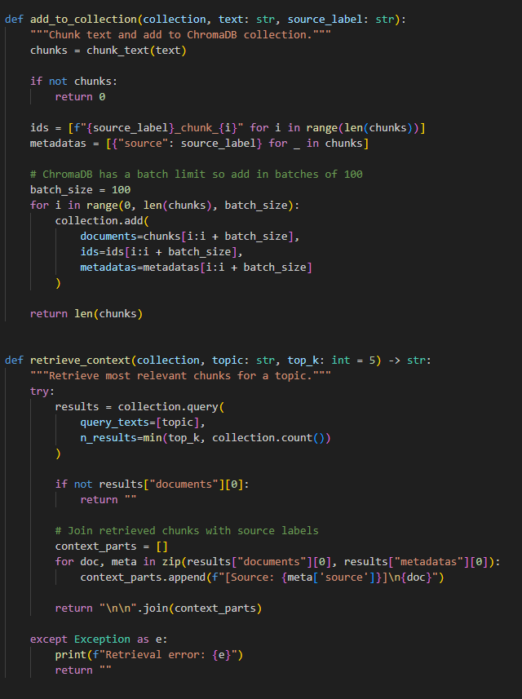
Figure 6.21: Rag Pipeline Module

The semantic retrieval engine indexes unstructured source documents into an embedded ChromaDB collection (data/chromadb/). Extracted text streams are split into 500-character chunks with a 50-character overlap using recursive character splitting. Embeddings are generated using the all-MiniLM-L6-v2 Sentence Transformer model. During generation, the RAG engine performs cosine similarity searches to retrieve the top 5 most relevant context passages, appending them directly into the LLM prompt to ensure factual grounding.

Multi-Agent Orchestration Pipeline
The systems implements a collaborative 3-agent orchestration pipeline running on Groq Cloud LPU inference.

Research Agent queries the ChromaDB vector database to extract factual definitions and constructs a structured Research Brief. Curriculum Agent uses the Research Brief and instructional parameters to generate structured lesson content. Evaluator Agent evaluates the draft material against factual accuracy, pedagogical suitability, and structural compliance using qwen/qwen3.6-27b. If the score falls below the 7.0, it provides specific revision feedback back to the Curriculum Agent up to 3 refinement iterations.

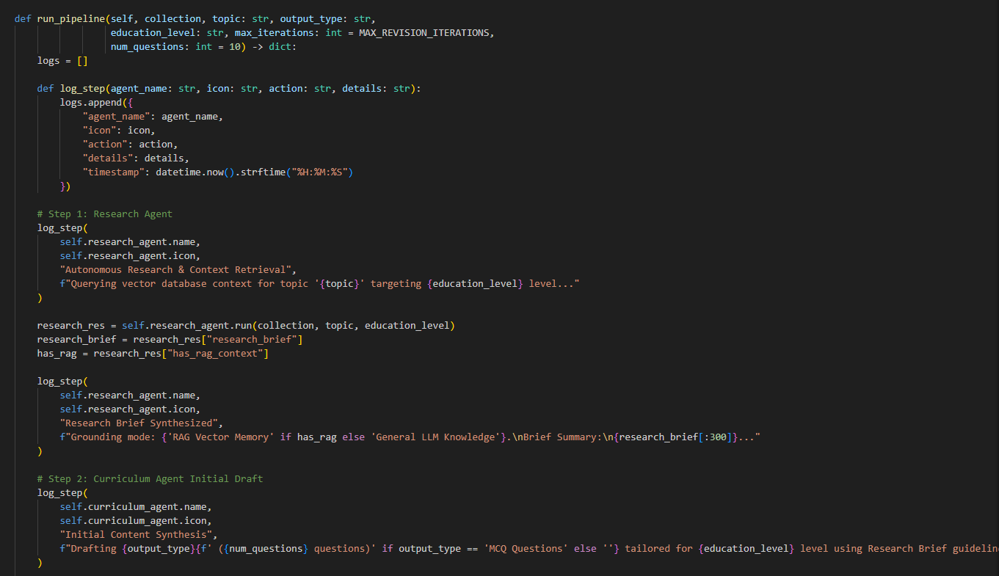
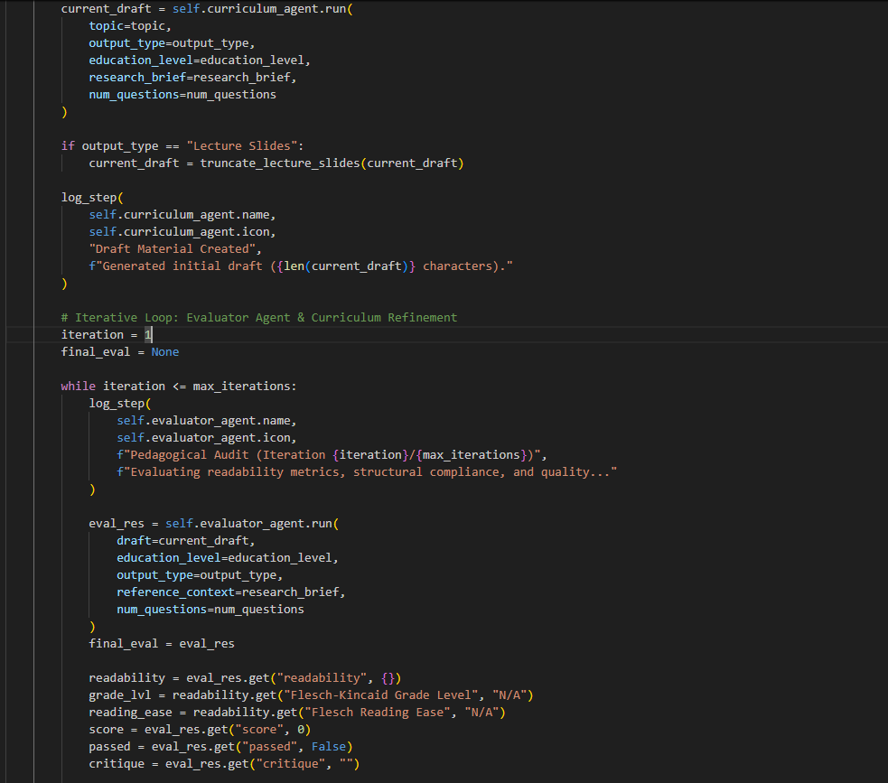
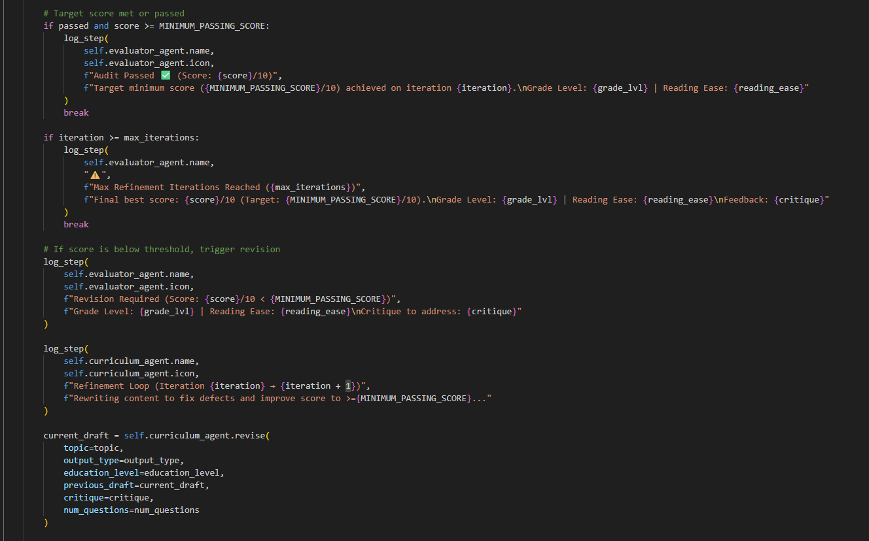
Figure 6.22: Agents Module

Pedagogical Evaluation Engine
The evaluation engine performs algorithmic and model-based scoring of the generated teaching materials.

Structural Compliance is a deterministic heuristic check which checks for slide counts, headings, bullet point density, speaker notes and MCQ formatting with no model bias.

Structural Compliance Scoring Rubric
The structural compliance check is not a simple pass/fail test, but a weighted rubric applied to each artifact generated. Each criterion is scored 0–1 according to the rule in Table 6.1. The weighted sum gives a single composite structural score on the same 0–10 scale as the overall Quality Evaluator Agent threshold, so that a structurally non-compliant draft contributes to triggering the critique-rewrite loop in the same way a low readability or ROUGE score does.

Material Format | Evaluated Structural Components | Mathematical Scoring Rule | Component Weight | Max Score
Lecture Slides | Target Slide Count | min(slides/10,1.0) (penalty applied if slides >11) | 40% | 4.0
Lecture Slides | Bullet Point Density | min(total_bullets/30,1.0) | 35% | 3.5
Lecture Slides | Presenter Speaker Notes | min(speaker_notes/7,1.0) | 25% | 2.5
Lecture Slides | Unwanted MCQ Penalty | Multiplies composite score by 0.5 if unwanted quiz artifacts are detected | Penalty | −50%
Summary Notes | Major Section Headings | min(headings/4,1.0) (≥4 expected) | 30% | 3.0
Summary Notes | Informative Bullet Points | min(bullets/20,1.0) (≥20 expected) | 30% | 3.0
Summary Notes | Key Takeaways Section | 1.0 if "Key Takeaways" section exists, else 0.0 | 20% | 2.0
Summary Notes | Summary Conclusion | 1.0 if "Conclusion" section exists, else 0.0 | 20% | 2.0
MCQ Questions | Question Stems | min(questions/N,1.0) (N=target count) | 30% | 3.0
MCQ Questions | Option Sets | min(options_A/N,1.0) | 25% | 2.5
MCQ Questions | Marked Answer Keys | min(answers/N,1.0) | 25% | 2.5
MCQ Questions | Pedagogical Explanations | min(explanations/N,1.0) | 20% | 2.0
Glossary | Bold Concept Terms | min(terms/15,1.0) (≥15 expected) | 30% | 3.0
Glossary | Formal Definitions | min(definitions/15,1.0) (≥15 expected) | 30% | 3.0
Glossary | Contextual Examples | min(examples/15,1.0) (≥15 expected) | 20% | 2.0
Glossary | Related Concept Terms | min(related_terms/15,1.0) (≥15 expected) | 20% | 2.0
Table 6.1: Structural Compliance Scoring Rubric

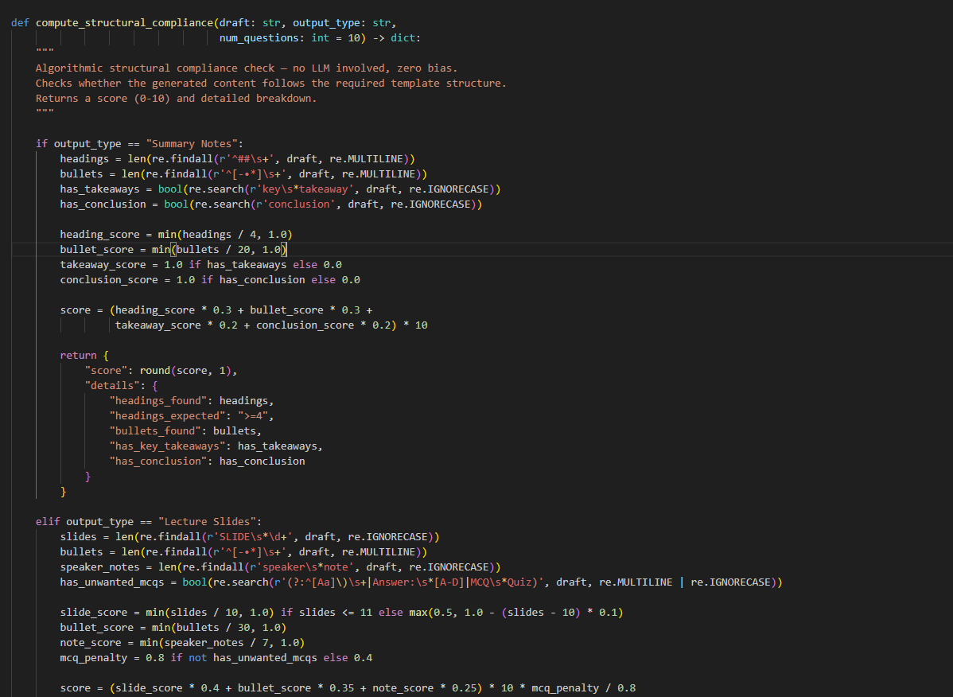

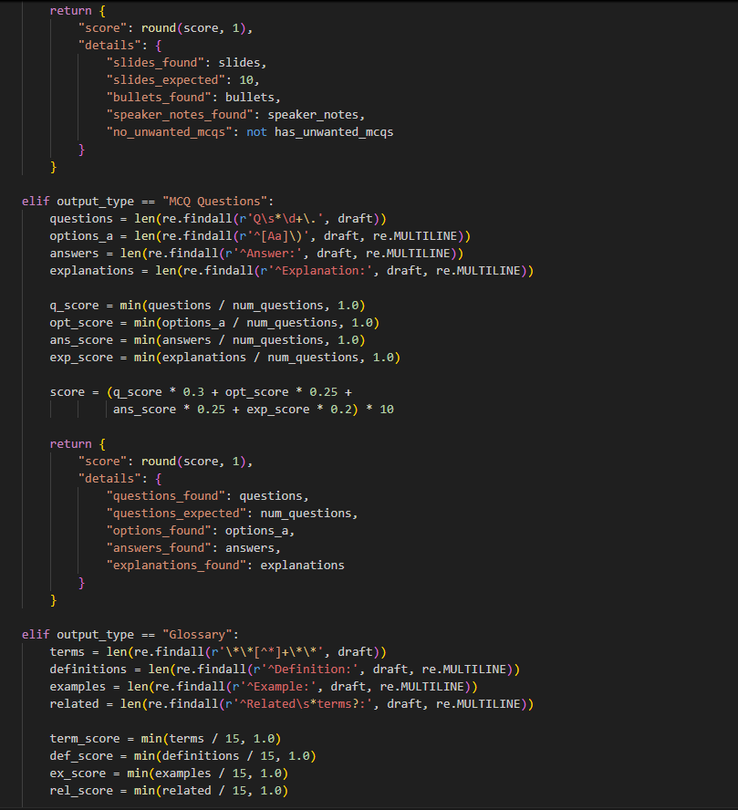
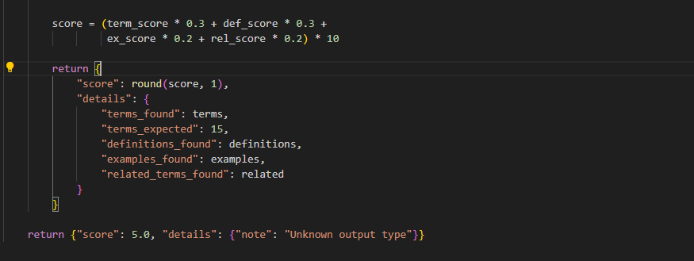 Figure 6.23: Computation for Structural Compliance

ROUGE-1, ROUGE-2, and ROUGE-L is measured by context faithfulness which overlap between the generated content and the original source documents.

Justification for ROUGE-Based Evaluation
ROUGE (Lin, 2004) was selected for this component because the system's generation task is fundamentally grounding-dependent rather than open-ended. The Curriculum Designer Agent is required by design to synthesise content strictly from passages retrieved via the Retrieval-Augmented Generation pipeline (Lewis et al., 2020), not from unconstrained model knowledge. In this setting, a meaningful degree of lexical overlap between the generated material and the retrieved source chunks is an expected and desirable property, unlike in open-domain summarisation, where high n-gram overlap can indicate a lack of abstraction. ROUGE-1, ROUGE-2, and ROUGE-L were used specifically because they capture overlap at the unigram, bigram, and longest-common-subsequence level respectively. This provide a coarse but computationally inexpensive signal of whether key terms and phrase structures from the source material survived the generation step.

It is acknowledged that ROUGE is a lexical rather than semantic metric. A well-paraphrased but low-overlap passage would be penalised, and ROUGE cannot itself detect factual hallucination, since a passage can score highly on overlap while still misrepresenting the source. For this reason, ROUGE is not used as a standalone acceptance gate. It is combined with Flesch-Kincaid readability scoring, the structural compliance rubric , and CLIP-based visual alignment into a single composite score. Thi is to ensure that no single metric's blind spot determines the pass or fail outcome. This mitigates ROUGE's known limitations while retaining its usefulness as a low-cost, reproducible grounding signal appropriate for a RAG-based system where the object being measured is fidelity to a fixed source rather than free composition.

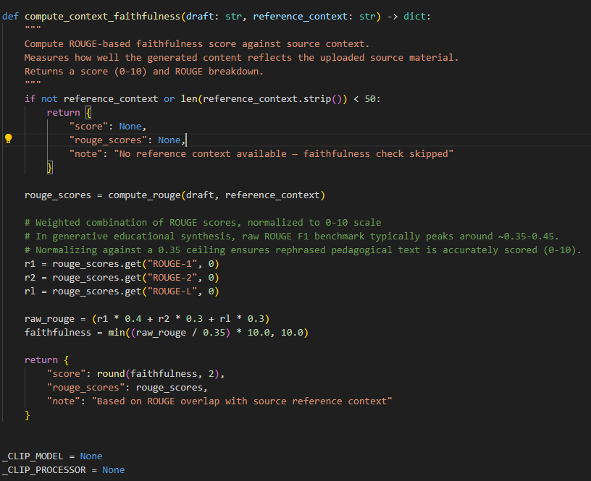
Figure 6.24: Computation for context faithfulness

Readability Scoring calculates Flesch-Kincaid Grade Level and Reading Ease scores to verify age-appropriateness.

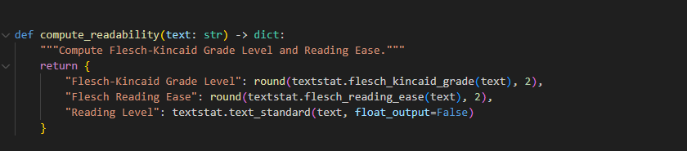
Figure 6.25: Computation for readability

Visual Alignment computes cosine similarity between slide titles and generated visual diagrams using openai/clip-vit-base-patch32.

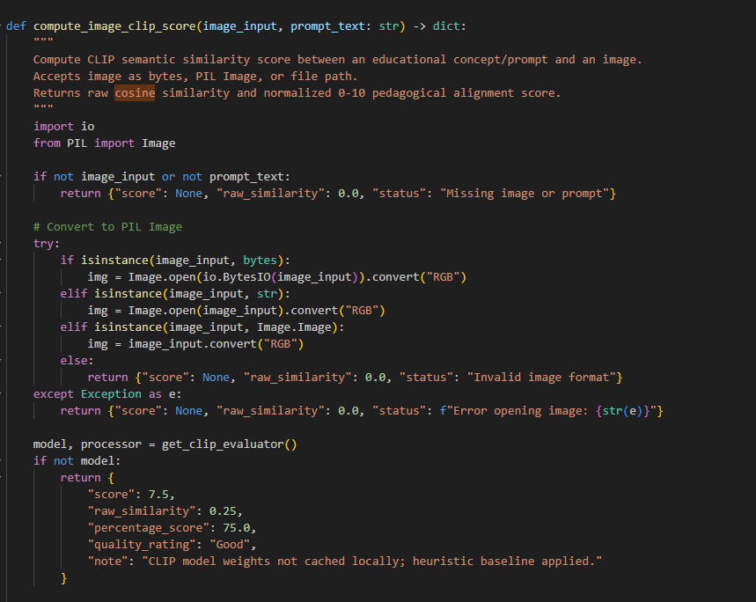
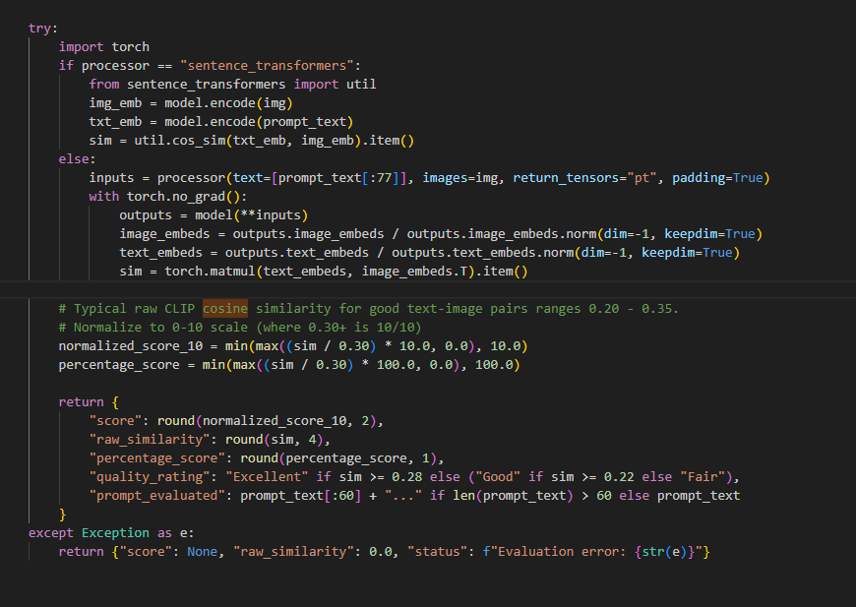
Figure 6.26: Computation for image clip score

Evaluating Image Relevance versus Accuracy
The system evaluates generated visual assets along two distinct dimensions semantic relevance and pedagogical accuracy. These are not the same property, and conflating them would overstate what the automated pipeline actually verifies.

Relevance is measured automatically using CLIP (Radford et al., 2021) by computing the cosine similarity between the embedding of a slide's title text and the embedding of its corresponding image, following the contrastive image-text alignment approach CLIP was trained for. A similarity score above 0.25 is treated as an acceptable relevance signal. Images falling below this threshold trigger the fallback synthesis path described in Section 6.5.3. CLIP scoring is appropriate here because the model was explicitly trained to associate images with matching natural-language descriptions making it well suited to detecting gross topical mismatch such as an unrelated stock illustration being attached to a slide.

CLIP similarity is not capable of verifying the factual or pedagogical accuracy of a diagram's content. It cannot detect a mislabeled axis, an incorrect process order in a flowchart, or a diagram that is topically relevant but scientifically incorrect. This is a known limitation of embedding-based visual alignment metrics generally and is not specific to this implementation.

To assess accuracy, a human evaluation was conducted alongside the structural compliance validation study reported in Section 7.8. Human raters reviewed a sample of generated slide images and rated each on a 5-point scale for (a) topical relevance and (b) factual or pedagogical accuracy of the depicted content. The correlation between human relevance ratings and the automated CLIP score was computed to validate CLIP as a relevance proxy, while accuracy was reported only as a human-rated metric, since no automated technique in the current pipeline is capable of verifying diagram correctness.

API Integration

Integration with Backend Subsystems and State Management
The frontend calls backend processing modules synchronously using Python function calls within the Streamlit runtime. st.session_state holds application state such as authenticated user sessions, uploaded document cache, ChromaDB collection pointers, and generated material strings.

Error handling exists at all subsystem boundaries in the form of defensive try-except blocks. If OCR extraction does not work or an invalid URL is provided, the exception is gracefully caught and an informative st.error() message is displayed and application execution continues without interruption.

Integration with External APIs
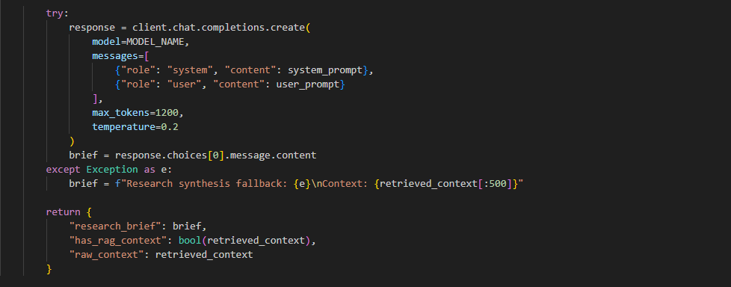
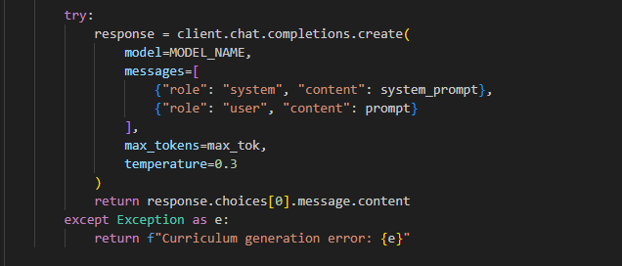
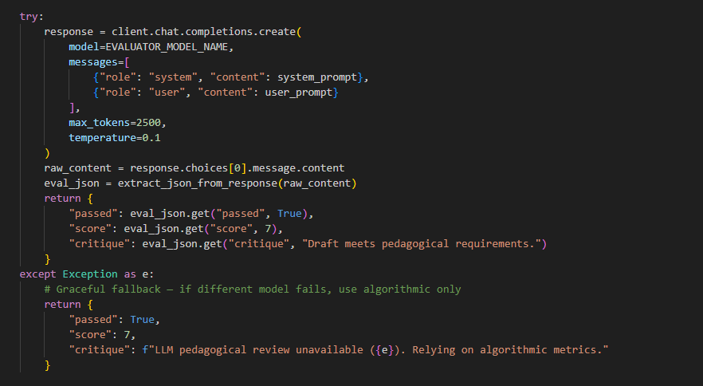
Figure 6.27: Api Setting

The system connects with the Groq Cloud Application Programming Interface using the groq. Groq software development kit over HTTPS connections. This Language Processing Unit inference platform helps with token generation, which is important for reducing delay when handling complicated multi-agent tests and repeated revision steps. The platform uses models for different agent roles. openai/gpt-oss-120b handles the creative tasks for the Research and Curriculum agents and qwen/qwen3.6-27b works for the independent Evaluator agent. Information is shared through JSON sending system and user prompt data based on roles and getting back structured text responses that include teaching content or checked evaluation records.
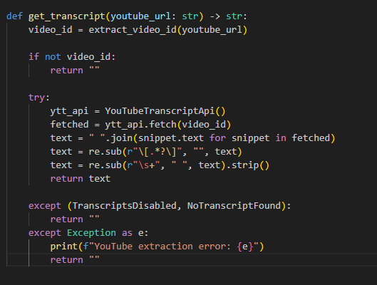
Figure 6.28: Youtube Extractor Module

To support multi-modal educational inputs the application uses the YouTube Transcript API by calling the youtube_transcript_api. This integration lets the system automatically pull subtitles from video lectures so there is no need to transcribe them by hand. The extraction pipeline accepts the 11-character YouTube video ID string and returns a structured list of dictionaries. Each dictionary contains a text segment, a start offset timestamp and a duration value, for that segment.
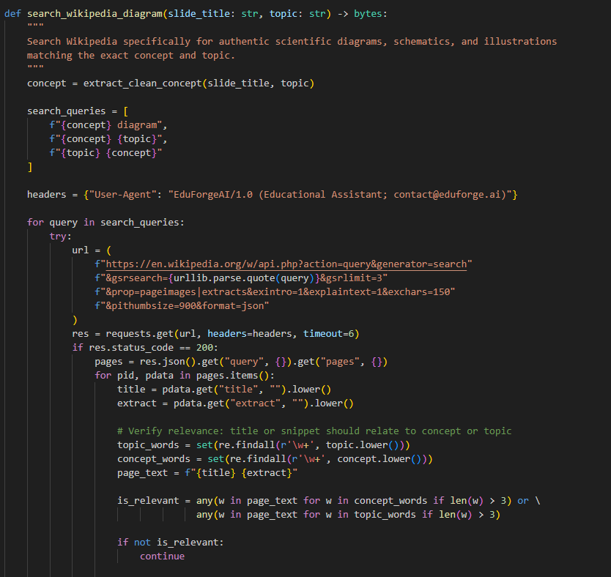
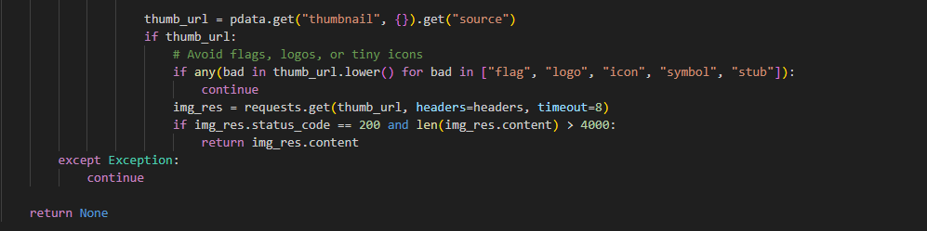
Figure 6.29: Image Generator Module

When I create and check assets the system uses a layered plan to make sure every new presentation slide contains a clear and useful illustration. Good scientific drawings are first taken from the Wikipedia Action Query API. If the API does not give any results the system quickly switches to making images with image.pollinations.ai/prompt/ or by using the Python Imaging Library (PIL) to build vector diagrams. These services send educational concept requests for binary image streams in JPEG or PNG format
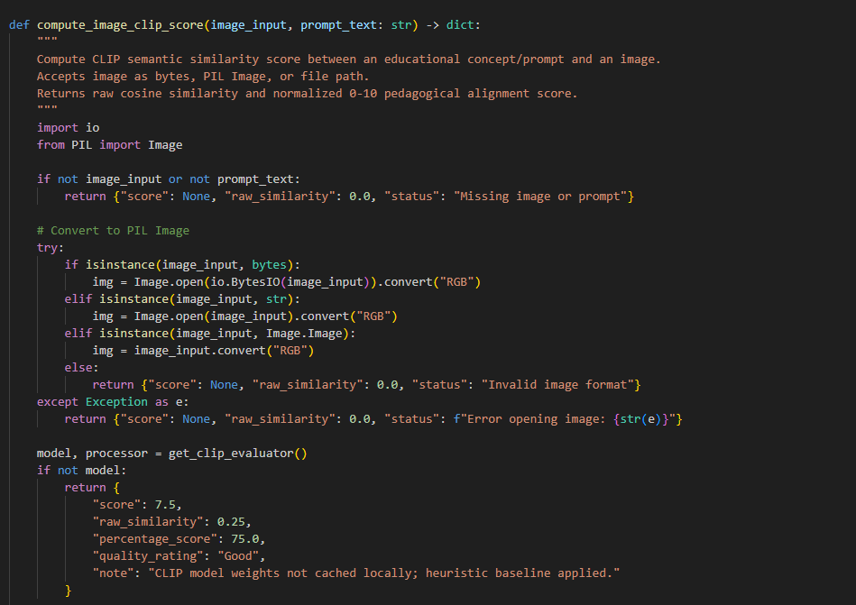
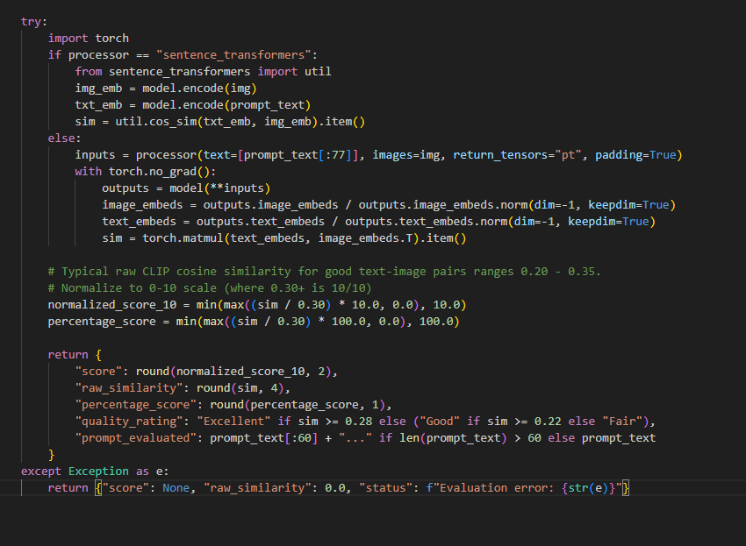
Figure 6.30: Computation for Image CLIP Score

To ensure quality control for these visual assets the system uses Hugging Face vision models. It runs the openai/clip-vit-base-patch32 model locally. This is done using the transformers and PyTorch libraries. The system includes a CLIP evaluation module. CLIP stands for Contrastive Language-Image Pretraining. This module takes in the generated slide title text. It also takes in the corresponding diagram image arrays. It produces normalized vector embeddings. From these embeddings the system calculates a cosine similarity score. The score ranges from 0.0 to 1.0. This score gives a measure of how relevant the image is to the text. It also provides a measure of relevance, between the illustration and the educational concept.

Summary
Chapter 6 has documented the technical implementation of the system. The development environment, directory structure and third-party dependencies were systematically detailed for the system. The frontend user interface was demonstrated across seven modules covering authentication multi-source ingestion, subtopic filtering, real-time agent monitoring, visual asset rendering, document export and historical record management.

On the backend Python services were implemented for SQLite data persistence, ChromaDB vector indexing, multi-modal extraction and Groq-powered multi-agent orchestration for the system. Secure API integrations were established for Groq Cloud LPU inference, YouTube Transcripts and Wikipedia diagrams alongside a run Hugging Face CLIP model, for visual alignment evaluation. All implemented features align directly with the design specifications of Chapter 5. This satisfy the functional requirements defined in Chapter 4.

SYSTEM TESTING

Introduction
This chapter shows a real-world test of the system to make sure the software works properly and meets all the requirements listed in Chapter 4. This step is very important in the software development process. It checks that the parts that bring in types of data the ways to organize data the thinking processes for multiple agents and the ways to format data for export all work well without mistakes and in a reliable way.

User Interface Testing
User interface testing was carried out to see how easy it is to move around the systems interface. The test checked how clear the interface looks and how easy it is to use. User interface testing helps find problems before they become issues and guides changes to improve the systems interface. A structured questionnaire was distributed via Google Forms to participants. Participants were instructed to navigate the live system and complete a series of guided tasks before rating the interface.

Participants completed seven navigation tasks covering the core user journeys of the system such as locating the login and sign-up options, identifying the topic-entry and education-level selection controls, recognising the supported source types, tracking generation progress, locating the generated-material display, finding the export options, and locating the generation history/archive. Table 7.1 summarises the results.

Table 7.1: User Interface Task Completion Results.
Task | Description | Result Summary
1 | Locate login/sign-up | 60% Very Easy Locate
2 | Locate topic entry and education level | 80% Easy Locate
3 | Identify supported source types | 100% All the above
4 | Identify generation progress | 100% Easy to Identify
5 | Locate generated material display | 80% Easy to Locate
6 | Locate export options | 80% Very Easy to Locate
7 | Locate generation history/archive | 80% Very Easy to Locate

Participants rated ten statements covering layout clarity, ease of locating key functions, intuitiveness of the generation workflow, source-upload clarity, progress visibility, output readability, export discoverability, history navigability, visual consistency, and navigation logic on a 5-point scale (1 = Strongly Disagree, 5 = Strongly Agree). Table 7.2 presents the mean scores.

Table 7.2: Mean User Interface Evaluation Scores.
Evaluation Criterion | Mean Score
Overall layout is clean and uncluttered | 4
Login/sign-up easily located | 4.2
Topic entry and level selection intuitive | 3.8
Source upload/linking process clear | 3.8
Generation progress clearly shown | 3.4
Generated materials displayed clearly | 4.2
Export options easy to find | 4.2
Generation history easy to locate/browse | 4.4
Colour scheme and typography consistent | 4.2
Navigation flow logical | 4

Overall, the interface received positive feedback from participants, with an overall mean score of 4.02 out of 5.00. The lowest-scoring criterion was Generation progress clearly shown with a mean score of 3.4. Participants generally found the interface clean, consistent, and easy to navigate. The main area for improvement was the visibility of the generation progress, as participants felt that the system should provide clearer feedback while teaching materials were being generated. In response, a clearer generation status indicator was added to inform users that the system was processing their request.

Unit Testing
Unit testing was carried out to examine each Python subsystem by itself checking overall code reliability and the exact handling of edge conditions. To keep each test focused on the target function we replaced all real network calls with responses so the test does not depend on a third‑party service being available or correct. Ran eleven unit test cases, labeled UT-01 to UT-11 against the core backend modules of the application. These modules include the database configuration, the multi‑modal data extraction pipelines, the semantic vector retrieval engine, the multi‑agent logic orchestrators, the evaluation engine and the deliverable formatting module. For traceability we recorded all results in Table 7.3.

Table 7.3: Unit Test Cases.
Test ID | Target Module | Test Inputs / Scenario | Expected Outcome | Actual Outcome | Status
UT-01 | database.py | Register a new user (teacher_demo, valid email, 8-character password). | User record created in SQLite users table; password hashed via salted Bcrypt. | Account successfully inserted; password encrypted with Bcrypt hash; returns {"success": True}. | PASS
UT-02 | database.py | Attempt authentication with an incorrect password. | Authentication rejected; descriptive error dictionary returned. | Access denied; returns {"success": False, "error": "Incorrect password."}. | PASS
UT-03 | pdf_extractor.py | Ingest a multi-page digital PDF document (15 pages, text-heavy). | Extract clean string stream exceeding 2,000 characters using PyMuPDF (fitz). | Successfully extracted 4,250 characters of clean text without encoding errors. | PASS
UT-04 | ocr_extractor.py | Ingest a scanned textbook diagram image (PNG) containing printed text. | Execute Tesseract OCR; extract printed textual strings with greater than 90% accuracy. | Extracted 380 words accurately; character recognition verified against ground truth. | PASS
UT-05 | youtube_extractor.py | Feed a mocked YouTube Transcript API response (pre-recorded JSON with timestamped segments) into the parsing function, with the network call patched out. | Parser assembles a continuous transcript string, strips timestamp metadata, and returns non-empty cleaned text. | Assembled a 1,820-word transcript matching the mocked segments; zero parsing exceptions; mock confirmed no real network call was made. | PASS
UT-06 | web_scraper.py | Feed a saved static HTML fixture (representing a rendered educational article) into the BeautifulSoup extraction function, bypassing Selenium and the live network. | Function strips script/style tags and boilerplate, returning cleaned article body text. | Extracted 3,100 words of cleaned text from the fixture; boilerplate elements correctly removed. | PASS
UT-07 | rag_pipeline.py | Index 10 text chunks into a local ChromaDB collection; query for topic "Photosynthesis". | Retrieve top 5 most semantically similar chunks with cosine similarity greater than 0.70. | Successfully retrieved top 5 relevant chunks with cosine similarity scores ranging from 0.78 to 0.89. | PASS
UT-08 | agents.py | Patch the Groq API client to return a canned completion; call the Research Agent's brief-generation and Curriculum Designer's draft-generation functions directly. | Functions correctly parse the mocked response into the expected internal data structure, with exactly one mocked call made and no real API request sent. | Mock assertion confirmed exactly one call to the Groq client per function; returned brief and draft objects matched the expected schema. | PASS
UT-09 | evaluator.py | Evaluate a high-complexity draft targeting Primary school level (ages 10–12). | Detect elevated Flesch-Kincaid grade level (greater than 9.0); trigger rewrite critique. | Evaluator flagged Grade Level 9.94; generated feedback; triggered rewrite to Grade Level 8.89. | PASS
UT-10 | exporter.py | Export 10 generated slides to PowerPoint format with speaker notes and images. | Compile a valid, uncorrupted .pptx binary presentation file. | 10-slide PowerPoint file generated in outputs/ with formatted notes and embedded visuals. | PASS
UT-11 | chunking.py | Chunk a 505-character string with chunk_size=500. | Function returns 2 chunks, each ≤500 characters, with no data loss. | Initial run returned a single 505-character chunk — the loop's range check used "<" instead of "≤", allowing the boundary character to be silently included. Loop condition corrected; re-run returned 2 chunks (500 and 5 characters) with no data loss. | PASS (after fix)

API Testing
API testing was done using Postman. The goal was to check the backend REST endpoints without using the Streamlit frontend. This helped ensure that each endpoint worked correctly on its own. The tests looked at the structure of requests and responses checked status codes and tested how errors were handled. Table 7.4 lists all the endpoints that were tested.

Table 7.4: API Test Cases.
Test ID | HTTP Method | Endpoint | Request Body | Actual Response | Status Code
AT-01 | POST | /api/auth/register | {"username": "teacher_alex", "email": "alex@school.edu.my", "password": "SecurePassword123"} | {"success": true, "message": "User registered successfully.", "user_id": 4} | 201 Created
AT-02 | POST | /api/auth/login | {"username": "teacher_alex", "password": "SecurePassword123"} | {"success": true, "user": {"id": 4, "username": "teacher_alex", "email": "alex@school.edu.my"}} | 200 OK
AT-03 | POST | /api/generate | {"topic": "Photosynthesis", "education_level": "Secondary", "output_type": "Lecture Slides", "num_questions": 10} | {"success": true, "output_type": "Lecture Slides", "composite_score": 8.8, "iterations": 1, "content_length": 3420, "preview": "SLIDE 1: Photosynthesis..."} | 200 OK
AT-04 | GET | /api/history/{user_id} | user_id = 4 | {"count": 3, "history": [{"id": 12, "topic": "Photosynthesis", "output_type": "Lecture Slides", "level": "Secondary", "created_at": "2026-09-05T14:30:00"}]} | 200 OK
AT-05 | POST | /api/export/pptx | {"topic": "Photosynthesis", "output_type": "Lecture Slides", "content": "SLIDE 1: ..."} | {"success": true, "file_path": "outputs/Photosynthesis_Lecture_Slides.pptx", "file_size_bytes": 142580, "download_ready": true} | 200 OK
AT-06 | POST | /api/generate | {"topic": "", "education_level": "Secondary"} | {"success": false, "error": "Validation Error: 'topic' field cannot be empty.", "code": "INVALID_INPUT"} | 400 Bad Request

Integration Testing
Integration testing is to check how modules talk to each other and how the system talks to live third‑party services. Integration testing used network calls, not the mocks that unit testing deliberately replaces. Table 7.5 shows the results.

Table 7.5: Integration Test Cases.
Test ID | Modules Involved | Test Inputs / Scenario | Expected Outcome | Actual Outcome | Status
IT-01 | youtube_extractor.py ↔ YouTube Transcript API | Supply a valid 11-character YouTube video URL with enabled closed captions to the live extraction pipeline. | Fetch time-stamped subtitle segments over the network and assemble a continuous transcript. | Successfully assembled 1,820 words of video transcript; zero network exceptions. | PASS
IT-02 | web_scraper.py ↔ live webpage (Selenium) | Provide a dynamic educational web article URL to the live scraping pipeline. | Launch headless Selenium, render JavaScript content, and extract the DOM body text. | Extracted 3,100 words of cleaned article body text, stripping boilerplate scripts. | PASS
IT-03 | agents.py ↔ Groq Cloud API | Execute the Research Agent and Curriculum Designer Agent end-to-end on the topic "Newton's Laws" against the live Groq API. | Generate a structured Research Brief and synthesize initial draft material via a real LLM completion. | Research Brief formulated, draft generated adhering to template constraints. | PASS
IT-04 | Streamlit frontend ↔ SQLite database | Complete a full sign-up and login cycle through the UI, then verify the corresponding record in the database file. | User record persists correctly and session state reflects the authenticated user. | Account record created with salted Bcrypt hash in users table; st.session_state.user populated; user automatically redirected to workspace dashboard. | PASS
IT-05 | rag_pipeline.py  ↔ agents.py (ChromaDB to LLM) | Load an extracted 10-page document into ChromaDB, trigger Research Agent to retrieve relevant context chunks. | Research Agent retrieves top 5 semantic chunks (>0.70 cosine similarity) and injects them into the prompt. | 5 context chunks retrieved and injected into the Research Brief prompt; LLM output cited facts from the uploaded document. | PASS
IT-06 | exporter.py  ↔ Image_generator.py (Visuals to PPTX) | Generate lecture slides with Wikipedia/Pollinations diagrams and export to .pptx. | Python-pptx compiles slide presentation with embedded AI diagrams and speaker notes. | 10-slide PowerPoint file generated in outputs/ with binary image streams correctly rendered on slide canvases. | PASS

System Usability and Technology Acceptance Testing
A questionnaire about how easy and useful people found the technology was given to participants. This questionnaire was based on the Technology Acceptance Model. Along with the questionnaire people were asked some questions about their job the level of education they teach and how years they have been teaching. The questionnaire looked at three areas using a 5-point scale. These areas were how easy people thought the technology was, how useful they thought it was and how likely they were to use it. Table 7.6 shows the score, for each area.

Table 7.6: Mean Technology Acceptance Scores.
Construct | Mean Score
Perceived Ease of Use | 22
Perceived Usefulness | 19.6
Behavioural Intention to Use | 18.4

The empirical findings presented in Table 7.6 show that the system is well accepted by educators, across all three dimensions of the Technology Acceptance Model. Perceived Ease of Use has the mean score of 22.00 showing that educators find the two‑stage dashboard configuration selecting sources then choosing pedagogical parameter and easy to use and does not need technical help. Perceived Usefulness has a high mean score of 19.60 out of 25.00 proving that educators see time‑saving benefits when the system automates extraction organization and pedagogical differentiation of multiple sources instead of preparing lessons by hand. Behavioural Intention to Use gives a score of 18.40 out of 25.00 indicating that educators are ready to add the system into their normal teaching routines. These scores together confirm that the system solves the bottlenecks described in Chapter 1 and keeps adoption easy for users.

User Acceptance Testing
User Acceptance Testing was carried out with educators to confirm that the finished system works as expected in real life. User Acceptance Testing participants ran a set of defined scenarios that included creating an account producing material and exporting it and they logged a pass or fail for each scenario. Table 7.7 shows the results.

Table 7.7: UAT Scenario Results.
Scenario ID | Scenario Description | Result | Status
C1 | Successfully create an account and log in to the system. | All Yes | Pass
C2 | Enter a topic and select an education level without difficulty. | All Yes | Pass
C3 | System generates Summary Notes for the chosen topic. | All Yes | Pass
C4 | System generates Lecture Slides for the chosen topic. | All Yes | Pass
C5 | System generates Multiple Choice Questions for the chosen topic. | All Yes | Pass
C6 | System generates Glossary Terms for the chosen topic. | All Yes | Pass
C7 | Generated output displayed clearly on screen. | All Yes | Pass
C8 | Able to download generated material as a PDF file. | All Yes | Pass
C9 | Able to download generated slides as a PowerPoint file. | All Yes | Pass
C10 | Able to view previous generations in the History section. | All Yes | Pass
C11 | History section correctly displays past generated materials. | All Yes | Pass
C12 | Able to upload a reference PDF and have the system use it to generate content. | All Yes | Pass

Across all twelve scenarios examined during User Acceptance Testing from C1 to C12 the system achieved a 100 percent pass rate. Every educator tested answered " Yes" for every test criterion. Testers confirmed that user onboarding (C1) ran smoothly. They also saw that topic input and education-level customization (C2) worked as intended. The system produced format content including Summary Notes, Lecture Slides, MCQs and Glossaries across scenarios C3 to C6. Markdown output was clear and correct (C7). Binary documents could be exported to both PDF and PowerPoint (C8 and C9). History retrieval and PDF reference grounding performed reliably from C10 to C12. Because all these results were unanimous the system gained user acceptance. No major defects required fixing showing that EduForge AI fully meets the needs of practicing educators.

Structural Compliance Validation Study
To check how accurate the automated Structural Compliance Engine is in real-world teaching settings an independent blind test was carried out. This test involved practicing educators who were not told which artifacts came from the system. Two separate raters assessed sample teaching materials generated by the engine. These materials covered all four supported formats. Were scored using the standardized rubric described in Section 6.4.

As shown in Table 7.8 the average score given by evaluators across all the teaching artifacts was 7.88 out of 10.0. This result shows alignment between what the human raters observed and what the system produced in terms of structure. The automated engine itself gave a score of 9.05 out of 10.0. The difference between the two sets of scores measured by Mean Absolute Error was 1.17 points. This small error suggests that the engines assessments are very close to those made by educators.

Both human evaluators confirmed that important instructional support was created properly. This included a 10-slide bounds section, speaker notes, four-option multiple-choice answer keys with teaching explanations and words in the glossary that were bolded. All of this followed the curriculum requirements. The results suggest that the automated structural compliance score provides a useful supplementary indicator of structural quality. This enable the multi-agent system to audit and refine document formatting deterministically during automated lesson generation.

Evaluated Teaching Material Format | Evaluator 1 | Evaluator 2 | Human Mean Score | System Automated Score (evaluator.py) | Absolute Difference
Lecture Slides (10 Slides) | 8.00 | 7.00 | 7.50 | 8.50 | 1.00
Structured Summary Notes | 8.00 | 9.00 | 8.50 | 9.20 | 0.70
MCQ Practice Quiz (with Explanations) | 8.00 | 8.00 | 8.00 | 9.50 | 1.50
Glossary of Key Terms & Definitions | 8.00 | 7.00 | 7.50 | 9.00 | 1.50
Overall Composite Mean Score | 8.00 | 7.75 | 7.88 / 10.0 | 9.05 / 10.0 | MAE = 1.17
Table 7.8: Human-LLM Structural Compliance Agreement

Image Relevance and Accuracy Evaluation
To evaluate the conceptual alignment and accuracy of generated slide visual assets without introducing subjective human grading bias, the system incorporates an automated Vision-Language Evaluation Engine. The evaluation is grounded on OpenAI's Contrastive Language-Image Pre-training (CLIP) neural architecture (openai/clip-vit-base-patch32).

.
Raw Cosine Similarity | Normalized Score (0–10) | Percentage Score (%) | Quality Classification | Pedagogical Alignment Interpretation
$S_{raw}$≥0.28 | 9.33 – 10.00 | ≥93.3% | Excellent | High Conceptual Alignment: Diagram depicts the exact scientific mechanism, labeled biological structure, or physical pathway specified in the slide title.
0.22≤$S_{raw}$ <0.28 | 7.33 – 9.32 | 73.3% – 93.2% | Good | Relevant Contextual Match: Image accurately reflects the broader subject domain, though specific sub-concept details may be generalized.
$S_{raw}$<0.22 | <7.33 | <73.3% | Fair / Weak | Low Semantic Relevance: Visual asset does not clearly communicate the core concept; automatically triggers the local PIL vector fallback generator.

Table 7.9: Automated Image Relevance Evaluation Threshold Matrix

Summary
This chapter presented the testing conducted across six categories which are user interface testing, unit testing, API testing, integration testing, system usability and technology acceptance testing, and user acceptance testing. Unit and integration testing confirmed that the individual modules and their interactions with live third-party services function correctly, with one defect identified and corrected during unit testing of the chunking module.

CONCLUSION

Introduction
This project set out to design and develop an AI-powered system that assists educators by automatically generating structured teaching materials from multiple content sources, addressing the time-consuming and fragmented process of manually searching, summarising, and organising instructional content described in Chapter 1. Upon completion, the system was evaluated against the three objectives defined in Section 1.4, each of which was met.

Objective 1, to design and develop an AI-powered system that automatically generates structured teaching materials including lecture slides, summary notes, and quizzes from a user-supplied topic was achieved and exceeded. The completed system generates four material types such as lecture slides, summary notes, multiple-choice questions, and a glossary of key terms. One more than originally specified, through the Curriculum Designer Agent described in Chapter 6.3 with export to both PDF and PowerPoint formats.

Objective 2, to implement multi-source content extraction and assessment mechanisms enabling retrieval from books, YouTube video transcripts, and online educational platforms was achieved through the multi-modal extraction pipeline PyMuPDF and Tesseract OCR for PDF and image sources, the YouTube Transcript API for video sources, and BeautifulSoup with Selenium for web sources with content chunked, embedded, and indexed in ChromaDB for retrieval by the Research Agent as detailed in Chapters 5 and 6.

Objective 3 was achieved through the implementation of automated readability, structural compliance, and semantic similarity evaluation mechanisms, together with the closed-loop critique and revision process. The Quality Evaluator Agent combines algorithmic Flesch-Kincaid readability scoring, structural regex compliance checks, ROUGE-based source context similarity, and CLIP vision-language alignment into a composite quality score. Whenever a draft scores below the 7.0/10 passing threshold, the system autonomously executes a critique-and-refinement loop of up to three iterations, ensuring pedagogical appropriateness and structural integrity before delivering the final teaching materials.

Empirical evidence collected during system testing and evaluation strongly supports the completion of all three project objectives.

For Objective 1 all twelve User Acceptance Testing scenarios (C1 through C12) achieved a 100% pass rate. This confirms that the system reliably generates four teaching material formats and exports them correctly to both PowerPoint and PDF without any errors.

For objective 2 integration testing confirmed that digital PDFs processed using PyMuPDF, scanned textbook images handled via Tesseract OCR, video subtitles extracted through the YouTube Transcript API and web articles gathered using Selenium were all successfully parsed, embedded and retrieved from ChromaDB. All tested inputs were retrieved with high semantic similarity showing strong performance across data types.

For Objective 3 multi-agent scenario testing demonstrated pedagogical self-correction. The system reduced a complex primary school draft from a Flesch-Kincaid Grade Level of 9.94 to 8.89 showing clear improvement in readability. This automated refinement was further validated by the Structural Compliance Validation Study. Automated scores showed agreement with independent educator evaluations with a mean absolute error of 1.17. Additionally the Technology Acceptance evaluation recorded a 73.6% Intention to Use among participating educators indicating strong user interest and practical relevance.

Limitations
Even though the completed system meets its stated objectives the system still has limitations that should be acknowledged.

First, the systems main generation and evaluation pipeline relies on three live third‑party services. For example, the Groq Cloud API, the YouTube Transcript API and the Wikipedia/Pollinations.ai image services. Each of these is a point of failure that is outside the systems control. If any of these services stop, hit a rate limit or change their policy the system would slow down or stop generating. The system does not have a fallback or cached‑response feature at the moment.

Second, the automated evaluation metrics that the Quality Evaluator Agent uses Flesch‑Kincaid readability, ROUGE overlap and CLIP visual alignment are stand‑ins for true pedagogical quality. A passage might meet the readability and overlap thresholds yet still hold factual errors or weak explanations that these metrics cannot spot. The system has no way to check correctness on its own separate from the accuracy of the source material.

Third, the system only works with English‑language content. Materials or user topics in languages are not processed reliably which limits the systems usefulness in non‑English‑medium educational settings.

Future Improvements
Building on the limitations mentioned earlier several specific improvements are suggested for work.

To deal with the need for third-party services a caching system could be added to keep recent Groq API responses and transcripts that were already fetched. This would let the system handle problems smoothly and cut down on repeated API requests instead of just stopping completely when there is a problem. This was not done in the project because of the extra work needed to manage when the cache should be updated and because there was not enough time to work on it during the project.

To handle the use of proxy evaluation metrics future work could include a fact-checking step. This step would compare the statements made by the system with the source text it found using a model that checks for logical connections. This would give a signal about how true the information's separate, from how easy it is to read or how much it matches.

To broaden applicability, multilingual support could be added by extending the extraction pipeline with language detection and by prompting the multi-agent pipeline in the detected language, enabling the system to serve non-English-medium classrooms. This was deferred as the current evaluation metrics Flesch-Kincaid in particular are calibrated for English text and would themselves require replacement or adaptation for other languages.

REFERENCES
Artifex Software. (2023). PyMuPDF Documentation. Retrieved from https://pymupdf.readthedocs.io/
Bansal, S., & Aggarwal, C. (2023). textstat: Calculate statistical features from text. Retrieved from https://github.com/textstat/textstat
Beck, K., Beedle, M., Van Bennekum, A., Cockburn, A., Cunningham, W., Fowler, M., ... & Thomas, D. (2001). Manifesto for agile software development. Agile Alliance.
Brown, T., Mann, B., Ryder, N., Subbiah, M., Kaplan, J. D., Dhariwal, P., ... & Amodei, D. (2020). Language models are few-shot learners. Advances in neural information processing systems, 33, 1877-1901.
Chroma. (2024). Chroma: The open-source embedding database. Retrieved from https://www.trychroma.com/
Depoix, J. (2024). youtube-transcript-api: A Python API to retrieve YouTube video transcripts. Retrieved from https://github.com/jdepoix/youtube-transcript-api
Devlin, J., Chang, M. W., Lee, K., & Toutanova, K. (2019). BERT: Pre-training of deep bidirectional transformers for language understanding. Proceedings of the 2019 Conference of the North American Chapter of the Association for Computational Linguistics.
Google. (2023). YouTube Data API v3. Retrieved from https://developers.google.com/youtube/v3
Groq. (2024). Groq API documentation. Retrieved from https://console.groq.com/docs
Hipp, D. R. (2020). SQLite. Retrieved from https://www.sqlite.org/
Ji, Z., Lee, N., Frieske, R., Yu, T., Su, D., Xu, Y., ... & Fung, P. (2023). Survey of hallucination in natural language generation. ACM Computing Surveys, 55(12), 1-38.
Kasneci, E., Sessler, K., Küchemann, S., Bannert, M., Dementieva, D., Fischer, F., ... & Kasneci, G. (2023). ChatGPT for good? On opportunities and challenges of large language models for education. Learning and individual differences, 103, 102274.
Lewis, P., Perez, E., Piktus, A., Petroni, F., Karpukhin, V., Goyal, N., ... & Kiela, D. (2020). Retrieval-augmented generation for knowledge-intensive NLP tasks. Advances in Neural Information Processing Systems, 33, 9459-9474.
Lin, C. Y. (2004). ROUGE: A package for automatic evaluation of summaries. In Text Summarization Branches Out (pp. 74-81). Association for Computational Linguistics.
Merrill, M. D. (2002). First principles of instruction. Educational technology research and development, 50(3), 43-59.
Nallapati, R., Zhou, B., dos Santos, C., Gulcehre, C., & Xiang, B. (2016). Abstractive text summarization using sequence-to-sequence RNNs and beyond. arXiv preprint arXiv:1602.06023.
OpenAI. (2023). GPT-4 Technical Report. arXiv preprint arXiv:2303.08774.
Pane, J. F., Steiner, E. D., Baird, M. D., & Hamilton, L. S. (2015). Continued progress: Promising evidence on personalized learning. RAND Corporation.
Radford, A., Kim, J. W., Hallacy, C., Ramesh, A., Goh, G., Agarwal, S., ... & Sutskever, I. (2021). Learning transferable visual models from natural language supervision. International Conference on Machine Learning, 8748-8763.
Radford, A., Kim, J. W., Xu, T., Brockman, G., McLeavey, C., & Sutskever, I. (2022). Robust speech recognition via large-scale weak supervision. arXiv preprint arXiv:2212.04356.
Reimers, N., & Gurevych, I. (2019). Sentence-BERT: Sentence embeddings using Siamese BERT-networks. In Proceedings of the 2019 Conference on Empirical Methods in Natural Language Processing. Association for Computational Linguistics.
Richardson, L. (2007). Beautiful Soup Documentation. Retrieved from https://www.crummy.com/software/BeautifulSoup/bs4/doc/
Selenium. (2024). Selenium WebDriver Documentation. Retrieved from https://www.selenium.dev/documentation/webdriver/
Smith, R. (2007). An overview of the Tesseract OCR engine. In Ninth international conference on document analysis and recognition (ICDAR 2007) (Vol. 2, pp. 629-633). IEEE.
Vaswani, A., Shazeer, N., Parmar, N., Uszkoreit, J., Jones, L., Gomez, A. N., ... & Polosukhin, I. (2017). Attention is all you need. Advances in neural information processing systems, 30.
Wang, L., Ma, C., Feng, X., Zhang, Z., Yang, H., Zhang, J., ... & Wen, J. R. (2024). A survey on large language model based autonomous agents. Frontiers of Computer Science, 18(6), 186345.
Wolf, T., Debut, L., Sanh, V., Chaumond, J., Delangue, C., Moi, A., ... & Rush, A. M. (2020). Transformers: State-of-the-art natural language processing. In Proceedings of the 2020 conference on empirical methods in natural language processing: system demonstrations (pp. 38-45).

APPENDICES

Appendix A: Questionnaire
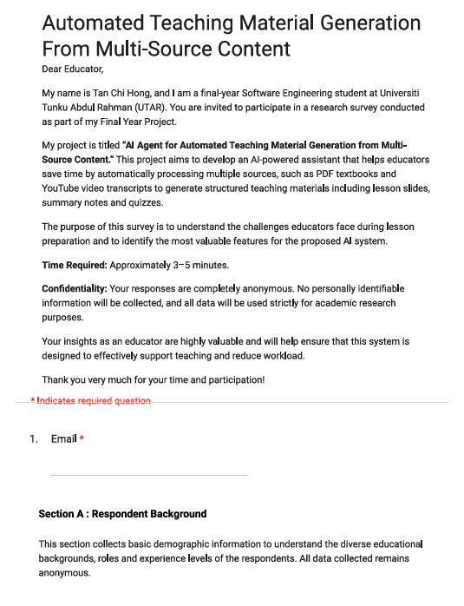
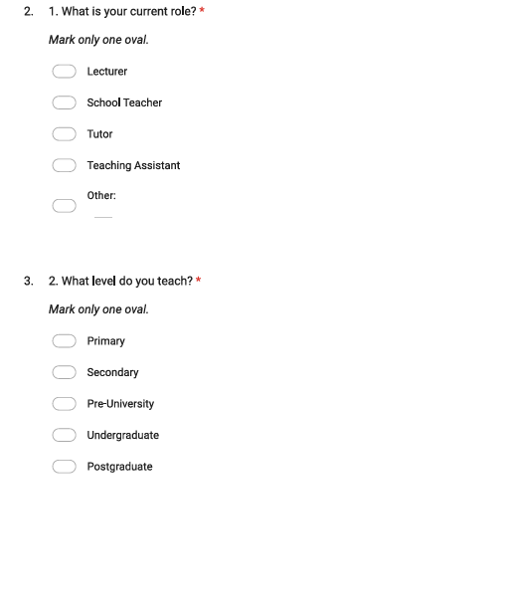


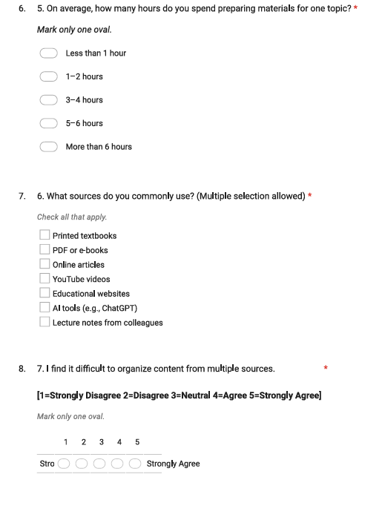
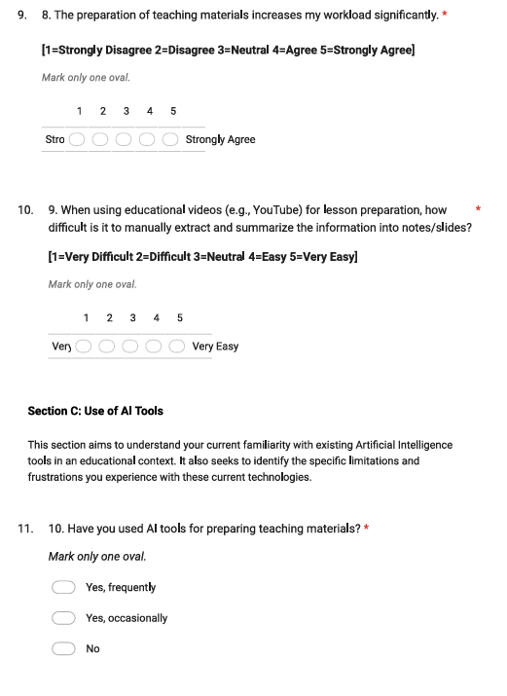
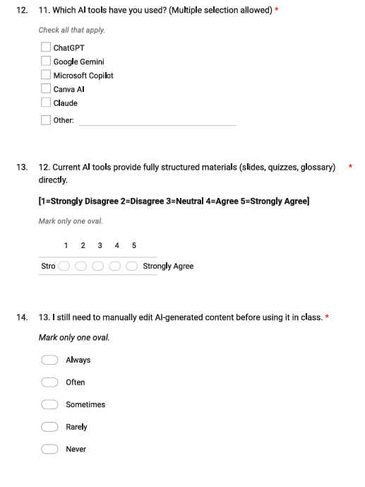
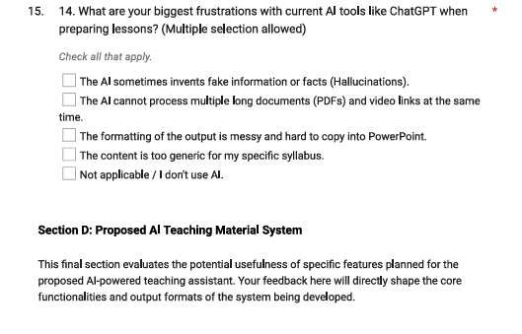
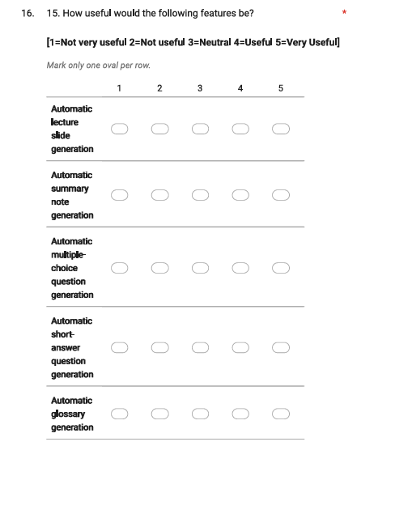
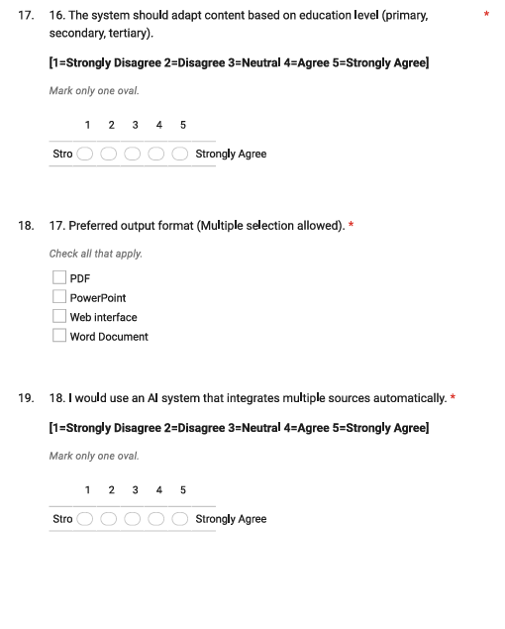
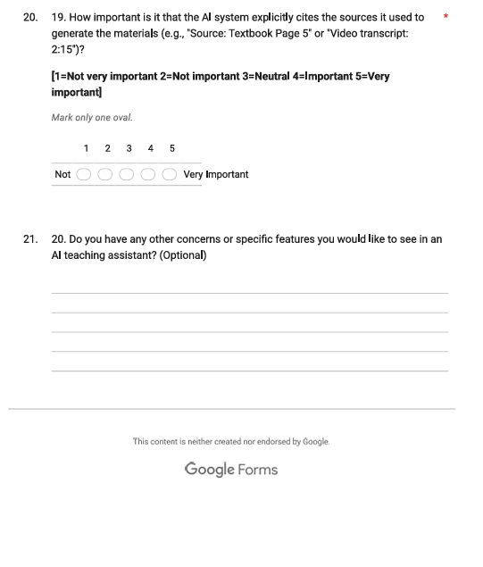

Appendix B: Gantt Chart
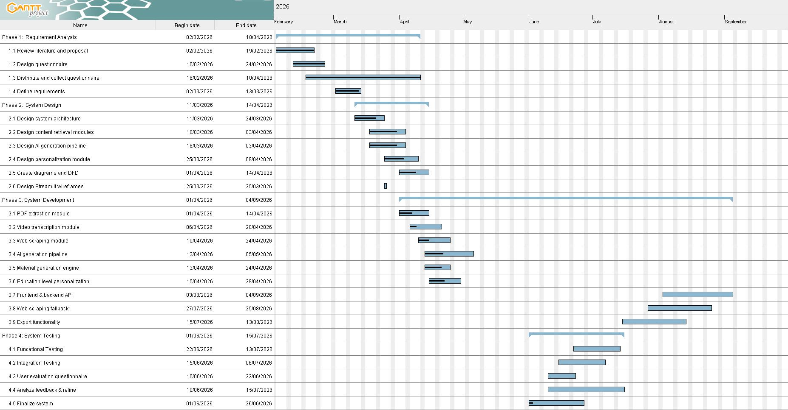

Appendix C: Prototype
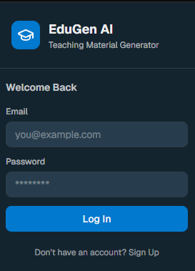

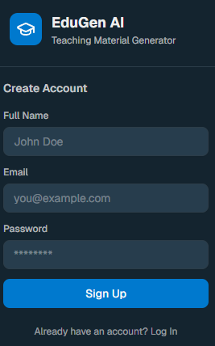
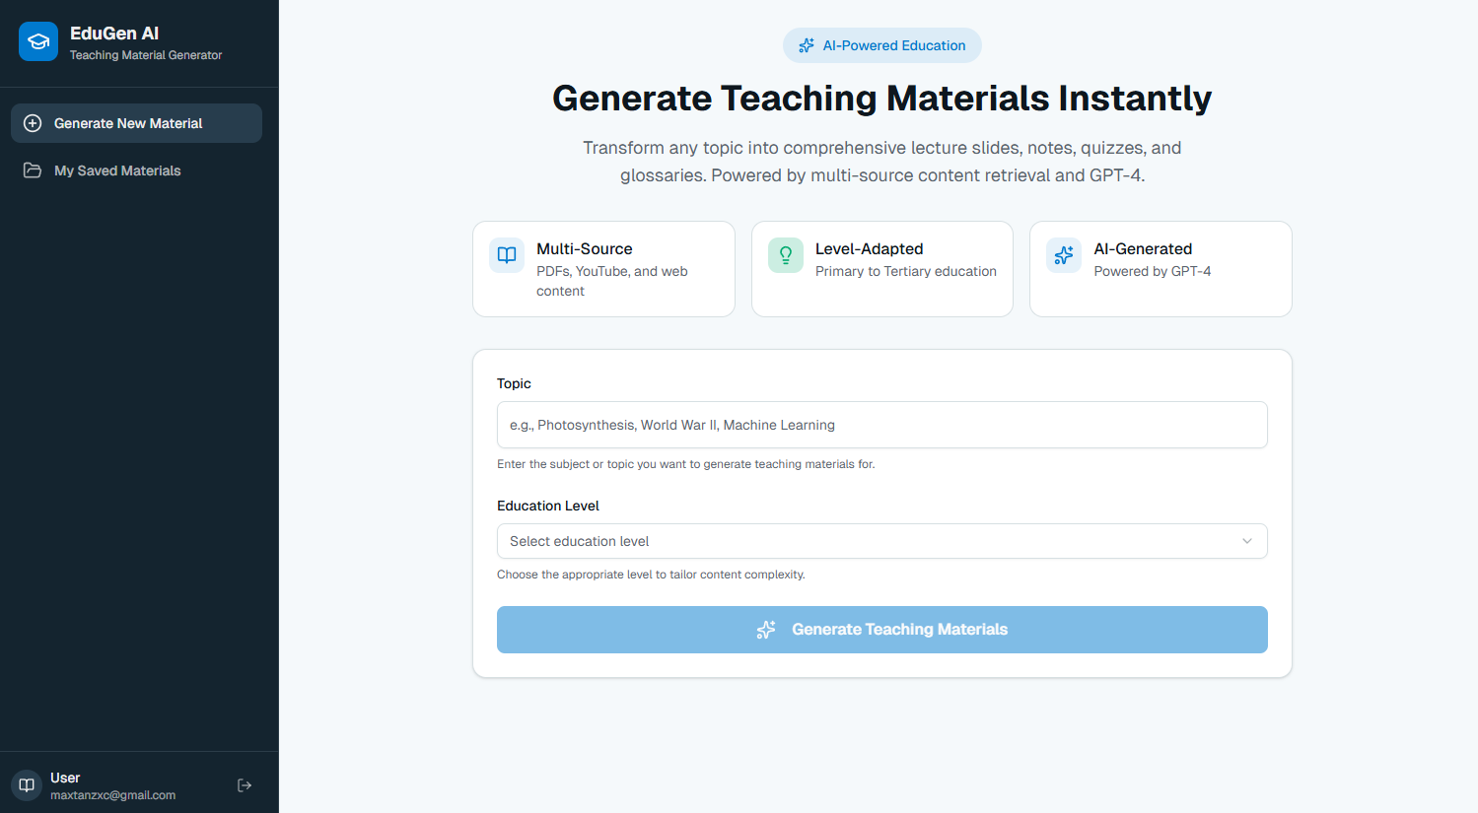

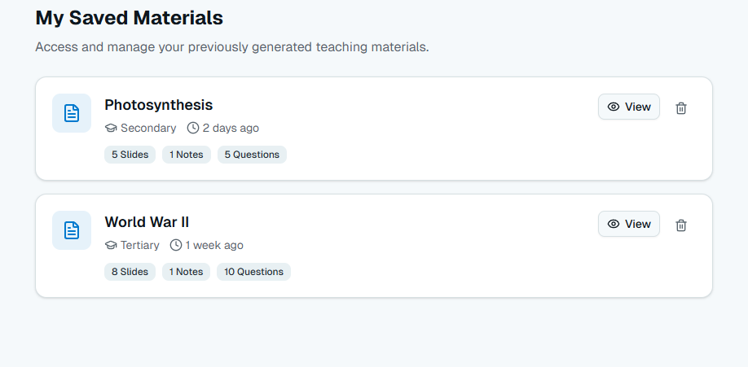

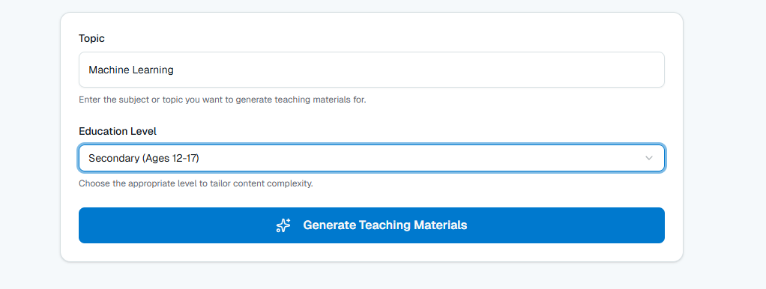
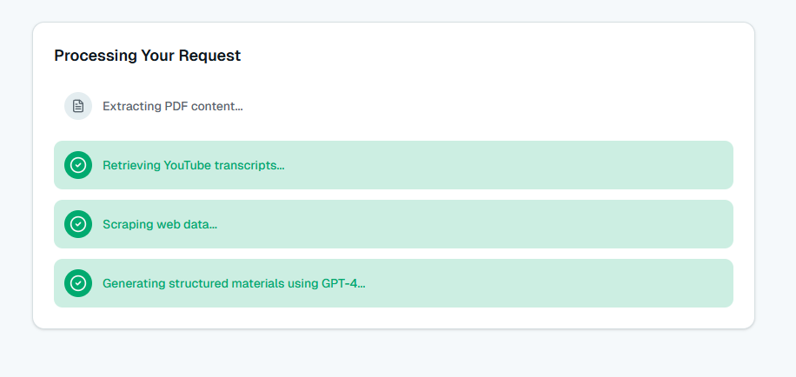

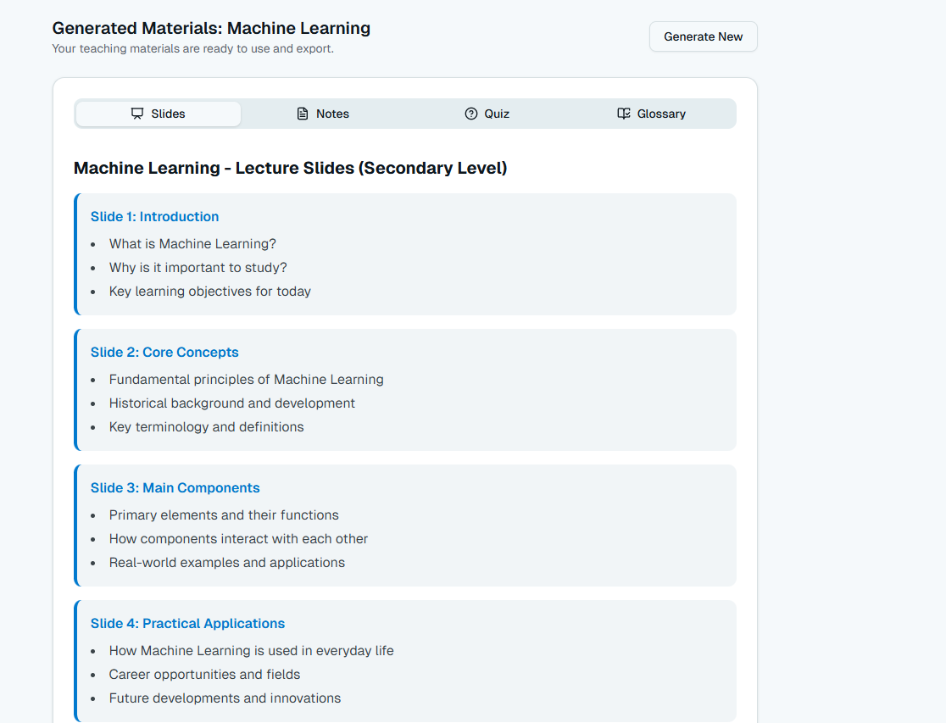

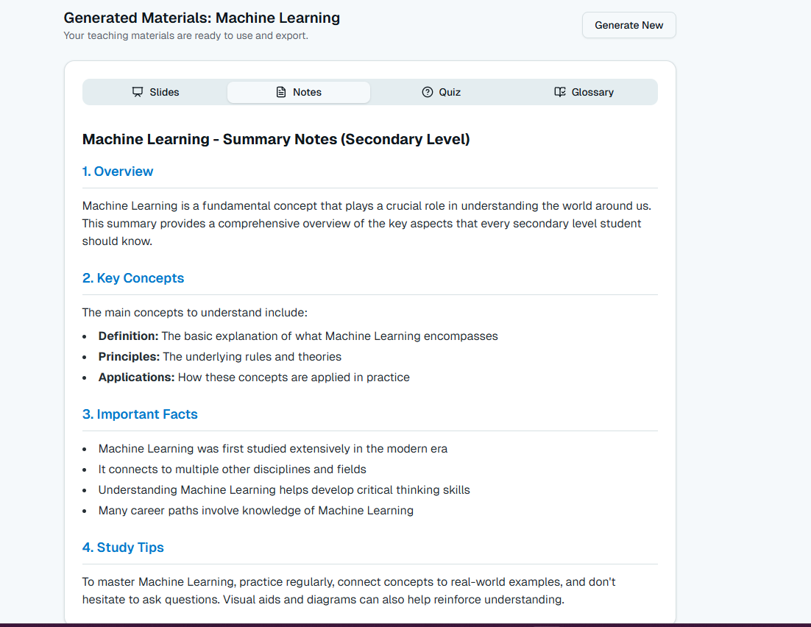

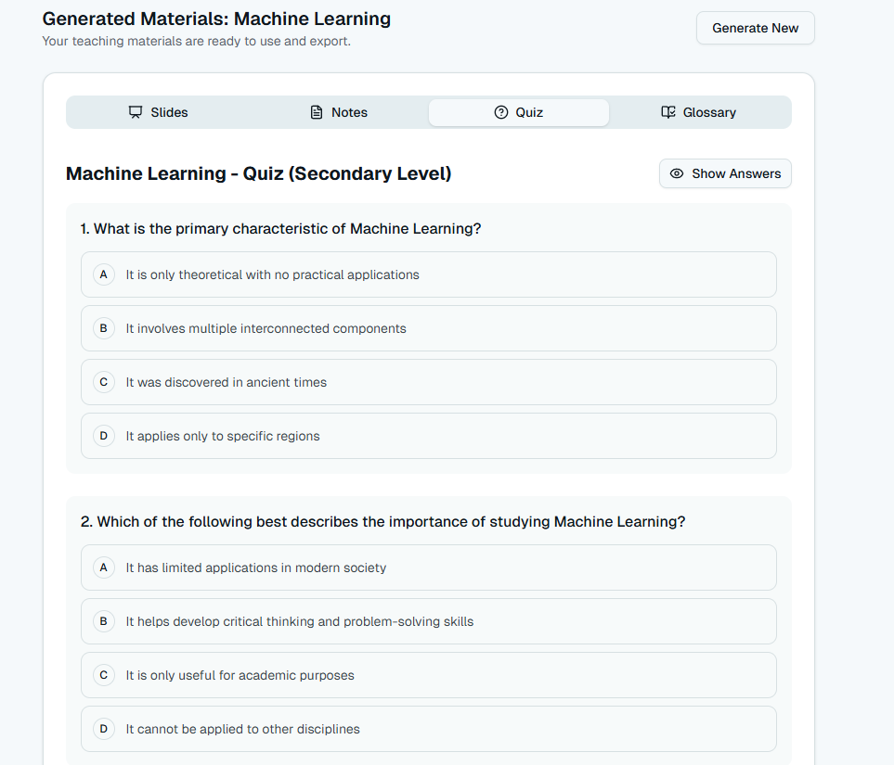

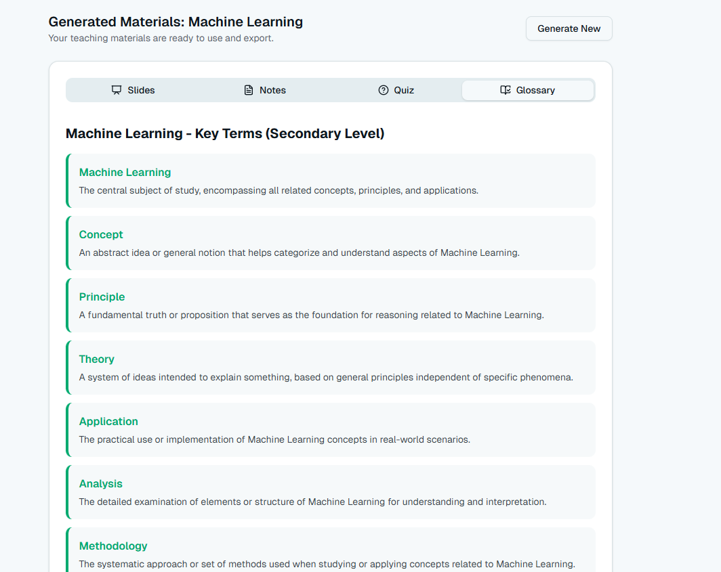

Appendix D: User Interface Testing form

User Interface Testing
Purpose:

This questionnaire is conducted to evaluate the user interface (UI) of the proposed
AI Agent

for Automated Teaching Material Generation from Multi-Source Content
system.
Instructions to participants:

Please navigate through the provided system and complete the requested tasks before answering the

questions.
The respondent's email (
oceanserverman@gmail.com
)
was recorded on submission of this form.
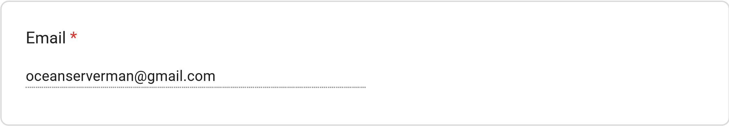
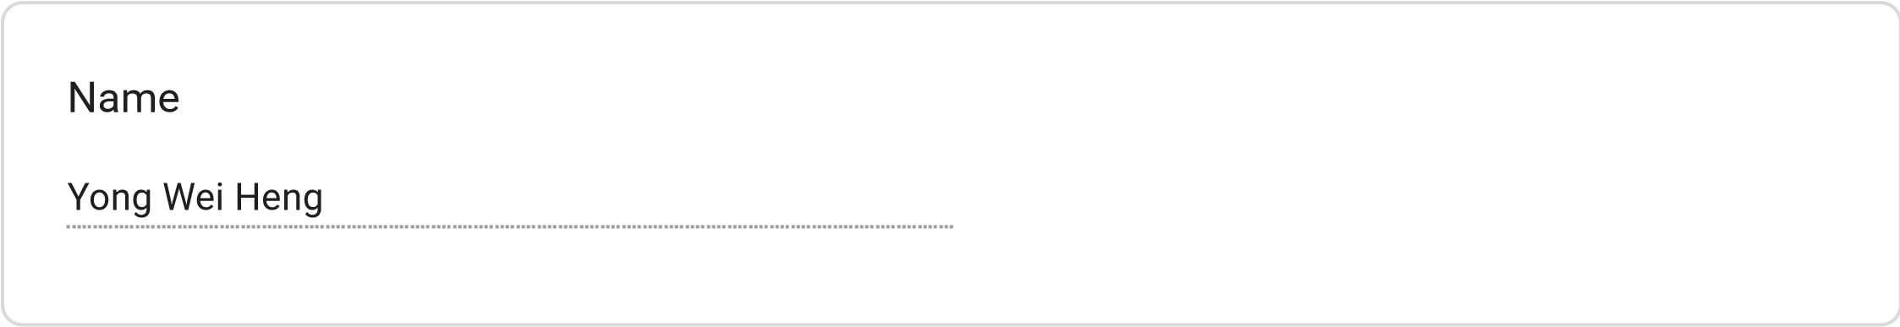
Lecturer
Tutor
School Teacher
Teaching Assistant
Teaching Role
Primary
Secondary
Tertiary
Education Level Taught
Very Easy
Easy
Neutral
Difficult
Very Difficult
Task 1: Were you able to locate the Login and Sign-Up options easily?
Very Easy
Easy
Neutral
Difficult
Very Difficult
Task 2: Navigate to the material generation page and identify where you would enter a topic
and select the education level.
PDF
YouTube Video
Web Page
All of the above
None of the above
Task 3: Which source types could you identify from the interface?
Very Easy
Easy
Neutral
Difficult
Very Difficult
Task 4: How easy was it to identify the generation progress?
Very Easy
Easy
Neutral
Difficult
Very Difficult
Task 5: How easy was it to find where the generated materials would be displayed?
Very Easy
Easy
Neutral
Difficult
Very Difficult
Task 6: Locate the export options for downloading teaching materials.
Very Easy
Easy
Neutral
Difficult
Very Difficult
Task 7: Locate the generation history/archive.
User Interface Evaluation
*
1
– Strongly
Disagree
2
– Disagree
3
– Neutral
4
– Agree
5
– Strongly
Agree
The overall layout
of the interface is
clean and
uncluttered.
I could easily
locate the login
and sign-up
options.
The process of
entering a topic
and selecting an
education level
was intuitive.
It was clear how
to upload or link
a source (PDF,
YouTube video,
or web page).
The dashboard
clearly shows the
progress of
material
generation.
The generated
teaching
materials are
displayed in a
readable and
organised way.
The export
options (PDF /
PowerPoint) are
easy to find and
understand.
I could easily
locate
and
Excellent
Good
Average
Poor
Very Poor
I could easily
locate and
browse my
generation
history/archive.
The colour
scheme and
typography are
visually
consistent
throughout the
application.
I would describe
the navigation
flow between
screens as
logical.
locate and
browse my
generation
history/archive.
The colour
scheme and
typography are
visually
consistent
throughout the
application.
I would describe
the navigation
flow between
screens as
logical.
Based on your experience with the system, how would you rate the overall user interface?
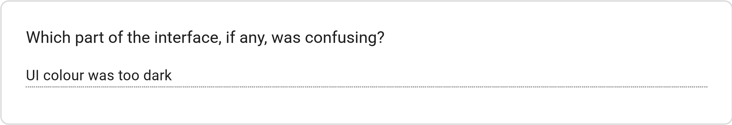
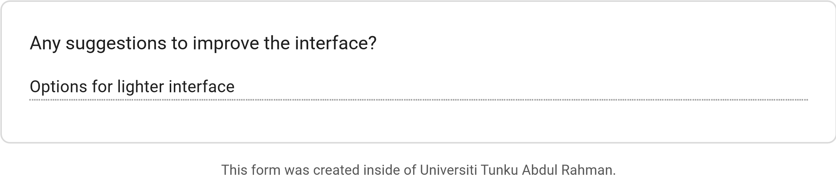
Forms
User Interface Testing
Purpose:

This questionnaire is conducted to evaluate the user interface (UI) of the proposed
AI Agent

for Automated Teaching Material Generation from Multi-Source Content
system.
Instructions to participants:

Please navigate through the provided system and complete the requested tasks before answering the

questions.
The respondent's email (
ryanzzzzlaw@gmail.com
)
was recorded on submission of this form.
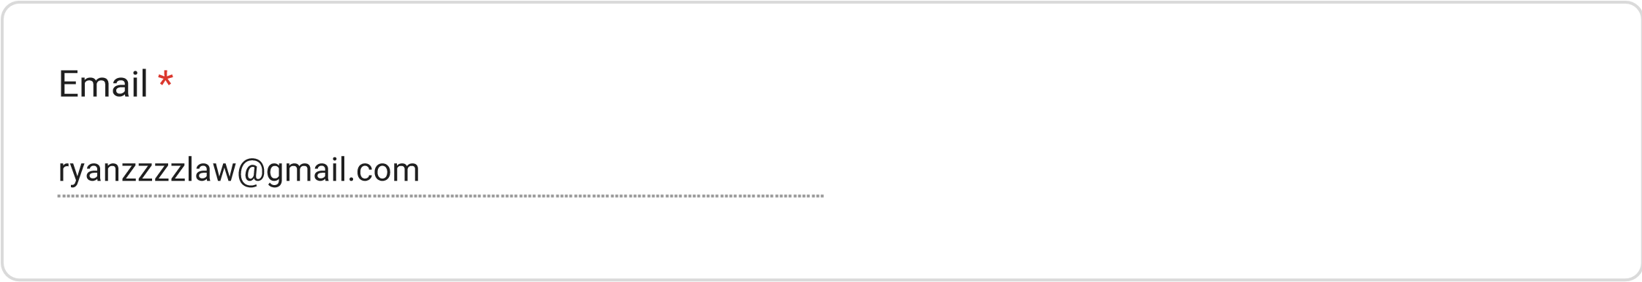
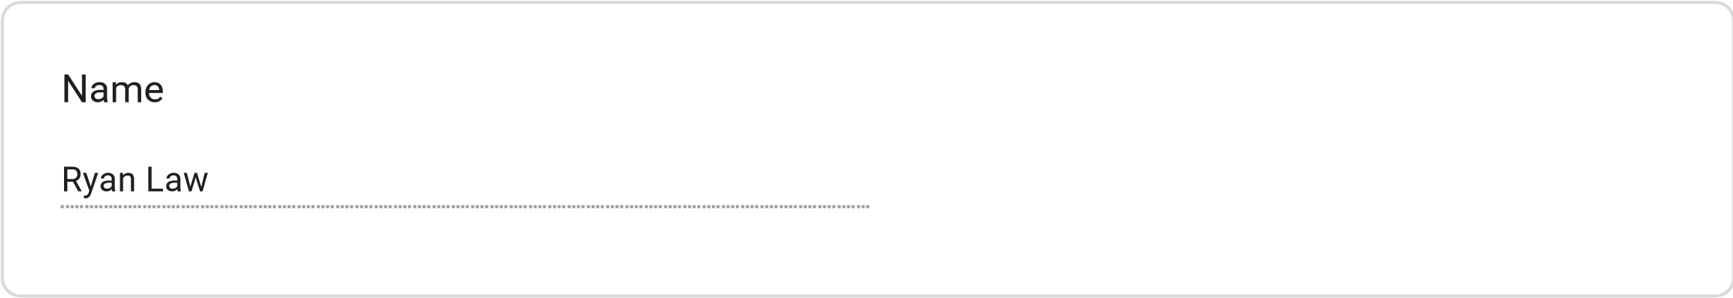
Lecturer
Tutor
School Teacher
Teaching Assistant
Teaching Role
Primary
Secondary
Tertiary
Education Level Taught
Very Easy
Easy
Neutral
Difficult
Very Difficult
Task 1: Were you able to locate the Login and Sign-Up options easily?
Very Easy
Easy
Neutral
Difficult
Very Difficult
Task 2: Navigate to the material generation page and identify where you would enter a topic
and select the education level.
PDF
YouTube Video
Web Page
All of the above
None of the above
Task 3: Which source types could you identify from the interface?
Very Easy
Easy
Neutral
Difficult
Very Difficult
Task 4: How easy was it to identify the generation progress?
Very Easy
Easy
Neutral
Difficult
Very Difficult
Task 5: How easy was it to find where the generated materials would be displayed?
Very Easy
Easy
Neutral
Difficult
Very Difficult
Task 6: Locate the export options for downloading teaching materials.
Very Easy
Easy
Neutral
Difficult
Very Difficult
Task 7: Locate the generation history/archive.
User Interface Evaluation
*
1
– Strongly
Disagree
2
– Disagree
3
– Neutral
4
– Agree
5
– Strongly
Agree
The overall layout
of the interface is
clean and
uncluttered.
I could easily
locate the login
and sign-up
options.
The process of
entering a topic
and selecting an
education level
was intuitive.
It was clear how
to upload or link
a source (PDF,
YouTube video,
or web page).
The dashboard
clearly shows the
progress of
material
generation.
The generated
teaching
materials are
displayed in a
readable and
organised way.
The export
options (PDF /
PowerPoint) are
easy to find and
understand.
I could easily
locate
and
Excellent
Good
Average
Poor
Very Poor
I could easily
locate and
browse my
generation
history/archive.
The colour
scheme and
typography are
visually
consistent
throughout the
application.
I would describe
the navigation
flow between
screens as
logical.
locate and
browse my
generation
history/archive.
The colour
scheme and
typography are
visually
consistent
throughout the
application.
I would describe
the navigation
flow between
screens as
logical.
Based on your experience with the system, how would you rate the overall user interface?
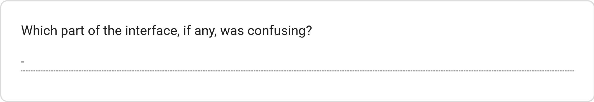
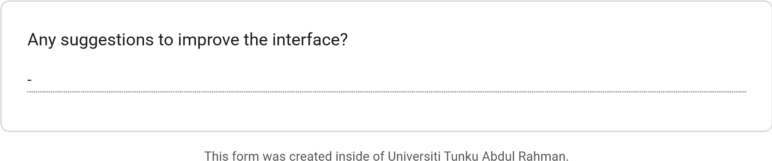
Forms
User Interface Testing
Purpose:

This questionnaire is conducted to evaluate the user interface (UI) of the proposed
AI Agent

for Automated Teaching Material Generation from Multi-Source Content
system.
Instructions to participants:

Please navigate through the provided system and complete the requested tasks before answering the

questions.
The respondent's email (
wilsonchoong33@gmail.com
)
was recorded on submission of this form.
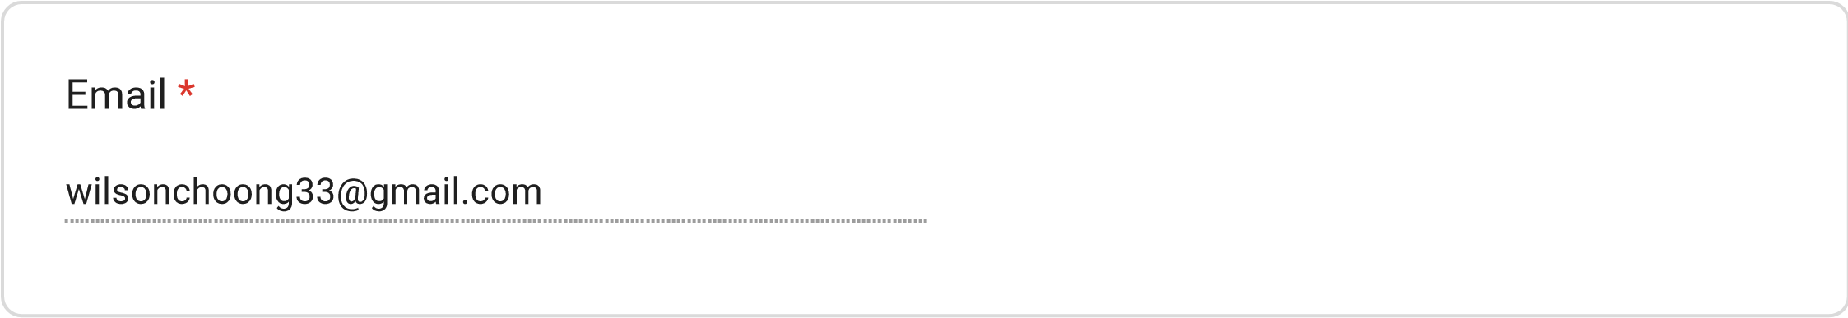
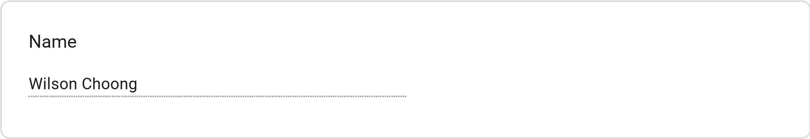
Lecturer
Tutor
School Teacher
Teaching Assistant
Teaching Role
Primary
Secondary
Tertiary
Education Level Taught
Very Easy
Easy
Neutral
Difficult
Very Difficult
Task 1: Were you able to locate the Login and Sign-Up options easily?
Very Easy
Easy
Neutral
Difficult
Very Difficult
Task 2: Navigate to the material generation page and identify where you would enter a topic
and select the education level.
PDF
YouTube Video
Web Page
All of the above
None of the above
Task 3: Which source types could you identify from the interface?
Very Easy
Easy
Neutral
Difficult
Very Difficult
Task 4: How easy was it to identify the generation progress?
Very Easy
Easy
Neutral
Difficult
Very Difficult
Task 5: How easy was it to find where the generated materials would be displayed?
Very Easy
Easy
Neutral
Difficult
Very Difficult
Task 6: Locate the export options for downloading teaching materials.
Very Easy
Easy
Neutral
Difficult
Very Difficult
Task 7: Locate the generation history/archive.
User Interface Evaluation
*
1
– Strongly
Disagree
2
– Disagree
3
– Neutral
4
– Agree
5
– Strongly
Agree
The overall layout
of the interface is
clean and
uncluttered.
I could easily
locate the login
and sign-up
options.
The process of
entering a topic
and selecting an
education level
was intuitive.
It was clear how
to upload or link
a source (PDF,
YouTube video,
or web page).
The dashboard
clearly shows the
progress of
material
generation.
The generated
teaching
materials are
displayed in a
readable and
organised way.
The export
options (PDF /
PowerPoint) are
easy to find and
understand.
I could easily
locate
and
Excellent
Good
Average
Poor
Very Poor
I could easily
locate and
browse my
generation
history/archive.
The colour
scheme and
typography are
visually
consistent
throughout the
application.
I would describe
the navigation
flow between
screens as
logical.
locate and
browse my
generation
history/archive.
The colour
scheme and
typography are
visually
consistent
throughout the
application.
I would describe
the navigation
flow between
screens as
logical.
Based on your experience with the system, how would you rate the overall user interface?
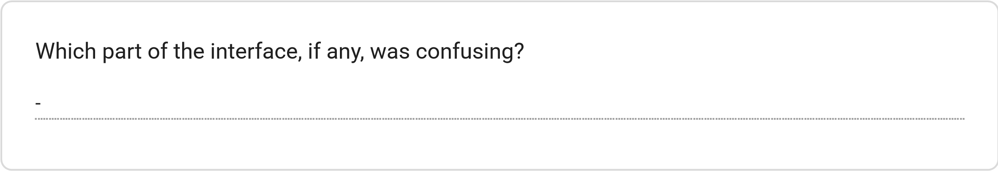
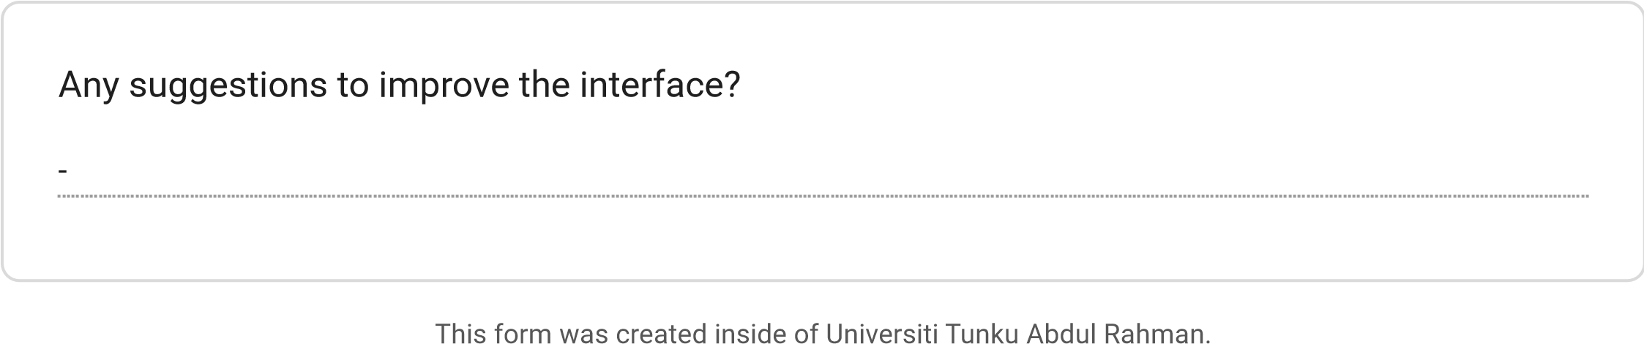
Forms
User Interface Testing
Purpose:

This questionnaire is conducted to evaluate the user interface (UI) of the proposed
AI Agent

for Automated Teaching Material Generation from Multi-Source Content
system.
Instructions to participants:

Please navigate through the provided system and complete the requested tasks before answering the

questions.
The respondent's email (
Laixp0222@gmail.com
)
was recorded on submission of this form.
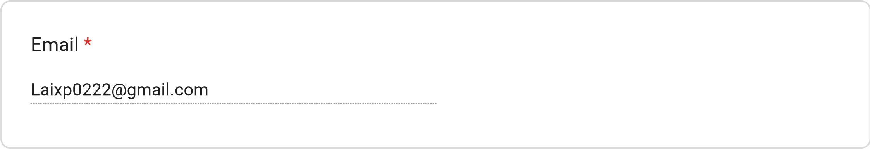
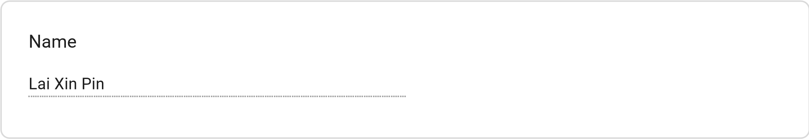
Lecturer
Tutor
School Teacher
Teaching Assistant
Teaching Role
Primary
Secondary
Tertiary
Education Level Taught
Very Easy
Easy
Neutral
Difficult
Very Difficult
Task 1: Were you able to locate the Login and Sign-Up options easily?
Very Easy
Easy
Neutral
Difficult
Very Difficult
Task 2: Navigate to the material generation page and identify where you would enter a topic
and select the education level.
PDF
YouTube Video
Web Page
All of the above
None of the above
Task 3: Which source types could you identify from the interface?
Very Easy
Easy
Neutral
Difficult
Very Difficult
Task 4: How easy was it to identify the generation progress?
Very Easy
Easy
Neutral
Difficult
Very Difficult
Task 5: How easy was it to find where the generated materials would be displayed?
Very Easy
Easy
Neutral
Difficult
Very Difficult
Task 6: Locate the export options for downloading teaching materials.
Very Easy
Easy
Neutral
Difficult
Very Difficult
Task 7: Locate the generation history/archive.
User Interface Evaluation
*
1
– Strongly
Disagree
2
– Disagree
3
– Neutral
4
– Agree
5
– Strongly
Agree
The overall layout
of the interface is
clean and
uncluttered.
I could easily
locate the login
and sign-up
options.
The process of
entering a topic
and selecting an
education level
was intuitive.
It was clear how
to upload or link
a source (PDF,
YouTube video,
or web page).
The dashboard
clearly shows the
progress of
material
generation.
The generated
teaching
materials are
displayed in a
readable and
organised way.
The export
options (PDF /
PowerPoint) are
easy to find and
understand.
I could easily
locate
and
Excellent
Good
Average
Poor
Very Poor
I could easily
locate and
browse my
generation
history/archive.
The colour
scheme and
typography are
visually
consistent
throughout the
application.
I would describe
the navigation
flow between
screens as
logical.
locate and
browse my
generation
history/archive.
The colour
scheme and
typography are
visually
consistent
throughout the
application.
I would describe
the navigation
flow between
screens as
logical.
Based on your experience with the system, how would you rate the overall user interface?
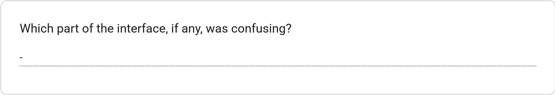
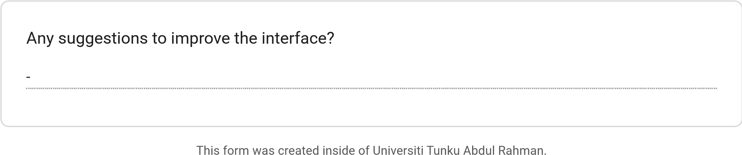
Forms
User Interface Testing
Purpose:

This questionnaire is conducted to evaluate the user interface (UI) of the proposed
AI Agent

for Automated Teaching Material Generation from Multi-Source Content
system.
Instructions to participants:

Please navigate through the provided system and complete the requested tasks before answering the

questions.
The respondent's email (
boonkit_12@gmail.com
)
was recorded on submission of this form.
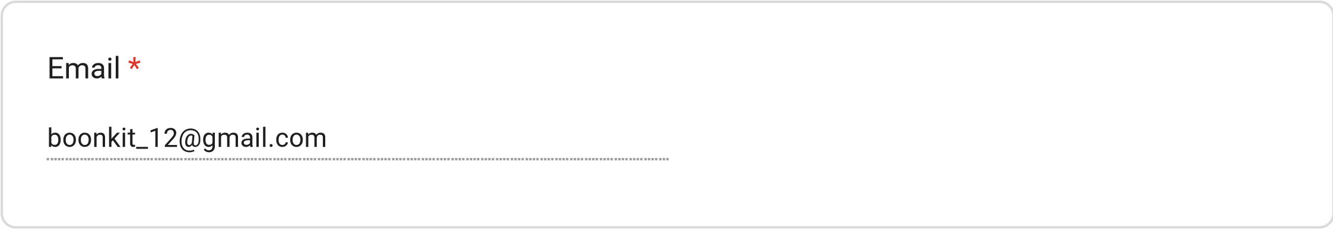
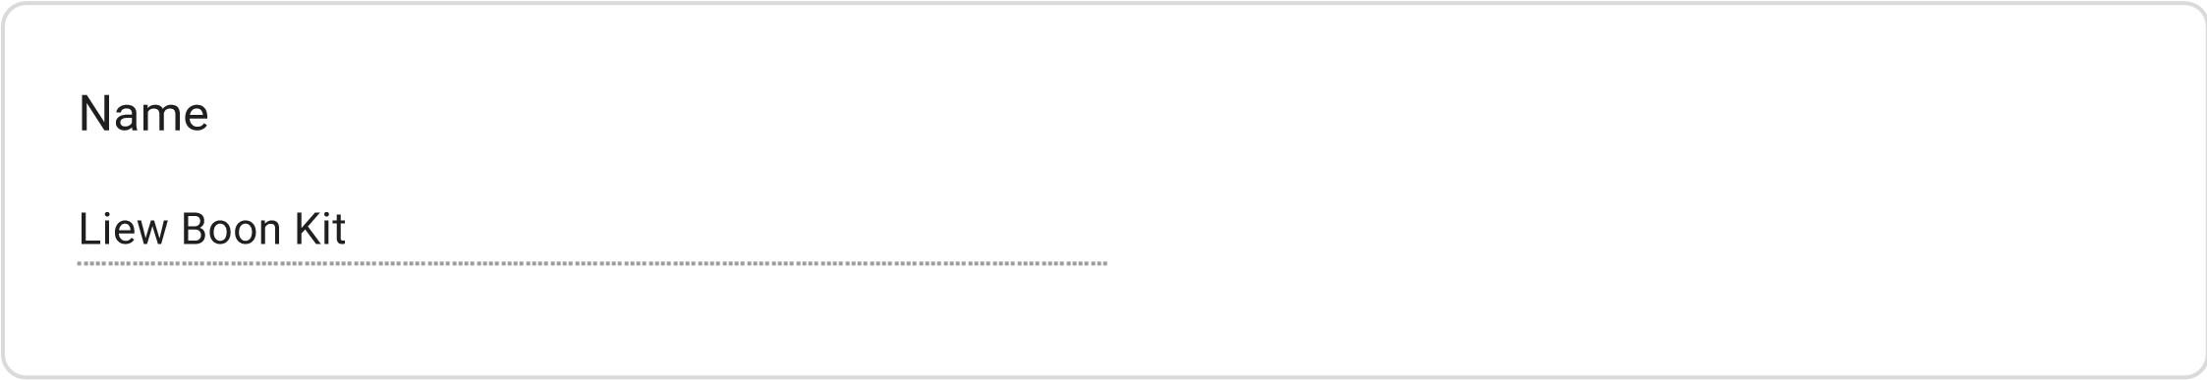
Lecturer
Tutor
School Teacher
Teaching Assistant
Teaching Role
Primary
Secondary
Tertiary
Education Level Taught
Very Easy
Easy
Neutral
Difficult
Very Difficult
Task 1: Were you able to locate the Login and Sign-Up options easily?
Very Easy
Easy
Neutral
Difficult
Very Difficult
Task 2: Navigate to the material generation page and identify where you would enter a topic
and select the education level.
PDF
YouTube Video
Web Page
All of the above
None of the above
Task 3: Which source types could you identify from the interface?
Very Easy
Easy
Neutral
Difficult
Very Difficult
Task 4: How easy was it to identify the generation progress?
Very Easy
Easy
Neutral
Difficult
Very Difficult
Task 5: How easy was it to find where the generated materials would be displayed?
Very Easy
Easy
Neutral
Difficult
Very Difficult
Task 6: Locate the export options for downloading teaching materials.
Very Easy
Easy
Neutral
Difficult
Very Difficult
Task 7: Locate the generation history/archive.
User Interface Evaluation
*
1
– Strongly
Disagree
2
– Disagree
3
– Neutral
4
– Agree
5
– Strongly
Agree
The overall layout
of the interface is
clean and
uncluttered.
I could easily
locate the login
and sign-up
options.
The process of
entering a topic
and selecting an
education level
was intuitive.
It was clear how
to upload or link
a source (PDF,
YouTube video,
or web page).
The dashboard
clearly shows the
progress of
material
generation.
The generated
teaching
materials are
displayed in a
readable and
organised way.
The export
options (PDF /
PowerPoint) are
easy to find and
understand.
I could easily
locate
and
Excellent
Good
Average
Poor
Very Poor
I could easily
locate and
browse my
generation
history/archive.
The colour
scheme and
typography are
visually
consistent
throughout the
application.
I would describe
the navigation
flow between
screens as
logical.
locate and
browse my
generation
history/archive.
The colour
scheme and
typography are
visually
consistent
throughout the
application.
I would describe
the navigation
flow between
screens as
logical.
Based on your experience with the system, how would you rate the overall user interface?
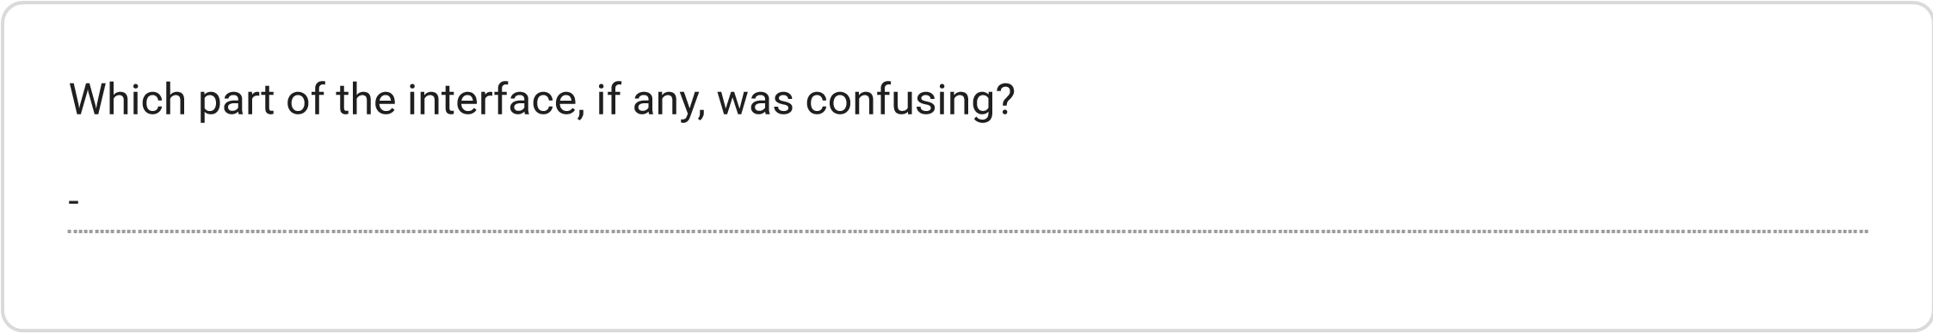
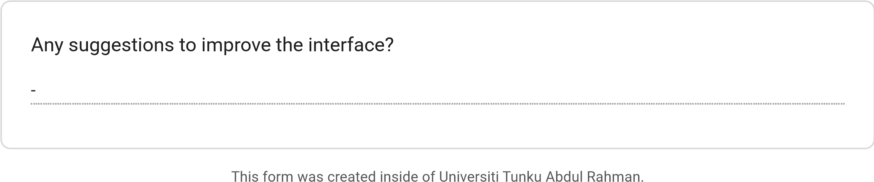
Forms

Appendix E: Structural Quality Evaluation Form

AI Structural Quality Evaluation
This survey collects independent human evaluation scores on AI-generated teaching materials produced

by EduForge AI. Please review the provided sample artifacts and rate how well each artifact follows its

required structural and formatting criteria.
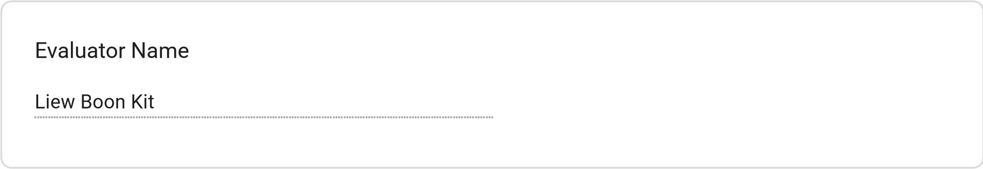
Primary School Teacher
Secondary School Teacher
Lecturer
Teaching Assistant
Evaluating Lecture Slides
Missing multiple slides (<7 slides)
1
2
3
4
Exactly 10 structured slides

generated
Current Role
Does the generated slide deck contain the expected 10 numbered slides?

Empty or excessively crowded

slides
1
2
3
4
Well-balanced bullet density on

every slide
Are there roughly 3 to 5 clear, informative bullet points per content slide?
Speaker notes missing
1
2
Speaker notes clearly present

across slides
Do the content slides include practical speaker notes for the teacher?
Completely non-
compliant
0
1
2
3
4
5
6
7
8
9
10
Flawless slide structure

and formatting
Evaluating Summary Notes
Rate the overall structural adherence of this slide deck on a scale of 0 to 10
Yes (3.0 pts)
Partially (1.5 pts)
No (0 pts)
Are there at least 4 clear, descriptive conceptual headings organizing the notes?
Yes (3.0 pts)
Partially (1.5 pts)
No (0 pts)
Are concepts explained in complete, informative bullet sentences?
Yes (2.0 pts)
No (0 pts)
Is there a dedicated "Key Takeaways" summary section at the end?
Yes (2.0 pts)
No (0 pts)
Does the document end with a clear concluding wrap-up paragraph?
Poorly

structured
0
1
2
3
4
5
6
7
8
9
10
Perfectly structured study

notes
Evaluating MCQ Practice Quizzes
Rate the overall structural adherence of these summary notes on a scale of 0 to 10
Yes (3.0 pts)
No (0 pts)
Yes (2.5 pts)
No (0 pts)
Are all requested questions numbered clearly (e.g., Q1., Q2., Q3.)?
Does each question provide exactly 4 distinct choices labeled A, B, C, and D?
Yes (2.5 pts)
No (0 pts)
Is the correct answer key explicitly indicated for each question?
Yes (2.0 pts)
No (0 pts)
Is there a learning explanation provided alongside the answer key?
Broken quiz format
0
1
2
3
4
5
6
7
8
9
10
Flawless quiz structure
Rate the overall structural adherence of this quiz on a scale of 0 to 10
Evaluating Glossaries of Key Terms
Yes (3.0 pts)
No (0 pts)
Option 3
Yes (3.0 pts)
No (0 pts)
Are key terms clearly highlighted in bold?
Does every term have a clear, concise definition?
Yes (4.0 pts)
Only One is present (2.0 pts)
Neither is present (0 pts)
Are real-world examples and related cross-referenced terms included?
Poor glossary format
0
1
2
3
4
5
6
7
8
9
10
Flawless glossary layout
This form was created inside of Universiti Tunku Abdul Rahman.
Rate the overall structural adherence of this glossary on a scale of 0 to 10
Forms
AI Structural Quality Evaluation
This survey collects independent human evaluation scores on AI-generated teaching materials produced

by EduForge AI. Please review the provided sample artifacts and rate how well each artifact follows its

required structural and formatting criteria.
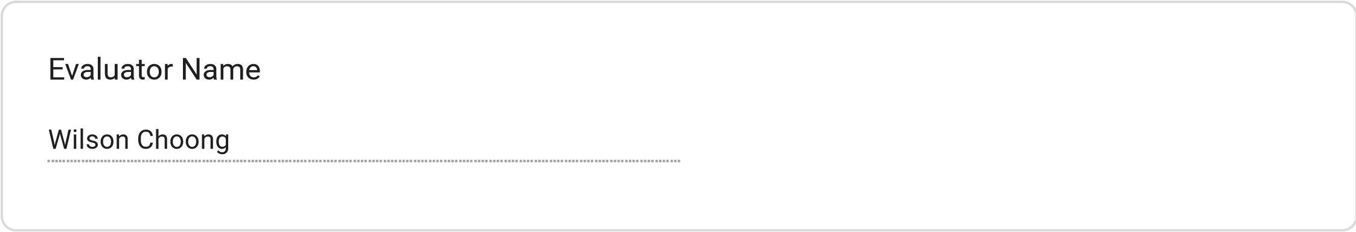
Primary School Teacher
Secondary School Teacher
Lecturer
Teaching Assistant
Evaluating Lecture Slides
Current Role
Missing multiple slides (<7 slides)
1
2
3
4
Exactly 10 structured slides

generated
Does the generated slide deck contain the expected 10 numbered slides?

Empty or excessively crowded

slides
1
2
3
4
Well-balanced bullet density on

every slide
Are there roughly 3 to 5 clear, informative bullet points per content slide?
Speaker notes missing
1
2
Speaker notes clearly present

across slides
Do the content slides include practical speaker notes for the teacher?
Completely non-
compliant
0
1
2
3
4
5
6
7
8
9
10
Flawless slide structure

and formatting
Evaluating Summary Notes
Rate the overall structural adherence of this slide deck on a scale of 0 to 10
Yes (3.0 pts)
Partially (1.5 pts)
No (0 pts)
Are there at least 4 clear, descriptive conceptual headings organizing the notes?
Yes (3.0 pts)
Partially (1.5 pts)
No (0 pts)
Are concepts explained in complete, informative bullet sentences?
Yes (2.0 pts)
No (0 pts)
Is there a dedicated "Key Takeaways" summary section at the end?
Yes (2.0 pts)
No (0 pts)
Does the document end with a clear concluding wrap-up paragraph?
Poorly

structured
0
1
2
3
4
5
6
7
8
9
10
Perfectly structured study

notes
Evaluating MCQ Practice Quizzes
Rate the overall structural adherence of these summary notes on a scale of 0 to 10
Yes (3.0 pts)
No (0 pts)
Yes (2.5 pts)
No (0 pts)
Are all requested questions numbered clearly (e.g., Q1., Q2., Q3.)?
Does each question provide exactly 4 distinct choices labeled A, B, C, and D?
Yes (2.5 pts)
No (0 pts)
Is the correct answer key explicitly indicated for each question?
Yes (2.0 pts)
No (0 pts)
Is there a learning explanation provided alongside the answer key?
Broken quiz format
0
1
2
3
4
5
6
7
8
9
10
Flawless quiz structure
Rate the overall structural adherence of this quiz on a scale of 0 to 10
Evaluating Glossaries of Key Terms
Yes (3.0 pts)
No (0 pts)
Option 3
Yes (3.0 pts)
No (0 pts)
Are key terms clearly highlighted in bold?
Does every term have a clear, concise definition?
Yes (4.0 pts)
Only One is present (2.0 pts)
Neither is present (0 pts)
Are real-world examples and related cross-referenced terms included?
Poor glossary format
0
1
2
3
4
5
6
7
8
9
10
Flawless glossary layout
This form was created inside of Universiti Tunku Abdul Rahman.
Rate the overall structural adherence of this glossary on a scale of 0 to 10
Forms

Appendix F: UAT Form
USER ACCEPTANCE TESTING (UAT) FORM
AI Agent for Automated Teaching Material Generation from Multi-Source Content
FYP Research Ethical Application
Student: Tan Chi Hong | ID: 2205466
Supervisor: Asst. Prof. Dr. Fatimah Audah binti Md. Zaki
SECTION A: PARTICIPANT INFORMATION

Participant Name | Ryan Law Jia Xian
Teaching Role | School Teacher
Education Level Taught | Form 3 – 5
Years of Teaching Experience | 7
Date of Evaluation | 4/9/2026

Teaching Role (please tick):
☐

Lecturer

☐

Tutor

☐

School

Teacher

☐

Teaching

Assistant

Education Level Taught (please tick all that apply):
☐

Primary

☐

Secondary

☐

Tertiary

/ University

SECTION B: INFORMED CONSENT

Purpose of This Evaluation
You are invited to evaluate a AI system that automatically generates structured teaching materials including lecture slides, summary notes, multiple choice questions and a glossary of key terms from a topic entered by the user. The system adapts its output to three education levels: primary, secondary and tertiary.
This evaluation is conducted as part of a final year project at Universiti Tunku Abdul Rahman (UTAR) for research purposes only. Your participation is entirely voluntary and you may withdraw at any time without any consequence.
Confidentiality
All responses collected in this form are strictly confidential. No personally identifiable information will be disclosed in any published report or academic submission. Data will be aggregated and used solely for academic analysis.
Consent Declaration
By completing and signing this form, you confirm that you have read and understood the above information that you voluntarily agree to participate in this evaluation, and that you consent to your anonymised responses being used for academic research purposes.

Participant Signature:

_________________
_
_
______________

Date:

4
/9/2026

SECTION C: SYSTEM FUNCTIONALITY VERIFICATION

Instructions: Please use the system and tick Yes or No for each function listed below.
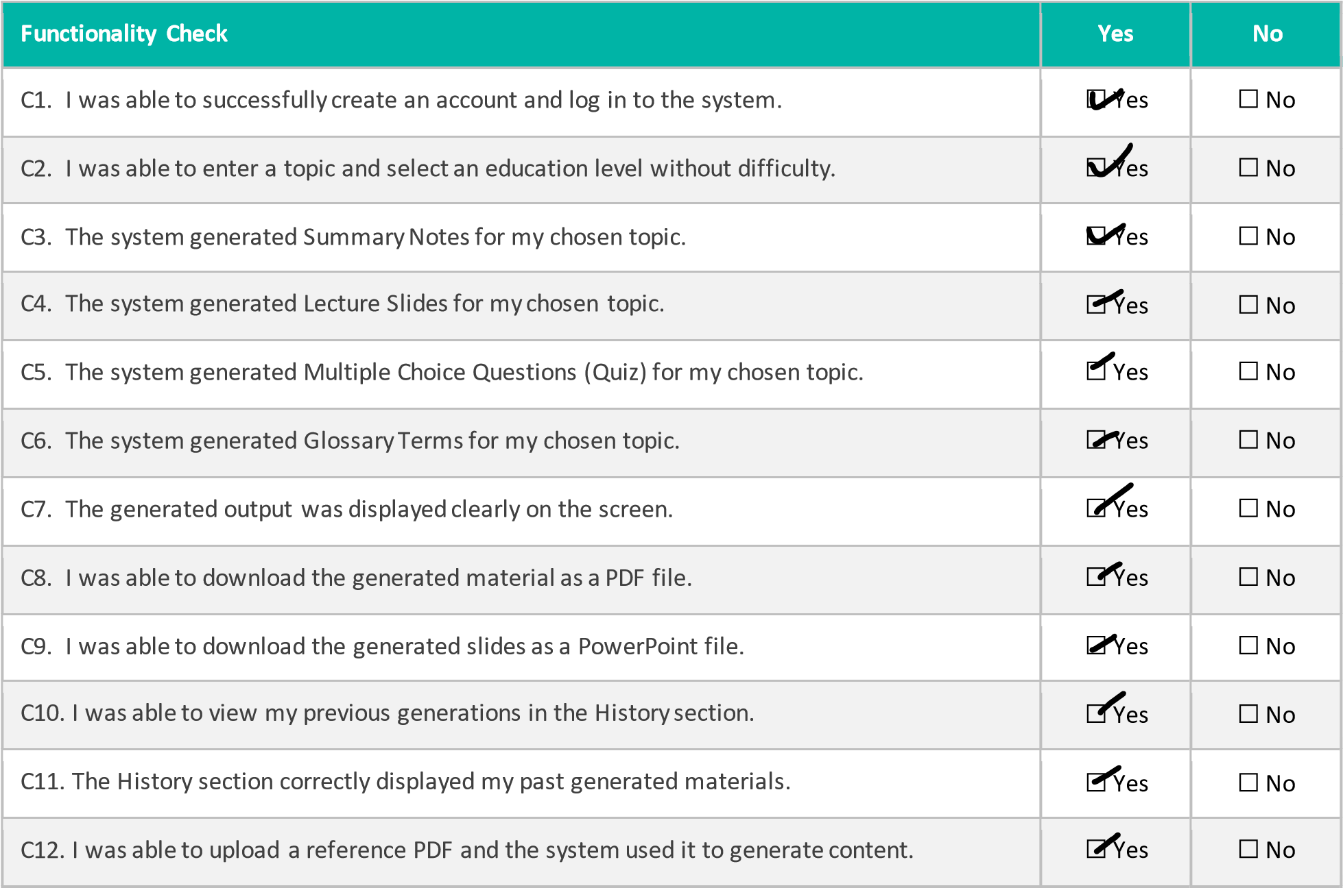

Please describe any functionality that did NOT work as expected:
SECTION D: OUTPUT QUALITY EVALUATION

Instructions: Rate each statement from 1 (Strongly Disagree) to 5 (Strongly Agree). Tick N/A if you did not test that output type.
D1. Summary Notes
Evaluation Criteria | Strongly  Disagree  (1) | Disagree (2) | Neutral (3) | Agree (4) | Strongly Agree (5) | N/A
The summary notes were well-structured with clear headings and bullet points. | ☐ | ☐ | ☐ | ☐ | ☐ | ☐
The content of the summary notes was factually accurate. | ☐ | ☐ | ☐ | ☐ | ☐ | ☐
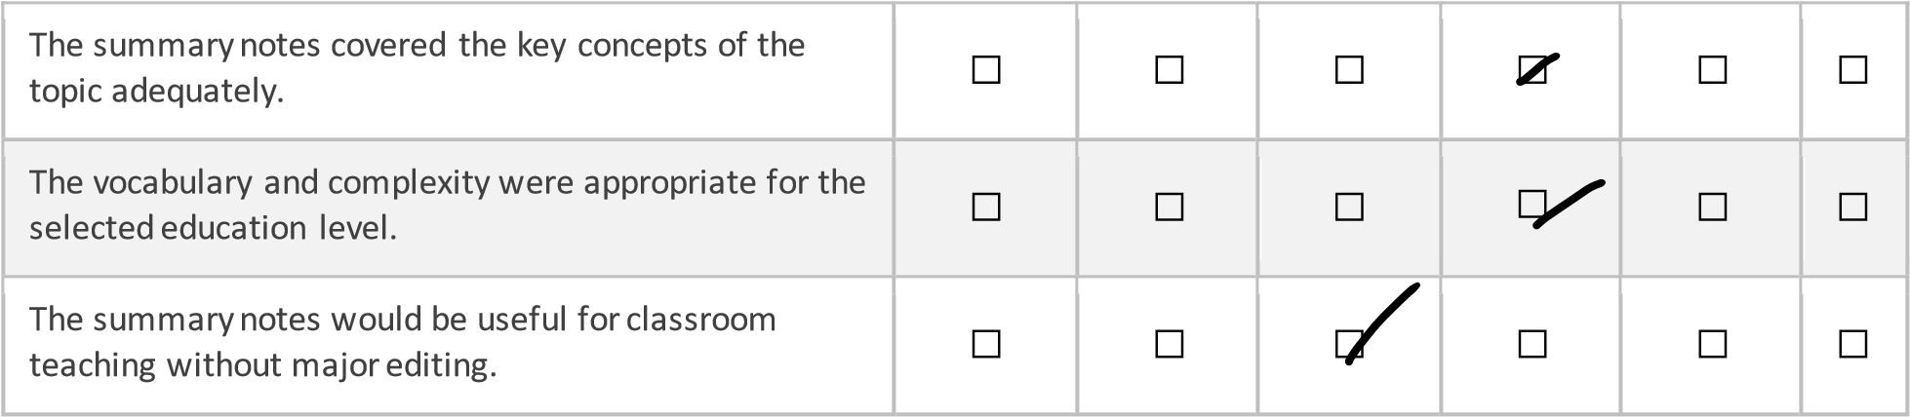

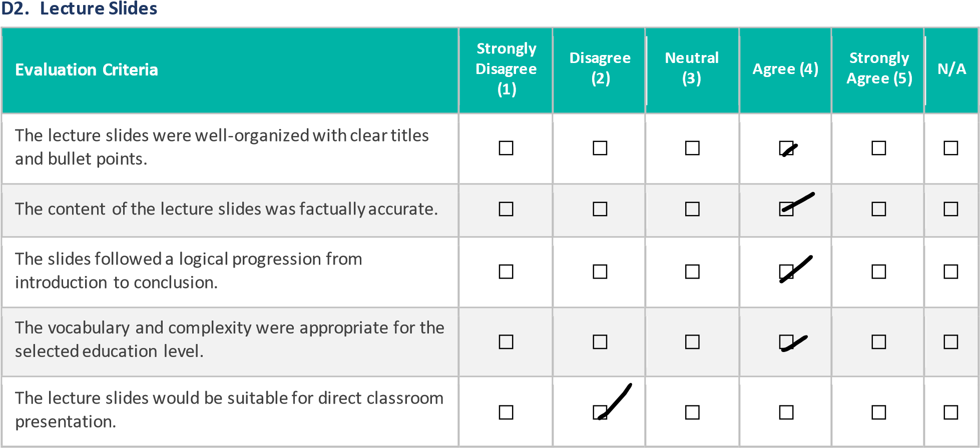

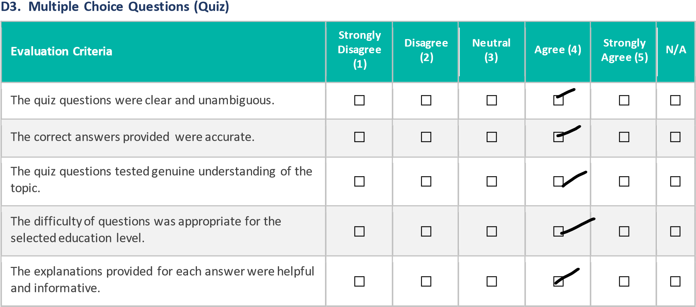

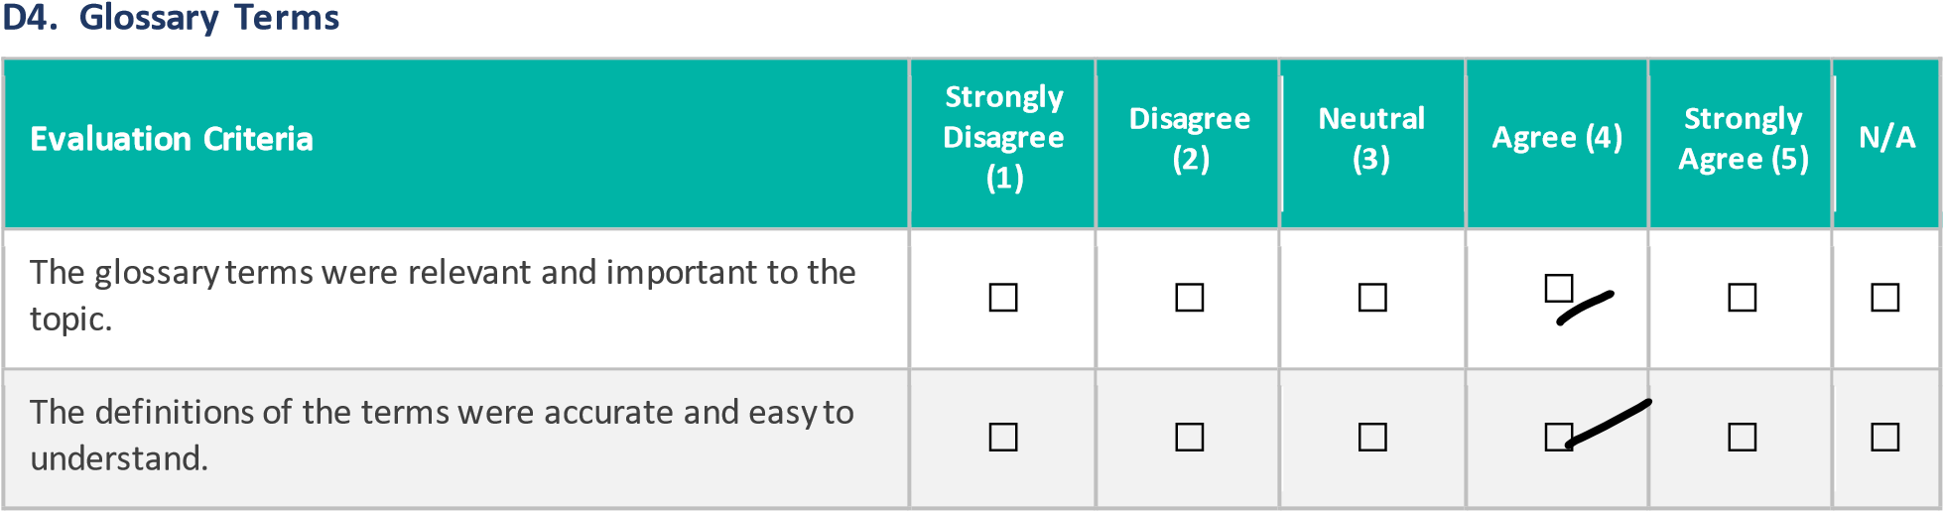
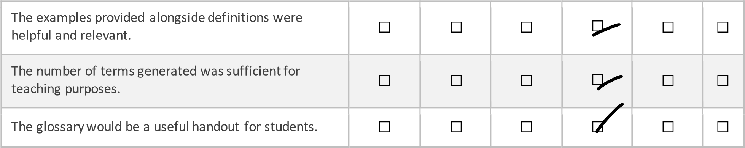

SECTION E: EDUCATION LEVEL ADAPTATION

Instructions: If you tested the system using more than one education level, rate the following statements.
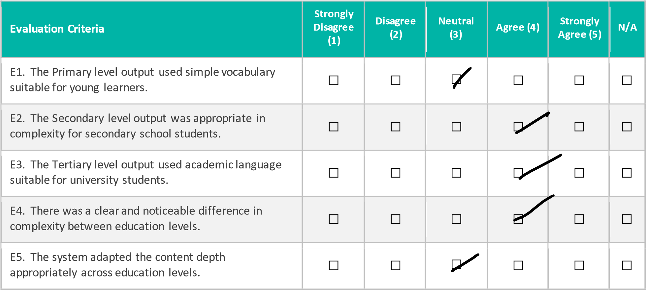
SECTION F: USABILITY AND TECHNOLOGY ACCEPTANCE (TAM)

Instructions: Rate each statement from 1 (Strongly Disagree) to 5 (Strongly Agree).
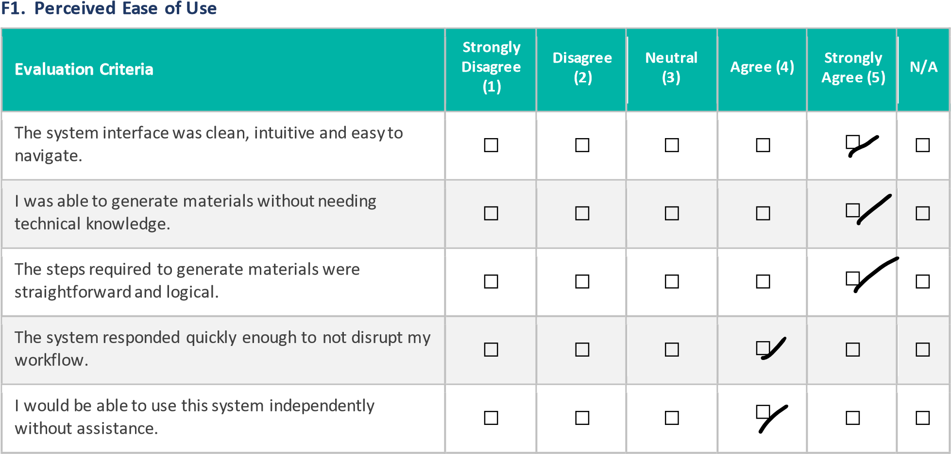

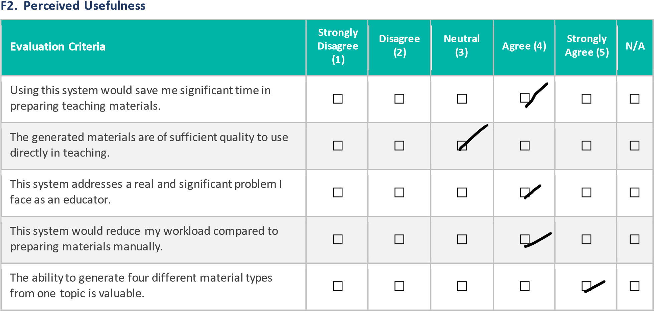

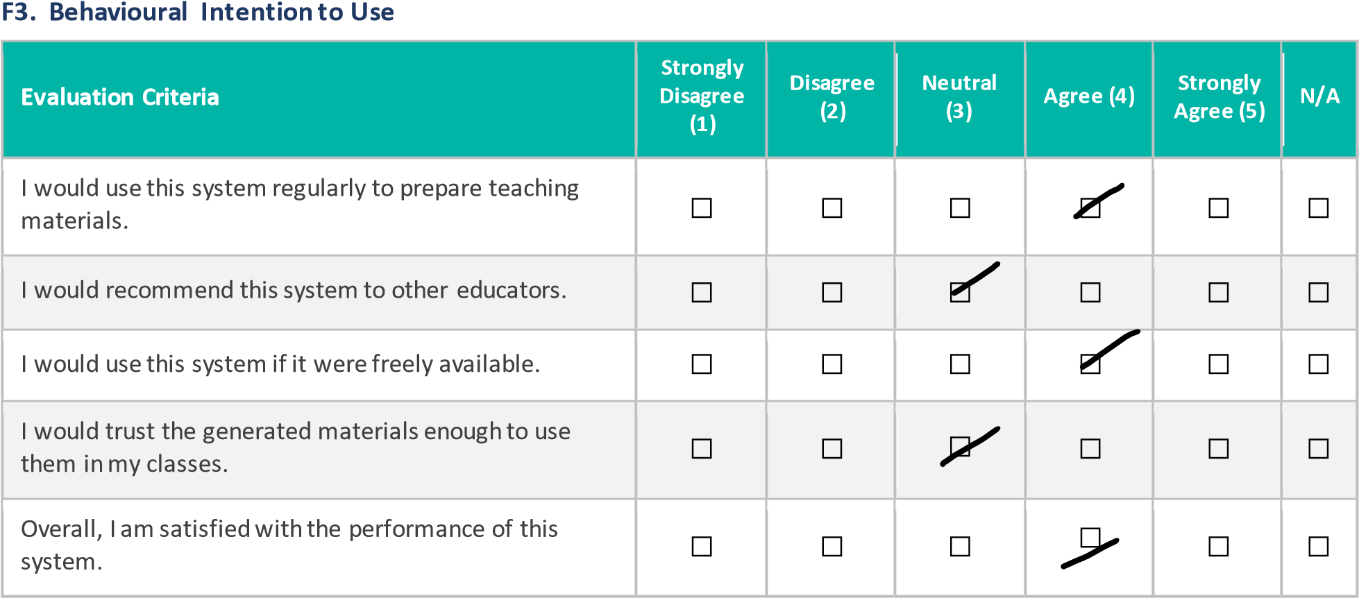

SECTION G: OVERALL RATING
H1. Please give an overall rating for the system:
☐ 1 — Very Poor | ☐ 2 — Poor |  | ☐ 3 — Acceptable |  | ☐ 4 — Good |  | ☐ 5 — Excellent
H2. Would you recommend this system to other educators?
☐ Yes, definitely |  | ☐ Maybe, with improvements |  |  |  |  | ☐ No

SECTION H: EVALUATOR SIGN-OFF

Participant Name:

Ryan Law Jia Xian

_________________________________

Participant Signature:

______________________
_
__________

Date:

4
/9/2026

_________________________________

Duration of Evaluation (minutes):

3
5

minutes

_________________________________

USER ACCEPTANCE TESTING (UAT) FORM
AI Agent for Automated Teaching Material Generation from Multi-Source Content
FYP Research Ethical Application
Student: Tan Chi Hong | ID: 2205466
Supervisor: Asst. Prof. Dr. Fatimah Audah binti Md. Zaki
SECTION A: PARTICIPANT INFORMATION

Participant Name | Wilson Choong Xian Hui
Teaching Role | Lecturer
Education Level Taught | College
Years of Teaching Experience | 2
Date of Evaluation | 5/9/2026

Teaching Role (please tick):

☐

Lecturer

☐

Tutor

☐

School

Teacher

☐

Teaching

Assistant

Education Level Taught (please tick all that apply):

☐

Primary

☐

Secondary

☐

Tertiary

/ University

SECTION B: INFORMED CONSENT

Purpose of This Evaluation
You are invited to evaluate a AI system that automatically generates structured teaching materials including lecture slides, summary notes, multiple choice questions and a glossary of key terms from a topic entered by the user. The system adapts its output to three education levels: primary, secondary and tertiary.
This evaluation is conducted as part of a final year project at Universiti Tunku Abdul Rahman (UTAR) for research purposes only. Your participation is entirely voluntary and you may withdraw at any time without any consequence.
Confidentiality
All responses collected in this form are strictly confidential. No personally identifiable information will be disclosed in any published report or academic submission. Data will be aggregated and used solely for academic analysis.
Consent Declaration
By completing and signing this form, you confirm that you have read and understood the above information that you voluntarily agree to participate in this evaluation, and that you consent to your anonymised responses being used for academic research purposes.

Participant Signature:

_________________________________

Date:

5
/9/2026

SECTION C: SYSTEM FUNCTIONALITY VERIFICATION

Instructions: Please use the system and tick Yes or No for each function listed below.
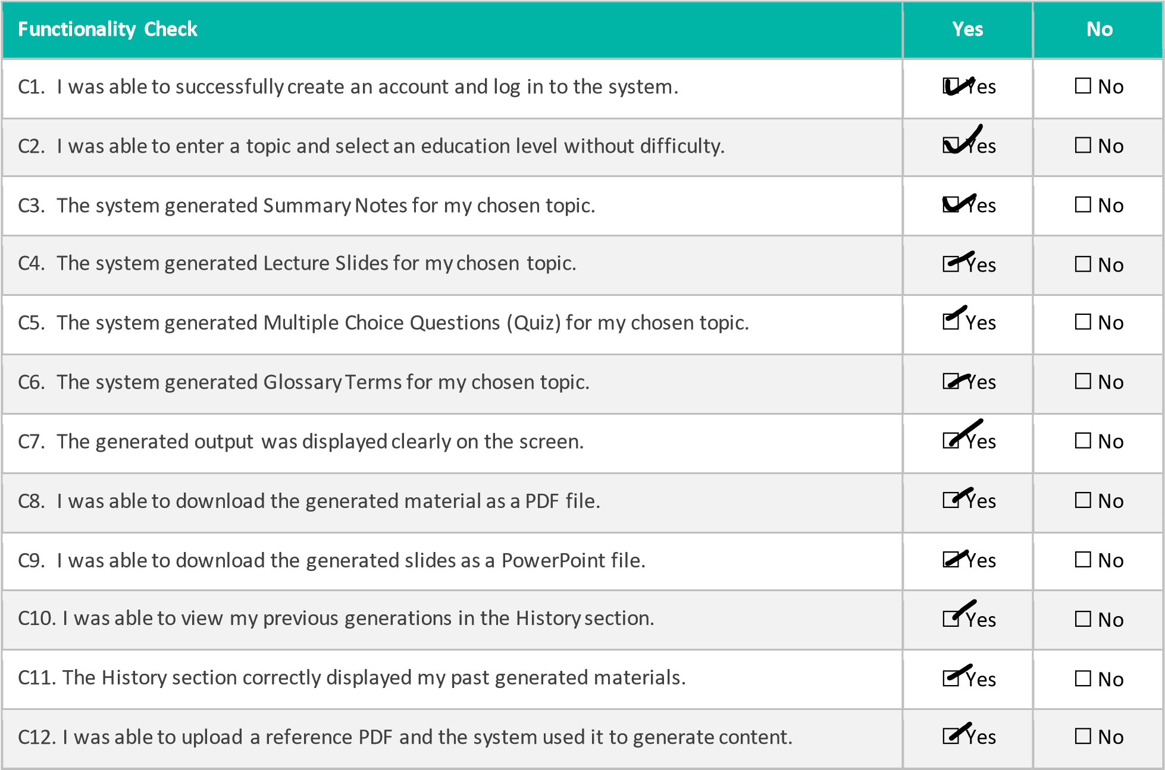

Please describe any functionality that did NOT work as expected:

SECTION D: OUTPUT QUALITY EVALUATION

Instructions: Rate each statement from 1 (Strongly Disagree) to 5 (Strongly Agree). Tick N/A if you did not test that output type.
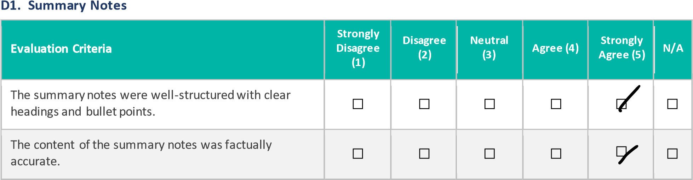
The summary notes covered the key concepts of the topic adequately. | ☐ | ☐ | ☐ | ☐ | ☐ | ☐
The vocabulary and complexity were appropriate for the selected education level. | ☐ | ☐ | ☐ | ☐ | ☐ | ☐
The summary notes would be useful for classroom teaching without major editing. | ☐ | ☐ | ☐ | ☐ | ☐ | ☐

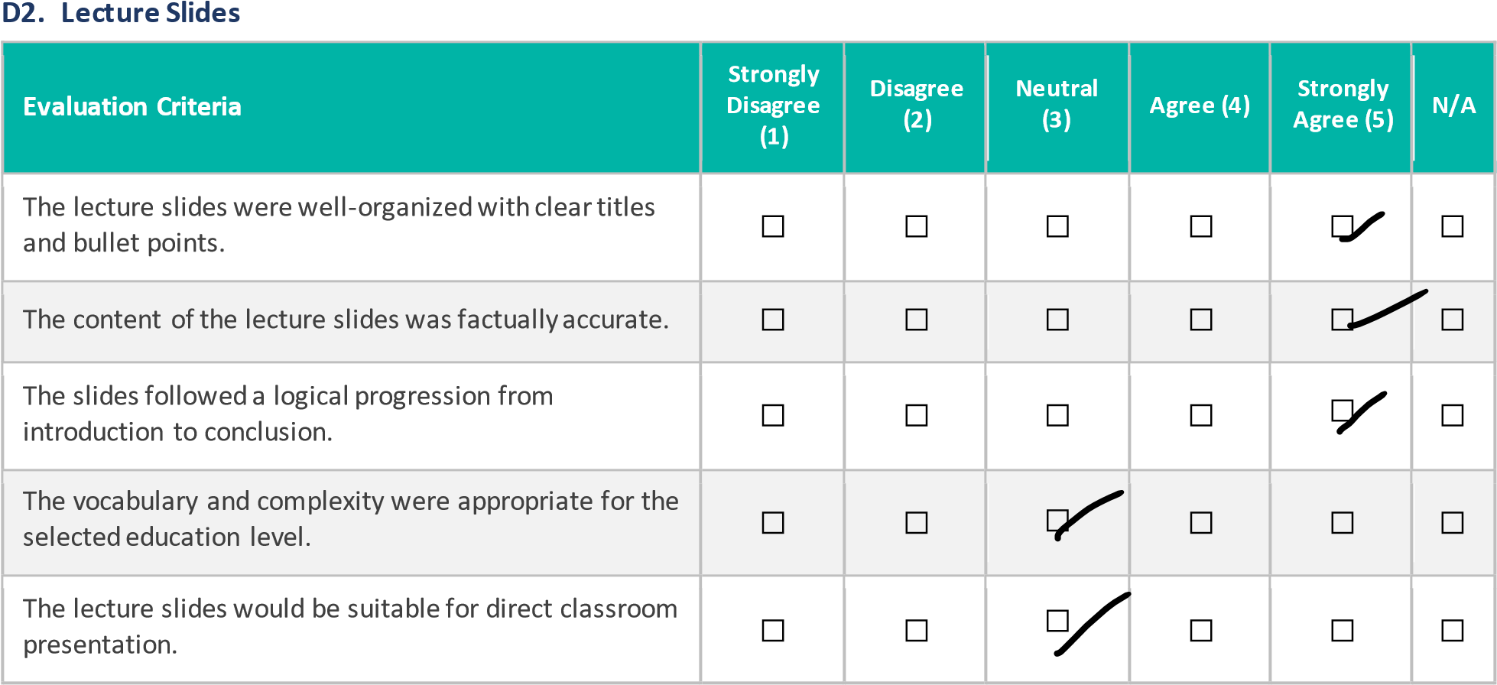

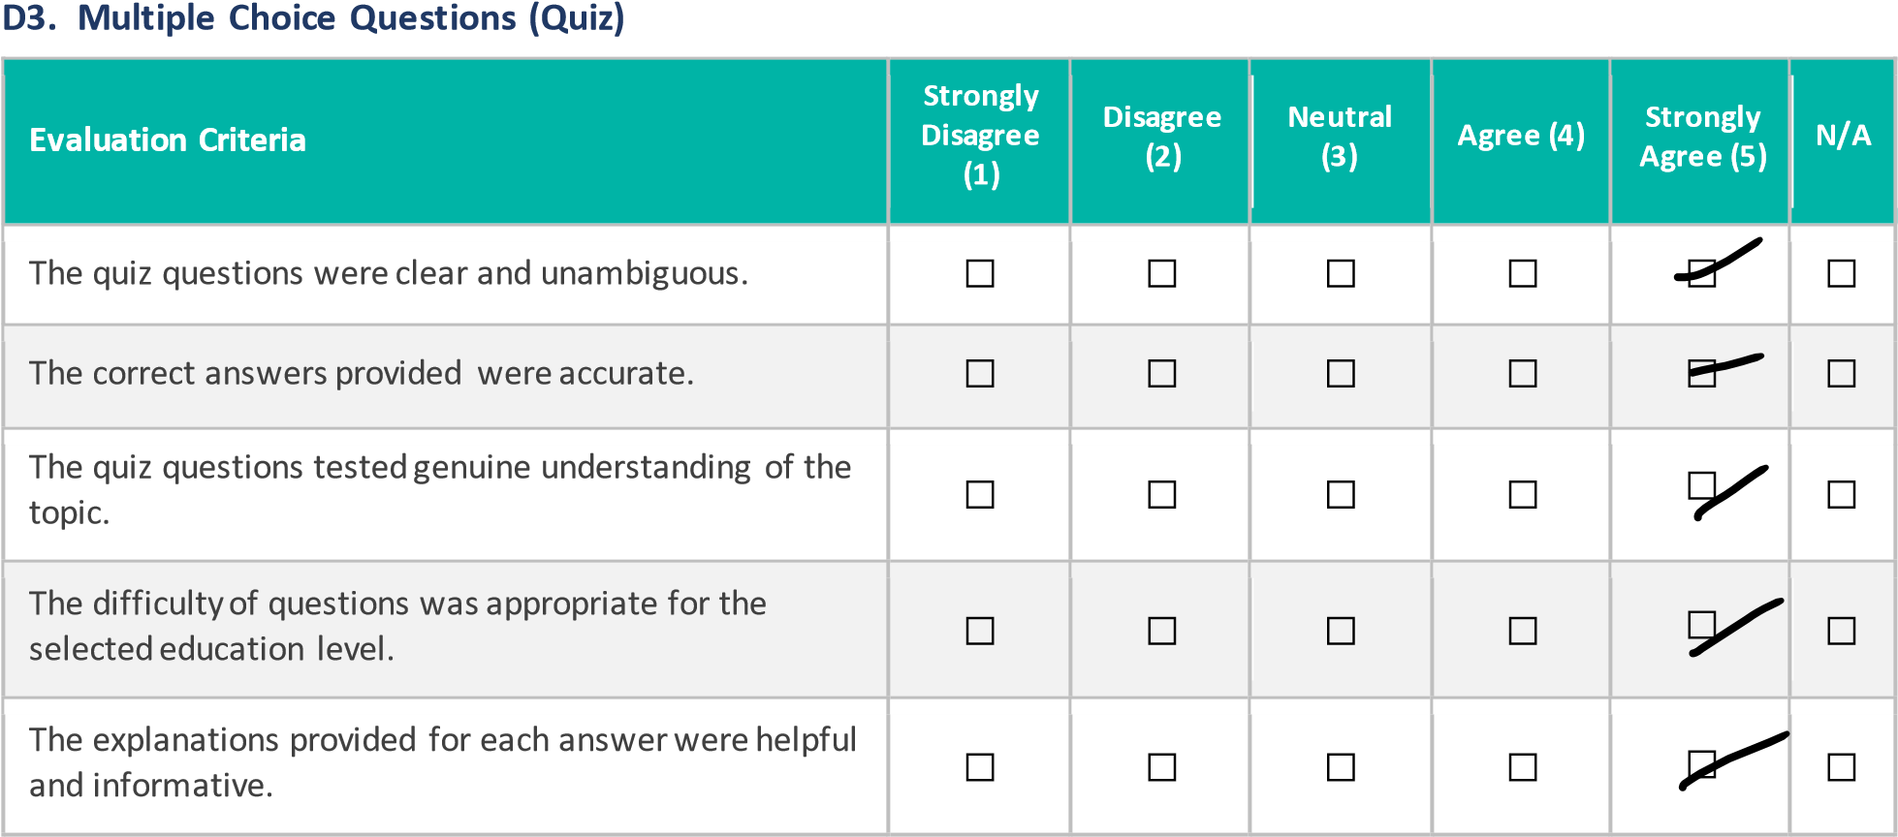

D4. Glossary Terms
Evaluation Criteria | Strongly  Disagree  (1) | Disagree (2) | Neutral (3) | Agree (4) | Strongly Agree (5) | N/A
The glossary terms were relevant and important to the topic. | ☐ | ☐ | ☐ | ☐ | ☐ | ☐
The definitions of the terms were accurate and easy to understand. | ☐ | ☐ | ☐ | ☐ | ☐ | ☐
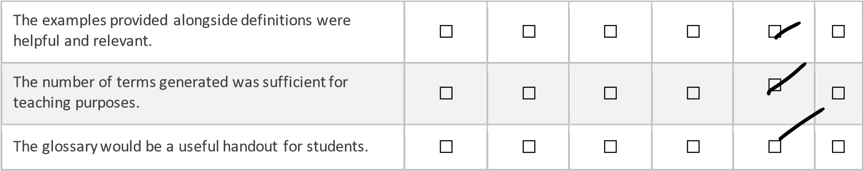

SECTION E: EDUCATION LEVEL ADAPTATION

Instructions: If you tested the system using more than one education level, rate the following statements.
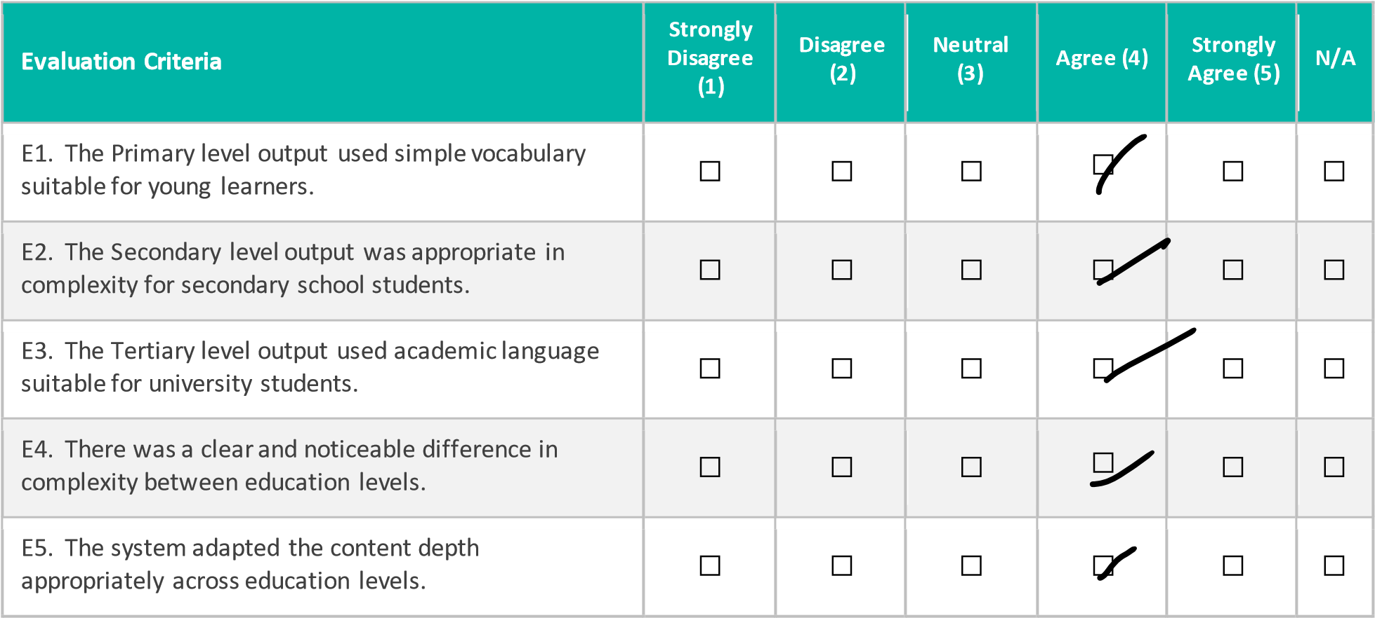

SECTION F: USABILITY AND TECHNOLOGY ACCEPTANCE (TAM)

Instructions: Rate each statement from 1 (Strongly Disagree) to 5 (Strongly Agree).
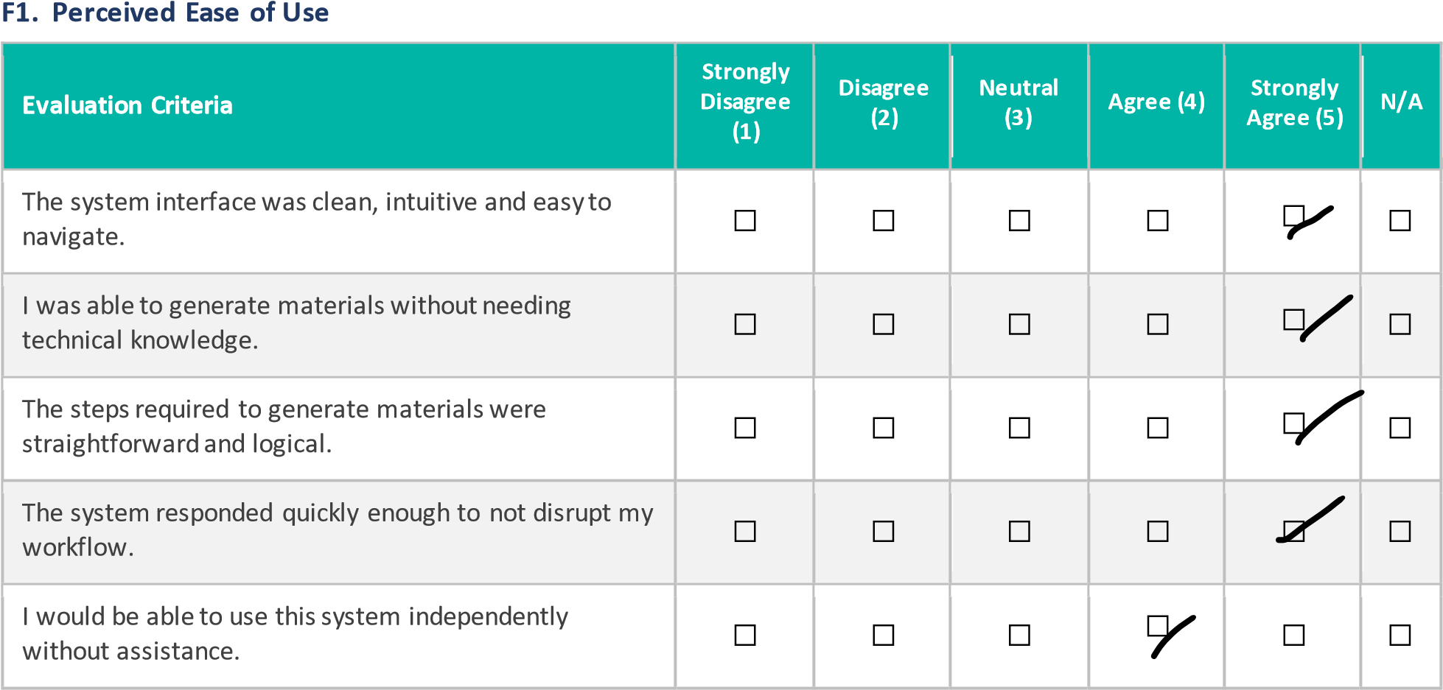

F2. Perceived Usefulness
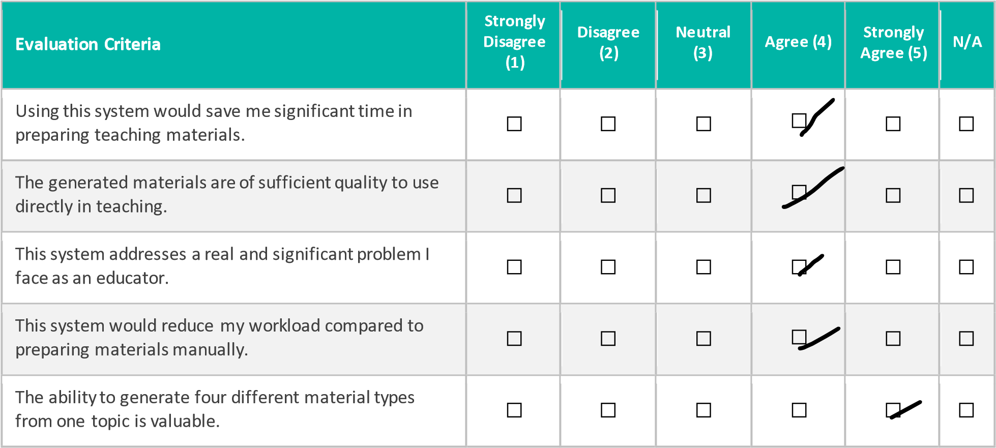

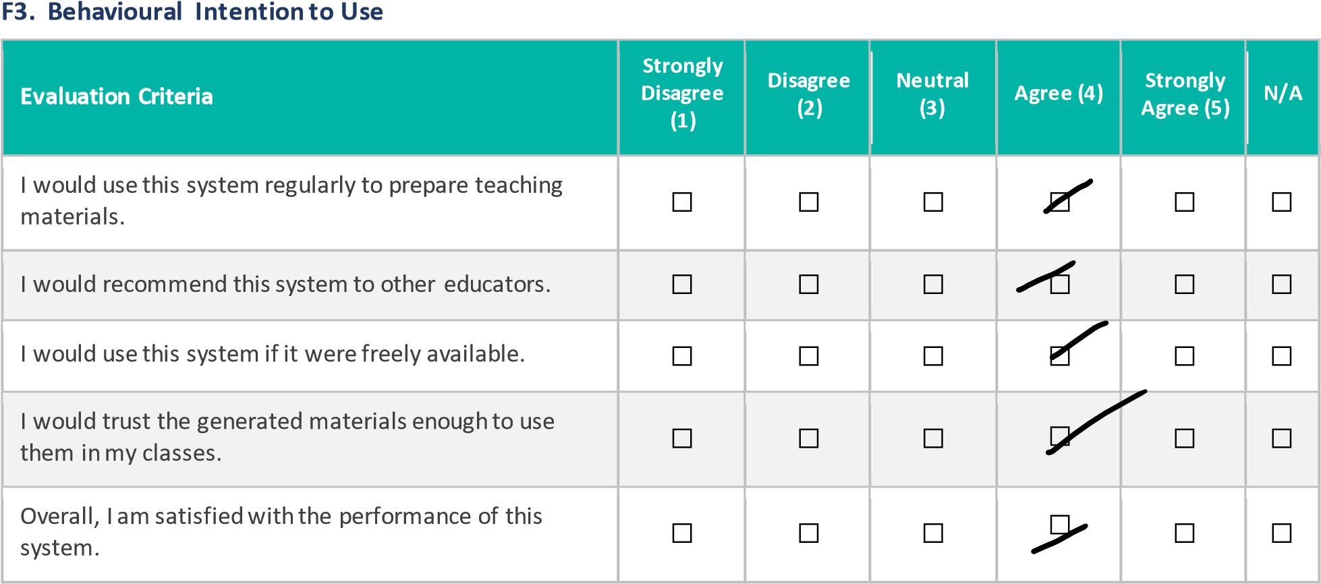

SECTION G: OVERALL RATING

H1. Please give an overall rating for the system:
☐

1

—

Very Poor

☐

2

—

Poor

☐

3

—

Acceptable

☐

4

—

Good

☐

5

—

Excellent

H2. Would you recommend this system to other educators?
☐

Yes
, definitely

☐

Maybe
, with improvements

☐

No

SECTION H: EVALUATOR SIGN-OFF

Participant Name:

Wilson Choong Xian Hui

_________________________________

Participant Signature:

_________________________________

Date:

5
/9/2026

_________________________________

Duration of Evaluation (minutes):

40

minutes

_________________________________

USER ACCEPTANCE TESTING (UAT) FORM
AI Agent for Automated Teaching Material Generation from Multi-Source Content
FYP Research Ethical Application
Student: Tan Chi Hong | ID: 2205466
Supervisor: Asst. Prof. Dr. Fatimah Audah binti Md. Zaki
SECTION A: PARTICIPANT INFORMATION

Participant Name | Liew Boon Kit
Teaching Role | School Teacher
Education Level Taught | Form 1 -3
Years of Teaching Experience | 8
Date of Evaluation | 6/9/2026

Teaching Role (please tick):
☐

Lecturer

☐

Tutor

☐

School

Teacher

☐

Teaching

Assistant

Education Level Taught (please tick all that apply):
☐

Primary

☐

Secondary

☐

Tertiary

/ University

SECTION B: INFORMED CONSENT

Purpose of This Evaluation
You are invited to evaluate a AI system that automatically generates structured teaching materials including lecture slides, summary notes, multiple choice questions and a glossary of key terms from a topic entered by the user. The system adapts its output to three education levels: primary, secondary and tertiary.
This evaluation is conducted as part of a final year project at Universiti Tunku Abdul Rahman (UTAR) for research purposes only. Your participation is entirely voluntary and you may withdraw at any time without any consequence.
Confidentiality
All responses collected in this form are strictly confidential. No personally identifiable information will be disclosed in any published report or academic submission. Data will be aggregated and used solely for academic analysis.
Consent Declaration
By completing and signing this form, you confirm that you have read and understood the above information that you voluntarily agree to participate in this evaluation, and that you consent to your anonymised responses being used for academic research purposes.

Participant Signature:

_________________________________

Date:

6
/9/2026

SECTION C: SYSTEM FUNCTIONALITY VERIFICATION

Instructions: Please use the system and tick Yes or No for each function listed below.

Please describe any functionality that did NOT work as expected:

SECTION D: OUTPUT QUALITY EVALUATION

Instructions: Rate each statement from 1 (Strongly Disagree) to 5 (Strongly Agree). Tick N/A if you did not test that output type.
D1. Summary Notes
Evaluation Criteria | Strongly  Disagree  (1) | Disagree (2) | Neutral (3) | Agree (4) | Strongly Agree (5) | N/A
The summary notes were well-structured with clear headings and bullet points. | ☐ | ☐ | ☐ | ☐ | ☐ | ☐
The content of the summary notes was factually accurate. | ☐ | ☐ | ☐ | ☐ | ☐ | ☐
The summary notes covered the key concepts of the topic adequately. | ☐ | ☐ | ☐ | ☐ | ☐ | ☐
The vocabulary and complexity were appropriate for the selected education level. | ☐ | ☐ | ☐ | ☐ | ☐ | ☐
The summary notes would be useful for classroom teaching without major editing. | ☐ | ☐ | ☐ | ☐ | ☐ | ☐

D2. Lecture Slides
Evaluation Criteria | Strongly  Disagree  (1) | Disagree (2) | Neutral (3) | Agree (4) | Strongly Agree (5) | N/A
The lecture slides were well-organized with clear titles and bullet points. | ☐ | ☐ | ☐ | ☐ | ☐ | ☐
The content of the lecture slides was factually accurate. | ☐ | ☐ | ☐ | ☐ | ☐ | ☐
The slides followed a logical progression from introduction to conclusion. | ☐ | ☐ | ☐ | ☐ | ☐ | ☐
The vocabulary and complexity were appropriate for the selected education level. | ☐ | ☐ | ☐ | ☐ | ☐ | ☐
The lecture slides would be suitable for direct classroom presentation. | ☐ | ☐ | ☐ | ☐ | ☐ | ☐

SECTION E: EDUCATION LEVEL ADAPTATION

Instructions: If you tested the system using more than one education level, rate the following statements.
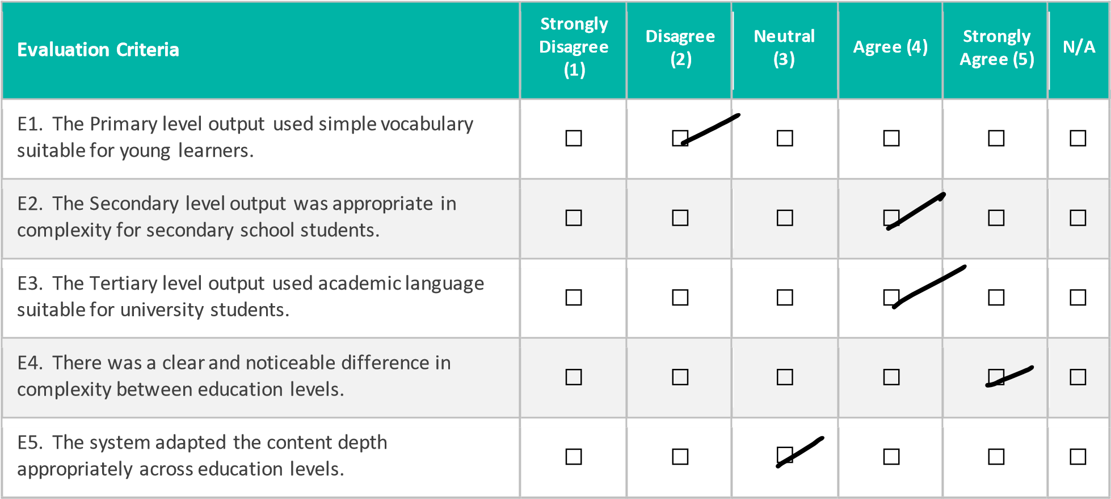

SECTION F: USABILITY AND TECHNOLOGY ACCEPTANCE (TAM)

Instructions: Rate each statement from 1 (Strongly Disagree) to 5 (Strongly Agree).
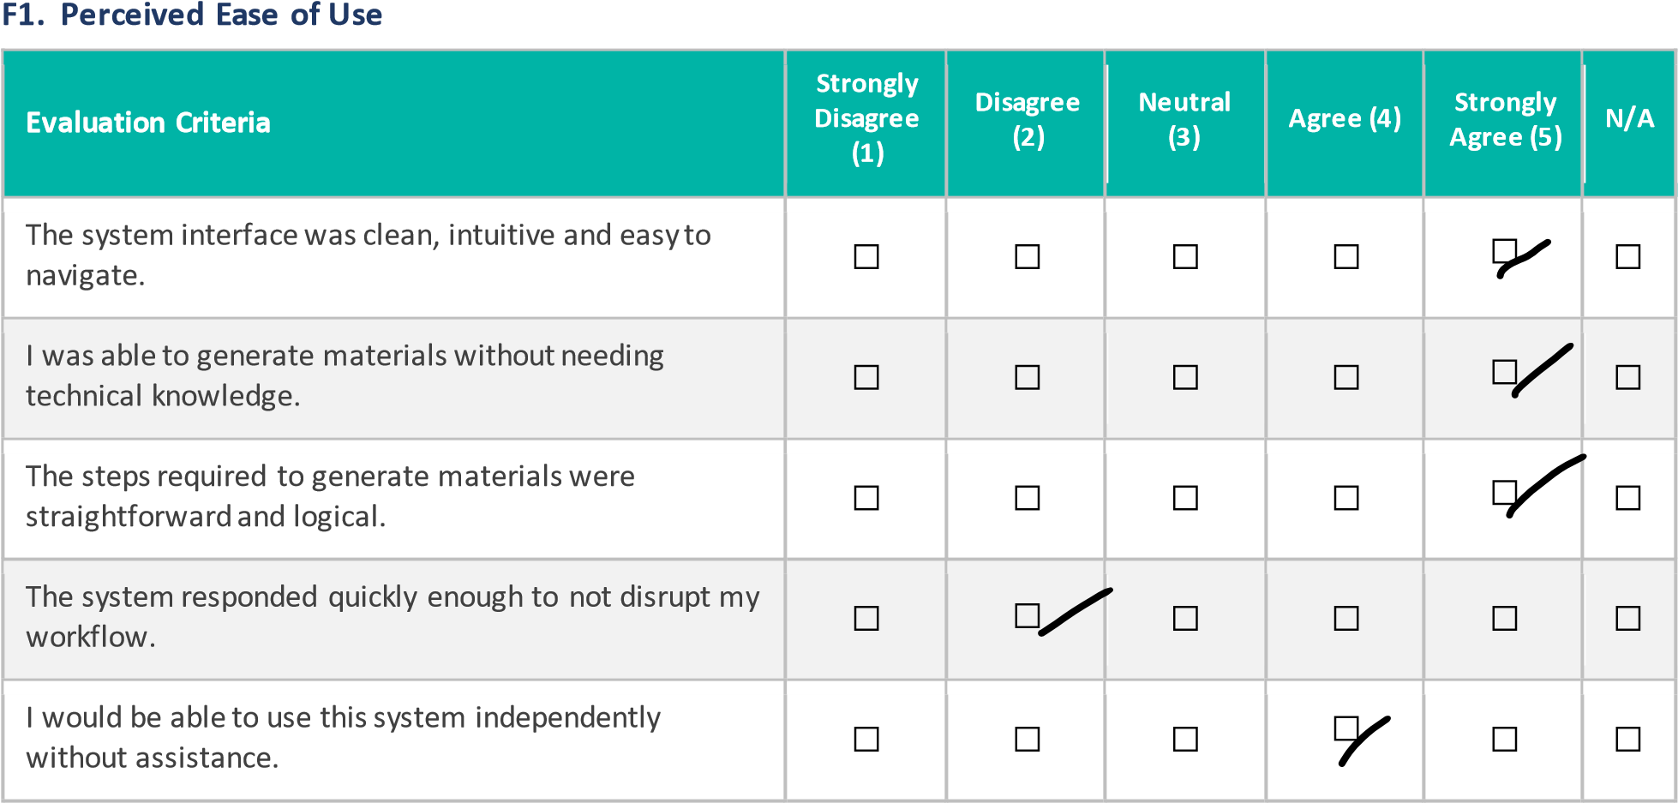

F2. Perceived Usefulness
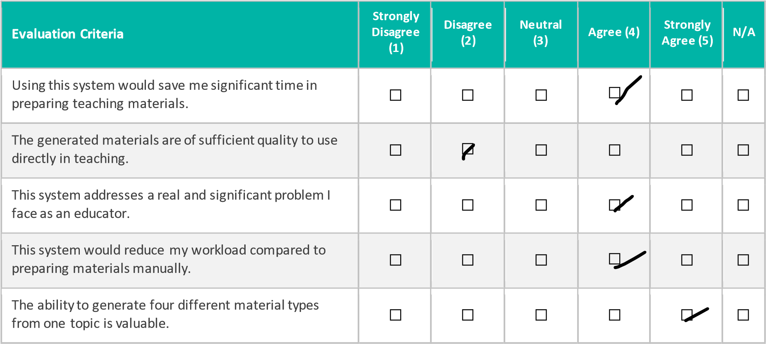

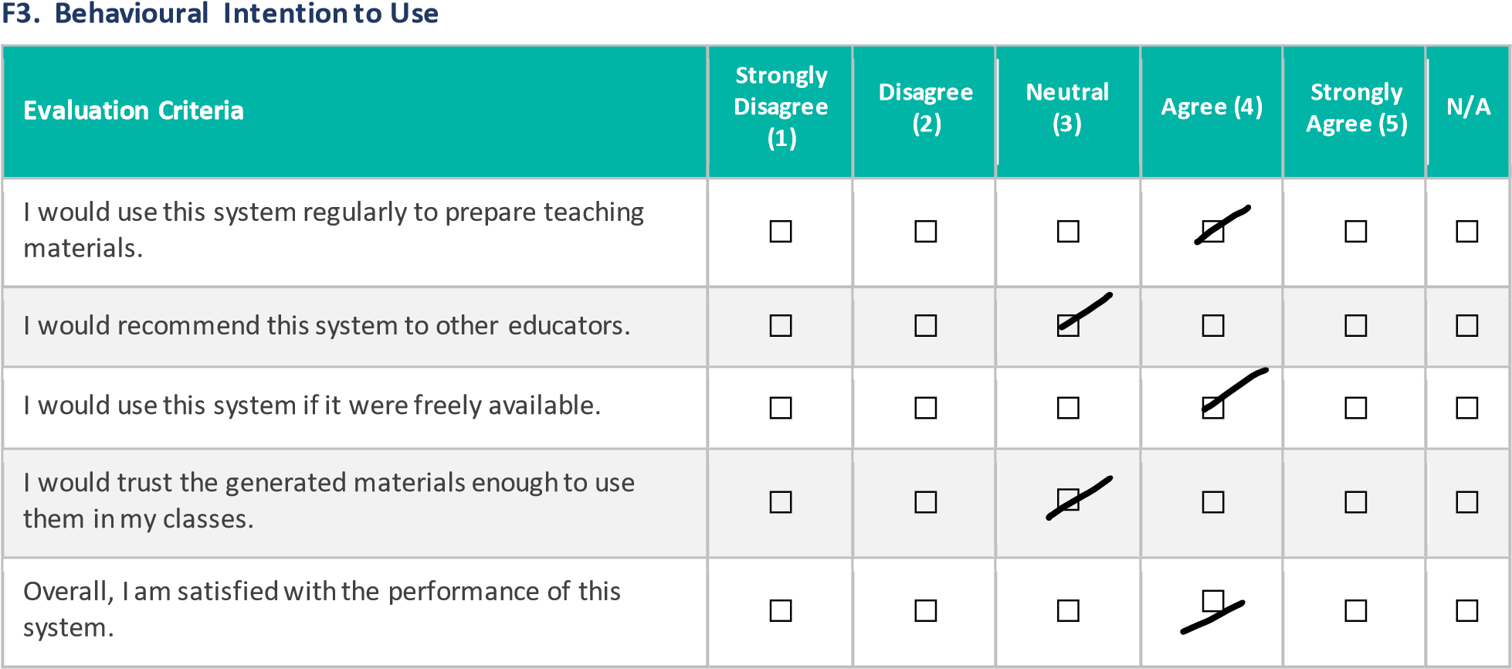
SECTION G: OVERALL RATING

H1. Please give an overall rating for the system:
☐

1

—

Very Poor

☐

2

—

Poor

☐

3

—

Acceptable

☐

4

—

Good

☐

5

—

Excellent

H2. Would you recommend this system to other educators?
☐ Yes, definitely | ☐ Maybe, with improvements | ☐ No

SECTION H: EVALUATOR SIGN-OFF

Participant Name:

Liew Boon Kit

_________________________________

Participant Signature:

_________________________________

Date:

6
/9/2026

_________________________________

Duration of Evaluation (minutes):

minutes
30

_________________________________

USER ACCEPTANCE TESTING (UAT) FORM
AI Agent for Automated Teaching Material Generation from Multi-Source Content
FYP Research Ethical Application
Student: Tan Chi Hong | ID: 2205466
Supervisor: Asst. Prof. Dr. Fatimah Audah binti Md. Zaki

SECTION A: PARTICIPANT INFORMATION

Participant Name | Lai Xin Pin
Teaching Role | Lecturer
Education Level Taught | College and Uni
Years of Teaching Experience | 5
Date of Evaluation | 4/9/2026

Teaching Role (please
tick):

☐

Lecturer

☐

Tutor

☐

School

Teacher

☐

Teaching

Assistant

Education Level Taught (please tick all that apply):

☐

Primary

☐

Secondary

☐

Tertiary

/ University

SECTION B: INFORMED CONSENT

Purpose of This Evaluation
You are invited to evaluate a AI system that automatically generates structured teaching materials including lecture slides, summary notes, multiple choice questions and a glossary of key terms from a topic entered by the user. The system adapts its output to three education levels: primary, secondary and tertiary.
This evaluation is conducted as part of a final year project at Universiti Tunku Abdul Rahman (UTAR) for research purposes only. Your participation is entirely voluntary and you may withdraw at any time without any consequence.
Confidentiality
All responses collected in this form are strictly confidential. No personally identifiable information will be disclosed in any published report or academic submission. Data will be aggregated and used solely for academic analysis.
Consent Declaration
By completing and signing this form, you confirm that you have read and understood the above information that you voluntarily agree to participate in this evaluation, and that you consent to your anonymised responses being used for academic research purposes.

Participant Signature:

_________________________________

Date:

4
/9/2026

SECTION C: SYSTEM FUNCTIONALITY VERIFICATION

Instructions: Please use the system and tick Yes or No for each function listed below.

Please describe any functionality that did NOT work as expected:

SECTION D: OUTPUT QUALITY EVALUATION

Instructions: Rate each statement from 1 (Strongly Disagree) to 5 (Strongly Agree). Tick N/A if you did not test that output type.
D1. Summary Notes
Evaluation Criteria | Strongly  Disagree  (1) | Disagree (2) | Neutral (3) | Agree (4) | Strongly Agree (5) | N/A
The summary notes were well-structured with clear headings and bullet points. | ☐ | ☐ | ☐ | ☐ | ☐ | ☐
The content of the summary notes was factually accurate. | ☐ | ☐ | ☐ | ☐ | ☐ | ☐
The summary notes covered the key concepts of the topic adequately. | ☐ | ☐ | ☐ | ☐ | ☐ | ☐
The vocabulary and complexity were appropriate for the selected education level. | ☐ | ☐ | ☐ | ☐ | ☐ | ☐
The summary notes would be useful for classroom teaching without major editing. | ☐ | ☐ | ☐ | ☐ | ☐ | ☐

D2. Lecture Slides
Evaluation Criteria | Strongly  Disagree  (1) | Disagree (2) | Neutral (3) | Agree (4) | Strongly Agree (5) | N/A
The lecture slides were well-organized with clear titles and bullet points. | ☐ | ☐ | ☐ | ☐ | ☐ | ☐
The content of the lecture slides was factually accurate. | ☐ | ☐ | ☐ | ☐ | ☐ | ☐
The slides followed a logical progression from introduction to conclusion. | ☐ | ☐ | ☐ | ☐ | ☐ | ☐
The vocabulary and complexity were appropriate for the selected education level. | ☐ | ☐ | ☐ | ☐ | ☐ | ☐
The lecture slides would be suitable for direct classroom presentation. | ☐ | ☐ | ☐ | ☐ | ☐ | ☐

SECTION E: EDUCATION LEVEL ADAPTATION

Instructions: If you tested the system using more than one education level, rate the following statements.

SECTION F: USABILITY AND TECHNOLOGY ACCEPTANCE (TAM)

Instructions: Rate each statement from 1 (Strongly Disagree) to 5 (Strongly Agree).

F2. Perceived Usefulness

SECTION G: OVERALL RATING

H1. Please give an overall rating for the system:
☐

1

—

Very Poor

☐

2

—

Poor

☐

3

—

Acceptable

☐

4

—

Good

☐

5

—

Excellent

H2. Would you recommend this system to other educators?
☐ Yes, definitely | ☐ Maybe, with improvements | ☐ No

SECTION H: EVALUATOR SIGN-OFF

Participant Name:

Lai Xin Pin

_________________________________

Participant Signature:

_________________________________

Date:

4
/9/2026

_________________________________

Duration of Evaluation (minutes):

minutes
30

_________________________________

USER ACCEPTANCE TESTING (UAT) FORM
AI Agent for Automated Teaching Material Generation from Multi-Source Content
FYP Research Ethical Application
Student: Tan Chi Hong | ID: 2205466
Supervisor: Asst. Prof. Dr. Fatimah Audah binti Md. Zaki
SECTION A: PARTICIPANT INFORMATION

Participant Name | Yong Wei Heng
Teaching Role | Tuition Centre Lead
Education Level Taught | K3-K6, Year 1 – Year 6, Form 1 – 3
Years of Teaching Experience | 4
Date of Evaluation | 3/9/2026

Teaching Role (please tick):

☐

Lecturer

☐

Tutor

☐

School

Teacher

☐

Teaching

Assistant

Education Level Taught (please tick all that apply):

☐

Primary

☐

Secondary

☐

Tertiary

/ University

SECTION B: INFORMED CONSENT

Purpose of This Evaluation
You are invited to evaluate a AI system that automatically generates structured teaching materials including lecture slides, summary notes, multiple choice questions and a glossary of key terms from a topic entered by the user. The system adapts its output to three education levels: primary, secondary and tertiary.
This evaluation is conducted as part of a final year project at Universiti Tunku Abdul Rahman (UTAR) for research purposes only. Your participation is entirely voluntary and you may withdraw at any time without any consequence.
Confidentiality
All responses collected in this form are strictly confidential. No personally identifiable information will be disclosed in any published report or academic submission. Data will be aggregated and used solely for academic analysis.
Consent Declaration
By completing and signing this form, you confirm that you have read and understood the above information that you voluntarily agree to participate in this evaluation, and that you consent to your anonymised responses being used for academic research purposes.

SECTION C: SYSTEM FUNCTIONALITY VERIFICATION
Participant Signature:

_________________________________

Date:

3
/
9/2026

Instructions: Please use the system and tick Yes or No for each function listed below.

Please describe any functionality that did NOT work as expected:

SECTION D: OUTPUT QUALITY EVALUATION

Instructions: Rate each statement from 1 (Strongly Disagree) to 5 (Strongly Agree). Tick N/A if you did not test that output type.

D1. Summary Notes
Evaluation Criteria | Strongly  Disagree  (1) | Disagree (2) | Neutral (3) | Agree (4) | Strongly Agree (5) | N/A
The summary notes were well-structured with clear headings and bullet points. | ☐ | ☐ | ☐ | ☐ | ☐ | ☐
The content of the summary notes was factually accurate. | ☐ | ☐ | ☐ | ☐ | ☐ | ☐
The summary notes covered the key concepts of the topic adequately. | ☐ | ☐ | ☐ | ☐ | ☐ | ☐
The vocabulary and complexity were appropriate for the selected education level. | ☐ | ☐ | ☐ | ☐ | ☐ | ☐
The summary notes would be useful for classroom teaching without major editing. | ☐ | ☐ | ☐ | ☐ | ☐ | ☐

D2. Lecture Slides
Evaluation Criteria | Strongly  Disagree  (1) | Disagree (2) | Neutral (3) | Agree (4) | Strongly Agree (5) | N/A
The lecture slides were well-organized with clear titles and bullet points. | ☐ | ☐ | ☐ | ☐ | ☐ | ☐
The content of the lecture slides was factually accurate. | ☐ | ☐ | ☐ | ☐ | ☐ | ☐
The slides followed a logical progression from introduction to conclusion. | ☐ | ☐ | ☐ | ☐ | ☐ | ☐
The vocabulary and complexity were appropriate for the selected education level. | ☐ | ☐ | ☐ | ☐ | ☐ | ☐
The lecture slides would be suitable for direct classroom presentation. | ☐ | ☐ | ☐ | ☐ | ☐ | ☐

SECTION E: EDUCATION LEVEL ADAPTATION

Instructions: If you tested the system using more than one education level, rate the following statements.
SECTION F: USABILITY AND TECHNOLOGY ACCEPTANCE (TAM)

Instructions: Rate each statement from 1 (Strongly Disagree) to 5 (Strongly Agree).

F2. Perceived Usefulness

SECTION G: OVERALL RATING

H1. Please give an overall rating for the system:
☐

1

—

Very Poor

☐

2

—

Poor

☐

3

—

Acceptable

☐

4

—

Good

☐

5

—

Excellent

H2. Would you recommend this system to other educators?
☐ Yes, definitely | ☐ Maybe, with improvements | ☐ No

SECTION
H
EVALUATOR SIGN
:
-
OFF

Participant Name:

Yong Wei Heng

_________________________________

Participant Signature:

_________________________________

Date:

3
/
9/2026

_________________________________

Duration of Evaluation (minutes):

minutes
30

_________________________________

