HCI Analysis

**(3 marks) What kind of content should be placed in the main content area of the website to facilitate online training of clients?**

Content that should be placed in the main content area of the home page include a welcome message with a description of the gym website, this could be a brief description of the gym with a button that says ‘more info’ if users wish to find out more information about Adrenaline Buzz Club (ABC).

After researching many other gym website, many websites included a motto to convey to users what their gym is about. Therefore, including a motto in ABC’s main content area would be a great way to captivate users and allow them to get a feel of what ABC has to offer. Also, since the gym is closed due to the ongoing pandemic, it would be important to notify users that the gym is currently closed, however the main content area should provide how ABC gym is finding exciting online alternatives to allow users to exercise from home. This could be achieved by providing a short description on services to allow members to exercise from home as well as other features that the gym also offers. This could be achieved with a button to click on to find out more information which would be included in addition to the short description.

Other common content that could placed in the main content area includes join up information. For instance this could be in the form of a short description that tells members how to sign up with a button below the text that links to a sign-up page where new comers or existing members could join the ABC website or if they do not have a gym membership they could join up on the website by clicking on an alternative link or another button.

Furthermore the home page could display information highlighting the main features of the gym with images to entice users to join their gym. This could include information about open hours for instance that it the gym is open 24/7. However, this is obviously not the case at the moment due to COVID pandemic, yet it is still good for members to know that usually the gym operates this way explaining that the gym at the moment is currently closed. The website could display information about online workout videos which are available for users to assist members with their workouts at home.

In addition, many competitor website include large background images of individuals exercising (Images of course will not reduce visibility of text), therefore images will have to be selected carefully. The use of such images is a great way to let users see the gym and entice them to train there. I believe that the website would benefit from having images of people from all different body types and backgrounds e.g. men, women, overweight people, muscular people, young/old etc.. displayed on the website The purpose of which is to appeal to all types of different individuals who may wish to become a member of ABC gym. Finally, since all workouts are online, perhaps including some images of people working out at home in front of a computer would be a great way to convey to users how the gym is assisting gym members to work out from home.

**How can the use of HTML5 and CSS3 help in authoring these features? Justify your answer by providing examples. Be realistic in your answer as you will have to program these features as a part of website creation. Your answer should not exceed 2-3 pages**

HTML5 could be used to create a div that would contain all of the main content inside which would be laid out using the grid template to divide the different parts of the home page up such as header, logo, main content, footer etc…   
CSS3 could control the dimensions and positioning of each section using features like padding to create space around each box in order to create a well designed laid out website. The use of the ‘class’ selector will be used within the div to incorporate the CSS3 styles. Once the grid layout has been established and the main content rows and columns are nicely configured a paragraph could be created within a container using CSS3 to create the container class to position it nicely. Furthermore in order to provide a brief description of the website, paragraph and heading tags (<p> and <h1>, <h2> etc,) would as well as using a background image url styling property in CSS3 to incorporate a background image. Obviously this would not obscure the text in any way and the image would have to be carefully selected to assure that this does not occur. Image and text could then be modified in styles CSS3 where properties such as font size, color and image dimensions could be modified to suit the site appropriately. Furthermore, to display the services that the gym offers, use of a nested box grid which contains 3 nested boxes within the 3rd main grid row at the bottom of main contents page (see layout image below) which could contain a service each. A little image could be used used to represent each service such as a computer image for online workout service which could be implemented via an <img> tag and the dimensions of the image could be modified in CSS3. Also the text and heading for each service would be modified in CSS3 also to set font size, style, colour and appropriate text-align, padding and margin properties will also be used in CSS3 to style, position and align text accordingly within each nested box. In order to include buttons, the HTML5 button tag could be used which uses a hover feature implemented in CSS3 that will change the background colour of the button with a transition animation to let users know that it is interactive and responsive.

**(5 marks) Suggest an alternative (to the one shown on page 2) layout for the website. You will need to draw a well-labelled diagram of the new layout. Consider the features of HTML5 and CSS3 that might help in creation of this layout. Analyse the layout considering the points such as: ease of use of the website, how user-friendly the layout is? and is the layout easily editable or extensible in the future (this is important as clients change their needs, requirements and thought process and website layout needs to be altered for future versions). Your answer should not exceed 1-2 page(s)**

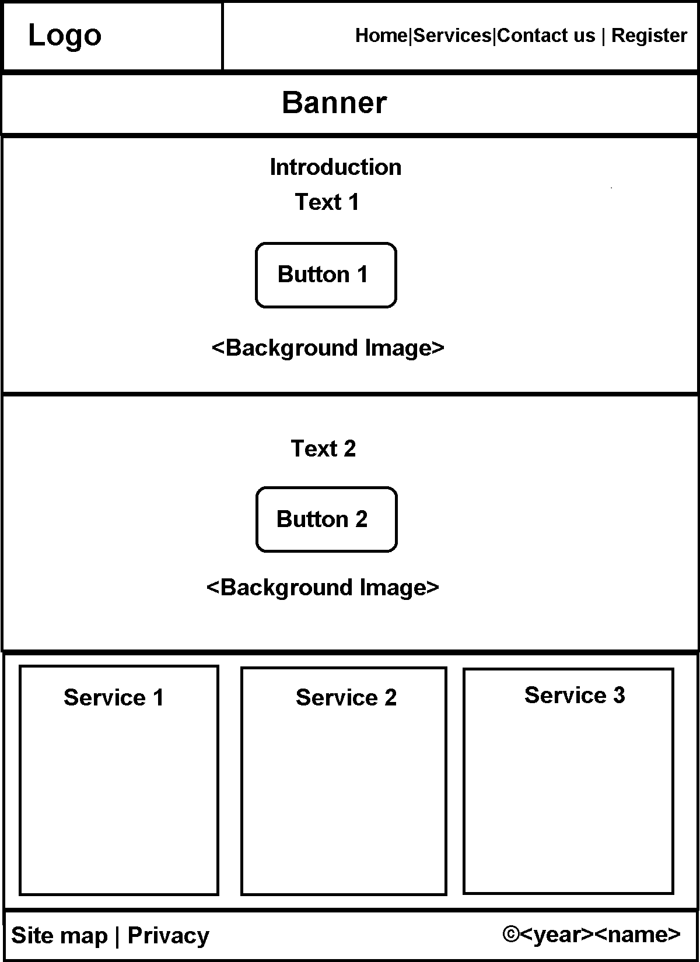

This website design will provide ease of use to those who visit the site. The navigation bar is allocated at the top right of the page and contains all of the pages available. Using CSS3, the navigation bar will be fixed to the top of the page so that when users scroll down the navigation bar will remain in place to offer flexibility and ease of use to navigate to any other page from any where within the site. In addition the page that is currently been viewed will be highlighted using a class in the <nav> tag which will be created in CSS3 to highlight the current page in the navigation bar to the colour white. More over a CSS3 animation will be used when the user hovers over the page to provide feedback to the user to let them know that it is interactive. The page layout is structured in a way that information is presented in a logical order, starting with a banner below the navigation bar which will display a background image of gym equipment to showcase the equipment on offer at ABC gym. Underneath the banner, a welcome message with more information is displayed within the third row of the grid box layout, registration information is displayed in the fourth row and services at the bottom fifth row. The services row contains another nested grid that evenly divides the row into three categories to uniformly spread apart each service. Finally, a footer is incorporated at the final sixth row. All of this is presented in an accessible grid layout that is logically presented to the user. Text is positioned centrally within the screen using the CSS3 property to align text centrally. Minimal text is used also to assure that the screen does not become to cluttered with textual information. Using background images is a great way to entice users to the website. Incorporating background images in rows 3 and 4 of the grid layout is a great way to promote accessibility, conveying information to users with contrasting text that draws the user to the text on screen against the darker background. Users do not like to read big chunks of information, therefore using images is a great way to visually convey information to visitors of the site. This layout is easily modifiable. For instance if I wanted to add another row with a category of information I could just add another box class in css3 and it would easily add a row below without altering the design of the site. Because the grid is set to a fixed length it will maintain an appropriate aspect ratio. If an image or text needs to be changed, the website is laid out in such a way that one can easily change the background image and text tags. Also, ideally the header and footer should be kept in a separate file that can be used for each page. So that the same code is not reused each time.

**(2 marks) Some of the club committee members want the use of Flash and/or Silverlight features on the website. The use of such techniques can lead to all sorts of usability issues. How will you address such issues with the use of HTML5 and CSS3? Differentiate between the use of plugins and HTML5. You answer should not exceed a page.**

Using Flash and/or silverlight can lead to a variety of usability issues. For instance adobe flash/silverlight cannot run on every type of operating system, e.g. Apple IOS. Furthermore, plugins would often fail when computer updates such as browser and java updates were carried out not to mention the numerous security vulnerabilities that flash and silver-light impose. Unlike silver-light/flash, HTML5 will work on browsers that do not yet support HTML5 as the page can still be viewed in a lesser rendering of HTML. Therefore, it is crucial that HTML5 is used for this website, however in order to implement all of the desirable features that silver-light/flash offer using HTML5 and CSS3 for the clients website such as video/audio, graphics and input widget movement features that made silver-light and flash so desirable to use can be addressed in the following ways using html5:

One of the main reasons why flash and silver-light plugins were used in website was to incorporate multimedia such as video and audio into websites. HTML5 offers a suitable alternative introducing new tags <audio> and <video> to incorporate multimedia into websites. Sources of video codec format can be specified also in HTML5 to support different video/audio types.

A popular reason for using flash and silver-light were because they handle graphics well especially bit map graphics. However, HTML5 now includes a <canvas> tag which can be used for bitmap graphics which was previously only possible using plugins.

Use of flash and silver-light plugins were popular to create input widgets and controls that replicate desktop applications. This proved very difficult prior to HTML5 using HTML, CSS and Javascript, however this is no longer an issue as HTML5 now includes a type tag attribute that can now be used on the <input> tag to tell the browser what kind of data is been inserted into the input field (such as date information) which facilitates the browser to do a better job of presenting the widget to the user. Furthermore a <menu> element can be used to create menus, toolbars and context menus therefore making a suitable alternative to silverlight and flash to create these widgets on the clients site.

Finally, a suitable alternative to flash/silver lights popular animation features is to use webkit which is implemented in CSS3, any animation that may be used in the website can be handled using webkit instead of flash and flashlght.

Working with the combination of HTML, CSS, and JavaScript to create controls that replicate desktop applications is a mess. Luckily, HTML5 has made improvements all around to the various widgets for input that allow for them to be used much more like desktop controls do, so you will find yourself reaching for Flash and Silverlight less often for this kind of need. For example, the "type" attribute on the <input>tag allows you to tell the browser what kind of data is going into a text field (such as date information), which in turn lets the browser do a better job of presenting the widget to the user. In addition, there is a <menu> element that lets you create menus, toolbars, and context menus, all of which add up to a very interactive experience with minimal work by the developer.

# **Video/audio**

Multimedia is one of the most important things that developers use Flash and Silverlight for. Indeed, once you take YouTube into account, Flash's use on the Web is overwhelmingly for video! Luckily, this is one of the things that HTML5 has gotten a handle on. HTML introduces two new tags, <audio> and <video>, for working with multimedia. While it is true that HTML5 has not settled on a particular codec for video at this point, it *is* possible to specify multiple sources of video content, so that you can encode the same video into enough codecs to have your bases covered. Ideal? No, but it is still a lot better than either handing off your content to a video site like YouTube or trying to craft your own video player.

# **Graphics**

Another reason folks use Flash and Silverlight is because they handle graphics well. Now, HTML has had various vector graphics systems in the past, and the current SVG standard is now well supported. But HTML5's <canvas> tag isn't for vector graphics, it is for bitmap graphics. Manipulating bitmap graphics is a task that both Flash and Silverlight do well, and before HTML5, Web developers could not do it without a plugin. With <canvas> a whole slew of possible games and applications open up for developers.

# **Input widget improvements**

Working with the combination of HTML, CSS, and JavaScript to create controls that replicate desktop applications is a mess. Luckily, HTML5 has made improvements all around to the various widgets for input that allow for them to be used much more like desktop controls do, so you will find yourself reaching for Flash and Silverlight less often for this kind of need. For example, the "type" attribute on the <input>tag allows you to tell the browser what kind of data is going into a text field (such as date information), which in turn lets the browser do a better job of presenting the widget to the user. In addition, there is a <menu> element that lets you create menus, toolbars, and context menus, all of which add up to a very interactive experience with minimal work by the developer.

# **Asynchronous operations**

The asynchronous processing model is critical to application development, because it allows you to do things like do heavy-duty processing in the background and not lock up the user interface, but then update the UI when the processing is done. HTML5 addresses this need with [the Web Workers specification](http://dev.w3.org/html5/workers/" \t "https://www.techrepublic.com/blog/web-designer/how-to-replace-flash-and-silverlight-with-html5/_blank). While Web Workers is not as well-supported as some of the other items presented here, expect for them to be much more useful in the next year or so. Why? Because the major browser hold up on Web Workers is Internet Explorer, and the IE10 preview 2 includes it. Web Workers will allow you to do the kinds of client-CPU-intensive tasks that are currently realistic with desktop applications of through Flash and Silverlight.

# **Communications**

[The WebSocket specification](http://dev.w3.org/html5/websockets/" \t "https://www.techrepublic.com/blog/web-designer/how-to-replace-flash-and-silverlight-with-html5/_blank) defines two-way communications between the browser and a host. This has always been a major shortcoming of the HTML + HTTP combination, and developers have tried to imitate round-trip communications in a variety of different ways. WebSocket actually piggybacks on top of HTTP, so you won't see the firewalls blocking it like you would with an entirely different protocol or port scheme. Like Web Workers, the WebSocket spec is still evolving and support is weak, but that is expected to change quickly; IE10 will support it, joining Firefox and Chrome, which means that within a year you can expect a high level of compatibility with WebSocket.

**References**

<https://pixabay.com/photos/fitness-weight-lifting-dumbbells-375472/>

**Security Camera**

<https://pixabay.com/vectors/surveillance-camera-security-video-147831/>

**Clock**

<https://pixabay.com/vectors/flat-design-symbol-icon-www-2442462/>

**Exercise**

<https://pixabay.com/vectors/weightlifter-gym-tool-athlete-3944725/>

**Computer**

<https://pixabay.com/vectors/flat-design-symbol-icon-www-2126880/>

Flash and silver light

<https://www.techrepublic.com/blog/web-designer/how-to-replace-flash-and-silverlight-with-html5/>