**Investigation**

Investigation methods

To ensure that I have a knowledgeable understanding of the system that I will be updating I am going to use several methods to gather information about the lockers based at Runshaw college. I will use:

A questionnaire in order to gain people’s opinions on lockers;

Documentation to get official stats about how many lockers are in use or paid for

And observation to look into the current state of lockers located around college.

Questionnaire

Questionnaires are a good method of investigation as they can give an honest opinion of a large amount of people in a relatively quick and cost-efficient manner. I decided to create my questionnaire in a simplistic manner and ask only for the basics. I did this to reduce chances of confusion when completing the survey and to make it easy to analyse and get the data I needed. The questions I asked were:

1. Knowledge that lockers are available is very good.
2. It is common to know how to access a locker.
3. I would consider using a locker in their current state.
4. If lockers were improved I would consider using them.
5. Lockers are a useful part of college

The options to answer were rated from 1 – 5 ranging from strongly disagree to strongly agree and were tabulated within an [excel file.](Questionaire.xlsx) I then calculated and average to get an accurate representation of a large amount of people and these were-

From this I can analyse that most people do know that lockers do exist however they don’t know how to then acquire them. Even if people did know how to use the lockers most people would still not consider using them. Contrasting to question 4 if the locker units were improved a substantial proportion of people would then consider changing their mind. The final question was to check to see if people that the upgrade had a point, asking if lockers were useful. The results were neutral and that was expected as simply people differ. The overall results from the question are positive showing that the locker upgrade is feasible and will be used.

Observation

I conducted observation myself to see how the current system worked. This meant I could analyse the positives of the current system and carry them through to my upgrade. This also gave me the chance to look at negatives and ensure that those problems were fixed in the changeover to a new system. My technique was finding the lockers in the college and taking 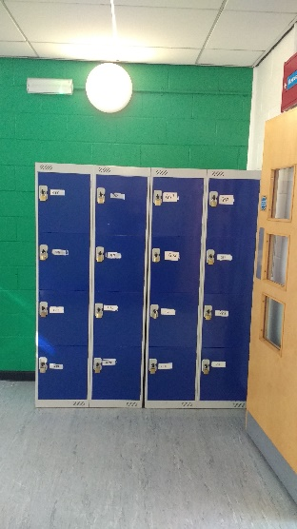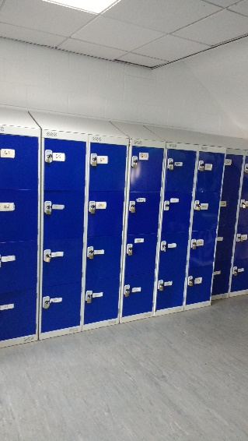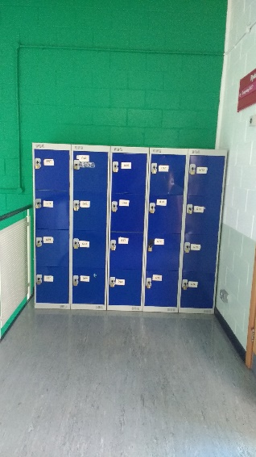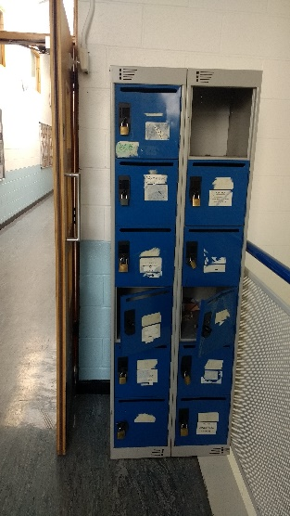pictures of them and analysing them myself, my findings were-

These pictures showed that location was very important moreover lockers must have easy access to ensure people want to use every locker unit not just specific ones. Contrasting the leftmost picture with the others I can see that maintenance is very important. The new system must be built to last to ensure they aren’t just left derelict which would waste the money spent on the improvement.

Documentation

To get the most accurate data I got documentation from the college to ensure it wasn’t opinion and was plain fact. From the documents, the results suggested that many lockers were rented out however this doesn’t mean that people were using them. My other investigation techniques suggested that they weren’t in use. The documents were manually inputted and this would have been time consuming when done so this further suggests that the automated data logging is a substantial improvement.

Conclusion

These methods are extremely important in this project as they will allow me to find all the problems within the current system. Moreover, I will be able to have a thorough, deep comprehension of what needs to be done to make the new system succeed. The techniques that I have used will also give me an outside opinion potentially showing complications that I may have missed myself, in turn this will improve the efficiency of the final application. This also means that I can personally design the system to fit the need of the user rather then what I thought they wanted.

Current System

Stake Holders:

* Runshaw Staff
  + Teachers
  + Cleaners
  + Management
* Students

Teachers

Teachers currently do not have access to lockers and it doesn’t affect them besides it being linked to the college. Having non-appealing lockers will negatively impact the college reputation which should be an item teachers consider.

Cleaners

Currently cleaners must check lockers frequently to keep them clean and if needed perform fixes or use a master key. A new system would affect what their job is but not massively.

Management

At the moment, management simply give out lockers and manually note down which lockers are in use. They will have to be trained to do this and it does affect what they do in their job but they don’t use the lockers themselves.

Students

Students are affected the most by lockers as they are the ones that use them daily. This means that their opinion is highly valued as they will be the ones using and paying for the system.

Inputs process and outputs (current system)

Currently all inputs are done manually onto an electronic system, an admin or staff member must be present to process the information and it increases the duration of this procedure significantly.

|  |  |  |  |
| --- | --- | --- | --- |
| Identifier | Inputs | Processes | Outputs |
| 01 | Student ID and name | Check if it is a valid ID and the student does attend the college | A either pass or fail of the previous check |
| 02 | Locker request | Check if there is an available locker in the unit desired then assign this locker to the student wishing to book | A confirmation of the booking working or a messages explain a failure in the booking |

Limitations of current system

I believe that the current system is effective, but it is not efficient and could be improved. There a flaws in the speed of the system the accessibility of the system and the possibility of human error. The system works very slowly and gives no quick access to a locker, they must first be booked paid for and then lock and key reserved. This will put of people from getting a locker as it is superfluously complicated and takes too much time. The accessibility of the lockers is limited as it is all based within the program office as well as many other process’ run by the college.

Research into already known solutions

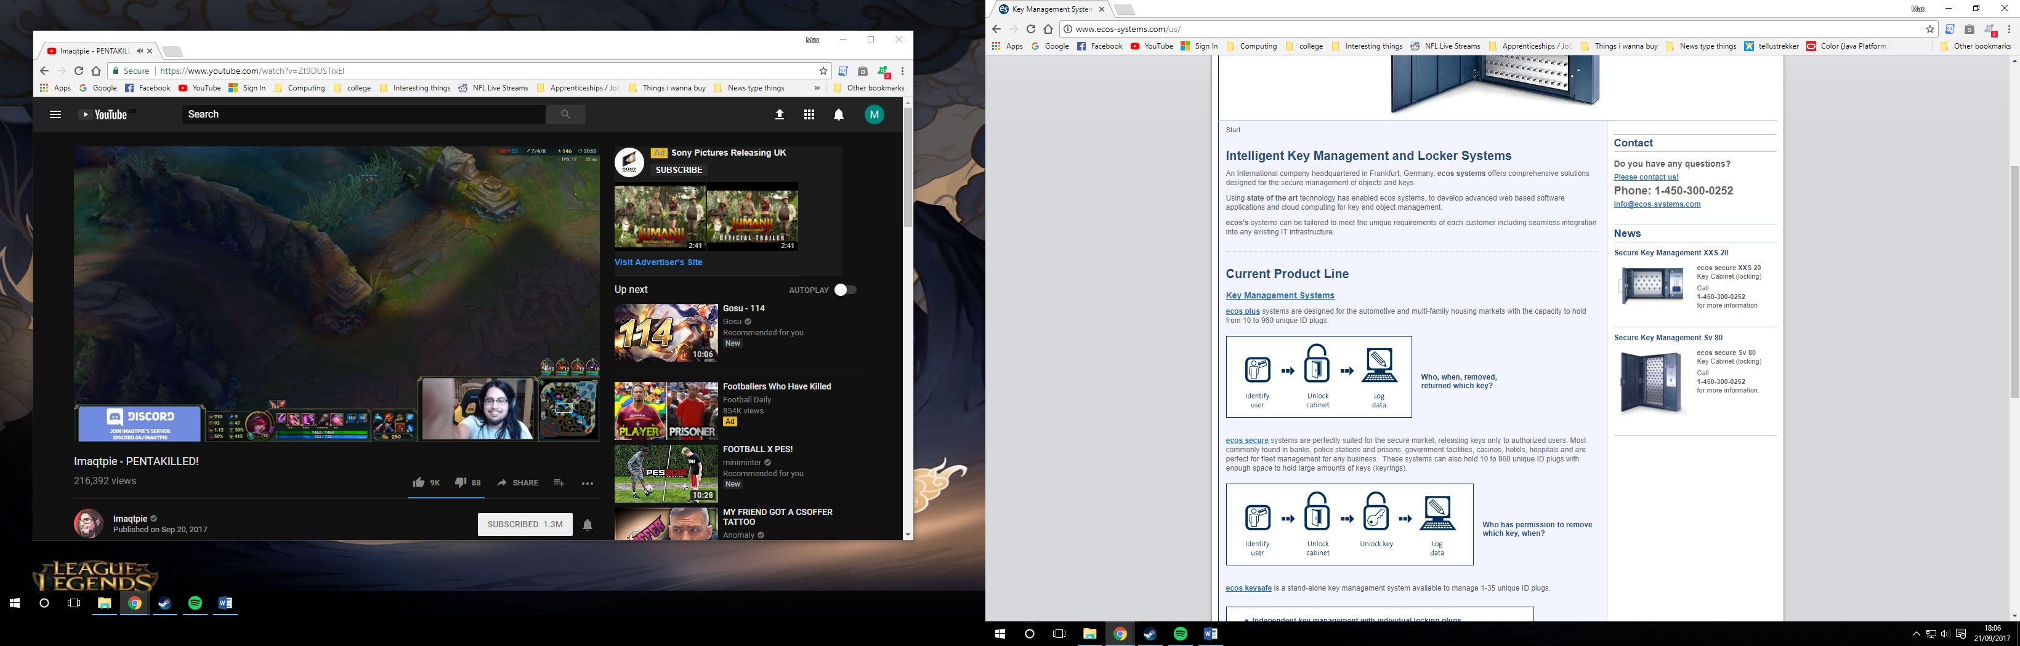After researching on the internet to find similar systems I find an American based company that sold locker units to be used in business’. Their system had a few variations and the most basic design used the same principal as my idea however the units they sell are not linked. They suggest that these units should be used in casinos or for any form of security for a large-scale business. I intend to use the same basic principal as this company however make mine specifically for a school purpose.

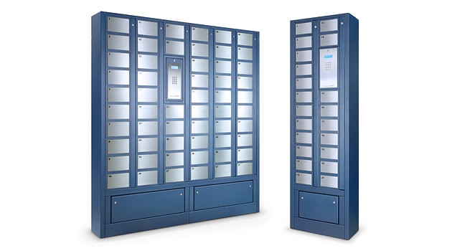On the website, they state that they use a 3-step process to use their lockers which is the same format that I intend to use, with one singular input and one output and multiple process in-between.

<http://www.ecos-systems.com/us/>

New System

Stakeholders

On the new system, there will be no more stake holders however the system will impact each of the stakeholders. There is a minimal effect on teachers as they will not need extra training nor be economically affected, they simply will just have lockers obtainable by them.

Cleaners and management would be affected largely as they will require extra training to ensure that the system is usable and kept purposeful. This fact may mean that the changeover may be delayed ensuring that all staffing members are able to use the new system.

Students are again most impacted as depending on what the college wanted they could charge to use the system or ask for donations to help fund the system. The main point of the project is to make lockers used more. This means that students are the people that need to be convinced to use the system, making their opinion highly valued.

Specification

The new system needs to provide fast access to lockers and must always be functional. It must be quick to ensure that students can use them going from lesson to lesson. Corridors are already a notoriously busy place so implementing the new locker system can’t increase the hold up as the accessibility would fail and they won’t be used.

Methods to use

Throughout this project the java language is going to be used to develop the back end of the system. This is because it is the language that I will be able to execute this project to the best of my ability with. It provides all the basic needs of a coding language such as class’ data types and functions. All of these will be used within the system to make it as efficient as possible.

|  |  |  |
| --- | --- | --- |
| Identifier | Name | Explanation |
| 01 | Class’ | I will use multiple class’ to ensure that my main program is written as clearly as possible with and as efficient as possible. This makes the code more organised and when writing will make it easier to spot where the code breaks. |
| 02 | Data types | Data types will be used so that I can use logical operators on integers when required. Boolean data types will be used to store data more efficiently as only 2 values can be stored on Boolean |
| 03 | Functions | Functions will be used to keep code efficient, instead of using the same line of code over and over one could simply call upon the function several times. Within the one class functions will assist keeping it organised as class’ would do for the entire project. |
| 04 | File handling | File handling will be crucial in this project as I need to be able to read from the database that will be created in a text file format. Java does support this and I am comfortable integrating it into my code |
| 05 | Java Swing | The java swing class is a way of coding a gui within java. This means that I will be able to create an attractive front end to accompany the back end of my system. Giving the user a way to interact with the code behind the screen. |

Objectives

There are a range of objectives with this project and all must be functional in order for the system to be efficient.

|  |  |  |
| --- | --- | --- |
| Identifier | Objective | Criteria |
| 01 | QR reading | When scanning the id card successfully recognise who the card belongs to. |
| 02 | Login | When the card has been read, understand who the user is and give access to correct privilege level. |
| 03 | Menu | Take the user to their desired menu being either the admin screen or the non admin screen. |
| 04 | Checking current use | The user should be able to see what their current locker status is. |
| 05 | Book desired locker | When the user wants to book a locker, if they pass the criteria they should be able to open and reserve their locker. |
| 06 | Open locker | The user should be able to scan in and open their locker upon request. |
| 07 | End usage | If the user wants to finish user their locker they should be able to finish and close it. |
| 08 | See availability | When logged in the user should be able to choose whatever locker they want to use within the unit. |
| 09 | Turn off system | On the admin screen they should be able to turn off the system so no one can access them |
| 10 | Turn on system | If the admin desires they should be able to turn the system back on so the unit can be accessed again. |
| 11 | Force unlock | The admins and admins only should be able to force unlock any locker if it is so desired. |
| 12 | Clock | A clock should be visible on the screen so the user can see how long they have left. |
| 13 | Map | A map of all units should be accessible so users can see where the nearest locker is to them. |

*Not going to be located here necessarily*

The type of system changeover is very important as it could have catastrophic impact on the whole project. The fact that there are many units around college means that there is an opportunity to use pilot changeover. This means that one unit can be implicated and if it has beneficial impact then the rest of the units can follow. Doing this will give security to the college as they can cancel the upgrade if it doesn’t give beneficial impacts as well giving staff and students the chance to get used to the lockers before they are applied.