Maxwell Banks
CSCI 2270
12.8.19
D&D Dungeon Master Helper

Data Structures Used in this Project:
Hash Tables – Hash tables were used to store monsters, items, spells, and abilities. This enabled easy and fast access to a given item among thousands at any given time.
Binary Search Trees – Binary search trees were used to store items, spells, and abilities for player inventories, to effectively store smaller amounts of data in such a way that the entire compendium is easily accessible at any given time.
Vectors – Used to store players in a party, classes in a player, and other potentially variable but small groups of data.
Arrays – Used to store fixed size groups of data, such as stats or skills.

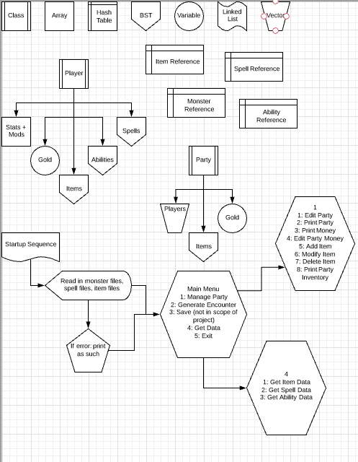

Data used:
Items.csv: File containing items and their rarity
Spells.csv: File containing spells and their level
Monsters.csv: File containing monsters and their CR
Abilities.csv: File containing abilities and their charges
Results:
This program is capable of managing a Dungeons and Dragons party, editing players as a session goes on and generating appropriately leveled randomized encounters for them through a combination of hash table and binary tree searches. Following object-oriented standards, the items, spells, abilities, monsters, players (as well as player stats), and party are all compartmentalized so as to make it easy and efficient to access any aspect with minimal computational resources required. The only feature missing is the ability to read in a .csv file for player sheets and the ability to save player sheets after a session, making this tool best sorted for a one-session campaign at the moment.

