|  |
| --- |
| Juicing the numbers  Part 2: Processing Operations |
| Maxwell Bo & Chantel Morris |



## Pure Fresh Processing

### **Introduction**

Underpinning Pure Fresh’s success is their efficiency in processing. Critical to this end is visibility of the operations on the ground. It is the intention of this report to identify operational constraints and recommend solutions to alleviate them.

### **Methodology**

As directed by the Client, the model was developed incrementally. The model was built in 5 stages as follows;

1. Base model, dictated by the constitution of juices, and their cost, in addition to the demand anticipated. Utilising this information, in addition to sale cost we were able to generate a processing cost across the eight quarters to come.
2. The second model incorporated the limitation that fruit concentrate was trucked in, one fruit at a time.
3. The third model restricted juice production to only two gourmet juices each quarter.
4. Subsequently, the client requested the model to ensure that one juice was not out of production for more than one quarter in a row. This was implemented in the fourth model.
5. The final communication from Pure Fresh asked us to optimise their deliveries.

### **Results**

#### Model 1

The processing cost of Pure Fresh’s operations in the Base model is $26, 240, 835.76.

The optimal production profile is detailed in Table 1.

*Table 1*

|  |  |  |  |  |  |  |  |  |
| --- | --- | --- | --- | --- | --- | --- | --- | --- |
|  | Q1 | Q2 | Q3 | Q4 | Q5 | Q6 | Q7 | Q8 |
| Orange Juice | 880 | 872 | 1206 | 981 | 781 | 1055 | 1420 | 1236 |
| Orange and MangoJuice | 311 | 347 | 469 | 389 | 329 | 363 | 484 | 568 |
| Breakfast Juice | 682 | 707 | 838 | 938 | 586 | 788 | 1141 | 988 |
| Tropical Juice | 492 | 586 | 726 | 739 | 450 | 549 | 645 | 779 |
| Guava Delight | 340 | 459 | 593 | 393 | 276 | 424 | 559 | 389 |
| Orchard Medley | 1151 | 621 | 697 | 909 | 1133 | 615 | 542 | 865 |
| Strawberry Surprise | 625 | 740 | 468 | 409 | 665 | 750 | 411 | 464 |

#### Model 2

Following the restriction regarding the trucking in of concentrate, processing operations were remodeled. The effects of that implementation are seen in Table 2. Furthermore, the change in production between the base model and the model with the trucking limitation, is detailed for each juice for each quarter in Table 3. Optimal trucking operations are detailed in Table 4.

The total cost, in light of the Pure Fresh’s trucking operations, is $26, 065, 452.96

*Table 2*

|  |  |  |  |  |  |  |  |  |  |
| --- | --- | --- | --- | --- | --- | --- | --- | --- | --- |
| kL | Q1 | Q2 | Q3 | Q4 | Q5 | Q6 | Q7 | Q8 | TOTAL |
| Orange Juice | 900 | 872 | 1206 | 981 | 781 | 1055 | 1420 | 1236 | 8451 |
| Orange and Mango Juice | 289 | 347 | 469 | 389 | 316 | 363 | 484 | 568 | 3225 |
| Breakfast Juice | 672 | 707 | 838 | 938 | 586 | 788 | 1141 | 988 | 6658 |
| Tropical Juice | 492 | 586 | 720 | 738 | 450 | 549 | 645 | 779 | 4959 |
| Guava Delight | 340 | 452 | 593 | 393 | 276 | 424 | 559 | 389 | 3426 |
| Orchard Medley | 1151 | 621 | 697 | 909 | 1131 | 615 | 542 | 865 | 6531 |
| Strawberry Surprise | 625 | 740 | 464 | 405 | 665 | 747 | 411 | 462 | 4519 |
| TOTAL | 4469 | 4325 | 4987 | 4753 | 4205 | 4541 | 5202 | 5287 |  |

Table 3

|  |  |  |  |  |  |  |  |  |
| --- | --- | --- | --- | --- | --- | --- | --- | --- |
| Change in Production in kL | Q1 | Q2 | Q3 | Q4 | Q5 | Q6 | Q7 | Q8 |
| Orange Juice | 20 | 0 | 0 | 0 | 0 | 0 | 0 | 0 |
| Orange and Mango Juice | -22 | 0 | 0 | 0 | -13 | 0 | 0 | 0 |
| Breakfast Juice | -10 | 0 | 0 | 0 | 0 | 0 | 0 | 0 |
| Tropical Juice | 0 | 0 | -6 | -1 | 0 | 0 | 0 | 0 |
| Guava Delight | 0 | -7 | 0 | 0 | 0 | 0 | 0 | 0 |
| Orchard Medley | 0 | 0 | 0 | 0 | -2 | 0 | 0 | 0 |
| Strawberry Surprise | 0 | 0 | -4 | -4 | 0 | -3 | 0 | -2 |

Table 4

|  |  |  |  |  |  |  |  |  |
| --- | --- | --- | --- | --- | --- | --- | --- | --- |
|  | Q1 | Q2 | Q3 | Q4 | Q5 | Q6 | Q7 | Q8 |
| Apple | 210 | 211 | 217 | 213 | 200 | 211 | 214 | 221 |
| Mango | 10 | 8 | 10 | 11 | 10 | 9 | 10 | 12 |
| Pineapple | 37 | 42 | 51 | 53 | 33 | 43 | 57 | 55 |
| Passionfruit | 1 | 1 | 1 | 1 | 1 | 1 | 1 | 1 |
| Guava | 5 | 6 | 7 | 5 | 5 | 6 | 7 | 5 |
| Strawberry | 5 | 6 | 4 | 4 | 6 | 6 | 4 | 4 |

#### model 3

Upon the limitation that only two gourmet juices could be produced per quarter, the optimal processing operation was modeled. The output of that model is found in Table 5 and 6. The selection of gourmet juices is found in Table 7. The change in processing cost is detailed in Table 8. The change evaluated was that in production between Model 2 and Model 3. This change was selected because the comparison between this model and the Base model is largely redundant, considering that trucking is an unavoidable reality of Pure Fresh operations.

The cost, upon this limitation was found to be $23, 426, 440.25, representing a 10.73% reduction in costs.

*Table 5*

|  |  |  |  |  |  |  |  |  |  |
| --- | --- | --- | --- | --- | --- | --- | --- | --- | --- |
|  | Q1 | Q2 | Q3 | Q4 | Q5 | Q6 | Q7 | Q8 | TOTAL |
| Orange Juice | 900.00 | 872 | 1206 | 981 | 781 | 1055 | 1420 | 1236 | 8451 |
| Orange and Mango Juice | 291 | 347 | 469 | 389 | 316 | 363 | 484 | 568 | 3227 |
| Breakfast Juice | 682 | 707 | 838 | 938 | 586 | 787 | 1141 | 986 | 6665 |
| Tropical Juice | 492 | 586 | 721 | 739 | 450 | 549 | 645 | 779 | 4961 |
| Guava Delight | 0 | 0 | 589 | 393 | 0 | 0 | 559 | 0 | 1541 |
| Orchard Medley | 1145 | 621 | 697 | 909 | 1133 | 615 | 542 | 865 | 6527 |
| Strawberry Surprise | 625 | 740 | 0 | 0 | 665 | 746 | 0 | 464 | 3240 |
| TOTAL | 4135 | 3873 | 4520 | 4349 | 3931 | 4115 | 4791 | 4898 |  |

*Table 6*

|  |  |  |  |  |  |  |  |  |
| --- | --- | --- | --- | --- | --- | --- | --- | --- |
|  | Q1 | Q2 | Q3 | Q4 | Q5 | Q6 | Q7 | Q8 |
| Apple | 183 | 175 | 175 | 177 | 178 | 176 | 177 | 190 |
| Mango | 10 | 8 | 10 | 11 | 10 | 9 | 10 | 12 |
| Pineapple | 34 | 38 | 50 | 53 | 30 | 38 | 57 | 51 |
| Passionfruit | 1 | 1 | 1 | 1 | 1 | 1 | 1 | 1 |
| Guava | 2 | 2 | 6 | 4 | 2 | 2 | 6 | 1 |
| Strawberry | 5 | 6 | 0 | 0 | 5 | 6 | 0 | 4 |

*Table 7*

|  |  |  |  |  |  |  |  |  |
| --- | --- | --- | --- | --- | --- | --- | --- | --- |
|  | Q1 | Q2 | Q3 | Q4 | Q5 | Q6 | Q7 | Q8 |
| Guava Delight | N | N | Y | Y | N | N | Y | N |
| Orchard Medley | Y | Y | Y | Y | Y | Y | Y | Y |
| Strawberry Surprise | Y | Y | N | N | Y | Y | N | Y |

*Table 8*

|  |  |  |  |  |  |  |  |  |
| --- | --- | --- | --- | --- | --- | --- | --- | --- |
| Change in kL | Q1 | Q2 | Q3 | Q4 | Q5 | Q6 | Q7 | Q8 |
| Orange Juice | 0 | 0 | 0 | 0 | 0 | 0 | 0 | 0 |
| Orange and Mango Juice | 2 | 0 | 0 | 0 | 0 | 0 | 0 | 0 |
| Breakfast Juice | 10 | 0 | 0 | 0 | 0 | -1 | 0 | -2 |
| Tropical Juice | 0 | 0 | 1 | 1 | 0 | 0 | 0 | 0 |
| Guava Delight | -340 | -452 | -4 | 0 | -276 | -424 | 0 | -389 |
| Orchard Medley | -6 | 0 | 0 | 0 | 2 | 0 | 0 | 0 |
| Strawberry Surprise | 0 | 0 | -464 | -405 | 0 | -1 | -411 | 2 |

#### Model 4

Model 4 involved restricting production of gourmet juice such that any gourmet juice was not out of production for consecutive quarters.

The cost of processing operations, following this restriction, was $23, 206, 547.65.

The detailed optimal production and truck operation plan is detailed in Table 9 and 10. The selection of gourmet juices is indicated in Table 11. The change between these production costs and those in Model 2, is detailed in Table 12.

*Table 9*

|  |  |  |  |  |  |  |  |  |
| --- | --- | --- | --- | --- | --- | --- | --- | --- |
|  | Q1 | Q2 | Q3 | Q4 | Q5 | Q6 | Q7 | Q8 |
| Orange Juice | 900 | 872 | 1206 | 981 | 781 | 1055 | 1420 | 1236 |
| Orange and Mango Juice | 291 | 347 | 469 | 389 | 316 | 342 | 484 | 568 |
| Breakfast Juice | 682 | 707 | 829 | 938 | 586 | 788 | 1141 | 986 |
| Tropical Juice | 492 | 586 | 726 | 739 | 450 | 549 | 645 | 779 |
| Guava Delight | 0 | 452 | 0 | 393 | 0 | 424 | 559 | 0 |
| Orchard Medley | 1145 | 0 | 697 | 909 | 1133 | 0 | 542 | 865 |
| Strawberry Surprise | 625 | 740 | 468 | 0 | 665 | 750 | 0 | 464 |
| TOTAL | 4135 | 3704 | 4395 | 4349 | 3931 | 3908 | 4791 | 4898 |

*Table 10*

|  |  |  |  |  |  |  |  |  |
| --- | --- | --- | --- | --- | --- | --- | --- | --- |
|  | Q1 | Q2 | Q3 | Q4 | Q5 | Q6 | Q7 | Q8 |
| Apple | 183 | 180 | 170 | 177 | 178 | 181 | 177 | 190 |
| Mango | 10 | 5 | 10 | 11 | 10 | 5 | 10 | 12 |
| Pineapple | 34 | 42 | 44 | 53 | 30 | 43 | 57 | 51 |
| Passionfruit | 1 | 1 | 1 | 1 | 1 | 1 | 1 | 1 |
| Guava | 2 | 6 | 1 | 4 | 2 | 6 | 6 | 1 |
| Strawberry | 5 | 6 | 4 | 0 | 6 | 6 | 0 | 4 |

*Table 11*

|  |  |  |  |  |  |  |  |  |
| --- | --- | --- | --- | --- | --- | --- | --- | --- |
|  | Q1 | Q2 | Q3 | Q4 | Q5 | Q6 | Q7 | Q8 |
| Guava Delight | N | Y | N | Y | N | Y | Y | N |
| Orchard Medley | Y | N | Y | Y | Y | N | Y | Y |
| Strawberry Surprise | Y | Y | Y | N | Y | Y | N | Y |

*Table 12*

|  |  |  |  |  |  |  |  |  |  |
| --- | --- | --- | --- | --- | --- | --- | --- | --- | --- |
| Net Change | Q1 | Q2 | Q3 | Q4 | Q5 | Q6 | Q7 | Q8 | Total |
| Orange Juice | 0.00 | 0.00 | 0.00 | 0.00 | 0.00 | 0.00 | 0.00 | 0.00 | 0.00 |
| Orange and Mango Juice | 2.00 | 0.00 | 0.00 | 0.00 | 0.00 | -21.00 | 0.00 | 0.00 | -19.00 |
| Breakfast Juice | 10.00 | 0.00 | -9.00 | 0.00 | 0.00 | 0.00 | 0.00 | -2.00 | -1.00 |
| Tropical Juice | 0.00 | 0.00 | 6.00 | 1.00 | 0.00 | 0.00 | 0.00 | 0.00 | 7.00 |
| Guava Delight | -340.00 | 0.00 | -593.00 | 0.00 | -276.00 | 0.00 | 0.00 | -389.00 | -1598.00 |
| Orchard Medley | -6.00 | -621.00 | 0.00 | 0.00 | 2.00 | -615.00 | 0.00 | 0.00 | -1240.00 |
| Strawberry Surprise | 0.00 | 0.00 | 4.00 | -405.00 | 0.00 | 3.00 | -411.00 | 2.00 | -807.00 |
|  | -334.00 | -621.00 | -592.00 | -404.00 | -274.00 | -633.00 | -411.00 | -389.00 | 0.00 |

#### Model 5

Pure Fresh were able to optimise their cost of delivery in Model 5. The optimal delivery route is seen in Figure 1 and the cost of that route is $725.

*Figure 1*

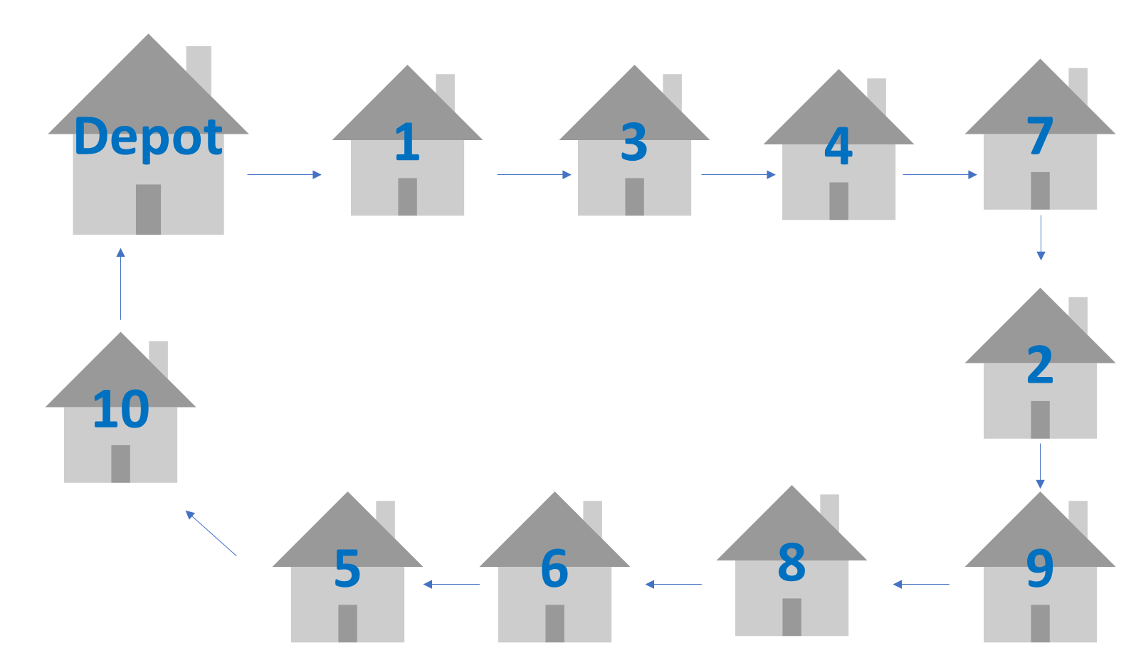

### **Recommendations**