|  |
| --- |
| Juicing the numbers  Part 2: Processing Operations |
| Maxwell Bo & Chantel Morris |

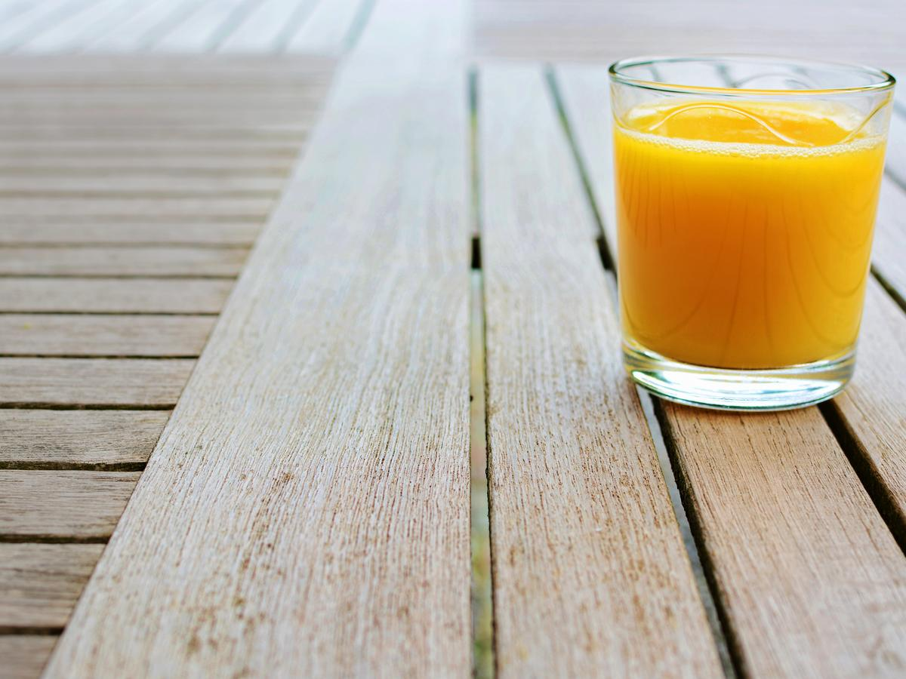

## Pure Fresh Processing

### **Introduction**

Underpinning Pure Fresh’s success is their efficiency in processing. Critical to this end is visibility of the operations on the ground. It is the intention of this report to identify operational constraints and recommend solutions to alleviate them.

### **Methodology**

As directed by the Client, the model was developed incrementally. The model was built in 5 stages as follows;

1. Base model, dictated by the constitution of juices, and their cost, in addition to the demand anticipated. Utilising this information, in addition to sale cost we generated a processing cost across the eight quarters to come.
2. The second model incorporated the limitation that fruit concentrate was trucked in, one fruit at a time.
3. The third model restricted juice production to only two gourmet juices each quarter.
4. Subsequently, the client requested the model to ensure that one juice was not out of production for more than one quarter in a row. This was implemented in the fourth model.
5. The final communication from Pure Fresh asked us to optimise their deliveries.

### **Results**

#### Model 1

The profit from Pure Fresh’s operations in the Base model is $26, 240, 835.76.

The optimal production profile is detailed in Table 1.

*Table 1 – Juice in kL*

|  |  |  |  |  |  |  |  |  |
| --- | --- | --- | --- | --- | --- | --- | --- | --- |
|  | Q1 | Q2 | Q3 | Q4 | Q5 | Q6 | Q7 | Q8 |
| Orange Juice | 880 | 872 | 1206 | 981 | 781 | 1055 | 1420 | 1236 |
| Orange and MangoJuice | 311 | 347 | 469 | 389 | 329 | 363 | 484 | 568 |
| Breakfast Juice | 682 | 707 | 838 | 938 | 586 | 788 | 1141 | 988 |
| Tropical Juice | 492 | 586 | 726 | 739 | 450 | 549 | 645 | 779 |
| Guava Delight | 340 | 459 | 593 | 393 | 276 | 424 | 559 | 389 |
| Orchard Medley | 1151 | 621 | 697 | 909 | 1133 | 615 | 542 | 865 |
| Strawberry Surprise | 625 | 740 | 468 | 409 | 665 | 750 | 411 | 464 |

#### Model 2

Following the restriction regarding the trucking in of concentrate, processing operations were remodeled. The effects of that implementation are seen in Table 2. Furthermore, the change in production between the base model and the model with the trucking limitation, is detailed for each juice for each quarter in Table 3. The greatest change in production will be in the first Quarter. Optimal trucking operations are detailed in Table 4.

The total profit for Model 2 is $26, 065, 452.96

*Table 2*

|  |  |  |  |  |  |  |  |  |  |
| --- | --- | --- | --- | --- | --- | --- | --- | --- | --- |
| kL | Q1 | Q2 | Q3 | Q4 | Q5 | Q6 | Q7 | Q8 | TOTAL |
| Orange Juice | 900 | 872 | 1206 | 981 | 781 | 1055 | 1420 | 1236 | 8451 |
| Orange and Mango Juice | 289 | 347 | 469 | 389 | 316 | 363 | 484 | 568 | 3225 |
| Breakfast Juice | 672 | 707 | 838 | 938 | 586 | 788 | 1141 | 988 | 6658 |
| Tropical Juice | 492 | 586 | 720 | 738 | 450 | 549 | 645 | 779 | 4959 |
| Guava Delight | 340 | 452 | 593 | 393 | 276 | 424 | 559 | 389 | 3426 |
| Orchard Medley | 1151 | 621 | 697 | 909 | 1131 | 615 | 542 | 865 | 6531 |
| Strawberry Surprise | 625 | 740 | 464 | 405 | 665 | 747 | 411 | 462 | 4519 |
| TOTAL | 4469 | 4325 | 4987 | 4753 | 4205 | 4541 | 5202 | 5287 |  |

Table 3

|  |  |  |  |  |  |  |  |  |
| --- | --- | --- | --- | --- | --- | --- | --- | --- |
| Change in Production in kL | Q1 | Q2 | Q3 | Q4 | Q5 | Q6 | Q7 | Q8 |
| Orange Juice | 20 | 0 | 0 | 0 | 0 | 0 | 0 | 0 |
| Orange and Mango Juice | -22 | 0 | 0 | 0 | -13 | 0 | 0 | 0 |
| Breakfast Juice | -10 | 0 | 0 | 0 | 0 | 0 | 0 | 0 |
| Tropical Juice | 0 | 0 | -6 | -1 | 0 | 0 | 0 | 0 |
| Guava Delight | 0 | -7 | 0 | 0 | 0 | 0 | 0 | 0 |
| Orchard Medley | 0 | 0 | 0 | 0 | -2 | 0 | 0 | 0 |
| Strawberry Surprise | 0 | 0 | -4 | -4 | 0 | -3 | 0 | -2 |

Table 4

|  |  |  |  |  |  |  |  |  |
| --- | --- | --- | --- | --- | --- | --- | --- | --- |
|  | Q1 | Q2 | Q3 | Q4 | Q5 | Q6 | Q7 | Q8 |
| Apple | 210 | 211 | 217 | 213 | 200 | 211 | 214 | 221 |
| Mango | 10 | 8 | 10 | 11 | 10 | 9 | 10 | 12 |
| Pineapple | 37 | 42 | 51 | 53 | 33 | 43 | 57 | 55 |
| Passionfruit | 1 | 1 | 1 | 1 | 1 | 1 | 1 | 1 |
| Guava | 5 | 6 | 7 | 5 | 5 | 6 | 7 | 5 |
| Strawberry | 5 | 6 | 4 | 4 | 6 | 6 | 4 | 4 |

#### model 3

Upon the limitation that only two gourmet juices could be produced per quarter, the optimal processing operation was modeled. The output of that model is found in Table 5 and 6. The selection of gourmet juices is found in Table 7. The change in processing cost is detailed in Table 8. This represents the difference in kilo litres of production between Model 2 and Model 3. This change was selected because the comparison between this model and the Base model is largely redundant, considering that trucking is an unavoidable reality of Pure Fresh operations. Naturally, considering the limitation of this model, the greatest reduction in production was seen amongst gourmet juices Guava Delight and Strawberry Surprise.

The profit, upon this limitation was found to be $23, 426, 440.25, representing a 10.73% reduction in profit from Model 2.

*Table 5*

|  |  |  |  |  |  |  |  |  |  |
| --- | --- | --- | --- | --- | --- | --- | --- | --- | --- |
| kL | Q1 | Q2 | Q3 | Q4 | Q5 | Q6 | Q7 | Q8 | TOTAL |
| Orange Juice | 900.00 | 872 | 1206 | 981 | 781 | 1055 | 1420 | 1236 | 8451 |
| Orange and Mango Juice | 291 | 347 | 469 | 389 | 316 | 363 | 484 | 568 | 3227 |
| Breakfast Juice | 682 | 707 | 838 | 938 | 586 | 787 | 1141 | 986 | 6665 |
| Tropical Juice | 492 | 586 | 721 | 739 | 450 | 549 | 645 | 779 | 4961 |
| Guava Delight | 0 | 0 | 589 | 393 | 0 | 0 | 559 | 0 | 1541 |
| Orchard Medley | 1145 | 621 | 697 | 909 | 1133 | 615 | 542 | 865 | 6527 |
| Strawberry Surprise | 625 | 740 | 0 | 0 | 665 | 746 | 0 | 464 | 3240 |
| TOTAL | 4135 | 3873 | 4520 | 4349 | 3931 | 4115 | 4791 | 4898 |  |

*Table 6*

|  |  |  |  |  |  |  |  |  |
| --- | --- | --- | --- | --- | --- | --- | --- | --- |
| kL of Concentrate | Q1 | Q2 | Q3 | Q4 | Q5 | Q6 | Q7 | Q8 |
| Apple | 183 | 175 | 175 | 177 | 178 | 176 | 177 | 190 |
| Mango | 10 | 8 | 10 | 11 | 10 | 9 | 10 | 12 |
| Pineapple | 34 | 38 | 50 | 53 | 30 | 38 | 57 | 51 |
| Passionfruit | 1 | 1 | 1 | 1 | 1 | 1 | 1 | 1 |
| Guava | 2 | 2 | 6 | 4 | 2 | 2 | 6 | 1 |
| Strawberry | 5 | 6 | 0 | 0 | 5 | 6 | 0 | 4 |

*Table 7*

|  |  |  |  |  |  |  |  |  |
| --- | --- | --- | --- | --- | --- | --- | --- | --- |
| Production Y/N | Q1 | Q2 | Q3 | Q4 | Q5 | Q6 | Q7 | Q8 |
| Guava Delight | N | N | Y | Y | N | N | Y | N |
| Orchard Medley | Y | Y | Y | Y | Y | Y | Y | Y |
| Strawberry Surprise | Y | Y | N | N | Y | Y | N | Y |

*Table 8*

|  |  |  |  |  |  |  |  |  |
| --- | --- | --- | --- | --- | --- | --- | --- | --- |
| Change in kL | Q1 | Q2 | Q3 | Q4 | Q5 | Q6 | Q7 | Q8 |
| Orange Juice | 0 | 0 | 0 | 0 | 0 | 0 | 0 | 0 |
| Orange and Mango Juice | 2 | 0 | 0 | 0 | 0 | 0 | 0 | 0 |
| Breakfast Juice | 10 | 0 | 0 | 0 | 0 | -1 | 0 | -2 |
| Tropical Juice | 0 | 0 | 1 | 1 | 0 | 0 | 0 | 0 |
| Guava Delight | -340 | -452 | -4 | 0 | -276 | -424 | 0 | -389 |
| Orchard Medley | -6 | 0 | 0 | 0 | 2 | 0 | 0 | 0 |
| Strawberry Surprise | 0 | 0 | -464 | -405 | 0 | -1 | -411 | 2 |

#### Model 4

Model 4 involved restricting production of gourmet juice such that any gourmet juice was not out of production for consecutive quarters.

The profit following this restriction, was $23, 206, 547.65.

The detailed optimal production and truck operation plan is detailed in Table 9 and 10. The selection of gourmet juices is indicated in Table 11. The change between these production costs and those in Model 2, is detailed in Table 12. This decision reduces the profit by $219, 892.6 which is obviously quite significant.

*Table 9*

|  |  |  |  |  |  |  |  |  |
| --- | --- | --- | --- | --- | --- | --- | --- | --- |
|  | Q1 | Q2 | Q3 | Q4 | Q5 | Q6 | Q7 | Q8 |
| Orange Juice | 900 | 872 | 1206 | 981 | 781 | 1055 | 1420 | 1236 |
| Orange and Mango Juice | 291 | 347 | 469 | 389 | 316 | 342 | 484 | 568 |
| Breakfast Juice | 682 | 707 | 829 | 938 | 586 | 788 | 1141 | 986 |
| Tropical Juice | 492 | 586 | 726 | 739 | 450 | 549 | 645 | 779 |
| Guava Delight | 0 | 452 | 0 | 393 | 0 | 424 | 559 | 0 |
| Orchard Medley | 1145 | 0 | 697 | 909 | 1133 | 0 | 542 | 865 |
| Strawberry Surprise | 625 | 740 | 468 | 0 | 665 | 750 | 0 | 464 |
| TOTAL | 4135 | 3704 | 4395 | 4349 | 3931 | 3908 | 4791 | 4898 |

*Table 10*

|  |  |  |  |  |  |  |  |  |
| --- | --- | --- | --- | --- | --- | --- | --- | --- |
|  | Q1 | Q2 | Q3 | Q4 | Q5 | Q6 | Q7 | Q8 |
| Apple | 183 | 180 | 170 | 177 | 178 | 181 | 177 | 190 |
| Mango | 10 | 5 | 10 | 11 | 10 | 5 | 10 | 12 |
| Pineapple | 34 | 42 | 44 | 53 | 30 | 43 | 57 | 51 |
| Passionfruit | 1 | 1 | 1 | 1 | 1 | 1 | 1 | 1 |
| Guava | 2 | 6 | 1 | 4 | 2 | 6 | 6 | 1 |
| Strawberry | 5 | 6 | 4 | 0 | 6 | 6 | 0 | 4 |

*Table 11*

|  |  |  |  |  |  |  |  |  |
| --- | --- | --- | --- | --- | --- | --- | --- | --- |
|  | Q1 | Q2 | Q3 | Q4 | Q5 | Q6 | Q7 | Q8 |
| Guava Delight | N | Y | N | Y | N | Y | Y | N |
| Orchard Medley | Y | N | Y | Y | Y | N | Y | Y |
| Strawberry Surprise | Y | Y | Y | N | Y | Y | N | Y |

*Table 12*

|  |  |  |  |  |  |  |  |  |
| --- | --- | --- | --- | --- | --- | --- | --- | --- |
| Net Change | Q1 | Q2 | Q3 | Q4 | Q5 | Q6 | Q7 | Q8 |
| Orange Juice | 0.00 | 0.00 | 0.00 | 0.00 | 0.00 | 0.00 | 0.00 | 0.00 |
| Orange and Mango Juice | 2.00 | 0.00 | 0.00 | 0.00 | 0.00 | -21.00 | 0.00 | 0.00 |
| Breakfast Juice | 10.00 | 0.00 | -9.00 | 0.00 | 0.00 | 0.00 | 0.00 | -2.00 |
| Tropical Juice | 0.00 | 0.00 | 6.00 | 1.00 | 0.00 | 0.00 | 0.00 | 0.00 |
| Guava Delight | -340.00 | 0.00 | -593.00 | 0.00 | -276.00 | 0.00 | 0.00 | -389.00 |
| Orchard Medley | -6.00 | -621.00 | 0.00 | 0.00 | 2.00 | -615.00 | 0.00 | 0.00 |
| Strawberry Surprise | 0.00 | 0.00 | 4.00 | -405.00 | 0.00 | 3.00 | -411.00 | 2.00 |

#### Model 5

Pure Fresh were able to optimise their cost of delivery in Model 5. The optimal delivery route is seen in Figure 1 and the cost of that route is $725.

*Figure 1*

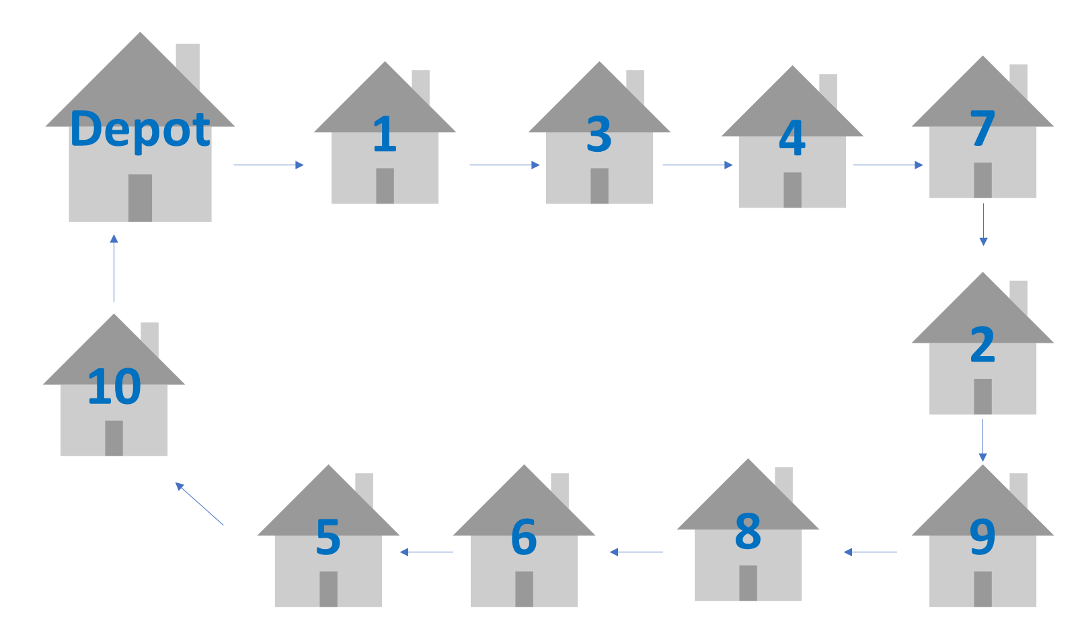

### **Recommendations and Insights**

1. Brisbane Sensitivity Analysis

As can be seen in Table 13 the supply of orange juice concentrate is a constraint, of significant value, in the first quarter of operations.

Pure Fresh should consider increasing the initial supply in order to increase profit. Note that this is from the original model, before the trucking is taken into account.

*Table 13*

|  |  |  |  |  |  |  |  |  |
| --- | --- | --- | --- | --- | --- | --- | --- | --- |
| Brisbane supply sensitivity analysis (Pi) | | | | | | | | |
|  | Q1 | Q2 | Q3 | Q4 | Q5 | Q6 | Q7 | Q8 |
| Pi | 526 | 0 | 0 | 0 | 0 | 0 | 0 | 0 |

The final model is even more constrained by Brisbane supply of orange juice concentrate, as seen in Table 14.

This is logical, considering that increasing production naturally increases sales. Of particular important to Pure Fresh is the time that this is most important. For example, maximising supply in the second quarter, perhaps at the expense of the first quarter could prove prudent.

*Table 14*

|  |  |  |  |  |  |  |  |  |
| --- | --- | --- | --- | --- | --- | --- | --- | --- |
| Brisbane supply sensitivity analysis (Slack) | | | | | | | | |
|  | Q1 | Q2 | Q3 | Q4 | Q5 | Q6 | Q7 | Q8 |
| Slack | 0 | 786 | 404 | 489 | 68 | 446 | 303 | 384 |

1. Pi Analysis

The shadow price of each juice across each quarter is detailed in Table 15. This price represents the value an increase in production would generate for each juice for each quarter, per kilolitre.

Clearly then, Pure Fresh should focus on unlocking Guava Delight and Strawberry Surprise first across all quarters as they represent the most value to be gained from an increase in demand.

*Table 15*

|  |  |  |  |  |  |  |  |  |
| --- | --- | --- | --- | --- | --- | --- | --- | --- |
| Demand sensitivity analysis (Pi) | | | | | | | | |
|  | Q1 | Q2 | Q3 | Q4 | Q5 | Q6 | Q7 | Q8 |
| Orange Juice | 0 | 526 | 526 | 526 | 526 | 526 | 526 | 526 |
| Orange and Mango Juice | 19 | 493 | 493 | 493 | 493 | 493 | 493 | 493 |
| Breakfast Juice | 684 | 762 | 762 | 762 | 762 | 762 | 762 | 762 |
| Tropical Juice | 782 | 803 | 803 | 803 | 803 | 803 | 803 | 803 |
| Guava Delight | 853 | 853 | 853 | 853 | 853 | 853 | 853 | 853 |
| Orchard Medley | 450 | 686 | 686 | 686 | 686 | 686 | 686 | 686 |
| Strawberry Surprise | 818 | 818 | 818 | 818 | 818 | 818 | 818 | 818 |

1. Slack Analysis

Table 16 represents the wastage in the optimal solution.

With this understanding on the operations, Pure Fresh should seek to offload the excess product predicted by the model in some way.

Table 17 highlights the waste of each fruit, in kL, each quarter. Because trucks are transported full, with not all of that fruit being used, there is moderately significant waste each quarter. With that information, Pure Fresh should seek to use the fruit in some other capacity, or consider changing the recipe in order to minimise waste.

*Table 16*

|  |  |  |  |  |  |  |  |  |
| --- | --- | --- | --- | --- | --- | --- | --- | --- |
| Demand sensitivity analysis (Slack) | | | | | | | | |
|  | Q1 | Q2 | Q3 | Q4 | Q5 | Q6 | Q7 | Q8 |
| Orange Juice | 72 | 0 | 0 | 0 | 0 | 0 | 0 | 0 |
| Orange and Mango Juice | 20 | 0 | 0 | 0 | 12 | 20 | 0 | 0 |
| Breakfast Juice | 0 | 0 | 8 | 0 | 0 | 0 | 0 | 1 |
| Tropical Juice | 0 | 0 | 0 | 0 | 0 | 0 | 0 | 0 |
| Guava Delight | 340 | 6 | 593 | 0 | 276 | 0 | 0 | 389 |
| Orchard Medley | 5 | 621 | 0 | 0 | 0 | 615 | 0 | 0 |
| Strawberry Surprise | 0 | 0 | 0 | 409 | 0 | 0 | 411 | 0 |

*Table 17*

|  |  |  |  |  |  |  |  |  |
| --- | --- | --- | --- | --- | --- | --- | --- | --- |
| Truck capacity (10) (Slack) | | | | | | | | |
|  | Q1 | Q2 | Q3 | Q4 | Q5 | Q6 | Q7 | Q8 |
| Apple | 0 | 2.65 | 2.29 | 4.85 | 0.2 | 5.55 | 5 | 0.82 |
| Mango | 0 | 1.16 | 1.66 | 6.89 | 0 | 0 | 1.68 | 0.21 |
| Pineapple | 1.44 | 1.04 | 0 | 6.36 | 0.92 | 2.26 | 1.12 | 0 |
| Passionfruit | 5.08 | 4.14 | 2.74 | 2.61 | 5.5 | 4.51 | 3.55 | 2.21 |
| Guava | 7.5 | 0 | 0.64 | 0.7 | 6.7 | 2.6 | 4.1 | 0.72 |
| Strawberry | 0 | 0.8 | 2.56 | 0 | 6.8 | 0 | 0 | 2.88 |

1. Sensitivity Analysis

For Model Two, we were able to test the model to discover which juices’ production could be reduced while maintaining the same amount of profit.

As can be seen in Table 18 and 19, this only occurred in Quarter 1 for both supply and demand. This further emphasises just how critical the demand and production is to Pure Fresh’s profit.

*Table 18*

|  |  |  |  |  |  |  |  |  |
| --- | --- | --- | --- | --- | --- | --- | --- | --- |
| Production sensitivity analysis (SAObjLow) for Model 2 | | | | | | | | |
|  | Q1 | Q2 | Q3 | Q4 | Q5 | Q6 | Q7 | Q8 |
| Orange Juice | 0 | 0 | 0 | 0 | 0 | 0 | 0 | 0 |
| Orange and Mango Juice | 473 | 0 | 0 | 0 | 0 | 0 | 0 | 0 |
| Breakfast Juice | 78 | 0 | 0 | 0 | 0 | 0 | 0 | 0 |
| Tropical Juice | 21 | 0 | 0 | 0 | 0 | 0 | 0 | 0 |
| Guava Delight | 0 | 0 | 0 | 0 | 0 | 0 | 0 | 0 |
| Orchard Medley | 236 | 0 | 0 | 0 | 0 | 0 | 0 | 0 |
| Strawberry Surprise | 0 | 0 | 0 | 0 | 0 | 0 | 0 | 0 |

*Table 19*

|  |  |  |  |  |  |  |  |  |
| --- | --- | --- | --- | --- | --- | --- | --- | --- |
| Demand supply sensitivity analysis (SARHSLow) | | | | | | | | |
|  | Q1 | Q2 | Q3 | Q4 | Q5 | Q6 | Q7 | Q8 |
| Orange Juice | 880 | 0 | 0 | 0 | 0 | 0 | 0 | 0 |
| Orange and Mango Juice | 207 | 0 | 0 | 0 | 0 | 0 | 0 | 0 |
| Breakfast Juice | 63 | 0 | 0 | 0 | 0 | 0 | 0 | 0 |
| Tropical Juice | 0 | 0 | 0 | 0 | 0 | 0 | 0 | 0 |
| Guava Delight | 0 | 0 | 0 | 0 | 0 | 0 | 0 | 0 |
| Orchard Medley | 944 | 0 | 0 | 0 | 0 | 0 | 0 | 0 |
| Strawberry Surprise | 0 | 0 | 0 | 0 | 0 | 0 | 0 | 0 |