CA1 Obstacle Avoidance Report
ROS 2 LiDAR Based Navigation

1 Introduction
The CA1 problem is to move a mobile robot through a field of coke cans without using a pre-built map. The robot receives a two-dimensional LiDAR scan and publishes velocity commands through ROS 2. It must decide from the current scan whether the path ahead is clear, whether a visible gap is wide enough, or whether it should move toward a safer side.
This problem is harder than simply looking for the largest distance reading. The LiDAR measures from one point on the robot, but the robot has a real width. Two cans can appear far apart when their separation is measured diagonally, while the space across the robot's planned route is still too narrow. A can that is closer to the robot can also block the route to a gap that looks open farther away.
The controller therefore follows a simple order of decisions. It first checks the corridor directly in front of the robot. If that corridor is clear, the robot moves straight. If it is blocked, the controller groups LiDAR points into cans, finds possible gaps, and moves toward the midpoint of a safe gap. When no safe gap exists, it moves toward the clearer side while checking that the side of the robot will not hit an obstacle.

Problem Requirements
The robot should make steady progress in open space, fit safely between cans, reject a route that contains a nearer obstacle, and recover when it is already close to a can. The controller should also avoid changing repeatedly between left and right because small changes in the LiDAR scan can make gap detections appear and disappear between control cycles.

Scope of the Solution
The solution is reactive and map-independent. It does not identify a named obstacle layout or use a special instruction for the front-left or front-right test. The same distance, width, and collision checks are used in the randomized map and in the denser L-shaped test layouts. This keeps the behavior general, although a purely reactive method still has limitations in deep corners and other concave obstacle arrangements.

2 Algorithm Used

LiDAR Processing
The 720-reading LaserScan is sampled every fourth beam. The controller uses the front half of the scan and arranges it from the robot's right side to its left side. Readings from 0.05 m to the 1.5 m look-ahead distance are converted into x and y points. Infinite readings represent open space when left and right clearance are compared.

Checking the Forward Corridor
The LiDAR marks the visible surface of each can. For the straight-ahead check, the controller uses a rectangular strip that begins at the robot, extends 0.75 m forward, and reaches 0.12 m to each side of an imaginary line through the middle of the robot. The strip is therefore 0.24 m wide. If any can return lies inside it, straight motion is blocked. Otherwise, the robot moves forward at 0.30 m/s. After avoiding a can, it requires eight clear scans (0.40 s) before returning to straight motion.
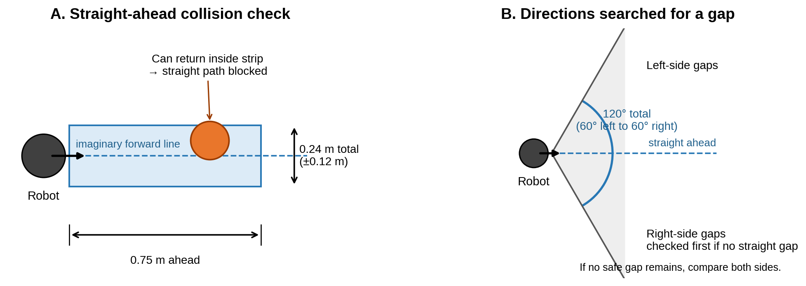
Figure 1 Forward collision strip and 120-degree gap-search region

Grouping Cans and Finding Gaps
Consecutive LiDAR returns are treated as the same can when their detected locations are no more than 0.12 m apart. For two neighboring cans, the controller uses the right inner edge of one can and the left inner edge of the next can. The gap midpoint is exactly halfway between these two edges.
The controller only considers gap midpoints inside the 120-degree cone directly in front of the robot: from 60 degrees left to 60 degrees right. A gap must also be at least 0.33 m wide across the planned travel direction and must not have a nearer can blocking the route.

Choosing a Motion
The robot first chooses a safe gap that is almost straight ahead. If none exists, the current code checks right-side gaps first because its preferred-side setting is right. This is only the order used to search for a gap; it is not a feature detected in the map. The robot then moves at 0.18 m/s toward the gap midpoint, which is halfway between the two inner can edges. If no suitable right-side gap exists, the fallback compares the measured space on both sides.

Fallback and Close Range Safety
If no safe opening remains, the controller compares the median LiDAR distance on each side and selects the clearer one. Before moving sideways at 0.25 m/s, it checks a 0.30 m path beside the robot. If that side is blocked and the opposite side is open, it switches and holds the new direction for 12 cycles. When both sides are blocked or the front is within 0.20 m, the robot reverses at 0.08 m/s.

3 The Math Behind the Algorithm
Each LiDAR reading gives a distance r and an angle theta. The controller uses these values to calculate the detected location relative to the robot. Positive x means forward and positive y means left.
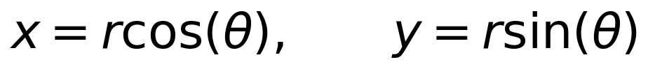
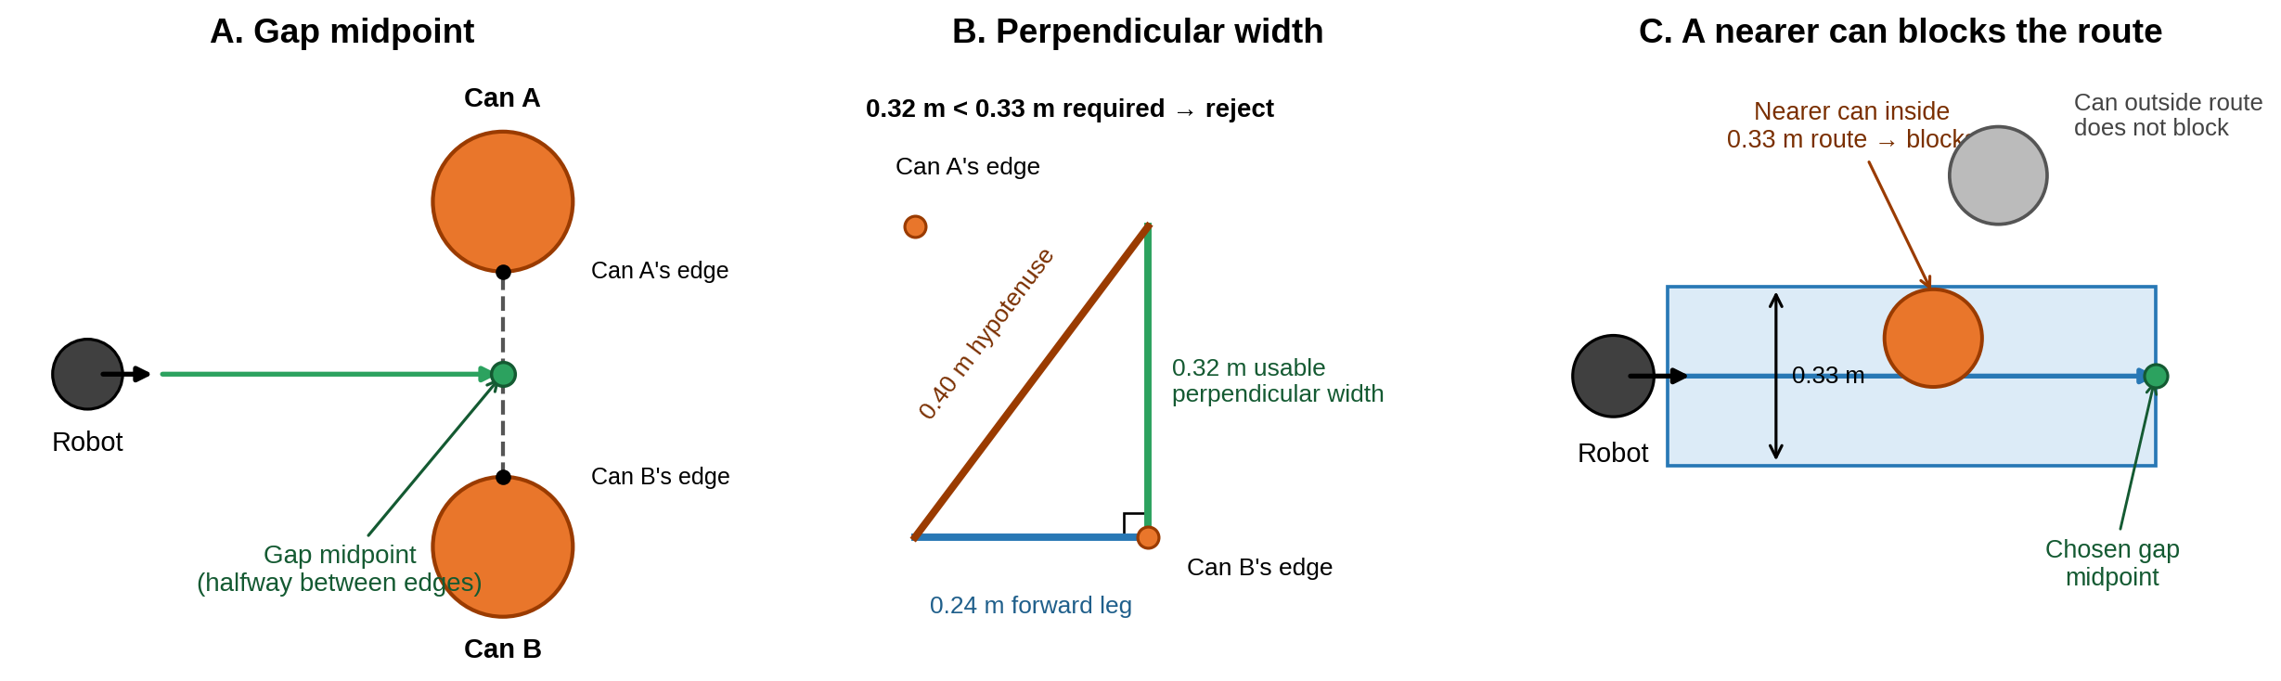
Figure 2 Gap midpoint, perpendicular-width triangle, and blocked-route check

Perpendicular Gap Width
Let g be the line between the two inner can edges. Let d be a unit vector that points from the robot to the gap midpoint. The useful gap is the part of g that is perpendicular to d. In two dimensions, the controller calculates this width using the following cross-product expression.
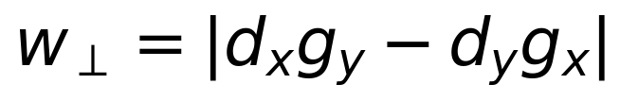
The line joining the two can edges is the 0.40 m hypotenuse, so it is the longest side. The controller cannot use this diagonal length as the space available to the robot. Instead, it uses the 0.32 m leg measured perpendicular to the planned path. Although 0.32 m is longer than the 0.24 m forward leg, it is still less than the required 0.33 m, so the gap is rejected. Figure 2B shows these measurements.

Robot Width and Route Check
The robot is 0.23 m wide and the controller adds 0.05 m of safety space on each side, giving a required width of 0.33 m. The controller then checks the whole route from the robot to the chosen gap midpoint. A nearer can blocks the route when it lies before that midpoint and its detected edge is less than 0.165 m from the route centreline. This 0.165 m is half of the 0.33 m route width. Figure 2C shows a blocking can inside the blue route and another can outside it.

4 Performance of the Algorithm
In Gazebo, the direct-path check gives smooth forward motion when no can is nearby. The controller runs every 0.05 s, or 20 times per second. It commands 0.30 m/s in open space, 0.18 m/s toward a gap, 0.25 m/s for sideways escape, and 0.08 m/s when reversing away from a close can.
The calculations are small enough for the CA1 platform. The scan is sampled every fourth beam, and only the front half is used for obstacle decisions. This leaves a modest number of can returns to group and check during each timer callback.

Performance in Difficult Layouts
The front-left and front-right L-shaped layouts showed two weaknesses. A side that first appears clear can become blocked as the robot moves closer, and small changes in the scan can make the preferred direction change repeatedly. These tests motivated the side-collision check and the short memory periods described below.

Improvements Made

Correct Gap Measurement
The direct distance between two can edges was replaced with the perpendicular width across the planned path. This stops the diagonal hypotenuse from making a narrow opening look safe.

Blocked Route and Close Obstacle Checks
An opening is rejected when a nearer can lies inside the 0.33 m wide path leading to it. LiDAR readings at 0.05 m are treated as cans, and the robot reverses when the front is within 0.20 m or both side paths are blocked.

Clearer Side Fallback and Reduced Oscillation
When no safe opening exists, the robot moves toward the side with more measured space. If a can blocks that side and the robot switches to the opposite side, the new direction is held for 12 control cycles. At 20 cycles per second, 12 cycles equal 0.60 s. At the commanded sideways speed of 0.25 m/s, this corresponds to about 0.15 m of commanded movement, which is close to the 0.165 m half-width of the safety path. The hold is therefore long enough to move away from the blocked side without forcing the choice for several seconds. The robot also waits for eight clear cycles before going straight again. Eight cycles equal 0.40 s, so the controller confirms the path is clear across several scans while remaining responsive.

Remaining Limitation
The current program does not lock onto one exact gap. It saves the latest gap direction, but the next cycle does not use that saved direction to choose the same gap again. The counter that could track how long a gap is missing is also never increased. Therefore, there is no four-cycle gap commitment yet. A future change could keep the chosen gap and switch only after the same gap has been missing or unsafe for four consecutive cycles. Four cycles equal 0.20 s at 20 Hz, which would ignore one to three noisy scans without delaying a necessary safety response for long.

5 Reflection

