Max Mattern

SDEV220 Fall 2022

M6 Tutorial: Templating and Dynamic Data

12/05/2022

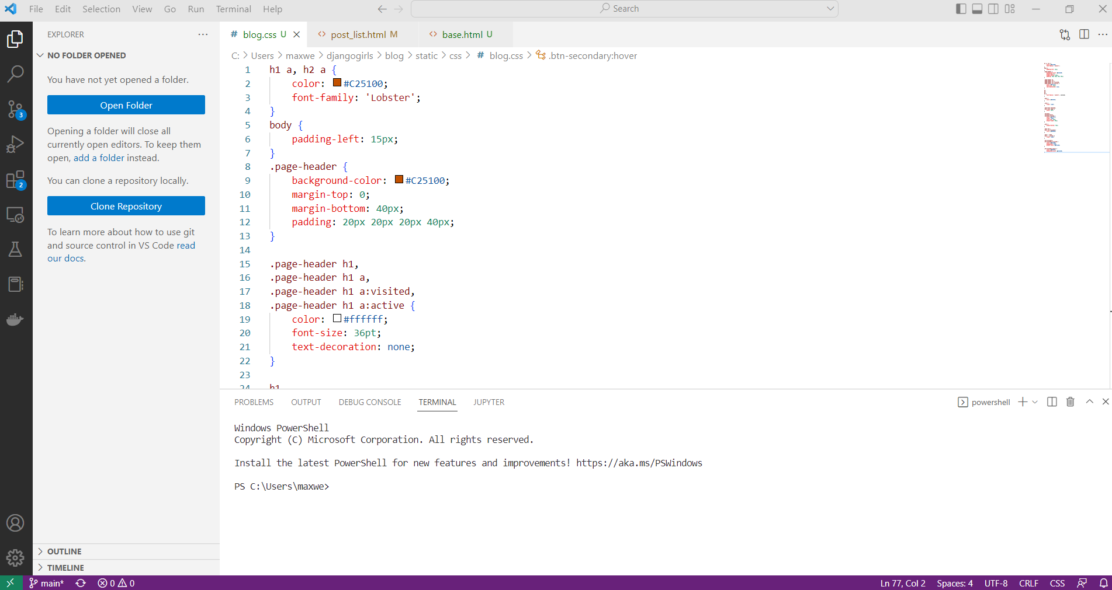

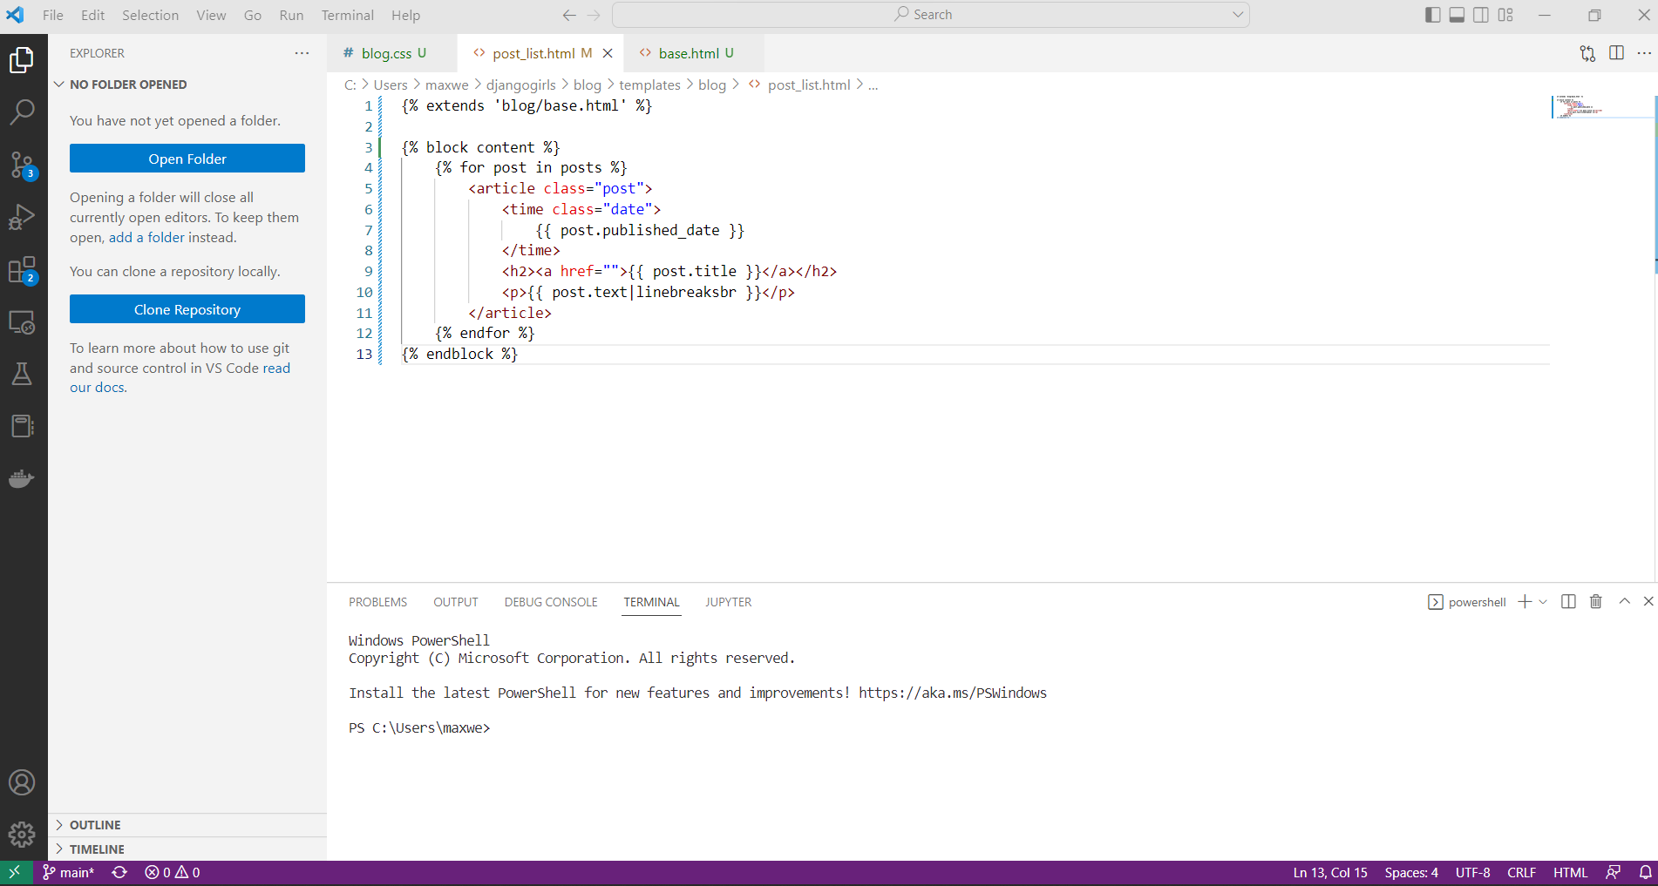

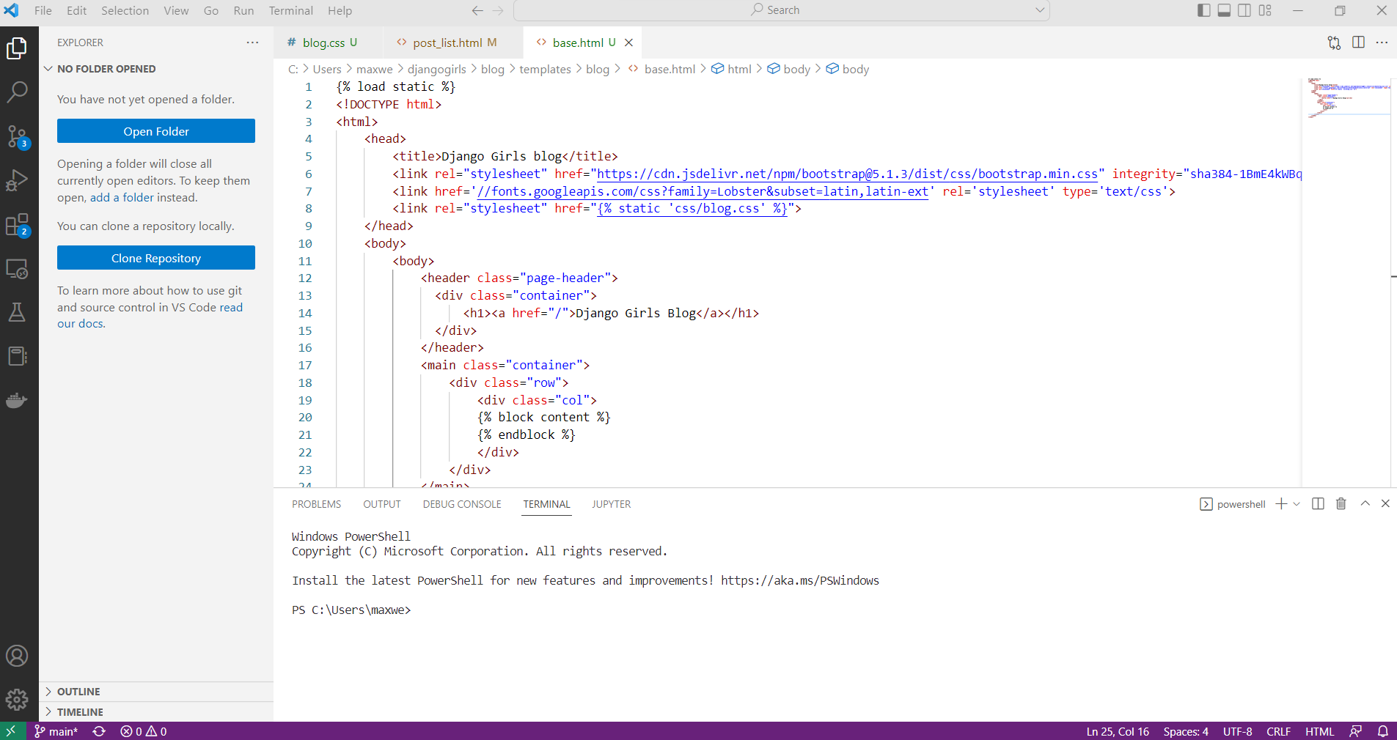

GITHUB REPO:

<https://github.com/MaxwellMattern/M06Tutorial_MM.git>