CS 205 - Preliminary Design Proposal
Fall 2017

Maxwell McFarlane
Robson Adem
Hayden Dodge
- Problem Definition & Overview
This project deals with designing a Supervisory Control and Data Acquisition (SCADA) system that has high configurability and analysis capabilities. More specifically, the SCADA system must be designed to handle sensor information, transform data into useful and meaningful forms, and automate control decisions. Our design breaks down the overall capability of the SCADA system into several components: collection, configuration, control, transformation, display, and exporting. Our proposal goal is to help information manipulation become easily digestible by the system by partitioning it into smaller, effective, interactive capabilities.
- User Stories
The following section is a listing of all the user stories that were found in the client discussion transcript. These user stories are meant to make break the client project description into discrete digestible ideas.

N | User Stories
1 | Record sensor data and write it to files.
2 | Allow for varying recording parameters.
3 | User should be able to make variable data acquisition states.
4 | Select data and export as spreadsheet or other useful data format.
5 | Program should be able to graph data in different modes.
6 | Combine multiple sensor input into new data set.
7 | Display data in real time.
8 | Different levels of sampling for different situation, but also a function of state.
9 | Storing data should not take up too much memory.
10 | Allow for data storage locally and in remote database.
11 | System should not be dependent on having internet or network connection.
12 | User should never have to go to the code and change for anything including the calibration.
13 | Configure algorithms, acquisition parameters, units, and formats.
14 | User should be able to calibrate and recalibrate a sensor either using pre built-in linear and nonlinear models or custom models.
15 | System can handle a change in sensor hierarchy structure.
16 | System can handle a change in sensor type.
17 | Calibration should be broken into different types of calibration: primary, operational, and verification. Primary and operational are essential.
18 | Calibration should have the user specify units of the measurement or the transform of the measurement.
19 | Utilize logs.
20 | Control policy should be completely customizable by the user.
21 | Control policy should be easy to reconfigure and override.
22 | Control policy should create a log for ease of use in debugging system.
23 | Control policy should be able to notify user and output to various indicators.
24 | Control policy can be designed as user defined states with state transitions. Program should be able to follow state transitions to handle different protocol for different scenarios.
25 | Exception handling for various sensor failure and unexpected sensor information should be incorporated in control policy design.
26 | Control Policy needs to be able to make decisions based off of live data.
27 | System should be installable on a variety of system from an easily accessible source.

- Use Cases
This section lists all the use cases found for the SCADA system project. This is useful for producing tests when implementing the project program. Each use case should be easily verifiable. These use cases were developed by naming primary actors and predicting how they would use the SCADA system

N | Use Case: | Researcher | Student | Guide | Priority
1 | Notification system | x |  |  | 1
2 | Indefinite SCADA run | x |  |  | 1
3 | System log | x |  |  | 1
4 | Display Live Data | x |  |  | 1
5 | Transform Data | x | x | x | 3
6 | Calibrate Sensor | x | x |  | 2
7 | Sample Sensor | x | x |  | 2
8 | Display Data | x |  | x | 2
9 | Access Data Base | x | x | x | 2
10 | Test Sensor |  | x |  | 1
11 | Export Data | x | x |  | 2
Table 1: This table shows the priority of the use cases for the SCADA system.

Use Case Diagram:
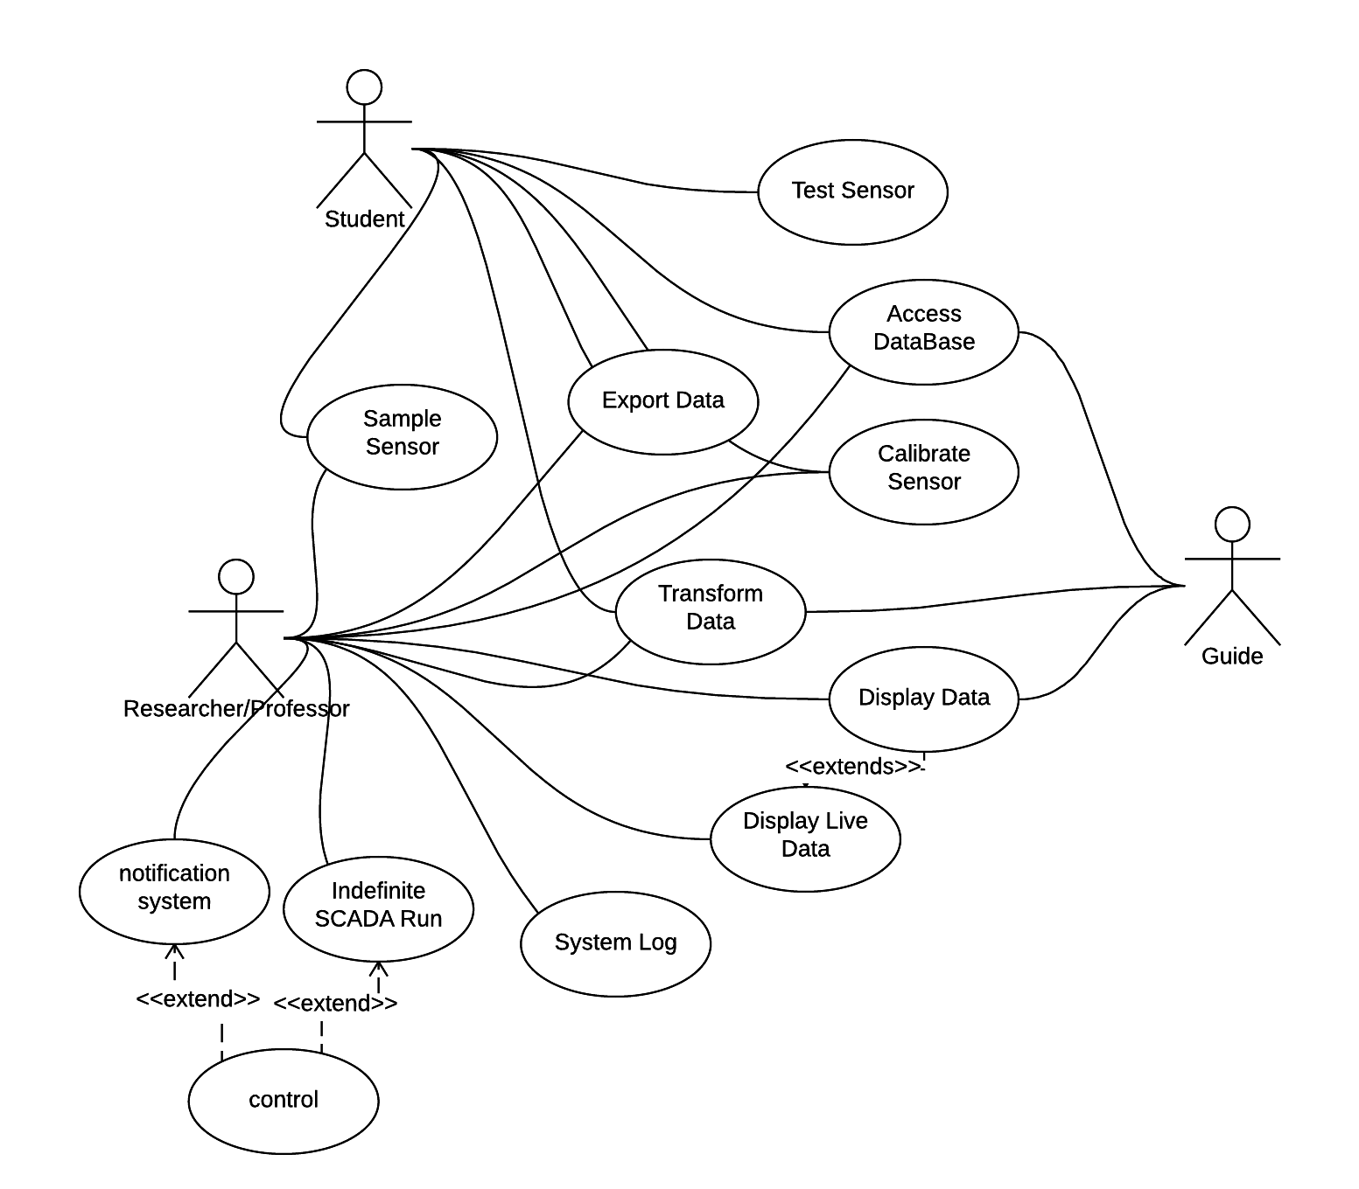

Table 2: This Use Case Diagram shows the usability of the SCADA for three primary actor.

- Description of the Major Design Components
The major design components for the proposed SCADA system are include systems the Collection, Calibration, Transformation, Control Policy, and a Display/Export components. Figure 1 shows how the major design components work to accomplish the design goals discussed in the prior sections. The flow of data through the system starts with the Sensors as they are the source of data for the project. The Collection system will manage the sampling settings and data acquisition for each sensor. Additionally, the Collection system will write the sampling data to the Data Management System (DMS). Once there is data in the DMS, the Calibration system can apply the calibration model to allow for a real-world interpretation. The Calibration system will write calibrated data back to the DMS. Once there is calibrated data in the DMS, the system is able to further manipulate data through the Transformation system, react to the Sensor data through the Control Policy system, and export the data for User visualization.

The Transformation system is used to apply further mathematical operations to the data. An example of such an operation is taking calibrated data from a voltmeter and an ammeter and multiplying them to create a power data point. The Control policy system will read and analyze the calibrated and/or transformed data and react according to the user defined policy. The user’s policy will define the conditions to perform actions to the Indicator outputs. Additionally, the Control Policy System is able to influence the Sensor collection settings to allow variability and customization of the sensor collection. Finally, the Display/Export system will be able to filter and export data so that the User can perform post analysis. The export functionality will be able to output spreadsheets and graphs as these are forms that user is able to interact with directly and use in 3rd party data analysis tools.

In addition to storing the current data collected by the SCADA system, the DMS is also responsible for data archival. This includes managing onboard and off board storage to allow for a variety of situation where the memory of the onboard DMS in limited.

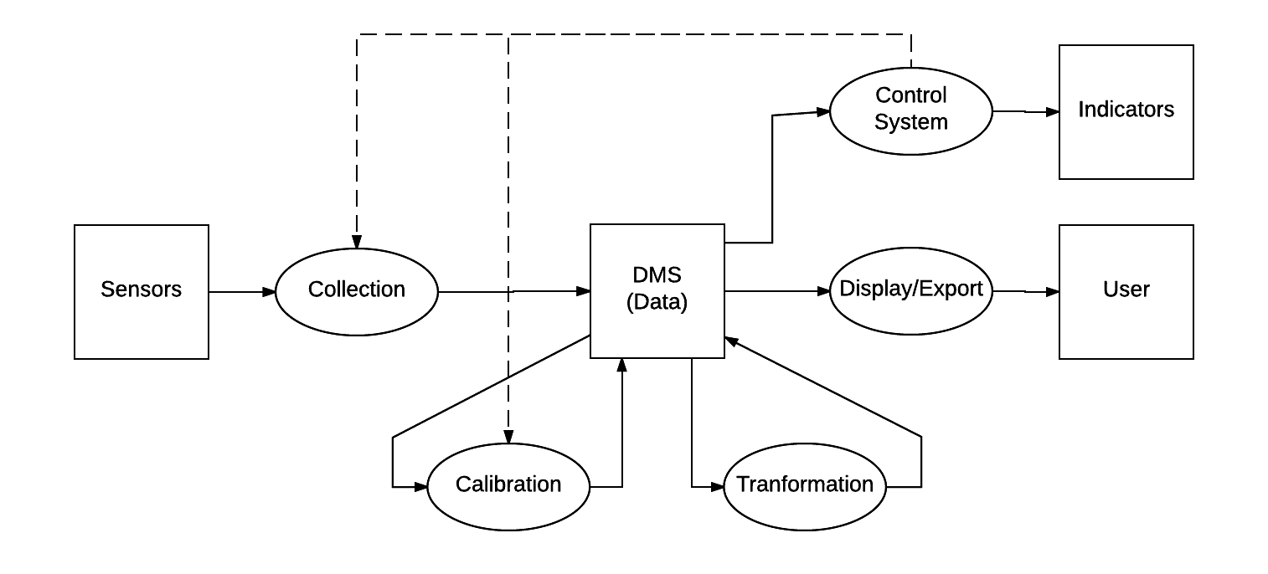

Figure 1: The major components of the system are responsible for the manipulation of data from the inputs, to archival, to the outputs.
Legend: *****HAYDEN***

- Logical Designs

- Data Management System(DMS) Logical Design

The DMS is a system that is meant to store collected information along with manipulated information in an efficient form. This means that the DMS will be tabulating incoming information so that stored data is easily located and interpreted. The secondary purpose of the DMS is to give partitions of specified data, called queries, or entire tables so that the user can observe, manipulate, and reformat the information inside the database.
The DMS is very important for the overall project because it allows the user to reference data so that he or she may interpret it. As a seen in the use cases table and diagram, this system is high priority for whoever is using the SCADA system. Many users will have to interact with the DMS.
The DMS organizes data into tables so that it makes finding and partitioning data easier. The only time when the DMS creates tables for the database is when interacting with the collection system and the transformation system. The raw data is saved to the database and associated with a sensor. The transformed data is saved after a sensors raw data has been manipulated to produce another data point, which is saved as a separate table. This provides clarity for the DMS when it comes to formatting certain data tables. If the user is looking for data that isn’t measured and instead transformed then the DMS will look for the transform database table instead of the raw data database table.
When the DMS receives a request for a query it takes in constraint information from the user or the surrounding system. The constraint information contains: query size, sensor serial number, collected or transform signal. These will allow the DMS to automatically search and return a query with the given specifications.
In order for the DMS to make a table for a given set of data then the DMS needs a sensor serial id, data point, and a timestamp, which is from the collection system. The database will the sensor serial id number and create a sensor look-up table from this. The database will be able to access the data points and timestamps through the referencing the serial id number. These tables will be used to format the database.
The Sensor look-up table is a major table for the SCADA system and is the first thing accessed when referencing the database. First, a system will give an index number and then the DMS will find the specific sensor which is being searched for. This id will then reference a table stored further into the database that contains the timestamps, raw data, the calibrated data, and the model of calibration. This form of storing tables allows for easy and predictable encapsulation of the information provided by the collection system. Not only could this be used for raw data provided but also for transformed data from the transformation subsystem. This table format is reusable, which is desirable if we should expand the SCADA. The transformation table would use the same format however create another table separate from their sensors but instead tied to the time stamps given to the system.

Table Type: Sensor Look-Up Table
N | SSID (sensor serial id)
0 | 0xFFFFF0
1 | 0xFFFFF4
... | ...
Table 3:All data created in table above is not indicative of the data that will be stored in the table.

Table Type: Sensor Data Table
N | Time Stamp | Raw Data | Calibrated Data | CalModel#
0 | 00:10:11:01 | 0xFFFF | 89.02 | 1
1 | 00:19:00:01 | 0xFF90 | 101.74 | 6
... | ... | ... | ... | ...
Table 4: All data created in table above is not indicative of the data that will be stored in the table.
Table Type: Transform Data Table
N | Time Stamp | Transform Data | Calibrated Data | CalModel#
0 | 00:10:11:01 | 0x001F | 1329.10 | 1
1 | 00:19:00:01 | 0x99FF | 23.00 | 6
... | ... | ... | ... | ...
Table 5: All data created in table above is not indicative of the data that will be stored in the table.

  - Display/Export Logical Design

The Display/Export systems are tied together for simplicity. The subsystem is designed to select a query of a given sensor’s table and then display it through the graphics user interface. The SCADA system is designed to output a dataset so that the user can read data from the SCADA. This design is simple to agree with how Nadovich wants the system to be implemented.

  - Control Logical Design

- Process View Designs
The process view design describes a high level view of what the system is expected to do when confronted with certain types of user input. This process view is specifically designed for the case where of data analysis, storage, and control, without too much depth into graphing or transforming. This design is preferable for our client because he is functionality inclined. Given the current design, in Appendix 8.2 Figure 1, the user can set-up a system that can show model-data in a presentation, or record experimental data for research, or control a device indefinitely. This design agrees with the functionality requirement.
- Appendix
The following Figures are visual aides to make the project overview more comprehensible.

  - DMS Logical Design
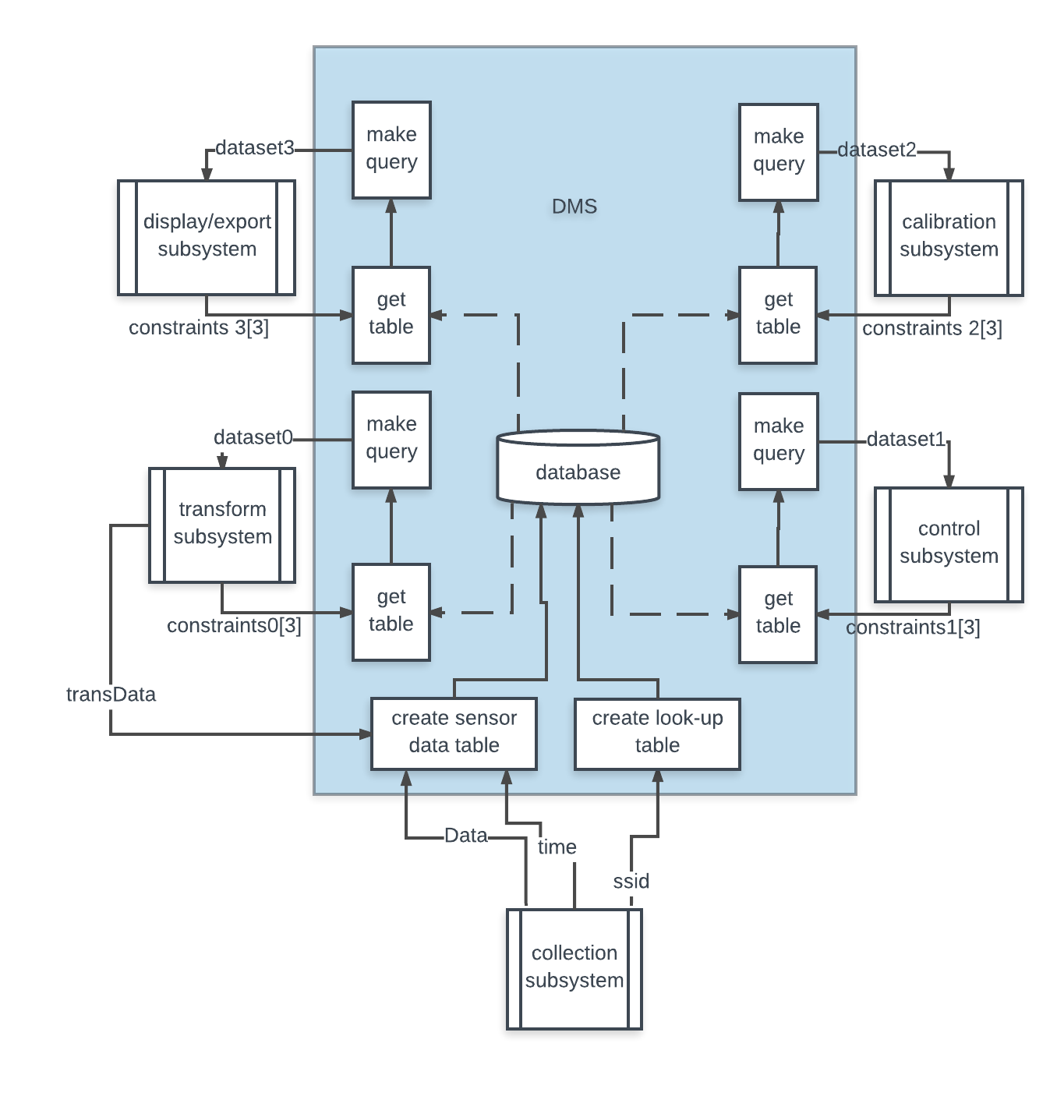
Figure 2:The figure above represents the implementation of the DMS. The system takes input from the collection system to create tables for new data. Then from the transformation system to produce a transformation table in the database. It gets inputs from several SCADA subsystems to return the demanded query from given constraints.

  - Display/Export Logical Design

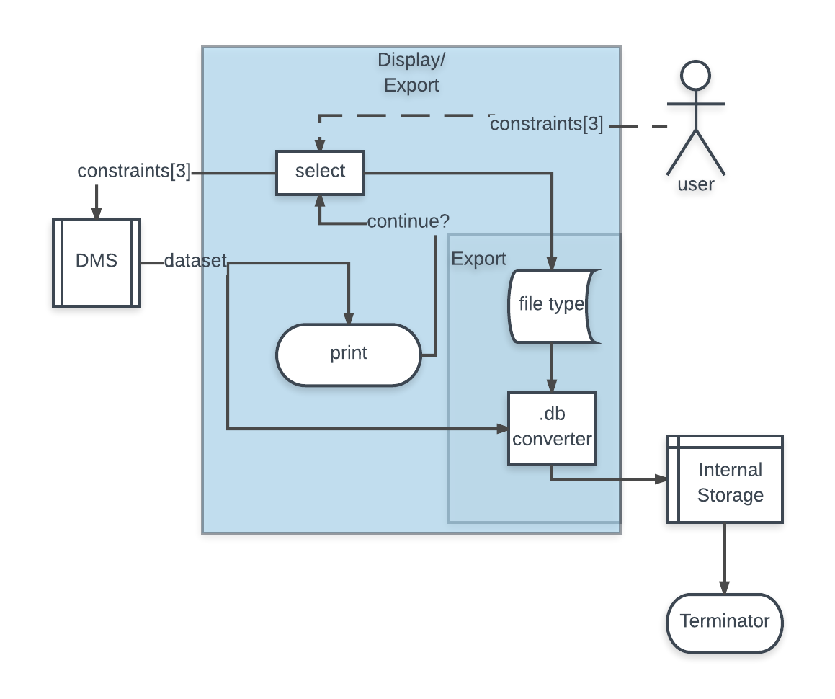
Figure 3: The logical view above represents the implementation of the display and export system. The system takes in user input for the constraints: query size, sensor id, and raw or transform signal. Then it returns the query to display or convert it.

  - Process View
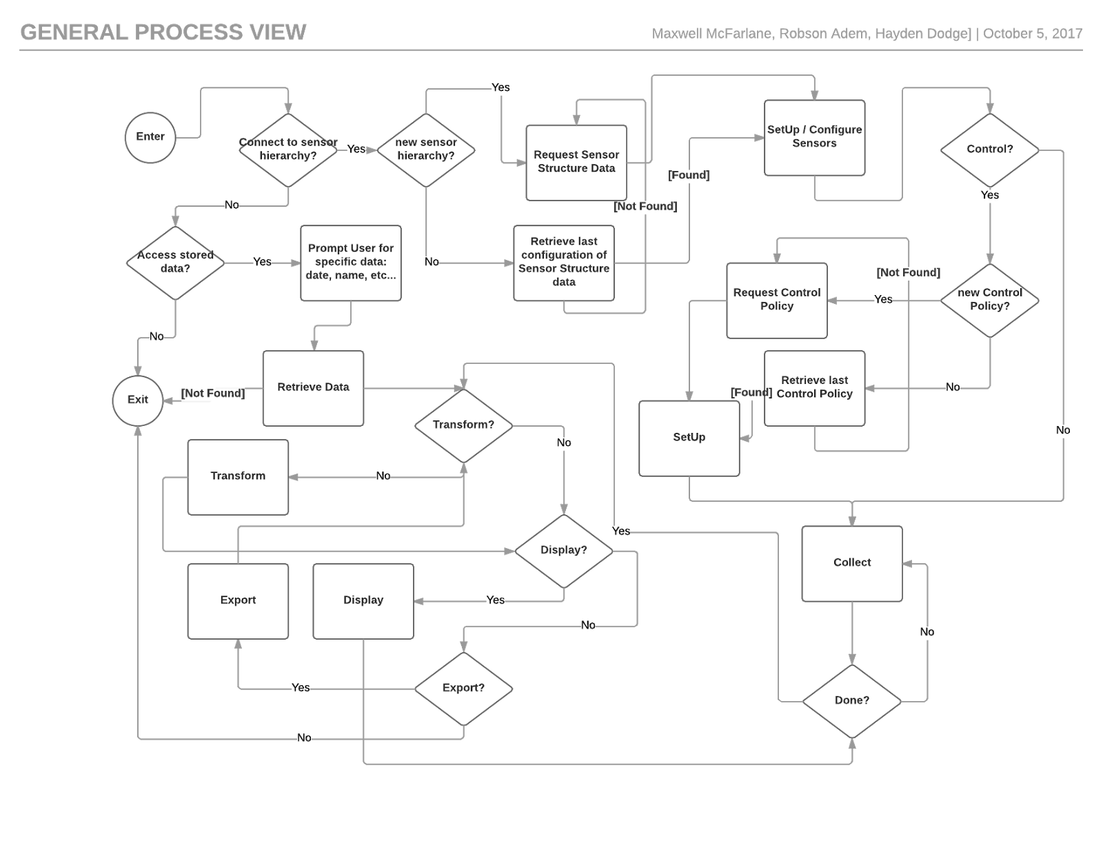
Figure 4: This figure represents the overview of how the system will handle input from the user to run efficient
  - Testing
Unit Testing:
DMS
Test [N] | Test Name | Test Description
1 | test make query | This will test that the system will make the right query using a test bench table and constraints. Then comparing the result to the expected query information.
2 | test create table | This will test that the system creates the correct table by using test bench values with different types. Then comparing the result to the expected.
3 | test look up table | This will test that the system creates an accurate look up table by providing test bench ssids. Then comparing the result with the expected.
4 | test sensor data table | This will test that the system creates an accurate sensor data table by providing test bench data and time values. Then comparing the result with the expected.
5 | test get table | This will test that the system both stores the table correctly into the database and that the system can retrieve it correctly by creating a table and requesting the same one. Then compare the resulting table with the expected table.

Display
Test [N] | Test Name | Test Description
1 | test select | This will test that the system is able to output the correct constraints to the DMS. This will take the results and then compare with the expected.
2 | test print | This will be a visual test to see if the query is printed in a comprehensive way onto a screen.

Export
Test [N] | Test Name | Test Description
1 | test select file type | This will test that the user can directly manipulate which type of file that the query/table can be exported to. Check that the resulting file is comprehensive, or non-corrupt.
2 | test converter | This will test that the file will change from the database format into a testbench format. Compare the result with the expected.

Integration-Testing:

UI Tests:

Test [N] | Test Name | Test Description
1 | test config tool | This will test that the user can manipulate the configuration settings of the collection system using the UI.
2 | test control tool | This will test that the user can change the control of the SCADA system with the UI.
3 | test display tool | This will test that the system will return the right query for a given selection by using the UI.
4 | test calibration tool | This will test that the user can change the calibration of the SCADA system sensors using the UI tool.
5 | test transformation tool | This will test that the user can apply transformations that have been stored as files in the SCADA librarya and apply new functions to transform data correctly using the UI.

- Citations

- Miles, R., and K. Hamilton. Learning UML 2.0. OReilly, 2006.

