Workflows for Spatial Exante Economic Analytics: Selected SOPs

Maxwell Mkondiwa (with Jordan Chamberlin and CSISA-EiA Team)

February 28, 2024

Table of contents

# Preface

What is all this? Standard Operating Procedures (SOP) for a research process which should be driven by a quest to discover the unknown seems far-fetched. It is far-fetched indeed as it should be. Let alone for spatial exante which depends very much on what the context demands. Our purpose for these SOPs is to standardize the spatial exante process so as to shorten the amount of time researchers spend on coding the common building blocks of spatial exante workflows[1].

The choice of which methods to showcase in the SOP reflects our taste and level of knowledge. It also reflects our goal which is to provide a prioritization assessment framework for potential investments.

We focus on three indicators for prioritization: yield gains, profit gains and robustness to risk.

[1] We develop the SOPs following advice from Hollman et al (2020) [https://journals.plos.org/ploscompbiol/article?id=10.1371/journal.pcbi.1008095].

**Acknowledgements:** We thank CSISA and EiA for funding this work. This draft manual was written by Maxwell Mkondiwa with support from Jordan Chamberlin. It has not been reviewed thoroughly. All remaining errors are ours.

# 1. Introduction

## 1.1 Overview

CSISA-EiA Spatial Exante Standard Operating Procedure (SpSOP) is a suite of validated toolkits that use economic theory, econometrics, and mathematical optimization models to target investments of different agronomic innovations at disaggregated spatial scales, as well as evaluating the returns on these investments. The returns are expressed depending on the toolkit as yield gains, profit gains, probability of getting a threshold level of yield gains or profit gains, yield or profit risk, producer surplus, financial indicators like cost benefit ratio and net present value, and willingness to pay measures.

We start with exploratory toolkit which involves literature review, back of the envelope calculations, and stakeholder engagements[1]. In the standard procedures for evaluating agricultural research (as described in Alston et al 1995), this procedure involves using scoring and other short cut approaches. This procedure is not a replacement for the other more objective and data grounded procedures we discuss next. It is a starting point for doing spatial exante work as it guides the nature and scope of toolkits to use next.

The next toolkit in the system assesses whether there are substantial economic gains for a farmer who is either risk agnostic or risk averse to likely adopt the technology. This toolkit assumes that the farmers are individually too small to affect the prices and quantities of other farmers.

In following toolkit, we relax these assumptions to estimate the producer and consumer surplus while considering farmers’ demand and supply price behaviour and equilibrium relationships. The two toolkits presented assume that the technology already exists and that all that remains is to increase its adoption.

In the final toolkit, we present a case of first ascertaining whether there is adoption potential given spatially explicit endowments and whether by adding attributes to the technology, farmers are then more likely to adopt it. We then use that system to compute the economic value of that adoption to the farmers.

How does one choose which toolkits to use? We present next a guide map to choosing the analytical methods given the available data, expertise and time.

[1] Within CSISA and EiA, the CAPTAIN tool (now called PAiCE) is a clear example of this toolkit.

## 1.2 Guidelines to comprehensive spatial quantitative exante toolkits

This paper has provides a list of spatial quantitative exante toolkits that are used to prioritize potential investments. These toolkits mostly use existing survey data or baseline data that most projects ideally collect prior to implementation.

Figure 1 shows a guidemap to selecting which exante approach to use for a selected study. We categorize the decision steps into four layers. First, one has to conduct a literature review, back of the envelope calculations of structural changes in the economy, and stakeholder engagements. This layer needs to be done regardless of the comprehensive approaches that are later used in the spatial exante assessment. It is possible to stop and start implementing at this point if prior exante studies were already conducted on the topic of interest and at a sufficient scale. In the second layer, one gathers all the necessary datasets required for the exante work. If there is no data, then instead of scaling the interventions, it is best to work with stakeholders to design on station, on-farm experiments, quantitative and qualitative surveys to start gathering evidence to be used for exante.

If survey data exist already, then one needs to start with the spatial profitability and risk assessment toolkit. In this tookit, the researcher needs to ask if the technology in question is sufficiently studied elsewhere such that there are already functional forms to use the parametric approach. If not clear on this then, he/she may use the causal ML based approaches. The researcher may use the spatial Bayesian krigging approach if the targeting is to focus on locations to implement including out of sample. He/she may consider the policy learning optimization approach if he/she is interested in understanding the indicators to use when partitioning who needs to be prioritized beyond the spatial aspects.

If crop simulation and long-term experimental datasets are available, one can use the spatial profitability and risk assessment toolkit as well. But in addition, he/she may be interested in using the evidence from these experiments to suggest new combinations of treatments that should be tested or scaled beyond what is observed to be beneficial. For that, the researcher can use the modern portfolio approaches (i.e., mean-variance optimization or mean-conditional value at risk optimization). If instead he/she is just interested at recommending for each grid the most robust practice for scaling, then he/she can use the willingness to pay bounds approach which recommends the best practice for any risk averse farmer to find it optimal to follow that strategy.

The spatial profitability assessment toolkit and the spatial optimization toolkit will provide an individual assessment of the benefits of. However, one may be interested to understand if this makes sense socially as well given the demand and supply behavioral patterns (i.e., elasticities). The equilibrium displacement modelling framework also called economic surplus approach is the traditional way of assessing producer and consumer surplus for the new agronomic technology. This approach will utilize supply/demand elasticities, the spatially explicit yield gains and cost reduction estimates and the assumed adoption trends to evaluate the returns on investments at a disaggregated level.

What if the new technology is just a variant of an old technology. For example, a new mix of herbicides or a new variety. In most cases, these are not widely adopted to warrant a spatial profitability assessment using observational data. In addition, the performance in agronomic trials will likely be misleading because farmers have not yet learned how to use the technology appropriately. How do we predict whether this new technology is will be adopted and that it’s worth investing in. For this, the researcher needs to consider the structural differentiated agronomy toolkit which uses characteristics of the technology and locational characteristics (including farmer demographics) to predict whether the new technology embodying particular traits is worth investing.

As it can be seen from the guidemap, these toolkits can be used in tandem because they give different insights into the likely benefits of investing in a particular technology. In addition, these approaches are not exhaustive. Each of the workflows we have presented have several variants and complementary methods that researchers can explore.

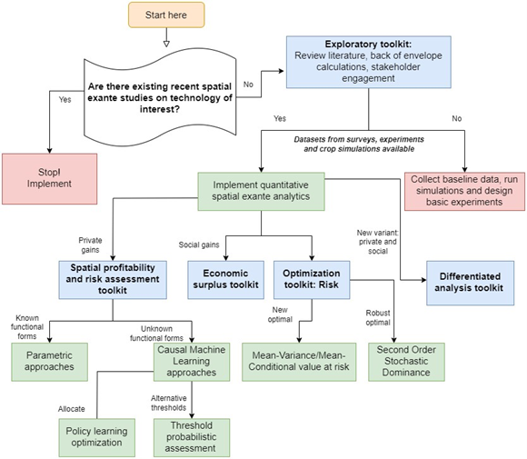

Figure 1: Guidemap to selecting spatial exante approaches

## 1.3 Target audience

The toolkits can be used by researchers, project managers, and students to conduct exante analyses that guide investments. Our target audience are researchers who are tasked to conduct spatially explicit exante analyses. We thus assume that the researchers have used most of these tools before or are at least aware of them. For those not familiar with the methods, we encourage the reader to go through the suggested references.

## 1.4 Stylized example: Sowing date use case

We focus on sowing date use case being implemented in India as an exemplar for the exante analytics presented in this SOP. However, we have applied the same techniques for other use cases including: (1) Herbicide integrated weed management in wheat, (2) multiple irrigations in wheat (irrigation scheduling) and short and long duration wheat varieties (varietal choice).

## 1.5 Replication materials

The replication materials for all the toolkits can be accessed on EiA Exante github page: <https://github.com/EiA2030-ex-ante>. We use publicly available datasets as such once the repository of interest is cloned, one should be able to replicate all the results in this SOP.

# 2. Exploratory toolkit: Back of the envelope, literature review, and stakeholder prioritization frameworks

There are cases in which spatial exante can be done using back of the environment calculations, literature review or stakeholder prioritization workshops. These cases include when there is ample evidence on ROI, or when the time or resources required would not allow collection of the necessary data for the comprehensive analytics. We discuss in this section the merits and demerits of the approach, an example from India, the data requirements, stylized outputs from such and link to replication materials.

***Advantages***

* It is the simplest approach and has less data requirements.
* It is useful when there is lack of data for a formal quantitative evaluation.
* For some agricultural innovations, formal quantitative methods are difficult or even impossible to implement.
* When there is mixed evidence on the probability of success, a stakeholder engagement can help in understanding the likely values. In addition, it helps in building an institutionalized “economic way of thinking” (Alston et al 1995).

***Disadvantages***

* The approach is less precise and can be biased by the nature of evidence available and by the set of the stakeholders.

***Stylized use case: Where to target sowing date advisories?***

Using literature review, it is clear that early sowing of wheat has yield advantages. In focus group discussions, farmers also expressed the same.

***Input data requirements***

* Literature database with estimates for each location
* Stakeholder workshop with a scoring matrix

***Toolkit workflow***

Following Alston et al (1995) and Lee et al (2014), the scoting toolkit involves the steps shown in the figure.

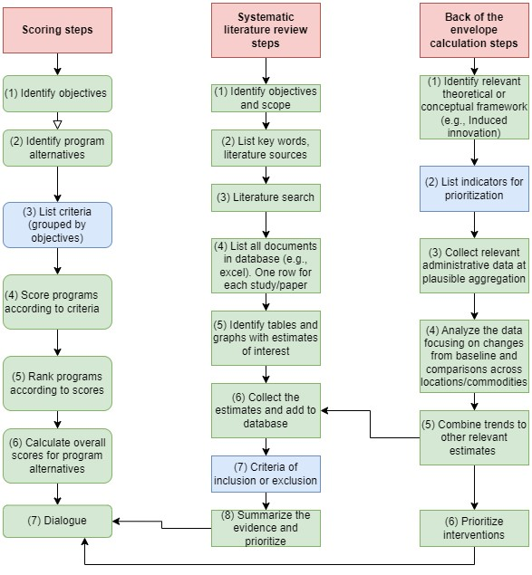

Figure 2: Stylized workflow for literature review, scoring and back of the envelope calculations

Replication materials: <https://github.com/EiA2030-ex-ante/Ex-ante-Summary-Tool>

**Key references**

Alston, J.M., Norton, G.W., and Pardey, P. 1995. “Science under scarcity: Principles and practice for agricultural research evaluation and priority setting”. CAB International. See Chapter 7 (pp. 463-498).

Binswanger, H.P. 1986. “Evaluating Research System Performance and Targeting Research in Land-abundant Areas of Sub-Saharan Africa.” World Development 14(4): 469-475. Doi: https://doi.org/10.1016/0305-750X(86)90063-X.

Lee, D.R., Edmeades, S., Nys, E., McDonald, A., Janssen, W. 2014. “Developing local adaptation strategies for climate change in agriculture: A priority-setting approach with application to Latin America”. Global Environmental Change 29: 78-91. Doi: https://doi.org/10.1016/j.gloenvcha.2014.08.002.

# 3. Spatial exante profitability and risk toolkit

## 3.1 Spatial parametric production function approach with risk

**Purpose:** The conventional approach is to estimate a parametric production function (also called crop response function), then use profit maximization or it’s dual cost minimization to identify optimal demand for the associated technology. If risk is considered important, the traditional approach is to assume a quadratic utility function and use mean-variance approaches to assess optimal choices under risk aversion preferences (e.g., Just-Pope production function or moments productions). To use this approach for spatial exante, we use spatial Bayesian models for point-referenced data (Note: spatial econometric approaches can also be used for this extension to the traditional model).

**Advantages**

* Simple to use with standard econometric approaches (e.g., OLS).

**Disadvantages**

* Difficult to identify the appropriate functional form and the results are largely dependent on this choice.

**Stylized use case: Are sowing date advisories risk proof?**

We use CSISA-KVK trial data to understand whether early sowing of wheat and planting of long duration wheat varieties increase mean yield and reduce risk. Workflow Figure 4 shows a workflow for the spatial parametric production function approach. This is categorized into four steps. First, one estimates a production risk function model using either the residual based (e.g., Just-Pope production function) or the moments-based approach using ordinary least squares approach. If there are concerns with endogeneity, then one can correct for these using the instrumental variables approach or other quasi-experimental methods. The simple approach we recommend is using Lewbel (2012) approach. Third, to make the estimate spatially explicit, we recommend using a spatially varying coefficient model to get estimates for each pixel in area of interest. Finally, one can use input and output prices to create economic indicators of interest.

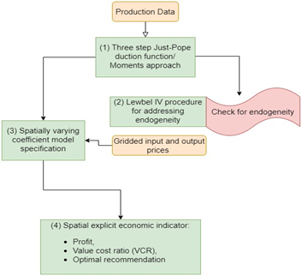

Figure 4: Workflow for spatial risk production function

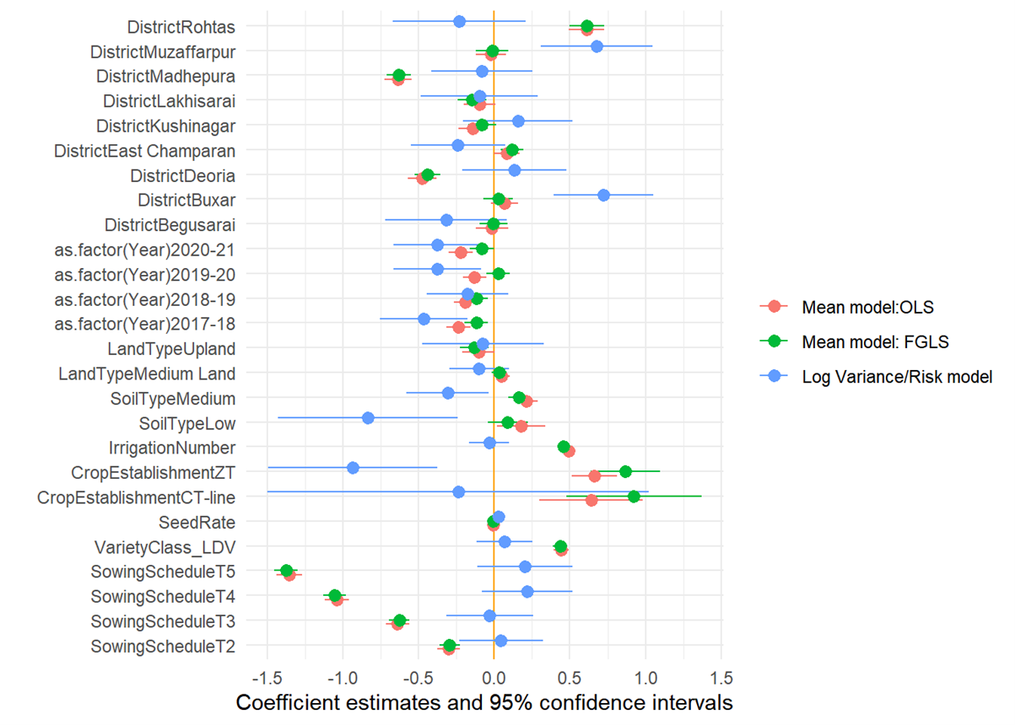

Figure 5: Just-Pope production risk model

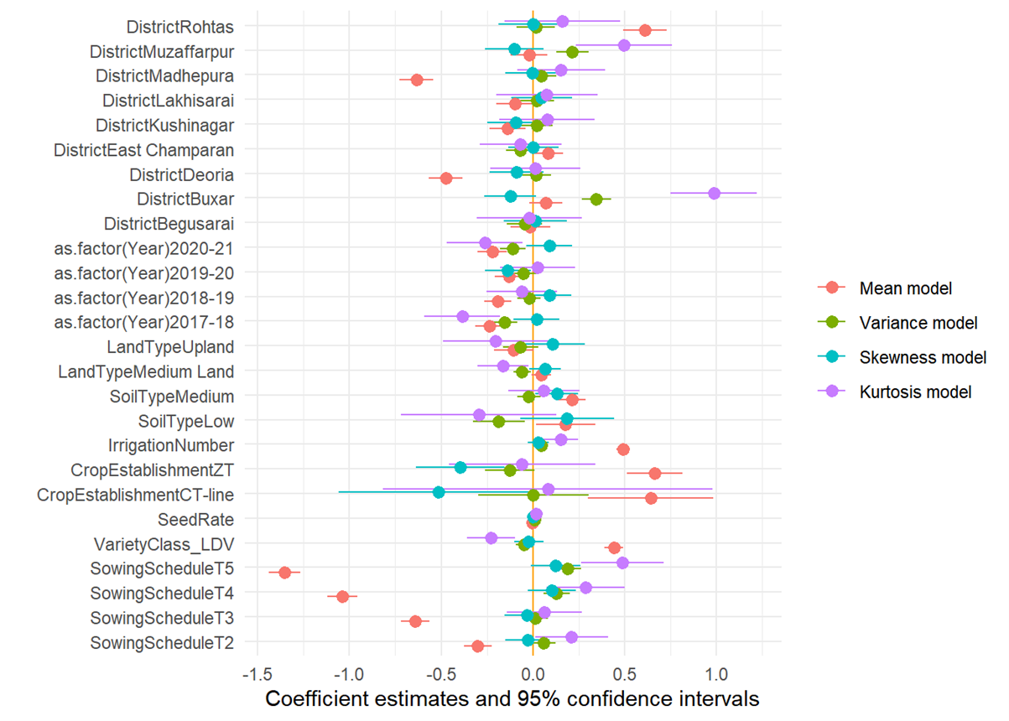

Figure 6: Moments based production risk model

***Replication materials:*** [***https://eia2030-ex-ante.github.io/SpatialParametricProduction_Risk_Model/***](https://eia2030-ex-ante.github.io/SpatialParametricProduction_Risk_Model/)

***Key references:***

Antle, J.M. 1983. “Testing the stochastic structure of production: A flexible moment-based approach”. *Journal of Business and Economic Statistics* 1(3): 192-201. Doi: 10.1080/07350015.1983.10509339.

Antle, J.M. 2010. “Asymmetry, partial moments and production risk.” *American Journal of Agricultural Economics 92(5):* . Doi: <https://doi.org/10.1093/ajae/aaq077>.

Di Falco, S., Chavas, J., and Smale, M. 2007. “Farmer management of production risk on degraded lands: the role of wheat variety diversity in the Tigray region, Ethiopia.” *Agricultural Economics* 36: 147-156. Doi:  <https://doi.org/10.1111/j.1574-0862.2007.00194.x>.

Di Falco, S., and Chavas, J. 2009. “On crop biodiversity, risk exposure, and food security in the highlands of Ethiopia”. *American Journal of Agricultural Economics* 91(3): 599-611. Doi: <https://doi.org/10.1111/j.1467-8276.2009.01265.x>.

## 3.2 Causal ML and spatial probabilistic assessment model

***Purpose:*** In some cases, the farmer is not only interested in shifting to a technology that gives the highest yield gains, but also the one that has the highest chance of giving him/her yields beyond a particular threshold.

***Advantages***

The spatial probabilistic approach adds value under the following circumstances:

* One is interested in segmentation of zones of opportunities.
* One is interested in threshold probabilities as measures of uncertainty.

***Disadvantages***

* The spatial Bayesian models are computationally expensive especially for large N data and can take many weeks to produce results. This can be resolved by using High Performance Computers.

***Stylized use case: Where to target sowing date advisories that achieve yield gains beyond a particular threshold?***

A farmer requires a substantial yield gain to change from the conventional behaviour. In recommending planting date changes, it is therefore important to provide the confidence we have that the farmer will likely attain yields higher than that threshold. A probabilistic assessment approach allows this through a threshold probability—the probability that a farmer in that location will achieve yield gains above the threshold.

***Input data requirements:*** The approach requires geo-referenced farm plots with attendant yield and traditional production variables (e.g., fertilizer, weed management, e.t.c).

***Toolkit workflow***

This toolkit is implemented by following the steps shown in the figure 7.

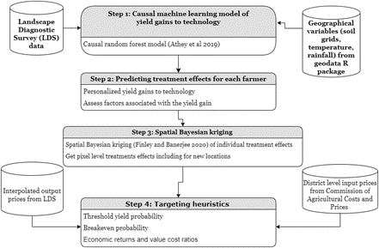

Figure 7: spatial probabilistic assessment toolbox

***Stylized outputs***

Using this toolkit, we see in Figure 8 that farmers in much of the area of interest (Bihar) would find early planting of wheat most beneficial and have a probability of getting an additional 100kg/ha due to early sowing alone.

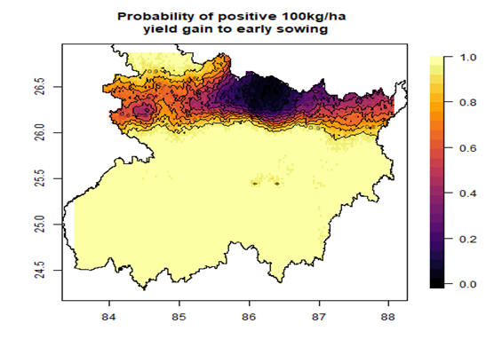

Figure 8: Stylized output for spatial probabilistic assessment showing probability of yield gains of above 100kg/ha with early planting of wheat (i.e., before 21st Nov)

***Replication materials:*** [***https://github.com/EiA2030-ex-ante/Spatial_probabilistic_targeting***](https://github.com/EiA2030-ex-ante/Spatial_probabilistic_targeting)

***Key references:***

Athey, S., Tibshirani, J., and Wager, S. 2019. “Generalized Random Forests.” *The Annals of Statistics* 47(2): 1148-1178. Doi: 10.1214/18-AOS1709.

McCullough, E.B., Quinn, J.D., Simons, A.M. 2020. “Profitability of climate-smart soil fertility investment varies widely across sub-Saharan Africa.” *Nature Food* 3:275-285. Doi: <https://doi.org/10.1038/s43016-022-00493-z>.

## 3.3 Causal ML and policy learning optimization model

***Purpose:*** To make individualized or personalized recommendations from observational data in a data-driven manner using causal machine learning frameworks.

***Advantages***

* Data-driven approach of recommending alternatives without making functional form assumptions. This is especially useful for agricultural inputs for which we do not have a clear functional form e.g., irrigation, sowing dates.

***Disadvantages***

* It requires enough sample sizes for each of the options being compared. This mean that for new innovations which have not been extensively adopted, this approach would not be beneficial.

***Stylized use case: Targeting sowing date advisories to individual farmers***

While sowing date and many other recommendations are made on the basis of climatic, biophysical and economic aspects, there may be several individual level reasons for not following with the recommendation, e.g., family members are busy with other duties during those weeks. We propose a robust methodology that rests on causal machine learning and policy learning to make recommendations that are the most beneficial for each individual farmer.

***Input data requirements:*** The data required is the same as for any conventional production function or impact assessment. These include yield, agronomic management variables (e.g., fertilizer applied), socio-economic variables, and input and output prices. One however, needs enough sample sizes for the treatment and control groups therefore the method works only for a technology which has been widely adopted.

***Toolkit workflow***

Figure 9 shows a step-by-step workflow for implementing the policy learning optimization model.

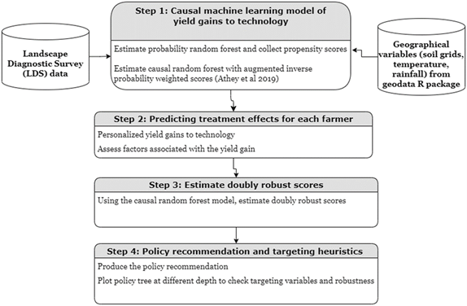

Figure 9: Workflow for causal ML and policy learning optimization

***Stylized outputs***

The output of steps 1 to 3 in the workflow are the individual level estimates of the yield gains from the proposed agronomic innovation. Figure 10 shows the distribution of yield gains to early sowing. Everyone in the sample would get a positive yield gain if they advance their planting strategy as compared to sowing after 16 December.  The highest yield gains are with planting before 10th November. However, the results in this figure do not prescribe a recommendation for that farmer. To prescribe a recommendation, we need to assume some objective function of the farmer. Policy learning uses minimum regret as an objective function to prescribe best practice for each farmer. Figure 11 then shows the transition matrix from status quo to proposed agronomic practice for each individual farmer.

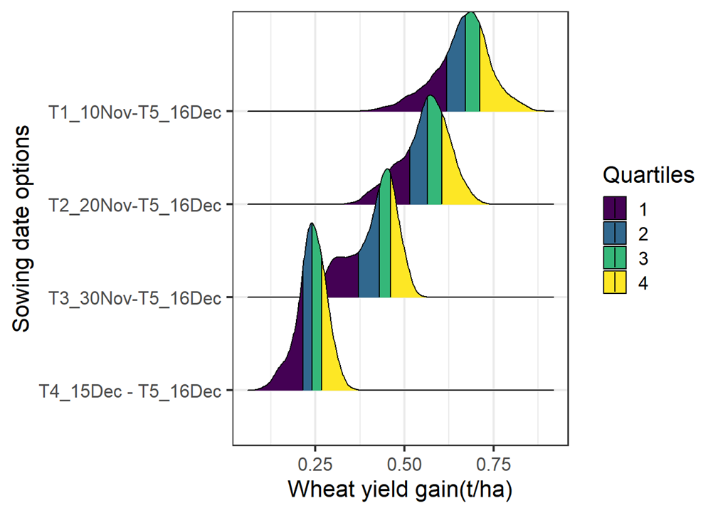

Figure 10: Distribution of conditional average treatment effects of wheat yield gains to early sowing from multi-armed causal ML model

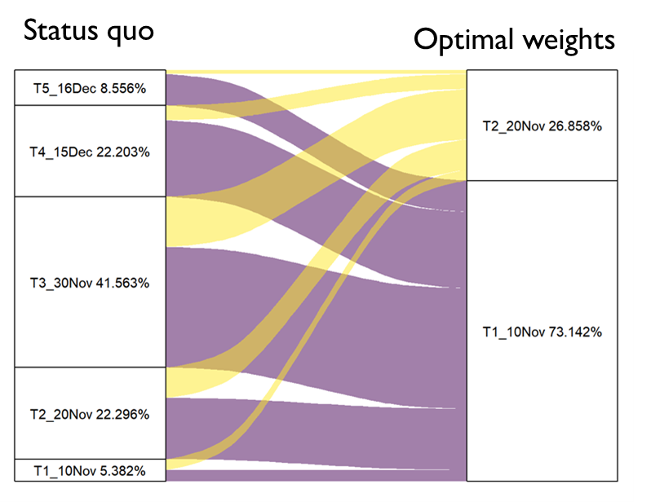

Figure 11: Transition matrix from status quo (as of 2019) to optimal allocations

***Replication materials:*** [***https://eia2030-ex-ante.github.io/causal_RF_targeting/***](https://eia2030-ex-ante.github.io/causal_RF_targeting/)

***Key references***

Athey, S., and Wager, S. 2021. “Policy learning with observational data”. *Econometrica*. Url: <https://onlinelibrary.wiley.com/doi/abs/10.3982/ECTA15732>.

# 4. Spatial optimization toolkit: Computational risk-return modeling

## 4.1 Mean-Variance (EV) and Mean-Conditional Value at Riskk (CVaR) modern portfolio theory optimization

**Purpose:** Mean-variance analysis seeks to maximize returns at the minimum risk (or variance). The approach was introduced by Harry Markowitz to identify efficient diversification options for investments.

***Advantages***

* Allows selection of multiple alternatives beyond combinations observed in the data

***Disadvantages***

* Focuses only two moments (mean and variance) yet other moments of the distribution may also matter.

***Stylized use case: Optimal sowing date and variety combinations***

We use CSISA-KVK trial data to demonstrate the approach. The agronomic trials cover a 5-year period in 8 districts in the Indian state of Bihar.

***Input data requirements:*** This is an outcome-based risk assessment requiring yield or profits data for multiple years for the same site.

***Toolkit workflow***

Mean-Variance optimization requires only the outcome variable for multiple realizations and portfolio choices. We then use quadratic optimization to identify the frontier and optimal weights indicating the amount of land or resources that should be devoted to particular choices.

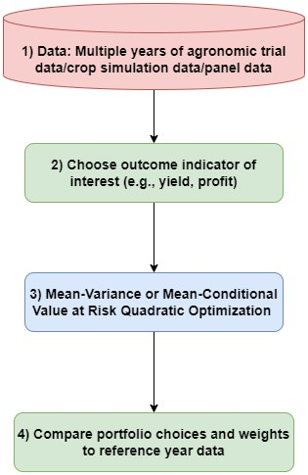

Figure 12: Mean-variance or mean-conditional value at risk (CVaR) workflow

***Stylized outputs***

Using a state level E-V optimization model of wheat yields, we find that HD-2967 sown before 10th November gives the highest returns and a risk neutral farmer would find it most beneficial.

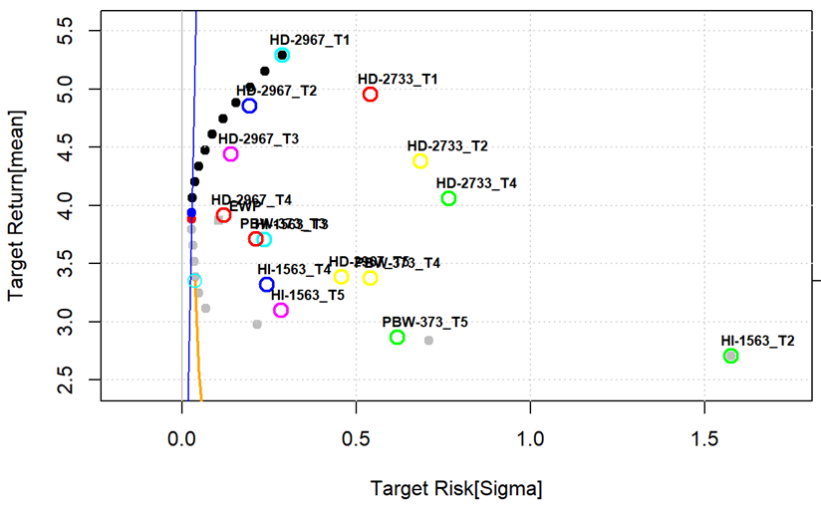

Figure 13: Planting date-varietal yield frontier for Bihar, 2016-2021.

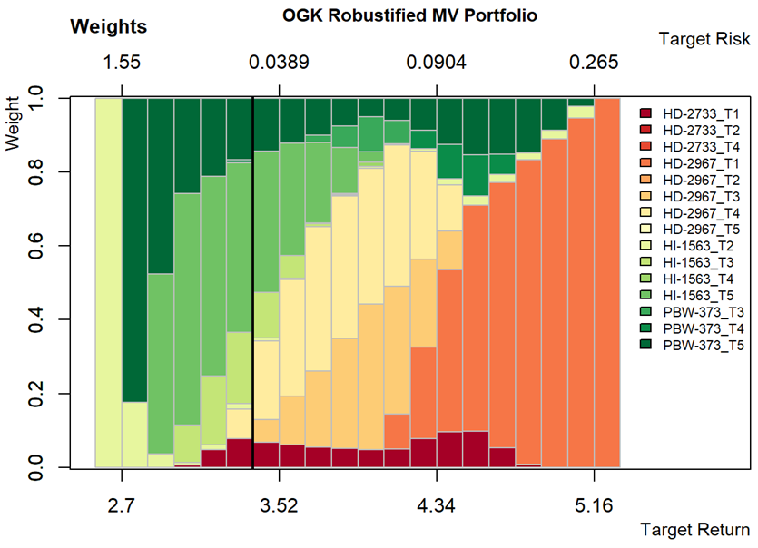

Figure 14: Optimal weights for planting date-variety yield frontier, 2016-2021.

***Replication materials:*** [***https://eia2030-ex-ante.github.io/Risk_modern_portfolio_theory_EV_model/***](https://eia2030-ex-ante.github.io/Risk_modern_portfolio_theory_EV_model/)

## 4.2 Willingness to pay bounds for second order stochastic dominance approach

**Purpose:** The commonly used risk measures focus on central moments (e.g., variance, conditional value at risk, skewness) of the distribution. Yield distributions overtime and space are however more complicated such that one may need to consider the whole distribution when evaluating which agronomic practice will likely work where and when. The use of stochastic dominance especially second order stochastic dominance allows the relationship between the cumulative distribution function of the outcome and the expected utility maximization behaviour under risk aversion. A computational approach developed by Hurley et al (2018) allows one to compute willingness to pay lower and upper bounds for a new technology to second order stochastically dominate an old practice such that any risk averse farmer will choose the new technology.

***Advantages***

* Unlike mean-variance optimization, this optimization strategy considers distributional comparisons

***Disadvantages***

* Computationally expensive especially when implementing across a large area of interest.
* The comparisons are pairwise thereby requiring many combinations to come up with the best alternative for each pixel.
* Difficult to apply with survey or agronomic datasets are it requires long timeseries. However, it is possible to implement the approach with monte-carlo simulated survey or agronomic trial datasets.

***Stylized use case: Where to target sowing date advisories?***

We use gridded crop growth simulation model results to identify scenarios that would be agronomically and economically beneficial even for a risk averse farmer.

***Input data requirements***

For the spatial exante (economic) component of the model, one only needs gridded crop simulation results for each of the scenarios.

***Toolkit workflow***

Figure 15 shows the workflow for implementation the computational second order stochastic dominance analysis.

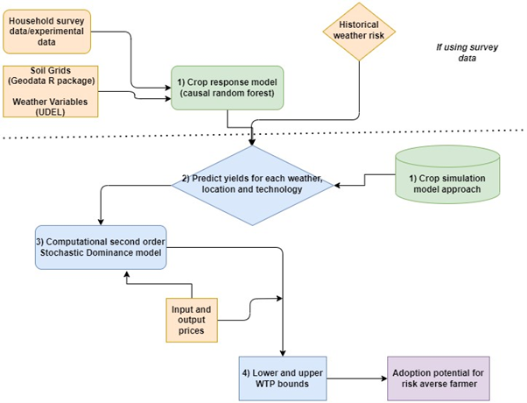

Figure 15: Risk optimization using second order stochastic dominance

***Stylized outputs***

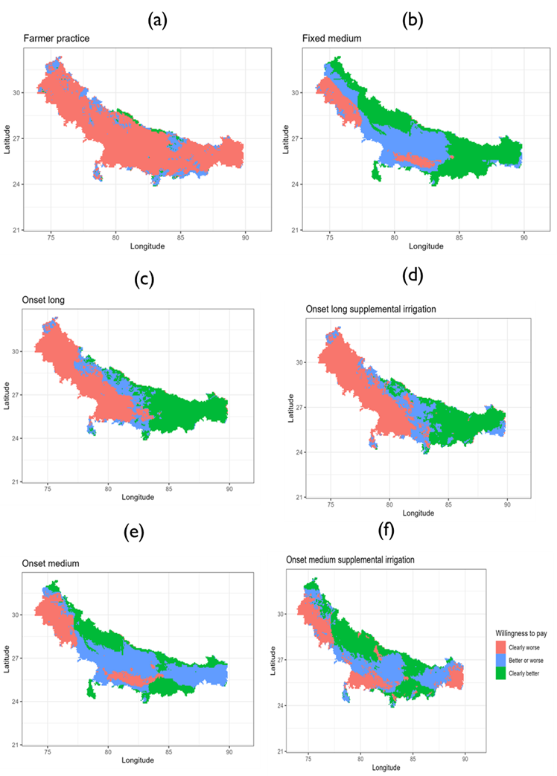

Figure 16: Willingness to pay based on partial profits for planting date scenario in comparison to fixed date with long duration rice variety strategy

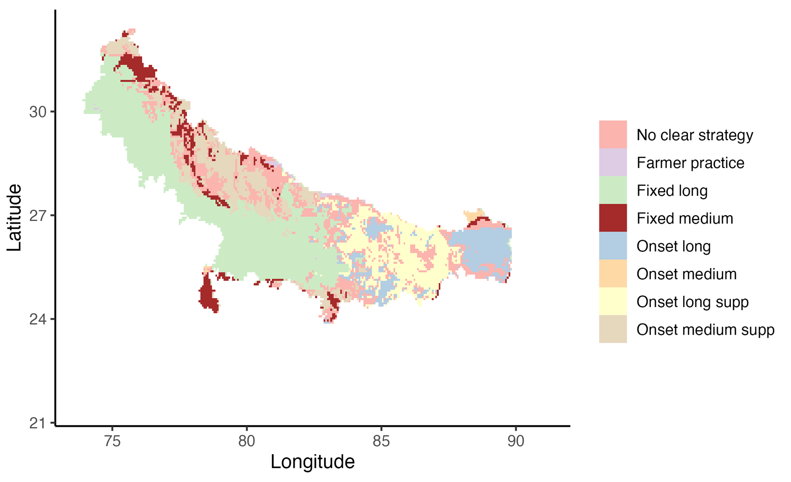

Figure 17: Robust and optimal rice planting date strategy

***Replication materials:*** <https://eia2030-ex-ante.github.io/WTP_Bounds_SOSD_Risk_Model/>

***Key references:*** For more methodological details of the approach, readers are referred to Hurley et al (2018).

Hurley, T., Koo, J., and Tesfaye, K. 2018. “Weather risk: how does it change the yield benefits of nitrogen fertilizer and improved maize varieties in sub-Saharan Africa?” *Agricultural Economics* 49: 711-723. Doi: 10.1111/agec.12454.

# 5. Spatial economic surplus and return on investments (ROI) toolkit

## 5.1 Discounted cash flow (DCF) economic surplus framework [Incomplete]

**Purpose:** Economic surplus framework is the most used approach in agricultural economics to evaluate the agricultural research benefits.

In recent years, scholars have also suggested the use of real options approach which then helps in valuing the time to wait and dynamic complexities appropriately.

***Why?***

* Relies on economic theory especially demand and supply as well as welfare economics

***Why not?***

* Given data requirements (e.g., on elasticities), the analyses are done at aggregate level (e.g., country level).

***Stylized use case: Would sowing date advisories pay?***

We estimate the returns on investments of early sowing advisories using the economic surplus approach.

**Input data requirements:** Surplus analysis approach requires data on area, yield , and output data. It also requires data on percent of area under the new technology, the supply and demand elasticities, yield gain due to the technology , price data and cost change data due to the technology.

***Toolkit workflow***

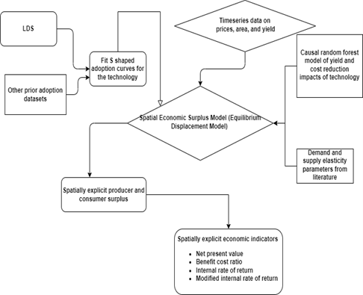

# 6. Structural differentiated agronomy toolkit

## 6.1 Targeting research, adoption and impacts of new innovations– hybrid characteristics-induced innovation model toolkit

***Why or why not a differentiated farming system (or agronomy) framework?***

A differentiated farming system approach focuses on identifying characteristics of the farming systems which farmers would find attractive. The goal is then to estimate the willingness of the farmers to pay for these farming system characteristics.

The advantage of doing this is that:

* It allows one to predict the adoption of new agronomic innovations
* It helps to assess the welfare impacts of many varieties of a technology unlike the traditional approach which treats them as separate inputs or goods.

***Stylized use case: Where to target sowing date advisories?***

We use the differentiated farming systems approach by analyzing the segmentation of sowing dates and drivers associated with farmers choice of which planting dates to sow their wheat.

***Input data requirements***

***Toolkit workflow***

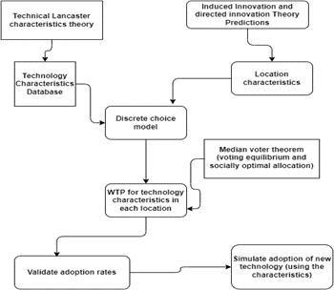

**Selected results**

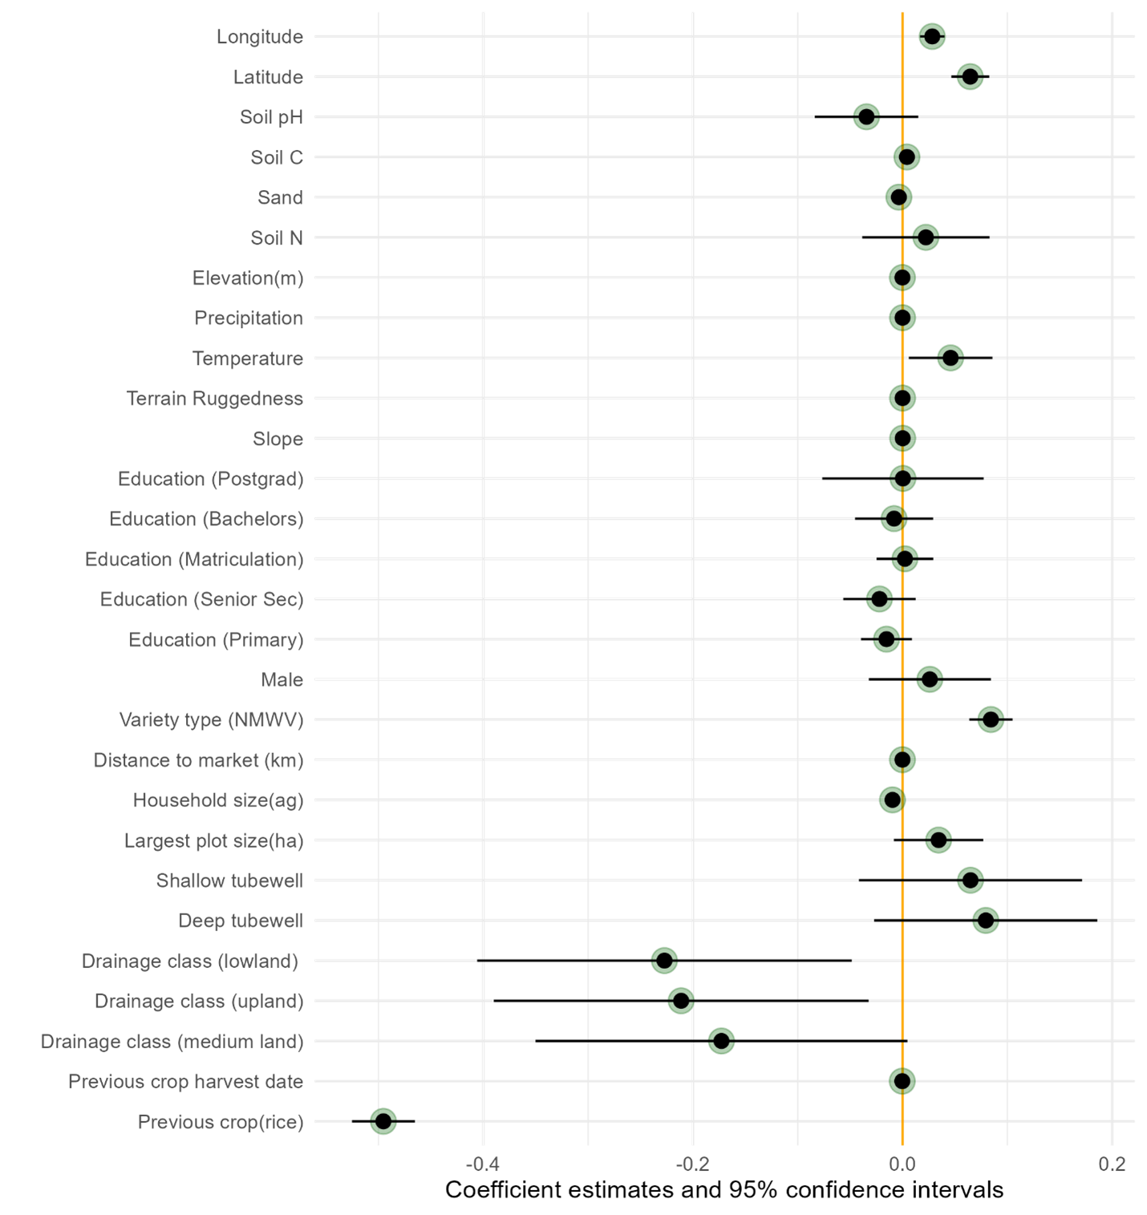

# 7. Conclusion

This paper has discussed toolkits for conducting spatial exante analyses using a case study of sowing date advisories. These toolkits are selected to showcase reproducible workflows that can be applied for other agronomic practices and in other areas of interest. In on-going research, we are also using mathematical optimization approaches, agent-based modelling approaches, knowledge guided machine learning and spatial multi-criteria approaches for targeting and prioritizing agricultural innovations. We believe automating research around these methods will allow agronomists and other stakeholders to quickly make scientific discoveries and respond to ever changing agronomic environments due to climate variability and change.

# 8. References

Alston, J.M., Norton, G.W., and Pardey, P. 1995. “Science under scarcity: Principles and practice for agricultural research evaluation and priority setting”. CAB International. See Chapter 7 (pp. 463-498).

Antle, J.M. 1983. “Testing the stochastic structure of production: A flexible moment-based approach”. Journal of Business and Economic Statistics 1(3): 192-201. Doi: 10.1080/07350015.1983.10509339.

Antle, J.M. 2010. “Asymmetry, partial moments and production risk.” American Journal of Agricultural Economics 92(5): . Doi: https://doi.org/10.1093/ajae/aaq077.

Athey, S., Tibshirani, J., and Wager, S. 2019. “Generalized Random Forests.” The Annals of Statistics 47(2): 1148-1178. Doi: 10.1214/18-AOS1709.

Athey, S., and Wager, S. 2021. “Policy learning with observational data”. Econometrica. Url: https://onlinelibrary.wiley.com/doi/abs/10.3982/ECTA15732.

Binswanger, H.P. 1986. “Evaluating Research System Performance and Targeting Research in Land-abundant Areas of Sub-Saharan Africa.” World Development 14(4): 469-475. Doi: https://doi.org/10.1016/0305-750X(86)90063-X.

Di Falco, S., Chavas, J., and Smale, M. 2007. “Farmer management of production risk on degraded lands: the role of wheat variety diversity in the Tigray region, Ethiopia.” Agricultural Economics 36: 147-156. Doi: https://doi.org/10.1111/j.1574-0862.2007.00194.x.

Di Falco, S., and Chavas, J. 2009. “On crop biodiversity, risk exposure, and food security in the highlands of Ethiopia”. American Journal of Agricultural Economics 91(3): 599-611. Doi: https://doi.org/10.1111/j.1467-8276.2009.01265.x.

Hurley, T., Koo, J., and Tesfaye, K. 2018. “Weather risk: how does it change the yield benefits of nitrogen fertilizer and improved maize varieties in sub-Saharan Africa?” Agricultural Economics 49: 711-723. Doi: 10.1111/agec.12454.

Lee, D.R., Edmeades, S., Nys, E., McDonald, A., Janssen, W. 2014. “Developing local adaptation strategies for climate change in agriculture: A priority-setting approach with application to Latin America”. Global Environmental Change 29: 78-91. Doi: https://doi.org/10.1016/j.gloenvcha.2014.08.002.

McCullough, E.B., Quinn, J.D., Simons, A.M. 2020. “Profitability of climate-smart soil fertility investment varies widely across sub-Saharan Africa.” Nature Food 3:275-285. Doi: https://doi.org/10.1038/s43016-022-00493-z.