Test Maxwell Morris

Maxwell Morris

Table of Contents
1. Current TODO List
2. FIRST!

Current TODO List
- [ ] Need to fix invalidation issues in the pipeline
- [ ] Need to make the site pretty
- [ ] Create a suitable structure for the website
- [ ] Write up a personal intro
- [ ] Stream line the upload sequence

FIRST!
Date: Sun 19 Jun 2022 21:03:21 AWST
Today’s goal was to set this website up so that I can write in org mode, push to github and be able to view it on the internet. I wasn’t certain I’d have enough time but it was actually quite doable. This was way easier then the first time I tried to set up a website.
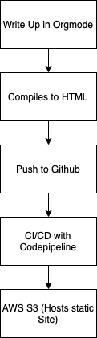 Figure 2.1: Outline of what is going on
Useful references:
- https://adamtheautomator.com/aws-s3-static-ssl-website/
- The AWS documentation is a good place to start

