Assignment 2B – Case Study
Written by Maxwell Repin (s3822965)

Student: s3822965 Practical Data Model: Assignment 2b Data Model

Entity Relationship Diagram (Note: Attributes do NOT need to be shown)

has
Bookings
Venue

Meet
has

has
in
in
RaceRider
StaffRoles
Race

in
in
in
Incident
Staff
Riders

has
has

Bike
Payment

Relational Model
Riders | Meet | Race | Venue | Staff
Rider_id | Meet_id | Race_id | Venue_id | Staff_id
Firstname | Date_start | Type (L/R) | Name | Firstname
Lastname | Signup_cutoff (-3 days from Date_start) | Date_start | Location | Lastname
Contact | Venue_id | Time_start | Price_per_day | Contact
Membership_expiry |  | Time_finish | Pref_Race (L/R/LR) | Preferred_Role/s (M/T/MT)
SeasonPoints |  | Meet_id
Waiver (Y/N) |  | StaffRoles_id
Member (Y/N)

RaceRider | StaffRoles | Bike | Payment | Incident
RaceRider_id | StaffRoles_id | Bike_id | Payment_id | Incident_id
Time_finished | Marshal1_id | Brand | Date | Date_occured
Place | Marshal2_id | Model | Payment_type | Time
Points_awarded | Timekeeper1_id | Colour | Amount | Description
Gear_check (Y/N) | Timekeeper2_id | Inspected (Y/N) | Membership_renewal (Y/N) | Further_action
Rider_id | Race_id | Safety_check_pass(Y/N) | Comments | RaceRider_id
Race_id |  | Comments | Rider_id
 |  | Rider_id

Booking
Booking_id
Date_Start
Date_End
Contact_number
Venue_id

Business Rules/Assumptions
- 2 marshals and 2 timekeepers required for each race.
- A rider can have many bikes.
- If one incident has many riders, then a new incident report is filled out for each individual rider (multiple Incident_id for one incident)
- Each rider has their gear checked every race.
- Signup_cutoff will be 11:59pm of the indicated date in that cut-off.
- Staff can be assigned different roles for each race (as there can be more than one race at each Meet).
- A Rider will sign one waiver that will cover the whole of their season.

SQL Code:

CREATE TABLE s3822965.Riders(
Rider_id INT(10) NOT NULL PRIMARY KEY,
Firstname VARCHAR(50),
Lastname VARCHAR(50),
Contact INT(50),
Membership_expiry DATE,
SeasonPoints INT(10),
Waiver VARCHAR(1),
MEMBER VARCHAR(1)
);

INSERT INTO s3822965.Riders
VALUES
(1, 'James', 'May', 0412386410, '2024-12-1', 1, 'Y', 'Y'),
(2, 'The', 'Stig', 0412386123, '2025-12-1', 99, 'Y', 'Y'),
(3, 'Jeremy', 'Clarkson', 0412384444, '2024-12-30', 28, 'Y', 'Y'),
(4, 'Richard', 'Hammond', 0413286410, '2025-12-1', 25, 'Y', 'Y'),
(5, 'Enzo', 'Ferrari', 0417786410, '2023-1-1' , 98, 'Y', 'N')
;

CREATE TABLE s3822965.Payment(
Payment_id INT(10) NOT NULL PRIMARY KEY,
DATE DATE,
Payment_type VARCHAR(20),
Amount DECIMAL(10,2),
Membership_renewal VARCHAR(1),
Comments VARCHAR(50),
Rider_id INT(10),
FOREIGN KEY (Rider_id) REFERENCES s3822965.Riders(Rider_id)
);

INSERT INTO s3822965.Payment
VALUES
(1, '2023-12-1', 'Cash', 200.00, 'Y', '', 1),
(2, '2024-1-19', 'Cash', 300.00, 'N', 'Fine: Speeding in Pit', 1),
(3, '2024-2-25', 'Card', 95.00, 'N', 'Meet 1: Entry Fee', 5),
(4, '2024-6-22', 'Cash', 599.99, 'N', 'Fine: Causing a collision', 3),
(5, '2024-8-9', 'Card', 95.00, 'N', 'Meet 5: Entry Fee', 5)
;

CREATE TABLE s3822965.Bike(
Bike_id INT(10) NOT NULL PRIMARY KEY,
Brand VARCHAR(40),
Model VARCHAR(40),
Colour VARCHAR(40),
Inspected VARCHAR(1),
Safety_check_pass VARCHAR(1),
Comments VARCHAR(100),
Rider_id INT(10),
FOREIGN KEY (Rider_id) REFERENCES s3822965.Riders(Rider_id)

);

INSERT INTO s3822965.Bike
VALUES
(1, 'Harley-Davidson', 'Zoomer', 'Black', 'Y', 'Y', '', 1),
(2, 'Honda', 'GT-200', 'Red', 'Y', 'Y', 'Coooooor blimey!', 1),
(3, 'Yamaha', 'Z700', 'White', 'Y', 'Y', '', 2),
(4, 'Ducati', 'B52', 'Black/Blue', 'Y', 'Y', 'I should get one of these', 3),
(5, 'Kawasaki', 'TripleZ', 'Gremlin-Green', 'Y', 'Y', 'Colour specified by rider', 4)
;

CREATE TABLE s3822965.Venue(
Venue_id INT(10) NOT NULL PRIMARY KEY,
NAME VARCHAR(100),
Location VARCHAR(100),
Price_per_day DECIMAL(10, 2),
Pref_Race VARCHAR(2)
);

INSERT INTO s3822965.Venue
VALUES
(1, 'Daytona International Speedway', 'Florida, US', 20.00, 'LR'),
(2, 'Autodromo Nazionale Monza', 'Monza, IT', 10000.00, 'L'),
(3, 'Silverstone Circuit', 'Northhamptonshire, EN', 5000.00, 'L'),
(4, 'Mugello Circuit', 'Tuscany, IT', 1000.00, 'LR'),
(5, 'Circuit de Barcelona-Catalunya', 'Montmelo, ES', 7500.00, 'LR')
;

CREATE TABLE s3822965.Meet(
Meet_id INT(10) NOT NULL PRIMARY KEY,
DATE DATE,
Signup_Cutoff DATETIME,
Venue_id INT(10),
FOREIGN KEY (Venue_id) REFERENCES s3822965.Venue(Venue_id)
);

INSERT INTO s3822965.Meet
VALUES
(1, '2024-1-15', '2024-1-12 23:59:59', 1),
(2, '2024-2-11', '2024-2-8 23:59:59', 2),
(3, '2024-3-01', '2024-2-28 23:59:59', 3),
(4, '2024-4-15', '2024-4-12 23:59:59', 4),
(5, '2024-5-25', '2024-5-22 23:59:59', 5)
;

CREATE TABLE s3822965.Staff(
Staff_id INT(10) NOT NULL PRIMARY KEY,
Firstname VARCHAR(50),
Lastname VARCHAR(50),
Contact INT(10),
Preferred_role VARCHAR(2)
);

INSERT INTO s3822965.Staff
VALUES
(1, 'Steve', 'Buscemi', 0456543341, 'M'),
(2, 'Matthew', 'McConaughey', 0414521521, 'MT'),
(3, 'Colin', 'Farrell', 0456596240, 'MT'),
(4, 'Colm', 'Doherty', 0480123341, 'T'),
(5, 'Brendan', 'Gleeson', 0456540655, 'T')
;

CREATE TABLE s3822965.StaffRoles(
StaffRoles_id INT(10) NOT NULL PRIMARY KEY,
Marshal_1_id INT(10),
FOREIGN KEY (Marshal_1_id) REFERENCES s3822965.Staff(Staff_id),
Marshal_2_id INT(10),
FOREIGN KEY (Marshal_2_id) REFERENCES s3822965.Staff(Staff_id),
Timekeeper_1_id INT(10),
FOREIGN KEY (Timekeeper_1_id) REFERENCES s3822965.Staff(Staff_id),
Timekeeper_2_id INT(10),
FOREIGN KEY (Timekeeper_2_id) REFERENCES s3822965.Staff(Staff_id)
);

INSERT INTO s3822965.StaffRoles
VALUES
(1, 1, 2, 3, 4),
(2, 1, 3, 4, 5),
(3, 2, 3, 4, 5),
(4, 1, 2, 3, 4),
(5, 3, 1, 5, 2)
;

CREATE TABLE s3822965.Race(
Race_id INT(10) NOT NULL PRIMARY KEY,
Race_Type VARCHAR(1),
DATE DATE,
Time_start TIME,
Time_finish TIME,
Meet_id INT(10),
FOREIGN KEY (Meet_id) REFERENCES s3822965.Meet(Meet_id),
StaffRoles_id INT(10),
FOREIGN KEY (StaffRoles_id) REFERENCES s3822965.StaffRoles(StaffRoles_id)
);

INSERT INTO s3822965.Race
VALUES
(1, 'L', '2024-1-15', '12:00:00', '12:35:33', 1, 1),
(2, 'R', '2024-1-15', '13:00:00', '15:12:19', 1, 2),
(3, 'L', '2024-2-11', '11:00:00', '11:41:23', 2, 3),
(4, 'L', '2024-3-1', '12:00:00', '12:25:11', 3, 4),
(5, 'L', '2024-4-15', '10:30:00', '10:46:59', 4, 5)
;

CREATE TABLE s3822965.RaceRider(
RaceRider_id INT(10) NOT NULL PRIMARY KEY,
Time_finished TIME,
Place INT(10),
Points_awarded INT(10),
Gear_check VARCHAR(1),
Rider_id INT(10),
FOREIGN KEY (Rider_id) REFERENCES s3822965.Riders(Rider_id),
Race_id INT(10),
FOREIGN KEY (Race_id) REFERENCES s3822965.Race(Race_id)
);

INSERT INTO s3822965.RaceRider
VALUES
(1, '12:15:47', 1, 15, 'Y', 1, 1),
(2, '12:15:59', 2, 13, 'Y', 2, 1),
(3, '12:16:14', 3, 11, 'Y', 3, 1),
(4, '12:16:33', 4, 8, 'Y', 4, 1),
(5, '12:17:21', 5, 7, 'Y', 5, 1)
;

CREATE TABLE s3822965.Incident(
Incident_id INT(10) NOT NULL PRIMARY KEY,
Date_occured DATE,
TIME TIME,
DESCRIPTION VARCHAR(100),
Further_action VARCHAR(100),
RaceRider_id INT(10),
FOREIGN KEY (RaceRider_id) REFERENCES s3822965. RaceRider(RaceRider_id)
);

INSERT INTO s3822965.Incident
VALUES
(1, '2024-1-15', '12:04:00', 'Crash with rider 4 on turn 15', 'Warning', 5),
(2, '2024-1-15', '12:04:00', 'Crash with rider 5 on turn 15', 'Rider 6 warned', 4),
(3, '2024-1-15', '12:07:29', 'Exceeding track limits', 'Warning', 3),
(4, '2024-2-11', '11:32:33', 'Ran off track at turn 2', 'Ambulance called. Driver injured', 1),
(5, '2024-3-01', '12:22:00', 'Exceeding track limits. 2nd infrigement in three races', 'Disqualified', 2)
;

CREATE TABLE s3822965.Booking(
Booking_id INT(10) NOT NULL PRIMARY KEY,
Date_Start DATE,
Date_End DATE,
Contact INT(10),
Venue_id INT(10),
FOREIGN KEY (Venue_id) REFERENCES s3822965.Venue(Venue_id)
);

INSERT INTO s3822965.Booking
VALUES
(1, '2023-12-24', '2024-01-02', 0411111111, 1),
(2, '2024-02-19', '2024-02-29', 0411133331, 1),
(3, '2024-03-11', '2024-03-12', 0412441111, 2),
(4, '2024-04-02', '2024-04-04', 0419991111, 3),
(5, '2024-05-08', '2024-05-15', 0411010110, 5)
;

Business Questions for Reports:

- We are wondering if our warning system for rider misconduct is working as intended. Show a list of Riders who have had a warning due to any reason. Show their name, what race they were in, if they were awarded points and what place they came despite receiving a warning.

- We are trying to cut costs and determine which venues are too expensive to race at. Send us the list of venues and make sure to have the most expensive ones first.

- How many members do we currently have? Are there still many riders that still race with us that don’t have a membership?

- We know roughly how long the different race types (Lap and Rally) go for but we have been receiving complaints from the riders saying that our guideline time is wrong? Check the average time and let me know if our website needs an update !

XML Code + Screenshots

<mobile>
<form name="Bike" title="Bike Datacapture Maintenance"</form>
<table>mobile</table>
<primarykey>mobileid</primarykey>
<navigation display="MobileID" displaylink="mobileid"></navigation>
<field fieldname="mobileid" label="Bike ID" control_width="50" validation="N,M,,,0,," control="T"></field>
<field fieldname="brandname" label="Brand name" control_width="200" validation="A,M,,,,," control="T"></field>
<field fieldname="PlanName" label="Model" control_width="200" validation="A,M,,,,," control="T"></field>
<field fieldname="phonecolour" label="Colour" control_width="100" validation="A,M,,,,," control="T"></field>
<field fieldname="Inspected" label="Inspected (Y/N)" control_width="20" validation="D,O,,,,," control="T"></field>
<field fieldname="Safety" label="Passed Safety Check (Y/N)" control_width="20" validation="D,O,,,,," control="T"></field>
<field fieldname="Comments" label="Comments" control_width="250" validation="D,O,,,,," control="T"></field>
<field fieldname="staffid" label="Rider ID" control_width="50" validation="N,M,,,,," control="T"></field>
</form>
</mobile>

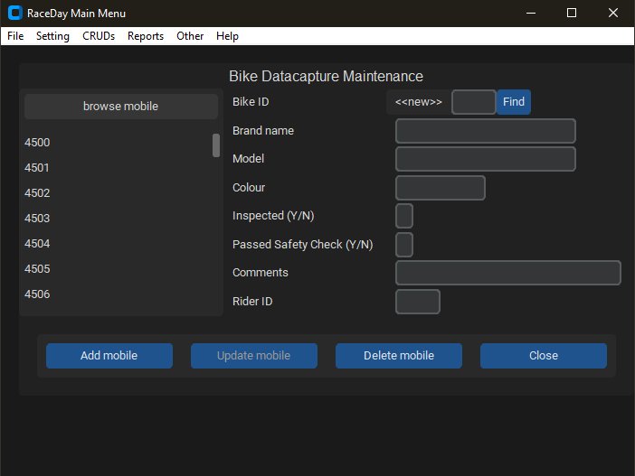

<mobile>
<form name="Rider" title="Rider Datacapture Maintenance"></form>
<table>customer</table>
<primarykey>customerid</primarykey>
<navigation display= "Surname" displaylink="customerid"></navigation>
<field fieldname="customerid" label="Rider ID" control_width="50" validation="N,M,,,0,," control="T"></field>
<field fieldname="Surname" label="Last Name" control_width="200" validation="X,M,,,,," control="T"></field>
<field fieldname="given" label="First Name" control_width="200" validation="X,M,,,,," control="T"></field>
<field fieldname="PhoneHome" label="Contact" control_width="150" validation="X,O,,,,," control="T"></field>
<field fieldname="Seasonpoints" label="Season Points Total" control_width="80" validation="N,O,,,0,9999," control="T"></field>
<field fieldname="Waiver" label="Waiver Signed (Y/N)" control_width="20" validation="N,O,,,0,9999," control="T"></field>
<field fieldname="Member" label="Member (Y/N)" control_width="20" validation="N,O,,,0,9999," control="T"></field>
</form>
</mobile>

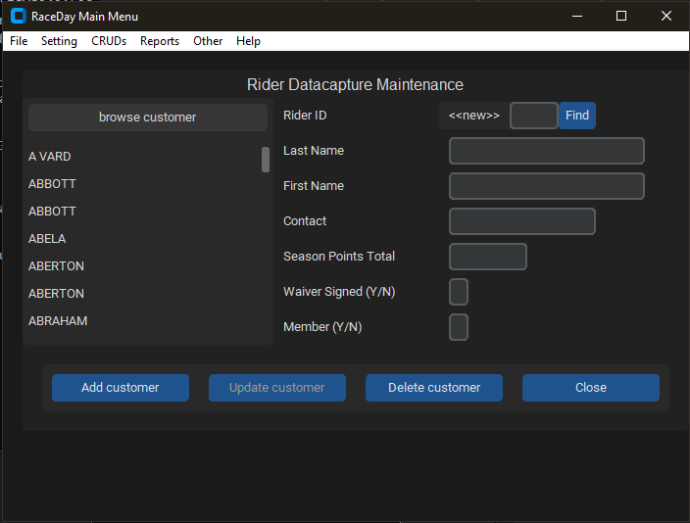

<mobile>
<main title="RaceDay Main Menu" width="700" height="500">
<connection database_type="access" filename="s3822965.accdb"></connection>
<authenticate login="True" tablename="staff" username="staffid" password="surname"></authenticate>
<item action="CRUD" label="Rider Maintenance" command="s3822965_rider.xml"></item>
<item action="CRUD" label="Bike Maintenance" command="s3822965_bike.xml"></item>

<item action="REPORT" label="Riders with Warnings" command="
SELECT Firstname + ' ' + Lastname AS Rider_Name,
rr.Race_id AS Race_Number,
ra.Date AS Race_Date,
rr.Place AS Place,
rr.Points_awarded AS Points_Given
FROM Riders r
LEFT JOIN RaceRider rr ON r.Rider_id = rr.Rider_id
LEFT JOIN Race ra ON rr.Race_id = ra.Race_id
WHERE rr.RaceRider_id IN (SELECT i.RaceRider_id
FROM Incident i
WHERE i.Further_action = 'warning')
;" space="28,3,3,40" justify="L,C,C,L"></item>

<item action="REPORT" label="Venue List (Price Descending)" command="
SELECT *
FROM Venue
ORDER BY Price_Per_Day DESC
;" space="15,10,7,10,10" justify="L,C,C,C,C"></item>

<item action="REPORT" label="Count of Participating Members / Non-Members" command="
SELECT MEMBER,
COUNT(*) AS COUNT
FROM Riders
GROUP BY MEMBER
;" space="11,9,6,12" justify="L,C,C,C"></item>

<item action="REPORT" label="Average Race Times for Lap/Rally Races" command="
SELECT Race_Type,
AVG(TIMEDIFF(Time_finish, Time_start)) / 60 + 'mins' AS Avg_Race_Time_Mins
FROM Race
GROUP BY Race_Type
;" space="11,9,6,12" justify="L,C,C,C"></item>

<help>mobile_help.xml</help>
</main>
</mobile>

