Table of contents

Installation and startup – page 2

Features – page 3

Main menu – page 3

Caculator – page 4

Math Game – page 5

Installation

You will need the Spyder IDE version 5.4.3 to run python 3.11.

To install download the zip file then unzip it to a folder. Then open Spyder and select dataManMain.py

You should be in a screen that looks like this

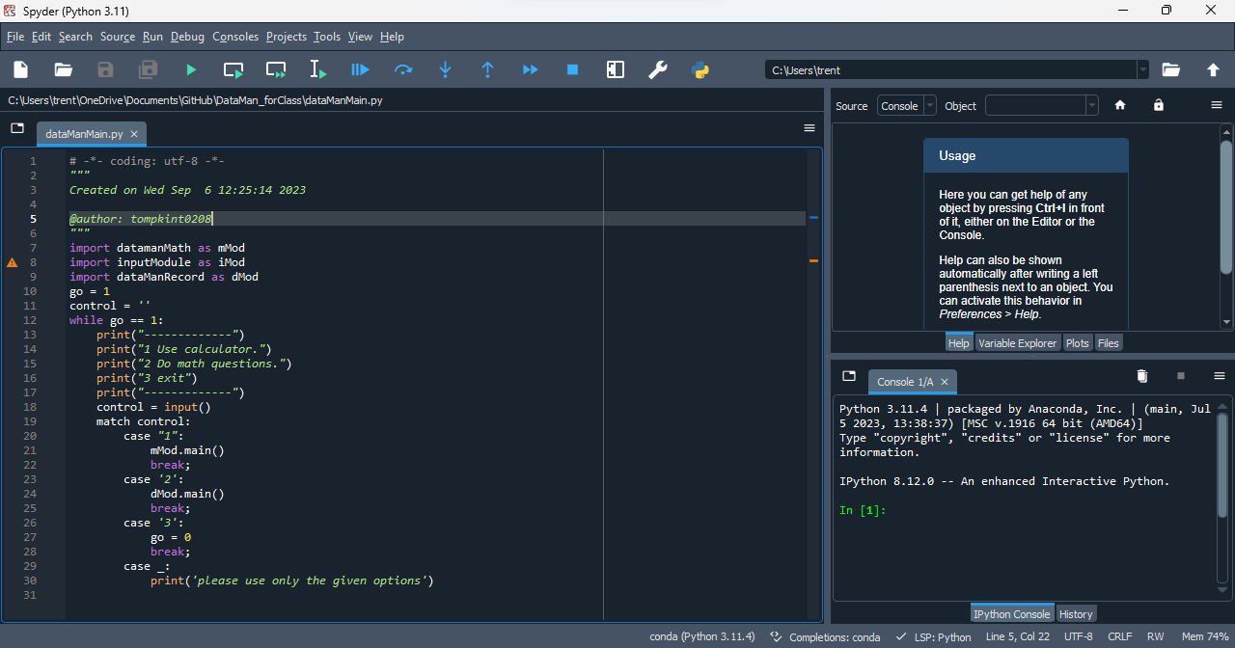

Then select run (the green play button) to run the file

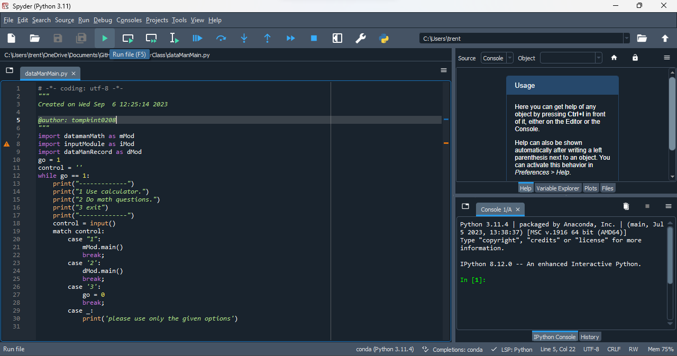

Then click in the consol on the bottom right.

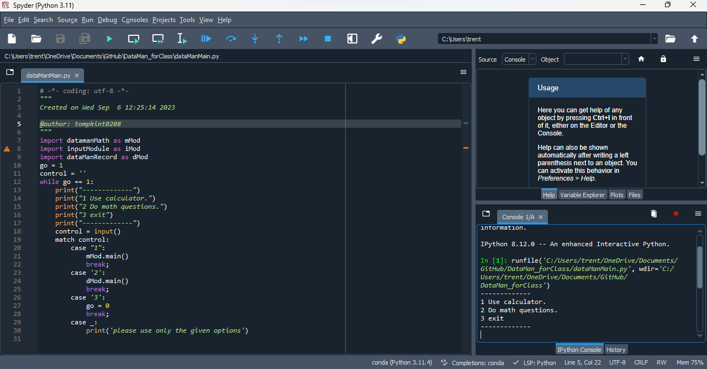

Features

Main Menu

The main menu has three options. Run calculator, run math game and exit. Entering “1” to select the calculator will bring you to the calculator program in which you can use the calculator. Entering “2” will bring up the math game program to answer a question. Entering “3” will exit the program and end the runtime.

Image of the main menu

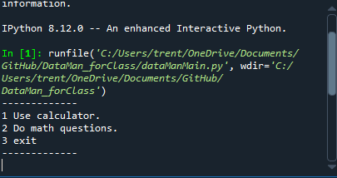

Calculator

The calculator allows the user to enter problems of their choosing with some stipulations. You must enter the equation in the correct format or risk breaking the program. Example “3+3-2" is acceptable while “3+3\*\*3(2)” is not due to the calculator not being able to do math with parathesis and there being a symbol immediately after a symbol.

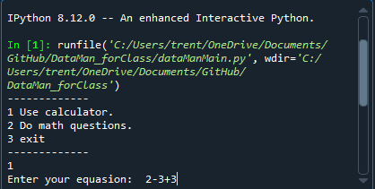

After entering your equation, the program will output the answer and then ask if you would like to enter another question.

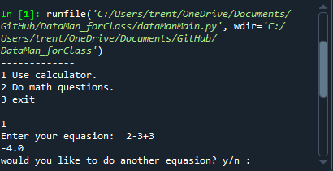

Entering “y” will allow you to reuse the calculator program. Entering “n” will bring you back to the main menu.

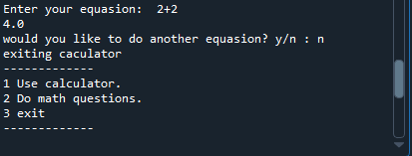

Math Game

After entering the math game program. The user will be prompted to enter the questions difficulty. Entering “1” will make the program only use integer numbers from 10-0 and only randomly use the symbols + and -. This difficulty is intended for young children.

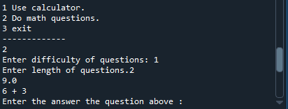

entering any number above “1" will make the possible numbers lager scaling 1 to the power of the number you enter. They will also include randomly the math symbols \* and / along with + and -.

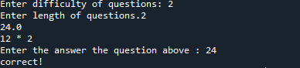

After entering the difficulty, the user will be prompted for question length. Question length corresponds to how many numbers total will be in the question. DO NOT ENTER “1" AS THAT WILL BREAK THE PROGRAM. Enter any whole number that is greater than 1.

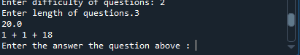

The user will then be asked the answer to the question and will be told if they got it wrong and be allowed to attempt to answer it until they get it right.

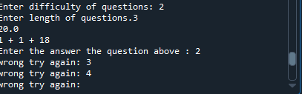

When the user gets the question right, they will be told “Correct!” and asked if they would like to play the math game again. Entering “y” will allow you to replay the Math game program. Entering “n” will bring you back to the main menu.

