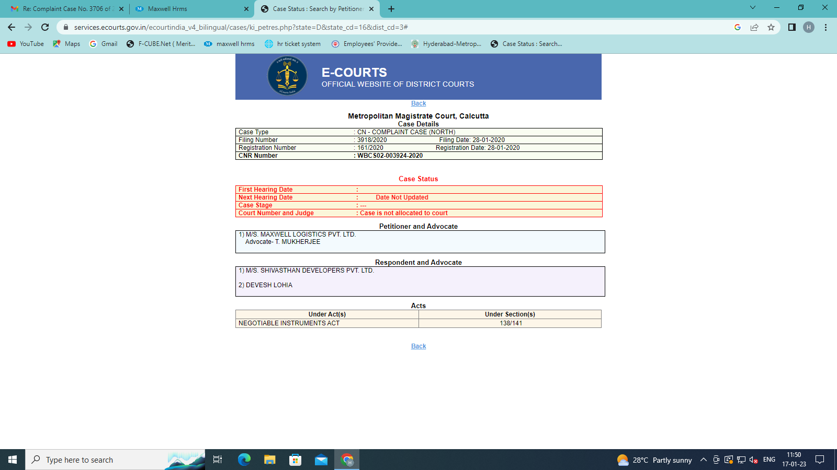

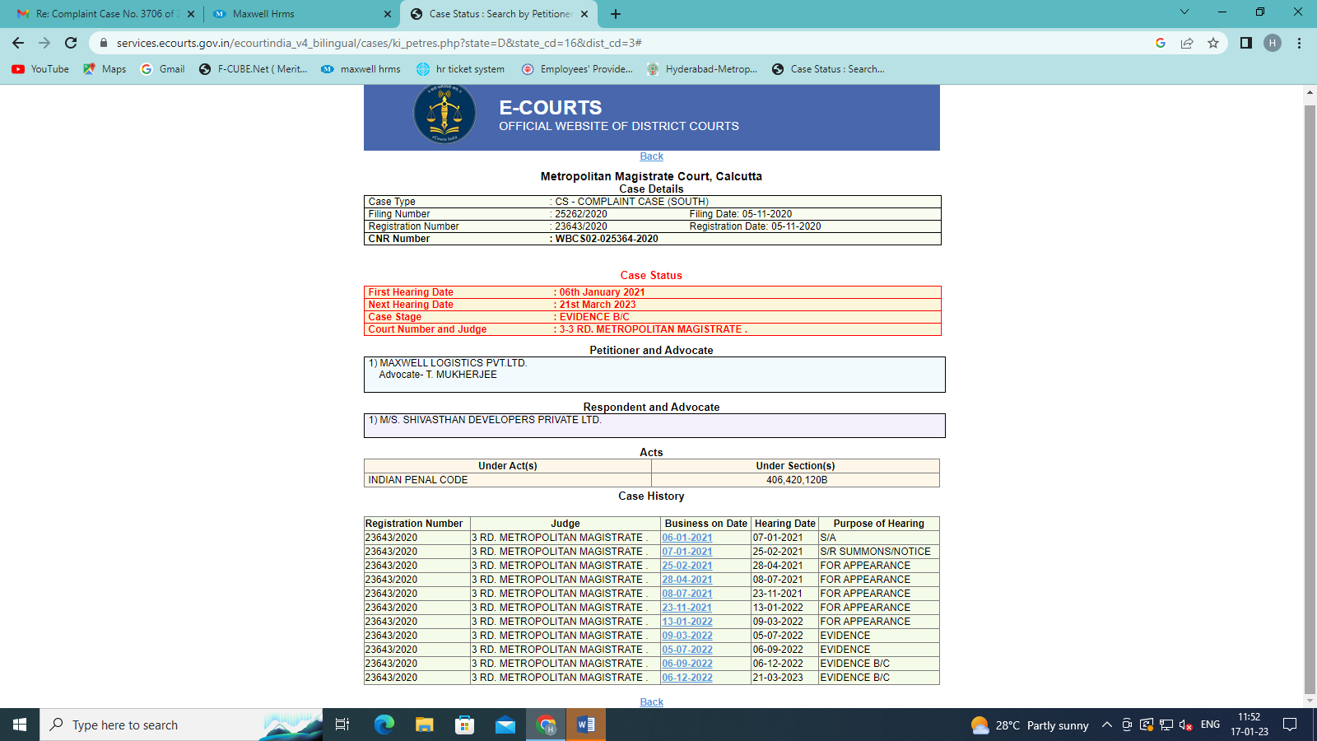

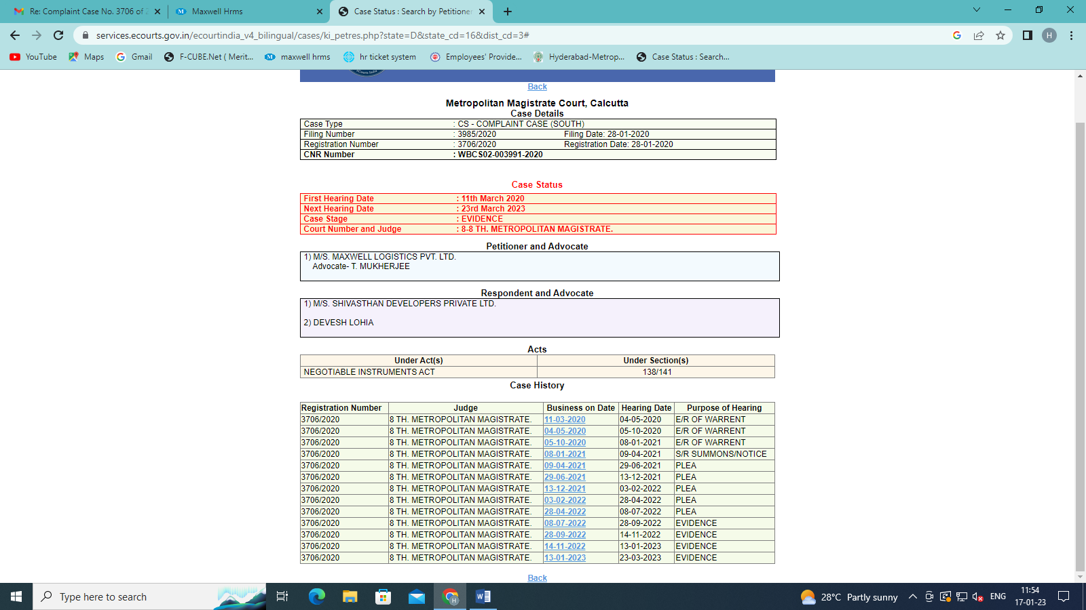

M/S Maxwell Logistics Private Limited
V/S
Mr.Chiranjeevi C/O Coimbatore
CC NO. /20
At

M/S Maxwell Logistics Private Limited
V/S
Mr.Chiranjeevi C/O Coimbatore
CC NO. /20
At

