CURRICULAM VITAE
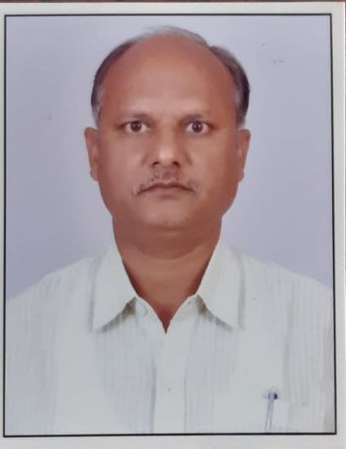
Shiv Kumar Singh
Traffic Manager

Contact no.: 9019075575

E-mail: shiv.singh3515@gmail.com

- OBJECTIVE: To prove my self as an assets for the company and secure challenging position where i can put forward my skill & knowledge in the growth and development of the company.

EDUCTION :
INTERMEDIATE | 1992
U P BOARD  METRICULATION | 1990
U P BOARD

- SKILL: O Telecom Communication

  - Internet surfing

  - Customer Handling

- INTERESTS: > LEADERSHIP
- SPORTS
- READING BOOKS
- LITERATURE

- STRENGHT:
Dedication towards work, communication skills, flexibility to handle changes, goal oriented approach, fast learner, team Player and positive thinking.

- EXPRIENCE: ABC India Ltd. 1994-2017
23 year experience in the company Overview : Team Supervisor, Officer in the company
Key job functions: customer handling
Operations work
Accounts

Premier Roadlines Ltd. 2017-2023
More than 5 years
Overview: Traffic Manager
Key job functions: Customer Handling
Operations, Lorry Placement

Currently working at Vinayaka Transport, Bangalore since Feb’23

- PERSONAL
DETAIL: | FATHER NAME : | Shri Matroo Singh
 | DATE OF BIRTH : NATIONALITY : MARITAL STATUS :  LANGUAGE : | 3rd Sept 1974 Indian  Married  Hindi & English

REFRENCE :

DATE:

