Automatic Misting Irrigation System


Abstract
This paper presents the design, implementation, and evaluation of a highly optimized, single-pump automatic misting and irrigation system based on the Arduino Uno microcontroller and Internet of Things (IoT) principles via Bluetooth communication. To address inefficient water usage, our proposed system employs a multi-tiered safety architecture utilizing soil moisture, rain, and DHT11 temperature sensors to perform contextaware decision-making. The system uniquely leverages a single 12V submersible pump for dual purposes: continuous root irrigation and advanced pulsed-cooling misting during heatwaves. Furthermore, the integration of a Software Real-Time Clock (RTC) synchronized via a mobile application eliminates the need for expensive physical timing modules. The inclusion of a robust Dry-Run Protection algorithm and a seamless Manual Override mode significantly enhances operational safety and maintenance flexibility. Experimental results demonstrate that the system efficiently manages environmental parameters with minimal latency, successfully preventing overwatering, motor burnout, and fungal risks.

INTRODUCTION
Agriculture and domestic plant care have experienced major shifts due to the integration of modern technologies. In precision horticulture, traditional irrigation methods like high-pressure manual hoses present significant drawbacks. Delivering large, heavy water droplets often leads to soil erosion, delicate leaf damage, and more critically, waterlogging at the bottom of the pots. This excessive water accumulation leads to root suffocation, creating a breeding ground for fatal fungal diseases and root rot, particularly in sensitive plants.
To address these limitations, misting (creating micro-droplets) is highly preferred, but simple manual misting nozzles lack flexibility. Therefore, there is an urgent need for an automated, context-aware misting irrigation system that does not just spray water, but intelligently customizes the water volume and environmental simulation based on user-defined plant profiles. This automation is exceptionally vital for high-water-demand crops or leafy greens that require constant humidity to thrive, a task that is highly laborintensive to maintain manually.
This paper proposes an intelligent automatic misting irrigation system built upon the Arduino Uno microcontroller platform. The system integrates a soil moisture sensor, a rain sensor, and a DHT11 temperature and humidity sensor to evaluate environmental states in real time. Utilizing a short-range Bluetooth communication link (HC-05/HC06), users can seamlessly monitor and override commands via a mobile application. The core innovation lies in its perfect nature simulation logic: during rainy periods, the system automatically stands down to let natural rainfall nourish the high-water crops, thereby saving resources. Conversely, during hot or dry periods, the system automatically triggers its multi-layered automation to supply precise micro-droplets, perfectly simulating a natural rainy season environment to safeguard the plants. The primary objectives include establishing the node architecture, ensuring latency-free Bluetooth data transmission, and executing six automated operational use cases alongside a robust dry-run protection mechanism.

Methods and Materials

Components and Peripheral Devices
The developed automatic misting irrigation system incorporates various electronic devices and components to perform its intended functions. The system uses an Arduino Uno R3 board as the central processing unit (brain of the system). For environmental monitoring, it utilizes a soil moisture sensor, a rain sensor, and a DHT11 temperature sensor. A Bluetooth module (HC-05/06) is used for short-range wireless communication with a mobile application. On the output side, a 5V relay module is deployed to control a 12V DC mini submersible water pump, utilizing an isolated power supply to prevent voltage drops. Additionally, a buzzer is integrated into the system to provide acoustic alarms and operational feedback.

System Model
A block diagram is designed to provide an easy visualization of the entire system. From the diagram, a discrete idea of all the incorporated modules and their responsibilities can be achieved on a macro level. On the input side of the Arduino Uno, there are three main components: the soil moisture sensor, the rain sensor, and the DHT11 sensor. On the output side, the relay controls the high-current water pump, and the buzzer serves as an alarm mechanism. The Bluetooth module acts as a bi-directional interface, sending sensor data to the mobile app and receiving manual operation commands from the user.
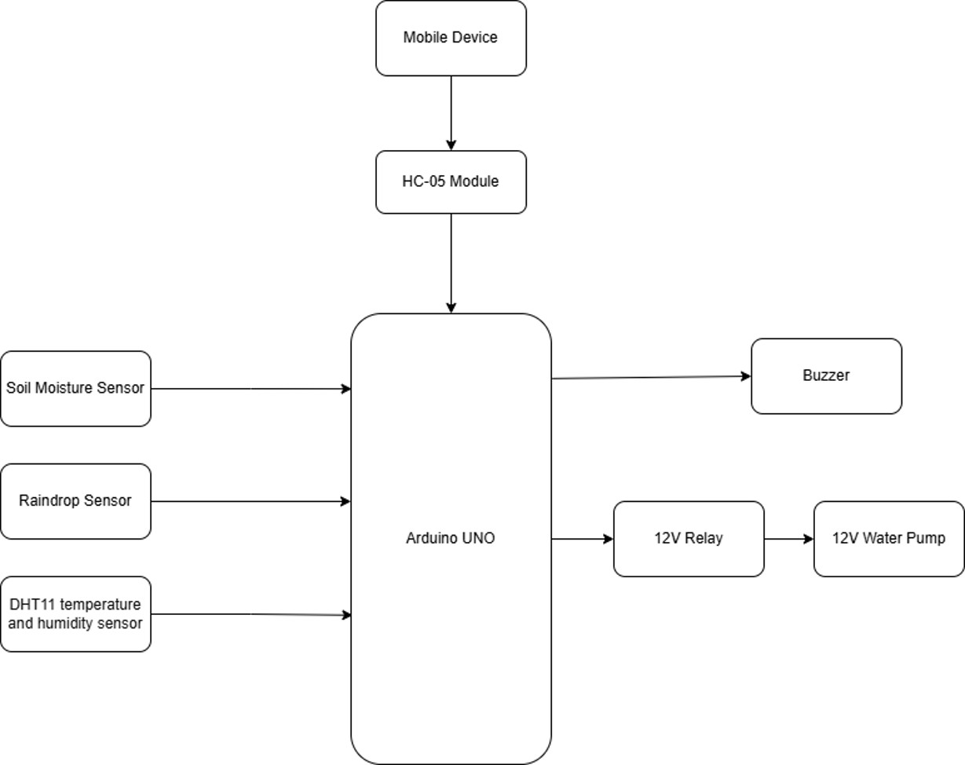
Figure 1: Block diagram of the automatic misting system

Electronic Circuit/Hardware Interfacing
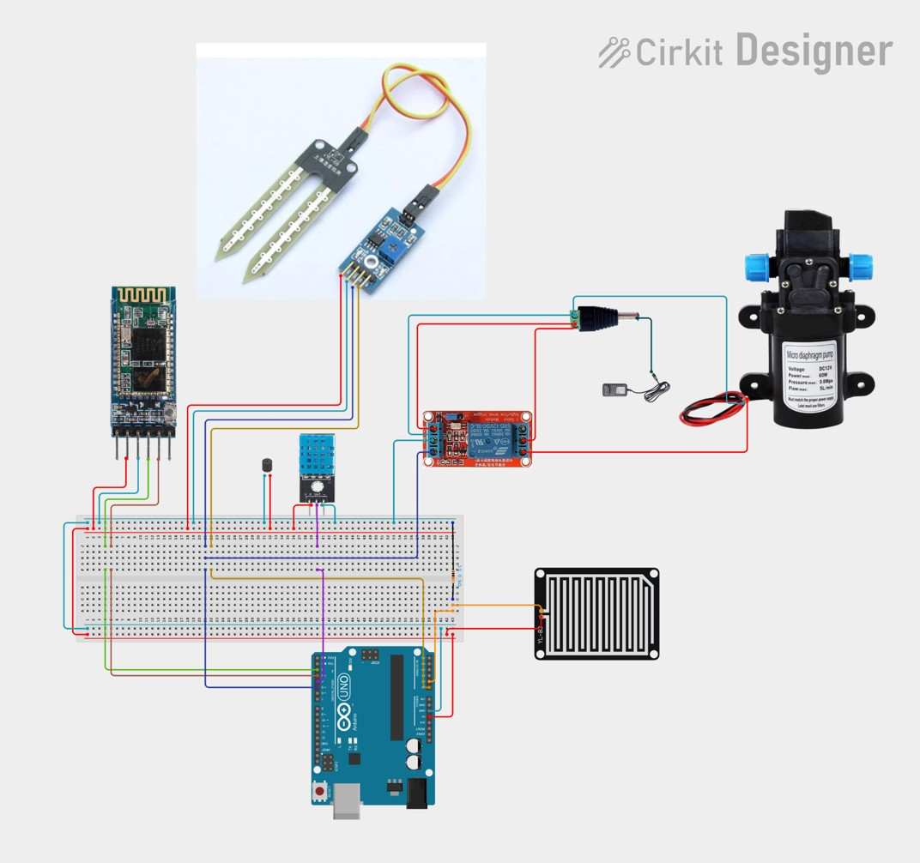
Figure 2: Circuit Schematic
The Arduino Uno R3 is used to make core decisions, such as toggling the water pump and processing safety overrides based on sensor data. In the hardware interfacing of the developed system, the analog outputs of the soil moisture sensor and rain sensor are connected to the Arduino’s analog pins A0 and A1, respectively (their digital output pins are intentionally left unconnected to prevent short circuits and logic conflicts). The DHT11 temperature sensor is connected to digital pin D4. To avoid data conflicts and upload errors via the standard USB port, the HC-05 Bluetooth module is configured using the SoftwareSerial library, interfaced to virtual RX and TX pins at D2 and D3. The actuating mechanism, comprising the 12V water pump, is controlled by a relay module connected exclusively to pin D5. The relay strictly isolates the 5V logic circuit from the 12V power circuit to eliminate electromagnetic interference. Furthermore, the signal pin of the buzzer is connected to digital pin D6 to emit audible alerts when safety parameters are breached or commands are received.

Software Programming and Mobile App Integration

Programming Flowchart
The Arduino Uno is a microcontroller-based device powered by the ATmega328P chip. Its functionality depends on the programming logic written in the Arduino IDE. The operational logic for the presented system is designed to execute dual pumping behaviors using a single relay on pin D5. According to the system’s flowchart, the Arduino continuously evaluates environmental parameters. If a soil watering sequence is required, the microcontroller outputs a continuous HIGH signal to the relay, keeping the pump running until the soil reaches an optimal moisture threshold. Conversely, if the DHT11 sensor detects high temperatures (≥ 35°C), the system initiates a cooling misting cycle by pulsing the relay ON for 5 seconds and OFF for 60 seconds to prevent over-saturation. In all operating modes, the rain sensor acts as the highest-priority safety override; if precipitation is detected, the microcontroller immediately forces pin D5 to LOW, halting the pump and sounding the buzzer to indicate a system suspension.
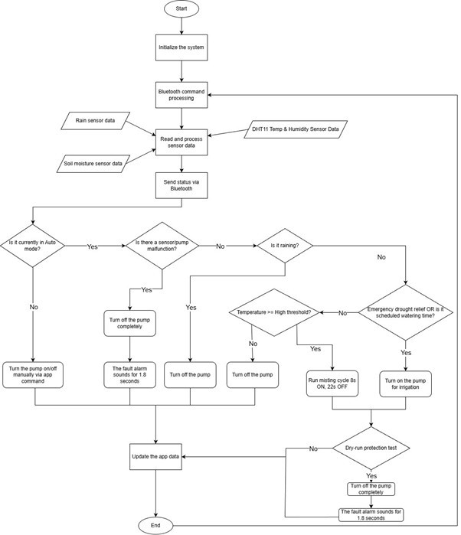
Figure 3: System Programming Flowchart

Sensors and Parameter Setup
- Sensors & Hardware Pinout Configuration All peripheral devices are assigned to the microcontroller pins as follows:
  - Soil Moisture Sensor (A0): Reads the analog voltage from the soil, averages 10 consecutive readings (at 5ms intervals) for noise reduction, and maps the result to a 0 - 100% range.

Rain Sensor (A1): Detects rainfall (Analog value > 500) to override and halt all pump operations while in Auto mode.
  - DHT11 Temperature & Humidity Sensor (Digital Pin 4): Measures the ambient temperature. This data acts as the trigger condition for the air cooling mode.
  - Relay Module (Digital Pin 5): Controls the ON/OFF state of the system’s single water pump. The activation state is HIGH (ON) and deactivation is LOW (OFF).
  - Buzzer (Digital Pin 6): Emits a beep during startup, upon switching between Auto/Manual modes, or plays 3 continuous beeps to alert a dry-run error.
  - Bluetooth Module HC-05/HC-06 (RX=2, TX=3): Handles two-way communication with the mobile application at a baud rate of 9600 bps.
- Operational Parameter Setup These are the default threshold parameters (which can be dynamically configured via the App) that dictate the pump’s behavior in Auto Mode:
- Emergency Moisture Threshold (Lower Moisture = 10%): If soil moisture drops to this level (and is > 0%), the needEmergencyWatering flag is set to trigger emergency watering regardless of the schedule.
- Target Moisture Threshold (Upper Moisture = 80%): When soil moisture reaches this level, the pump automatically shuts off (applies to both emergency and scheduled watering).
- Cooling Temperature Threshold (Temp Threshold = 35°C): When the temperature is ≥ 35°C, with no sensor errors, and the system is not currently busy watering the soil, the misting cooling scenario is activated.
- Rain Detection Threshold (Rain Threshold = 500): When the A1 pin value is > 500, the isRaining flag becomes true, prompting the system to shut off the pump and suspend all running schedules.
3. Timing & Safety Setup This section highlights the major logic updates designed to optimize hardware protection and operational efficiency:
- Cooling Cycle: The updated misting scenario utilizes a 30-second loop (30,000 ms). The pump activates for exactly 8 seconds (8,000 ms) and pauses for 22 seconds. The system repeats this pulse cycle until the ambient temperature drops below the 35°C threshold.
- Dry-run Protection / Pump Burnout Prevention (Dry-run Timer): Evaluated every 10 seconds (10,000 ms) while the pump is active. If the soil moisture does not increase by at least 3%, the system locks the relay and triggers the buzzer alarm. New Feature: This protection is now strictly enforced in Auto mode. In Manual mode, this timer is disabled.
- Scheduled Watering Timeout: Capped at 5 minutes (300,000 ms). If the pump runs continuously for 5 minutes without reaching the 80% moisture target, it automatically shuts off to prevent potential flooding.
Telemetry Interval: Every 2 seconds (2,000 ms), the microcontroller aggregates all current data (Time, Moisture, Temperature, Rain status, Error states) and transmits a complete telemetry packet via Bluetooth to the App.
4. System Error Codes & Exception Handling The system now features smarter error handling, clearly distinguishing between Auto and Manual modes:
- ERR:SOIL: Triggered when soil moisture is < 2% or ≥ 100% (indicating a disconnected or shorted sensor wire). New Feature: This error is only flagged and halts the circuit in Auto mode. If the user switches to Manual mode, this error is bypassed, allowing full manual control.
- ERR:SENSOR: Triggered when the DHT11 sensor is disconnected or damaged (the read function returns NaN). This safely disables the cooling feature.
- ERR:WATER: The dry-run protection detects that the pump is running but the soil remains dry (empty water tank or disconnected pipe). It instantly locks the circuit in Auto mode.
- SYS:OK: Indicates the system is functioning perfectly with no errors.
- Automated Error Clearing: When the user toggles between Auto and Manual modes, the microcontroller automatically clears previous error flags (isPumpError = false, isSoilError = false) to restart the evaluation cycle smoothly.

Results and Discussion

Prototype Implementation and Telemetry Testing
The developed smart misting and irrigation system was practically implemented based on the proposed circuit design. Once powered, the HC-05 module successfully paired with the mobile application. The real-time telemetry successfully captured and displayed environmental fluctuations. When the soil moisture sensor was submerged in water or placed in dry soil, the App’s dashboard instantly reflected the percentage changes (0100%) with a maximum latency of 2 seconds, proving the reliability of the analogRead mapping algorithm.

Operational Scenarios Evaluation
To validate the efficiency and the hierarchical decision-making algorithm of the microcontroller, the prototype was subjected to rigorous testing under five distinct simulated environmental scenarios. The response times and actions were recorded as follows:
- Test Case 1: Smart Scheduled & Emergency Watering: The soil moisture threshold was configured dynamically via the App (Lower Limit: 30%, Upper Limit: 80%). When the soil moisture dropped to 25% (Emergency state), the system immediately activated the relay (RELAY_PIN 5). The pump ran continuously until the soil sensor registered exactly 80%, at which point the pump was instantly deactivated. The same flawless execution was observed when the Software RTC matched the predefined "Scheduled Time" string while the soil was dry.
Test Case 2: Software RTC Synchronization and Scheduled Watering Setup: To eliminate the cost and complexity of a physical Real-Time Clock (RTC DS1307) module, the system was tested using a Software RTC synchronized via the mobile App. Time Synchronization: Upon connecting to the Bluetooth module, the App automatically transmitted the exact current time of the smartphone (e.g., ’C06:30:00’). The Arduino successfully parsed this string, updated its internal variables (currentHour, currentMinute, currentSecond), and maintained accurate timekeeping using the millis() function without any noticeable drift during the testing period. Schedule Execution: A specific watering schedule string (e.g., ’T06:35’) was sent from the App to the microcontroller. Exactly at 06:35, the system checked the soil moisture. Since the soil was below the 80% upper limit, the pump was triggered automatically. The pump ran until the soil reached the target moisture and then shut off, confirming that the dynamic scheduling and virtual timekeeping algorithms function flawlessly.
- Test Case 3: Pulsed-Cooling Mechanism (Heatwave Simulation): To test the dual-purpose single-pump architecture, the soil moisture was kept stable at 60% (no watering needed), but the temperature threshold was artificially lowered on the App to 25°C to simulate a heatwave (since the ambient room temperature was 28°C). The system successfully bypassed continuous pumping and initiated the advanced cooling sequence: The relay engaged for exactly 8 seconds to generate a cooling mist, followed by a strict 22-second forced shutdown. This 30-second loop repeated seamlessly, confirming the system can reduce ambient heat without causing soil waterlogging.
- Test Case 4: Ultimate Rain Override (Pre-check and Active Interruption): The rain sensor grid was shorted with a water droplet to simulate unexpected rainfall. Scenario A (Pre-check): While the system was idle, the scheduled watering time arrived. However, due to the simulated rain, the pump remained completely locked. Scenario B (Active Interruption): While the pump was actively irrigating the dry soil, the rain sensor was triggered. The microcontroller executed an immediate interruption (within <100ms), halting the pump and transmitting a "Raining" status to the dashboard. This proved the rain override holds the highest priority in the logic hierarchy.
- Test Case 5: Hardware Fault Protection (Dry-run Timeout): In Auto Mode, a critical failure was simulated by removing the water intake tube from the reservoir while the pump was triggered to irrigate. The microcontroller engaged its internal timer. After exactly 10 seconds of pump operation with the soil moisture increasing by less than 3% (remaining stagnant), the algorithm successfully deduced a "dry-run" condition. It forcefully shut down the relay, activated the buzzer alarm (3 continuous beeps), and locked the Auto Mode loop, sending an ERR:WATER code to the App to prevent motor burnout.
- Test Case 6: Sensor Disconnection Handling: The soil moisture sensor’s signal wire (A0) was purposely unplugged during Auto Mode. The analog reading plummeted to 0%. The system correctly bypassed the emergency watering protocol (which requires moisture > 0%) and instead flagged an ERR:SOIL malfunction, locking the pump to prevent flooding the area due to a false "dry soil" reading. Similarly, disconnecting the DHT11 sensor triggered an ERR:SENSOR

flag, safely disabling only the cooling protocol while keeping other systems intact. These comprehensive tests confirmed that the multi-tiered safety architecture operates robustly, ensuring plant health and hardware longevity under all anticipated agricultural anomalies.

Discussion on Manual Override Flexibility
A significant achievement of this prototype is the seamless integration of the Manual Mode. Testing confirmed that switching to Manual Mode (’M’ command) successfully bypassed the strict auto-safety protocols (including the 10-second dry-run timeout and sensor error locks). This allowed uninterrupted manual operation of the pump for maintenance purposes (e.g., nozzle cleaning or tank draining). Furthermore, switching back to Auto Mode successfully cleared all temporary error flags (isPumpError, isSoilError), resetting the system for normal autonomous operation without requiring a hardware reboot. Overall, utilizing a single pump for dual purposes (continuous irrigation and pulsed-misting) drastically reduced hardware complexity and power consumption, proving the system to be a highly cost-effective and reliable solution for small-scale smart agriculture.

CONCLUSION
In this paper, a smart, context-aware automated misting irrigation system based on the Arduino Uno and Bluetooth communication has been successfully designed, prototyped, and evaluated. Moving away from traditional mechanical watering, this system offers a highly optimized, resource-efficient micro-droplet environment that prevents leaf damage, soil erosion, and root rot caused by traditional over-watering. The system’s software and hardware components operate synchronously to deliver six core operational use cases, specialized for high-water-demand plant profiles through an advanced nature simulation workflow.
Practical testing demonstrated that the system intelligently adapts to varying weather conditions. When natural rainfall occurs, it halts operation to let nature do the work, preventing resource waste; during dry, sunny conditions, it autonomously deploys precision misting to replicate a humid, rainy season ecosystem. Engineering bottlenecks such as serial data collision and critical voltage drops during pump activation were successfully resolved using the SoftwareSerial library and hardware isolation techniques involving a dedicated relay module and decoupling capacitors. Additionally, the embedded Dry-Run Protection algorithm successfully safeguards the system by forcing an emergency shutdown and sending real-time error flags to the mobile application upon detecting water scarcity.
For future work, the system’s short-range Bluetooth link can be upgraded to global IoT networks by integrating Wi-Fi or Cellular modules (such as NodeMCU or ESP32) to support long-range cloud data logging and remote control. Incorporating advanced predictive machine learning models based on historical weather patterns will further optimize water efficiency and maximize crop yields for a wider range of agricultural applications.

References
- A. A. R. Madushanki et al., "Adoption of the Internet of Things (IoT) in agriculture," Int. J. Adv. Comput. Sci. Appl., 2019.
- A. Glória et al., "Water management for sustainable irrigation systems using Internetof-Things," Sensors, 2020.

Member Contributions
Table 1: Task Assignments and Contribution Levels
No | Name | Contribution
1 | Huỳnh Việt Thắng | 95%
2 | Dương Bảo Khang | 90%
3 | Nguyễn Thanh Quốc Linh | 90%
4 | Mai Đình Quân | 100%

