

Project IOT102

IoT-Based Single-Axis Solar Tracker with Battery Monitoring and Cloud Dashboard

No | Name | Email
SE203727 | Hoàng Tiến Mạnh | manhvipbao@gmail.com
SE203865 | Võ Đặng Anh Khoa | anhkhoacod123@gmail.com
SE203784 | Đặng Thị Phương Anh | anh17806@gmail.com
SE184179 | Nguyễn Thành Luân | thanhluannguyen141@gmail.com

Abstract
This paper presents the design, implementation and evaluation of a low-cost, single-axis solar tracking system based on the ESP32-S3 microcontroller and an Internet of Things (IoT) dashboard built on Firebase Realtime Database. A quad array of LDR (light dependent resistor) modules mounted at the four quadrants of the panel measures the irradiance gradient, and a hobby servo continuously aligns the panel with the brighter side using a hysteresis deadband that eliminates oscillation around the equilibrium point. Unlike open-loop astronomical trackers, the proposed controller is fully sensor-driven and therefore requires no GPS, real-time clock or site calibration. The power subsystem comprises a 5 W polycrystalline panel, a TP4056 charging module, a single 18650 Li-ion cell and an LM2596 buck converter that supplies a dedicated 5 V rail for the servo, keeping stall currents away from the microcontroller regulator. The firmware implements a complete safety state machine: a safe-stop mode with cloud alert on sensor failure or low battery, automatic eastward parking followed by light-sleep standby at night, an offline fallback when Wi-Fi or Firebase is unreachable, and a manual override that accepts a target angle from the dashboard. Telemetry is published every second to the cloud, where the panel angle, four irradiance channels, battery voltage, state of charge and operating mode are visualized in real time. Experimental results on a prototype show stable tracking within the deadband, correct night parking, deterministic fault handling and end-to-end telemetry latency of approximately one second.
1 INTRODUCTION
The global shift toward renewable generation has made photovoltaic (PV) systems one of the most accessible sources of electricity for households and small farms. However, the energy harvested by a PV panel depends strongly on the angle of incidence of sunlight. A fixed panel is typically tilted at the latitude angle and therefore collects maximum energy only around solar noon, while the cosine loss increases rapidly during the morning and afternoon. Published studies report gains between roughly 20% and 40% when a panel follows the sun instead of remaining fixed, depending on latitude, season and tracking topology.
Dual-axis trackers maximize the harvested energy but require two actuators, a mechanical frame with two degrees of freedom, and a more complex control law, which is difficult to justify for small domestic installations. A single-axis east–west tracker offers most of the available gain with one actuator and a simple hinge, making it the preferred compromise for low-power prototypes. Classical single-axis trackers are often open-loop and compute the sun position from an astronomical model, which requires accurate geographic coordinates and a real-time clock. Sensor-based closed-loop tracking avoids both requirements: the controller simply drives the panel toward the direction of maximum measured irradiance.
The sensing element is the key design choice. Photodiodes and pyranometers are accurate but expensive, whereas LDR modules based on the LM393 comparator cost a fraction of a dollar, are widely available and provide both an analog output and a digital threshold output. When four LDRs are arranged in quadrants separated by a small shadow cross, the difference between the left and right averages is a monotonic function of the angular error, which is sufficient for a proportional step controller with hysteresis.
Remote supervision is the second requirement of a practical installation. A cloud dashboard replaces a local display, allows the operator to inspect irradiance, battery state and operating mode from any device, and provides a command channel for manual positioning during maintenance. The ESP32-S3 is well suited to this role because it integrates Wi-Fi, a dual-core Xtensa LX7 processor and a 12-bit ADC, keeping the bill of materials low.
This work therefore pursues five objectives: (i) implement quad-LDR sensing with a deadband-based tracking law; (ii) protect the mechanical structure by parking the panel at the east limit during the night and entering a low-power standby state; (iii) guarantee safe behaviour under sensor failure or battery depletion; (iv) expose real-time telemetry and a manual override through a Firebase dashboard; and (v) evaluate the complete prototype under representative operating scenarios.
2 Methods and Materials
2.1 Components and Peripheral Devices
The prototype is built around an ESP32-S3 DevKit N16R8 board, which provides 16 MB of flash memory, 8 MB of PSRAM, 240 MHz dual-core processing and an integrated Wi-Fi transceiver. Irradiance is measured by four LM393-based LDR modules, each containing a photoresistor in a voltage divider, a comparator with a multi-turn potentiometer for threshold adjustment, and an analog output (AO) together with a digital output (DO). A metal-gear hobby servo rated at approximately 20 kg·cm drives the panel hinge through a short linkage.
The power subsystem consists of a 5 W polycrystalline panel, a TP4056 constant current/constant voltage charging module with battery protection, a single 18650 Li-ion cell of 2500 mAh, and an LM2596 step-down converter adjusted to 5.0 V. The buck converter feeds the servo directly and the 5 V input of the development board, so that servo stall current never passes through the on-board regulator. A 1 µF ceramic capacitor is placed across the servo supply terminals to absorb commutation transients. Battery voltage is scaled by a 10 kΩ/10 kΩ divider before being applied to an ADC input. The cloud dashboard is a single-page web application that reads and writes the Firebase Realtime Database.
2.2 System Model
Figure 1 shows the block diagram of the system. The power path is drawn in the upper row: the solar panel charges the 18650 cell through the TP4056 module, and the cell voltage is regulated down to 5 V by the LM2596 converter. This rail feeds the servo and the ESP32-S3 board. The control path occupies the lower part of the diagram. Four LDR modules and the battery divider form the input layer and are connected exclusively to ADC1 channels, because ADC2 is unavailable while the Wi-Fi radio is active. The ESP32-S3 executes the tracking state machine and drives the servo with a 50 Hz pulse-width modulated signal. The same device acts as a bidirectional gateway to the Firebase Realtime Database: it publishes telemetry and subscribes to the operating mode and the manual target angle. The resulting architecture is a closed-loop control system with a cloud supervision layer operating in parallel rather than in the control path, so that loss of connectivity never interrupts tracking.
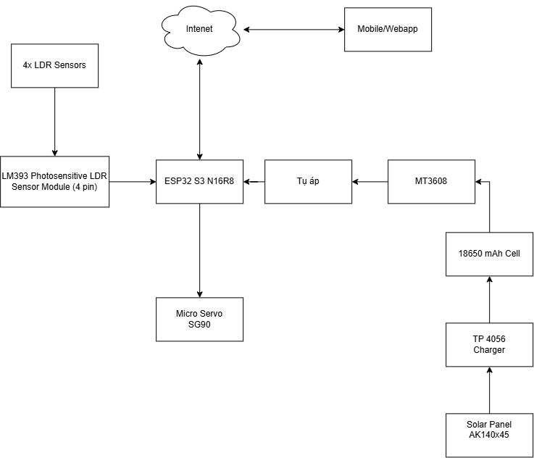
Figure 1: Block diagram of the solar tracking system
3 Electronic Circuit/Hardware Interfacing
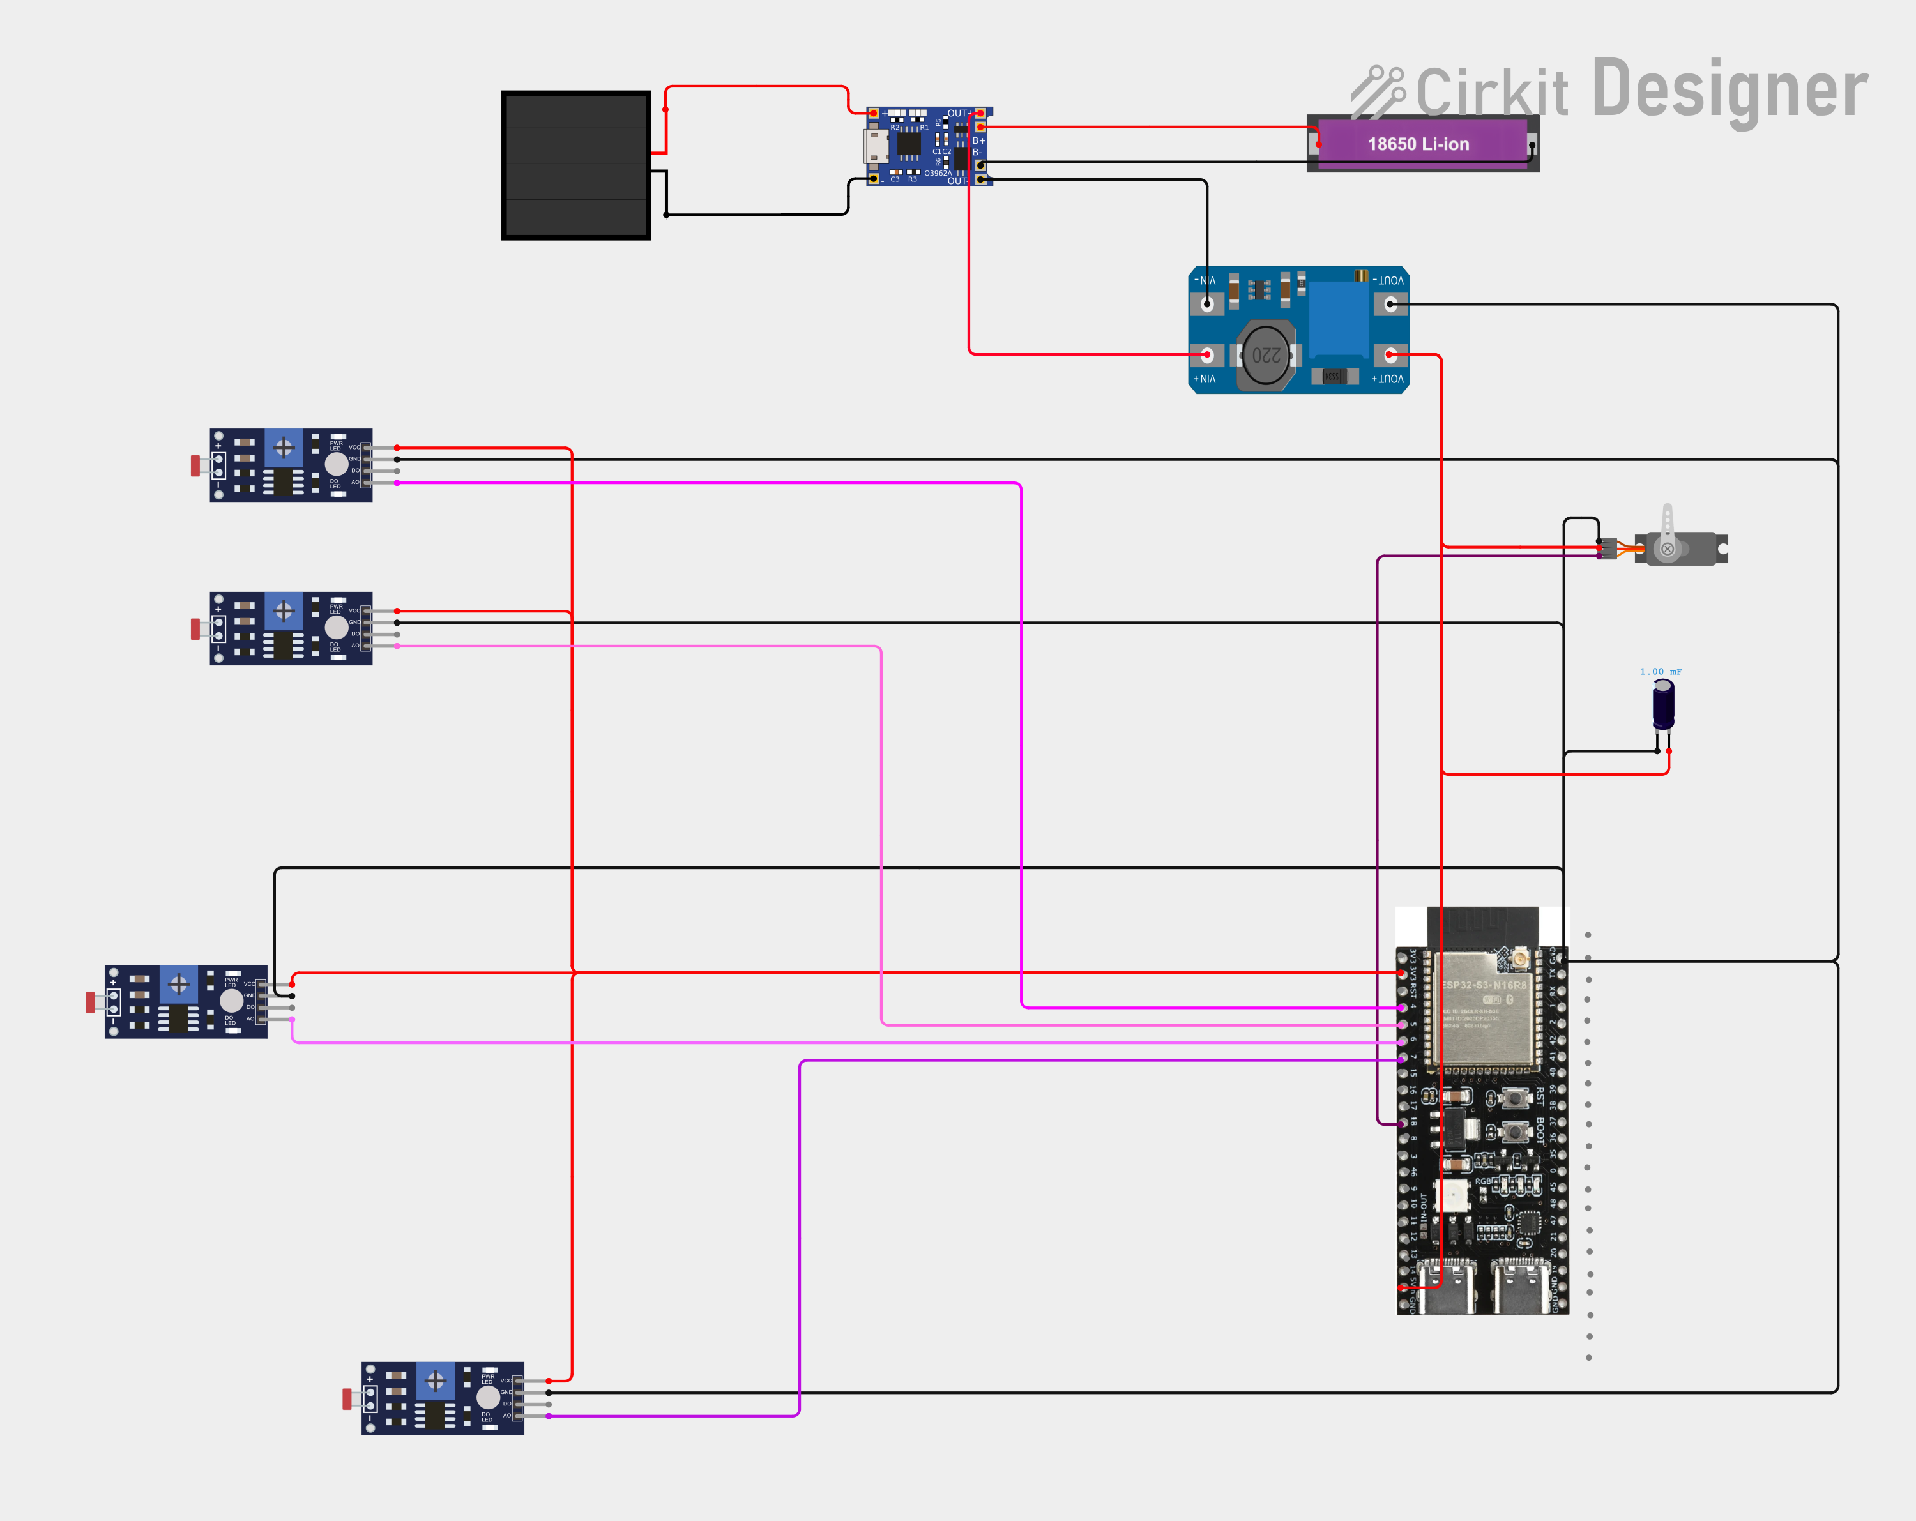
Figure 2: Circuit schematic of the prototype
The ESP32-S3 performs all control decisions: it reads the four irradiance channels, estimates the battery state of charge, computes the tracking step, and publishes telemetry. In the hardware interface, the analog outputs of the LDR modules are connected to GPIO4, GPIO5, GPIO6 and GPIO7, which correspond to ADC1 channels 3 to 6. All four inputs are configured with 11 dB attenuation, giving an effective input range of approximately 0 to 3.1 V, and each reading is the average of sixteen consecutive samples taken 200 µs apart to suppress switching noise from the servo and the buck converter.
The digital outputs of the LDR modules are wired to GPIO15, GPIO16 and GPIO17 and are used only as an auxiliary brightness indicator; the fourth digital output is left unconnected because GPIO18 is reserved for the servo signal. The servo pulse train is generated on GPIO18 with a 50 Hz frame and a pulse width between 500 µs and 2400 µs, mapping the mechanical limits of the hinge. The servo supply is taken from the LM2596 output rather than from the 5 V pin of the board: a hobby servo can draw well over one ampere during acceleration or stall, which would collapse the USB supply and reset the microcontroller. The 1 µF capacitor across the servo terminals attenuates the current spike at each direction change, and all grounds are joined at a single point to avoid ground loops.
Battery voltage is monitored through a 10 kΩ/10 kΩ divider connected between the protected battery output and GPIO8 (ADC1 channel 7). The divider halves the battery voltage, so the maximum cell voltage of 4.2 V becomes 2.1 V at the ADC pin, which lies comfortably inside the 3.1 V range and protects the input against over-voltage. The divider draws approximately 210 µA, a negligible load compared with the sleep current of the board and the servo consumption. The board itself is supplied from the same 5 V rail through its 5V input. Because the native USB port of the ESP32-S3 is a USB-Serial/JTAG interface, the Arduino IDE option USB CDC On Boot must be enabled; otherwise the Serial object is routed to UART0 and the serial monitor remains empty even though the firmware is running.
4 Software Programming and Mobile App Integration
4.1 Programming Flowchart
The firmware is organised as a single cooperative loop, illustrated in Figure 3. After initialisation of the serial console, the ADC channels, the servo and the network stack, the controller verifies whether Wi-Fi and the Firebase session are available. If they are not, the system activates the offline mode and continues with local control only, retrying the connection every fifteen seconds in the background. When the link is available, the dashboard command block reads the operating mode and the manual target angle from the Firebase configuration node.
Sensor processing follows: the four LDR channels are sampled and averaged, the battery voltage is measured and converted into a state of charge, and diagnostic counters detect stuck channels. A first telemetry frame is published at this point so that the dashboard always reflects the raw measurements. The controller then evaluates the mode. In manual mode the servo is driven directly to the angle requested by the operator and the automatic safety chain is bypassed, which is intended for maintenance. In automatic mode the fault condition is evaluated first: if a sensor has been stuck at the rail for two hundred consecutive samples, or if the battery voltage has fallen below 3.2 V, the servo is detached, the safe mode is latched and a fault flag is published to the dashboard.
If no fault is present, the night condition is tested against the night threshold of the total average irradiance. At night the panel is returned to the east limit and the controller enters a ten-second light-sleep interval before publishing the updated state, which reduces average consumption while keeping the display refreshed. During the day the irradiance difference between the left and right pairs is compared with the deadband. If the magnitude of the difference exceeds the deadband the servo advances one step of five degrees toward the brighter side; otherwise the panel holds its current angle and the motor remains idle. The battery monitor updates the charging state from the slow voltage trend, a second telemetry frame is published, and the loop repeats continuously.
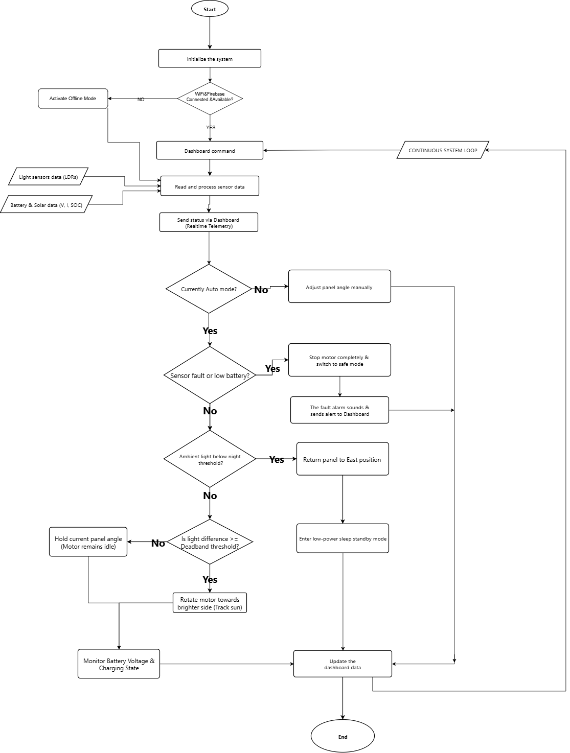
Figure 3: System programming flowchart

4.2 Sensors and Parameter Setup
1. Sensors & Hardware Pinout Configuration All peripheral devices are assigned to the microcontroller pins as follows:
• LDR modules (GPIO4, GPIO5, GPIO6, GPIO7): Analog outputs of the top-left, top-right, bottom-left and bottom-right sensors. Each reading averages sixteen samples at 200 µs intervals; the left average combines TL and BL, the right average combines TR and BR.
• LDR digital outputs (GPIO15, GPIO16, GPIO17): Comparator outputs used as an auxiliary day/night indicator. The bottom-right digital output is not connected because GPIO18 drives the servo.
• Battery voltage input (GPIO8): 10 kΩ/10 kΩ divider with a ratio of 2.0, converted back to battery voltage in software and then mapped linearly to a state of charge between 3.0 V and 4.2 V.
• Servo (GPIO18): 50 Hz PWM, pulse width 500–2400 µs, corresponding to 0° (east limit), 90° (centre) and 180° (west limit). Power is supplied from the LM2596 5 V rail with a 1 µF decoupling capacitor.
• Firebase Realtime Database: Telemetry is written to /solar_controller/telemetry and the command block is read from /solar_controller/config, which contains the mode field (AUTO or MANUAL) and the manual_angle field in degrees.
2. Operational Parameter Setup The following default thresholds govern the automatic behaviour:
• Night threshold (250 counts): A total average irradiance below approximately 6% of the full scale declares night. The value is deliberately low so that deep cloud cover during the day does not trigger parking.
• Deadband threshold (60 counts): The servo moves only when the left–right difference exceeds about 1.5% of the full scale. This hysteresis prevents the hunting oscillation that would otherwise occur when the panel is aligned with the sun.
• Tracking step (5°): Each control cycle advances the servo by one step toward the brighter side. The small step smooths the motion and limits the mechanical load on the hinge.
• Low battery threshold (3.2 V): Below this cell voltage the controller declares a battery fault and enters safe mode. The full-charge reference is 4.15 V and the state of charge is mapped linearly between 3.0 V and 4.2 V.
• Parking angle (0°): At night the panel is driven to the east limit, which both protects the mechanism from dew and wind loading and prepares the panel for the next sunrise.
3. Timing & Safety Setup The timing constants were selected to balance responsiveness and bus load:
• Telemetry interval: A minimum of one second between consecutive Firebase writes. Both the status frame and the update frame pass through the same throttle, so the database is never flooded.
• Configuration polling: The dashboard command node is read once per second. A change of mode or target angle is therefore applied with a worst-case latency of about one second.
• Network supervision: The Wi-Fi connection attempt times out after twelve seconds; a failed connection is retried every fifteen seconds. The Firebase token is refreshed continuously by the ready() call inside the main loop.
• Night standby: Ten seconds of light sleep per loop iteration at night. RAM and the Wi-Fi session are retained, so operation resumes transparently after wake-up.
• Fault detection: A channel is declared faulty after two hundred consecutive samples at the rail (0 or 4095 counts), which corresponds to roughly two seconds of continuous saturation and discriminates a real wiring fault from a brief shadow.
4. System Error Codes & Exception Handling The firmware distinguishes the following conditions and reports them in the telemetry frame:
• ERR:SENSOR: One or more LDR channels remain saturated at either rail. The controller latches the safe mode, detaches the servo and raises the fault flag.
• ERR:BATTERY: The measured cell voltage is below 3.2 V. The servo is stopped to prevent a brown-out reset during a large current draw.
• SAFE_STOP: The action reported while the safe mode is latched. The servo output is disabled, so the panel remains mechanically free and the gear train is not stressed.
• OFFLINE: Wi-Fi or Firebase is unreachable. Tracking continues locally, telemetry is suppressed and the offline flag is set in the next successful frame.
• Automatic clearing: Fault flags are re-evaluated every cycle and clear automatically when the measurements return to their valid range, so a transient shadow or a short voltage dip does not require a reboot.
5 Results and Discussion
5.1 Prototype Implementation and Telemetry Testing
The prototype was assembled on a bench according to the schematic of Figure 2. The servo was first exercised with a sweep sketch to verify the pulse range and the mechanical limits of the hinge; the full travel was achieved without binding and without resetting the board, which confirmed that the dedicated 5 V rail supplies the stall current correctly. The four LDR channels were then logged at 115200 baud with the panel exposed to uniform indoor illumination. The recorded analog values remained between 1910 and 1965 counts, approximately 47% of the 12-bit full scale, with a corresponding input voltage between 1655 mV and 1698 mV. The channel-to-channel spread was below 3%, which is adequate for differential tracking because only relative values are used by the control law.
Telemetry was verified end to end: each change of mode, angle or fault state appeared on the dashboard within approximately one second, matching the configured write interval. The battery monitor reported a state of charge consistent with the measured terminal voltage, and the charging state indicator followed the slow voltage trend produced by the TP4056 module. Loss of the access point was also tested: the firmware raised the offline flag, continued local tracking and reconnected automatically once the access point returned.
5.2 Operational Scenarios Evaluation
To validate the decision hierarchy, the prototype was subjected to six simulated operating scenarios. The observed behaviour is summarised below.
• Test Case 1: Automatic tracking. One side of the sensor cross was shaded progressively. When the left–right difference exceeded 60 counts, the servo advanced in steps of five degrees toward the brighter side and stopped as soon as the difference returned inside the deadband. The panel settled within one step of the equilibrium angle.
• Test Case 2: Deadband hold. With uniform illumination the difference remained below the deadband and the servo stayed idle for the whole observation period. No hunting oscillation was observed, confirming that the hysteresis removes the limit cycle typical of proportional-only trackers.
• Test Case 3: Night parking and standby. The sensor array was covered to emulate sunset. Once the total average fell below 250 counts, the panel was driven to the east limit and the controller entered light sleep for ten seconds per iteration. Telemetry continued to be published between sleep intervals and the parking action was reported to the dashboard.
• Test Case 4: Fault injection. An LDR channel was disconnected, which drove its reading to the upper rail. After two hundred consecutive saturated samples the controller detached the servo, latched the safe mode and published the fault flag. Reducing the battery voltage below 3.2 V produced the same safe stop with the corresponding battery flag.
• Test Case 5: Manual override. The mode field was set to MANUAL from the dashboard and a target angle was written to manual_angle. The servo moved to the requested position within one polling period and ignored the irradiance difference, allowing the operator to inspect or clean the panel. Returning the mode to AUTO resumed tracking immediately.
• Test Case 6: Offline resilience. The access point was switched off during tracking. The controller detected the loss, entered offline mode, kept executing the local tracking law and continued to hold the panel within the deadband. When the access point was restored, the connection was re-established within one retry interval and telemetry resumed without a reboot.
Across all scenarios the safety hierarchy behaved deterministically: faults always took precedence over tracking, night parking took precedence over the deadband decision, and manual mode bypassed the automatic chain exactly as specified in the flowchart. The measured telemetry latency remained close to the one-second write interval, which is adequate for supervisory purposes.
5.3 Discussion on Manual Override Flexibility
The manual mode proved to be a practical addition rather than a redundant feature. During maintenance the operator can park the panel, clean the glass or inspect the hinge without physically disconnecting the actuator, and the transition back to automatic operation requires only a change of the mode field. Because the override is implemented in the cloud layer and not by bypassing the control task, the local safety functions remain active in the sense that sensor diagnostics continue to run and are reported, while the actuator command is taken from the operator.
The prototype also revealed several limitations. Only a voltage measurement is available for the battery, so the charging state is inferred from the slow voltage trend instead of a current sensor; adding an INA219 module would allow a true coulomb count and a more accurate state of charge. The single-axis configuration corrects the azimuth error only, so seasonal elevation changes are still handled by the fixed tilt of the frame. Under direct midday sun the LDR modules approach saturation, which compresses the differential signal; a small aperture or a diffuser over each sensor would extend the linear range. Finally, the gear backlash of the hobby servo introduces a dead zone of about one degree, which is small compared with the tracking step and therefore does not affect the control law in practice.
Despite these limitations, the combination of a quad-LDR sensor, a hysteresis controller, a dedicated power rail and a cloud dashboard delivers a tracking system whose cost is dominated by the panel and the battery rather than by the electronics. The architecture is modular: the tracking law, the safety state machine and the telemetry layer are independent code blocks, so each can be replaced without touching the others.
6 CONCLUSION
This paper described the design, implementation and evaluation of a low-cost single-axis solar tracker built on the ESP32-S3 and supervised through a Firebase dashboard. Four LDR modules measure the irradiance gradient, a servo aligns the panel with a five-degree step and a deadband of sixty counts, and a safety state machine protects the actuator against sensor failure and battery depletion. The power subsystem separates the servo rail from the microcontroller supply, which eliminated the brown-out resets observed when the actuator was connected to the board regulator.
Testing confirmed stable tracking without oscillation, correct night parking and standby behaviour, deterministic fault handling, seamless manual override and continued local operation during network outages. Telemetry reached the dashboard with approximately one second of latency, which is sufficient for supervisory control and for recording the energy behaviour of the installation.
Future work will extend the prototype in four directions: a second axis for seasonal elevation tracking, an INA219 current sensor for coulomb counting and true state-of-charge estimation, a maximum power point tracking stage between the panel and the charger, and over-the-air firmware updates combined with historical cloud logging so that the tracking law can be tuned from measured irradiance profiles.
References
[1] H. Mousazadeh, A. Keyhani, A. Javadi, H. Mobli, K. Abrinia, and A. Sharifi, "A review of principle and sun-tracking methods for maximizing solar systems output," Renewable and Sustainable Energy Reviews, vol. 13, no. 8, pp. 1800–1818, 2009.
[2] G. K. Singh, "Solar power generation by PV (photovoltaic) technology: A review," Energy, vol. 53, pp. 1–13, 2013.
[3] Espressif Systems, ESP32-S3 Technical Reference Manual, Espressif Systems, 2023.
[4] Google, "Firebase Realtime Database documentation," Google LLC, 2024. [Online]. Available: https://firebase.google.com/docs/database

