IoT-BASED DUAL-AXIS SOLAR TRACKER WITH FIREBASE CLOUD CONTROL
Final Project Report – SE2044 / IOT102 – Group 4

Abstract
This paper presents the design, implementation, and evaluation of a dual-axis solar tracking system integrated with an IoT cloud platform. The system employs an Arduino Uno as the real-time sun-tracking controller and an ESP32-S3 as a Wi-Fi gateway that bridges UART telemetry and commands to Firebase Realtime Database. Four LDR sensors determine the brightest direction; two servos continuously orient the solar panel. An INA219 power monitor accumulates energy (Wh) while a relay with hysteresis and emergency-stop logic safely charges a battery via a TP4056 module. Users interact through a role-based web dashboard hosted on Firebase Hosting (user / admin / device roles). Experimental results demonstrate reliable auto-tracking, stable cloud telemetry with sub-2-second latency, robust dry-run / link-loss fallback, and safe emergency latch behaviour. The architecture deliberately separates local safety logic (UNO) from cloud connectivity (ESP), ensuring the panel never remains in an unsafe state even when the Internet is unavailable.

1 INTRODUCTION
Solar energy harvesting efficiency is strongly dependent on the angle of incidence of sunlight on the photovoltaic surface. Fixed-tilt panels lose a significant fraction of potential energy, especially in tropical latitudes with high solar path variation. Dual-axis trackers that continuously follow the sun can increase daily yield by 25–40 % compared with fixed installations. However, commercial trackers are often expensive, complex, and lack remote monitoring.
This project addresses those limitations by delivering a low-cost, fully IoT-enabled dual-axis solar tracker. The core mechanical control runs on a classic Arduino Uno for deterministic real-time behaviour, while an ESP32-S3 handles all networking and cloud interaction. The separation of concerns guarantees that tracking and battery-charging safety remain functional even if the Wi-Fi link or Firebase service is lost. Remote users can switch between automatic and manual modes, adjust angle limits and voltage thresholds, issue an emergency stop, and view live telemetry plus historical energy charts through a modern web dashboard.
The primary objectives of this work are: (1) accurate two-axis sun tracking using four LDRs; (2) safe automatic relay control of the solar-to-battery charge path with hysteresis and emergency latch; (3) reliable UART protocol between UNO and ESP32-S3; (4) role-based Firebase Realtime Database and Hosting dashboard; (5) graceful degradation when the cloud link is lost.

2 Methods and Materials

2.1 Components and Peripheral Devices
The system is built around two microcontrollers and a set of carefully selected sensors and actuators:
- Arduino Uno R3 – real-time tracking controller, servo driver, INA219 interface, LCD, relay.
- ESP32-S3 Dev Module – Wi-Fi client, Firebase bridge, battery voltage ADC, captive-portal setup.
- 4 × LDR (Light Dependent Resistor) arranged in a quadrant (Top-Left, Top-Right, Bottom-Left, Bottom-Right).
- 2 × MG996R / SG90 servo motors for pan (horizontal) and tilt (vertical) axes.
- INA219 high-side current/voltage sensor (I2C) for solar panel power and energy accumulation.
- 20×4 LCD I2C (address 0x27) for local status display.
- 5 V relay module controlling the solar panel output to a TP4056 lithium charger.
- Voltage divider on ESP32 ADC for battery state-of-charge estimation.
- Firebase project (Auth, Realtime Database, Hosting) providing the cloud backend and dashboard.

2.2 System Model
Figure 1 shows the high-level block diagram of the complete system. On the left side, the four LDRs and the INA219 feed the Arduino Uno. The Uno drives the two servos and the relay, and exchanges a compact text protocol over UART (9600 baud) with the ESP32-S3. The ESP acts purely as a gateway: it never hosts a web server for end users; instead it pushes telemetry to /device/tele and pulls commands from /cmd on Firebase Realtime Database. The actual dashboard is served by Firebase Hosting and authenticates users with three roles (user, admin, device).
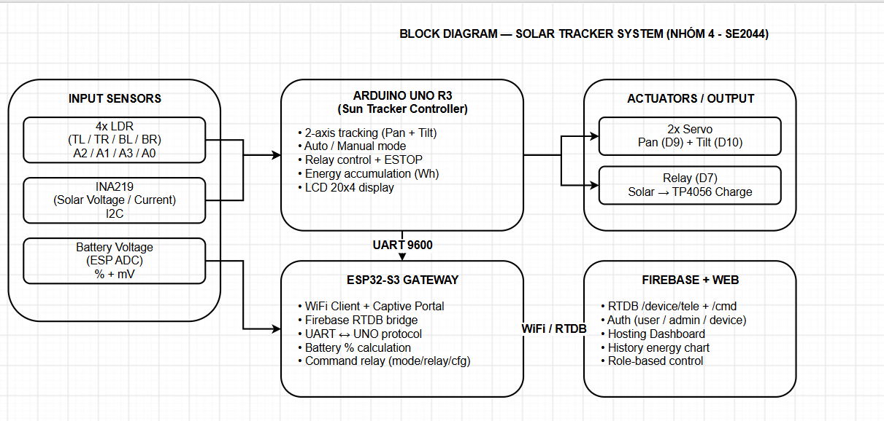
This architecture yields two important safety properties: (a) local tracking and relay logic continue to operate if the ESP loses Wi-Fi or Firebase connectivity; (b) an emergency-stop command latches the relay OFF on the Uno and can only be cleared by an explicit Recover command from the web, preventing accidental re-enable.

3 Electronic Circuit / Hardware Interfacing
The Arduino Uno is the sole real-time actuator. Pin assignments are as follows:
- Servo Pan → D9, Servo Tilt → D10 (PWM).
- LDR Top-Left → A2, Top-Right → A1, Bottom-Left → A3, Bottom-Right → A0.
- INA219 → I2C (SDA/SCL).
- Relay → D7 (active-high or active-low configurable).
- LCD I2C → 0x27.
- UART to ESP → D0 (RX) / D1 (TX) at 9600 baud. Important: D0 must be disconnected while flashing the Uno.
The ESP32-S3 measures battery voltage through a resistive divider on an ADC pin, runs a captive portal (SSID “SolarTracker-Setup”, password 12345678) when no Wi-Fi credentials are stored, and maintains a persistent Firebase connection once online. All configuration (angle limits, solar ON/OFF thresholds, battery stop/resume percentages) is pushed from the admin dashboard through the ESP to the Uno via a single “K” command packet.
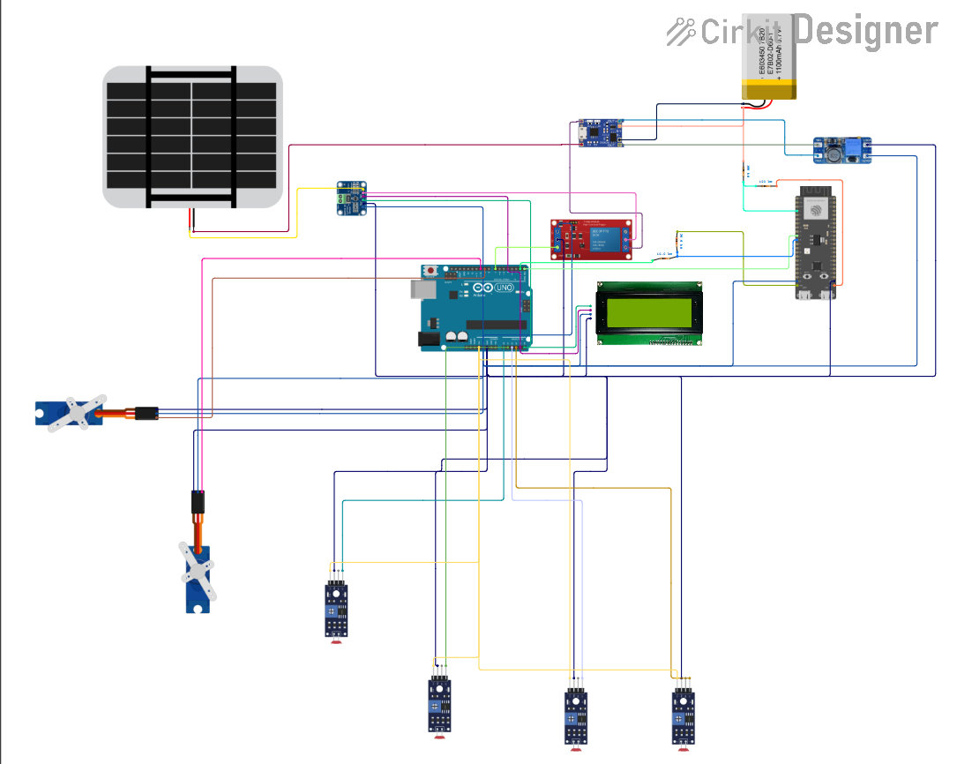

4 Software Programming and Web Integration

4.1 Programming Flowchart
Figure 2 illustrates the main control flow on the Arduino Uno and the complementary gateway behaviour of the ESP32-S3. The Uno continuously samples the four LDRs, decides whether it is night, steps the servos toward the brighter quadrant (or holds position when within tolerance), evaluates the relay state according to solar voltage, battery percentage and the emergency latch, and transmits a compact telemetry line every second. The ESP parses this line, writes it to Firebase, and simultaneously listens for /cmd changes which it forwards as M (mode + targets), R (relay command) or K (configuration) packets.
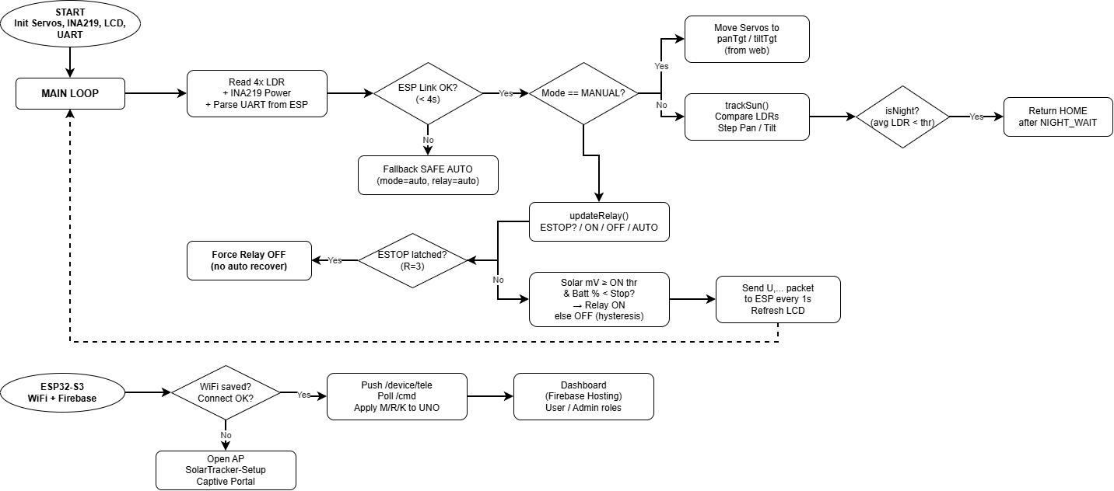

4.2 Sensors, Parameters and Protocol

4.2.1 Pin-out and Runtime Parameters (Uno)
- Tracking interval: 50 ms; step size: 1°; tolerance: 20 (raw LDR units).
- Night threshold: average LDR < 60 → after 60 s return to HOME (0°, 0°).
- Default angle limits: Pan 0–150°, Tilt 0–160° (overridable from dashboard).
- Solar ON threshold (default): 3700 mV; OFF threshold: 3300 mV with 5 s hold (hysteresis).
- Battery stop: 100 %; resume: 90 %.
- ESP link timeout: 4 s → automatic fallback to safe auto mode and auto relay.

4.2.2 UART Protocol
ESP → Uno:
- E,<wifi 0/1/2>,<batt %>,<batt mV>
- M,<mode 0=auto 1=manual>,<panTarget>,<tiltTarget>
- R,<0=auto | 1=on | 2=off | 3=EMERGENCY-STOP>
- K,<panMin>,<panMax>,<tiltMin>,<tiltMax>,<solarOn mV>,<solarOff mV>,<battStop %>,<battResume %>
Uno → ESP:
- U,<solar mV>,<mA>,<mW>,<mWh>,<pan>,<tilt>,<relay>,<mode>,<ldrTL>,<ldrTR>,<ldrBL>,<ldrBR>
R=3 is a latched emergency state. The relay stays OFF and auto logic is inhibited until the web issues a different R command (Recover).

4.2.3 Firebase Data Model
- /device/tele – live telemetry written only by the ESP (device role).
- /device/status – ONLINE / AP_SETUP / REBOOTING.
- /history – energy samples every 5 minutes.
- /cmd/* – mode, pan, tilt, relay, emergency, cfg*, wifi* (written by user/admin).
- /users/<uid>/role – user | admin | device (read-only for clients).

4.3 Web Dashboard Features
The dashboard (https://solarcontroller-1cc93.web.app) supports two human roles:
- user: view live telemetry, switch AUTO/MANUAL, move pan/tilt sliders, control relay (auto/on/off), issue EMERGENCY OFF, change Wi-Fi credentials.
- admin: everything above plus the CONFIG panel that writes angle limits and solar/battery thresholds to the Uno.
A red banner is displayed while the emergency latch is active. Telemetry older than 5 s is flagged as “ESP MẤT KẾT NỐI” even if the status node still says ONLINE.

5 Results and Discussion

5.1 Prototype Implementation and Telemetry Testing
The complete hardware was assembled and the firmware flashed. After the first Wi-Fi configuration via the captive portal, the ESP successfully joined the local router and appeared ONLINE on the dashboard. Live values of solar voltage, current, power, accumulated energy, pan/tilt angles and the four LDR readings updated every 1–2 seconds with no noticeable lag under normal network conditions.
[Suggestion: insert screenshots of the dashboard in AUTO mode, MANUAL mode with sliders, the CONFIG panel (admin only), and the red EMERGENCY banner. Also photograph the LCD showing “WiFi:OK”, battery percentage and current power.]

5.2 Operational Scenarios Evaluation
The following test cases were executed:
Test Case 1 – Automatic Sun Tracking: Under clear sky the panel continuously followed the sun. When one quadrant was artificially shaded the servos stepped toward the brighter side within a few hundred milliseconds. When average light fell below the night threshold the system waited 60 s then returned to HOME.
Test Case 2 – Manual Override: Switching to MANUAL on the dashboard immediately stopped auto-tracking; the pan and tilt sliders drove the servos to the commanded angles. Returning to AUTO resumed tracking from the current position.
Test Case 3 – Relay Hysteresis & Battery Protection: With solar voltage above 3.7 V and battery below the stop percentage the relay closed, allowing charging. When voltage dropped below 3.3 V for more than 5 s, or battery reached 100 %, the relay opened. The hysteresis prevented rapid on/off chatter.
Test Case 4 – Emergency Stop: Pressing EMERGENCY OFF on the web latched the relay OFF. Auto logic no longer re-enabled it. Only the Recover button cleared the latch. Even after a power cycle of the ESP the latch remained until an explicit Recover was received.
Test Case 5 – Link Loss Safety: Disconnecting the UART or powering off the ESP for > 4 s caused the Uno to fall back to SAFE AUTO mode and auto-relay logic. Tracking and charging continued without cloud supervision.
Test Case 6 – Captive Portal & Wi-Fi Change: Clearing Preferences forced the ESP into AP mode. Connecting a phone to “SolarTracker-Setup” and submitting new credentials caused a clean reboot and successful reconnection. Changing Wi-Fi from the dashboard also triggered a controlled reboot.
[Suggestion: record response times, measure actual energy yield over a sunny day versus a fixed panel of the same size, and document any mechanical backlash or servo jitter observed.]

5.3 Discussion on Safety and Scalability
The dual-microcontroller design proved decisive for safety. Local decisions on the Uno never depend on cloud latency. The emergency latch is the only state that requires network connectivity to clear, which is an acceptable trade-off for a laboratory prototype. For production the same latch could be mirrored on a physical button. Future work can replace the ESP32-S3 with a cheaper ESP32-C3 or add LoRa for remote farms while keeping the identical UART protocol.

6 CONCLUSION
A complete dual-axis solar tracker with cloud supervision has been designed, implemented and evaluated. The Arduino Uno delivers deterministic tracking and battery-safe relay control, while the ESP32-S3 provides a clean, role-based interface to Firebase. The system successfully handles automatic tracking, manual override, emergency stop, link-loss fallback and remote configuration. The architecture is cost-effective, educationally transparent, and ready for extension to multi-panel arrays or predictive irradiance models.
Future improvements include: (1) replacing LDRs with a small camera or closed-loop encoder feedback for higher pointing accuracy; (2) adding a simple ML model on the ESP or in the cloud that predicts the next day’s optimal tracking schedule; (3) expanding the dashboard with multi-device management and energy-billing reports.

References
[1] A. A. R. Madushanki et al., “Adoption of the Internet of Things (IoT) in agriculture,” Int. J. Adv. Comput. Sci. Appl., 2019.
[2] Firebase Documentation – Realtime Database & Hosting, Google, 2024.
[3] Adafruit INA219 Current Sensor Breakout, Adafruit Industries.
[4] ESP32-S3 Series Datasheet, Espressif Systems.
[Suggestion: add 2–3 more academic papers on solar trackers or IoT energy systems.]

Member Contributions
Table 1: Task Assignments and Contribution Levels (to be finalized by the group)
No | Name | Main Responsibilities | Contribution
1 | Hoàng Tiến Mạnh | ESP32 firmware, Firebase bridge, captive portal, UART protocol | 25%
2 | Võ Đặng Anh Khoa | Arduino Uno tracking algorithm, servo & relay logic, INA219 | 25%
3 | Đặng Thị Phương Anh | Hardware assembly, wiring, mechanical structure, testing | 25 %
4 | Nguyễn Thành Luân | Web dashboard (HTML/JS), role-based rules, documentation | 25 %

