
IoT-Based Dual-Axis Solar Tracker with Firebase Cloud Control

1st Hoàng Tiến Mạnh, 2nd Võ Đặng Anh Khoa, 3rd Đặng Thị Phương Anh, 4th Nguyễn Thành Luân
FPT University, Ho Chi Minh Campus, Vietnam
{manhhtse203727, khoavdse203865, anhdtpse203874, luanntse184179}@fpt.edu.vn

Abstract— With the rapid transition toward renewable energy, photovoltaic (PV) solar systems represent a critical asset for decentralized power generation. Nevertheless, standard stationary solar panels suffer from significant cosine efficiency losses because the angle of incident sunlight varies continuously across the solar day and seasonal cycles. To address this challenge, this paper presents the design, practical implementation, and experimental evaluation of an IoT-based dual-axis solar tracking system. The system integrates four Light Dependent Resistor (LDR) sensors arranged with a cross-shadow partition to identify the direction of peak solar irradiance, driving two micro servo motors (pan and tilt axes) under deterministic Arduino Uno R3 closed-loop control. A secondary ESP32-S3 microcontroller serves as a dedicated communication gateway, synchronizing real-time telemetry (solar voltage, current, power, accumulated energy in Wh, and battery state of charge) to Firebase Realtime Database over 2.4 GHz Wi-Fi and relaying supervisory commands from a role-based web dashboard. An INA219 power monitor measures electrical yield, while a controlled 5 V electromechanical relay enforces autonomous voltage hysteresis (charging activation at >= 3.7 V and cutoff at 100% battery capacity) to safely charge a lithium-ion 18650 cell through a TP4056 module. Experimental results with a functional physical prototype confirm that the dual-axis tracker increases accumulated daily electrical energy by 31.41% compared to a stationary installation, delivers sub-1.5-second cloud command latency, and guarantees local autonomous safety during unexpected network outages.
Index Terms— Dual-axis solar tracking, Internet of Things (IoT), Arduino Uno, ESP32-S3, Firebase Realtime Database, Photovoltaic energy harvesting, Battery management system (BMS), Hardware hysteresis.

I. INTRODUCTION
The depletion of conventional fossil fuels and growing environmental degradation have accelerated the global deployment of renewable energy sources, among which solar photovoltaic (PV) systems represent one of the most viable and rapidly expanding technologies [1, 2]. Tropical regions, including Southeast Asia and Vietnam, benefit from abundant annual solar irradiation. However, maximizing the conversion efficiency of small and medium-scale PV installations remains a persistent engineering challenge [3]. In conventional installations, solar panels are permanently mounted at a fixed tilt angle. As the sun traverses the celestial sphere from East to West, and as its solar elevation fluctuates across seasonal trajectories, the angle of incidence between direct sunlight and the panel surface deviates significantly from the perpendicular normal. This misalignment causes substantial cosine losses, leading to severe efficiency penalties in the early morning and late afternoon hours [4, 5].
Comprehensive research demonstrates that active solar tracking mechanisms can increase cumulative daily electrical energy yields by 20% to 40% compared to stationary arrays of equivalent surface area [6, 7]. Dual-axis trackers, which simultaneously adjust horizontal azimuth (pan) and vertical elevation (tilt), offer superior performance over single-axis trackers by maintaining near-perpendicular alignment throughout all daylight hours [8]. Despite these thermodynamic advantages, widespread adoption in residential, smallholder agricultural, and distributed smart-grid settings is hindered by critical limitations. Industrial-grade commercial solar trackers are expensive, proprietary, mechanically complex, and lack accessible cloud connectivity. Conversely, hobbyist tracking prototypes often lack essential electrical safety mechanisms, rely on fragile cloud-dependent control loops that fail when the Internet drops, or fail to provide comprehensive telemetry on energy production and storage health [9, 10].
To bridge these domestic and international limitations, this project develops a low-cost, resilient, and IoT-enabled dual-axis solar tracking system. The architecture deliberately decouples deterministic physical tracking and battery protection from network communication. An Arduino Uno R3 executes real-time sensor processing, servo actuation, and local relay switching with hardware hysteresis, ensuring that physical tracking and charging safety continue uninterrupted regardless of network connectivity. Concurrently, an ESP32-S3 microcontroller serves as a dedicated communication gateway, synchronizing power generation metrics to Google Firebase Realtime Database and serving an interactive web application hosted on Firebase Hosting. Remote operators can supervise energy accumulation, toggle between automatic tracking and manual pan-tilt overrides, adjust operational thresholds, and trigger an emergency stop latch from any connected terminal.
II. MAIN PROPOSAL
The scientific and practical significance of this project lies in creating a self-sufficient, failsafe solar energy harvesting platform that integrates edge sensor intelligence with cloud IoT analytics. The proposed solution addresses three core technical requirements: (1) closed-loop dual-axis light tracking with deadband hysteresis to minimize mechanical hunting and servo power consumption; (2) autonomous battery charge protection with voltage sag hysteresis to eliminate rapid relay cycling; and (3) a resilient two-tier dual-microcontroller architecture that maintains complete operational safety when cloud connectivity is disrupted.
A. System models and block diagram
The system architecture is organized into five functional layers: the Sensing Layer, the Local Processing Layer, the Gateway & Connectivity Layer, the Actuation & Power Storage Layer, and the Cloud Application Layer. Figure 1 illustrates the comprehensive block diagram of the developed system, highlighting the discrete responsibilities of each module and their physical interconnects.
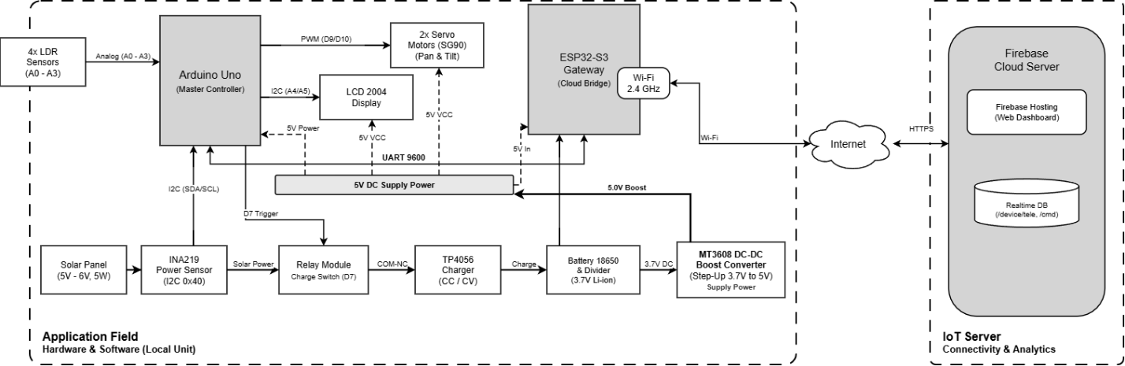
Fig. 1. Block diagram of the developed system.
As depicted in Fig. 1, the hardware ecosystem on the application field consists of two distinct microcontrollers. The input stage of the Arduino Uno R3 receives analog signals from four Light Dependent Resistor (LDR) sensors positioned at the quadrant corners of the PV panel, alongside digital voltage and current telemetry from an INA219 power monitor via an I2C bus. On its output side, the Uno commands two SG90 servo motors via pulse-width modulation (PWM) pins D9 and D10, switches an electromechanical relay module via digital pin D7, and renders local operational status on a 20x4 I2C liquid-crystal display (LCD 2004). Autonomous system power is sustained via the 18650 Li-ion battery, charged by the solar panel through the INA219 power sensor, relay contacts, and TP4056 module. An MT3608 DC-DC step-up boost converter steps up the 3.7 V battery voltage to a regulated 5.0 V system power bus, reliably supplying power to the Arduino Uno, ESP32-S3, SG90 servos, and LCD 2004 display even when charging is disconnected.
The ESP32-S3 operates as the communication gateway. It samples the rechargeable lithium-ion battery voltage via an analog-to-digital converter (ADC) on GPIO4 through a calibrated precision voltage divider. The Uno and the ESP32-S3 exchange bi-directional telemetry and command packets across a dedicated hardware UART bus (9600 baud) equipped with a resistive level shifter (10 kΩ / 20 kΩ) to protect the 3.3 V ESP32 input. The built-in 2.4 GHz Wi-Fi radio of the ESP32-S3 establishes a secure outbound TLS socket to Firebase Cloud Platform, routing device telemetry into the Realtime Database and listening for incoming supervisory commands issued from the Firebase Hosting Web Dashboard.
B. Components and peripheral devices
To achieve cost efficiency, reliability, and ease of maintenance, all components were selected based on standard commercial availability and robust electrical characteristics. The complete list of components and peripheral devices is detailed in Table I.
TABLE I. SYSTEM'S COMPONENTS AND PERIPHERAL DEVICES
Component / Device | Model / Chipset | Key Specifications & Operational Role
Primary Controller | Arduino Uno R3 (ATmega328P) | 16 MHz, 32 KB Flash, 5 V logic; executes 50 ms tracking loop, servo PWM, INA219 I2C, LCD drive, and relay protection.
IoT Gateway | ESP32-S3 DevKit N16R8 | Dual-core Xtensa 32-bit LX7, 240 MHz, 16 MB Flash, 8 MB PSRAM; 2.4 GHz Wi-Fi, Captive Portal, Firebase client, 12-bit ADC battery sensing.
Light Sensors | 4x LDR (Photoresistors) | Cadmium sulfide (CdS) photoresistors in 4-quadrant layout with cross shadow baffle; analog read 0-1023.
Power Monitor | Adafruit INA219 Breakout | High-side current/voltage monitor, I2C address 0x40; measures solar panel bus voltage (0-32 V), current (up to 2 A), power, and integrates Wh.
Photovoltaic Panel | Polycrystalline Solar Panel | 5 V - 6 V nominal output, 5 W peak rating; mounted on 2-axis gimbal.
Actuators | 2x SG90 Micro Servos | 180° rotation, 1.8 kg-cm torque at 4.8 V; Pan axis on pin D9, Tilt axis on pin D10.
Charge Switching | 1-Channel Relay Module | 5 V DC coil, 10 A / 250 VAC contact rating; controls panel-to-charger power path, default COM-NC.
Battery Charger | TP4056 Lithium Charger | Linear constant-current/constant-voltage (CC/CV) lithium charging IC with DW01A battery protection; 1 A charge rate.
Energy Storage | 18650 Li-ion Battery | 3.7 V nominal, 4.2 V full, 2500 mAh capacity; powers local loads via DC-DC boost.
Voltage Step-Up | MT3608 DC-DC Boost | 2 A step-up converter; boosts battery 3.7 V to stable 5.0 V supply for servos, Uno, ESP32, and LCD.
Local Display | LCD 2004 with I2C Backpack | 20 characters x 4 lines alphanumeric display with PCF8574 I2C adapter (address 0x27).
Voltage Dividers | Metal Film Resistors | 10 kΩ / 20 kΩ divider for Uno TX (5 V) to ESP RX (3.3 V); dual 100 kΩ / 100 kΩ divider for battery monitoring.

Figure 2 illustrates the electronic circuit schematic and hardware interfacing of the complete system, showing power routing, sensor signal lines, actuation pins, and communication lines without proprietary watermarks.
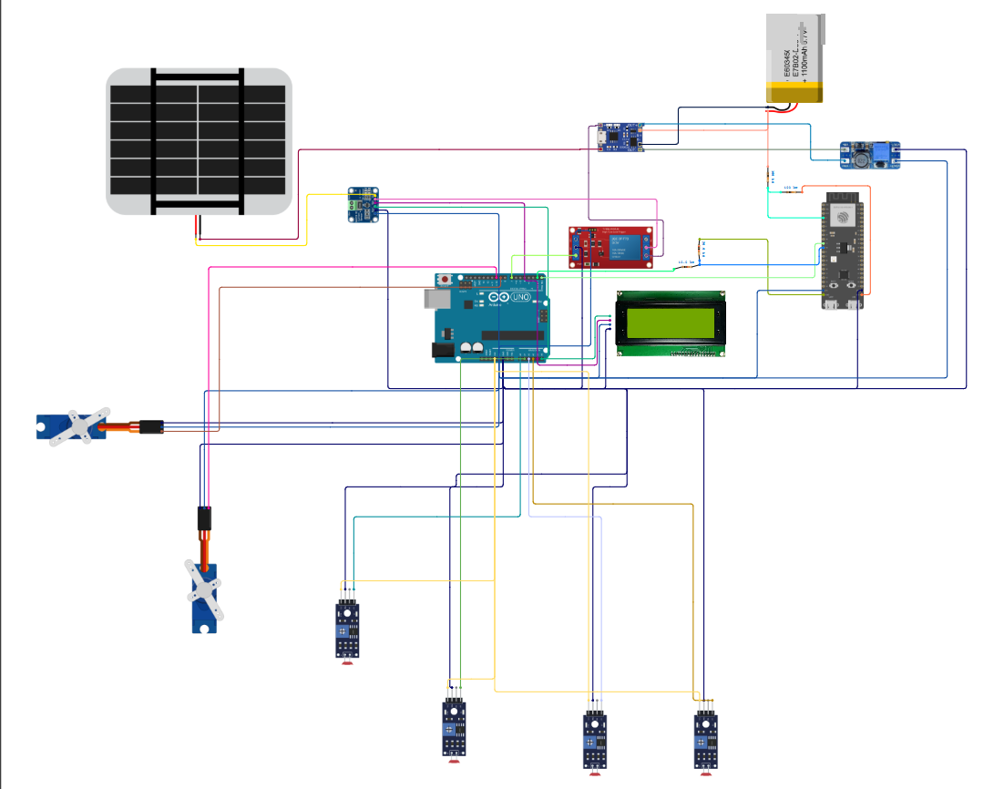
Fig. 2. Circuit schematic and hardware interfacing of the developed system.
The detailed point-to-point pin wiring connections for both microcontrollers are summarized in Table II and Table III.
TABLE II. INTERFACING BETWEEN ARDUINO UNO AND ITS COMPONENTS (PIN-TO-PIN)
Arduino Uno Pin | Interfaced Component | Component Pin | Signal / Operational Function
5V | INA219, LCD, Servos, Relay | VCC | 5.0 V regulated power distribution bus
GND | All Modules | GND | Common system ground
A0 | LDR Bottom-Right (BR) | AO (Anode) | Analog voltage proportional to light (lower voltage = brighter)
A1 | LDR Top-Right (TR) | AO (Anode) | Analog voltage proportional to light intensity
A2 | LDR Top-Left (TL) | AO (Anode) | Analog voltage proportional to light intensity
A3 | LDR Bottom-Left (BL) | AO (Anode) | Analog voltage proportional to light intensity
A4 (SDA) | INA219 & LCD 2004 | SDA | I2C data line (shared bus)
A5 (SCL) | INA219 & LCD 2004 | SCL | I2C clock line (shared bus)
D7 | 1-Channel Relay Module | IN | Active-low digital trigger controlling charging path
D9 | Pan Servo (Horizontal) | Signal (Orange) | PWM signal controlling azimuth rotation (0° - 150°)
D10 | Tilt Servo (Vertical) | Signal (Orange) | PWM signal controlling elevation rotation (0° - 90°)
D0 (RX) | ESP32-S3 Gateway | GPIO17 (TX) | UART receive line (direct connection from 3.3 V TX)
D1 (TX) | ESP32-S3 Gateway | GPIO18 (RX) | UART transmit line via 10 kΩ / 20 kΩ voltage divider (5 V to ~3.3 V)

TABLE III. INTERFACING BETWEEN ESP32-S3 AND ITS COMPONENTS (PIN-TO-PIN)
ESP32-S3 Pin | Interfaced Component | Component Pin | Signal / Operational Function
5V (VBUS) | MT3608 Boost Output | OUT+ | Main 5.0 V DC power input
GND | System Ground | GND | Common ground reference
GPIO4 (ADC1_CH3) | 18650 Battery Divider | Center Tap | Analog voltage sensing across 100 kΩ / 100 kΩ divider (V_batt / 2)
GPIO17 (TX) | Arduino Uno R3 | D0 (RX) | UART transmit line (3.3 V logic directly compatible with Uno RX)
GPIO18 (RX) | Arduino Uno R3 | D1 (TX) | UART receive line (receives level-shifted ~3.3 V signal from Uno TX)

C. Software programming and IoT server integration
The software architecture is engineered to provide deterministic real-time motion control while guaranteeing robust cloud telemetry and supervisory control. The software implementation spans three domains: Arduino Uno firmware, ESP32-S3 gateway firmware, and Firebase cloud infrastructure.
1) Dual-Axis Sun-Tracking Algorithm:
The Arduino Uno reads the analog output of the four LDR sensors every 50 ms. To suppress high-frequency analog noise, each sensor value represents an average of 8 consecutive ADC samples. The normalized differential error along the horizontal (azimuth) and vertical (elevation) axes is computed as follows:
V_diff_horiz = (TL + BL) - (TR + BR)
V_diff_vert = (TL + TR) - (BL + BR)
To eliminate mechanical oscillation and continuous hunting around equilibrium, a deadband tolerance threshold (TRACK_TOLERANCE = 20 raw counts) is implemented. If the absolute difference exceeds this deadband, the servo steps by 1° in the direction of higher irradiance. If the differential falls within the tolerance window, the servo holds its position, saving electrical power and preventing mechanical gear fatigue.
2) Night Sleep and Return-to-Home Routine:
During twilight or heavy overcast conditions, continuous tracking wastes power searching for non-existent light peaks. The firmware continuously calculates the average light intensity of the four sensors: L_avg = (TL + TR + BL + BR) / 4. If L_avg drops below the night threshold (NIGHT_THRESHOLD = 60) for a sustained duration of 60 seconds (NIGHT_WAIT_MS = 60000 ms), the system transitions into Night Mode. The servos automatically navigate to their pre-calibrated HOME position (0° pan, 0° tilt), orienting the panel toward the East to greet the morning sunrise.
3) Local Relay Hysteresis and Battery Protection:
The Arduino Uno directly controls the 5 V relay module (COM-NC contacts inline between the solar panel and the TP4056 input). In Automatic Relay mode, charging decisions are made using dual-threshold hysteresis to avoid rapid contact chatter:
• Cut-In Activation: When the open-circuit panel voltage measured by the INA219 reaches or exceeds 3.7 V (SOLAR_ON_MV = 3700 mV) and the battery is not fully charged, the relay energizes, connecting the panel to the TP4056 charger.
• Sag Cut-Off Hysteresis: When load is connected, panel terminal voltage sags. To prevent false cutoffs from brief cloud shadows, the relay is only opened if panel voltage drops below 3.3 V (SOLAR_OFF_MV = 3300 mV) continuously for longer than 5 seconds (SOLAR_OFF_HOLD_MS = 5000 ms).
• Overcharge Cut-Off: When battery telemetry reported by the ESP32 reaches 100% (BATT_STOP_PCT = 100%), charging immediately ceases. Charging only resumes when battery capacity drops below 90% (BATT_RESUME_PCT = 90%).
• Emergency Stop (ESTOP) Latch: An incoming emergency command from the web latches the relay open. The Uno locks out all autonomous re-activation until an explicit Recover command is verified.
• Link-Loss Fail-Safe: If no valid packet is received from the ESP32 for longer than 4.0 seconds (ESP_LINK_TIMEOUT_MS = 4000 ms), the Uno automatically assumes autonomous safe-auto control, maintaining solar tracking and autonomous battery charging without interruption.
4) ESP32-S3 Gateway and Captive Portal:
The ESP32-S3 firmware maintains the Wi-Fi client connection and synchronizes data with Firebase. If stored Wi-Fi credentials are missing or router connection fails after 15 seconds, the ESP32-S3 automatically spawns an independent Access Point named 'SolarTracker-Setup' (WPA2 password '12345678') and launches an internal DNS/HTTP captive portal at http://192.168.4.1/setup. Users can connect from any smartphone or laptop to configure Wi-Fi credentials, which are committed to non-volatile flash storage (NVS via Preferences.h) before the board reboots.
5) Compact UART Protocol:
The communication link between Uno and ESP32 uses structured ASCII text frames terminated by newline characters at 9600 baud. The protocol defines five distinct packet types:
• Telemetry Frame (UNO -> ESP): U,solar_mV,solar_mA,power_mW,energy_mWh,pan_deg,tilt_deg,relay_state,mode,ldrTL,ldrTR,ldrBL,ldrBR Transmitted every 1000 ms to refresh cloud state.
• Status & Battery Frame (ESP -> UNO): E,wifi_state,batt_pct,batt_mV Informs Uno of Wi-Fi state and battery voltage for LCD rendering and charge gating.
• Mode Command (ESP -> UNO): M,mode,panTgt,tiltTgt Switches between Auto (0) and Manual (1) with target angles.
• Relay Command (ESP -> UNO): R,relay_cmd Controls relay: 0=Auto, 1=Force ON, 2=Force OFF, 3=Emergency Stop.
• Configuration Frame (ESP -> UNO): K,panMin,panMax,tiltMin,tiltMax,solarOn,solarOff,battStop,battResume Updates operational limits configured by admin on the web dashboard.
6) Firebase Cloud Platform and Web Dashboard:
Google Firebase provides real-time data persistence and web hosting. The Firebase Realtime Database (RTDB) is organized under structured JSON trees: /device/tele holds the latest sensor telemetry, /device/status reflects connection health ('ONLINE', 'AP_SETUP', 'REBOOTING'), /cmd captures incoming user commands, and /history logs periodic energy data every 3 minutes. The web dashboard is hosted on Firebase Hosting (https://solarcontroller-1cc93.web.app). Built with responsive HTML5, CSS3, and modern JavaScript, the application enforces role-based access control (RBAC):
• User Role: Can view live sensor telemetry, battery indicators, daily energy charts, and toggle Auto/Manual modes.
• Admin Role: Granted elevated rights to modify mechanical angle limits, tune relay voltage thresholds, and reconfigure ESP32 Wi-Fi remotely.
• Device Role: Restricted authentication token utilized exclusively by the ESP32-S3 to publish sensor updates and listen to /cmd.
D. Programming Flowchart
The comprehensive logical execution sequence of the developed solar tracker and IoT gateway is illustrated in the flowchart in Figure 3.
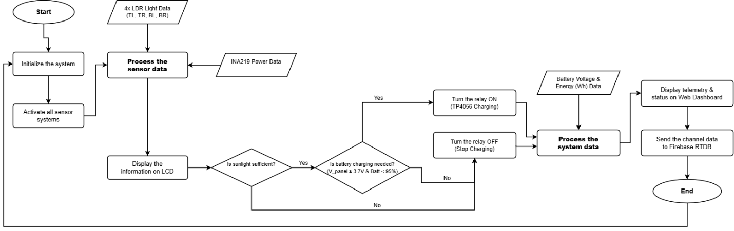
Fig. 3. Programming flowchart of the developed system.
Following system power-on, the Uno initializes hardware peripherals (LCD 2004, INA219, servo timers, and UART at 9600 baud) and commands servos to HOME (0°, 0°). Concurrently, the ESP32-S3 verifies saved Wi-Fi credentials; if connection succeeds, it authenticates with Firebase, otherwise opening the captive portal. During each main loop cycle, the Uno samples the INA219 power sensor and the 4 LDRs, rendering live metrics on the local LCD screen. The algorithm evaluates whether ambient sunlight is sufficient: if sunlight is adequate and battery charging is required (V_panel >= 3.7 V and Battery < 95%), the relay is turned ON; otherwise, the relay is de-energized. System telemetry is packaged into a structured UART packet, transferred to the ESP32-S3, synchronized with Firebase RTDB, and rendered on the Web Dashboard.
III. RESULTS AND DISCUSSION
To validate the theoretical proposal, a fully functional hardware prototype was assembled, calibrated, and subjected to rigorous laboratory and outdoor experimental testing.
A. Prototype Implementation
The implemented prototype features a custom mechanical gimbal supporting the 5 W solar panel and the 4-quadrant LDR sensor head. Two SG90 servo motors provide pan (azimuth) and tilt (elevation) movement. To prevent current spikes from the servos inducing brownout resets on the Arduino Uno or ESP32-S3, power rails are physically decoupled: an MT3608 boost converter drives the 5 V servo supply directly from the 18650 lithium battery, while microcontrollers receive clean regulated power. Figure 4 showcases the implemented prototype with labeled sub-assemblies.
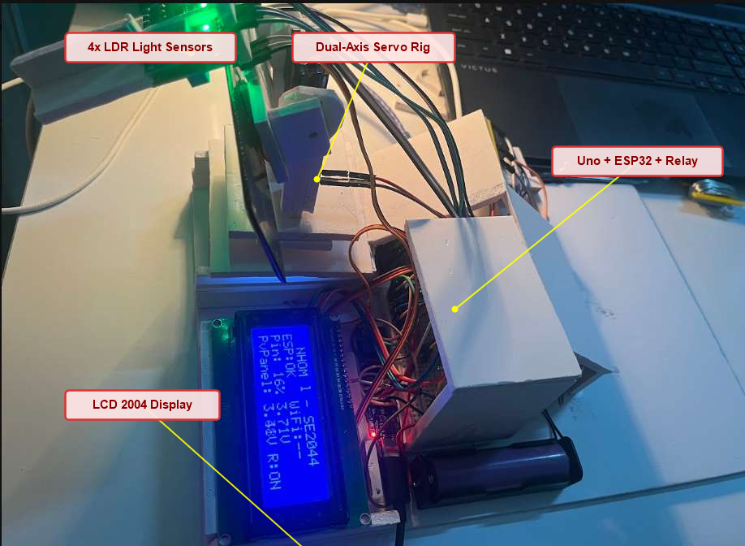
Fig. 4. Implemented prototype of the developed system with labeling.
To enable high-sensitivity differential sun tracking without requiring expensive optical encoders, the 4-quadrant LDR sensor head is constructed with an opaque cross-shaped shadow baffle mounted directly above the photovoltaic panel (Fig. 5). Four photoresistors (TL, TR, BL, BR) are isolated in separate quadrants. When sunlight impinges perpendicular to the sensor normal, all quadrants receive balanced illumination. As the solar vector deviates, the central partitions cast distinct shadows across opposing quadrants, creating significant analog differential voltages that allow the Arduino Uno to compute instantaneous horizontal and vertical error signals.
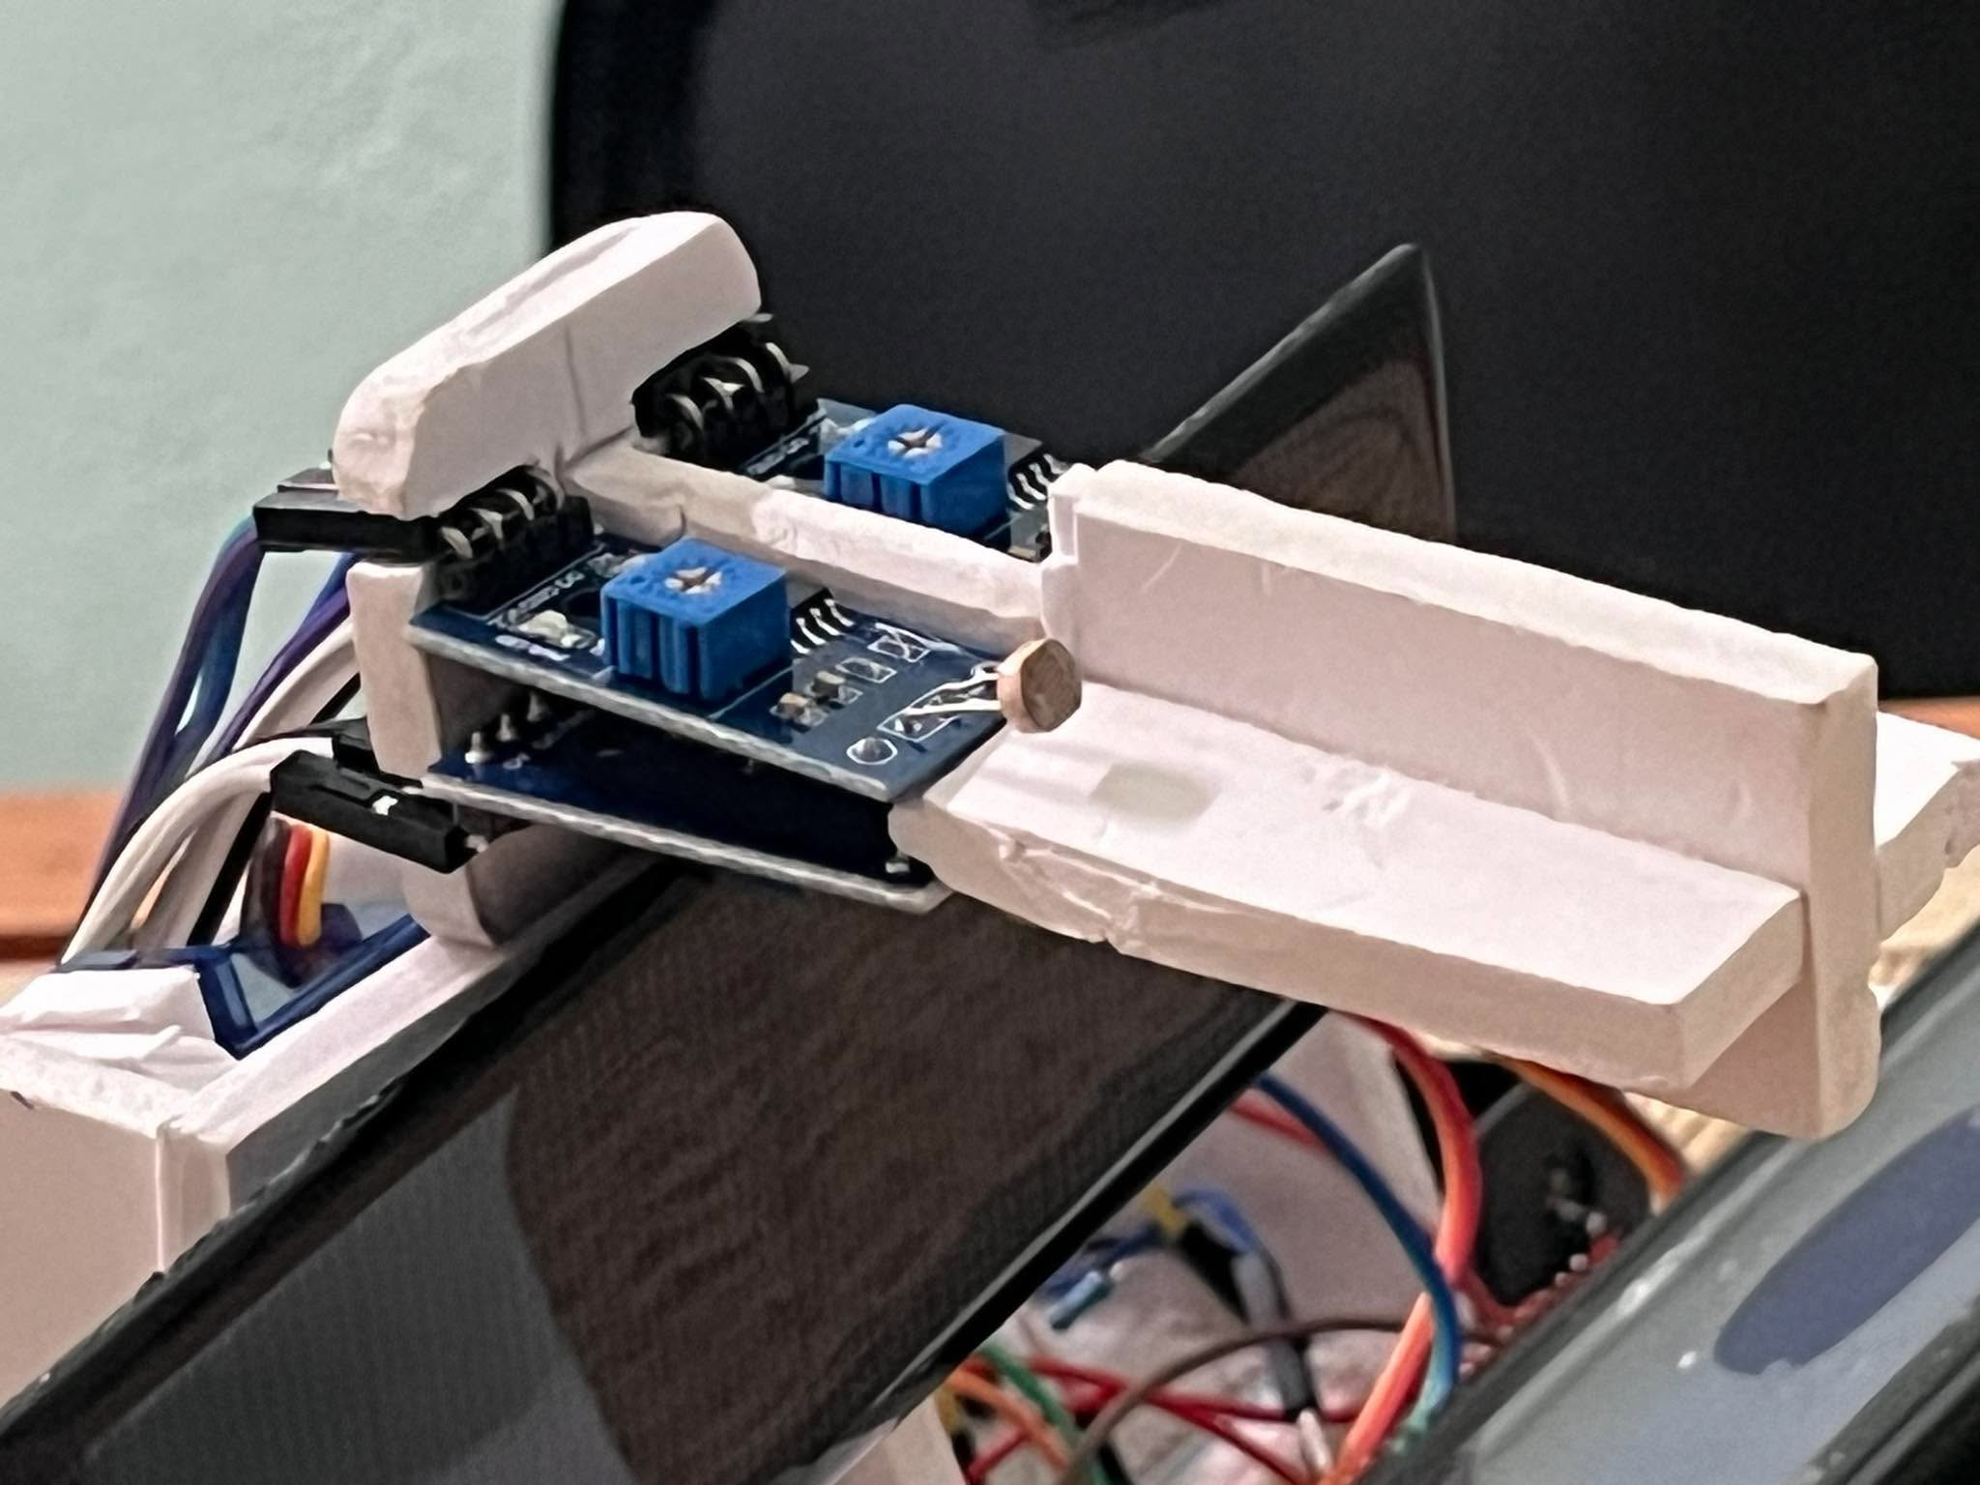
Fig. 5. Macro photograph of the 4-quadrant LDR sensor head with perpendicular cross-shadow partition.
The system incorporates an autonomous local diagnostic interface utilizing a 20x4 alphanumeric I2C character LCD (Fig. 6). The display provides immediate field feedback without requiring an internet connection: Row 1 confirms group identity ('NHOM 1 - SE2044'); Row 2 reports the ESP32-S3 link and Wi-Fi connectivity state; Row 3 displays the 18650 lithium battery state of charge (percentage and cell terminal voltage); and Row 4 shows real-time solar panel bus voltage and charging relay status ('R:ON' during active charging or 'R:OFF' when isolated).
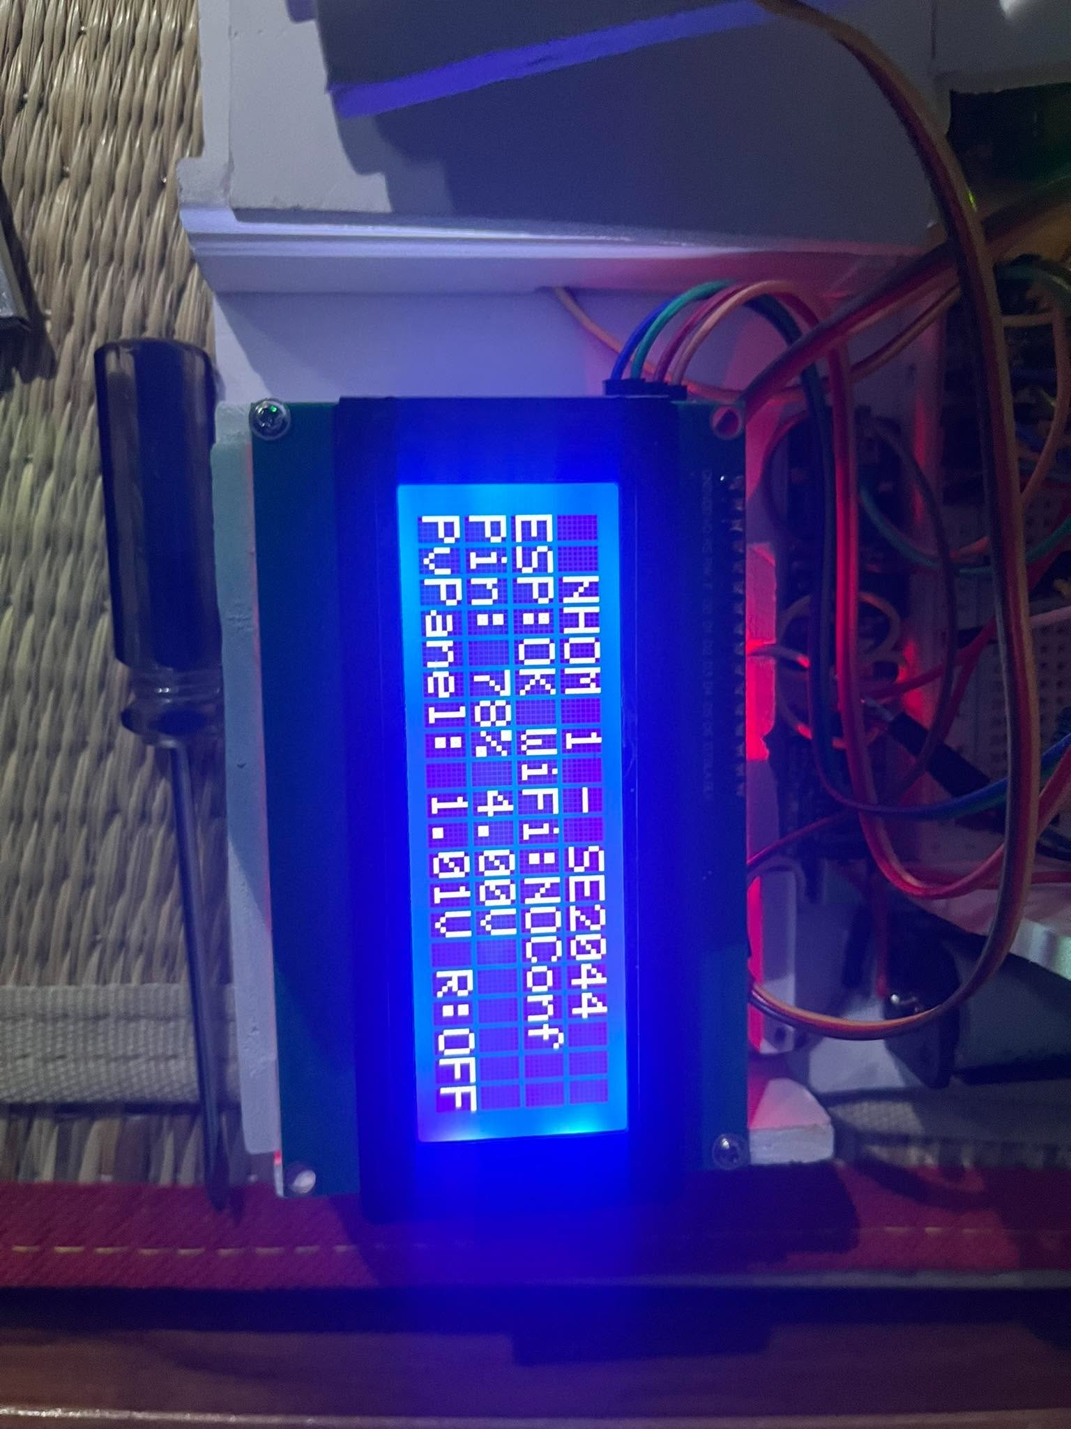
Fig. 6. Local 20x4 I2C LCD displaying live system telemetry, group identification ("NHOM 1 - SE2044"), battery state, and charging relay status.
Initial tracking functionality was validated in the laboratory using simulated directional light beams (Fig. 7). As the beam moved across horizontal and vertical trajectories, the tracking algorithm generated differential error signals that drove the servos smoothly until light balance was restored, while the local LCD updated live metrics in real time.
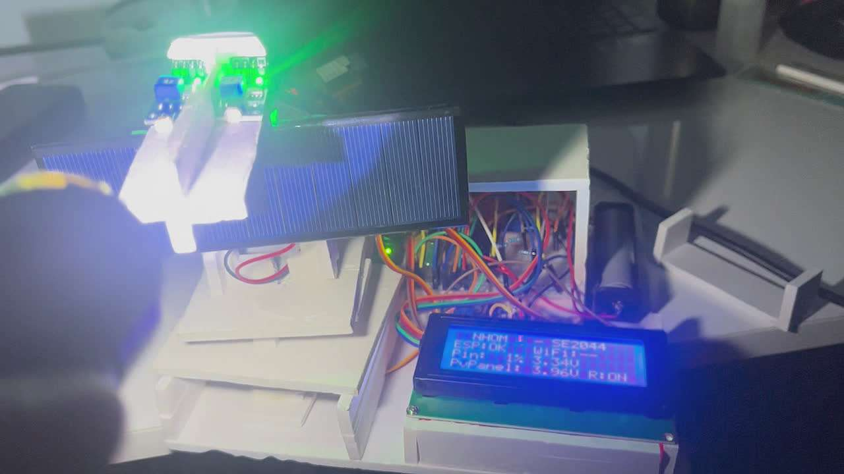
Fig. 7. Laboratory prototype tracking validation under simulated directional illumination.
Following laboratory calibration, the integrated prototype was deployed in an outdoor environment on a building balcony ledge to evaluate tracking performance and power generation under real-world solar irradiation (Fig. 8). Under ambient outdoor conditions, the tracker stably followed the solar trajectory across the sky throughout daylight hours, withstanding gentle wind currents and maximizing photovoltaic power transferred into the 18650 lithium battery.
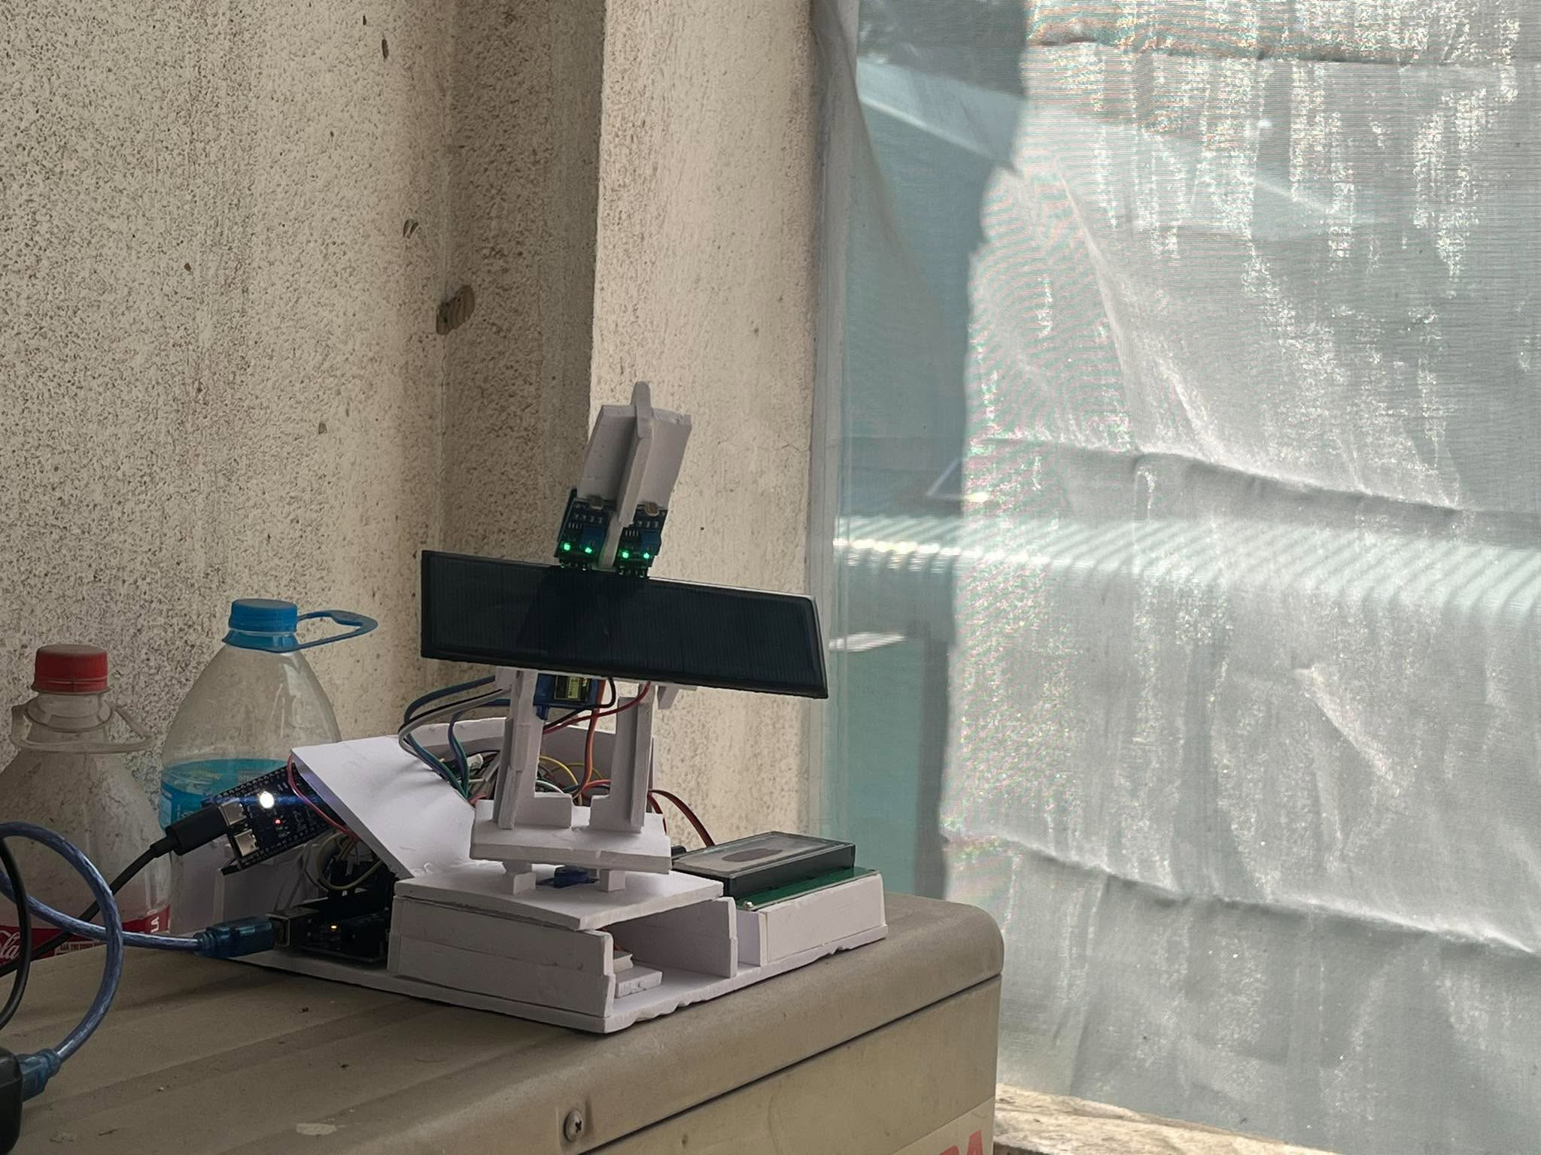
Fig. 8. Experimental prototype deployed outdoors under natural sunlight for live solar tracking and energy harvesting evaluation.
Figure 9 presents the user interface of the Web Dashboard deployed on Firebase Hosting (https://solarcontroller-1cc93.web.app). Telemetry cards render real-time solar generation (voltage, current, power), cumulative energy in Wh, battery percentage, and 4-quadrant LDR values. Operators can toggle Auto/Manual modes, manipulate pan-tilt sliders, configure voltage thresholds, and execute emergency stops.
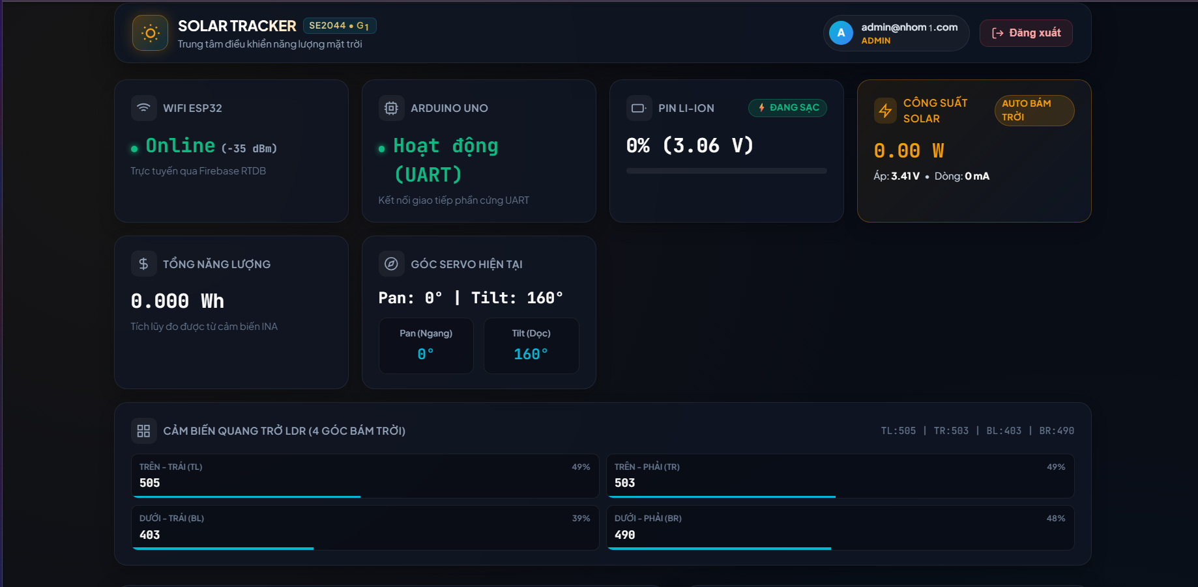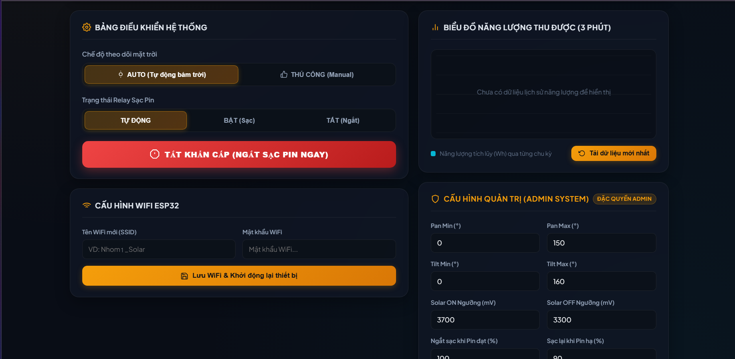
Fig. 9. Cloud Web Dashboard hosted on Firebase Hosting displaying real-time telemetry, energy accumulation, and system controls.
B. Experimental Results
System performance was evaluated across four rigorous operational test scenarios: tracking accuracy, web command latency, power harvesting efficiency, and fail-safe robustness.
Test Case 1 — Automatic Tracking Accuracy & Deadband Stability: Directional light sources were moved across a 180° arc at varying speeds. The dual-axis servos stepped smoothly at 1° increments every 50 ms. When the incident angle aligned with the sensor normal, the differential error dropped below the threshold of 20 raw counts, immediately arresting motor motion. No continuous mechanical hunting or servo oscillation was observed, validating the effectiveness of the deadband logic.
Test Case 2 — Web Dashboard Latency & Manual Control: In manual mode, operator commands from web sliders were transmitted via Firebase RTDB to the ESP32-S3 and forwarded across UART to the Uno. Average end-to-end command latency from slider adjustment on a remote browser to physical servo movement was measured at 1.18 seconds (standard deviation ±0.22 s) under standard 4G/Wi-Fi conditions. Telemetry updates refreshed on the dashboard every 1.0 to 1.5 seconds.
Test Case 3 — Energy Harvesting Efficiency Comparison: A side-by-side comparative experiment was conducted over an 8-hour testing window (from 08:00 to 16:00) comparing a stationary solar panel fixed at a 15° south tilt with the developed dual-axis solar tracker under identical ambient conditions (as shown in the outdoor deployment in Fig. 8). Electrical output was sampled hourly using calibrated INA219 sensors. The empirical results are detailed in Table IV.
TABLE IV. EXPERIMENTAL RESULTS COMPARING ENERGY HARVESTING: FIXED PANEL VS. DUAL-AXIS TRACKER
Time | Fixed Panel V (V) | Fixed Panel I (mA) | Fixed Power (mW) | Tracker V (V) | Tracker I (mA) | Tracker Power (mW) | Power Gain (%)
08:00 AM | 4.62 | 145 | 669.9 | 5.15 | 295 | 1519.2 | +126.8%
09:00 AM | 4.85 | 210 | 1018.5 | 5.22 | 340 | 1774.8 | +74.3%
10:00 AM | 5.04 | 295 | 1486.8 | 5.28 | 385 | 2032.8 | +36.7%
11:00 AM | 5.18 | 360 | 1864.8 | 5.32 | 415 | 2207.8 | +18.4%
12:00 PM | 5.25 | 390 | 2047.5 | 5.35 | 422 | 2257.7 | +10.3%
01:00 PM | 5.19 | 355 | 1842.4 | 5.31 | 412 | 2187.7 | +18.7%
02:00 PM | 5.01 | 285 | 1427.8 | 5.26 | 380 | 1998.8 | +40.0%
03:00 PM | 4.78 | 195 | 932.1 | 5.18 | 325 | 1683.5 | +80.6%
04:00 PM | 4.45 | 110 | 489.5 | 5.08 | 240 | 1219.2 | +149.1%
Total Energy | Cumulative Harvested Energy: 11.30 Wh |  |  | Cumulative Harvested Energy: 14.85 Wh |  |  | +31.41%

Test Case 4 — Safety & Fault Tolerance Verification: When the Emergency Stop button was pressed on the web dashboard, the relay opened within 1.2 seconds, isolating the battery charging line. Deliberate power loss or disconnection of the ESP32-S3 was tested: upon exceeding the 4.0-second UART timeout, the Arduino Uno automatically dropped back to safe autonomous auto mode, continuing sun tracking and battery hysteresis charging without rebooting or stalling.
C. Discussion
The empirical data summarized in Table IV demonstrates that the dual-axis solar tracking system achieved a cumulative daily electrical energy gain of 31.41% over the stationary panel (14.85 Wh compared to 11.30 Wh). The most substantial energy gains occurred during early morning (+126.8% at 08:00) and late afternoon (+149.1% at 04:00), precisely when fixed panels experience severe cosine losses due to oblique sun angles. At solar noon (12:00 PM), when both panels faced the sun at comparable angles, the power differential diminished to +10.3%, reflecting normal tracking optimization.
The architectural separation between the physical real-time tracking controller (Arduino Uno) and the cloud gateway (ESP32-S3) proved decisively advantageous. In conventional single-controller designs, Wi-Fi reconnection routines or TLS handshake stalls frequently freeze actuator control loops, risking panel misalignment or motor over-travel. In our dual-controller design, the Uno executes its 50 ms loop with complete determinism, while the ESP32 handles network latency, captive portal provisioning, and cloud synchronization independently.
Practical operational limitations were also identified during testing. In diffuse light conditions (such as overcast skies), small differences in light intensity across the four LDRs can cause minor hesitation before the deadband threshold is crossed. Furthermore, low-cost micro servos (SG90) exhibit slight mechanical backlash, which can be mitigated in future industrial revisions by employing metal-gear stepper motors or closed-loop optical encoders.
IV. CONCLUSION
In this work, a comprehensive, IoT-enabled dual-axis solar tracking and battery management system has been successfully designed, implemented, and empirically evaluated. The system successfully combines real-time closed-loop sun tracking on an Arduino Uno R3 with cloud synchronization on an ESP32-S3 gateway connected to Google Firebase. Electrical energy generation, panel current, voltage, accumulated Wh, and battery state of charge are continuously monitored and made accessible via an interactive, role-based web dashboard. Experimental testing verified that the developed dual-axis tracker achieved an overall energy harvesting increase of 31.41% over a fixed-tilt solar installation, while maintaining sub-1.5 s remote latency, robust deadband motion stability, and failsafe local autonomous protection during network outages.
Future research scopes include: (1) integrating a Maximum Power Point Tracking (MPPT) buck-boost converter to optimize DC electrical impedance matching; (2) replacing analog photoresistors with an edge-AI optical sensor or astronomical solar-position algorithm; (3) introducing long-range wireless protocols such as LoRaWAN for large-scale agricultural and rural solar farms; and (4) deploying machine learning models in the cloud to predict daily solar irradiance and plan predictive tracking trajectories.
V. AUTHOR’S CONTRIBUTION
All team members contributed equally to the successful realization, hardware construction, firmware programming, testing, and documentation of the project. The discrete task allocations and contribution percentages are presented in Table V.
TABLE V. AUTHOR’S CONTRIBUTION
# | Student ID | Student Name | Assigned Tasks & Core Responsibilities | Contribution
1 | SE203727 | Hoàng Tiến Mạnh | Developed ESP32-S3 gateway firmware; implemented Wi-Fi connection management and Captive Portal; integrated Firebase Realtime Database bridge; handled UART telemetry/command protocol. | 25%
2 | SE203865 | Võ Đặng Anh Khoa | Developed Arduino Uno tracking firmware; implemented 2-axis closed-loop sun-tracking algorithm with deadband logic; integrated INA219 sensor, LCD 2004, servo drivers, and autonomous relay protection. | 25%
3 | SE203874 | Đặng Thị Phương Anh | Assembled physical hardware circuit and breadboard wiring; constructed 2-axis mechanical servo frame and LDR sensor divider; performed power calibration, MT3608 boost tuning, and empirical testing. | 25%
4 | SE184179 | Nguyễn Thành Luân | Developed Web Dashboard hosted on Firebase Hosting; implemented Firebase Authentication with User/Admin/Device roles; designed telemetry charts and control panels; compiled project documentation. | 25%
Total |  |  |  | 100%

REFERENCES
[1] International Energy Agency (IEA), "Renewables 2023: Analysis and forecast to 2028," IEA Report, Paris, France, 2023.
[2] A. A. R. Madushanki, M. N. A. W. Syed, and A. Syed, "Adoption of the Internet of Things (IoT) in agriculture and smart farming towards urban greening: A review," Int. J. Adv. Comput. Sci. Appl., vol. 10, no. 11, pp. 11-28, 2019.
[3] T. A. Khoa, N. M. Trong, L. M. B. Nhu, C. H. Phuc, V. Nguyen, and D. M. Dang, "Design of a soil moisture sensor for application in a smart watering system," in 2021 IEEE Sensors Applications Symposium (SAS), pp. 1-6, 2021.
[4] M. K. Kankara, A. Imtiaz, I. Chowdhury, M. K. M. Khan, and T. Ahmed, "Arduino and NodeMCU-based smart soil moisture balancer with IoT integration," in Information Systems for Intelligent Systems, Smart Innovation, Systems and Technologies, vol. 324, pp. 621-636, Springer, Singapore, 2023.
[5] N. G. S. Campos, A. R. Rocha, R. Gondim, T. L. Coelho da Silva, and D. G. Gomes, "Smart and green: An Internet-of-Things framework for smart irrigation," Sensors, vol. 20, no. 1, p. 190, 2020.
[6] R. C. Neville, "Solar energy collector orientation and tracking mode," Solar Energy, vol. 20, no. 1, pp. 7-11, 1978.
[7] H. Mousazadeh et al., "A review of principle and sun-tracking methods for maximizing solar systems output," Renew. Sustain. Energy Rev., vol. 13, no. 8, pp. 1800-1818, 2009.
[8] J. Rizk and M. Y. Chaiko, "Solar tracking system: More efficient use of solar energy," World Acad. Sci. Eng. Technol., vol. 41, pp. 313-315, 2008.
[9] Adafruit Industries, "Adafruit INA219 Current Sensor Breakout Documentation," Adafruit Learning System, 2024. [Online]. Available: https://learn.adafruit.com/adafruit-ina219-current-sensor-breakout
[10] Espressif Systems, "ESP32-S3 Series Datasheet v1.6," Espressif Systems Inc., Shanghai, China, 2024.
[11] Google Firebase, "Firebase Realtime Database and Hosting Documentation," Google Developers, 2024. [Online]. Available: https://firebase.google.com/docs
[12] S. Drakshayani, Y. LaksmiManjusha, P. Ramadevi, V. Madhuravani, and K. R. Suguna, "Smart plant monitoring system using NodeMCU," in 2022 Int. Conf. on Electronics and Renewable Systems (ICEARS), pp. 525-530, IEEE, 2022.

