**Лабораторна №10**

**Варіант 2**

Завдання 1

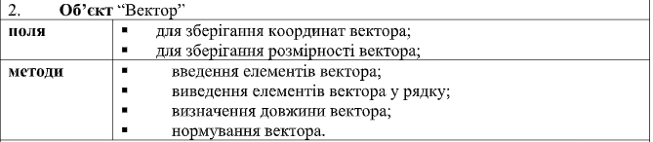

Розв’язок:

import math

class Vector:

def __init__(self, coords):

self.coords = coords

self.size = len(coords)

def input(self):

for i in range(self.size):

coord = float(input("Coord #{0} = ".format(i+1)))

self.coords[i] = coord

def __str__(self):

cstr = ""

for i in range(self.size):

c = self.coords[i]

cstr += str(c)

if i != self.size-1:

cstr += ', '

return "Vector{0}D ({1})".format(self.size, cstr)

def length(self):

s = 0

for c in self.coords:

s += c * c

return math.sqrt(s)

def normalize(self):

l = self.length()

for i in range(self.size):

self.coords[i] = self.coords[i] / l

v = Vector([3,4,5,6])

print(v)

v.input()

print("length =",v.length())

v.normalize()

print("normalized =", v)

Завдання 2