**Лабораторна №11**

**Варіант 2**

Завдання 1

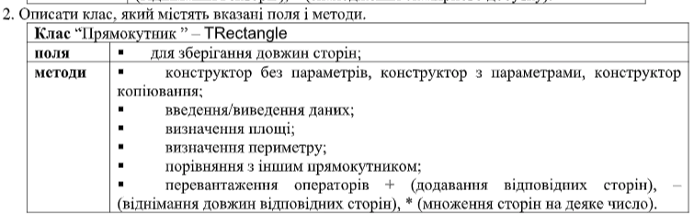

Розв’язок:

**class Rectangle:**

**a = 0**

**b = 0**

**def __init__(self, a, b):**

**self.a = a**

**self.b = b**

**def __str__(self):**

**return "Rectangle ({0}, {1})".format(self.a, self.b)**

**def input(self):**

**self.a = float(input("Rectangle Width = "))**

**self.b = float(input("Rectangle Height = "))**

**def area(self):**

**return self.a * self.b**

**def perimeter(self):**

**return (self.a + self.b) * 2**

**def __eq__(self, other):**

**return abs(self.area() - other.area()) < 0.0001**

**def __add__(self, other):**

**return Rectangle(self.a + other.a, self.b + other.b)**

**def __sub__(self, other):**

**return Rectangle(self.a * other.a, self.b - other.b)**

**def __mul__(self, n):**

**return Rectangle(self.a * n, self.b * n)**

**test = Rectangle(3,5)**

**print(test)**

**print("S = {0}".format(test.area()))**

**print("P = {0}".format(test.perimeter()))**

**print("+(7,5) = {0}".format(test + Rectangle(7,5)))**

**print("*5 = {0}".format(test * 5))**

**print("eq (3,5) = {0}".format(test == Rectangle(3,5)))**

**print("eq (6,10) = {0}".format(test == Rectangle(6, 10)))**

Вивід:

**Rectangle (3, 5)**

**S = 15**

**P = 16**

**+(7,5) = Rectangle (10, 10)**

**\*5 = Rectangle (15, 25)**

**eq (3,5) = True**

**eq (6,10) = False**