重点：

========================BASICS========================

PPT 12 Instructions

PPT 13 Data Representation and 件错就错

PPT 14 ALU 算术运算 and 电路实现

PPT 15 ALU 部件组成

PPT 16 Floating point numbers and 运算

========================CPU========================

PPT 21 x86 Instructions

PPT 22 MIPS

PPT 23 Datapath

PPT 24 Single Cycle

PPT 25 Multicycle

PPT 26 Pipeline

PPT 27 Hazards

PPT 28 Hazards2

========================MEMORY========================

**PPT 31 层次存储器系统 Hierarchical Memory and 动态存储DRAM**

* Hierarchical Memory
  + Hierarchy
    - Register
    - Cache
    - Main Memory
    - Magnetic Disk
    - Tape/Optical Disk
  + Features
    - Price, speed, reliability, go down along with the hierarchy
    - Capacity goes up when going down hierarchy
* Principle of Hierarchy 局部性原理
  + Spatial 空间局部性
  + Sequential 时间局部性
* DRAM
  + Characteristics
    - Reading is Slow
      * 破坏性读出
      * 定期刷新
    - 快速分页组织
    - High Capacity
      * Small unit storage area (area = the amount of devices it takes)
    - Low Cost
      * 1 transistor and 1 capacitor
  + Read/Write Process
    - Read
      * Send Data on Bit Line
      * Select Word Line
    - Write
      * Send a high voltage on the bit line
      * Select word line
      * Detect whether it’s a High or a Low
      * Write Back

**PPT 32 静态存储器Static Memory及高速缓冲存储器Cache**

* SRAM
  + Read/Write Process
    - Write
      * Set the Bit line (bit = 1, ~bit = 0)
      * Select word line
    - Read
      * Charge bit and ~bit with 高电平Vdd
      * Select the word line
      * Depending on the state of the 触发器 one of the bit lines will be low
      * 放大器will detect bit and ~bit’s changes, read stored value
  + Characteristics
    - High speed
    - Storage density is low, 单位面积存储容量小 (small storage capacity per unit area)
    - 数据入／出公用管脚 data entering/exiting uses same pins
    - 能耗高 high energy
    - 成本高 high cost

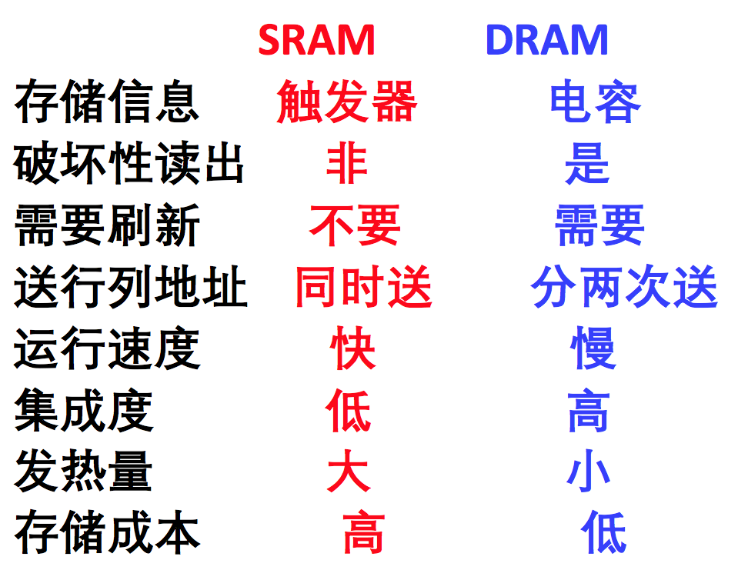

* Cache Parameters
  + 块(line/block): the smallest unit of data transferred to the cache
  + 命中(hit): found the thing you’re looking for
    - 命中率(Hit Rate): 命中次数／访问次数
    - 命中时间: the time it takes to send the data from the higher tier of memory to the CPU
  + 缺失(miss): blocks that you have to look for in lower tiers of the hierarchy
    - 缺失率 (miss penalty): 1 – 命中率
    - 缺失损失 (miss penalty): the time it takes for send data back to CPU
  + 命中时间<缺失损失
  + Average 访问时间= HR * 命中时间 + (1 - HR) * 缺失损失
* Typical values for parameters
  + 块大小:4~128 Bytes
  + 命中时间:1~4周期
  + 失效损失:
    - 访问时间:6~10个周期
    - 传输时间:2~22个周期
  + 命中率:80%~99%
  + Cache容量:1KB~256KB
* Cache Mapping地址映射
  + 直接映射 Direct Mapping
    - (see: <https://www.youtube.com/watch?v=pSarQQTJbDA>)
    - Process:
    - Characteristics:
      * Most simple
      * The tag is short, so the comparative circuit would be simple,
      * If the main memory has 2m blocks, cache has 2c blocks, then the tag only needs m – c bits.
      * Comparison only happens once
      * **利用率低，命中率低** Most amount of misses**，效率较低** Slowest
  + 全相联
    - Process:
    - Characteristics:
      * The main memory can correspond to any block in the cache, making Full associative cache mapping very flexible.
      * The tag (标志位) is long, so it takes a lot of resources to compare. If the main memory has 2m blocks, then the tag must have m bits
      * If the Cache has n blocks, then there needs to be n comparative circuits (比较电路)
      * **使用成本太高**
  + 多路组相连

PPT 33 Cache

PPT 34 虚拟存储器 Virtual memory

PPT 35 磁表面存储设备 Magnetic surface storage

PPT 36 光盘的存储原理 Disk storage

========================IO SYSTEM========================

PPT41 IO

PPT 42 总线 BUS

PPT 43 接口电路和外部设备Interface circuits and external devices