PHYS 1152 · Data analysis exercise
Work and Energy on an Air Track
Name: ______________________ Student ID: ____________ Date: __________
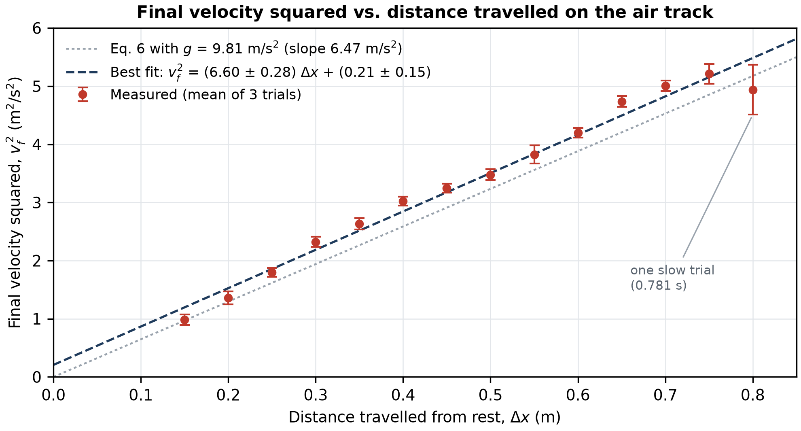
Figure 1. Square of the final velocity, v_{f}², of the air-track train (m = 100.6 ± 0.05 g) pulled from rest by a hanging mass (m′ = 49.5 ± 0.05 g), against the distance travelled between the light gates, Δx. Each point uses the mean of three timings, with v_{f} = 2Δx/t̄. Error bars show ±1 standard uncertainty, combining the standard error of the mean time and ±0.5 cm in Δx. Dashed line: unweighted least-squares fit (slope in m/s², intercept in m²/s²). Dotted line: Eq. 6 with g = 9.81 m/s².
Shape. v_{f}² increases linearly with Δx (R² = 0.979), as expected from Eq. 6, v_{f}² = 2g[m′/(m+m′)]Δx, for constant acceleration from rest. The intercept, 0.21 ± 0.15 m²/s², is within 1.5 uncertainties of the predicted zero. The one clear outlier is Δx = 0.80 m, where the first trial (0.781 s) is far from the other two (0.683 s, 0.696 s).
Slope. A least-squares fit (Excel LINEST) gives a slope of 6.60 ± 0.28 m/s². The uncertainty is the standard error of the slope, which LINEST estimates from the scatter of the 14 points about the line.
Error bars. Because the train starts from rest with constant acceleration, v_{f} = 2v_{avg} = 2Δx/t̄. Propagating gives δ(v_{f}²) = v_{f}²√[(2δt/t̄)² + (2δx/Δx)²], where δt is the standard error of the mean of the three times and δx = 0.5 cm. The bars are 0.08–0.17 m²/s² (2–6 %), except 0.43 m²/s² at 0.80 m because of the slow trial. The fitted line passes through only 6 of the 14 bars (10 of 14 lie within two bar-lengths). The bars therefore understate the real scatter: a standard error from only three trials is poorly determined (at 0.40 m the three times agree to within 4 ms), and the bars do not include variation in how the train was positioned and released.
Value of g. Comparing the slope with Eq. 6, slope = 2gm′/(m+m′), so g = slope × (m+m′)/(2m′) = 6.597 × 150.1 g/(2 × 49.5 g) = 10.00 m/s². Propagating the slope uncertainty and the ±0.05 g uncertainty of each mass in quadrature gives δg = √[(1.516 × 0.282)² + 0.003² + 0.007²] = 0.43 m/s², so g = 10.0 ± 0.4 m/s². The slope uncertainty dominates; the masses contribute almost nothing.
Comparison. The tabulated value, 9.81 m/s², is 0.19 m/s² (1.9 %) below our result, which is about 0.4 of our uncertainty, so the two agree. The agreement depends partly on the 0.80 m point: refitting without it gives a slope of 7.02 ± 0.17 m/s² and g = 10.6 ± 0.3 m/s², above 9.81 m/s². A likely systematic effect is that the timer starts when the train breaks the first beam. If the train starts slightly behind the beam, it is already moving when timing begins, so 2Δx/t̄ overestimates v_{f}. This would raise both g and the intercept, as we observe. Friction, air drag and the pulley would push g the other way, so they are not the cause.
Work–energy theorem. Because v_{f}² is proportional to Δx with the slope the theorem predicts, the kinetic energy gained by the system, ½(m+m′)v_{f}², equals the work done by gravity on the hanging mass, m′gΔx, within our ≈4 % uncertainty. Our data are consistent with the work–energy theorem, with no measurable energy lost to friction on the air track.

Raw data
Spreadsheet screenshot: three timings at each gate separation from 80 cm to 15 cm, the derived v_{f} and v_{f}², the standard error of each mean time, the error bars, and the LINEST output (slope 6.5965, standard error 0.2818).
