# ERD for RecyGlo Progress Tracking LMS

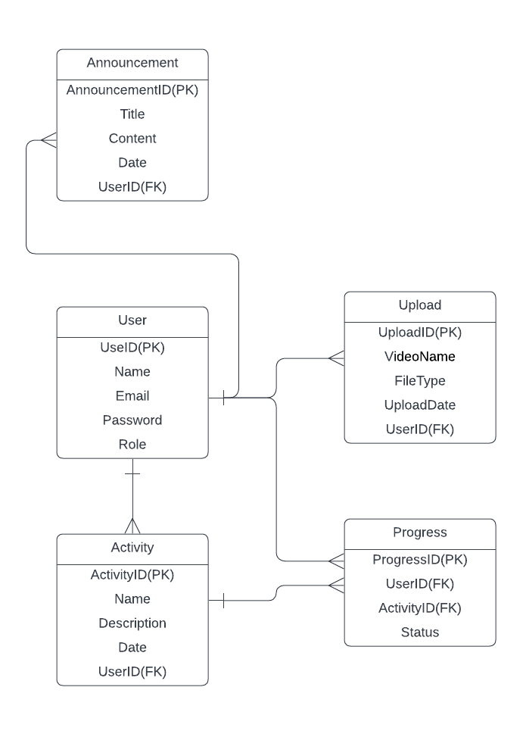

Fig- ERD of progress tracking LMS

**Link**- https://lucid.app/lucidchart/62072a77-5708-4e35-86f7-57cf08ec1dbf/edit?viewport_loc=-151%2C-179%2C2338%2C986%2C0_0&invitationId=inv_1eebd0f9-32d8-4612-8cc3-62036d7b3a5f