**Report**

Data

The data is a collection of names, net worth and car descriptions. It is a mock data.

|  |  |  |  |  |  |  |
| --- | --- | --- | --- | --- | --- | --- |
| **first_name** | **last_name** | **car_color** | **car_make** | **car_types** | **car_model_year** | **net_worth** |
| Tadd | Robet | Blue | BMW | van | 2013 | 659243.6 |
| Gaylor | Gabler | Blue | BMW | truck | 1989 | 986879 |
| Jermaine | Fayerbrother | Blue | BMW | roadster | 2003 | 799169 |
| Weider | Whitehead | Blue | BMW | roadster | 2001 | 670754.1 |
| Lexie | Gniewosz | Blue | BMW | pickup | 2005 | 412285.1 |
| Hilton | Halladay | Pink | BMW | SUV | 2006 | 621479.7 |
| Abbie | Meaden | Pink | BMW | pickup | 2010 | 139936.5 |
| Hermie | Eveque | Yellow | BMW | pickup | 2007 | 193534.5 |
| Claudetta | Humphris | Yellow | BMW | pickup | 1998 | 412677.9 |
| Trevor | Pybworth | Yellow | BMW | roadster | 1994 | 239528 |
| Toddy | Patriskson | Yellow | BMW | roadster | 2005 | 416825.2 |
| Emmy | Baldelli | Blue | BMW | SUV | 2005 | 997435.8 |
| Thadeus | Alywin | Pink | BMW | SUV | 2009 | 924073.3 |
| Krystyna | Chellenham | Pink | BMW | roadster | 1997 | 533954.9 |
| Eimile | Dellenbrook | Red | BMW | pickup | 2006 | 435720.2 |
| Otto | Sobczak | Blue | Ford | SUV | 1997 | 43566.33 |
| Gram | Hedau | Blue | Ford | truck | 1973 | 996555.9 |
| Elton | Nizard | Blue | Ford | pickup | 1986 | 765858.8 |
| Anneliese | Cropton | Blue | Ford | roadster | 2003 | 235883.5 |
| Colly | Skacel | Yellow | Ford | roadster | 2002 | 377871.2 |
| Clarette | Cornwall | Blue | Ford | van | 1999 | 967240.8 |
| Codee | Corradetti | Yellow | Ford | truck | 1997 | 6451.09 |
| Cheslie | Beilby | Blue | Hyundai | van | 2009 | 253980.9 |
| Clarita | Churm | Blue | Mitsubishi | van | 1986 | 561020.2 |
| Carlyn | Sherwin | Blue | Mitsubishi | SUV | 2000 | 935157.4 |
| Cheston | Roscow | Pink | Mitsubishi | SUV | 2008 | 434446.9 |
| Chaunce | Sweating | Pink | Mitsubishi | SUV | 1992 | 334998.1 |
| Patsy | Wozencraft | Pink | Mitsubishi | truck | 1996 | 831102 |
| Franky | Armit | Pink | Mitsubishi | pickup | 2005 | 283982.3 |
| Bendicty | Gilluley | Red | Mitsubishi | SUV | 2010 | 576297 |
| Kyrstin | Habbert | Red | Mitsubishi | SUV | 1968 | 292616.6 |
| Briant | Hoopper | Red | Mitsubishi | SUV | 1996 | 251745.1 |
| Kary | MacRory | Red | Mitsubishi | roadster | 1995 | 504786.9 |
| Lanie | Kuscha | Yellow | Mitsubishi | truck | 1994 | 876337.4 |
| Hartwell | Mair | Yellow | Mitsubishi | roadster | 1997 | 215697.3 |
| Dael | Bissex | Yellow | Mitsubishi | truck | 1987 | 97048.27 |
| Maddie | Cowin | Yellow | Toyota | roadster | 1995 | 702778.5 |
| Rufus | Grattage | Yellow | Toyota | SUV | 2006 | 952957.9 |
| Alicia | Bysaker | Blue | Toyota | van | 1995 | 555120.7 |
| Artair | Langton | Blue | Toyota | van | 1996 | 334259.7 |
| Jemima | Larkings | Pink | Toyota | van | 1999 | 202756.6 |
| Gael | Tomashov | Pink | Toyota | van | 1996 | 26057.08 |
| Godard | Bredee | Pink | Toyota | truck | 1993 | 428668 |
| Veronike | Dumper | Pink | Toyota | truck | 1994 | 297365.6 |
| Haleigh | Narramor | Red | Toyota | van | 2012 | 390441.1 |
| Carmencita | McGlew | Red | Toyota | roadster | 2011 | 447756.1 |
| Nikolia | Bartolomeotti | Yellow | Toyota | pickup | 2011 | 675907.6 |
| Min | Pray | Yellow | Toyota | roadster | 2011 | 24306.61 |
| Clayborn | Docherty | Yellow | Toyota | pickup | 2011 | 966634.1 |
| Belle | Yanov | Yellow | Toyota | pickup | 1997 | 68545.83 |

Test Case / Use Cases

1. Requirements met: Standard #1, #2, #3, #4, #10

Lines 182 – 194 shows how types of data are decided, categorical data are differentiated to a text data if there are 5 or less unique values of that column.

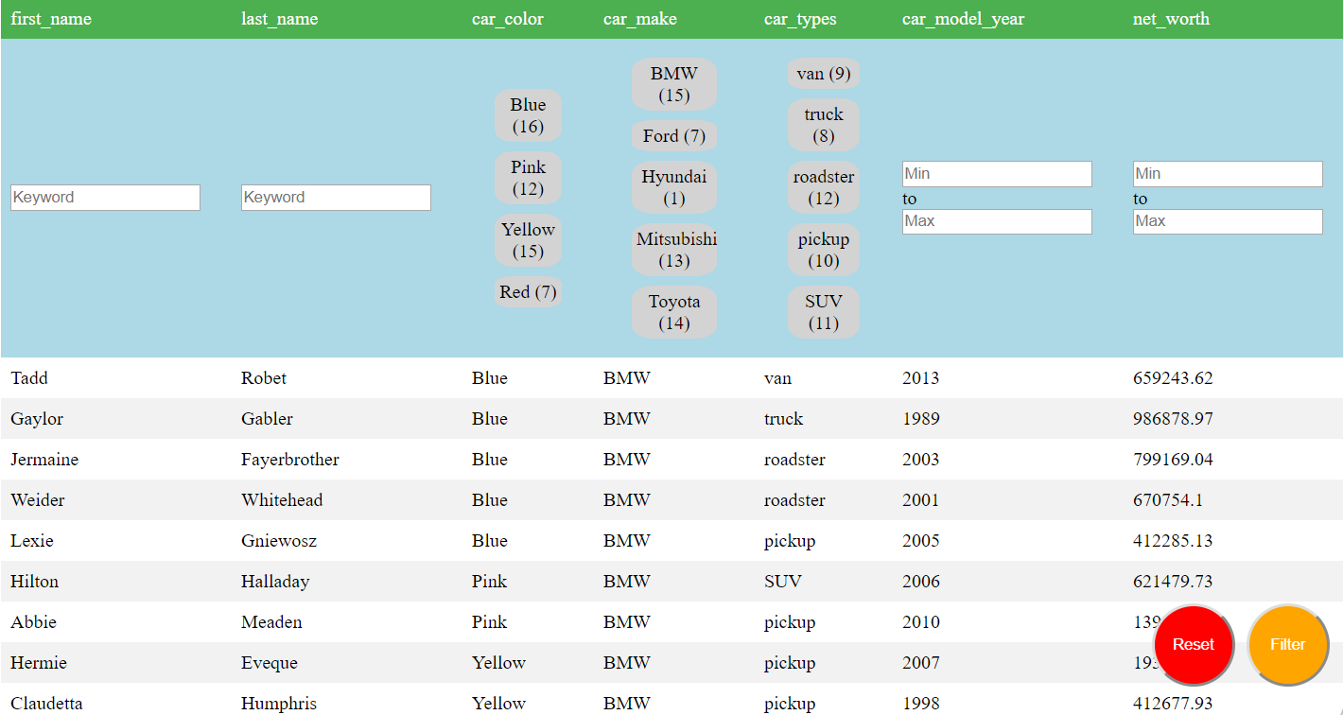

1. Requirements met: Standard #5, #6 and Advanced #2

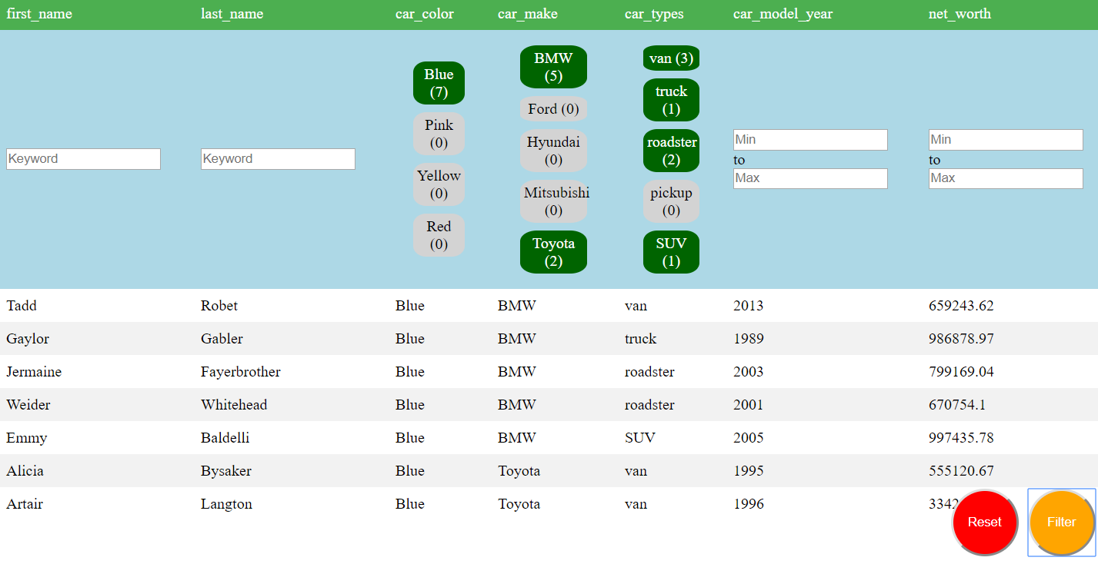

1. Requirements Met: Standard #7

After you click reset given the previous screenshot is the previous state.

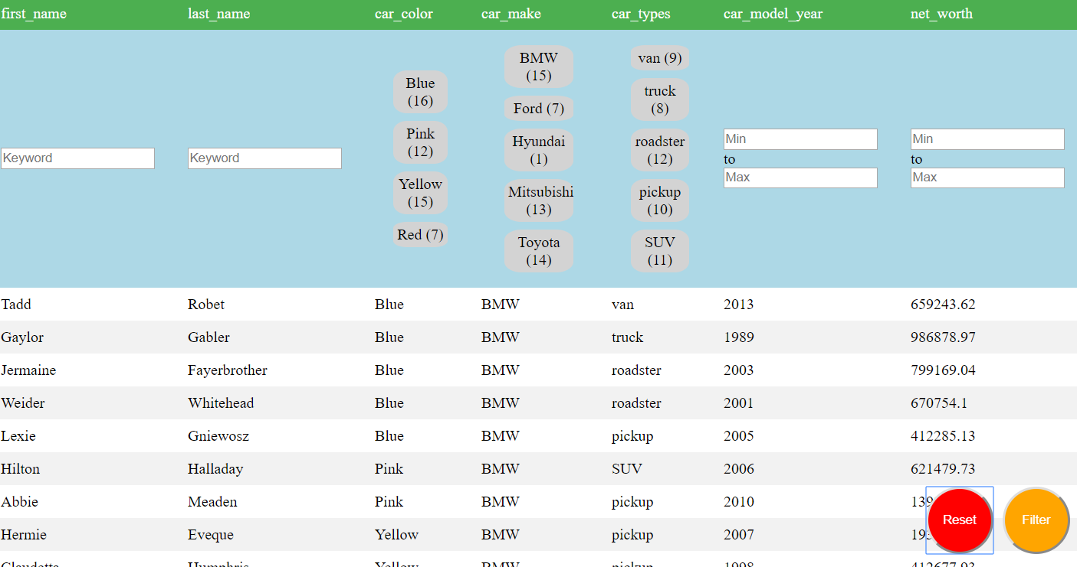

1. Requirements Met: Standard #9

Refreshing the browser or exiting it would persist the filters. (Requirements partially met as it didn’t save the list of filters but instead saved only the latest filter)

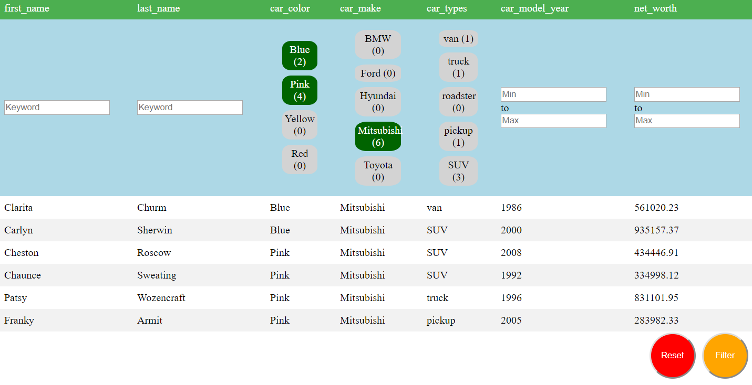

1. Requirements Met: Standard #11

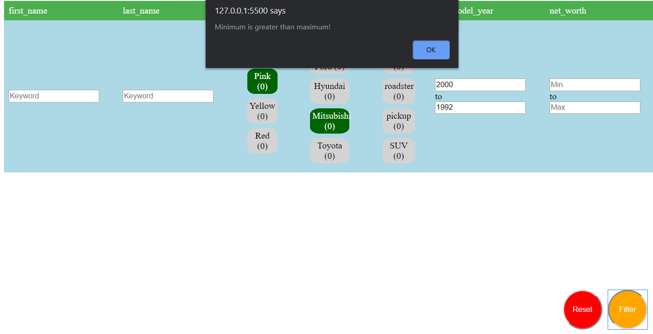

If maximum is less than minimum, a pop up will show.

Also, you can’t type anything other than numbers in the input boxes.

1. Requirements Met: Advanced 1

As you can see in first column (first_name), the filter is set to CL also with car_color blue. This shows the capabilities of the text filter using a keyword.

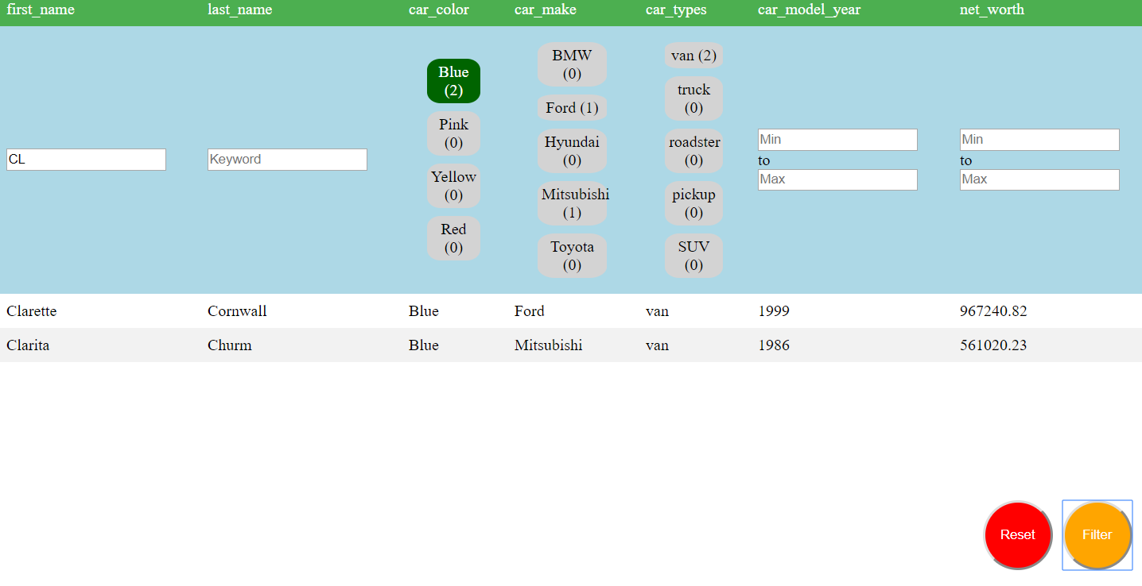

1. Requirements Met: Advanced #3

All MOCK_DATA.csv displayed.

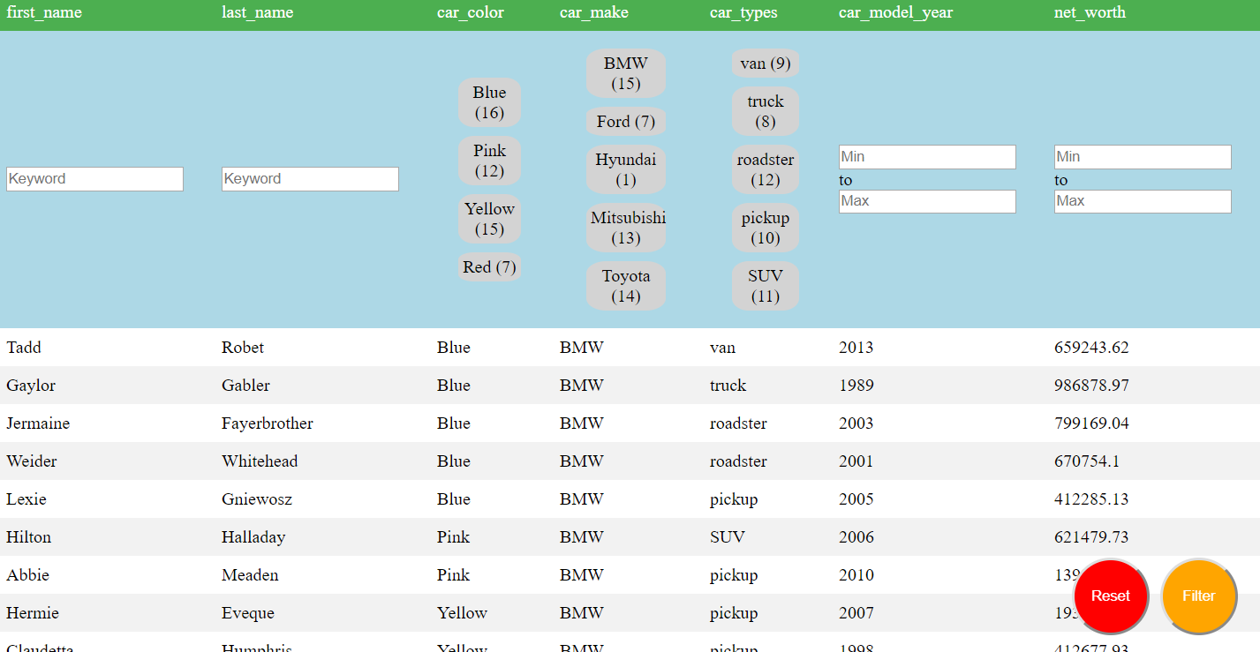

Removing all but 7 columns.

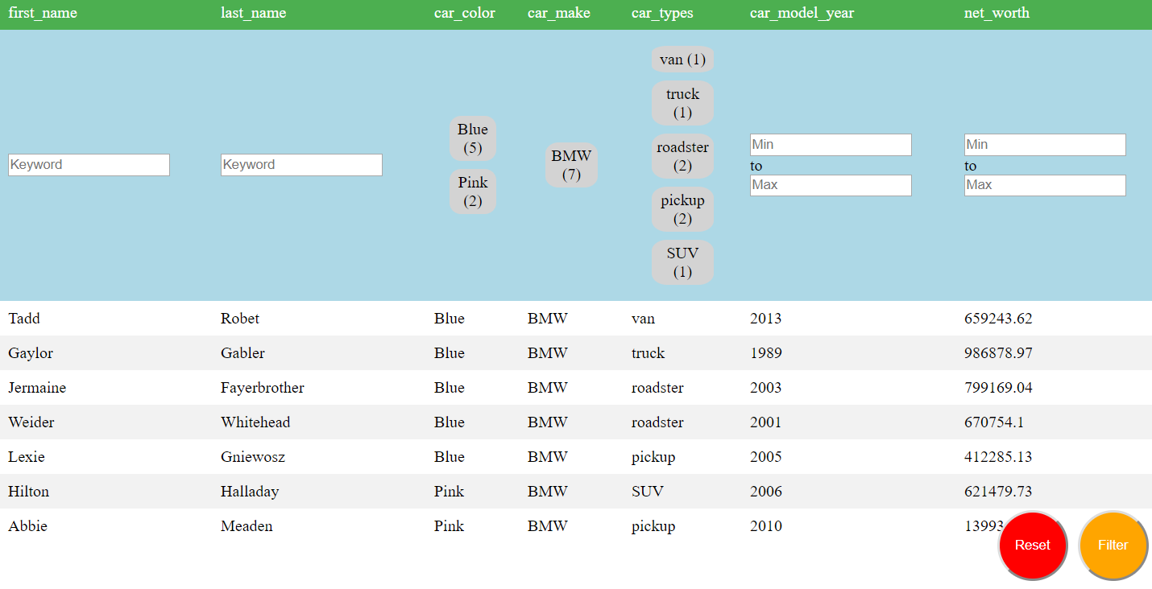

Removing last_name, car_types and car_model_year

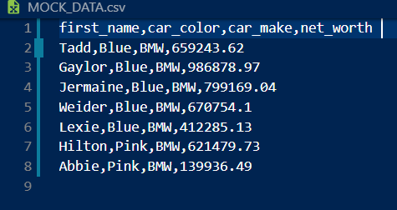

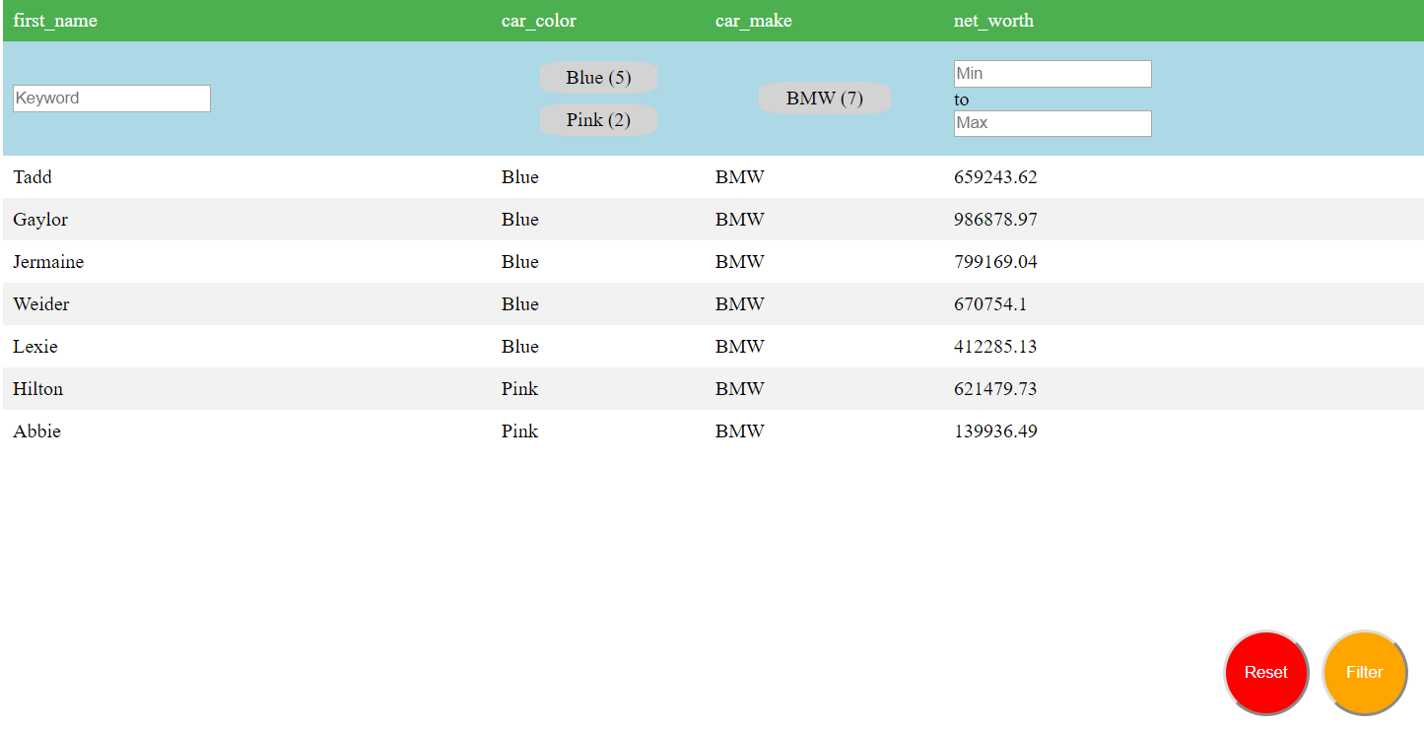

Adding back car_types and car_model_year

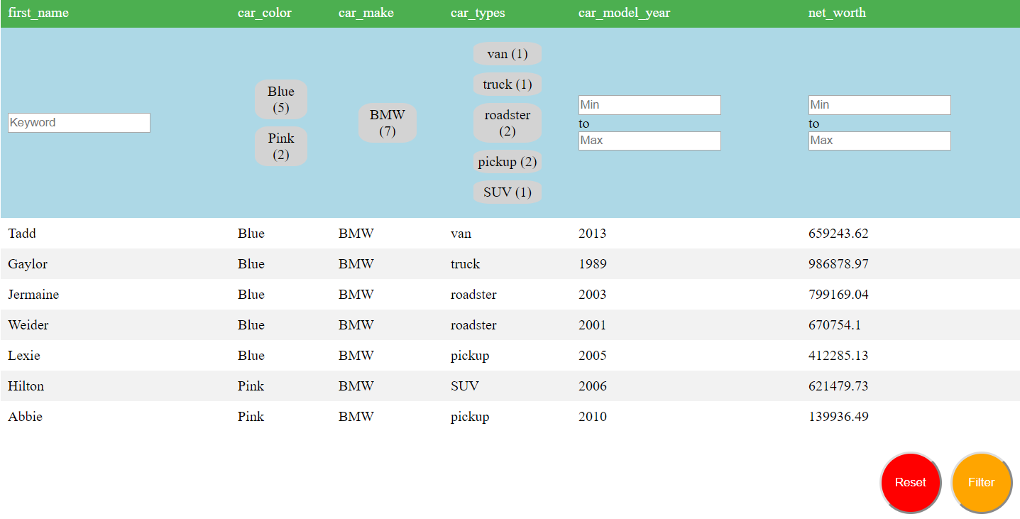

Adding a new row, [Newman, Brown, Ferarri, sportscar, 2020, 100000]

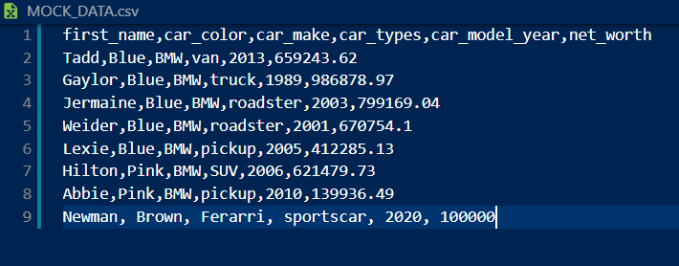

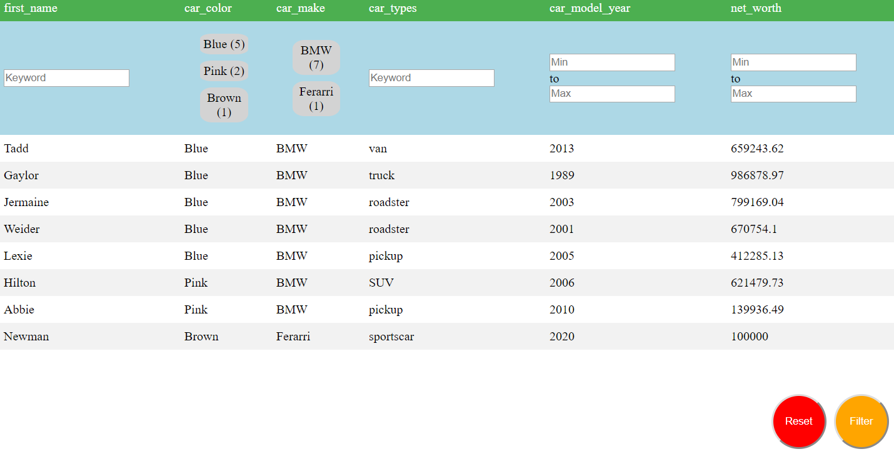

Other requirements met: Standard #13. #8

The code is composed of multiple functions that work together. If there are functions that are not interrelated and doesn’t use global variables thus easy to maintain.

Data is from a server as and has 50 rows as seen in line 3.

