Grading the professor: Many college courses conclude by giving students the opportunity to evaluate the course and the instructor anonymously. However, the use of these student evaluations as an indicator of course quality and teaching effectiveness is often criticized because these measures may reflect the influence of non-teaching related characteristics.
In this homework assignment, you need to perform various descriptive statistics to visualize the data from this study in order to learn what goes into a positive professor evaluation.

The data: The data were gathered from end of semester student evaluations for a large sample of professors from the University of Texas at Austin. In addition, six students rated the professors’ physical appearance. (This is a slightly modified version of the original data set that was released as part of the replication data for Data Analysis Using Regression and Multilevel/Hierarchical Models (Gelman and Hill 2007).) The result is a data frame where each row contains a different course and columns represent variables about the courses and professors.
Download the “evals.csv” file located in this module. Save it to a convenient folder on your computer and load it into R. Change the file location (stuff in “ ” below) to match where this file is located!

evals <- read.csv("D:/SJU/DSS 445 R Statistical Programming/evals.csv",header=T)

Variable | Description of Variable
score | average professor evaluation score: (1) very unsatisfactory - (5) excellent.
rank | rank of professor: teaching, tenure track, tenured.
ethnicity | ethnicity of professor: not minority, minority.
gender | gender of professor: female, male.
language | language of school where professor received education: english or non-english.
age | age of professor.
cls_perc_eval | percent of students in class who completed evaluation.
cls_did_eval | number of students in class who completed evaluation.
cls_students | total number of students in class.
cls_level | class level: lower, upper.
cls_profs | number of professors teaching sections in course in sample: single, multiple.
bty_avg | average beauty rating of professor.
pic_outfit | outfit of professor in picture: not formal, formal.
pic_color | color of professor’s picture: color, black & white.

Problem 1: Perform some descriptive statistics on the professor’s ages (variable called age). Calculate some summary statistics and display the data using a histogram (with proper colors, labels, titles, etc.)

Problem 2: Visualize the relationship between course evaluation scores (score) and the ages (age) of the professors using a scatterplot. Make the graph visually appealing by changing the type of point, the xlim to be 1-5 and ylim to be 20-80, the colors, the axis labels, and the title of the graph. Does there appear to be an association between professor’s age and evaluation score? Quantify this association with the correlation coefficient.

Problem 3: Describe the relationship between course evaluation scores and native language of the professor by creating a side-by-side boxplot. Also visualize the distributions of course evaluation scores by language using two histograms in the same graphics window. For both the histograms and boxplot, change the color and titles of the graphs. Do native English-speaking or native non English-speaking professors get higher course evaluations, on average? Is it a statistically significant difference?
Problem 4: Summarize the gender of professors using a table and a bar plot. Make sure the table and plot are properly labeled and titled!
Problem 5: Describe the relationship between rank of the professor (rank) and the level of the course (cls_level) by generating a two-way table and a clustered bar plot. Add a title to the clustered bar plot. Add a legend to the plot describing the bar colors of each group.

What to submit??
You should be submitting a R script file with all code for each problem. You also should submit a Word document with output (graphs, tables, etc.) and a few sentences describing what you found for each problem. (i.e. what relationships did you find or not find based on the R output?)
I am not only going to be grading your R code to produce the output, but also your interpretations and conclusions of the output!

Loading in the data:
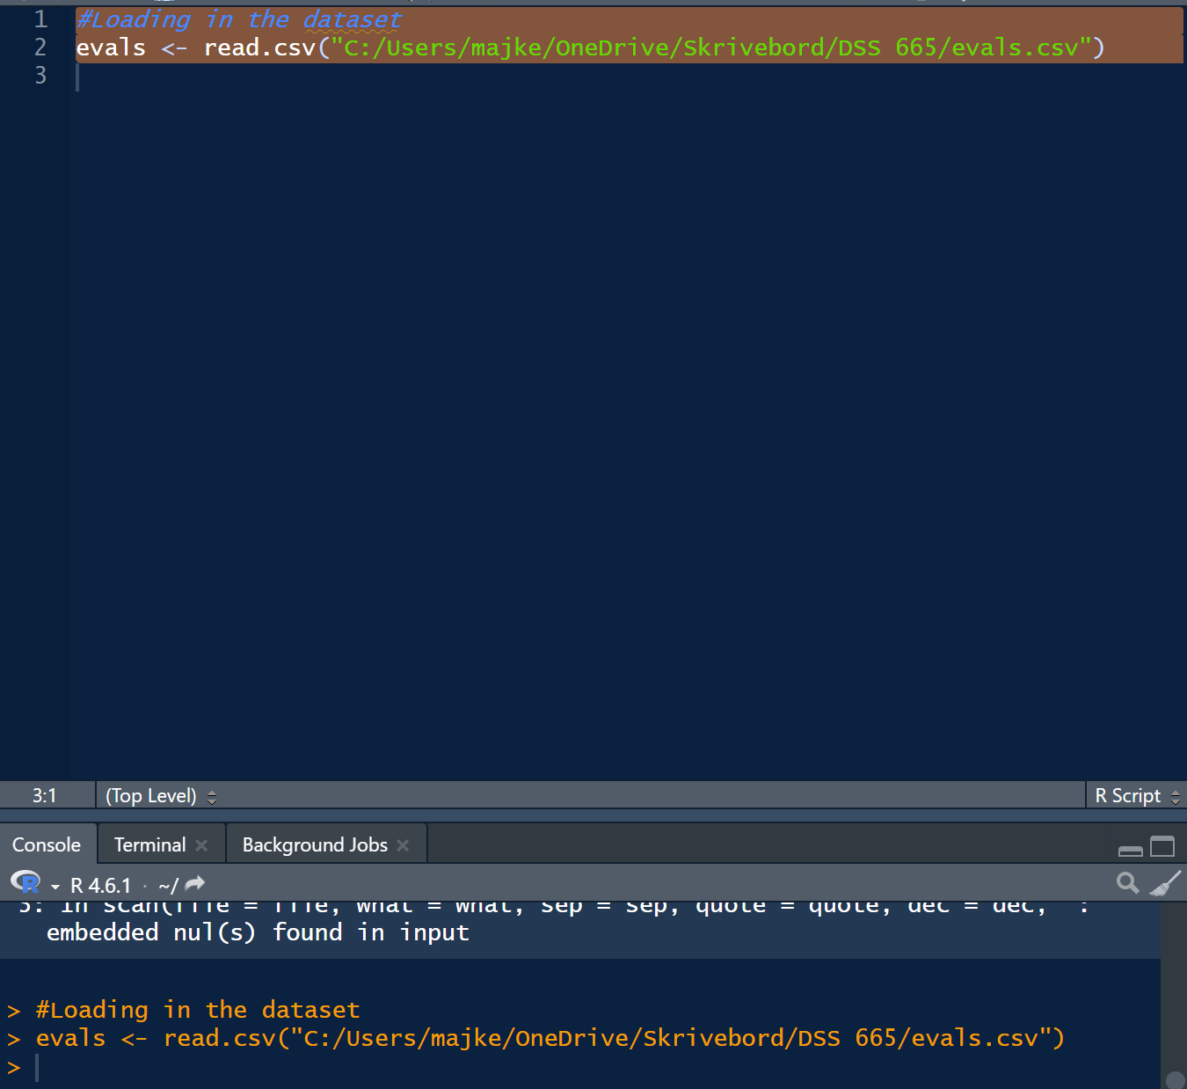

Problem 1:
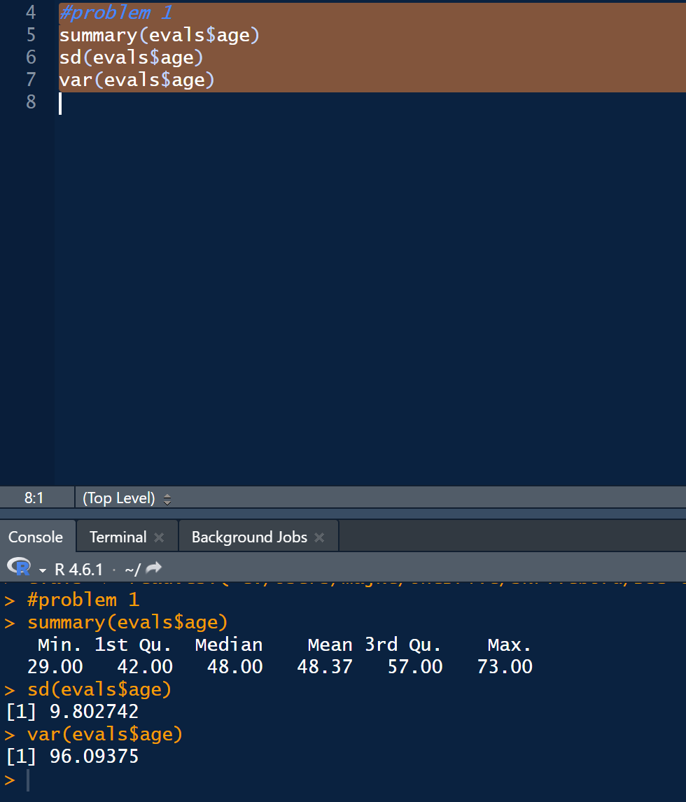
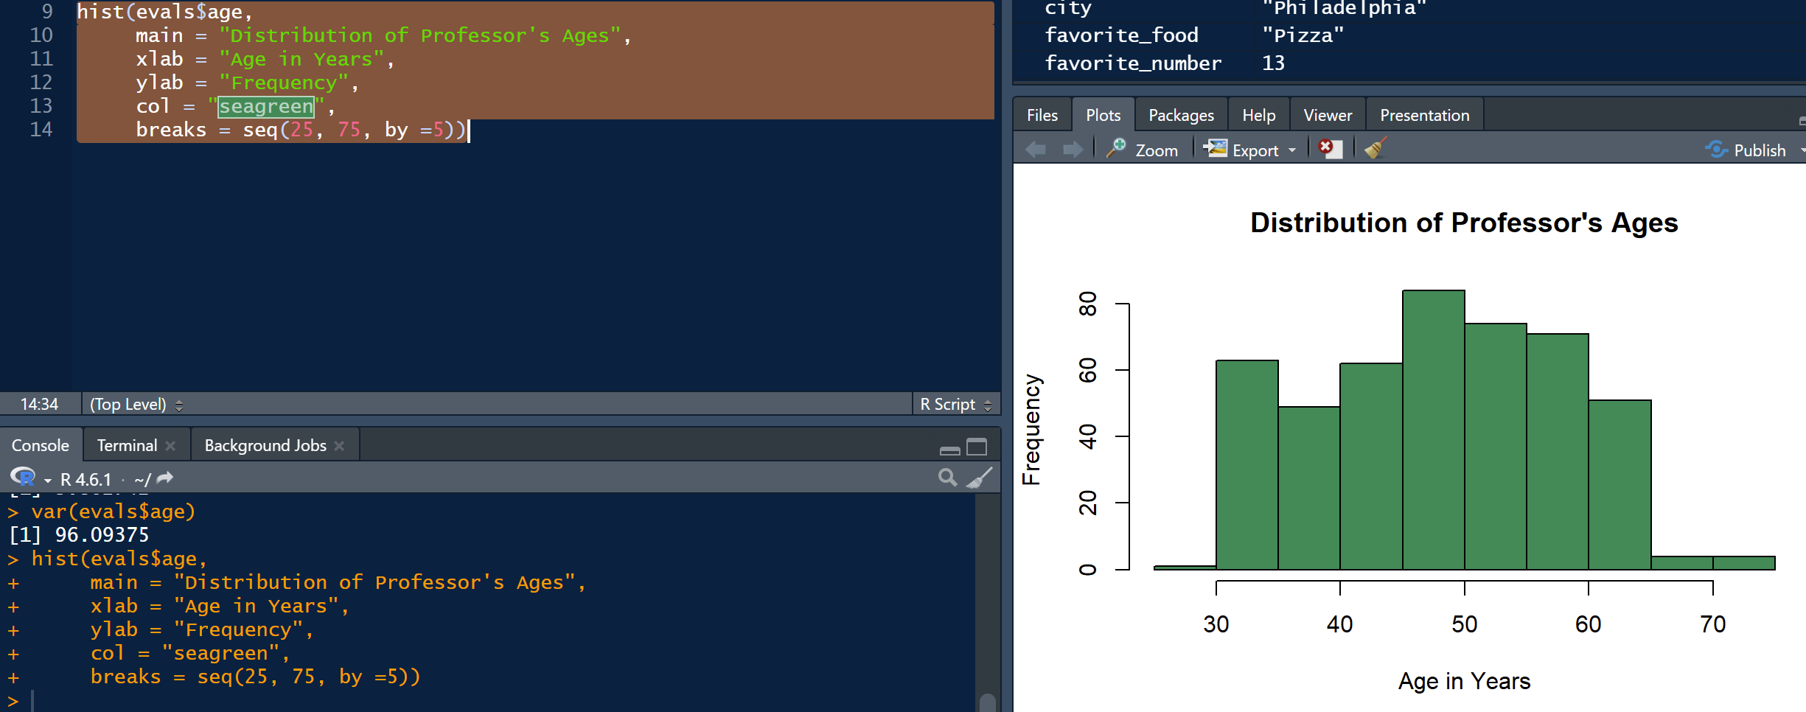
From these descriptive statistics we can see that the youngest professor is 29 whilst the oldest is 73. The Average age is 48 and the standard deviation is 9. From the histogram we can see that the biggest age group is 45-50 yearolds and and very few are above the age of 65. The distribution is roughly symmetric and most observations lie around the mean.
Problem 2:
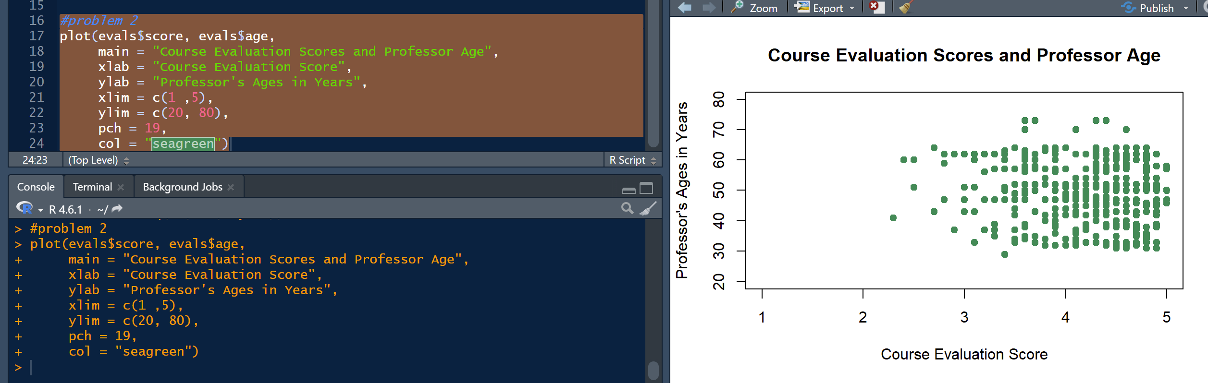
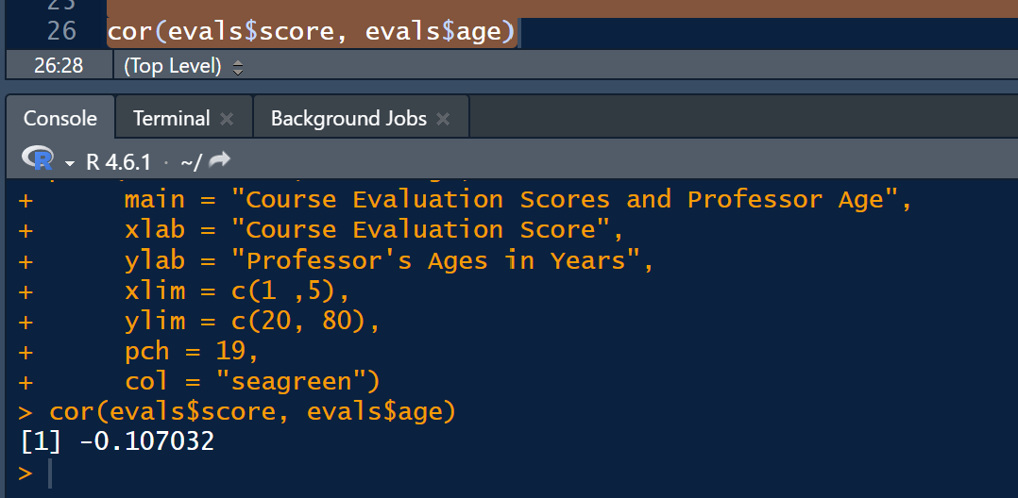
The scatterplot shows little assocication between professor’s ages and their evaluation scores. The correlation coefficient is -0.11 which shows a very low negative linear association, meaning older professors tend to receive slightly lower scores, but the relationship between the two is small.

Problem 3:
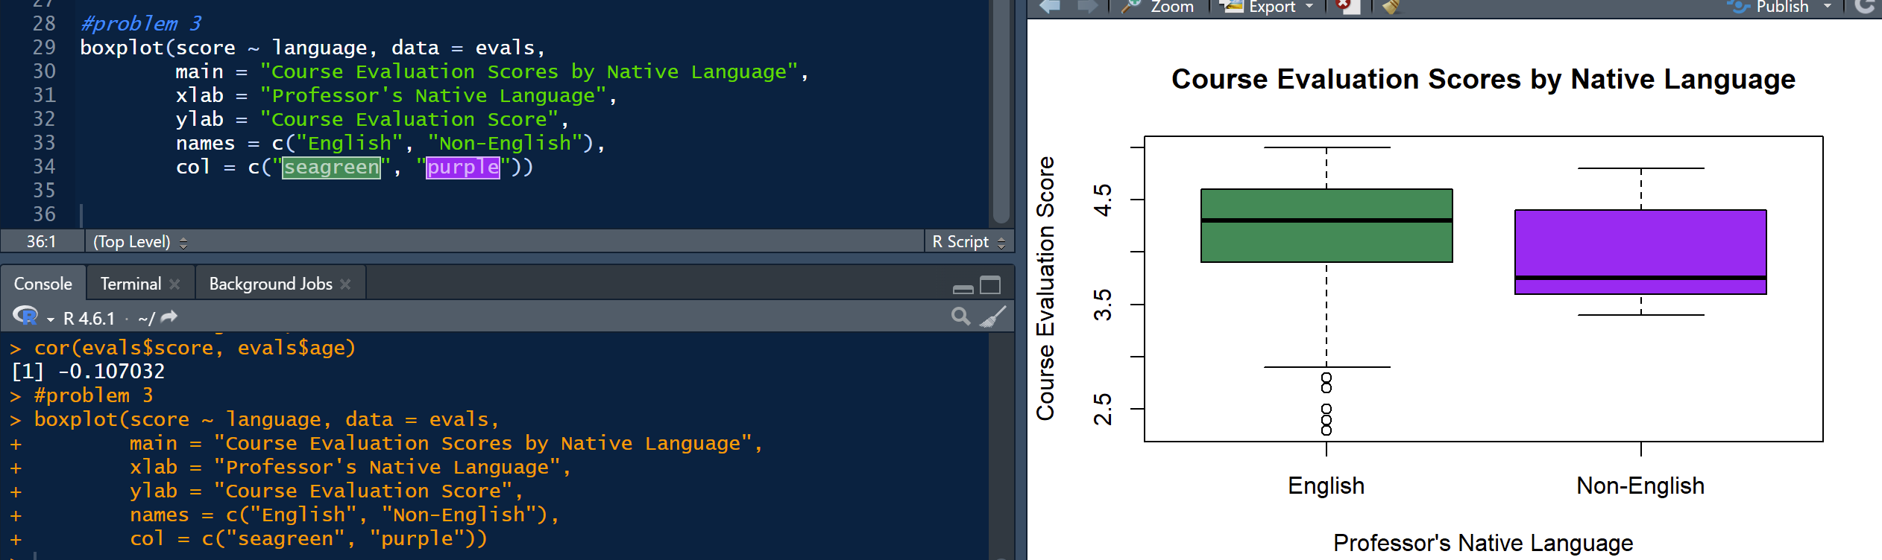
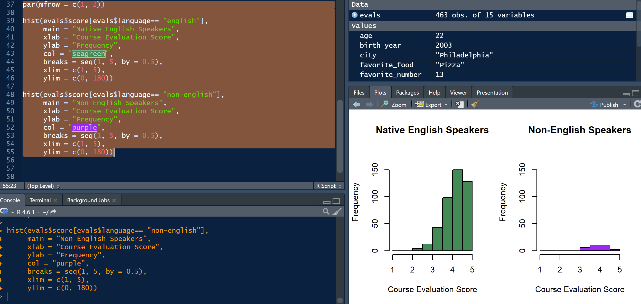
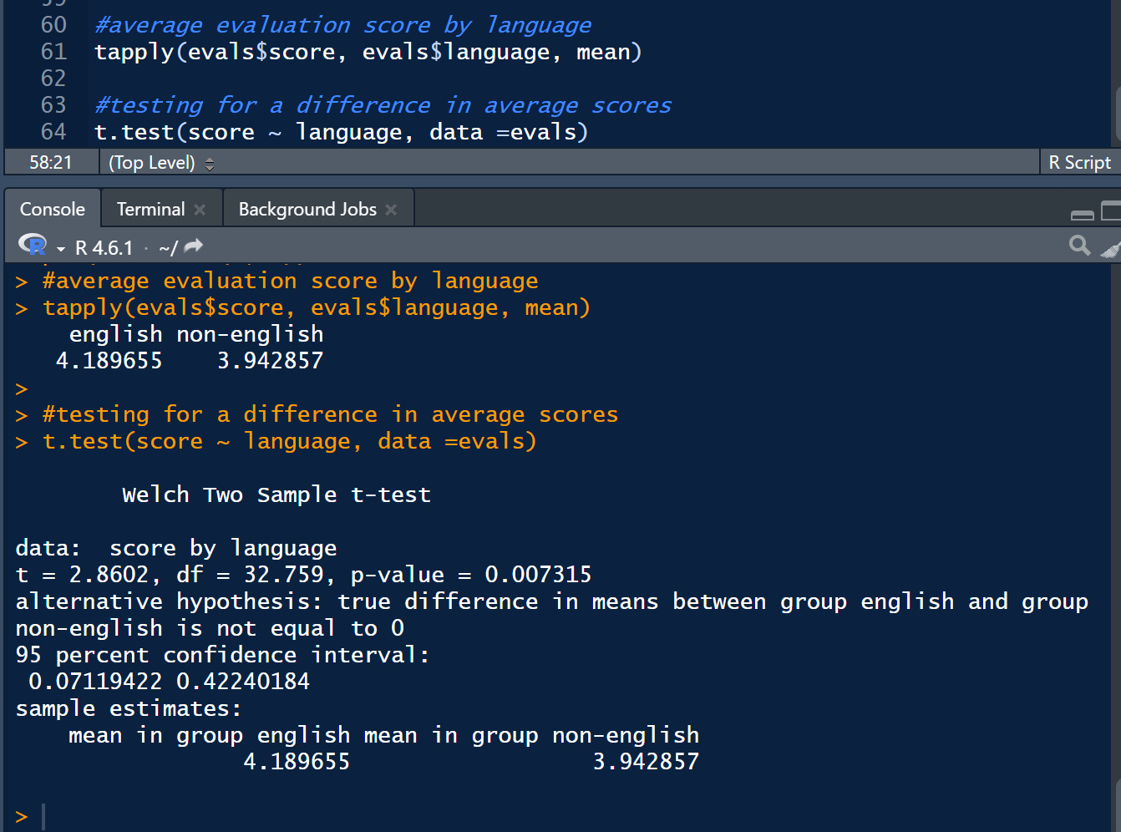
From the above we can see that native english speakers receive on average higher scores (4.1 vs 3.9). The p value given is 0.007 which is below 0.05, so the difference is statisically significant at this level.
We can also see this from the boxplot which has a lower 1st, 2nd and 3rd quartile for non-native english speakers compared to native english speakers. From the histograms we can see that there are way less non-native english speakers in this dataset. The majority of them got 3.5-4.5 in score, whereas the native english speakers in majority got 4-5 in score.
Problem 4:
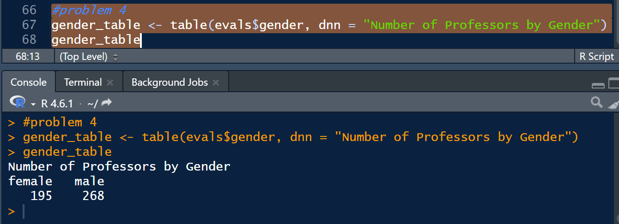
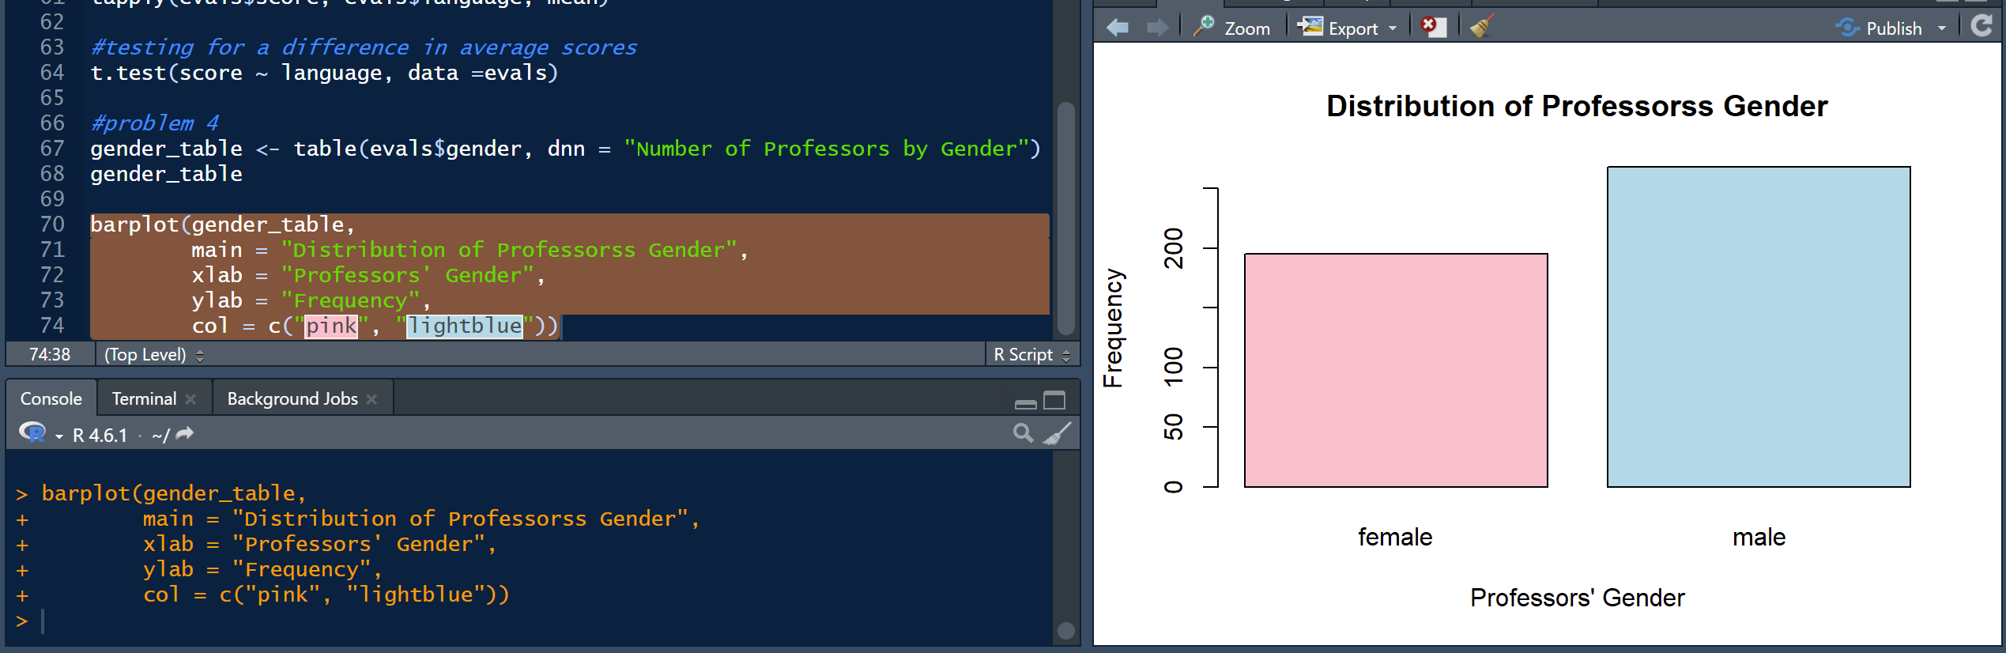
From the barplot we can tell that there are more male professors than female professors in this dataset.
Problem 5:
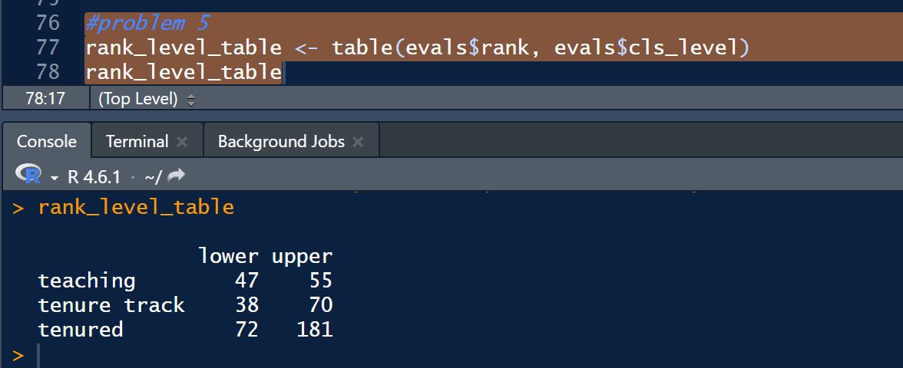
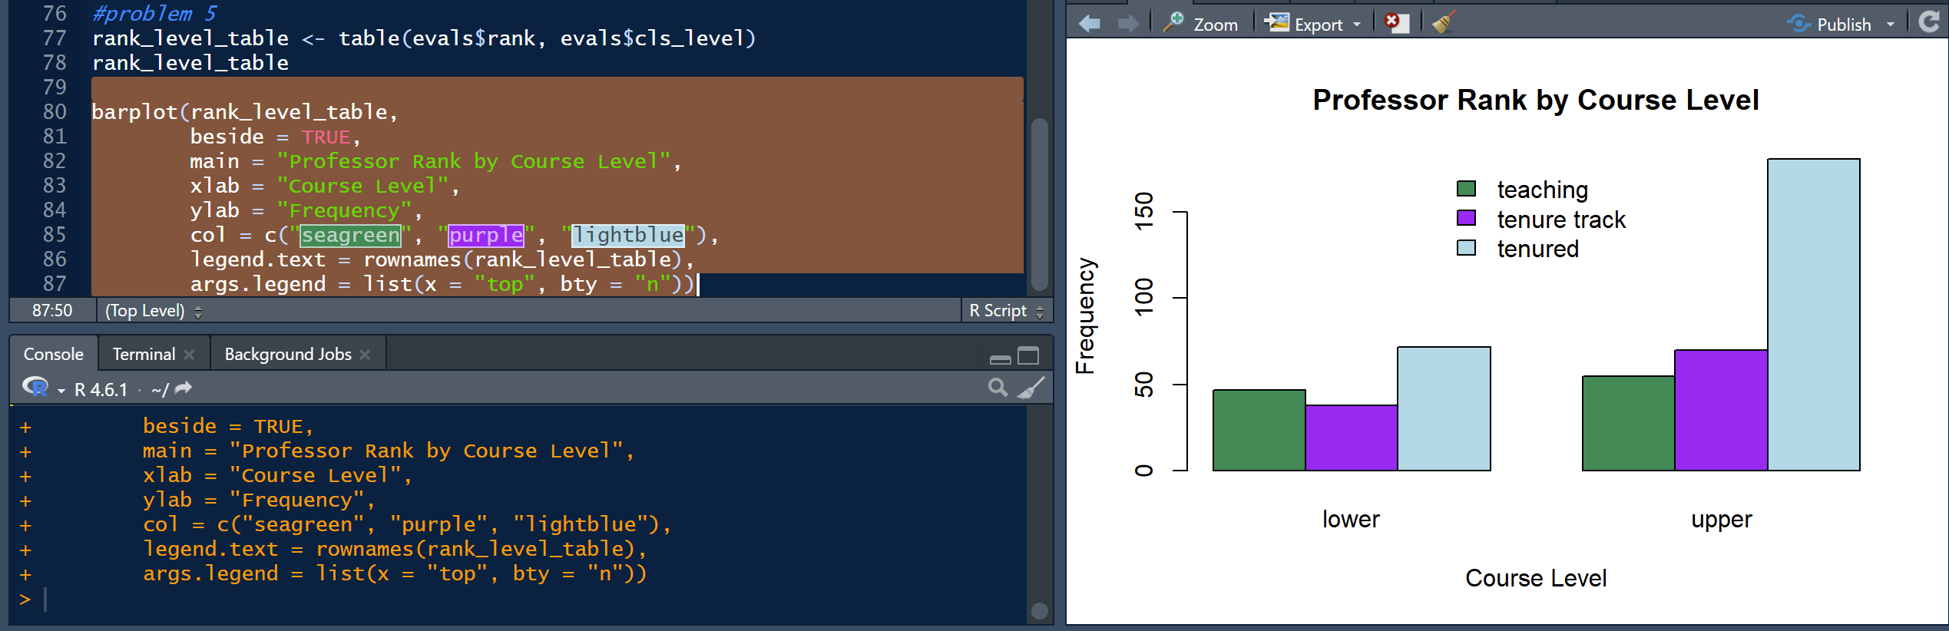
From the barplot we can tell that for upper course levels the vast majority of professors are of the tenured rank. For the lower course levels, the tenured professors represent the bigesst group but not by much.

