Problem 1: load the ISwR package and run the code below.
library(ISwR)
age <- juul[ ,1]
igf1 <- juul[ ,4]
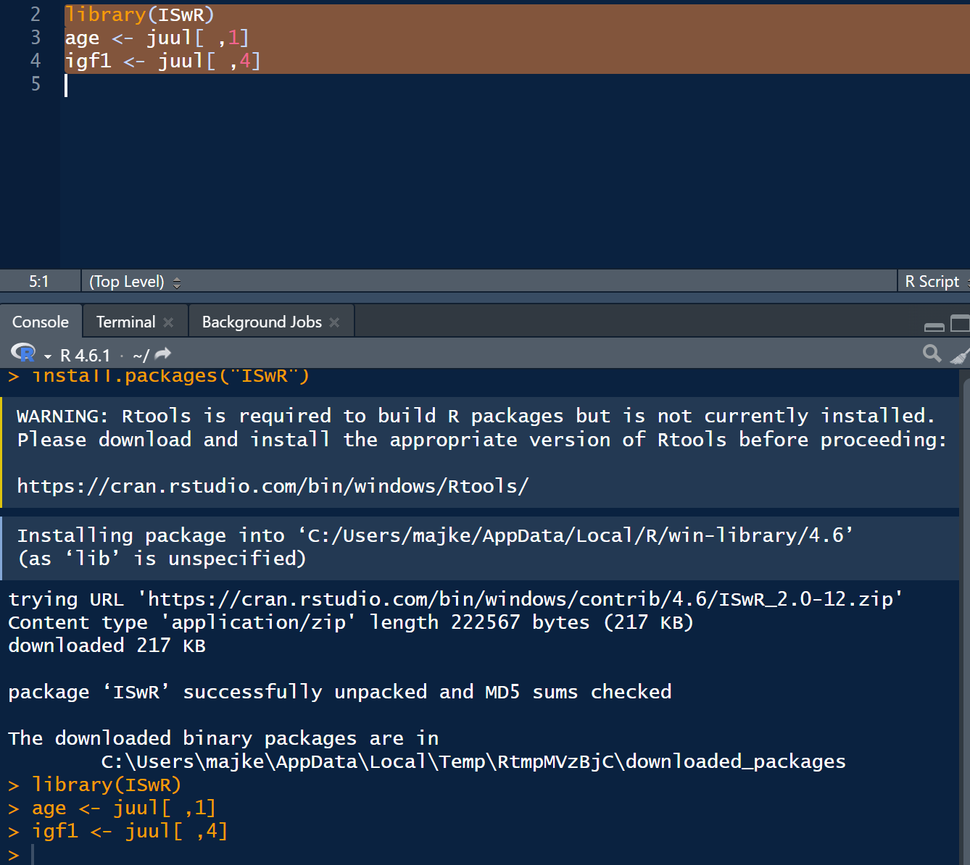

Now, create a scatterplot of age vs. igf1 variable. Change the points to blue solid squares. Add a title.
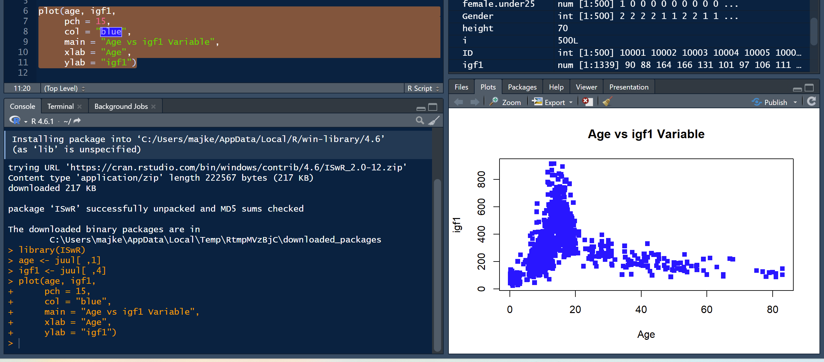
plot(age, igf1,
+ pch = 15,
+ col = "blue",
+ main = "Age vs igf1 Variable",
+ xlab = "Age",
+ ylab = "igf1")

Notice that there are 9 observations in this data set that has age right around 80 years old. Change these 9 points to be red circles.
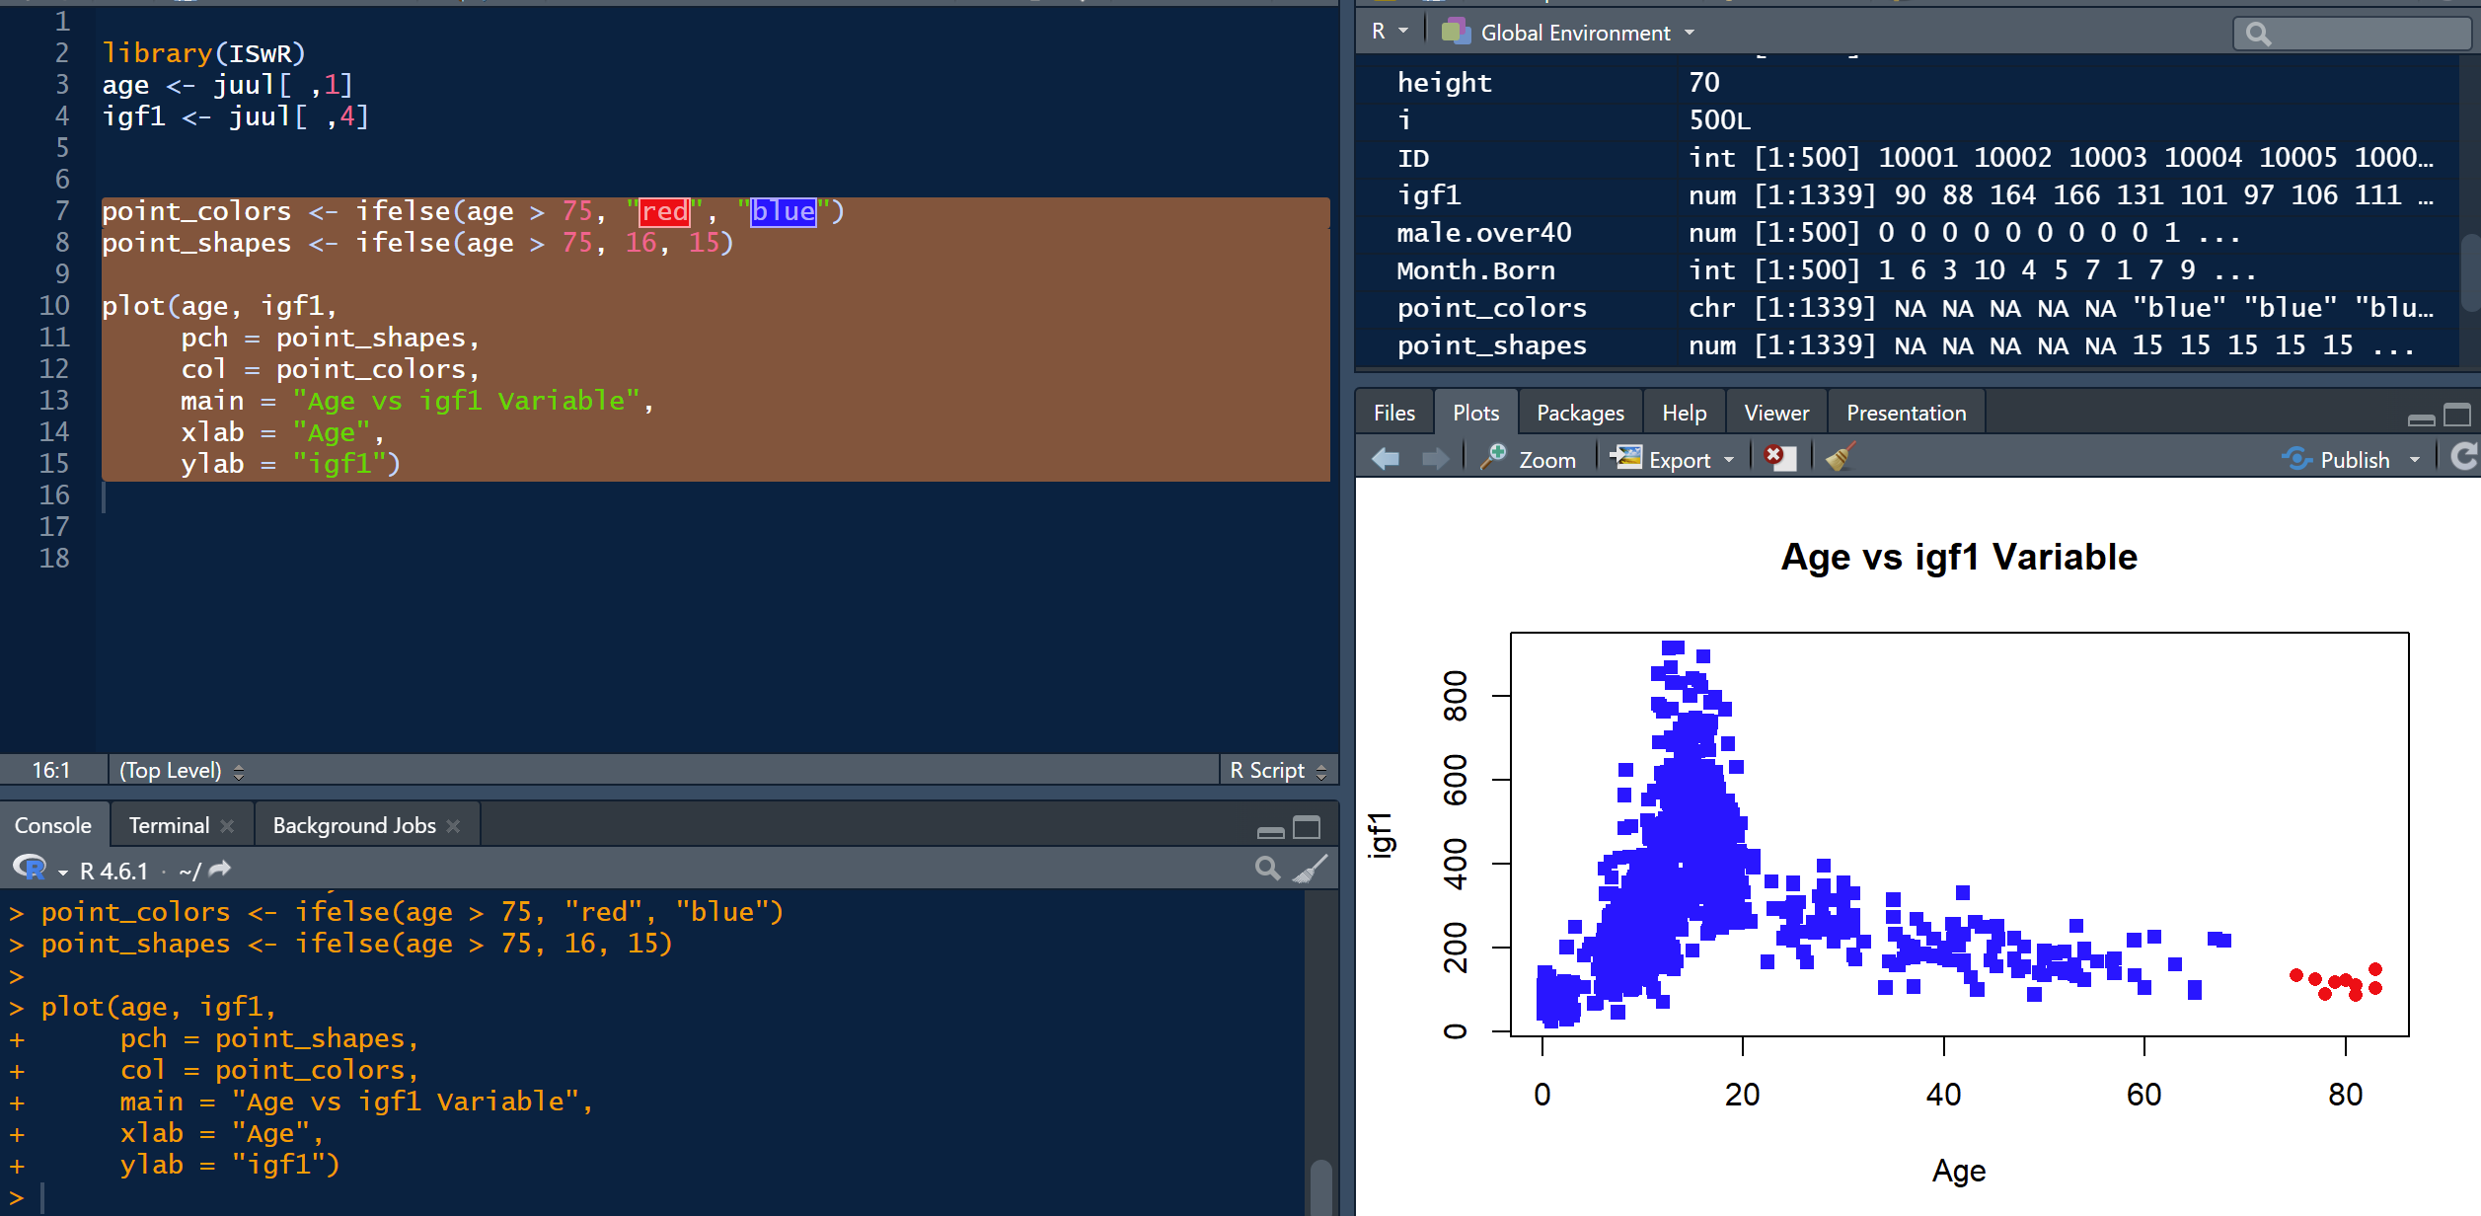
point_colors <- ifelse(age > 75, "red", "blue")
> point_shapes <- ifelse(age > 75, 16, 15)
>
> plot(age, igf1,
+ pch = point_shapes,
+ col = point_colors,
+ main = "Age vs igf1 Variable",
+ xlab = "Age",
+ ylab = "igf1")

Problem 2: Use R to write a for-loop that prints the following output:
1
3
5
7
9
11

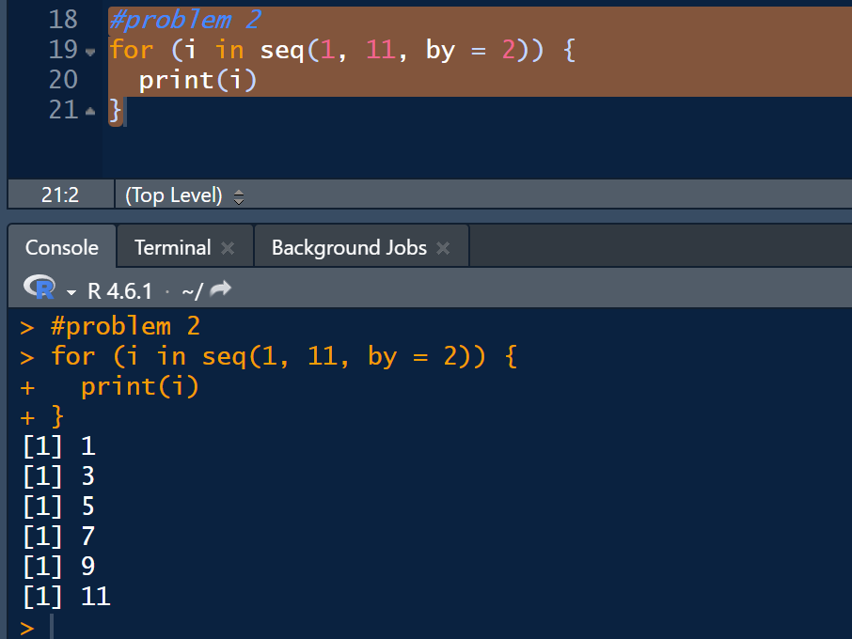
#problem 2
> for (i in seq(1, 11, by = 2)) {
+ print(i)
+ }
[1] 1
[1] 3
[1] 5
[1] 7
[1] 9
[1] 11

Problem 3: Write a while loop that prints the same output as the for-loop for Problem 2.

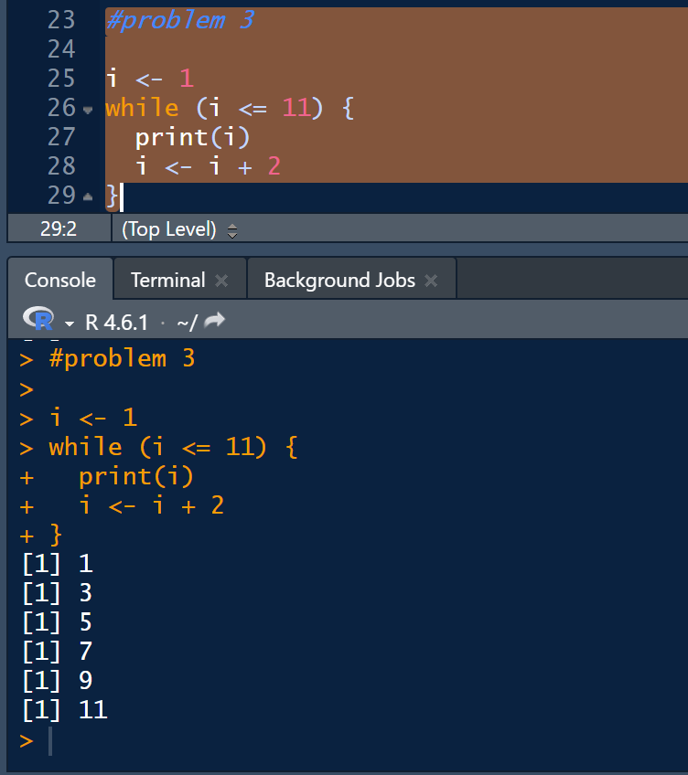
#problem 3
>
> i <- 1
> while (i <= 11) {
+ print(i)
+ i <- i + 2
+ }
[1] 1
[1] 3
[1] 5
[1] 7
[1] 9
[1] 11

Problem 4: Write an if-statement nested inside your for-loop from Problem 2 that prints "three" instead of the output "3", so that the output becomes:
1
“three”
5
7
9
11


