**Using the Custom GUI Template Creator from JSON in Unity**

This document provides step-by-step instructions on how to use the custom GUI template creator in Unity to generate a user interface (UI) from a JSON template.

**Prerequisites**

* Unity installed on your computer.
* The custom GUI template creator window added to your Unity project.

**Step 1: Open the GUI Generator Window**

* Launch Unity.
* In the Unity Editor, click on the "Window" menu at the top.
* From the "Window" menu, find and click on "GUI Generator."

**Step 2: Populate the JSON File Name**

* In the GUI Generator window, locate the "JSON File Name" field.
* Enter the file name of your JSON template. Ensure the file is placed in an accessible location within your project.

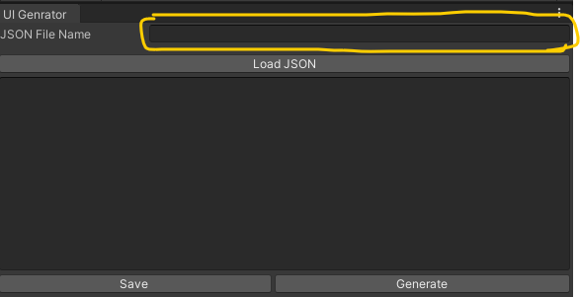

**Step 3: Load JSON**

* After entering the JSON file name, click on the "Load JSON" button.
* The content of the JSON file will be loaded into the text field below.

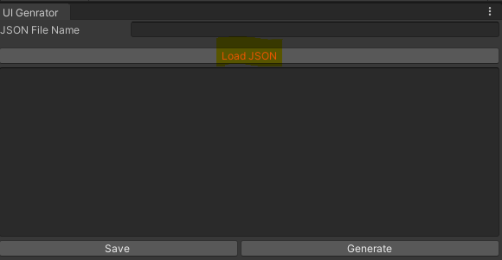

**Step 4: Modify the JSON (Optional)**

* Review the JSON content in the text field.
* Make any necessary modifications to the JSON data if required.

**Step 5: Generate UI from Template**

* Once you are satisfied with the JSON data or have made any necessary modifications, click on the "Generate" button.
* The custom GUI template creator will use the JSON data to generate a UI based on the specified template.

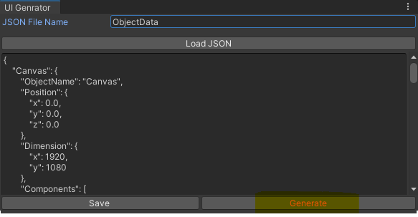

**Step 6: Review and Refine**

* Inspect the generated UI in the Unity Editor.
* Make any additional adjustments or refinements to the generated UI as needed.
* Test the UI to ensure it functions as expected.

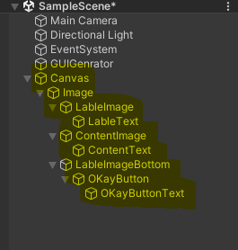

**Step 7: Save and Implement**

* After refining the UI, save your changes.
* Implement the UI within your Unity project as required.

**Step 8: Modifying JSON Data for New Objects**

* Locate the JSON file containing the template data.
* Open the JSON file in a text editor.
* Add new objects to the JSON data by following the established structure. Ensure that each new object is properly formatted and complies with the template schema.
* As of now we have support of limited components and attributes. However, they can be modified from the GUIElementLoader.cs

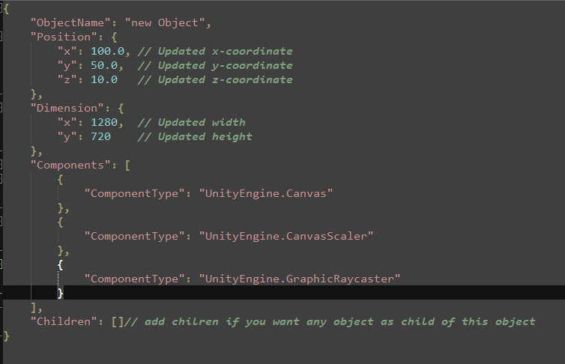

* Below is the sample output given by the default file ObjectData.json

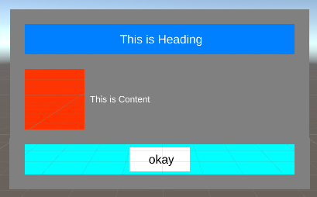

**Conclusion**

This document has guided you through the process of using the custom GUI template creator in Unity to generate a UI from a JSON template. By following these steps, you can efficiently create and customize user interfaces for your Unity projects.