Airport XR Companion Current UI Wireframes
Exact iPhone 17 simulator screenshots captured July 19, 2026 from the current AirportXRCompanion build.
Capture mode: automated walkthrough. The walkthrough banner is visible because the screenshots are direct simulator captures rather than reconstructed mockups.
# | Screen | Visible purpose | Screenshot
1 | Journey | Current layover overview, weather cards, active gate, and persistent Return to Gate action. | journey.png
2 | Flights | Ordered itinerary editor with flight cards, refresh/edit controls, and bottom navigation. | flights.png
3 | AR Guide | Turn-by-turn AR guidance with current maneuver, movement preview, and route controls. | ar-guide.png
4 | Map | Terminal map with current position, route, selected landmark, route steps, and gate-return control. | map.png
5 | Layover & Transit | Layover planning screen with facility filters, selected plan, spend panel, and return control. | layover-transit.png
6 | Settings | Traveler profile and document-pre-fill area with country, passport type, purpose, luggage, and document input. | settings.png

Screen Set
- Journey, Flights, AR Guide, Map, Layover & Transit, and Settings are included.
- Images are embedded from the simulator PNG files in Documentation/Screenshots/2026-07-19-current-ui-wireframes/final.

1. Journey
Wireframe reading: Current layover overview, weather cards, active gate, and persistent Return to Gate action.
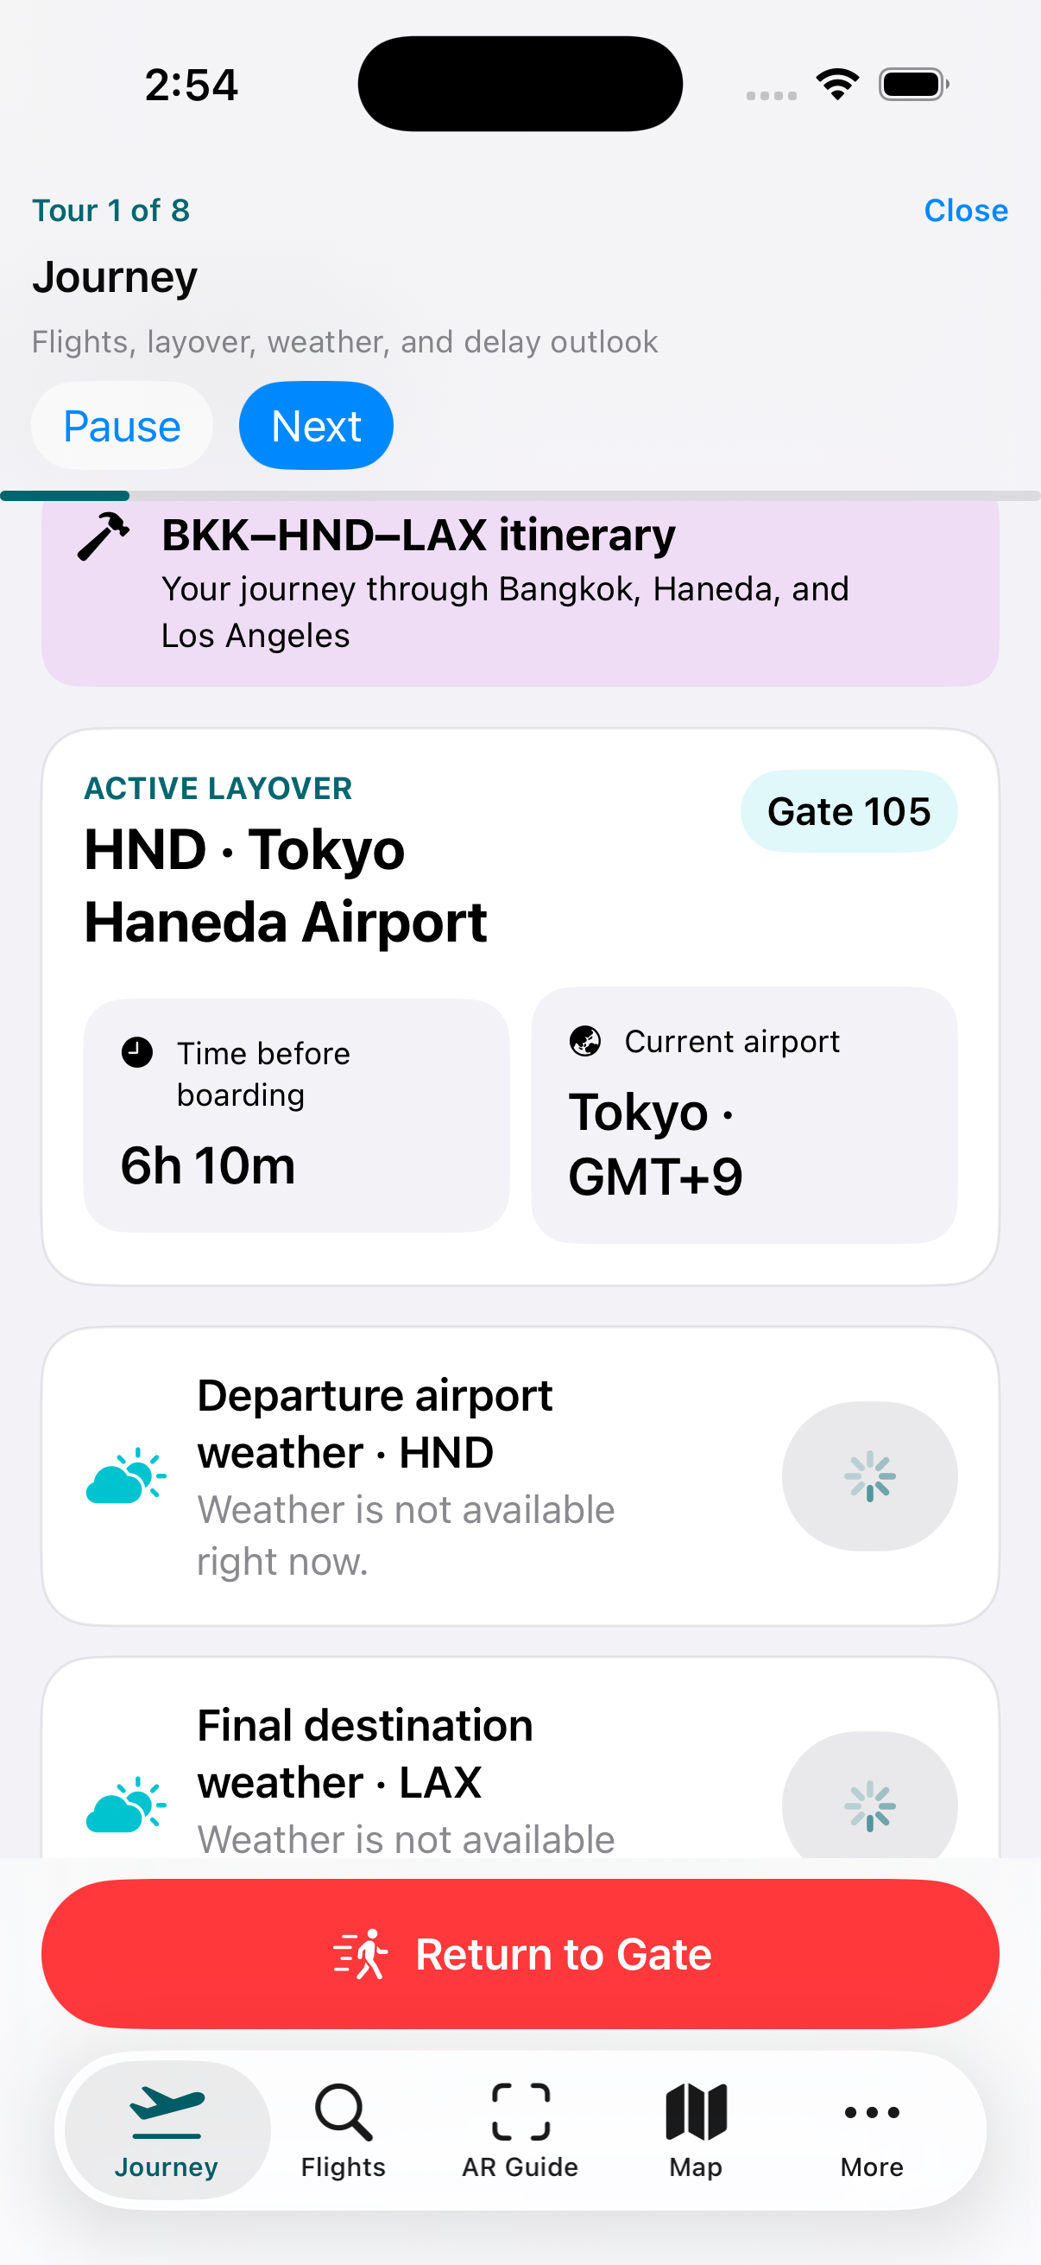
Figure 1. Journey current UI capture. Source file: journey.png

2. Flights
Wireframe reading: Ordered itinerary editor with flight cards, refresh/edit controls, and bottom navigation.
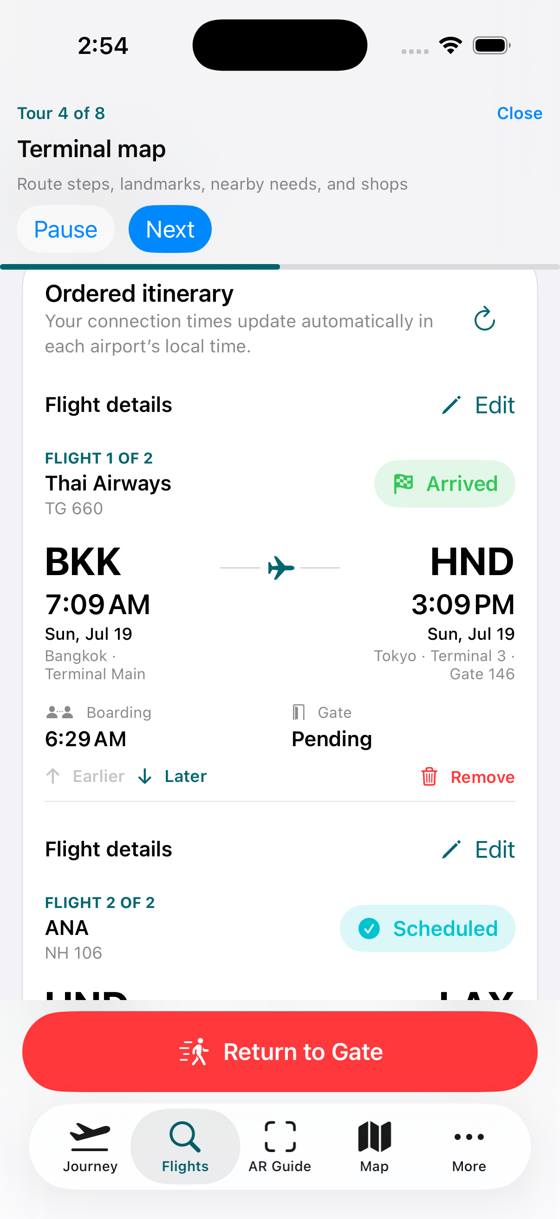
Figure 2. Flights current UI capture. Source file: flights.png

3. AR Guide
Wireframe reading: Turn-by-turn AR guidance with current maneuver, movement preview, and route controls.
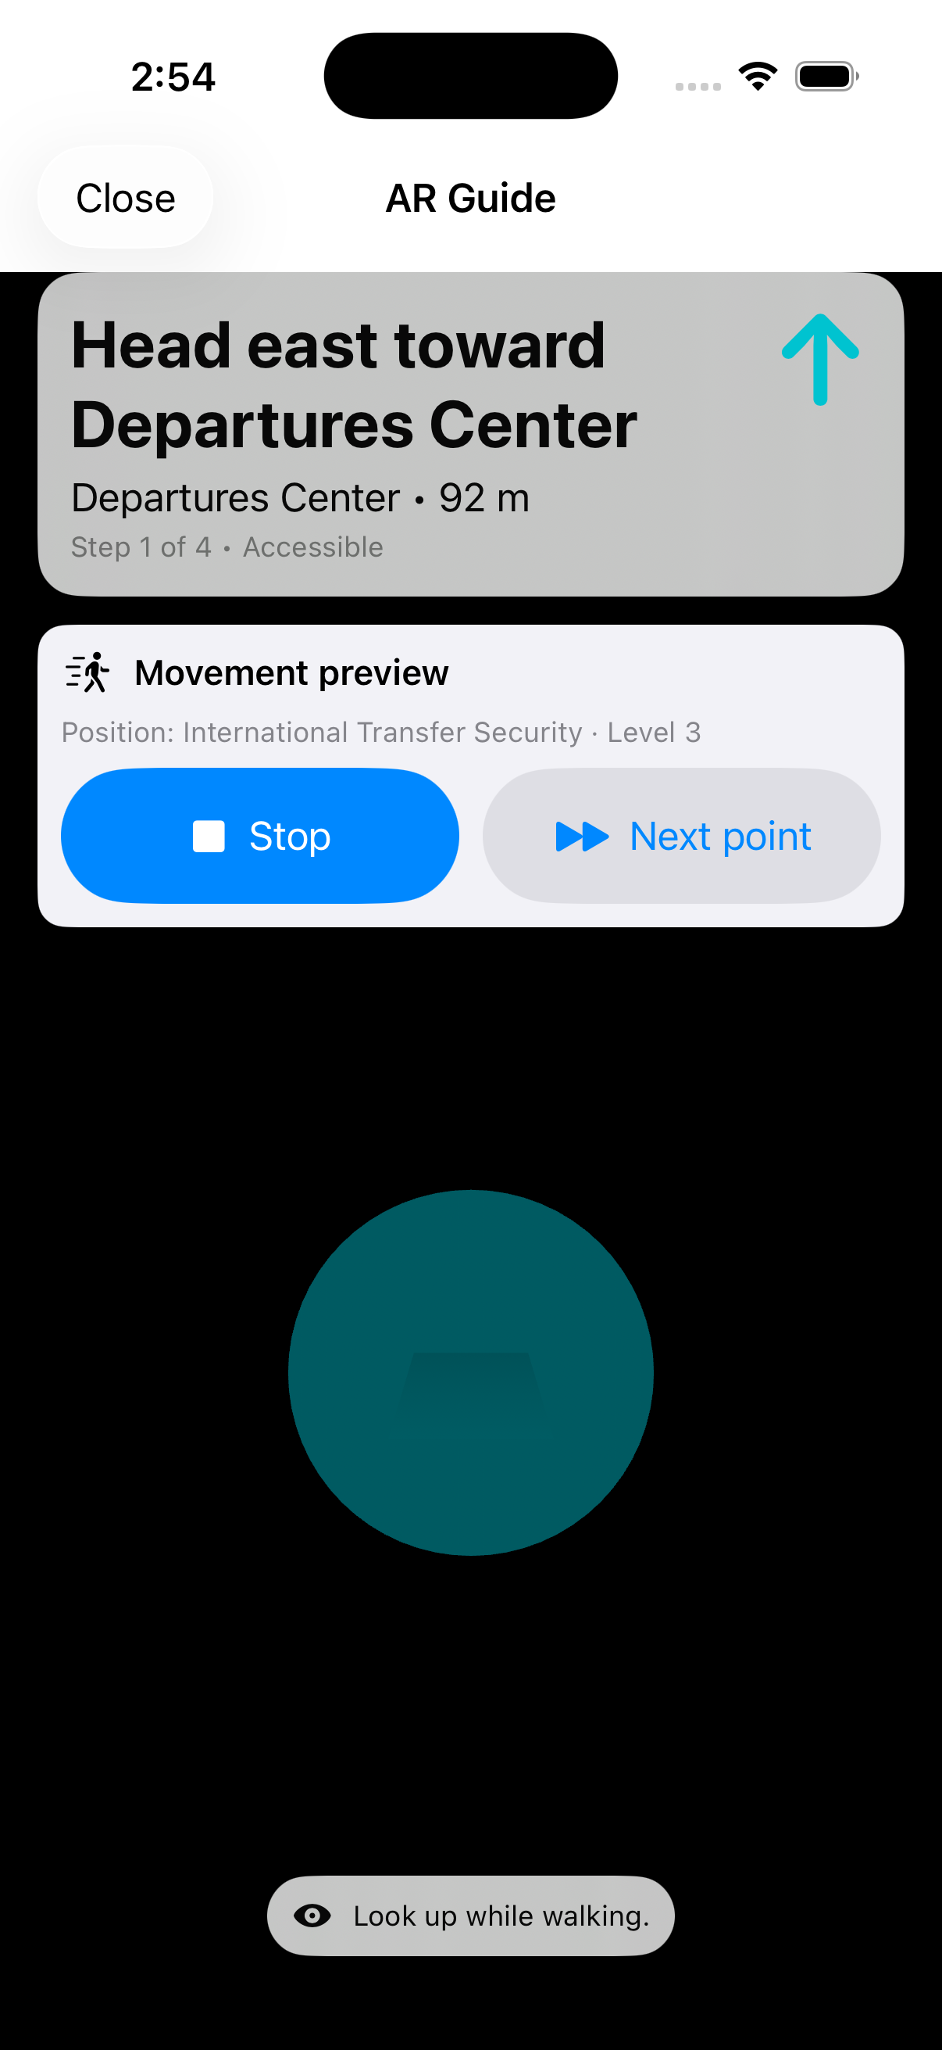
Figure 3. AR Guide current UI capture. Source file: ar-guide.png

4. Map
Wireframe reading: Terminal map with current position, route, selected landmark, route steps, and gate-return control.
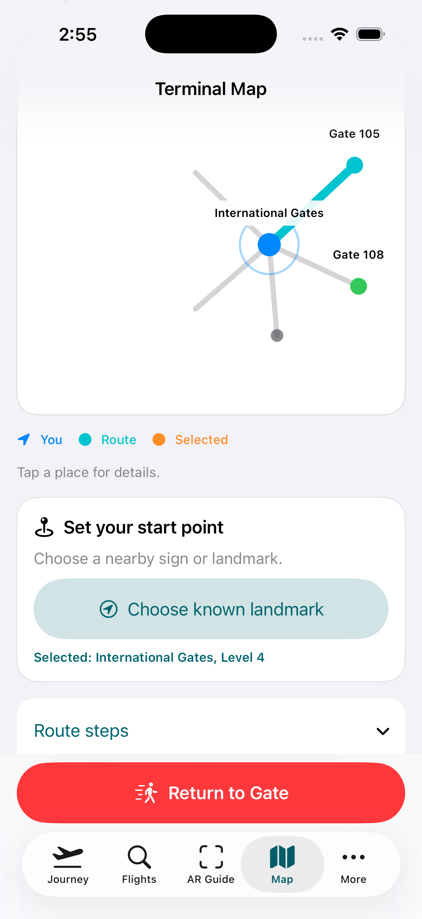
Figure 4. Map current UI capture. Source file: map.png

5. Layover & Transit
Wireframe reading: Layover planning screen with facility filters, selected plan, spend panel, and return control.
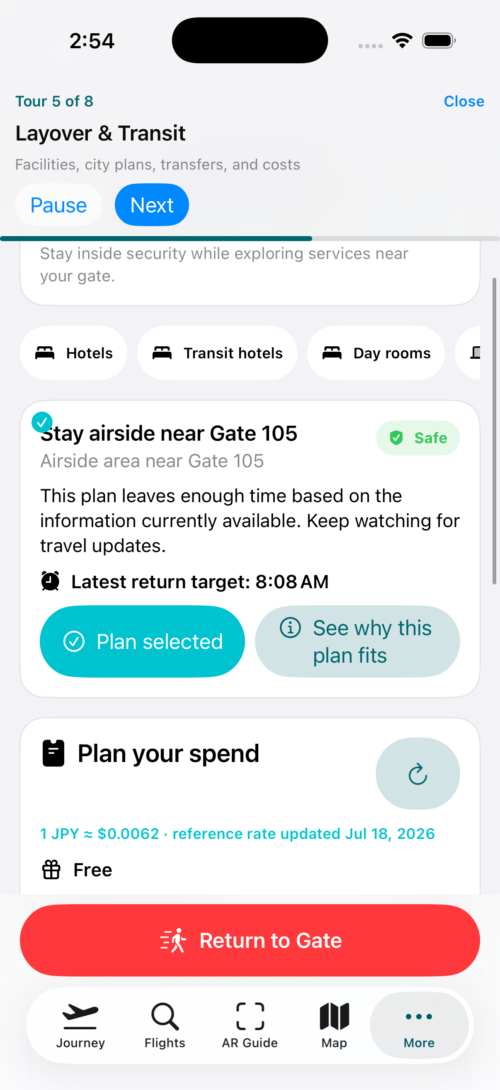
Figure 5. Layover & Transit current UI capture. Source file: layover-transit.png

6. Settings
Wireframe reading: Traveler profile and document-pre-fill area with country, passport type, purpose, luggage, and document input.
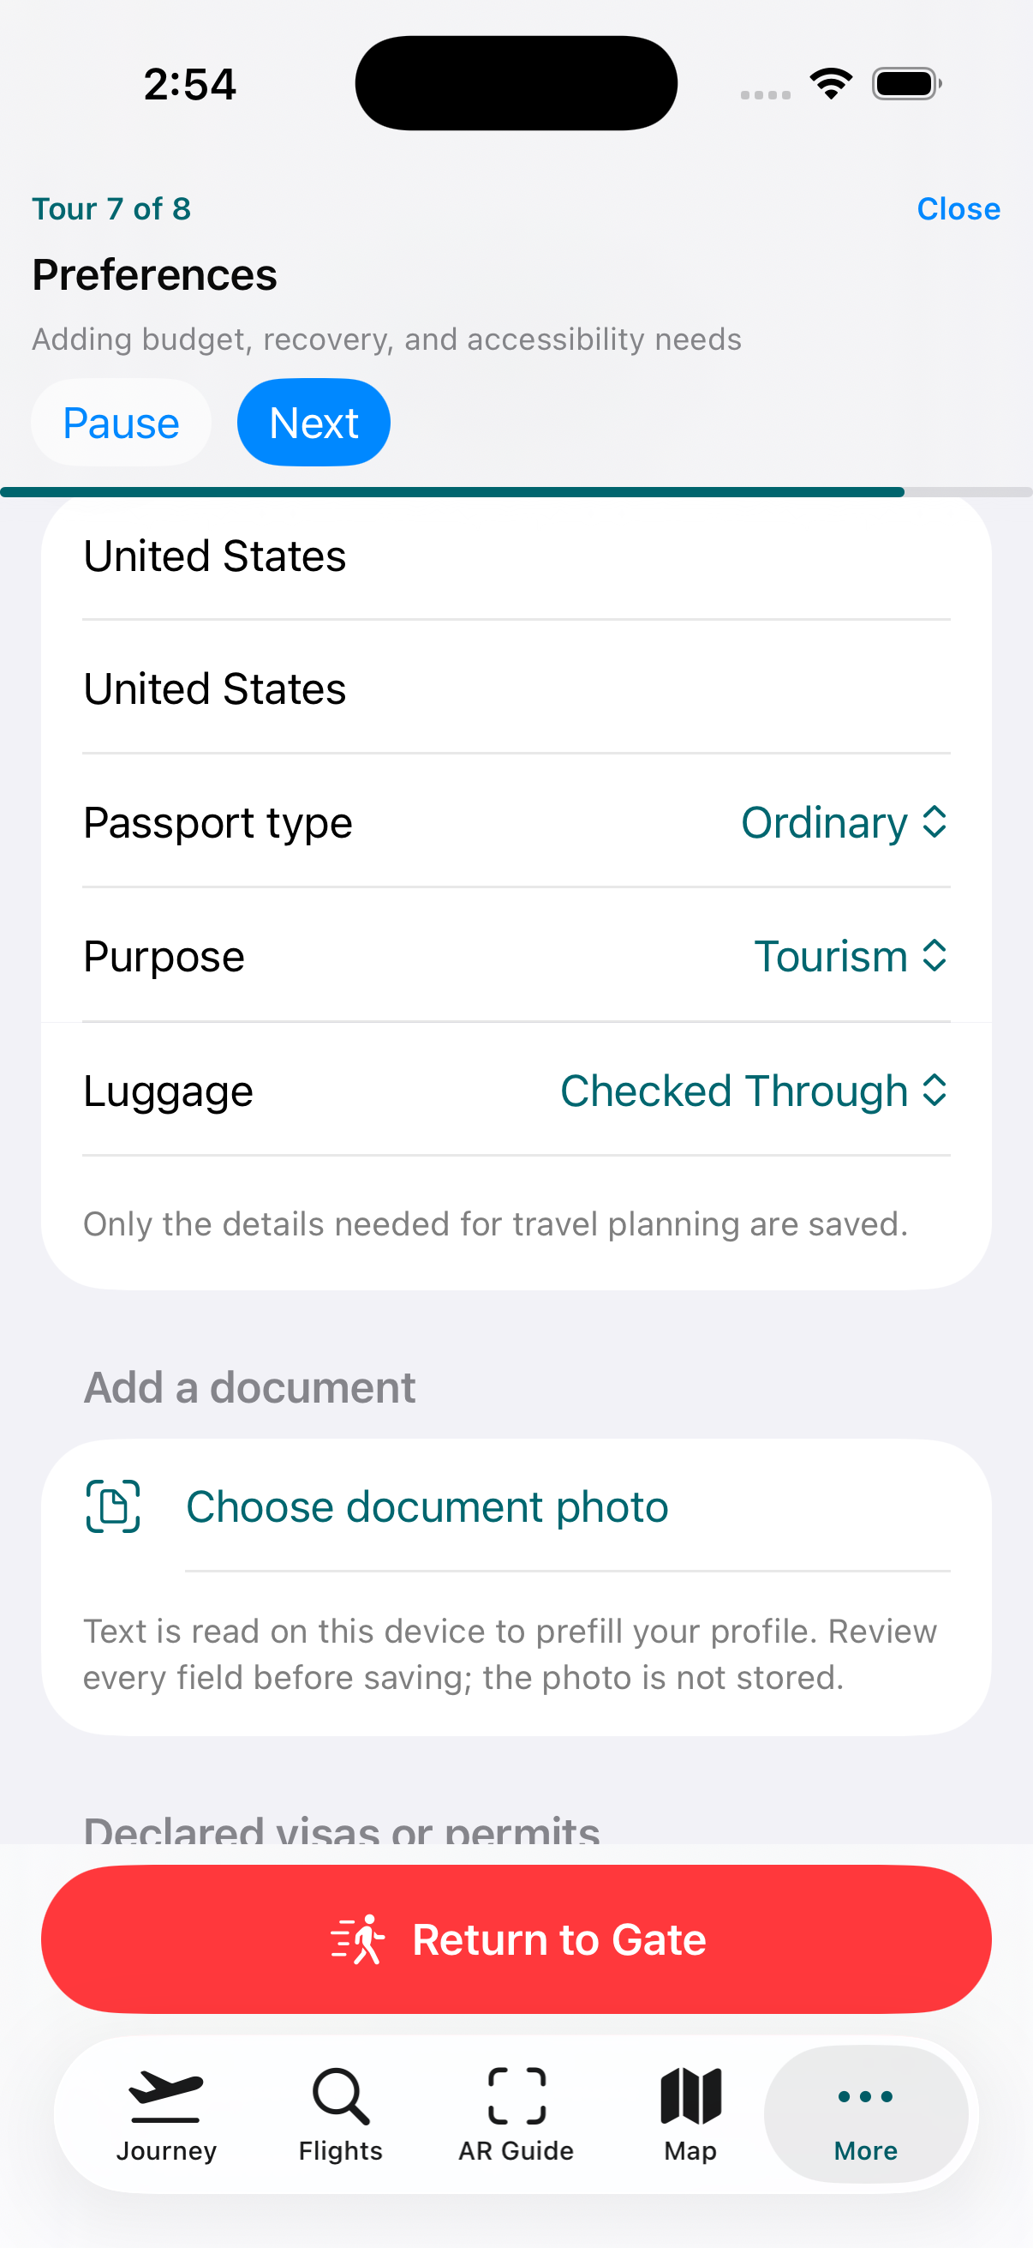
Figure 6. Settings current UI capture. Source file: settings.png

