UserStoryTest&Demo
CEN4020 Project 2 — Bellini College Class Scheduling System
Team MayfairMI6

Contributors:
Seyoung Kan — Stories 1 & 8 (Upload, Export)
Anthony Saade — Stories 3 & 4 (Room Timetable, Instructor Schedule)
Haruto Venkatesan — Stories 2 & 6 (Search/Filter, Semester Comparison)
Jose Wong — Stories 5 & 7 (Vacancy Search, Utilization Stats)

Note: Stories 1 and 8 are the two mandatory stories and are documented first.
All tests pass (24/24 route smoke tests + 7/7 unit tests).

User Story 1: Upload Excel File & Import Data [MANDATORY]

1. User Story Description
As a member of the Bellini scheduling committee, I want to upload the provided Excel files and automatically import the class data into the system, so that the scheduling database can be populated quickly without manual data entry.

2. IOD Diagram & Use Case Implementation Checklist
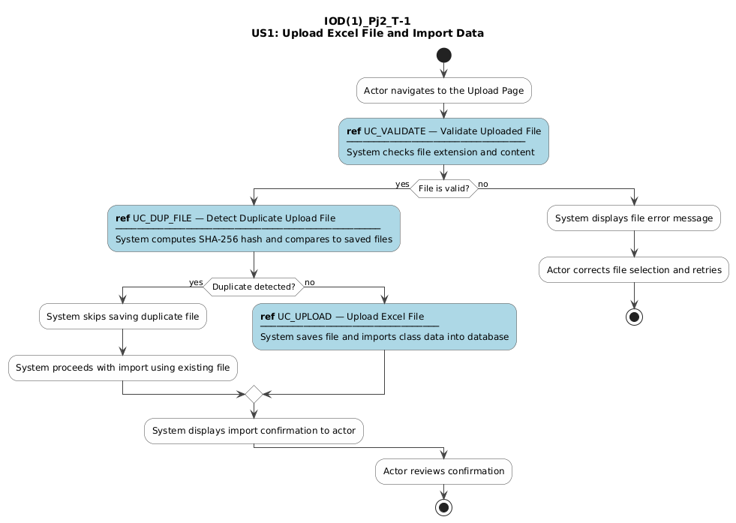

The table below lists every use case referenced in the IOD above, with its implementation and test status verified against the application source code.
Use Case | Physically Implemented? | Tested?
UC_VALIDATE — Validate Uploaded File | Yes | Yes
UC_DUP_FILE — Detect Duplicate Upload File | Yes | Yes
UC_UPLOAD — Upload Excel File | Yes | Yes

3. Video Demo
Video URL / embedded demo:
[INSERT VIDEO URL — sunny: upload valid file, rainy: upload .pdf / blank file / duplicate]

Sunny-day (happy path) scenario:
Navigate to the home page → choose a valid .xlsx file (e.g., Bellini Classes S25.xlsx) → click 'Upload & Import' → system responds with 'Imported N new rows. Rows in database: N' and the schedule database is updated.
Rainy-day (negative path) scenario(s):
1) Submit a non-Excel file (e.g., a .pdf) → system returns 400 with 'Invalid file type. Only .xlsx and .xls files are accepted.'
2) Submit an empty/blank file → system returns 400 with 'Uploaded file is empty or has no data.'
3) Re-upload an already-uploaded file → system detects the SHA-256 hash duplicate, skips saving a second copy, still imports and deduplicates by CRN+TERM.

4. Self-Evaluated Score (0–5)
★★★★★ (5/5)
All upload, validation, deduplication, and import flows are fully implemented and tested. The system correctly handles all four documented alternative flows.

5. v2.0 Improvement Suggestions
Support .csv and .ods file formats in addition to Excel. Add a drag-and-drop upload area and a progress bar for large files. Show a per-column import summary (rows added, rows skipped, conflicts detected). Allow the user to preview the data before committing the import. Provide a version history so that a previous import can be rolled back.

User Story 8: Export Schedule (Excel / CSV) [MANDATORY]

1. User Story Description
As a scheduling committee member, I want to export the finalized class schedule to a downloadable format such as Excel or CSV, so that it can be shared easily with departments and administrative staff.

2. IOD Diagram & Use Case Implementation Checklist
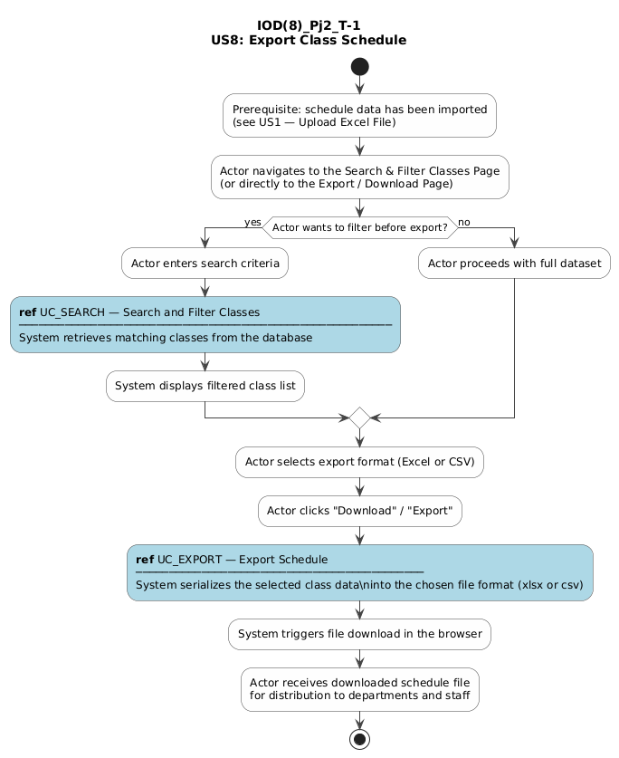

The table below lists every use case referenced in the IOD above, with its implementation and test status verified against the application source code.
Use Case | Physically Implemented? | Tested?
UC_SEARCH — Search and Filter Classes (optional pre-filter) | Yes | Yes
UC_EXPORT — Export Schedule | Yes | Yes

3. Video Demo
Video URL / embedded demo:
[INSERT VIDEO URL — sunny: download CSV and Excel, rainy: request /export/schedule/pdf]

Sunny-day (happy path) scenario:
Navigate to the home page → click 'View Uploaded Files' → click 'Export Schedule CSV' or 'Export Schedule Excel' → browser immediately downloads schedule_database.csv or schedule_database.xlsx containing all imported class data.
Rainy-day (negative path) scenario(s):
Request an unsupported format (e.g., GET /export/schedule/pdf) → system returns HTTP 400 with message 'Unsupported format. Use csv or excel.'

4. Self-Evaluated Score (0–5)
★★★★★ (5/5)
CSV and Excel export are fully implemented, downloadable, and validated by smoke tests. Error handling for unsupported formats returns the correct 400 response.

5. v2.0 Improvement Suggestions
Add filtering options so the user can export a subset of the schedule (by semester, department, or room) rather than the entire database. Include color-coded conflict highlighting in the Excel output. Support PDF export with a print-friendly layout. Add a column-selector so departments can receive only the fields they need.

User Story 3: Room Weekly Timetable

1. User Story Description
As a scheduling committee member, I want to view the weekly timetable of a specific classroom, so that I can understand room utilization and identify available time slots.

2. IOD Diagram & Use Case Implementation Checklist
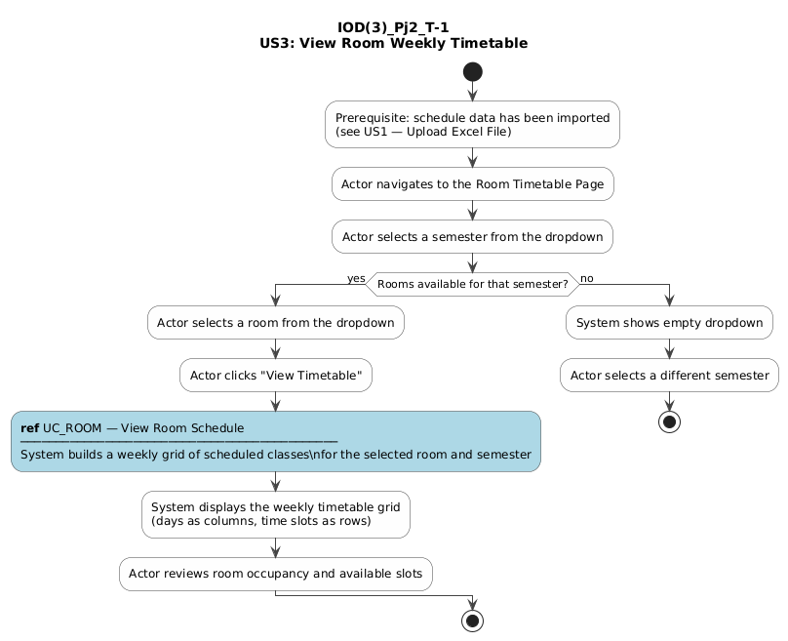

The table below lists every use case referenced in the IOD above, with its implementation and test status verified against the application source code.
Use Case | Physically Implemented? | Tested?
UC_ROOM — View Room Schedule | Yes | Yes

3. Video Demo
Video URL / embedded demo:
[INSERT VIDEO URL — sunny: view populated timetable, rainy: missing semester redirect]

Sunny-day (happy path) scenario:
Navigate to 'Room Weekly Timetable' → select a semester (e.g., Spring 2025) → select a room (e.g., CWY 107) → click 'View Timetable' → system displays a weekly grid showing all classes, their time slots, and the room's percentage utilization.
Rainy-day (negative path) scenario(s):
Navigate to the room timetable URL with no semester parameter (e.g., /schedule/room/CWY 107 without ?semester=…) → system redirects to the room selection page instead of rendering an empty timetable.

4. Self-Evaluated Score (0–5)
★★★★★ (5/5)
Room selection, timetable grid rendering, utilization percentage display, and the missing-semester redirect are all implemented and smoke-tested.

5. v2.0 Improvement Suggestions
Make the timetable grid responsive for mobile screens. Add color-coded utilization bands (green / yellow / red) based on occupancy thresholds. Allow PDF or image export of the timetable. Support multi-week views for irregular meeting patterns.

User Story 4: Instructor Weekly Schedule

1. User Story Description
As a scheduling committee member, I want to view the weekly teaching schedule of an instructor, so that I can ensure their assigned classes do not overload or conflict with their availability.

2. IOD Diagram & Use Case Implementation Checklist
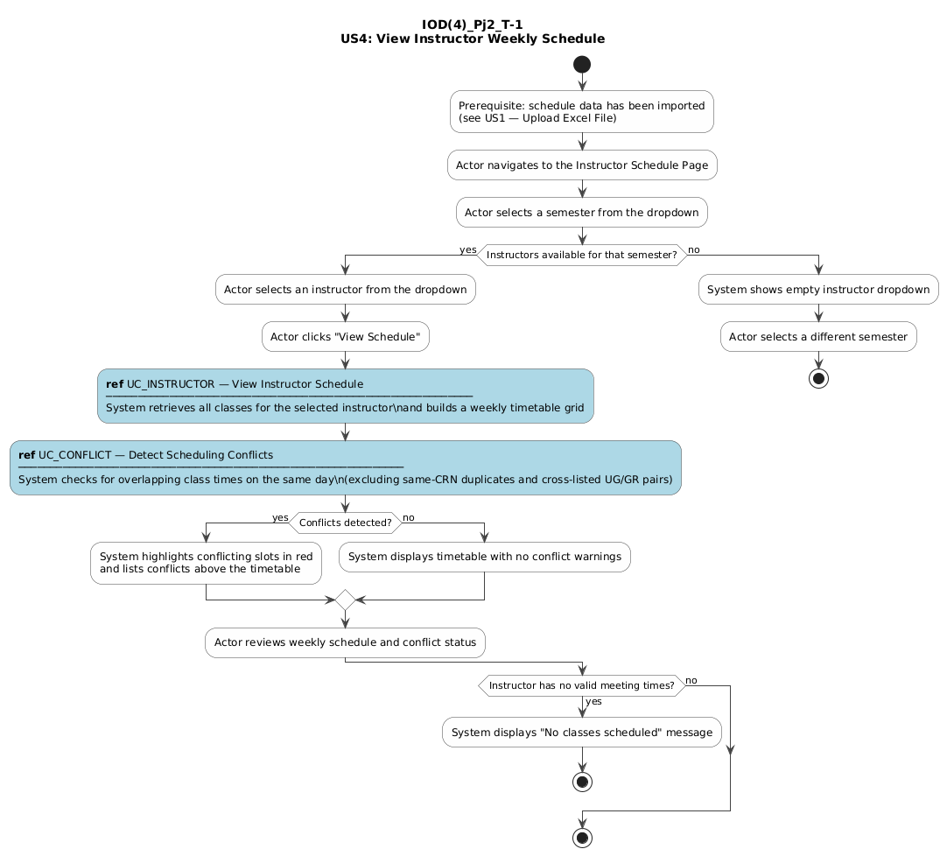

The table below lists every use case referenced in the IOD above, with its implementation and test status verified against the application source code.
Use Case | Physically Implemented? | Tested?
UC_INSTRUCTOR — View Instructor Schedule | Yes | Yes
UC_CONFLICT — Detect Scheduling Conflicts | Yes | Yes

3. Video Demo
Video URL / embedded demo:
[INSERT VIDEO URL — sunny: conflict-free schedule, rainy: conflict highlighted + cross-listed pair]

Sunny-day (happy path) scenario:
Navigate to 'Instructor Weekly Schedule' → select a semester → select an instructor who has no conflicts → click 'View Schedule' → system renders their weekly grid with all classes and the total class count, with no conflict warnings shown.
Rainy-day (negative path) scenario(s):
1) Select an instructor with overlapping class times → system highlights the conflicting blocks in red and lists the conflicts above the timetable.
2) Two classes that are cross-listed UG/GR sections (same title, one 4xxx and one 5xxx) with the same time slot → system does NOT flag them as a conflict.

4. Self-Evaluated Score (0–5)
★★★★★ (5/5)
Instructor schedule, conflict detection, cross-listed pair exemption, and the same-CRN duplicate exemption are all implemented and covered by dedicated unit tests.

5. v2.0 Improvement Suggestions
Provide a printable / PDF version of the instructor's timetable. Add an email-to-instructor button that attaches their schedule. Support overload-hours threshold warnings (e.g., flag if > 4 courses per week). Show historical schedule comparison across semesters for the same instructor.

User Story 2: Search & Filter Classes

1. User Story Description
As a scheduling committee member, I want to search and filter classes by course code, instructor, semester, or department, so that I can quickly locate specific classes within the large dataset.

2. IOD Diagram & Use Case Implementation Checklist
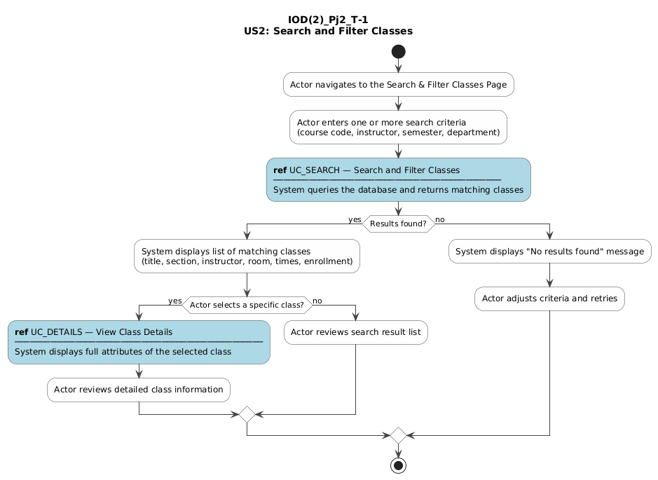

The table below lists every use case referenced in the IOD above, with its implementation and test status verified against the application source code.
Use Case | Physically Implemented? | Tested?
UC_SEARCH — Search and Filter Classes | Yes | Yes
UC_DETAILS — View Class Details | Partial | Partial

3. Video Demo
Video URL / embedded demo:
[INSERT VIDEO URL — sunny: search by department/semester, rainy: empty search + no results]

Sunny-day (happy path) scenario:
Navigate to 'Search & Filter Classes' → enter 'COP' in the Department field and select 'Spring 2025' as the semester → click 'Search' → system returns a table of matching classes showing course code, title, section, instructor, room, days, times, semester, and enrollment.
Rainy-day (negative path) scenario(s):
1) Click 'Search' without entering any criteria → system does not perform a search and prompts the user to enter at least one value.
2) Enter a course code that does not exist (e.g., 'XYZ9999') → system displays 'No classes found matching your search criteria.'

4. Self-Evaluated Score (0–5)
★★★★☆ (4/5)
Multi-criteria search with live results is fully working. The individual class detail page (UC_DETAILS) is partially implemented — class information is visible in search results rows but there is no dedicated per-class drill-down page.

5. v2.0 Improvement Suggestions
Add fuzzy / partial-match search so minor typos still return results. Implement a dedicated class detail page accessible from each search result row. Support saving and reusing favorite search filters. Add sortable result columns and pagination for large result sets.

User Story 6: Semester Comparison

1. User Story Description
As a scheduling committee member, I want to compare schedules across different semesters (e.g., Spring 2025 vs Fall 2025), so that I can analyze course offerings and adjust future scheduling plans.

2. IOD Diagram & Use Case Implementation Checklist
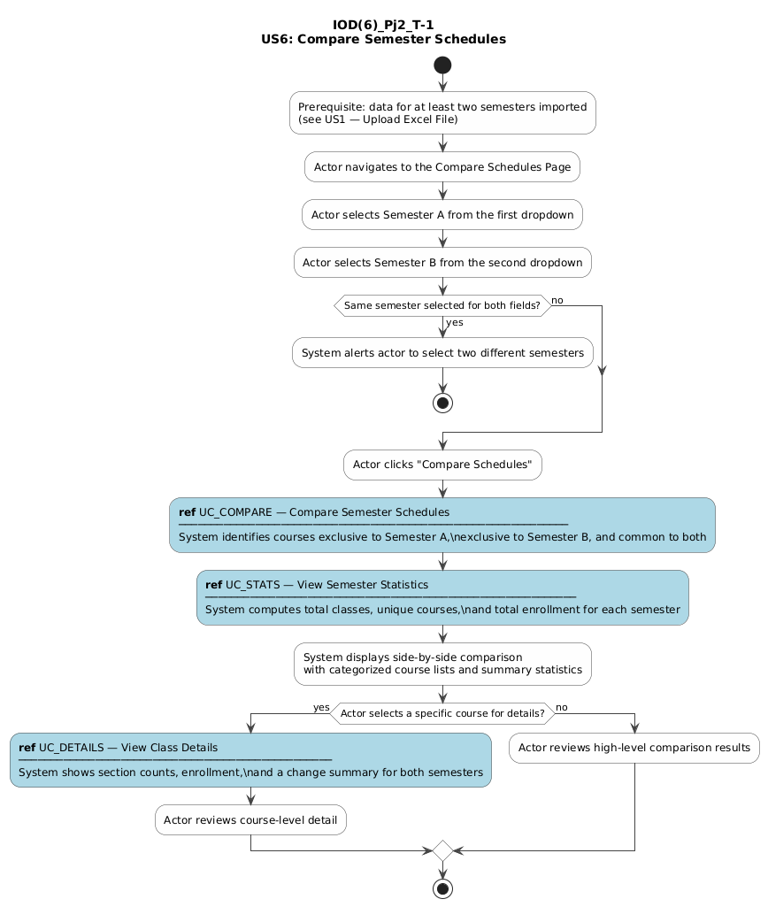

The table below lists every use case referenced in the IOD above, with its implementation and test status verified against the application source code.
Use Case | Physically Implemented? | Tested?
UC_COMPARE — Compare Semester Schedules | Yes | Yes
UC_STATS — View Semester Statistics | Yes | Yes
UC_DETAILS — View Course Drill-Down Detail | Yes | Yes

3. Video Demo
Video URL / embedded demo:
[INSERT VIDEO URL — sunny: compare S25 vs F25 + drill-down, rainy: same-semester alert]

Sunny-day (happy path) scenario:
Navigate to 'Compare Schedules' → select 'Spring 2025' and 'Fall 2025' → click 'Compare Schedules' → system shows courses only in Spring 2025, only in Fall 2025, and in both, along with summary statistics. Click a course code → system opens the detail view showing sections and enrollment for each semester.
Rainy-day (negative path) scenario(s):
1) Select the same semester for both dropdowns → system alerts the user that two different semesters must be chosen and does not navigate.
2) Leave one semester field blank → system alerts the user to complete both fields.

4. Self-Evaluated Score (0–5)
★★★★★ (5/5)
All three use cases (compare, stats, detail drill-down) are fully implemented. The alternative flows for same-semester and missing-semester selections are handled correctly and tested by smoke tests.

5. v2.0 Improvement Suggestions
Add a three-way or N-way semester comparison. Visualize enrollment trends with line/bar charts using Chart.js or similar. Highlight courses whose enrollment increased or decreased by more than a threshold. Allow the comparison to be exported as an Excel report.

User Story 5: Room & Time Slot Suggestions (Vacancy Search)

1. User Story Description
As a scheduling committee member, I want the system to suggest available rooms and time slots when scheduling a new class, so that scheduling decisions can be made faster and with fewer conflicts.

2. IOD Diagram & Use Case Implementation Checklist
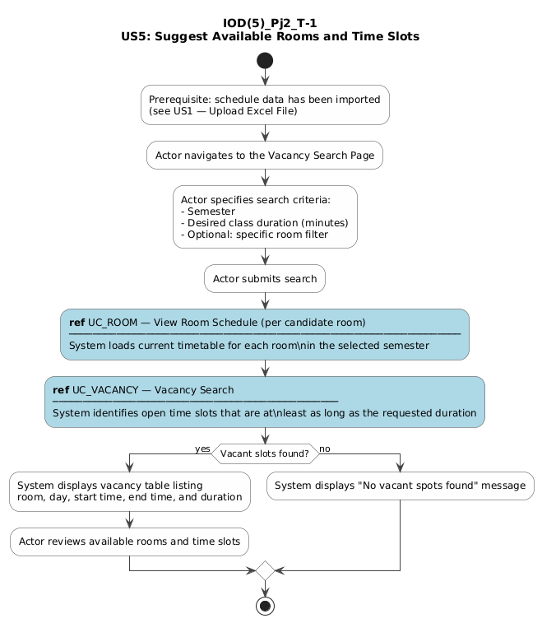

The table below lists every use case referenced in the IOD above, with its implementation and test status verified against the application source code.
Use Case | Physically Implemented? | Tested?
UC_ROOM — View Room Schedule (per candidate room) | Yes | Yes
UC_VACANCY — Vacancy Search | Yes | Yes

3. Video Demo
Video URL / embedded demo:
[INSERT VIDEO URL — sunny: vacancy search with results, rainy: missing params / fully-booked room]

Sunny-day (happy path) scenario:
Navigate to 'Vacancy Search' → select 'Spring 2025' semester → enter 75 minutes duration → leave room filter blank → click 'Search' → system lists every room with all available time windows ≥ 75 minutes for each day of the week.
Rainy-day (negative path) scenario(s):
1) Submit the form with semester blank or duration missing → system redirects back to the selection page with an error message.
2) Enter duration = 0 or a negative number → system redirects with 'Duration must be greater than zero.'
3) Select a room that is fully booked for the chosen duration → the system shows that room row with 'No vacancies' for every day.

4. Self-Evaluated Score (0–5)
★★★★☆ (4/5)
Vacancy search for semester and duration is fully functional and tested. The optional room filter also works. The feature lists available windows but does not yet rank or recommend rooms by utilization, capacity, or proximity — hence 4/5.

5. v2.0 Improvement Suggestions
Rank suggested rooms by current utilization so lightly-used rooms are preferred. Filter rooms by minimum seating capacity. Use an ML-based model trained on historical enrollment to predict the best room. Provide a 'Book this slot' button that pre-fills the class scheduling form.

User Story 7: Classroom Utilization Statistics

1. User Story Description
As a department coordinator, I want to visualize classroom utilization statistics (such as percentage of time rooms are occupied), so that the college can optimize use of physical resources.

2. IOD Diagram & Use Case Implementation Checklist
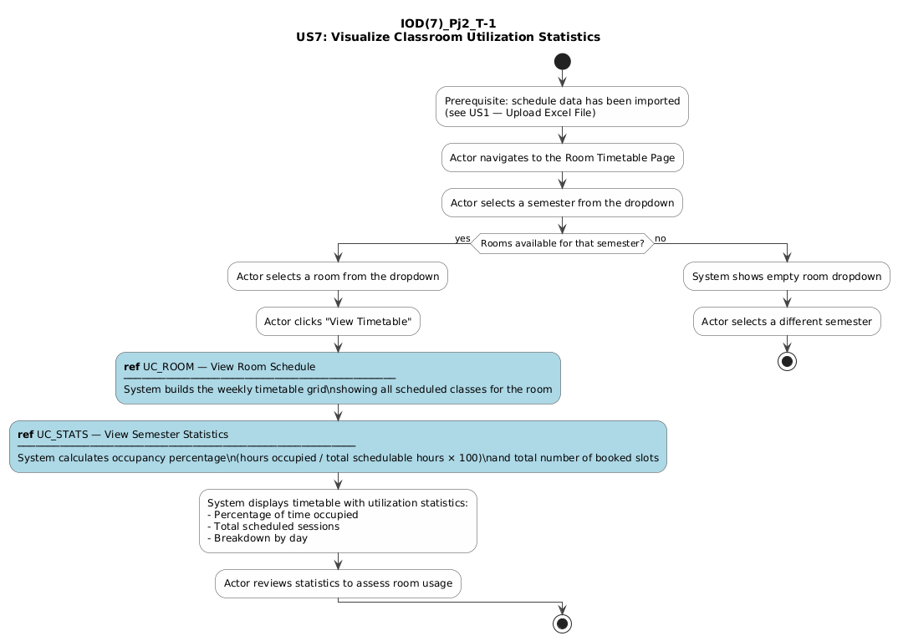

The table below lists every use case referenced in the IOD above, with its implementation and test status verified against the application source code.
Use Case | Physically Implemented? | Tested?
UC_ROOM — View Room Schedule | Yes | Yes
UC_STATS — View Utilization Stats | Partial | Partial

3. Video Demo
Video URL / embedded demo:
[INSERT VIDEO URL — sunny: room with high utilization, rainy: empty room showing 0%]

Sunny-day (happy path) scenario:
Navigate to 'Room Weekly Timetable' → select a semester and room → view timetable → the page header displays 'Percentage used: X%' and 'Weekday percentage used: Y%' computed from the room's occupied time slots.
Rainy-day (negative path) scenario(s):
Navigate to the timetable of a room with no classes scheduled in the selected semester → system displays the grid with all slots empty and shows 'Percentage used: 0%' and 'Weekday percentage used: 0%'.

4. Self-Evaluated Score (0–5)
★★★☆☆ (3/5)
Per-room occupancy percentages (overall and weekday) are correctly computed by percentage_occupied() in data_service.py and shown in the room timetable. However, there is no dedicated utilization dashboard that compares all rooms side-by-side or renders charts/graphs, so the story is only partially satisfied.

5. v2.0 Improvement Suggestions
Build a dedicated 'Utilization Dashboard' page showing all rooms ranked by occupancy with sortable columns. Add bar and pie charts (Chart.js) for visual comparison. Support semester-over-semester utilization comparison. Identify chronically under-used rooms and flag them for possible re-assignment. Export the utilization report as Excel or PDF.

User Story 9: Delete Uploaded Excel File

1. User Story Description
As a scheduling committee member, I want to delete an uploaded Excel file from the system, so that I can remove outdated or incorrect data and keep the file list clean.

2. IOD Diagram & Use Case Implementation Checklist
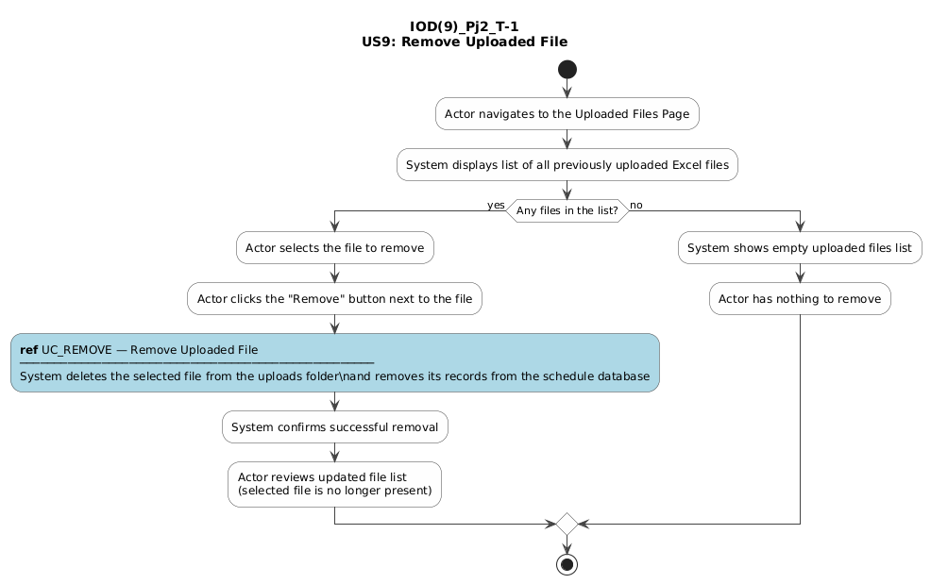

The table below lists every use case referenced in the IOD above, with its implementation and test status verified against the application source code.
Use Case | Physically Implemented? | Tested?
UC_REMOVE — Remove Uploaded File | Yes | Partial

3. Video Demo
Video URL / embedded demo:
[INSERT VIDEO URL — sunny: delete a file and see rebuilt count, rainy: delete non-existent file]

Sunny-day (happy path) scenario:
Navigate to 'View Uploaded Files' → locate an uploaded Excel file → click 'Delete' → system removes the file from the uploads folder, rebuilds the schedule database from the remaining files, and redirects back to the file list with a confirmation message: 'Deleted file: X. Rebuilt schedule with N rows.'
Rainy-day (negative path) scenario(s):
Attempt to delete a file name that does not exist (e.g., send POST to /delete/nonexistent.xlsx) → system redirects back to the file list with 'File not found: nonexistent.xlsx' rather than a 500 error.

4. Self-Evaluated Score (0–5)
★★★★☆ (4/5)
Delete route with post-delete schedule rebuild and error handling is fully implemented in file_routes.py. The smoke test suite does not include an explicit delete test (to preserve test data), so testing is rated 'Partial' — hence 4/5.

5. v2.0 Improvement Suggestions
Add a confirmation dialog before deletion to prevent accidental removal. Implement a soft-delete / recycle-bin so files can be restored within a session. Show a diff of how many rows will be removed from the schedule before confirming. Log all delete operations with a timestamp and the acting user's identity.

User Story 10: View Detailed Class Information

1. User Story Description
As a scheduling committee member, I want to view the detailed information of a specific class, so that I can review all of its attributes including enrollment, room assignment, meeting days, and times.

2. IOD Diagram & Use Case Implementation Checklist
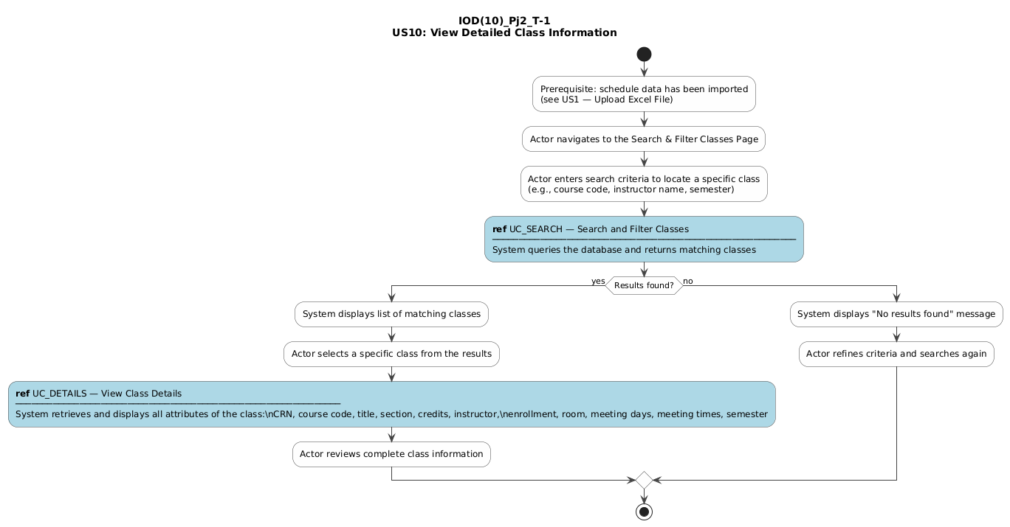

The table below lists every use case referenced in the IOD above, with its implementation and test status verified against the application source code.
Use Case | Physically Implemented? | Tested?
UC_SEARCH — Search and Filter Classes | Yes | Yes
UC_DETAILS — View Class Details | Partial | Partial

3. Video Demo
Video URL / embedded demo:
[INSERT VIDEO URL — sunny: search and review full class row, rainy: search missing CRN]

Sunny-day (happy path) scenario:
Navigate to 'Search & Filter Classes' → search for a known course code (e.g., 'COP4703') → the results table shows all matching sections with columns for course title, section, instructor, room, meeting days, times, semester, and enrollment, providing a detailed view of each class.
Rainy-day (negative path) scenario(s):
Search for a CRN or course code that no longer exists in the database → system displays 'No classes found matching your search criteria' rather than an error page.

4. Self-Evaluated Score (0–5)
★★★☆☆ (3/5)
All class attributes are present and visible in search result rows. However, there is no dedicated individual class detail page (accessible by CRN) as described in the use case UC_DETAILS. A user must perform a search to locate a class — there is no direct /class/<crn> URL — so the story is partially satisfied.

5. v2.0 Improvement Suggestions
Create a dedicated /class/<crn> detail page for each class showing all attributes in a structured layout. Add links from search results, room timetable cells, and instructor schedule cells to the class detail page. Include enrollment history (trend across past semesters) on the detail page. Allow authorized users to edit class attributes directly from the detail page.

