**Installation instructions for the R, R studio and required packages**

1. Download and install the latest version of R (currently 3.4.4) for your platform [here](https://cran.r-project.org/) (https://cran.r-project.org/). Accept all default options during installation.

!! There might be issues if people don’t have administration rights on your computer. Then, please work with people who can handle administration rights on your computer.

1. Download and install the latest version of Rstudio desktop (currently 1.1.447) for your platform [here](https://www.rstudio.com/products/rstudio/download) (https://www.rstudio.com/products/rstudio/download/). Again, accept all default options during installation.

!! There might be issues if people don’t have administration rights on your computer. Then, please work with people who can handle administration rights on your computer.

1. Window : Download MiKTeX (<https://miktex.org/download)> and install it (basic-miktex-2.9.6643-x64.exe). Find your version of MiKTeX in the folder you specified. Double click on the MiKTeX file and follow the installation instructions. This will probably take 10-15 minutes to complete. You do not need to open anything after MiKTeX is finished installing.

Mac : Click on this link to download MacTeX : <http://tug.org/cgi-bin/mactex-download/MacTeX.pkg> This is a large file (approximately 3GB) and may take 5 minutes or more, depending on your internet connection, to download. Find your version of MacTeX in the folder you specified (ex. mactex-xxx.pkg). Double click on the PKG file and follow the installation instructions. You do not need to open anything after MacTeX is finished installing.

1. Now launch Rstudio. You should see a screen similar with this. Check that the text in the **Console** pane reads R version 3.4.4.

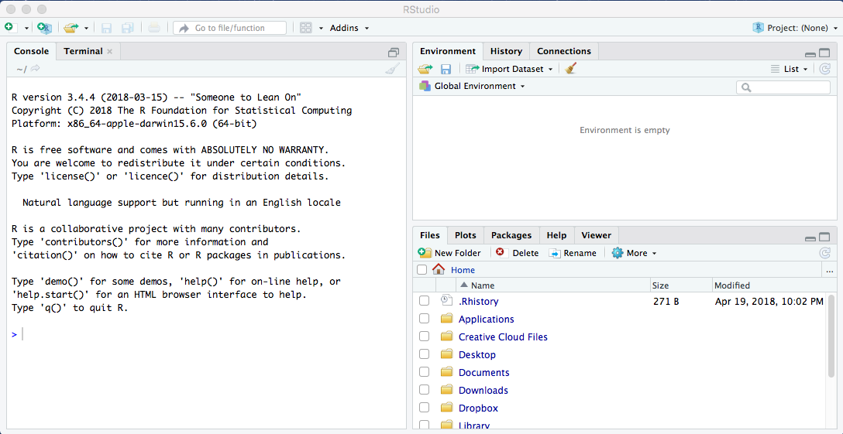

1. Install required packages. To do so: Rstudio through the **File > Open File…** > select the attached R script, ‘**Install required packages_P3-IntroStat.R**’. Press the **'Source'** button in the top right corner of the script pane (as captures below).

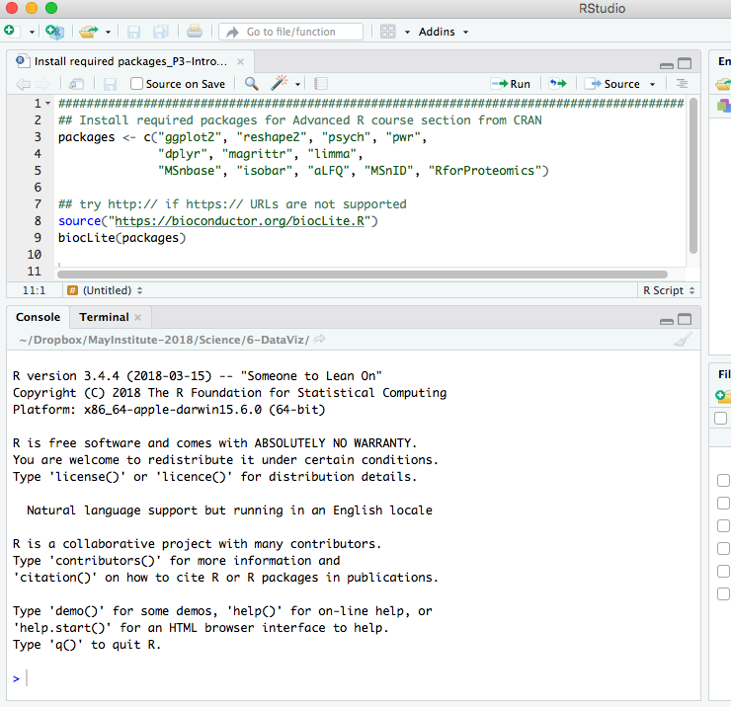

!! They might be asked to update existing packages as below. Answer (push) ‘n’ and push ‘Enter’.

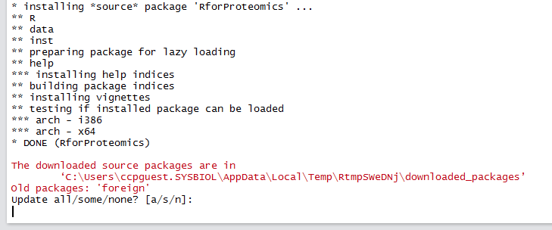

If all packages are installed, you can see similar at the end of Console like below. If you can see an error or different screen, please get back to us.

