# Visual representation of program hierarchy:

# UML rough draft diagram of project:

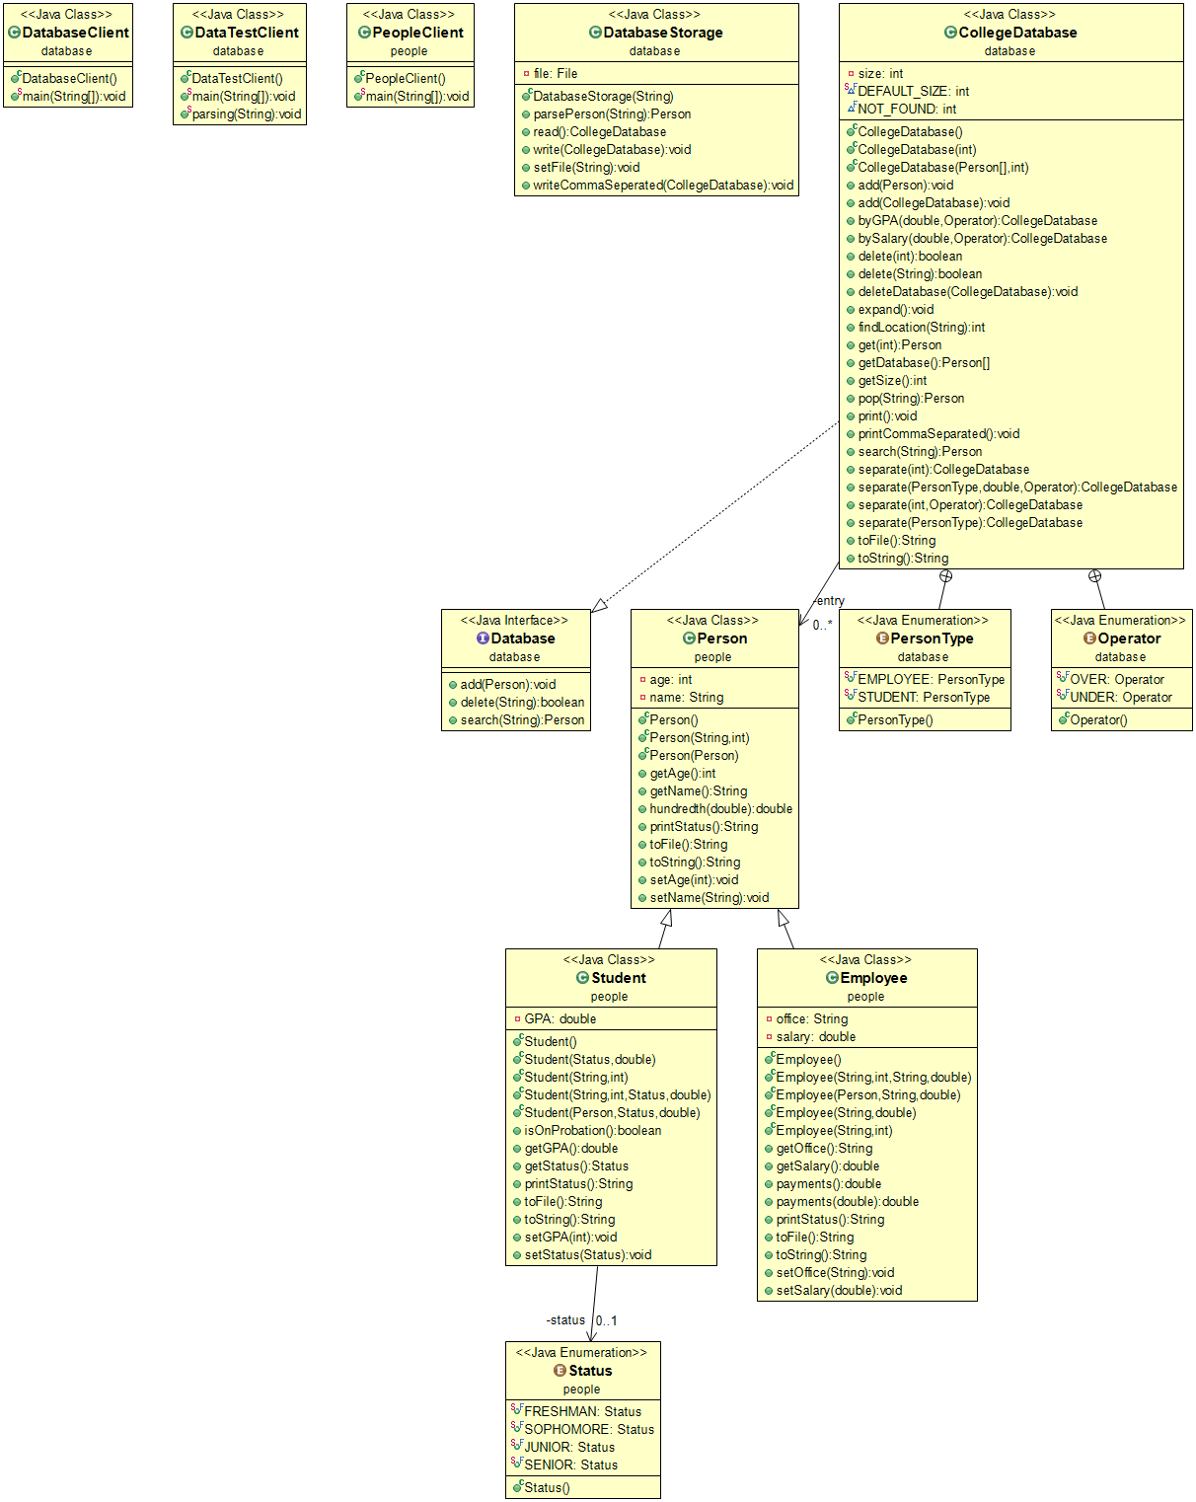



**Test clients: UML’s not required**

Java Project: FinalProject

# The purpose:

The purpose of this project is to take information read from a file, store it, and manipulate it in useful ways. The information in the files should represent people affiliated with a college, students or employees specifically. The information about each person should be represented on a single line with the individual data separated by commas. For students, you should provide their relationship to the college (student), their name, age, college status (Freshman, Sophomore, etc), and their GPA respectively. For Employees, provide their relationship to the college (Employee), their name, age, office location, and salary respectively. This information is all stored in a database. This data can be searched, separated into more specific databases (by relationship to college, GPA, salary, etc).

# Applications:

This project could be paired with an online submission forum (or any other input or data collection software) if it could write submission data to a file in comma separated format as described above. It would allow data to be gathered about people affiliated with the college to perform statistic assessments.

Statistical information that could be gathered using this project:

* Number of students 21 years of age.
* GPA trends of students.
* Percent of students who are senior citizens (over 64 years of age).
* Percent of students who are minors (under 18 years of age).
* Percent of students on probation (GPA under 2.0).
* Number of employees paying 12% income tax (salary between $9,526 and $38,700)
* Total income tax due for current Employees in one year.
* Total number of Students.
* Total number of Employees.
* Ratio of Students to Employees.

# Important Definitions:

**Java Project:**

*a phrase used to refer to this entire set of programs.*

**Package:**

*a word used to describe a set of programs that work together to perform specific tasks on a data set.*

**Class / object:**

*words used to describe a program that stores one or more pieces of information and all the ways you can manipulate or use that information. For example, if you store a birthdate and the current date (the information), you can identify the difference in years (the use or manipulation of that information) to learn their age.*

**Data:**

*information about an object. For example, a birthdate could be information about a person.*

**Method:**

*the way you manipulate given information to return new information.*

**Return:**

*to send information back.*

**Print:**

*to display information on the computer screen for a user to observe.*

**File Path:**

*The location and name of a file or folder, for example:*

*“C:\Users\E\Documents\School\Fall 2018\CSC_142\F18\CollegePersons.txt”*

*Is a valid file path on my computer (not on all computers).*

# Java project breakdown:

This project contains two packages:

1. a people package, and a
2. database package.

## People Package:

The people package contains three classes:

1. a Person Object class,
2. a Student Object class, and
3. an Employee Object class.

### Person Objects:

A Person Object holds two pieces of information:

1. a name, and
2. an age.

A Person Object can be created one of three ways:

1. With no information: **newPerson()**

If a Person object is created with no information,

* its name is blank (null), and
* its age is set to zero.

1. Using another Person Object: **new Person(**Person**)**

If a Person object is created using another Person object, it basically creates a copy.

* The new Person’s name is set to be the other Person’s name, and
* the new persons age is set to be the other Person’s age.

1. Using a name and an age: **new Person(**name, age**)**

If a Person object is created using a name and an age,

* the name is set to the given name, and
* the age is set to the given age.

A Person Object’s stored information can be manipulated using methods:

Note: to apply a method to a Person object: PersonObject**.MethodName(**RequiredInformation**)**

* **getAge()** *Objective: access Person’s age.*

Returns to the user the age stored in the Person object.

* **getName()** *Objective: access Person’s name.*

Returns to the user the name stored in the Person object.

* **hundredth(double)** *Objective: round a decimal to the second place (ex. 43.3456 becomes 43.35).*
  + Requires you to send it a number (not a whole number, it should have a decimal attached. Ex. 43.3456). This method does not require access to information stored in a Person object to run successfully.
  + The given number is multiplied by one-hundred (ex. 43.3456 x 100 = 4334.56).
  + Then, the number is rounded to the nearest integer (ex. 4334.56 becomes 4335).
  + Next, the number is divided by 100 (ex. 4335/100 = 43.35).
  + This number is returned to the user (ex. 43.35).
* **printStatus()** *Objective: identify a Person’s relationship to a college.*

Returns the title “College Person” to the user.

* **setAge(int)** *Objective: change the age stored in the Person object.*
  + Requires you to send it an integer.
  + Sets the Person object’s age to the value of the given integer.
* **setName(String)** *Objective: change the name stored in the Person object.*
  + Requires you to send it a word or String of words (ex. “John” or “John Smith”).
  + Sets the Person object’s name to the word(s) given.
* **toFile()** *Objective: To access all stored information about a Person, separated by comma’s.*
  + Returns to the user the Person’s relationship to a college, and
  + the information stored in the Person object (name and age)
  + separated by commas (ex. “College Person,John Smith,32”).
* **toString()** *Objective: To access stored information about a Person with labels and formatting.*
  + Returns to the user the Person’s relationship to a college, and
  + the information stored in the Person object (name and age)
  + formatted each on their own line

For example:

--------------------------------------------------

COLLEGE PERSON

Name: John Smith

Age: 32 ).

### Employee Objects:

Inheritance note:

An Employee is a type of Person. This means that they contain the same stored data as a Person object and the same methods of manipulating that data.

The following Person methods have different outputs for Employee objects:

* + **printStatus()**
  + **toFile()**
  + **toString()**

An Employee Object holds two pieces of information:

1. an office location, and
2. a salary.

An Employee Object can be created one of five ways:

1. With no information: **newEmployee()**

If an Employee object is created with no information,

* its name is blank (null),
* its age is set to zero,
* its office location is blank (null), and
* its salary is set to zero.

1. Using a Person Object, an office location, and a salary: **new Employee(**Person, office, salary**)**

If an Employee object is created using a Person object, an office location, and a salary,

* it creates a copy of the given Person’s information as described in the “Person Object” section.
* The Employee’s office location is set to the given office location, and
* the Employee’s salary is set to the value of the given salary.

1. Using an office location and a salary: **new Employee(**office, salary**)**

If an Employee object is created using an office location and a salary,

* the office location is set to the given location, and
* the salary is set to the value of the given salary.

1. Using a name and an age: **new Employee(**name, age**)**

If an Employee object is created using a name and an age,

* the Employee’s name is set to the given name, and
* the age is set to the value of the given age.

1. Using a name, age, office location and salary: **new Employee(**name, age, office, salary**)**

If an Employee object is created using a name, age, office location, and salary,

* the Employee’s name is set to the given name,
* the age is set to the value of the given age,
* the office location is set to the given location, and
* the salary is set to the value of the given salary.

An Employee Object’s stored information can be manipulated using methods:

Note: to apply a method to an Employee type Person object use one of the following:

* EmployeeObject**.MethodName(**RequiredInformation**)**
* ((Employee)PersonObject)**.MethodName(**RequiredInformation**)**
* **getOffice()** *Objective: access Employee’s office location.*

Returns to the user the office location stored in the Employee object.

* **getSalary()** *Objective: access Employee’s salary.*

Returns to the user the salary stored in the Employee object.

* **payments()** *Objective: access the Employee’s payment installments.*

Sends the salary stored in the Employee object to the Employee object’s **payments(Double)** method as the required information for that method (see next bullet point).

* **payments(Double)** *Objective: calculate payment installments.*
  + Requires you to send it a number representing a salary. This method does not require access to information stored in an Employee object to run successfully.
  + The given salary is divided by 24, thus giving the individual payment amounts for an Employee whose salary is dispersed into 24 payments per year.
  + That payment amount is then sent to the **hundredth(double)** Person method to get the dollar amount rounded to the penny.
  + The value of this dollar amount is returned to the user.
* **printStatus()** *Objective: identify a Person’s relationship to a college.*
  + Overrides the Person object printStatus() method.
  + Returns the title “Employee” to the user.
* **setOffice(String)** *Objective: change the office location stored in the Employee object.*
  + Requires a new office location.
  + Sets the Employee object’s office location to the given office location.
* **setSalary(Double)** *Objective: change the salary amount stored in the Employee object.*
  + Requires you to give it a number representing the new salary amount.
  + Sets the Employee object’s salary equal to the value of the given number.
* **toFile()** *Objective: access all stored information about a Person, separated by comma’s.*
  + Overrides the Person object toFile() method.
  + Returns to the user the Person’s relationship to a college, and
  + information stored in the Employee object (name, age, office location, and salary)
  + separated by commas (ex. “Employee,John Smith,32,STEM 207,52125.0”).
* **toString()** *Objective: access stored information about a Person with labels and formatting.*
  + Overrides the Person object toString() method.
  + Returns to the user the Person’s relationship to a college, and
* information stored in the Employee object (name, age, office location, salary, and payment installments)
* formatted each on their own line.

For example:

--------------------------------------------------

EMPLOYEE

Name: John Smith

Age: 32

Office: STEM 207

Salary: 52125.0

Payments: 2171.88

--------------------------------------------------

### Student Objects:

Inheritance note:

A Student is a type of Person. This means that they contain the same stored data as a Person object and the same methods of manipulating that data.

The following Person methods have different outputs for Student objects:

* + **printStatus()**
  + **toFile()**
  + **toString()**

A Student Object holds two pieces of information:

1. a GPA, and
2. a college Status, which can be FRESHMAN, SOPHOMORE, JUNIOR, SENIOR, or null *exclusively*.

A Student Object can be created one of five ways:

1. With no information: **newStudent()**

If a Student object is created with no information,

* its name is blank (null),
* its age is set to zero,
* its Status is blank (null), and
* its GPA is set to zero.

1. Using a Person Object, a Status, and GPA: **new Student(**Person, Status, GPA**)**

If a Student object is created using a Person object, a Status, and a GPA,

* it creates a copy of the given Person’s information as described in the “Person Object” section.
* The Student object’s college status is set to the Status, and
* the Student object’s GPA is set to the value of the given GPA.

1. Using a Status and a GPA: **new Student(**Status, GPA**)**

If a Student object is created using a Status and a GPA,

* the name is blank (null),
* the age is set to zero,
* the Status is set to the given Status, and
* the GPA is set to the value of the given GPA.

1. Using a name and an age: **new Student(**name, age**)**

If a Student object is created using a name and an age,

* the Student object’s name is set to the given name,
* the age is set to the value of the given age,
* the Status is blank (null), and
* the GPA is set to zero.

1. Using a name, age, Status, and GPA: **new Student(**name, age, Status, GPA**)**

If a Student object is created using a name, age, Status, and GPA,

* the Student’s name is set to the given name,
* the age is set to the value of the given age,
* the Status is set to the given Status, and
* the GPA is set to the value of the given GPA.

A Student Object’s stored information can be manipulated using methods:

Note: to apply a method to a Student type Person object use one of the following:

* StudentObject**.MethodName(**RequiredInformation**)**
* ((Student)PersonObject)**.MethodName(**RequiredInformation**)**
* **getGPA()** *Objective: access Student’s GPA.*

Returns to the user the value of the GPA stored in the Student object.

* **getStatus()** *Objective: access Student’s Status.*

Returns to the user the Status stored in the Student object.

* **isOnProbation()** *Objective: determine whether or not a Student is on probation.*
  + Accesses the GPA stored in the Student object.
  + If this GPA is greater than or equal to 2.0,
    - the student is not on probation.
    - In this case, false would be returned to the user.
  + If the GPA is greater than or equal to zero, but less than 2.0,
    - the student is on probation.
    - In this case, true would be returned to the user.
  + If neither of these conditions are true, the stored GPA value is a negative number, which is an invalid GPA value. The program stops, and it informs you of this error.
* **printStatus()** *Objective: identify a Person’s relationship to a college.*
  + Overrides the Person object method.
  + Returns the title “Student” to the user.
* **setGPA(Double)** *Objective: change the GPA stored in the Student object.*
  + Requires you to give it a number representing the new GPA.
  + Sets the Student object’s GPA equal to the value of the given number.
* **setStatus(Status)** *Objective: change the Status stored in the Student object.*
  + Requires a new Status.
  + Sets the Student object’s Status to the given Status.
* **toFile()** *Objective: access all stored information about a Person, separated by comma’s.*
  + Overrides the Person object method.
  + Returns to the user the Person’s relationship to a college, and
  + the information stored in the Student object (name, age, GPA, and Status)
  + separated by commas (ex. “Student,Jane Doe,21,3.3,3.3”).
* **toString()** *Objective: access stored information about a Person with labels and formatting.*
  + Overrides the Person object method.
  + Returns to the user the Person’s relationship to a college, and
  + the information stored in the Student object (name, age, GPA, and Status)
  + formatted each on their own line.

For Example:

--------------------------------------------------

STUDENT

Name: Jane Doe

Age: 21

GPA: 3.3

Status: SOPHOMORE

--------------------------------------------------

## Database Package:

The database package contains two classes:

1. a DatabaseStorage Object class, and
2. a CollegeDatabase Object class.

Note**:** CollegeDatabase is a type of Database, which means it is required to contain all Database methods as listed below:

* + - **add(Person)**
    - **delete(String)**
    - **search(String)**

### DatabaseStorage Objects:

A DatabaseStorage Object holds one piece of information:

1. a file.

A DatabaseStorage Object can be created one of two ways:

1. With no information: **newDatabaseStorage()**

If a DatabaseStorage object is created with no information, it’s file is blank (null).

1. Using a file path: **new DatabaseStorage(**filePath**)**

If a DatabaseStorage object is created using a file path (file location and name),

* it accesses the **setFile(String)** DatabaseStorage method described below
* to set the DatabaseStorage object’s file to be the file at the specified location with the specified name.

A DatabaseStorage Object’s stored information can be manipulated using methods:

Note: to apply a method to a DatabaseStorage object:

DatabaseStorageObject**.MethodName(**RequiredInformation**)**

* **parsePerson(String)**

*Objective: translate information on a single line of a file into a format that the program understands and can manipulate.*

* Requires a single line from a file.
* It checks the content of the line to see if it describes an Employee or a Student.
* It returns the information to the user as an Employee or a Student.
* **read()**

*Objective: translate each line in a file into useable and manipulatable information about Students and Employees and store it in a College Database.*

* Opens the file stored in the current DatabaseStorage object.
* Sends each line into the **parsePerson(String)** method.
* Stores Information from each line in a College Database.
* Returns the database to the user.
* **setFile(String)**

*Objective: set the name and location of the file to store in the DatabaseStorage object.*

* Requires you to send it a file path.
* It sets the name and location of the file stored in the DatabaseStorage object to the given file path.
* **write(CollegeDatabase)**

*Objective: write to a file stored information about a database of Person’s, with labels and formatting.*

* Requires you to give it a College Database.
* Writes to the file stored in the DatabaseStorage object information about every Student and Employee in the database.
* The information will be clearly labeled using the **toString()** methods for Students and Employees.

For example, if the database contained only the Employee and Student we discussed earlier, this method would write the following text to the file stored in the DatabaseStorag object:

--------------------------------------------------

EMPLOYEE

Name: John Smith

Age: 32

Office: STEM 207

Salary: 52125.0

Payments: 2171.88

--------------------------------------------------

--------------------------------------------------

STUDENT

Name: Jane Doe

Age: 21

GPA: 3.3

Status: SOPHOMORE

--------------------------------------------------

* **writeCommaSeparated(CollegeDatabase)**

*Objective: To access all stored information about a Person, separated by commas.*

* Requires you to give it a College Database.
* Writes to the file stored in the DatabaseStorage object information about every Student and Employee in the database.
* The information will be written as in the **toFile()** methods for Students and Employees (ex. “College Person,John Smith,32”).

### CollegeDatabase Objects:

Inheritance note:

A CollegeDatabase is a type of Database, which means it must meet the minimum requirements for a Database object.

The following methods are required for all Database Objects:

* + **add(Person)**
  + **delete(String)**
  + **search(String)**

A CollegeDatabase Object holds 7 pieces of information:

1. A database (list), of Person objects (Employees and Students),
2. The size or number of people in the database,
3. The default size for a database (the number 20),
4. A value representing a person who was not found in the database (the number -1),
5. The two types of Person’s who can be stored in the database (“EMPLOYEE”, and “STUDENT”),
6. the two types of operators that could be used to search for people with certain things in common (“OVER”, and “UNDER”),
7. and a program that can accept input submissions from a user (input scanner).

A CollegeDatabase Object can be created one of three ways:

1. With no information: **newCollegeDatabase()**

If a CollegeDatabase object is created with no information, it sends the default size to the next option (See number two below).

1. Using an integer capacity: **new CollegeDatabase(**capacity**)**

If a CollegeDatabase object is created with a capacity, the capacity of the database inside this object is set to the given number.

1. Using a database of information about people and an integer representing the number of people in the database: **new CollegeDatabase(**database, count**)**

If a CollegeDatabase object is created using a database and an integer, the database stored inside the CollegeDatabase becomes the given database, and the count of people in the CollegeDatabase is set to the integer given.

A CollegeDatabase Object’s stored information can be manipulated using methods:*******

Note: to apply a method to a CollegeDatabase type object use the following:

* CollegeDatabaseObject**.MethodName(**RequiredInformation**)**
* **add(CollegeDatabase)** *Objective: access Student’s GPA.*

Returns to the user the value of the GPA stored in the Student object.

* **add(Person)** *Objective: access Student’s Status.*

Returns to the user the Status stored in the Student object.

* **byGPA()** *Objective: determine whether or not a Student is on probation.*