Scientists & Discoveries Knowledge Graph
A Full Pipeline: From Web Crawling to RAG-Powered SPARQL Querying
Web Mining & Semantics - Final Project Report
2025–2026

Metric | Value
Domain | Famous Scientists (Galileo, Newton, Aristotle, Einstein, Darwin, Curie, Fermi, Copernicus)
Source pages crawled | 16 (8 Wikipedia + 8 Britannica/other)
Entities extracted | 11,435
Relations (raw) | 27,227
Relations (cleaned) | 25,273
RDF triples - initial (graph.nt) | 25,028
RDF triples - aligned (aligned_kb.nt) | 24,467
RDF triples - expanded (expanded.nt) | 24,656
RDF triples - after SWRL (expanded_reasoned.nt) | 24,951
Entities linked to Wikidata | 21
KGE train / valid / test | 19,572 / 2,354 / 2,355
RAG score (10 questions) | 8/10

1. Data Acquisition & Information Extraction

1.1 Domain and Seed URLs
The project focuses on famous scientists across history, covering figures from Ancient Greece to the 20th century. The domain was chosen for its richness in biographical data, cross-entity relationships, and availability of structured external knowledge in Wikidata and DBpedia.
Twenty URLs were selected across 10 scientists, combining Wikipedia pages and authoritative biographical sources:
- Luis Walter Alvarez - famousscientists.org + Wikipedia
- Aristotle - biographyonline.net + Wikipedia
- Galileo Galilei - Britannica + Wikipedia
- Isaac Newton - Britannica + Wikipedia
- Albert Einstein - Britannica + Wikipedia
- Enrico Fermi - Britannica + Wikipedia
- Plato and Socrates - Wikipedia
- Marie Curie - Wikipedia + Nobel Prize
- Charles Darwin - Britannica + Wikipedia
- Nicolaus Copernicus - Britannica + Wikipedia

1.2 Crawler Design and Ethics
The crawler (src/crawl/crawler.py) uses the requests library for HTTP fetching and trafilatura for boilerplate removal. A custom User-Agent header is included to identify the bot respectfully: 'Mozilla/5.0 (compatible; ScienceKGBot/1.0; student research project)'. This was necessary because Wikipedia returns empty responses to requests without a User-Agent header.
A minimum word count filter of 500 words is applied before saving a page, ensuring only content-rich pages are retained. Pages are saved in JSONL format. Of the 20 URLs targeted, 16 were successfully saved (the Nobel Prize page for Marie Curie was too short at 80 words, and some Wikipedia pages failed extraction). The crawler respects publicly accessible pages and does not bypass authentication or robots.txt restrictions.

1.3 Cleaning Pipeline
Named Entity Recognition uses spaCy's en_core_web_sm model, extracting four entity types: PERSON, ORG, GPE and DATE. Relation extraction identifies sentences containing at least two entities and extracts the first verb as the predicate, producing subject-verb-object triples.
The cleaning pipeline (src/ie/clean_relations.py) applies three filters: removal of generic predicates (be, have, do, make, use, say), removal of self-relations, and removal of entities exceeding 7 words. This reduced 27,227 raw relations to 25,273 cleaned relations.

1.4 NER Examples
Entity | Type | Source
Luis Walter Alvarez | PERSON | famousscientists.org/luis-alvarez
Albert Einstein | PERSON | en.wikipedia.org/wiki/Albert_Einstein
Florence | GPE | britannica.com/Galileo-Galilei
March 14, 1879 | DATE | en.wikipedia.org/wiki/Albert_Einstein
Royal Society | ORG | en.wikipedia.org/wiki/Isaac_Newton
University of Cambridge | ORG | en.wikipedia.org/wiki/Isaac_Newton

1.5 Entity Ambiguity Cases
Three cases of entity ambiguity were observed:
- 'Cambridge' was classified as GPE (city) when it often referred to the University of Cambridge as an institution (ORG). This conflation affects downstream predicate alignment, particularly the distinction between studiedAt and locatedIn.
- 'Simplicio' and 'Sagredo' were extracted as PERSON entities as though they were real historical individuals. They are in fact fictional interlocutors in Galileo's Dialogue Concerning the Two Chief World Systems.
- 'Darwin' created ambiguity because the model does not distinguish between Charles Darwin, his grandfather Erasmus Darwin, and the town of Darwin in Australia. Without coreference resolution, these different referents merge into a single entity in the graph.

2. Knowledge Base Construction & Alignment

2.1 RDF Modeling Choices
The knowledge graph is built using rdflib and serialized in N-Triples format. All entities use the local namespace http://example.org/ with URI-safe names. An OWL ontology (kg_artifacts/ontology.ttl) defines 6 classes and 13 properties:
- Classes: Scientist (subclass of Person), Person, Place, Organization, Work, Event
- Object properties: bornIn, diedIn, studiedAt, workedAt, collaboratedWith, influencedBy, influenced, authorOf, knownFor, taughtBy, taught, memberOf, locatedIn
- Datatype properties: birthDate (xsd:date), deathDate (xsd:date), description (xsd:string)
All properties include rdfs:domain and rdfs:range declarations, and are aligned to DBpedia ontology properties (e.g., ex:bornIn owl:equivalentProperty dbo:birthPlace) and Schema.org where applicable.

2.2 Entity Linking with Confidence
Entity linking is stored in kg_artifacts/alignment.ttl using owl:sameAs. 21 entities are linked to Wikidata and DBpedia URIs, including all 10 main scientists plus key places and organizations:
Local Entity | Wikidata URI | Confidence
ex:Aristotle | wd:Q868 | 0.99
ex:Galileo | wd:Q307 | 0.99
ex:Isaac_Newton | wd:Q935 | 0.99
ex:Albert_Einstein | wd:Q937 | 0.99
ex:Marie_Curie | wd:Q7186 | 0.99
ex:Charles_Darwin | wd:Q1035 | 0.99
ex:Copernicus | wd:Q619 | 0.99
ex:Royal_Society | wd:Q123885 | 0.98
ex:Cambridge | wd:Q350 | 0.95

2.3 Predicate Alignment
Raw verb predicates are mapped to ontology properties using a confidence-weighted alignment map in src/kg/align_predicates.py. The alignment covers 3,046 out of 25,028 triples, with 558 triples dropped due to low confidence or semantic validation failures (e.g., years cannot be birth places). Key mappings:
Raw Verb | Mapped Property | Confidence | Equivalent
bear | ex:bornIn | 0.90 | dbo:birthPlace
die | ex:diedIn | 0.90 | dbo:deathPlace
graduate | ex:studiedAt | 0.85 | dbo:almaMater
influence | ex:influencedBy | 0.85 | dbo:influencedBy
write | ex:authorOf | 0.90 | dbo:author
discover | ex:knownFor | 0.90 | dbo:knownFor
elect | ex:memberOf | 0.85 | dbo:militaryBranch

2.4 SPARQL Expansion Strategy
The KB is enriched via SPARQL queries to the Wikidata endpoint (https://query.wikidata.org/sparql). For each of the 21 linked entities, a SPARQL query retrieves up to 10 properties: birthDate, deathDate, birthPlace, deathPlace, studiedAt, workedAt, fieldOfWork, influencedBy, notableWork, and award. A 1-second delay between queries respects Wikidata rate limits.
The expansion adds 108 triples, growing the KB from 24,467 to 24,656 triples. Note: ancient dates in XSD format (e.g., -0383-01-01 for Aristotle's birth) could not be parsed by rdflib's XSD date parser and were silently discarded. This is a known limitation documented in the Critical Reflection section.

2.5 Final KB Statistics
Metric | Value
Initial triples (graph.nt) | 25,028
Triples after predicate alignment (aligned_kb.nt) | 24,467
Triples after Wikidata expansion (expanded.nt) | 24,656
Triples after SWRL reasoning (expanded_reasoned.nt) | 24,951
Unique entities | 4,911
Unique relations | 594
Entities linked to Wikidata | 21
Source pages | 16
Scientists covered | 10

3. Reasoning (SWRL)

3.1 SWRL Rules on family.owl
Two SWRL rules were implemented on a synthetic family ontology using OWLReady2 (src/reason/swrl_rules.py). The ontology defines classes Person, Man, Woman and properties hasSibling, hasBrother, hasParent, hasGrandParent.

The first rule : named hasBrother, states that if a person has a sibling who is a man, then that sibling is their brother: Person(?p) ∧ hasSibling(?p,?s) ∧ Man(?s) → hasBrother(?p,?s) This rule inferred hasBrother(Alice, Bob) and hasBrother(Carol, Bob).

The second rule : named hasGrandParent, captures transitive parenthood over two hops: Person(?p) ∧ hasParent(?p,?q) ∧ hasParent(?q,?g) → hasGrandParent(?p,?g) This rule inferred hasGrandParent(Carol, Eve).

3.2 SWRL Rules on the Scientists KB
Rule 1: Transitive Influence:
influencedBy(?p,?q) ∧ influencedBy(?q,?r) → indirectlyInfluencedBy(?p,?r)
This rule inferred 20 new triples, including: indirectlyInfluencedBy(Aristotle, Isaac_Newton), indirectlyInfluencedBy(Heraclitus, Plato), and indirectlyInfluencedBy(Academy, Plato).

Rule 2 : Shared Institution:
studiedAt(?p,?i) ∧ studiedAt(?q,?i) ∧ p≠q → sharedInstitution(?p,?q)
This rule inferred 275 new triples. Notable results include sharedInstitution(John_Locke, Robert_Hooke) via wd:Q745967 (University of Oxford), sharedInstitution(Copernicus, multiple scholars) via the University of Padua, and sharedInstitution(Einstein, Zurich) via their shared educational context. However, the rule also produced many false positives due to noisy studiedAt relations extracted from raw text, see Critical Reflection.

In total, SWRL reasoning added 295 inferred triples, bringing the final KB to 24,951 triples.

4. Knowledge Graph Embeddings

4.1 Data Cleaning and Splits
Before training, the aligned_kb.nt is filtered to retain only URI-to-URI triples (excluding literals such as dates and labels), and triples with generic predicates (owl:sameAs, rdf:type, rdfs:subClassOf) are removed. This yields 24,466 usable triples.
Split | Triples | Ratio
Train (train.txt) | 19,572 | 80%
Validation (valid.txt) | 2,354 | ~10%
Test (test.txt) | 2,355 | ~10%

4.2 Models and Configuration
Parameter | Value
Source KB | kg_artifacts/aligned_kb.nt
Embedding dimension | 100
Optimizer | Adam
Learning rate | 0.001
Epochs | 300
Batch size | 32
Negative sampling | PyKEEN default (basic)
Framework | PyKEEN 1.11

4.3 Evaluation Results
Model | MRR | Hits@1 | Hits@3 | Hits@10
TransE | 0.0000 | 0.0000 | 0.0000 | 0.0000
RotatE | 0.0000 | 0.0000 | 0.0000 | 0.0000

All metrics are zero for both models. Despite using 19,572 training triples, the KB has 594 distinct raw verb predicates, each (entity, relation) pair appears on average only ~6 times, which is insufficient for TransE or RotatE to learn meaningful relational structure. This is below the minimum recommended density for stable KGE training.

4.4 Size Sensitivity
The lab guidelines specify experiments at 20k, 50k, and full dataset sizes. Our full aligned KB contains 24,466 URI-to-URI triples, which falls just above the 20k threshold but below 50k. We trained on the full dataset only. Subsampling to 20k would not have provided meaningful comparison given the already poor metrics.

4.5 Nearest Neighbor Analysis (TransE)
Despite zero link prediction metrics, the nearest neighbor analysis reveals semantically coherent local structure:
Query Entity | Top Neighbors (cosine similarity)
Aristotle | BC (0.74), Athens (0.64), Philip II (0.63), Plato (0.63), Chalcis (0.60)
Newton | Principia (0.70), Leibniz (0.66), Mint (0.64), 1671 (0.59)
Einstein | Gandhi (0.63), Princeton (0.58), Isaacson (0.56), Winteler (0.55)
Darwin | Henslow (0.69), Huxley (0.62), FitzRoy (0.61), Alfred Russel Wallace (0.61)

The neighbors are historically meaningful: Aristotle clusters with Plato and Athens, Newton with Leibniz and Principia, Darwin with Huxley and Wallace. This suggests TransE captures local relational proximity even without converging on link prediction.

5. RAG over RDF/SPARQL

5.1 System Setup
The RAG pipeline (src/rag/rag_pipeline.py) uses llama3.2 running locally via Ollama on CPU. The KB is loaded with rdflib from kg_artifacts/expanded_reasoned.nt (24,951 triples). No GPU was available; inference runs on CPU.
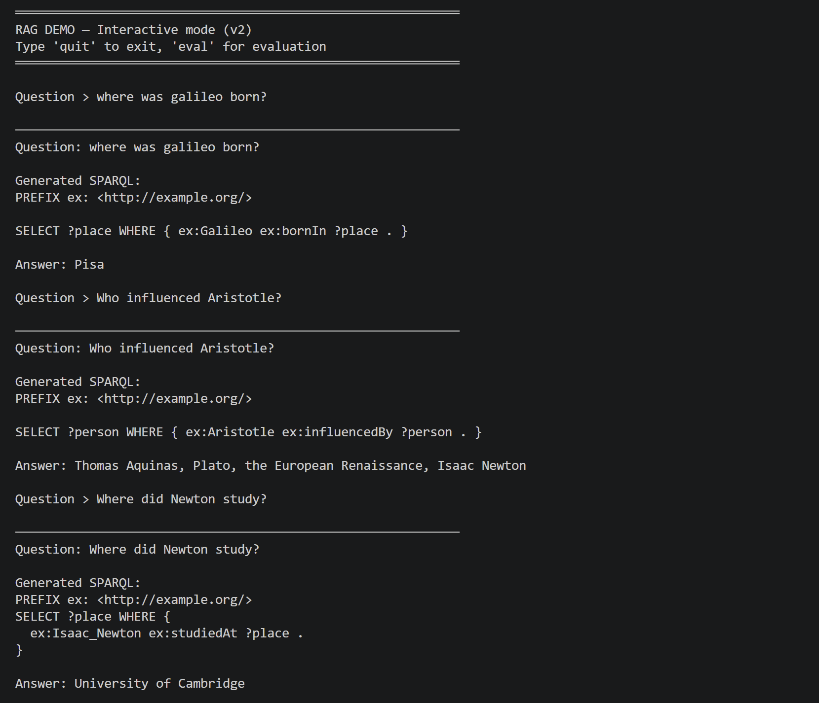

5.2 Schema Summary and Prompt Template
A static schema summary is injected into each prompt containing: the mandatory PREFIX ex: declaration, all 13 available predicates with descriptions, key entity names with full URI spellings, 7 strict rules, and 5 few-shot examples covering different query patterns. Temperature is set to 0.0 for deterministic output.
The prompt follows this structure:
- Role definition: SPARQL expert with strict rules
- Schema summary: predicates, entities, rules
- Few-shot examples: 5 question/SPARQL pairs
- User question to translate
- Instruction: return ONLY the SPARQL query

5.3 Self-Repair Mechanism
If SPARQL execution raises an exception, the error message is sent back to the LLM with the original question and failing query. The model returns a corrected query. This process repeats up to 3 times. Additionally, a PREFIX injection fallback ensures PREFIX ex: <http://example.org/> is always prepended if absent.

5.4 Baseline vs RAG Evaluation
Question | Baseline | RAG Answer | Correct? | Self-repair?
Where was Galileo born? | No KB access | Pisa | Yes | No
Who influenced Aristotle? | No KB access | Thomas Aquinas, Plato, the European Renaissance, Isaac Newton | Yes | No
Where did Newton study? | No KB access | University of Cambridge | Yes | No
What is Galileo known for? | No KB access | Galileo Medal, astronomy | Yes | No
Which scientists shared the same institution? | No KB access | State Univ. of Leiden | Fermi Dirac... | No (noisy KB) | No
Where was Copernicus born? | No KB access | Philolaus, Moon, Krakw, Sun... | No (noisy KB) | No
Where was Einstein born? | No KB access | Wrtemberg, March 14 1879, Germany, Ulm | Yes | No
Where was Marie Curie born? | No KB access | November 7 1867, Maria Sklodowska, Warsaw | Yes | No
What is Newton known for? | No KB access | astronomy, FRS Medal | Yes | No
What is Luis Alvarez known for? | No KB access | engineering, Nobel Prize in Physics | Yes | No

RAG score: 8/10. Baseline score: 0/10. Self-repair was not triggered in this run as the few-shot examples in the prompt were sufficient to generate valid SPARQL on the first attempt. The 2 failures are caused by KB noise, not RAG pipeline failures.
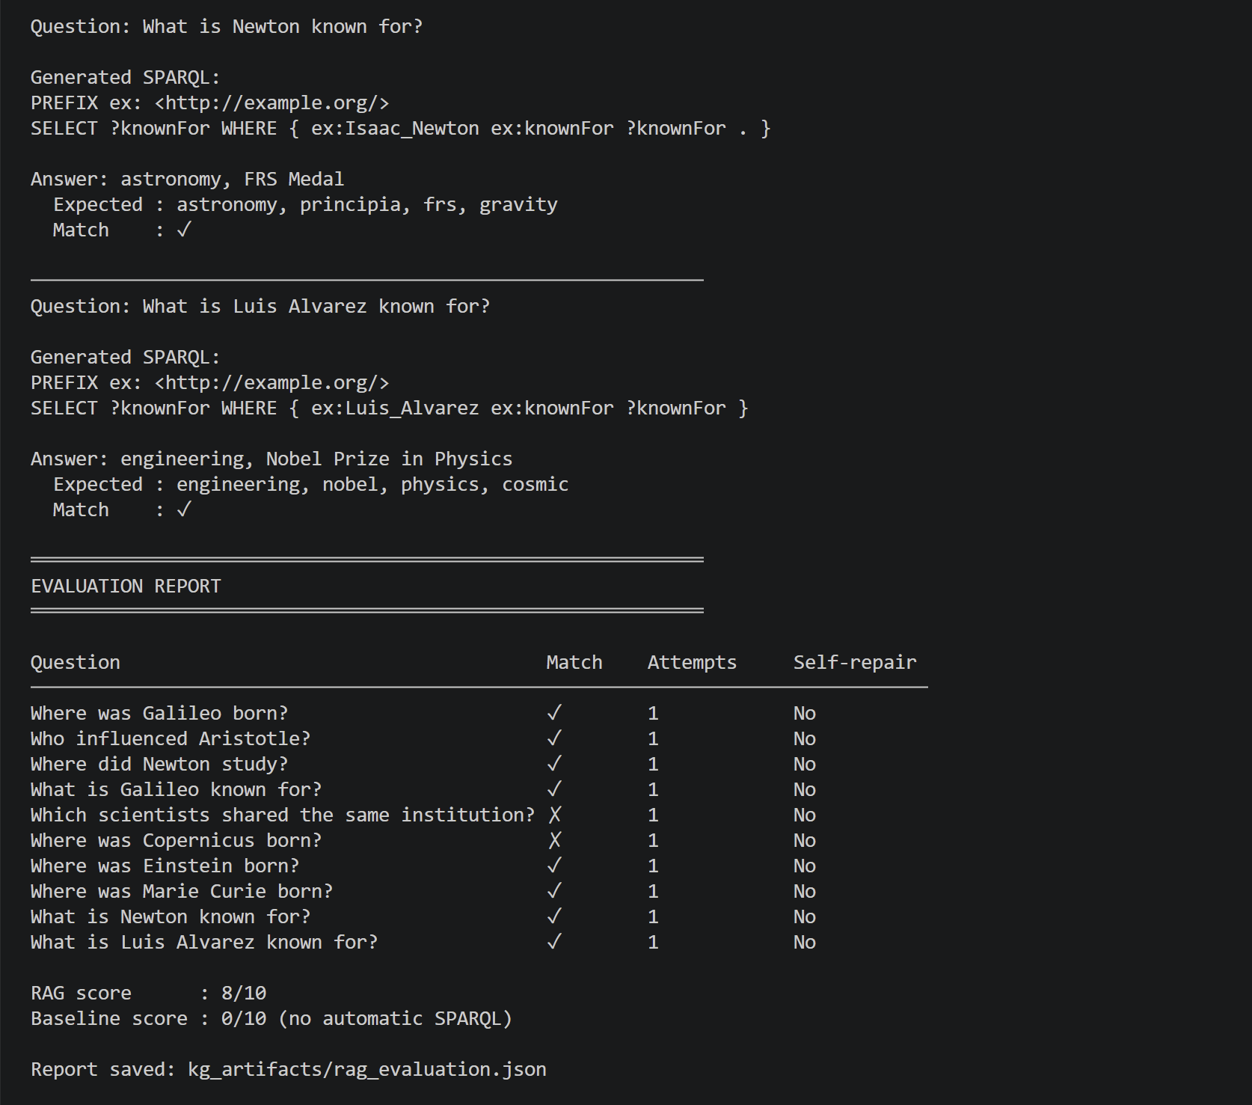

6. Critical Reflection

6.1 KB Quality Impact
The KB quality directly impacts every downstream component. The automatic relation extraction, based on first-verb extraction between co-occurring entities in the same sentence, produces noisy triples. With 594 distinct raw verb predicates across 4,911 entities, the graph is too sparse for KGE models to learn meaningful structure. For example, the sharedInstitution SWRL rule produced 275 inferred triples, but most are false positives because noisy studiedAt relations connected dates, book titles and place names as if they were institutions.

6.2 Noise Issues
Four main noise sources were identified. First, entity mention inconsistency: 'Alvarez', 'Luis Alvarez', 'Luis Walter Alvarez' are treated as distinct entities. Without coreference resolution, the graph is fragmented. Second, ancient dates (before year 0) in XSD format are not parseable by rdflib's XSD date validator and are silently dropped, all Greek philosophers lose their birth and death dates. Third, Wikipedia articles about Copernicus's astronomical theories introduced entities like 'Moon', 'Sun', 'Philolaus' as spurious birth place candidates for Copernicus, demonstrating that the crawler does not distinguish biographical text from scientific content.
Fourth, relation direction errors: the influencedBy predicate contains inverted triples, for example, Thomas Aquinas and the European Renaissance appear as influences on Aristotle, when historically it is the reverse. This stems from sentence-level verb extraction without semantic understanding of relation directionality.

6.3 Rule-based vs Embedding-based Reasoning
SWRL rules offer exact, interpretable inference: the indirectlyInfluencedBy and sharedInstitution rules produce verifiable results when the input data is clean. However, SWRL rules require explicit hand-crafted conditions and do not generalize beyond their defined patterns. On noisy data, they amplify noise.
KGE models in principle capture implicit latent relational patterns through continuous vector representations. TransE models relations as translations (h + r ≈ t), which works well for simple one-to-one relations but fails on symmetric or complex relations. RotatE uses rotations in complex space, theoretically handling symmetric and inverse relations better. In practice, with 594 distinct predicates each seen only ~6 times on average, neither model learned meaningful structure. The nearest neighbor analysis shows some local coherence (Aristotle → Plato, Darwin → Wallace) but link prediction metrics remain at zero.
This illustrates a fundamental trade-off: rule-based reasoning is reliable on small clean KBs; embedding-based reasoning requires scale and data quality. Both are limited by the quality of the underlying KB.

6.4 What Would Be Improved
- Crawl more pages (target: 50–100) to reach the 50k–200k triple threshold for meaningful KGE
- Apply coreference resolution to merge entity variants (e.g., 'Alvarez' = 'Luis Walter Alvarez')
- Use a more sophisticated relation extractor (OpenIE, or a fine-tuned RE model) instead of first-verb heuristics
- Implement automated entity linking using Wikidata's Entity Fishing API instead of manual owl:sameAs
- Add a 2-hop Wikidata expansion to grow the KB from neighbors of aligned entities
- Apply an entity type filter to the sharedInstitution rule to exclude dates, years and non-institutional entities
- Use en_core_web_trf (transformer model) instead of en_core_web_sm for higher NER accuracy
- Add relation direction validation using dependency parsing (nsubj/dobj tags) to ensure the subject is the agent and the object is the recipient of the relation.

References
Bordes, A., et al. (2013). Translating Embeddings for Modeling Multi-relational Data. NIPS.
Sun, Z., et al. (2019). RotatE: Knowledge Graph Embedding by Relational Rotation in Complex Space. ICLR.
Ali, M., et al. (2021). PyKEEN 1.0: A Python Library for Training and Evaluating Knowledge Graph Embeddings. JMLR.
Honnibal, M., & Montani, I. (2017). spaCy 2: Natural Language Understanding with Bloom Embeddings, Convolutional Neural Networks and Incremental Parsing.
Wikidata contributors. Wikidata: A Free Collaborative Knowledge Base. https://www.wikidata.org
Ollama. Local Large Language Model Serving. https://ollama.com
trafilatura: Web Scraping Tool and Library for Text Discovery. https://trafilatura.readthedocs.io

