IA-32

# IA-32 Register

IA-32 is the Pentium processor family in order to distinguish them from their 64-bit architectures.

## Register Set

* There are 3 types of registers:
  + General-purpose data registers
  + Segment Registers
  + Status and control regiters
* Registers are inside the CPU
* Each register contains 32 bytes – and 4 bytes per data
* EAX = 4 bytes

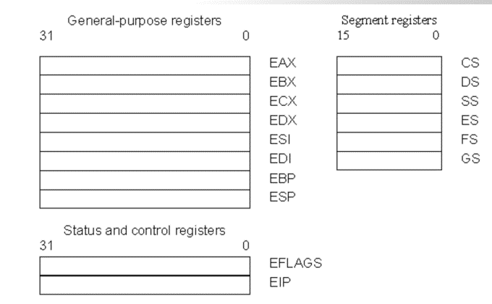

## General-Purpose Registers

* EAX – E = Extended
* EBP – Pointer to data on the stack
* ESP – Stack Pointer – PUSH, POP, CALL, RET