# CSC535 Homework#1

1. Wireshark:
   1. UDP:
      1. Length = 89
      2. Graphical user interface

         Description automatically generated
      3. Hexadecimal value:
         1. 01 bb ce 05 00 23 8b c7
         2. 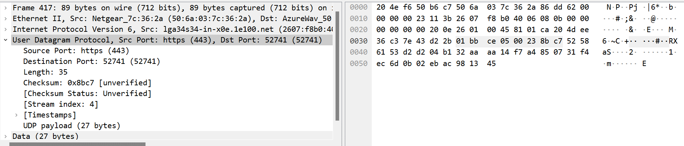
   2. CheckSum : 0x8bc7 =
      1. Graphical user interface, application

         Description automatically generated
   3. bb ce 05 00 23 8b c7 = 303
      1. 303 = 0000 0011
      2. FF = 1111 1111
      3. = 1111 1100 = FC
      4. FC != 8BC7
   4. This is because the pseudo-header is created to calculate the checksum and then not use it, so the client/user will create a pseudo header again and then creates another check sum at the destination.
   5. Graphical user interface, text, application

      Description automatically generated
      1. Source IP = 22 66 be b3
      2. Destination IP = c0 a8 00 1a
      3. UDP length = 89
   6. 1F9+182+89 = 404+1f9 = 5FD
      1. 5FD = 1111 1101
      2. FF = 1111 1111
      3. = 0000 0010 = 2
2. With GBN, is it possible for the sender to receive an ACK for a packet that falls outside of its current sending window? Please describe your assumption clearly.
   1. Yes it is possible, because Go Back N it uses a process where the receiver sends a single acknowledgment in response to a certain number (n) of frames received, this is called cumulative acknowledgement. An example is when a sender has a window size of 3 and sends packets 1, 2, 3 at T0 and at T1 the receiver ACKS 1, 2, 3. Then at T2 the sender will be timed out and resends 1, 2, 3. Then at T3 the receiver will receive the copies and re acknowledges 1 ,2 ,4,