CSC535 Computer Networking
Homework #3 Network Layer
- Find the cost of the shortest paths from A to all other nodes using Dijkstra’s
Algorithm. Show your work:
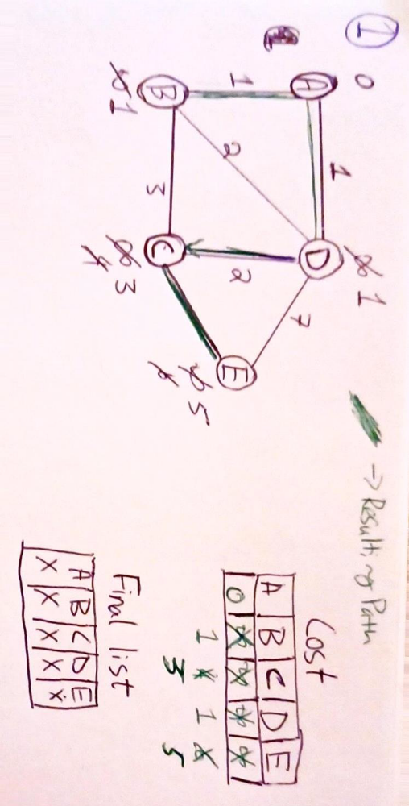

- Find the costs of the cheapest paths from all nodes to F using Bellman-Ford
algorithm. Show your work
