# CSC317 Digital Image Processing

# Homework Assignment #3

1. 1 Program File – Prob1.py

1. Prob2.py

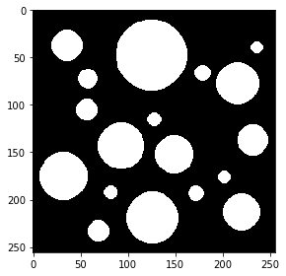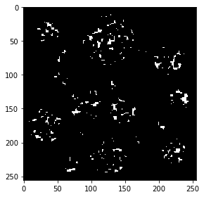

1. Sobel X and Y, Just like with many other examples I first turned the picture black and white then proceeding to convert them. File—Prob3.py
   1. Sobel X-
      1. In this vision I was able to make out the picture’s vertical pattern, edges or any type of disturbance in the picture
   2. Sobel Y
      1. Similarly to the previous vision I has able to make out the picture’s horizontal edges. More so than the actual picture
   3. The picture

1. 4
   1. a

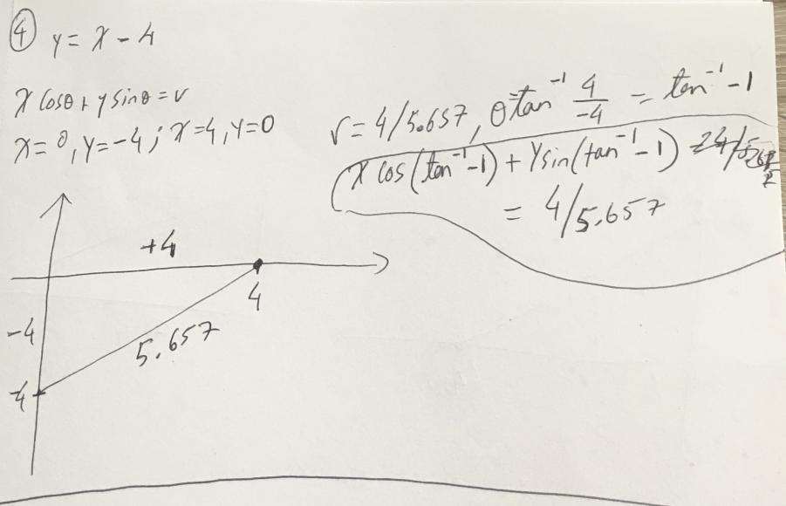

* 1. FF

