

SCHOOL OF INFORMATICS & IT

Diploma in Information Technology

Introduction to Blockchain Application Development (CIT2C26)
Smart Contract Solution

Student Name (Matric Number) : May Thet Naing Bo ( 2303675I )

Class : P01
Jenny LING (TP)
Tutor : Mr. Ryan Justin

Submission Date : 11/08/2025

Declaration of Originality

I am the originator of this work and I have appropriately acknowledged all other original sources used as my references for this work.

I understand that Plagiarism is the act of taking and using the whole or any part of another person’s work, including work generated by AI, and presenting it as my own.

I understand that Plagiarism is an academic offence
and if I am found to have committed or abetted the offence of plagiarism in relation to this submitted work, disciplinary action will be enforced.

Note to Tutor: This page is only to be used if your subject specifically allows AI-generated content to be used. Please delete this page if it is not required.

Declaration on the use of Generative AI tools for assignments

Describe how you have used Generative AI tools such as ChatGPT or Dall.E- in your assignment.

Share the link to the conversations you had with the AI tool (i.e., the prompts you used and the responses you get from the AI tool).

Please refer to this PDF on “How to share the conversations made with ChatGPT?”

How do you indicate the reference?
The content generated by AI tools are not retrievable except by the user who generated them, so they are considered non-recoverable sources. Although non-recoverable data or quotations in APA Style papers are usually cited as personal communications, with ChatGPT-generated text there is no person communicating. Quoting text from ChatGPT chat is therefore more like sharing the output of an algorithm, with a reference list entry and the corresponding in-text citation.
According to the official APA Style site, ChatGPT references should be cited as:
E.g. OpenAI. (2024). ChatGPT (Feb 13 version) [Large language model].
https://chat.openai.com/chat

Note: The information in parentheses refers to the update or revision date of the model used. Refer to the release notes in the ChatGPT application.

Important Note:

- Do not copy answers produced by the AI tool in totality as it is considered as plagiarism.

- Do not rely on any information produced by the AI tool blindly. You should always verify the answer with other sources. Do not assume that these answers provided by the AI tool are correct.

- To achieve quality outputs from the AI tool, you should provide good prompt that is clear and specific. Be precise and provide context. Avoid asking open-ended questions.

Table of Contents
Declaration of Originality 2
Smart Contract Design 1
1.1 Contract Overview 1
1.2 Fields and Variables 2
1.3 Naming Conventions 5
1.4 Function Details 6
1.5 Error Handling and Edge Cases 10
Additional Features 11

Smart Contract Design

Contract Overview
This smart contract implements the CCN Carnival System for managing stalls during a carnival event. In this design, the organizer (the deployer of the system) acts as the chief authority of the contract. The organizer has the ability to authorize accounts, manage system or members, and transfer the organizer role to another person who will assume these responsibilities. Any account authorized by the organizer becomes a TP member (student or staff) and can perform stall ownership roles. Stall owners can register stalls, receive payments, close stalls early, and issue refunds. Buyers can make fixed-price purchases or donations. Overall, the contract supports role-based access control and automatic stall closure after the operating period ends.

Flow Chart
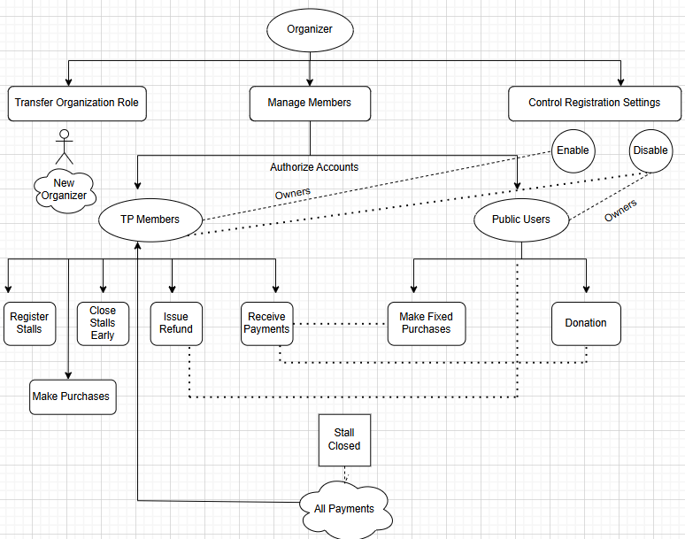

Fields and Variables
Global/Time Configuration
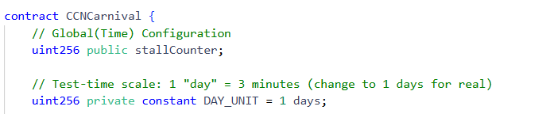
uint256 public stallCounter
Name – stallCounter
Data Type – uint256
Scope – public
Purpose – To auto-increment counter used to assign a unique id to each new stall.
uint256 private constant DAY_UNIT = 1 day
Name – DAY_UNIT
Data Type – uint256
Scope – Private
Purpose - Time scale in production.
Organizer & Registration Gate
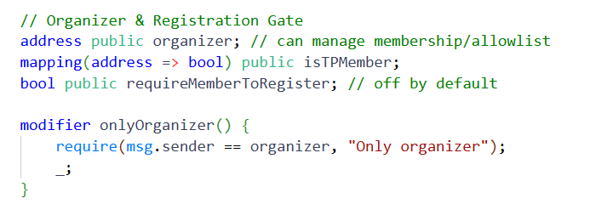
address public organizer
Name – organizer
Data Type – address
Scope – public
Purpose - Current organizer (initially the deployer) has control over membership and registration rules.
mapping(address => bool) public isTPMember
Name – isTPMember
Data Type – mapping(address => bool)
Scope – public
Purpose - Stores allowlist of authorized TP members (true if authorized, false if not authorised).
bool public requireMemberToRegister
Name – requireMemberToRegister
Data Type – bool
Scope – public
Purpose - Toggle: if true, only TP members can register stalls as owners.
Domain Model Types
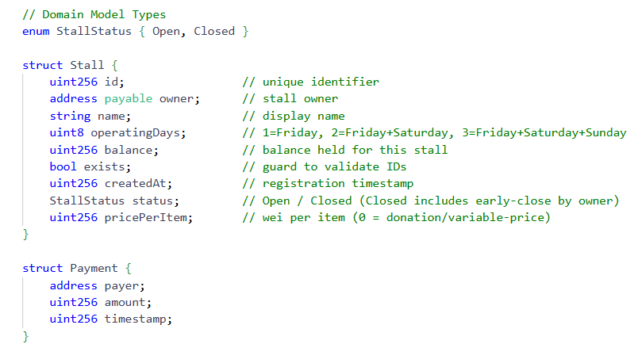

enum StallStatus { Open, Closed }
Name – StallStatus
Data Type – enum
Scope – N/A
Purpose – Defines the lifecycle of all stalls whether they are open or closed
struct Stall
Name – Stall
Data Type - struct
Scope – N/A
Purpose – Holds all stall details (id, owner, name, days, balance, exists, createdAt, status, pricePerItem)
struct Payment
Name – Payment
Data Type – struct
Scope – N/A
Purpose – Holds payment record (payer, amount, timestamp)
Storage (core state)
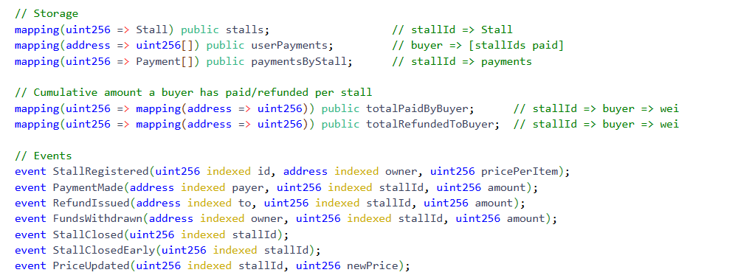
mapping(uint256 => Stall) public stalls
Name – stalls
Data Type – mapping(uint256 => Stall)
Scope – public
Purpose – maps stall ID to its Stall struct data
Mapping(address => uint256[]) public userPayments
Name – userPayments
Data Type – mapping(address => uint256[])
Scope – public
Purpose – For each buyer, it stores an array of stall IDs they have paid into.
mapping(uint256 => Payment[]) public paymentsByStall
Name – paymentsByStall
Data Type - mapping(uint256 => Payment[])
Scope – public
Purpose – For each stall, it stores an array of Payment records
mapping(uint256 => mapping(address => uint256)) public totalPaidByBuyer
Name – totalPaidByBuyer
Data Type - mapping(uint256 => mapping(address => uint256))
Scope – public
Purpose – Cumulative amount (in wei) paid by a buyer to a specific stall
mapping(uint256 => mapping(address => uint256)) public totalRefundedToBuyer
Name – totalRefundedToBuyer
Data Type - mapping(uint256 => mapping(address => uint256))
Scope – public
Purpose – Cumulative amount (in wei) refunded to a buyer for a specific stall
bool private _entered
Name - _entered
Data Type – bool
Scope – private
Purpose - Simple reentrancy lock used by the nonReentrant modifier to protect ETH-transferring functions (issueRefund, withdrawFunds).

Naming Conventions
In the CCNCarnival contract, naming conventions are used consistently for variables functions and events to improve readability and maintainability.
- State Variables are written in camelCase (e.g. stallCounter, requireMemberToRegister, pricePerItem) for clarity and to follow
- Constants are written in UPPER_CASE_WITH_UNDERSCORES (e.g., DAY_UNIT) to indicate that the value is fixed and immutable after compilation.
- Mappings and complex storage variables follow the same camelCase format (e.g.,, userPayments, totalPaidByBuyer).
- Functions names are also written in camelCase(e.g., registerStall, updatePrice, buyFromStall, issueRefund) to clearly indicate actions.
- Event names also use PascalCase (e.g., StallRegistered, PaymentMade, RefundIssued) to differentiate them from functions and variables.
- Structs use PascalCase for type names (Stall, Payment) and camelCase for their fields.

Function Details
constructor()
Purpose: Initialize the contract’s organizer.
Parameters: none
Return type: none
Visibility: public (default for constructors)
Logic & behaviour: When the contract starts, it makes the person who deployed it the organizer. By default, anyone can register stalls, but this can be changed later.
transferOrganizer(address _newOrganizer)
Purpose: Hand over organizer role to another address.
Parameters: _newOrganizer (address) = new organizer (must be non-zero).
Return type: none
Visibility: external
Logic and behaviour : Only the current organizer can call this. It checks that the new organizer’s address is not empty, sends an event saying the organizer changed, and then updates the organizer’s address.
setMember(address _account, bool _isMember)
Purpose: Add or remove an address from the TP member allowlist.
Parameters: _account (address) = target address.
_isMember (bool) = true to add, false to remove.
Return type: none
Visibility: external
Logic and behaviour: Only the organizer can run this. It updates whether a given account is a TP member and then announces the change with an event.
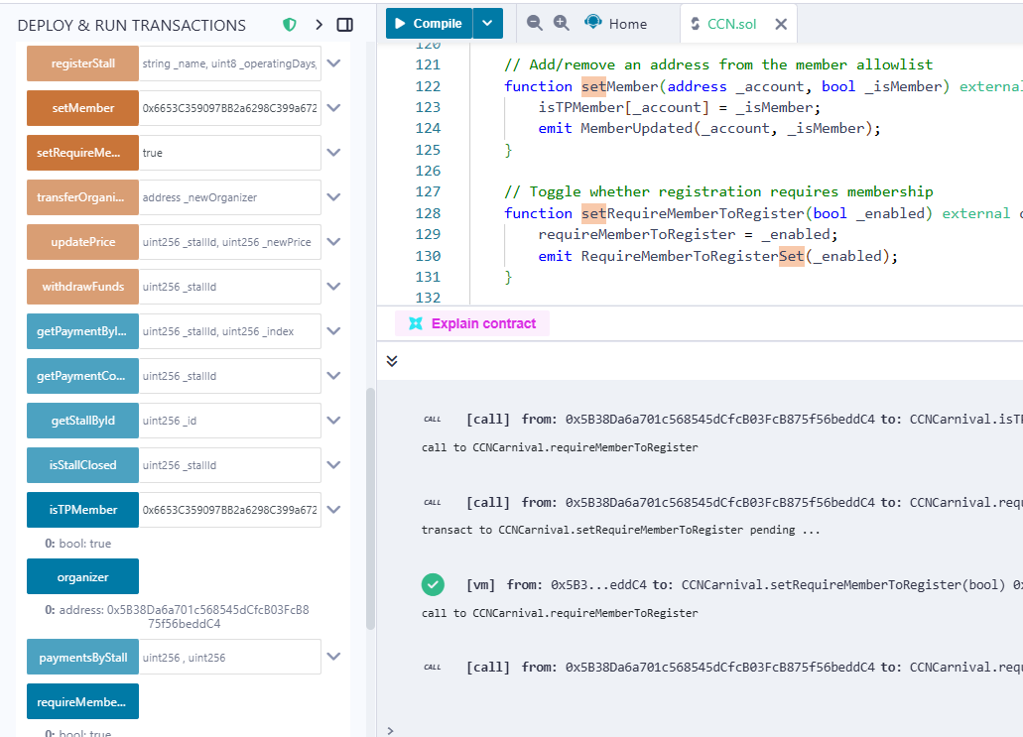

setRequireMemberToRegister(bool _enabled)
Purpose: Toggle whether only TP members can register stalls.
Parameters: _enabled (bool) = true to enforce allowlist; false to open registration.
Return type: none
Visibility: external
Logic and behaviour : Only the organizer can run this. It turns the “member-only registration” setting on or off and then records the change with an event.
registerStall(string memory _name, uint8 _operatingDays, uint256 _pricePerItem)
Purpose: Create a new stall.
Parameters: _name (string) = stall name (1–64 chars).
_operatingDays (uint8) = 1, 2, or 3 (Fri / Fri+Sat / Fri+Sat+Sun).
_pricePerItem (uint256) = fixed price in wei (0 = donation/variable).
Return type: none
Visibility: external
Logic and behaviour : If member-only registration is turned on, the sender must be a TP member. It checks that the stall duration and name are valid. Then it increases the stall counter, saves the new stall details (open status, current time), and announces the registration with an event.
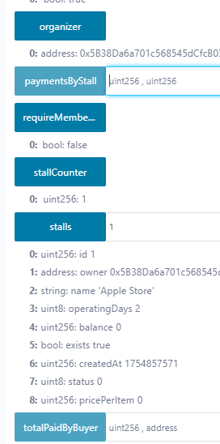

updatePrice(uint256 _stallId, uint256 _newPrice)
Purpose: Change a stall’s fixed price (set 0 to switch to donation mode).
Parameters: _stallId (uint256) = target stall.
_newPrice (uint256) = new price in wei.
Return type: none
Visibility: external
Logic and behaviour: Checks that the stall exists and the caller owns it. Then updates the item’s price and announces the change with an event.
closeEarly(uint256 _stallId)
Purpose: Close a stall before its scheduled end (e.g., out of stock). Stops new payments immediately.
Parameters: _stallId (uint256)
Return type: none
Visibility: external
Logic and behaviour : Checks that the stall exists and the caller is the owner. If the stall is open, it marks it as closed early and sends an event. This doesn’t let the owner withdraw funds early.
payToStall(uint256 _stallId) payable
Purpose: Send a donation/variable payment to an open stall.
Parameters: _stallId (uint256)
Return type: none
Visibility: external payable
Logic and behaviour : Checks that the stall exists and is open. Requires the payment to be more than zero. Adds the payment to the stall’s balance, records it in the buyer’s and stall’s payment history, updates the buyer’s total paid amount, and sends a payment event.
buyFromStall(uint256 _stallId, uint256 qty) payable
Purpose: Buy qty items at the stall’s fixed price.
Parameters: _stallId (uint256)
qty (uint256) = must be > 0.
Return type: none
Visibility: external payable
Logic and behaviour : Checks that the stall exists and is open. Requires the quantity to be above zero and the stall to have a fixed price. Calculates the total cost and ensures the payment matches exactly. Adds the payment to the stall’s balance, records it in both buyer and stall history, updates the buyer’s total paid amount, and sends a payment event.
issueRefund(address payable _buyer, uint256 _stallId, uint256 _amount)
Purpose: Refund ETH from a stall’s balance to a buyer, within limits and only before end time.
Parameters: _buyer (address payable) = refund recipient; must be non-zero and have paid before.
_stallId (uint256)
_amount (uint256) = refund amount in wei.
- Return type: none
- Visibility: external
- Security: nonReentrant
- Logic and hebaviour : Checks that the stall exists and the caller is the owner. Makes sure the buyer’s address is valid, the refund amount is above zero, and the stall has not closed yet. Requires that the buyer has paid before and that the total refunds won’t exceed what they paid.
withdrawFunds(uint256 _stallId)
Purpose: Withdraw entire stall balance after the operating period has ended.
Parameters: _stallId (uint256)
Return type: none
Visibility: external
Security: nonReentrant
Logic and behaviour : Checks that the stall exists and the caller is the owner. Makes sure the stall’s operating time has ended. If it is not already closed, the owner can mark it as closed. Requires there is money to withdraw, sets the balance to zero, sends the funds to the owner, and emits a withdrawal event.
receive() external payable
Purpose: Reject direct ETH transfers; force users to use payToStall or buyFromStall.
Parameters : none
Return : none
Visibility: external payable
Logic and behaviour : If someone tries to send ETH directly to the contract, the transaction is rejected with an error message telling them to use the pay or buy functions instead.

Error Handling and Edge Cases
Error Handling
- Every state-changing function validates preconditions using require(...) with specific messages (e.g, "Stall: not owner", "Buy: incorrect payment", "Refund: stall has closed").
- receive() immediately reverts ("Direct payments not allowed. Use pay/buy.") to ensure all funds flow through validated functions.
- Owner-only actions use onlyStallOwner. Organizer actions use onlyOrganizer.
- Registration can be allowlisted with requireMemberToRegister.
Edge Cases
Registration & roles
- Non-member ( not authorized ) tries to register when member required is on = revert "Register: not an authorized member".
- Organizer can switch gate anytime.
Removing a member only stops future registrations (that means existing stalls are still manageable by their respective owners).
Stall lifecycle & payments
- Pay/buy after stall is closed = stallOpen triggers auto-close and reverts "Stall: closed".
- Close early stops new payments immediately; does not allow early withdrawal
- Donation with zero value = revert "Pay: amount required".
- Buy without entering the quantity = revert "Buy: qty > 0".
- Buy on donation stall = revert "Buy: stall not fixed-price".
- Wrong ETH sent (under/over) = revert "Buy: incorrect payment".
Refunds
- Refund after closing time = revert "Refund: stall has closed".
- Refund to a buyer address that has never paid = revert "Refund: buyer has no payments for this stall".
- Over-refund beyond buyer’s lifetime total → revert "Refund exceeds buyer's total paid".
- Refund when stall balance insufficient → revert "Refund: insufficient stall balance".
- No address / zero amount → respective reverts guard misuse.
Withdrawals
- Withdraw before closing time = revert "Withdraw: stall still operating".
- Withdraw when balance is zero = revert "Withdraw: no funds".

Additional Features
Apart from the core requirements, I created new features and functions in my solidity code as well as implemented the frontend interface design.
New features ( functions ) include :
Allowlist for Members
- The organizer can turn on a rule so that only approved students or staff can register stalls become the owners.
- This keeps outsiders from joining as owners easily.
Organizer Role Transfer
- The organizer can give their role to someone else.

Organizer Mode
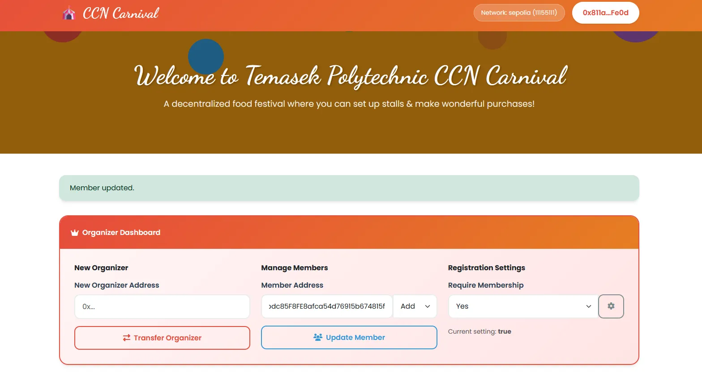

Close Stall Early
- Stall owners can close their stall before the ending time (e.g, if they run out of stock).
- Closing early stops payments but owners can only withdraw money after the planned end date.
Refunds Only Before End Time
- Refunds can only be given while the stall is still running.
- No refunds after the event is over.
Refund Limit Per Buyer
- A stall owner cannot refund a buyer more than what they have paid.
- This prevents mistakes and money misuses.
Payment Records
- The contract stores two types of payment records:
  - By stall – who paid, how much, and when.
  - By buyer – which stalls a buyer has paid to.
- This makes it easy to check payment history.
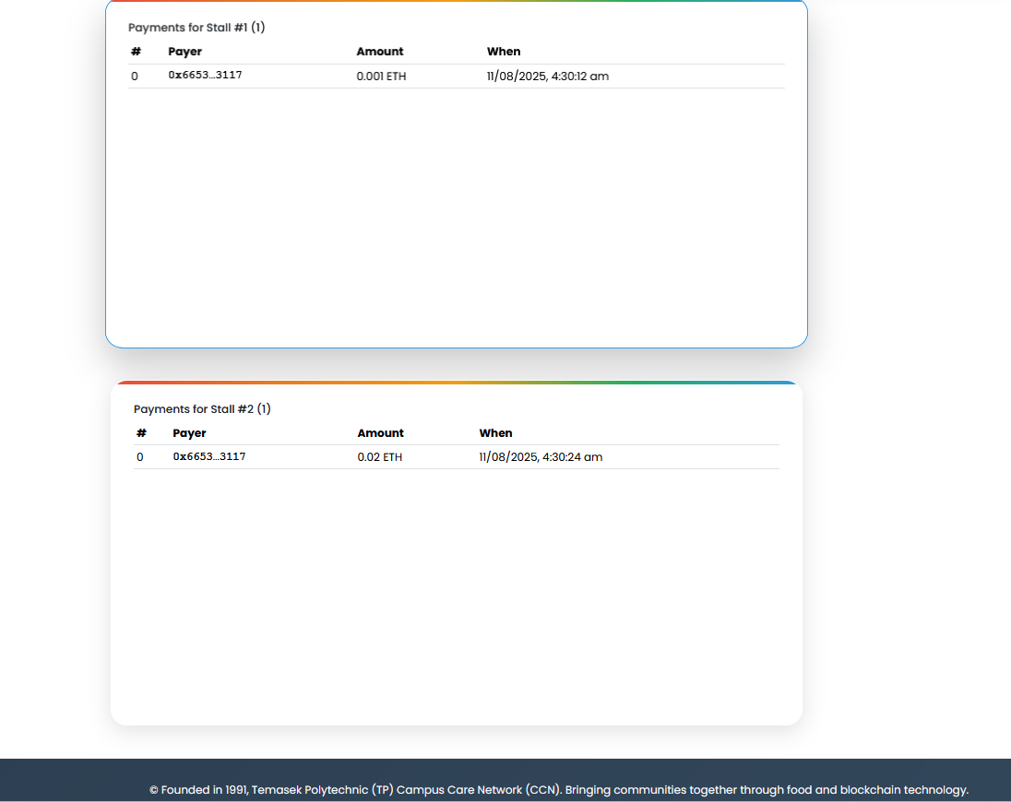

Change Price Mode
- Stall owners can set a fixed price for items or allow free/donation payments.
- The buyer gets more flexible choices.

Frontend Interface Design
Owner Mode
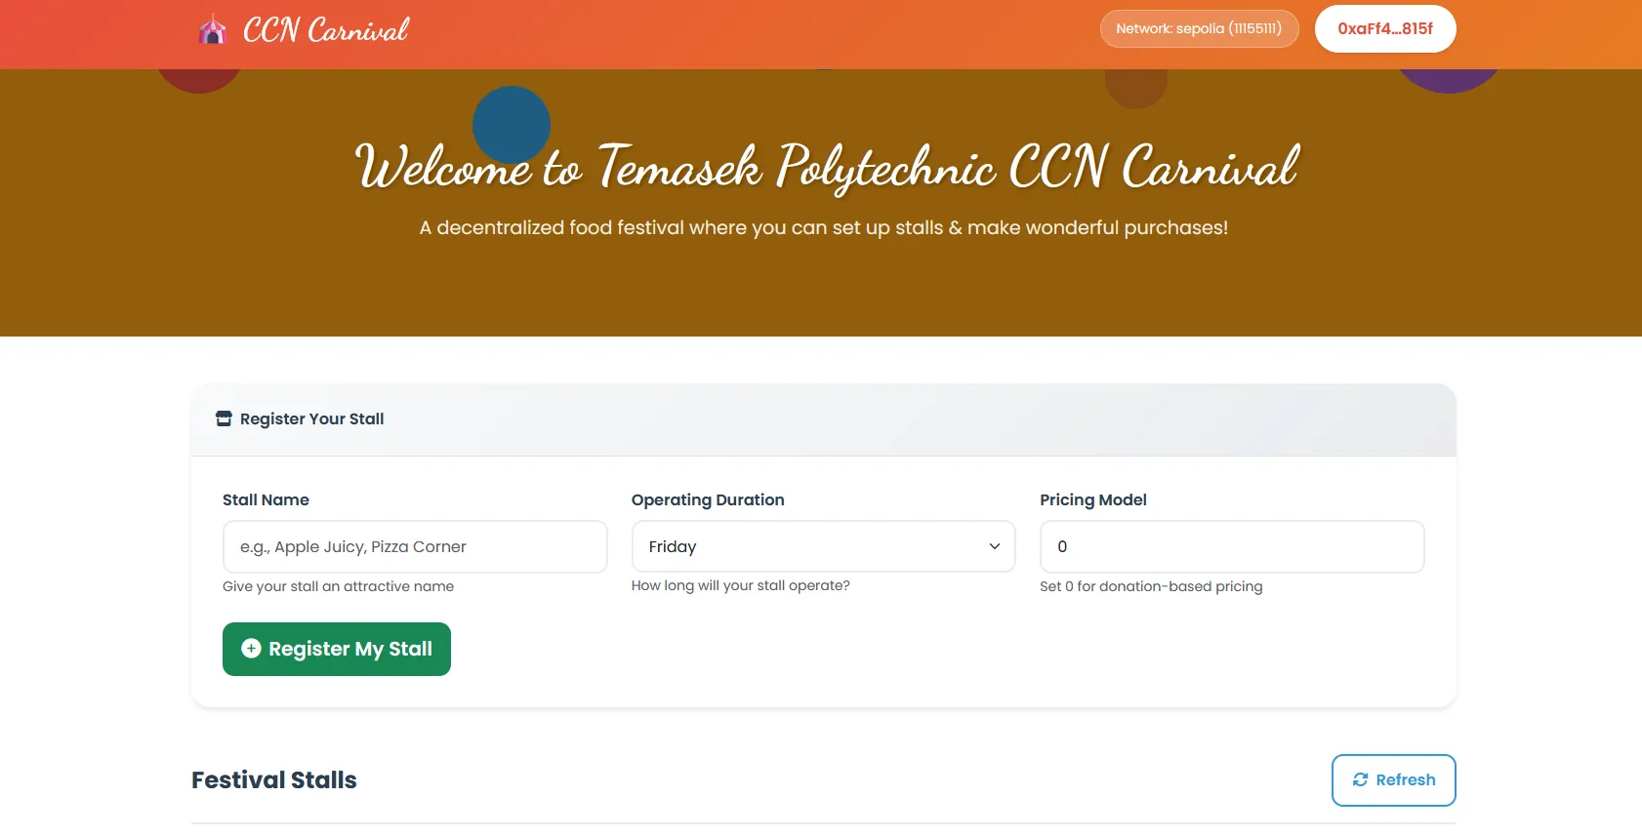

Owner Mode
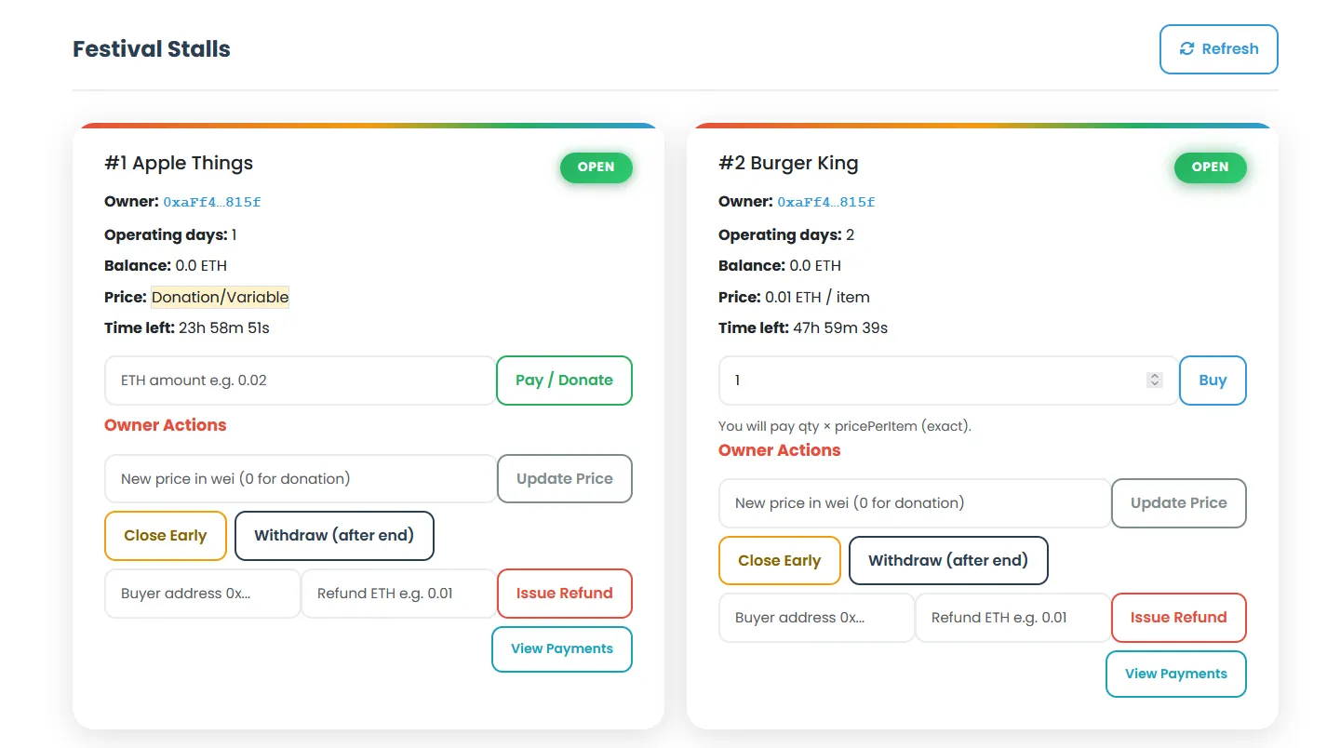
Buyer Mode
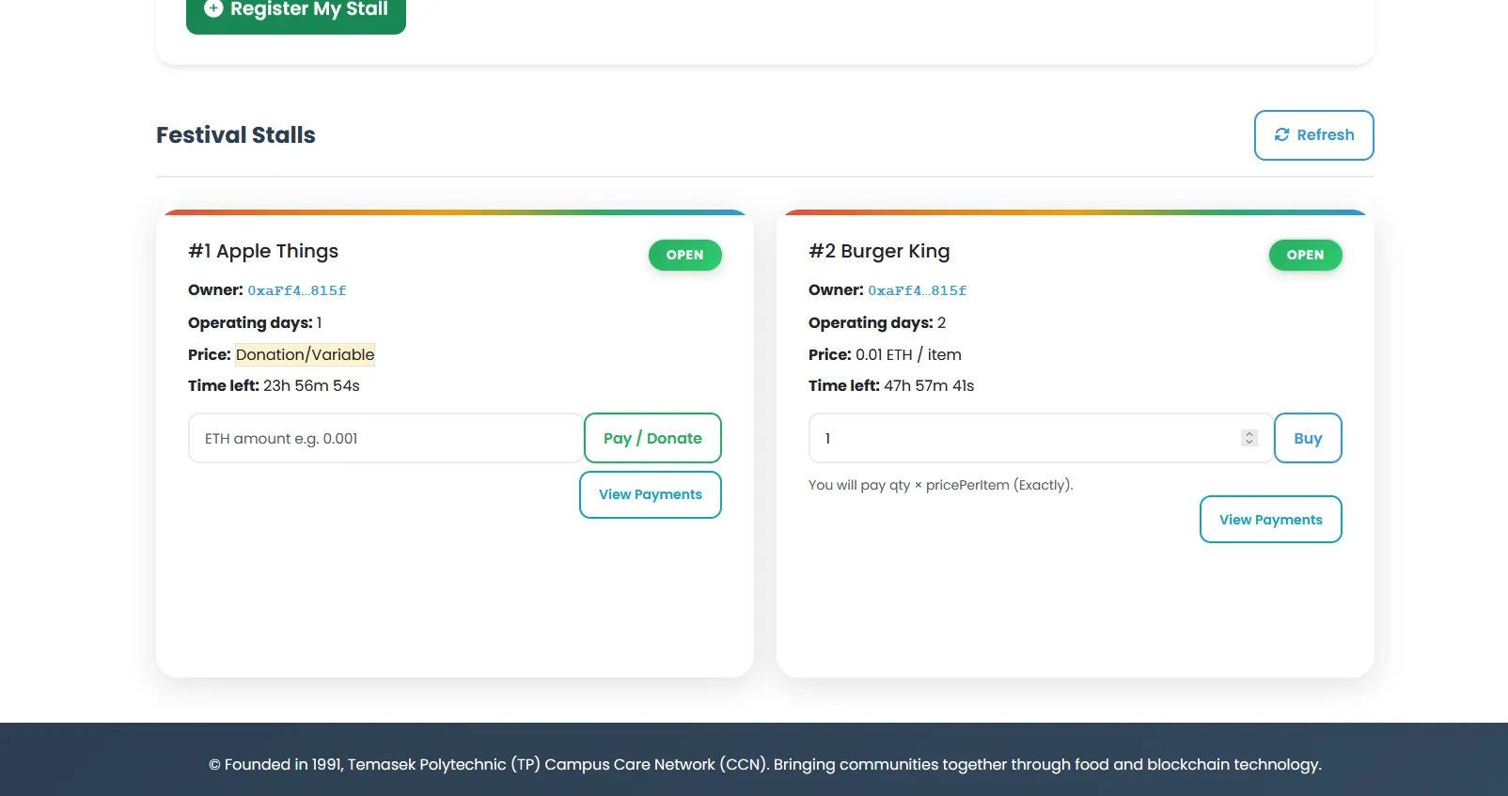

Challenges
During the frontend integration of my CCNCarnival smart contract, one of the main challenges was ensuring that the deployed contract’s ABI matched exactly with the one loaded in my HTML file. At first, I encountered errors like "no matching fragment", caused by calling functions with parameters that did not exist in the ABI from an older deployment. This meant I had to carefully recompile the contract, redeploy it, and copy only the correct ABI array into the frontend.
Testing and debugging was also tricky because I had to coordinate between MetaMask accounts, Sepolia network deployments, and UI features. Any mismatch in network, address, or ABI instantly broke function calls. I had to test out multiple iterations of deployment, address updates, and UI adjustments so that the frontend display stalls, process payments, and allow owner actions without any error.

