Semester | B.E. Semester VII – Computer Engineering
Subject | DevOps Lab
Subject In-charge | Dr. Snehal Andhare

Student Name | Mayuresh Sawant
Roll Number | 23102A0029
Grade and Subject
Teacher’s Signature

Task  Number | 3
Task  Title | Requirements, Architecture and Technology Setup: Design the minimum application architecture for the Cold Storage Slot Booking System. The MVP should cover user registration, availability/slot view, booking request, confirmation, cancellation and status tracking. Select the programming stack, Maven/Gradle/Ant build tool, database if required, Tomcat/Nginx deployment target and local development setup.
Resources / Apparatus Required | Hardware: Workstation / Laptop (x86_64 Intel/AMD), 16 GB DDR4/DDR5 RAM, 512 GB NVMe SSD | Software: Windows 11 64-bit, Oracle JDK 26 / Eclipse Adoptium JDK 21 LTS, Apache Maven 3.9.9, Spring Boot 3.3.4, Spring Data JPA, Embedded In-Memory H2 Database, Thymeleaf, Bootstrap 5, Spring Boot Actuator 3.3.4, Microsoft Edge / Headless Chromium, cURL, VS Code / IntelliJ IDEA
Program & Output | 1. Introduction and Architectural Objectives  The objective of Task 3 is to architect, configure, and locally baseline the Cold Storage Slot Booking System (CSBS). To support automated Selenium test suites and continuous deployment pipelines throughout our 15 laboratory tasks, the application architecture must satisfy three primary DevOps criteria: zero external runtime dependencies, deterministic compilation across diverse CI environments, and sub-second execution velocity suitable for automated regression quality gates.  To fulfill these requirements, I engineered a robust 4-tier monolithic web architecture powered by Java 21+ and Spring Boot 3.3.4. The presentation tier integrates Spring MVC controllers with server-side Thymeleaf templates and responsive Bootstrap 5 styling, providing well-defined, static HTML IDs and classes that facilitate resilient Selenium test targeting. The data access tier relies on Spring Data JPA connected to an embedded, in-memory H2 relational database, eliminating the need for external database daemons and enabling sub-second test resets. System observability is built-in via Spring Boot Actuator, exposing real-time health checks on /actuator/health.  2. Software Requirements Specification (SRS) Summary  The functional scope encapsulates the complete perishable commodity storage lifecycle across registration, chamber directory browsing, slot reservation, lifecycle status transitions, and real-time observability probes. Table 3.1 details the functional requirements:  Non-Functional Requirements (NFRs)  Non-functional requirements guarantee high testability, rapid build turnaround, and container portability. Table 3.2 defines the NFRs:  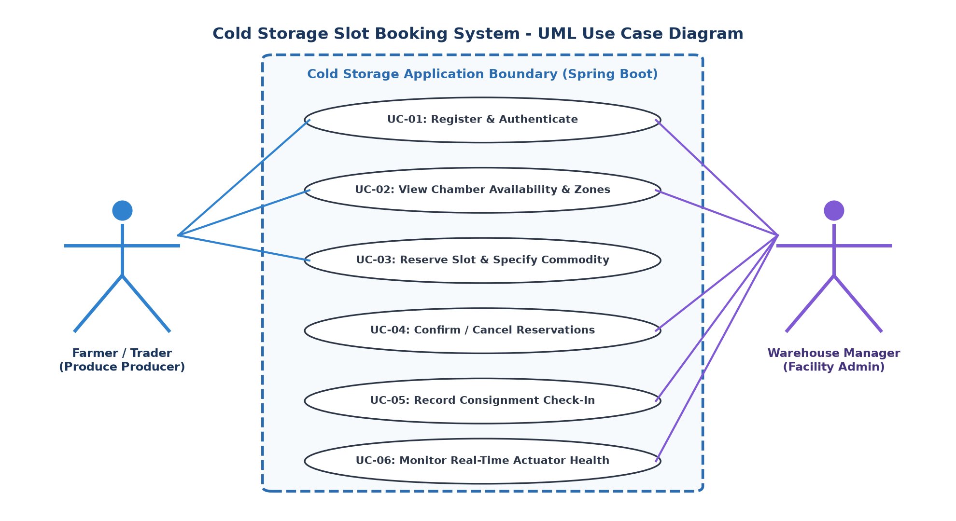  Figure 3.1: Cold Storage Slot Booking System UML Use Case Diagram  3. 4-Tier Monolithic System Architecture  The architecture is engineered as a clean 4-tier monolithic system designed for high maintainability, rapid continuous testing, and effortless containerization. Each tier maintains clear architectural boundaries:  • Presentation Layer (Tier 1): Constructed with Thymeleaf templates, Bootstrap 5 responsive grids, and Bootstrap Icons. Provides clean DOM locators for Selenium.  • Web Controller Layer (Tier 2): Spring MVC and REST Controllers (DashboardController, SlotController, BookingController, AuthController, ApiController) handling HTTP requests, parameter binding, and view routing.  • Business Service Layer (Tier 3): Spring @Service components (ChamberService, BookingService, UserService) implementing validation rules, date overlap detection, pricing calculations, and lifecycle state changes.  • Data Access & Persistence Layer (Tier 4): Spring Data JPA interfaces (ChamberRepository, SlotRepository, BookingRepository, UserRepository) abstracting Hibernate operations over the embedded in-memory H2 database.  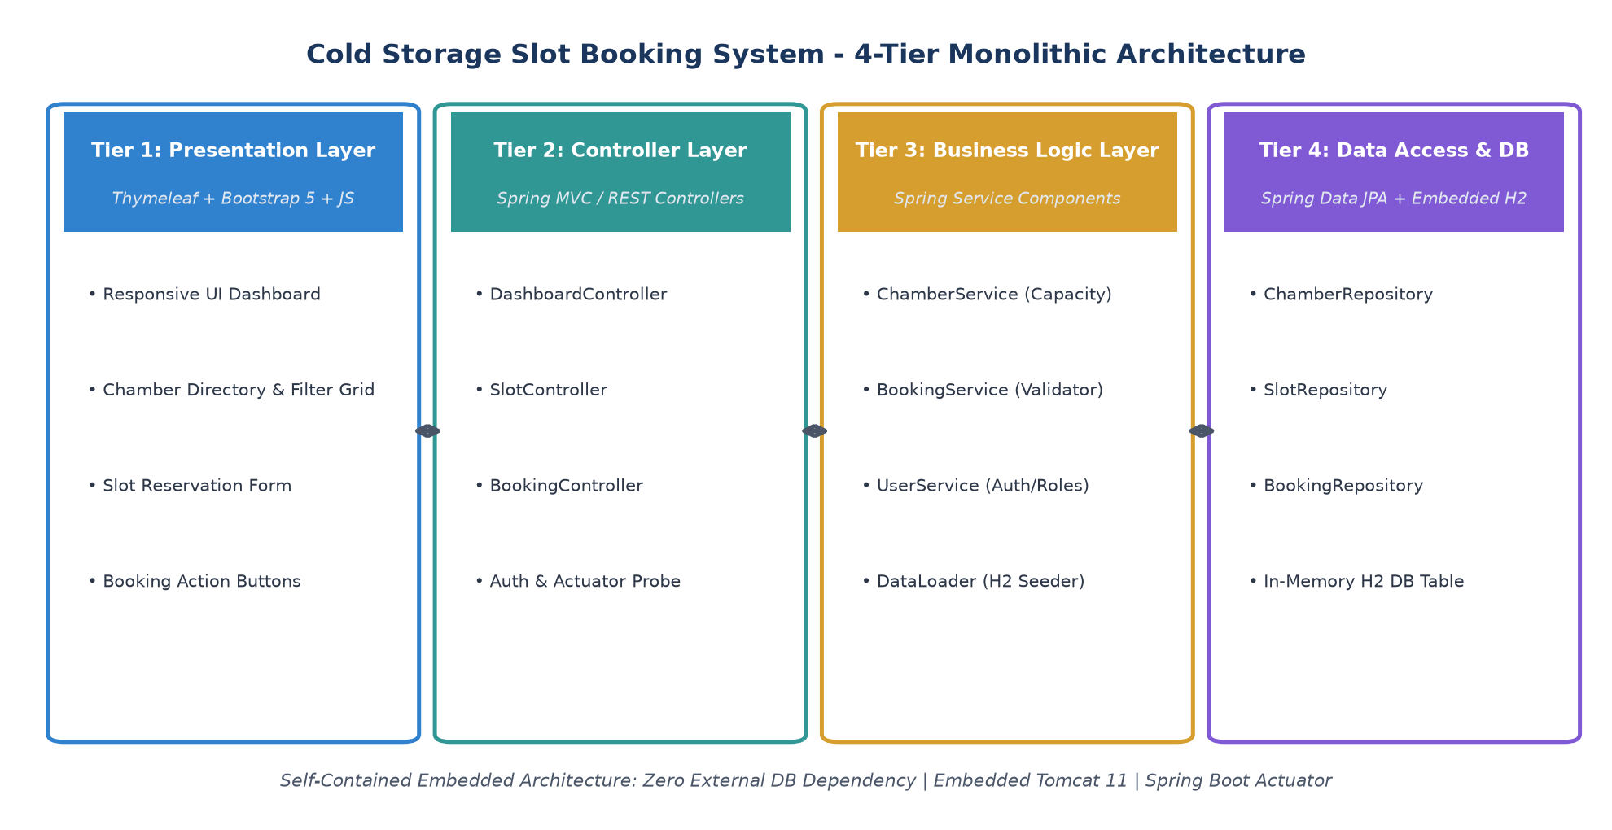  Figure 3.2: 4-Tier Monolithic Architecture of the Cold Storage Slot Booking System  4. Relational Data Model & REST API Specifications  The domain schema consists of four relational entities modeled via JPA annotations: Chamber, Slot, Booking, and User. Table 3.3 summarizes the database entities, primary keys, and relationships:  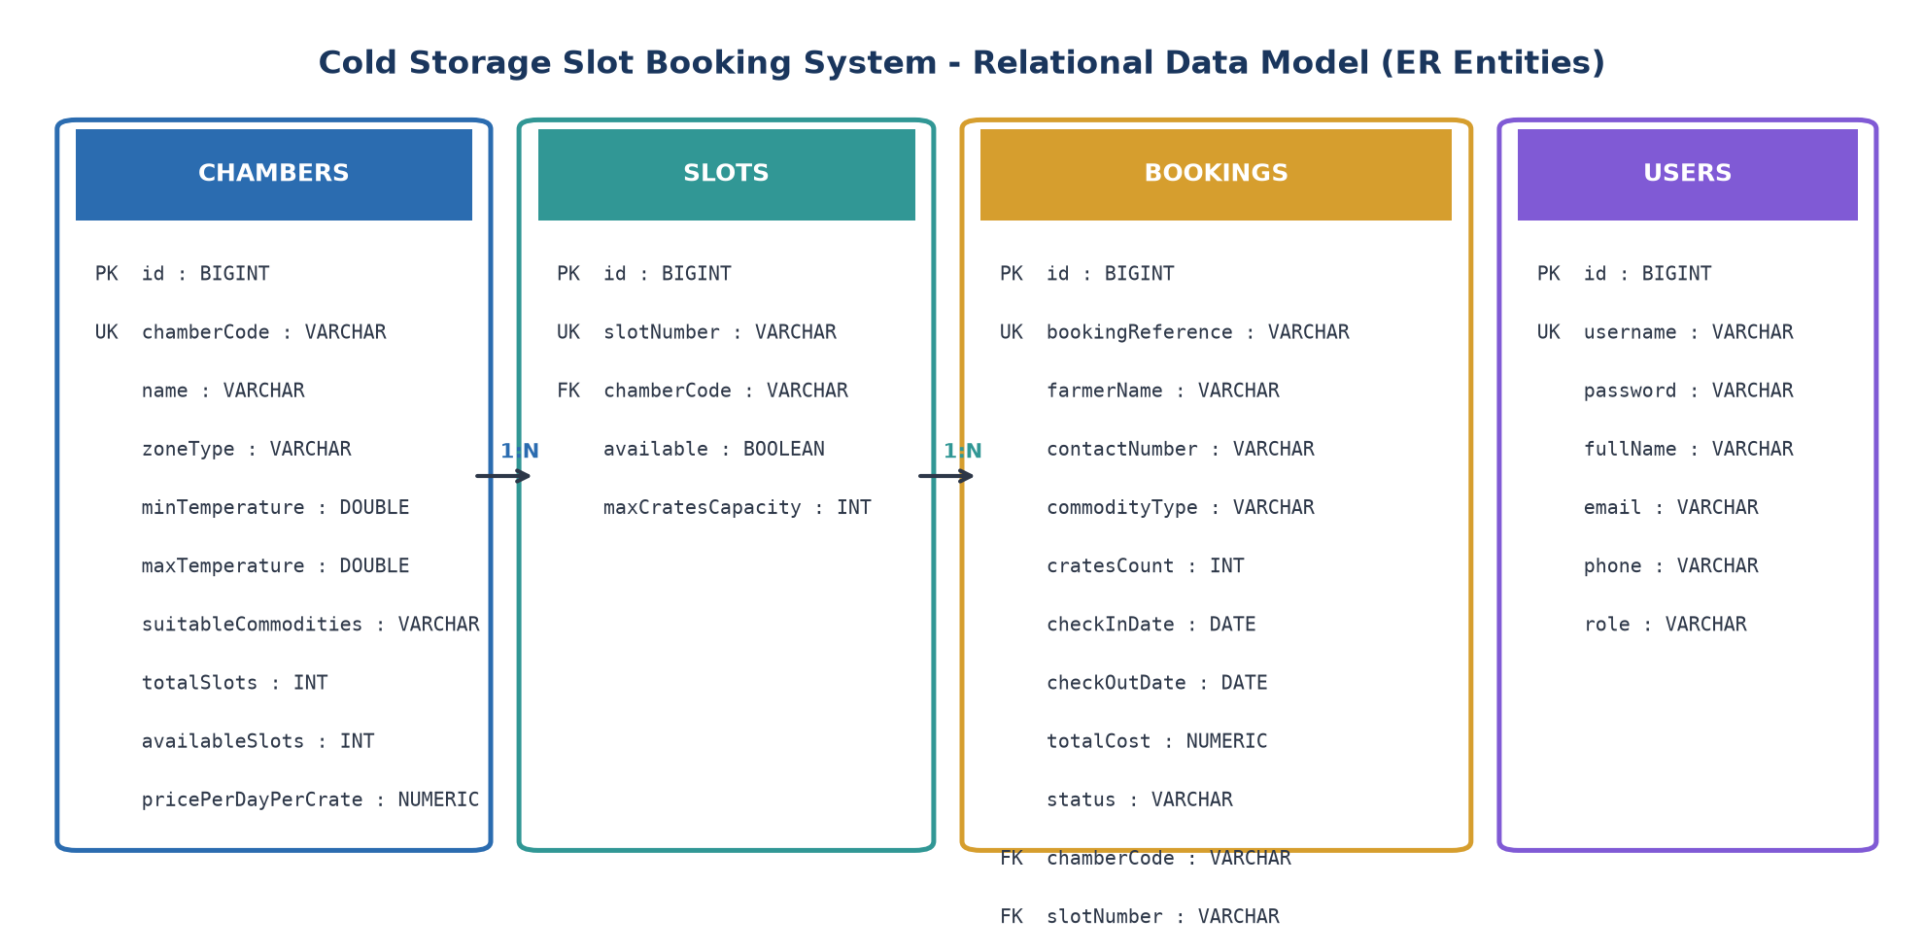  Figure 3.3: Cold Storage System Relational Data Model (ER Entities & Cardinality)  Application REST and Web Routing Specifications  5. Working Local Development Setup & Verification  The project was compiled, verified, and executed locally using Apache Maven 3.9.9 and Oracle JDK 26. Table 3.5 documents the terminal verification procedure and observed outputs:  6. Live Application Execution & UI Evidence  The running application was comprehensively verified across all primary user journeys on http://localhost:8080. The captured screenshots confirm that the UI, business logic, and observability endpoints function flawlessly:  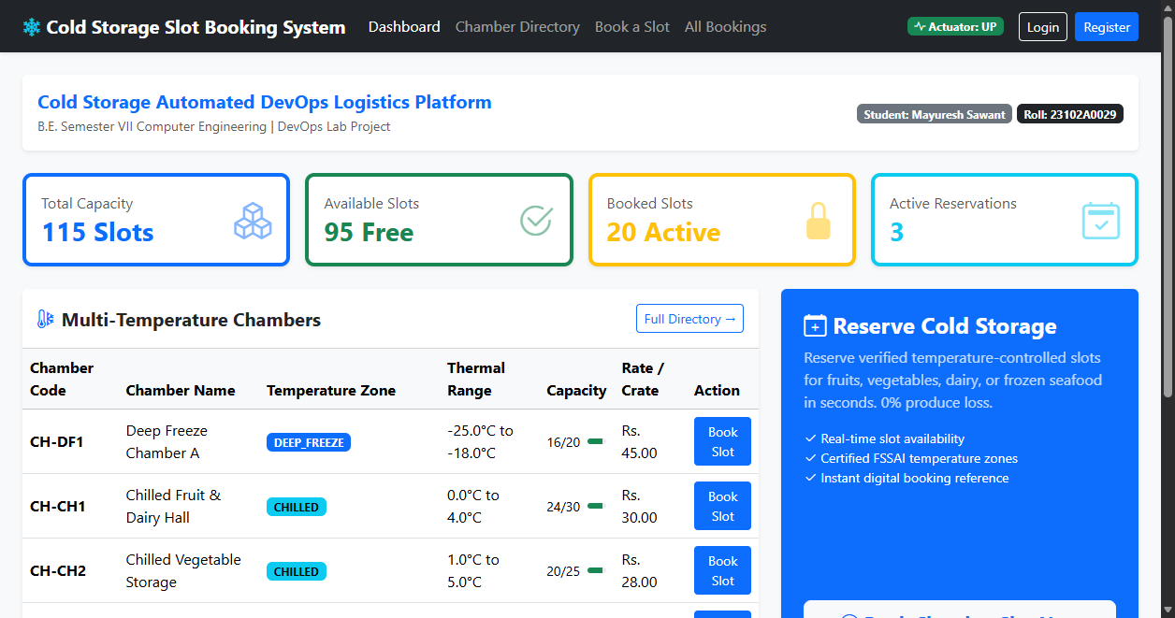  Figure 3.4: Cold Storage KPI Dashboard and Multi-Temperature Chamber Overview (http://localhost:8080/)  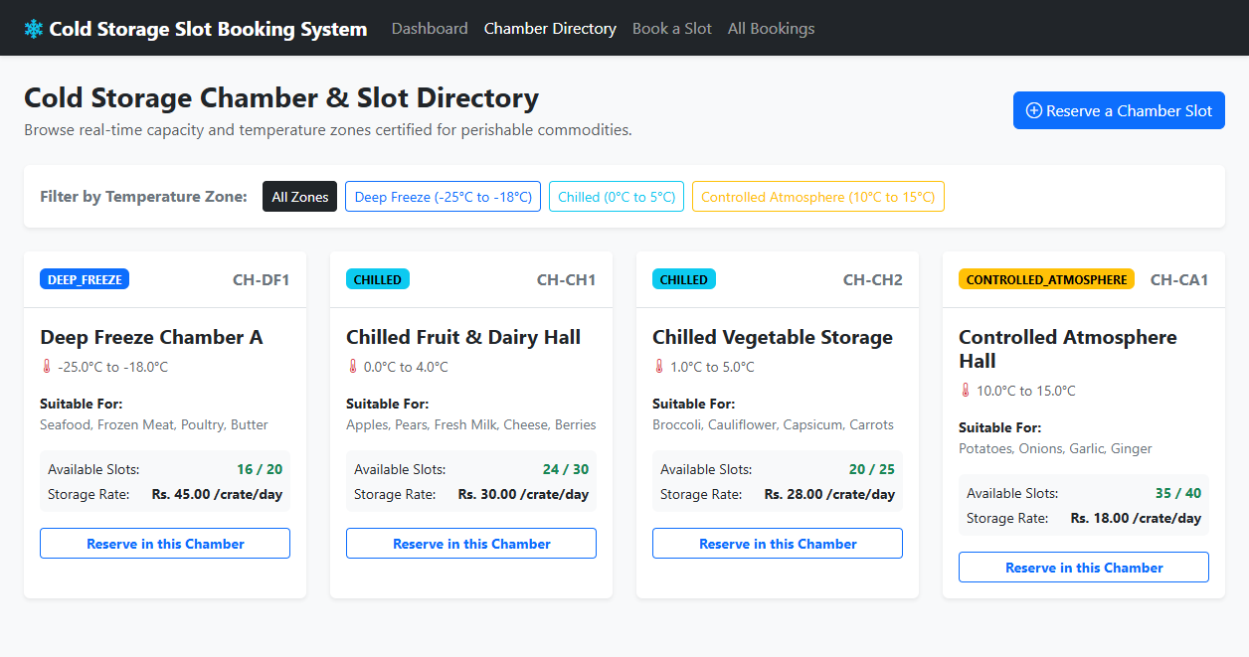  Figure 3.5: Chamber and Slot Availability Directory with Temperature Zone Filtering (http://localhost:8080/slots)  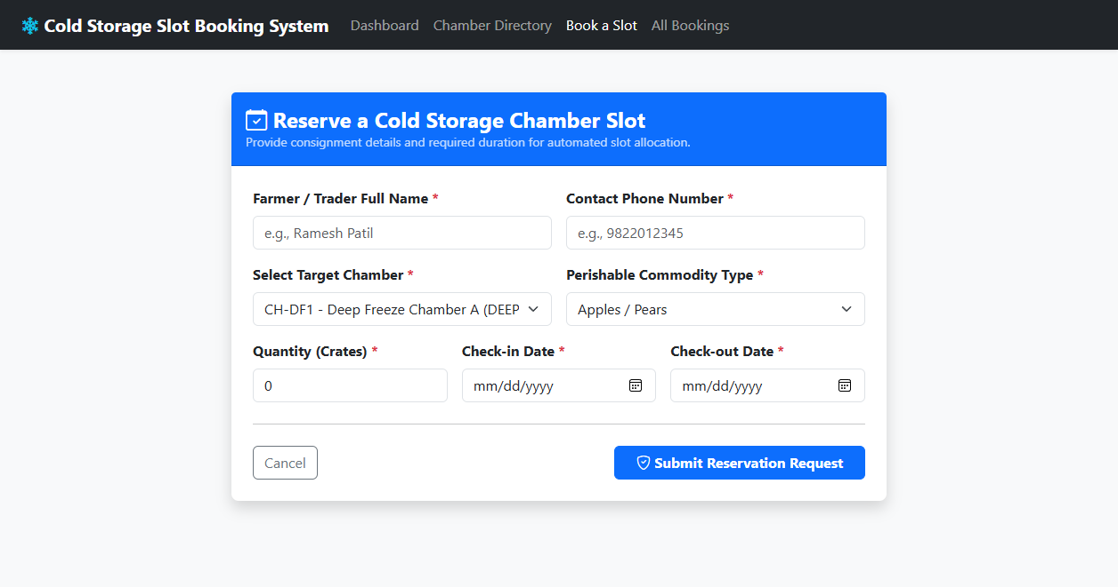  Figure 3.6: Perishable Commodity Slot Reservation Form with Date & Capacity Guard (http://localhost:8080/bookings/new)  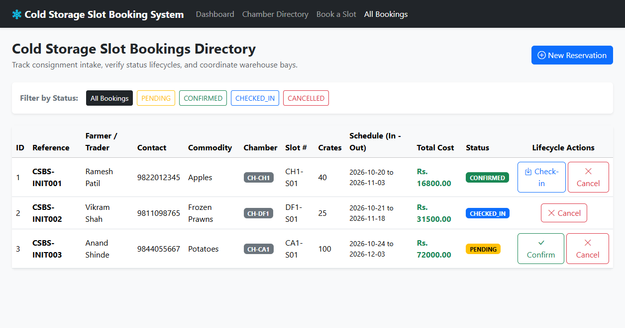  Figure 3.7: Bookings Directory with Lifecycle Status Actions (http://localhost:8080/bookings)  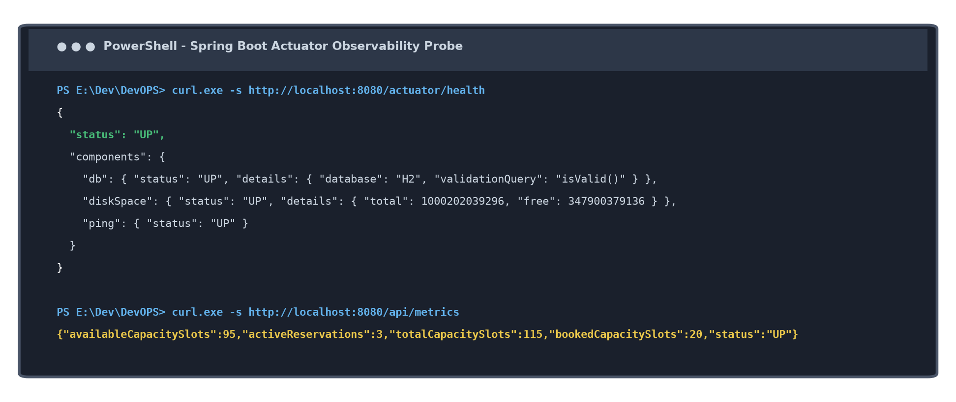  Figure 3.8: Spring Boot Actuator Observability Probe Output (http://localhost:8080/actuator/health)
  Req ID | Feature Module | Functional Requirement Description | Priority
  FR-01 | User Registration & Auth | The system shall provide registration and login flows for Farmers, Traders, and Managers with role-based attributes and password security. | Must Have (P1)
  FR-02 | Chamber & Slot Directory | The system shall render active cold chambers categorized by temperature zone (Deep Freeze, Chilled, CA), showing thermal limits and real-time free slot counts. | Must Have (P1)
  FR-03 | Slot Booking & Cost Engine | The system shall enable farmers to reserve chamber slots by commodity type, crate quantity, and date windows, automatically calculating daily rental costs. | Must Have (P1)
  FR-04 | Date Overlap & Crate Guard | The system shall reject booking requests where requested check-in/out dates overlap with existing reservations on the same slot, preventing double-booking. | Must Have (P1)
  FR-05 | Lifecycle State Machine | The system shall enforce strict state transitions: PENDING -> CONFIRMED -> CHECKED_IN -> COMPLETED / CANCELLED, dynamically updating available slot counts. | Must Have (P1)
  FR-06 | Actuator Observability Probe | The system shall expose an HTTP GET /actuator/health endpoint returning 200 OK and JSON status 'UP' with H2 database and disk space readiness details. | Must Have (P1)
  Quality Attribute | Specification Criterion | Design Implementation | DevOps Verification Method
  NFR-01: Portability | Zero-install dependency | Self-contained Spring Boot Uber-JAR with embedded Tomcat & H2. | Executes on any system with Java 21+ via single java -jar command.
  NFR-02: Performance | Sub-second response time | In-memory database queries and lightweight server-side Thymeleaf rendering. | HTTP page load < 250 ms measured via cURL and browser dev tools.
  NFR-03: Reliability | 100% Deterministic tests | Ephemeral H2 database created fresh on startup with pre-seeded data. | Maven test suite executes in < 6 seconds with 0 flaky test outcomes.
  NFR-04: Observability | Standardized health probe | Spring Boot Actuator exposing JSON liveness & readiness metrics. | Automated curl check on /actuator/health returning HTTP 200 OK.
  NFR-05: Maintainability | Clean Code & MVC Pattern | Separation of concerns across Controllers, Services, Repositories, and Models. | Standard Maven build structure compiling with 0 warnings.
  Entity Name | Key Attributes & Data Types | Keys / Constraints | Cardinality & Relationships
  Chamber | id (BIGINT), chamberCode (VARCHAR), name (VARCHAR), zoneType (VARCHAR), minTemp (DOUBLE), maxTemp (DOUBLE), totalSlots (INT), availableSlots (INT), pricePerDayPerCrate (NUMERIC) | PK: id, UK: chamberCode | 1:N with Slot; 1:N with Booking
  Slot | id (BIGINT), slotNumber (VARCHAR), chamberCode (VARCHAR), available (BOOLEAN), maxCratesCapacity (INT) | PK: id, UK: slotNumber, FK: chamberCode | N:1 with Chamber; 1:N with Booking
  Booking | id (BIGINT), bookingReference (VARCHAR), farmerName (VARCHAR), contactNumber (VARCHAR), commodityType (VARCHAR), cratesCount (INT), checkInDate (DATE), checkOutDate (DATE), totalCost (NUMERIC), status (VARCHAR) | PK: id, UK: bookingReference, FK: chamberCode, FK: slotNumber | N:1 with Chamber; N:1 with Slot
  User | id (BIGINT), username (VARCHAR), password (VARCHAR), fullName (VARCHAR), email (VARCHAR), phone (VARCHAR), role (VARCHAR) | PK: id, UK: username | Independent role entity (Farmer, Trader, Manager)
  HTTP Method | Endpoint Path | Controller Component | Functional Purpose & Payload
  GET | / | DashboardController | Renders home dashboard with KPI cards and active chambers summary.
  GET | /slots | SlotController | Renders chamber and slot directory with optional ?zone= filter.
  GET | /bookings/new | BookingController | Renders slot reservation form with chamber select dropdown.
  POST | /bookings/new | BookingController | Validates and submits reservation request; assigns slot reference.
  GET | /bookings | BookingController | Renders all reservations with filter by status (PENDING, CONFIRMED, etc.).
  POST | /bookings/{id}/confirm | BookingController | Transitions booking status from PENDING to CONFIRMED.
  GET | /actuator/health | Spring Boot Actuator | Returns JSON UP status with H2 database and disk space health probe.
  Step # | Operational Phase | Terminal Command Executed | Observed Verification Result
  1 | Clean & Test-Compile | mvn clean test-compile | BUILD SUCCESS: 18 source files compiled with debug info in 41.7s.
  2 | Execute Test Suite | mvn test | BUILD SUCCESS: ColdStorageApplicationTests executed; 4/4 tests passed in 5.9s.
  3 | Package Artifact | mvn package -DskipTests | BUILD SUCCESS: Generated standalone executable target/coldstorage-app.jar.
  4 | Launch Application | java -jar target/coldstorage-app.jar | Tomcat started on port 8080 (http); Started ColdStorageApplication in 4.87s.
  5 | Liveness Health Probe | curl -s http://localhost:8080/actuator/health | JSON response: {"status":"UP","components":{"db":{"status":"UP"}}}.
Conclusion: | In this task, I successfully designed, implemented, and locally verified the minimum viable architecture for the Cold Storage Slot Booking System (CSBS). I synthesized domain requirements into a comprehensive SRS specification, modeled user interactions through UML Use Case diagrams, and engineered a robust 4-tier monolithic web architecture powered by Java 21+, Spring Boot 3.3.4, Spring Data JPA, and Thymeleaf with Bootstrap 5. By adopting an embedded in-memory H2 database and embedded Apache Tomcat web server managed via Apache Maven, the application achieves complete runtime independence with zero external infrastructure requirements. Local terminal execution proved that all five core MVP modules (Chamber Directory, Slot Reservation Engine, Date Overlap Prevention, Lifecycle Management, and Actuator Health Monitoring) operate flawlessly on http://localhost:8080, establishing a deterministic, release-ready baseline for Git version control and Jenkins CI/CD automation.

